# Homework: Programming Languages

Problems for homework for the ["Software Technologies" course @ Software University.](https://softuni.bg/trainings/4383/software-technologies-january-2024)  
Submit this document as your homework.

## JavaScript:

1. Open the Browser Console.
2. Create a **JS function** for **calculating and returning** the **area of a rectangle**.
3. **Create the constants needed** and **assign** some random **values**:
4. **Execute the JS function** in the Browser Console:
5. **Print the calculated area on the Browser Console** in the following format: "The area of the rectangle is: areaValue sq.cm." :
6. **Example:**

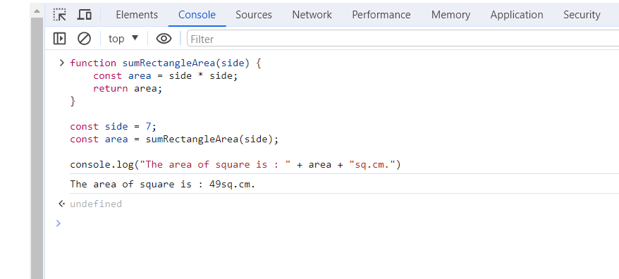

* **Replace all example pictures with screenshots from your PC.**

## HTML & CSS

1. **Using the tutorial from the Exercise Document, Crate a simple Web Page that looks like the Example Below.**
2. **Example:**

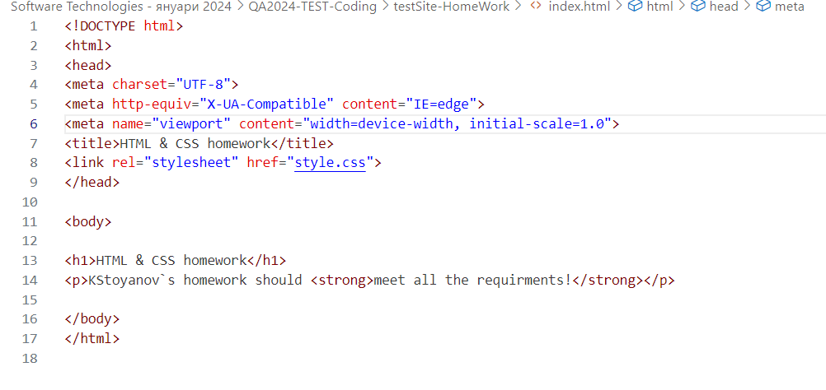

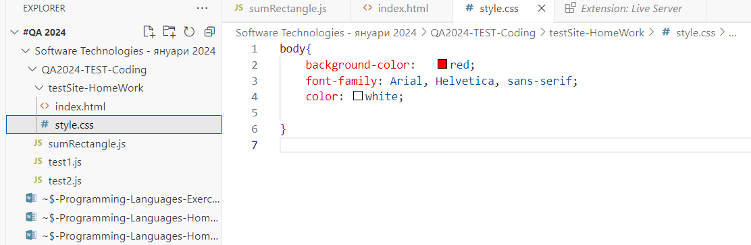

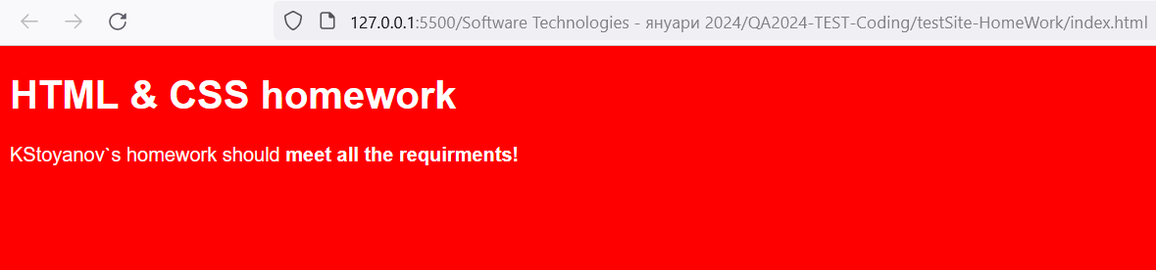

* **Replace all pictures with screenshots from your PC.**