Name:Italiya Drashti Nitshbhai
Roll no:18
Sem :7
Div:A
Subject:Full Stack Devlopment Using Mern Stack
Practical Assignment-2

QUESTION:1
2 components using CDN approach.
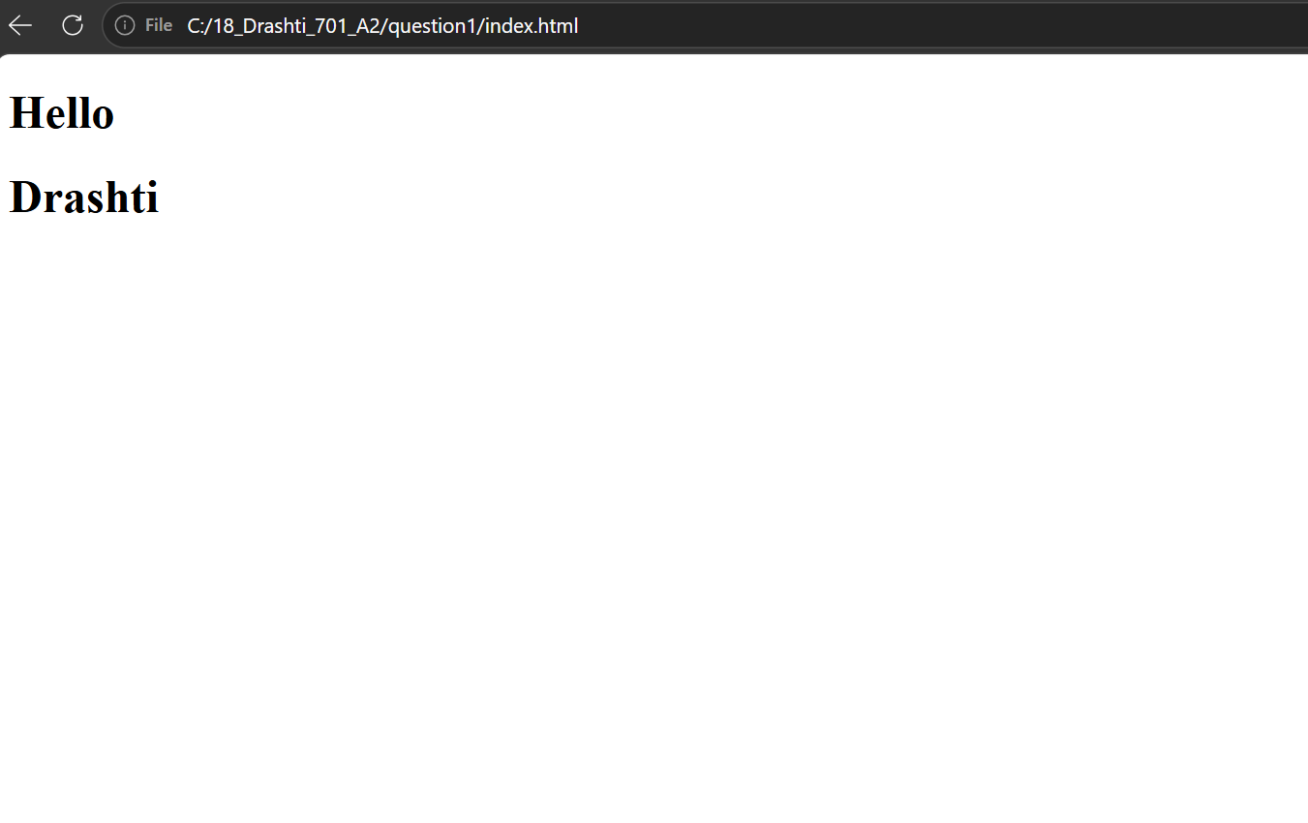

QUESTION:2
Create Vite/CRA based react app, add bootstrap to it, add router to it and give links for components with following requirements:
1) Create and display component using function component.
2) Take a suitable case and develop components for
conditional rendering, list, nested components, children (containment)
3) Develop counter component with increment, decrement, reset.
4) Develop components using useState and useRef using function components.
5) Develop components for digital clock using useState and useEffect.
6) Develop component for live form validation with manual validation.
7) Develop component for live form validation with any third party validation library.
8) Develop component that fetches data from a employees .json JSON file and display in a table.
9) Develop component to fetch data from students.json and display. Add search and filtering. Search should be based on student firstname and filtering is based on semester, div, gender etc.

QUESTION:3
Develop "To Do" app.
