Student number / name: 21382104 / Italo Gomes Santana

Introduction

I will present in this document ten scenarios that I judged the main ones for the stakeholders. Through the provided data, Medicare and Australian Government can now have the results about the implemented plans between 2006 and 2011. Also, they are able to design new strategies for the next years regarding the scenarios showed in this document.

The data warehouse schema suggested for the problem is present in the final of the document as well as final comments about this project.

**CASE #1**

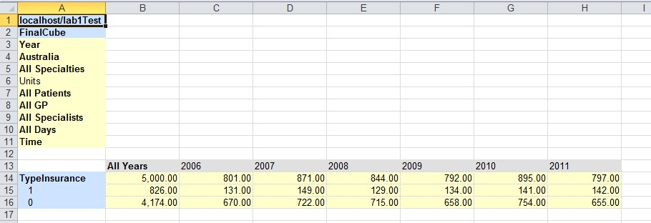

I treated the value 1 as a ‘Yes’ answer if the health system user has a private insurance (16.52%). Otherwise, the value 0 means the user is fully dependent on the public health system (83.48%). This result means that the government should put more effort into the health system, regarding treatments for fully dependents.

**CASE #2**

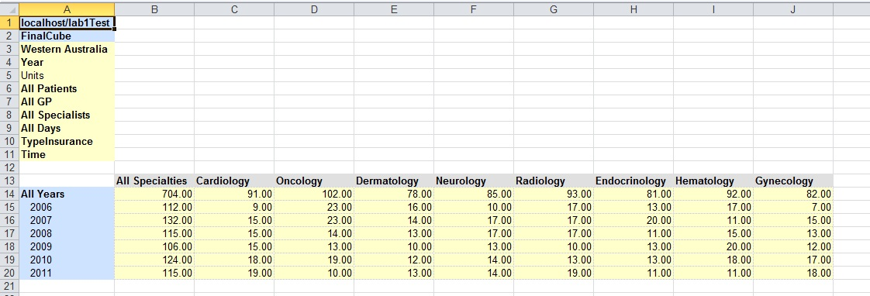

This case shows that in Western Australia, the numbers of cardiology problems have risen gradually along the years. It indicates that the government should change its campaign to prevent cardiology problems from now on, mainly those related with Pediatric Tachycardia that suffered a little outbreak in 2011(see detailed table below).

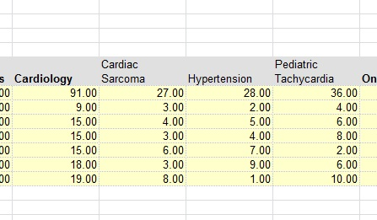

**CASE #3**

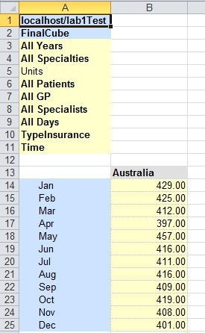

The case #3 shows that the number of appointments remains steady. In addition, the table illustrates that between April and May exist a big gap that it is meaningful. Assuming that the ticket prices to travel overseas are cheap due to low season (mainly in April and May), people are likely to suffer diseases from their destinations. So, the government could improve its strategies to handle with people that transited in these countries.

**CASE #4**

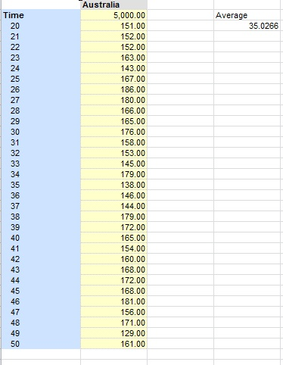

The appointment time assumed here is between 10 and 50 minutes. The average of the duration of this is 35 minutes. Assuming that 30 minutes is the minimum for each appointment, the results are quite accurate to the goal proposed by the government.

**CASE #5**

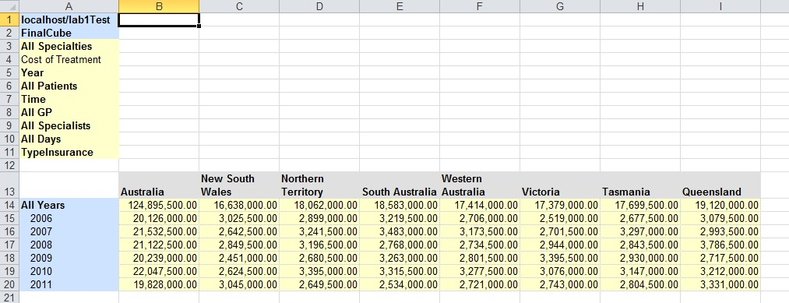

These values are related with the total cost of the treatments of each appointment. As it is showed, the state that the government has spent much money is Queensland.

The picture below shows the costs related with all specialties and the states. It can guide the government to search new changes and reduce costs of treatments, mainly about Hematology(most expensive).

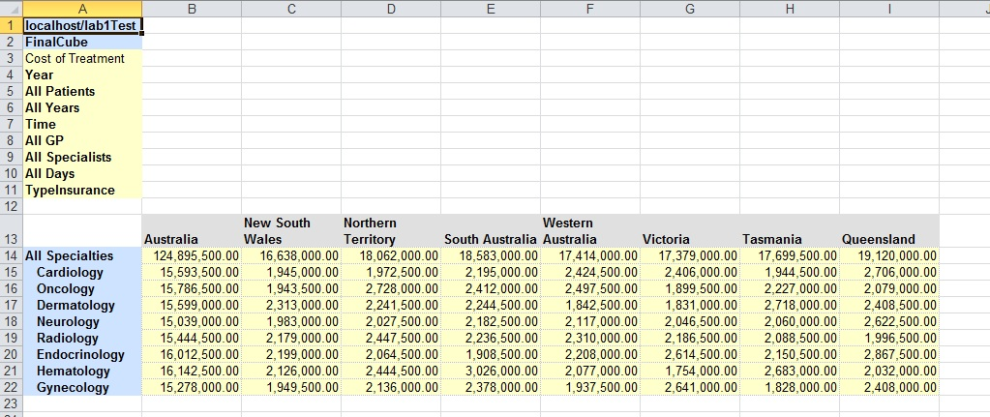

**CASE #6**

This case shows the pharmaceutical benefit provided by the government and how it impacts in each state. Again, Queensland holds the highest amount of pharmaceutical benefit in all years. The limit of the pharmaceutical benefit for each patient is up to $500, the amount of money over the limit is paid by the patient. If the budget available for the pharmaceutical benefit is too high to the government afford, then the government should review its pharmaceutical benefits policies.

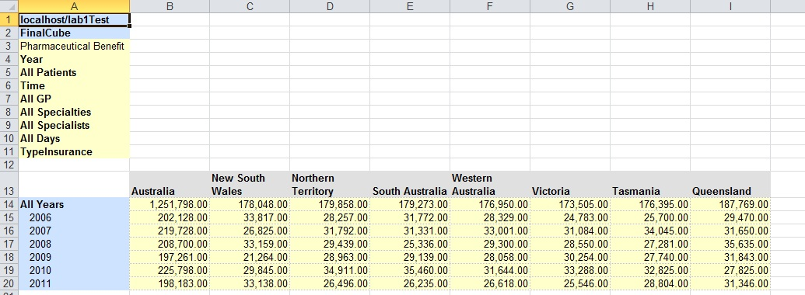

**CASE #7**

This case shows the quantity of days that the user should wait for the specialist. Therefore, considering the data showed below, it is a severe situation to the government deal with. It should take decisions as soon as possible to solve the problem of the queue’s length.

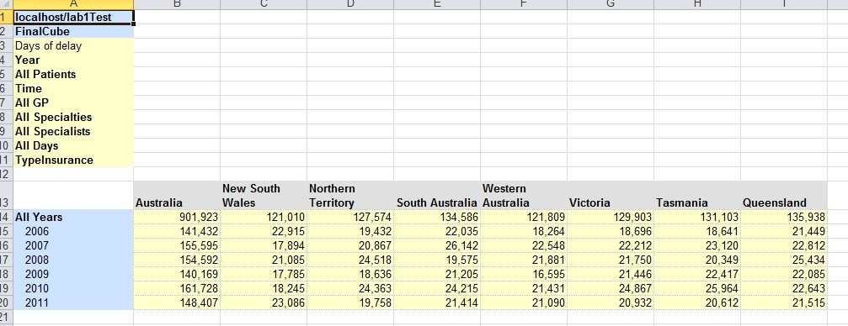

**CASE #8**

**CASE #9**

**CASE #10**

**DATA WAREHOUSE SCHEMA**

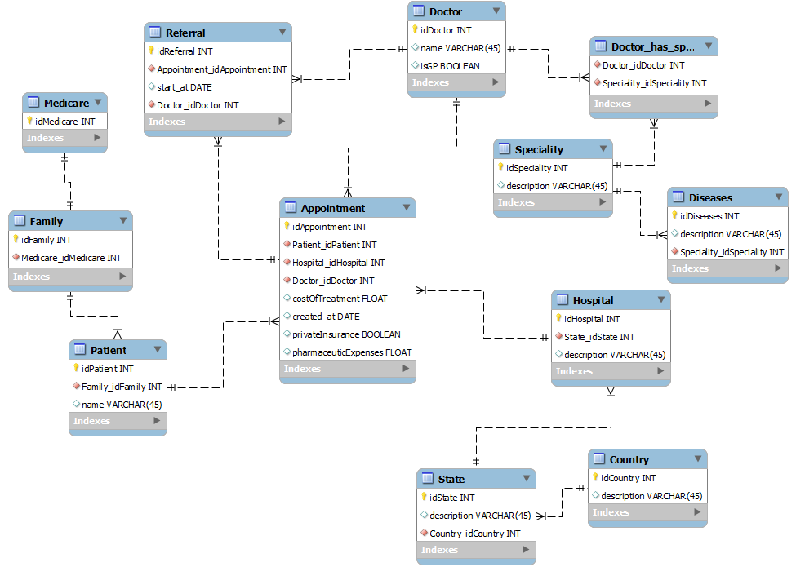

**FINAL COMMENTS**

Although the data presented in this project are totally random, the results showed trends and behaviors that are easily observed by using the Palo.

If you have any questions about the project that I did not mention in this document (data generator code, cube’s details and so on), I am very happy to help you.