Excersice number 1

ID: 208925578 and 314789264

**Intro assignment**

1. A. HTTP

1. B. DNS

1. Graphical user interface, application, table

   Description automatically generatedc. TCP
2. The time that took from when the HTTP GET message was sent until the HTTP OK reply was received was 0.058873 seconds.
3. The IP address of gaia.cs.umass.edu is 82.102.180.168 and my computer address is 192.168.1.34.



1. GET Package

OK Package

**HTTP assignment**

1. They are both running HTTP 1.1
2. My browser accept Hebrew and English
3. My computer: 192.168.1.34

gaia: 128.119.245.12

1. The status code is 200
2. The page last modified in Thu, 10 Mar 2022 06:59:01 GMT
3. 128 bytes
4. I cant find any



1. I do not see any if modified since line.
2. Text

   Description automatically generatedThe server did return the contents of the file. I can tell by looking at the file data and see the 371 bytes has returned to my browser.

No if-modified-since line



1. I can see if-modified-since line. The information that that follows is the last time the page was modified.



1. The status code is 304 and the phrase is “Not Modified”. The server did not return the contents of the file because there is not header that indicates that as in the first response packet.

1. There are two GET requests. The packet number of the GET request for the Bill or Rights is 50.



1. The packet number is 102.
2. The status code is 200 and the phrase is “OK”.



1. It took 3 TCP segments to carry the HTTP response.



1. The browser sent 3 HTTP GET messages. The first one was sent to to gaia.cs.umass.edu

The second was sent to this host as well. The third request was sent to Kurose.cslash.net.



1. I can tell that the browser downloaded each images serially, because each image has it’s own GET request and response.



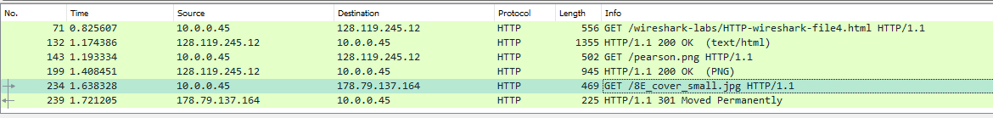



1. The status code is 401 and the phrase is “Unauthorized”.



1. Graphical user interface, text, application

   Description automatically generatedThe new field is “Authorization”, which includes the credentials to access the page.

