SEIR model simulation

## Load packages

library(deSolve)  
library(tidyverse)

## Set initial values

I_init <- 1e-07  
E_init <- 3 * I_init  
R_init <- 0  
S_init <- 1 - I_init - E_init - R_init  
  
R0_1_init <- 10  
R0_2_init <- -4  
R0_init <- 0.5 * (R0_1_init + R0_2_init)  
  
init <- c(  
 S = S_init,  
 E = E_init,  
 I = I_init,  
 R = R_init,  
 R0_1 = R0_1_init,  
 R0_2 = R0_2_init,  
 R0 = R0_init  
)

## Set parameters

pi_r <- 1 / 18  
pi_e <- 1 / 5.2  
R0_1bar <- -4  
R0_2bar <- 10  
eta1 <- 1 / 35  
eta2 <- 1 / 100  
  
parameters <- c(  
 pi_r = pi_r,  
 pi_e = pi_e,  
 R0_1bar = R0_1bar,  
 R0_2bar = R0_2bar,  
 eta1 = eta1,  
 eta2 = eta2  
)

## Set time frame

times <- seq(0, 548, by = 1)

## Formulate the SIR model

sir <- function(time, state, parameters) {  
  
 with(as.list(c(state, parameters)), {  
  
 dS = -0.5 * (R0_1 + R0_2) * pi_r * S * I  
 dE = 0.5 * (R0_1 + R0_2) * pi_r * S * I - pi_e * E  
 dI = pi_e * E - pi_r * I  
 dR = pi_r * I  
   
 dR0_1 = -eta1 * (R0_1 - R0_1bar)  
 dR0_2 = -eta2 * (R0_2 - R0_2bar)  
 dR0 = -0.5 * eta1 * (R0_1 - R0_1bar) -0.5 * eta2 * (R0_2 - R0_2bar)  
   
 results = c (dS, dE, dI, dR, dR0_1, dR0_2, dR0)  
 list (results)  
 })  
}

## Solve ODE

out <- ode(  
 y = init,  
 times = times,  
 func = sir,  
 parms = parameters  
)

## Plot pandemic progress

out_long <- out %>%   
 as.data.frame() %>%  
 select(time, S, E, I, R) %>%   
 pivot_longer(-time, names_to = "group", values_to = "prop")  
  
out_long %>%   
 filter(group == "I", time <= 160) %>%   
 ggplot(aes(x = time, y = prop * 100, color = group)) +  
 geom_line(size = 1) +   
 theme_light() +   
 labs(  
 x = "days",  
 y = "% of population"  
 )

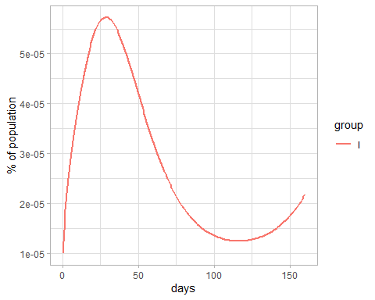

# Plot R_t

R0_long <- out %>%   
 as.data.frame() %>%  
 select(time, R0, R0_1, R0_2) %>%   
 pivot_longer(-time, names_to = "type", values_to = "value")  
  
R0_long %>%   
 filter(type == "R0", time <=160) %>%   
 ggplot(aes(x = time, y = value, color = type)) +  
 geom_line(size = 1) +   
 theme_light() +   
 labs(  
 x = "days",  
 y = "basic reproduction number"  
 )

