# Test

The code is under <https://github.com/itamaredbmaestro/BlazorTest>

Please share your screen while doing this test.

The test should take around 2 hours.

The following program has a list of employees working in customer support, for each employee we have the number of calls handled in regards to the minimum requirement of 10 calls per working day (that number could be negative if they handled less than required.

### Question 1

Update “BlazorDbTable\Pages\EMail.razor” to look like this:

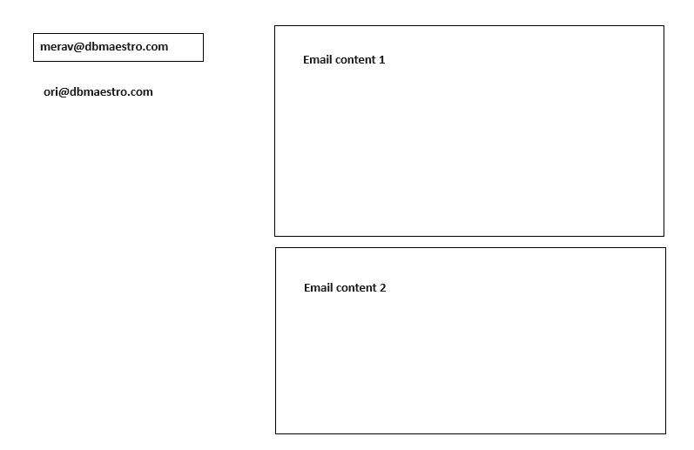

Use “BlazorDbTable\ViewModel\EMailsVM.cs” as the view model for this page.

All the content will be taken from “BlazorTestBL\BlazorTestBL.cs” class (GetEmployees to get the list of employees and CreateEmployeeEmail to create the emails for each employee).

The functions that you need are “GetEmployees” to get the list of employees and their emails and “CreateEmployeeEmail” to get the list of emails for a specific employee.

Use “BlazorDbTable\Pages\Employees.razor” and “BlazorDbTable\ViewModel\EmployeesVM.cs” as a reference if needed.

### Question 2

Implement the method BlazorTestBL.GetEmployeeBestPerformance

This method returns the consecutive days where the sum of all the calls handled over the minimum required is the largest,

i.e

Day 1 – (-2)

Day 2 – 1

Day 3 – (-3)

Day 4 – 4

Day 5 – (-1)

Day 6 – 2

Day 7 – 1

Day 8 – (-5)

Day 9 – 4

The result should be Days 4-7 where the number of calls over is 6.

In other words, find the sub array from an array of positive and negative numbers that has the maximum sum.

Put the algorithm in “BlazorTestBL\BlazorTestBL.cs” in function “GetEmployeeBestPerformance”

Results should be:

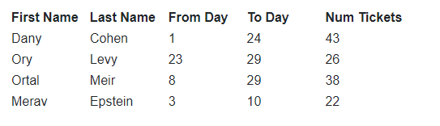

## Database

You have the following tables:

Competitors:

|  |  |  |  |
| --- | --- | --- | --- |
| ID | Name | PhoneNO | Address |
| 1 | Danny | 052-1234567 | Hayarkon Tel Aviv |
| 2 | Lisa | 052-2223344 | Rotchiled Tel Aviv |
| 3 | Avi | 052-7654321 | King Gorge Tel Aviv |

Contests:

|  |  |
| --- | --- |
| ID | Content |
| 1 | Scavenger hunt |
| 2 | House decoration |
| 3 | Arts and Crafts |

Results:

|  |  |  |
| --- | --- | --- |
| Competitor | Contest | Points |
| 1 | 1 | 5 |
| 1 | 2 | 5 |
| 1 | 3 | 5 |
| 2 | 2 | 8 |
| 2 | 3 | 2 |
| 3 | 1 | 7 |
| 3 | 2 | 2 |
| 3 | 3 | 9 |

### Question 1

Create a query that will return for each competitor, how many points he has.

The results should be:

|  |  |  |
| --- | --- | --- |
| ID | Name | Points |
| 1 | Danny | 15 |
| 2 | Lisa | 10 |
| 3 | Avi | 18 |

## Question 2

Create a query that will return competitors that didn’t participate in one of the contents and which contest they didn’t participate in.

The results should be:

|  |  |  |  |
| --- | --- | --- | --- |
| Competitor_ID | Competitor_Name | Contest_ID | Contest_Name |
| 2 | Lisa | 1 | Scavenger hunt |