# Test

The code is under <https://github.com/itamaredbmaestro/BlazorTest>

Please share your screen while doing this test.

The test should take around 2 hours.

The following program has a list of employees working in customer support, for each employee we have the number of calls handled in regards to the minimum requirement of 10 calls per working day (that number could be negative if they handled less than required.

### Question 1

Implement function BlazorTestBL.DuplicateManagerEmployees

This method gets a tree as a parameter and returns nodes that are not valid (have more than one parent).

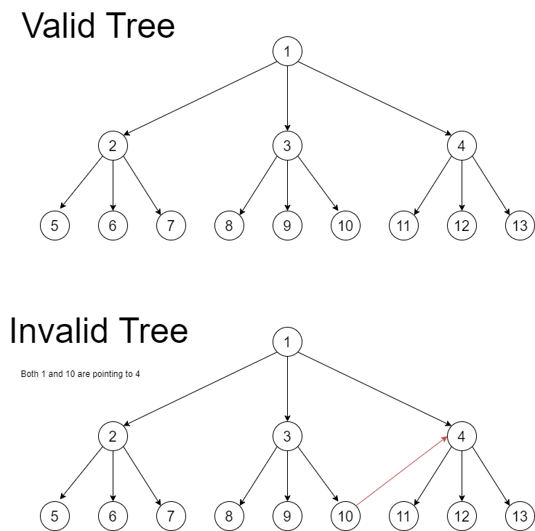

Each node has some values including an ID, you can assume that the ID is a unique value (meaning if you encounter the same ID twice, you got to the same node)

### Question 2

Update “BlazorDbTable\Pages\HirarchialTree.razor” to look like this:

Use “BlazorDbTable\ViewModel\HirarchialTreeVM.cs” as the view model for this page.

All the content will be taken from “BlazorTestBL\BlazorTestBL.cs” class (GetEmployeeHirarchy function to get the employee hierarchy).

The function that you need is “GetEmployeeHirarchy” to get the hierarchy of the employees.

Use “BlazorDbTable\Pages\Employees.razor” and “BlazorDbTable\ViewModel\EmployeesVM.cs” as a reference if needed.

Bonus: Add buttons to go up and down the Hierarchy (only if you have time for this).

## Database

You have the following tables:

Customer:

|  |  |
| --- | --- |
| ID | Name |
| 1 | Danny |
| 2 | Lisa |
| 3 | Avi |
| 4 | Haim |
| 5 | Gil |
| 6 | Avital |

Account:

|  |  |
| --- | --- |
| ID | Amount |
| 1 | 500 |
| 2 | 1000 |
| 3 | 750 |
| 4 | 875 |
| 5 | 125 |
| 6 | 575 |

Account_Owner:

|  |  |
| --- | --- |
| Customer | Account |
| 1 | 1 |
| 2 | 2 |
| 3 | 3 |
| 4 | 4 |
| 5 | 5 |
| 6 | 6 |
| 1 | 2 |
| 4 | 6 |

### Question 1

Create a query that will return the total amount that each customer has.

The results should be:

|  |  |  |
| --- | --- | --- |
| ID | Name | Amount |
| 1 | Danny | 1500 |
| 2 | Lisa | 1000 |
| 3 | Avi | 750 |
| 4 | Haim | 1450 |
| 5 | Gil | 125 |
| 6 | Avital | 575 |

## Question 2

Create a query that will return the people that have accounts together.

The results should be:

|  |  |  |  |
| --- | --- | --- | --- |
| ID1 | Name1 | ID2 | Name2 |
| 1 | Danny | 2 | Lisa |
| 4 | Haim | 6 | Avital |