Course: AI-Driven Intrusion and Malware Detection
Milestone 3 Final Report — Pipeline Implementation, Evaluation & Intelligent Ensemble Optimization
AI-Driven Detection of Lateral Movement (MITRE ATT&CK TA0008)
Table 1. Project metadata.
Item | Value
Project title | Applied AI/ML Architectures for Cyber Intrusion Detection — AI-Driven Detection of Lateral Movement (TA0008)
Team members (name, student ID, e-mail) | Ela Ambar Grynbaum [FILL: ID] — ela.ambar2306@gmail.com; Daniel Shostak [FILL: ID] — danshostak0@gmail.com; Itamar Tsafrir Ornstein [FILL: ID] — itamarit77@gmail.com; Itamar Klartag [FILL: ID] — itamarklartag@gmail.com (as listed in Milestone 2)
Assigned primary dataset (A) | LMD-2023 — Sysmon event logs with the creators’ labels (Normal, EoRS = exploitation of remote services, EoHT = exploitation of hashing techniques → binary); 1,752,836 events, 8.06% attack
Assigned generalization dataset (B) | Mordor APT29 (Open Threat Research Forge, OTRF; emulation days 1 + 2) — Sysmon, Security, System and PowerShell telemetry; provenance-derived weak labels (Milestone 2 §3.1.1); 783,367 events, 3.77% attack
Code repository & branch | [FILL: private GitHub/GitLab link with instructor access], branch main — milestone3/: run_m3.py, m3pkg/, build_report_m3.js, README.md, results/
Model artifact archive | [FILL: link to the models/ folder — the same repository or a shared drive] — 14 MB, fold-0 artifacts per dataset: Random Forest, LightGBM, Isolation Forest (.pkl), LSTM (.pt); listing in results/models_listing.txt
Date of submission | 2026-09-29
11 pt Calibri, 1.5 line spacing; tables and captions are set smaller. Every result in this report is read by the report generator from the pipeline’s outputs (results/m3_results.json, host_class_counts.json and the stage timings in run.log); the typed numbers are the metadata above, the model settings quoted from config.py, the published results of §2.4, the Milestone-2 statistics cited as such and the published size figures of the LLM in §4.1.

Part 1: Step 7 — Modular Pipeline Architecture & Algorithmic Design

1.1 Pipeline Architecture
The implementation is a strict five-stage sequential pipeline (Figure 1). Stage 1 is the only stage that knows what a raw source looks like: one adapter parses the LMD-2023 Sysmon CSV (94 columns, Milestone 2 Table 4), another the multi-channel Windows event JSON of Mordor, and both emit the same 26-column intermediate event table (row id, timestamp, host, event id, binary and sub-type label, 20 telemetry fields). The brief’s pre-processing step is split: raw-field normalisation into the common schema is Stage 1, fold-dependent scaling and encoding follow feature computation (Stage 3), since trailing-window features need raw counts first. From Stage 2 on every module consumes only that table or its products: Stage 2 is the Milestone-2 feature module with identical feature definitions, so the 35-column prospective schema — the 42 candidates minus the five absolute-time features, the command-line length and the PID-equality control (Milestone 2 Table 9) — is computed by the same code for both datasets (1,752,836 LMD and 783,367 Mordor events; every feature is either a property of the event itself or a trailing per-host window / causal running maximum, so no feature of an event at time t reads any event after t); Stage 3 builds the grouped folds, fits the robust scaler on training rows and, for transfer, the quantile alignment (class weights are derived inside each model’s fit); Stage 4 exposes the four models behind one fit()/score() interface returning an attack score in [0, 1]; Stage 5 computes every metric, the error forensics, the cascade and the LLM arbitration, and writes one results file. The only dataset-specific values downstream of Stage 1 are two configuration numbers — the block length of the grouping key (10 min for LMD, 2 min for Mordor, whose whole capture spans 5.6 h in two short emulation windows) and the LSTM window stride (4 / 2, for cost) — plus one verification branch, the reduced-feature runs of §2.2, executed for Mordor only because the reduced set exists to test Mordor’s labelling rule. Execution is checkpointed per stage (run_m3.py --stage …: 4.1 h of training and evaluation plus 4.0 h of LLM inference, Table 2; the LightGBM-dependent stages were recomputed once after the correction of §1.4, 27 min).
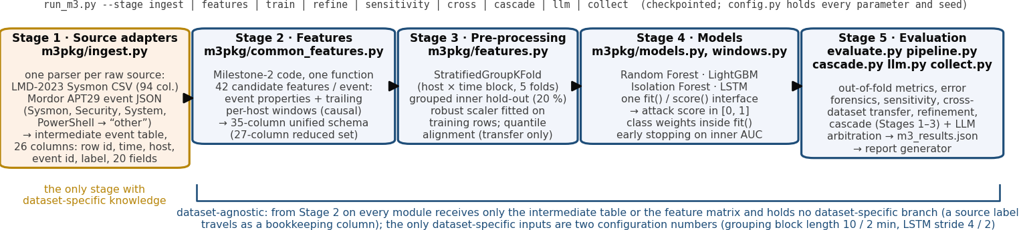
Figure 1. The five-stage modular pipeline: module per stage, what it produces, and the dependency rule — Stage 1 is the only stage with dataset-specific knowledge.

1.2 Environment, Tooling & Reproducibility Specifications
Table 2. Environment and reproducibility specification (library versions and timings read from the run).
Item | Specification
Runtime & hardware | Ubuntu 24.04 (Linux 6.17), Intel Core Ultra 7 255H (16 cores, 6P + 8E + 2LP-E), integrated graphics only — no CUDA; PyTorch and Ollama on CPU; Python 3.12.3
Core framework dependencies | numpy 2.5.3, pandas 3.0.6, scikit-learn 1.9.1, lightgbm 4.7.0, torch 2.14.0+cu130, pyarrow 25.0.1, matplotlib 3.11.2, requests 2.34.2; local LLM served by Ollama (Part 4)
Deterministic seeds | SEED = 42 for StratifiedGroupKFold (inner GroupShuffleSplit and LSTM of fold k: 42 + k), NumPy, RandomForest, IsolationForest, LightGBM (deterministic = True, force_row_wise = True) and torch (manual_seed / cuda.manual_seed_all, cudnn.deterministic = True); LLM calls: temperature 0, seed 42 (escalation-order ties are an arbitrary draw, quantified in §3.1)
Compute budget (wall clock) | full run: ingest 21 s, features 45 s, training with cross-validation and error analysis 56 min, sensitivity sweep 2.2 h, cross-dataset transfer 60 min, cascade 3 s, refinement 35 min; LightGBM-dependent stages recomputed after the §1.4 correction: 27 min; LLM stage 4.0 h wall clock, 26.0 s per arbitration call (Mordor)

1.3 Class Imbalance Mitigation Strategy
Selected technique: cost-sensitive learning with fold-wise class weights, plus threshold moving on a grouped hold-out inside the training fold — no resampling. Attack prevalence is 8.06% in LMD-2023 and 3.77% in Mordor. Random Forest uses class_weight = balanced_subsample (every bootstrap re-weighted to equal class mass), LightGBM scale_pos_weight = n_neg/n_pos of the training fold, the LSTM a class-weighted binary cross-entropy (pos_weight = n_neg/n_pos); the Isolation Forest is unsupervised and needs no balancing. The decision threshold of every model is the F1-maximising score on the inner hold-out of its fold.
Theoretical defence. Weighting minimises the importance-weighted empirical risk Σᵢ w(yᵢ)·ℓ(yᵢ, f(xᵢ)) with w(1) = n₀/n₁, which gives the two classes equal total weight in the training objective, without changing the data the model sees, leaving the FPR/FNR trade-off to the threshold. Random under-sampling to parity would discard 91%–96% of the benign rows, the only sample of each environment’s background and exactly what a detector must learn to reject. SMOTE-type interpolation is inappropriate here: the inputs are trailing counts, rates, binary flags and a nominal event category, so a convex combination of two attack rows is not an event that can occur, and the attack rows are dense bursts whose information is the window statistics, which interpolation smears (Milestone 2). No resampling variant or unweighted model was run, so no empirical claim is made for weighting over resampling: the choice is a priori; §2.2 measures the other half of the strategy, the threshold.
Leakage prevention. Folds are unions of whole groups g = (host, ⌊t/Δ⌋), Δ = 10 min (LMD) and 2 min (Mordor), so g(i) ≠ g(j) for every training row i and test row j; the inner hold-out V is a union of whole groups of the training fold with V ∩ test = ∅. Scaler medians and IQRs, class weights, early-stopping rounds, thresholds τ = argmax F1 over V (searched on a 200-quantile grid of the hold-out scores) and the cascade bands (400-quantile grid) are functions of the training fold only. What the grouping cannot remove is the trailing-window dependence at block boundaries (the one-hour out-degree window and the LSTM’s 20-event windows straddle blocks), so the split is a strict grouped split, not a temporal separation or a host hold-out (every LMD fold contains 5–6 of the 6 hosts, every Mordor fold all 4); Milestone 2 showed that no chronological split of LMD-2023 gives a test period with both classes in adequate share.

1.4 Validation Strategy & Explicit Hyperparameter Optimization
Validation: stratified group 5-fold cross-validation (StratifiedGroupKFold, groups = host × time block) on every row, with a grouped hold-out inside each training fold — 20% of its groups (GroupShuffleSplit): 20% of the rows on LMD but 11%–38% on Mordor, whose blocks differ greatly in size — for early stopping (LightGBM, LSTM) and the F1-optimal threshold; every metric is out-of-fold. Stratification is over groups, so positives balance only as far as the blocks allow: LMD folds hold 28,234–28,261 attack rows each, whereas Mordor’s attack rows cluster in a few dense blocks and one fold receives 15,787 of the 29,549 (53%), the other four 3,390–3,506 — the asymmetry behind the fold variance of §1.5. Table 3 lists the hyper-parameters; all were fixed before the run and none was changed after seeing a test fold. One correction was made between the first run and this report, found in code review: LightGBM’s early stopping had also been tracking the validation log-loss (LightGBM’s default metric next to the requested AUC; the callback stops on whichever stagnates first, and on a class-weighted objective the log-loss can stagnate within a few rounds). The criterion was set to the pre-registered inner-validation AUC only and every LightGBM-dependent stage (cross-validation and reduced-feature runs, sensitivity sweep, transfer, cascade and LLM stage — the last with its prompt corrected at the same time: the placeholder masking and the score-with-threshold wording that §4.2 now shows; the interrupted first LLM run was never reported) was recomputed; the superseded LightGBM cross-validation files are kept with the results. Effect: the stopping round changed in 6 of the 10 folds and 3 of the 5 reduced-set folds (per-fold values in the code README); out-of-fold F1 moved from 0.9830 to 0.9831 on LMD and from 0.8369 to 0.8394 on Mordor (reduced set 0.1475 → 0.1516), so the first run’s conclusions stand; Mordor fold 0’s two-round stop is the inner AUC’s own optimum (§1.5).
Table 3. Explicit hyper-parameter configuration of the four models (values from config.py).
Model | Configuration | Why each parameter was set
Random Forest | n_estimators = 300; max_depth = 12; min_samples_leaf = 20; max_features = √d (set explicitly); class_weight = balanced_subsample | more trees lower the vote variance; depth 12 and 20 rows per leaf limit memorisation of rare values or single hosts (Milestone-2 finding); √d de-correlates trees; balanced_subsample is the cost-sensitive loss
LightGBM | n_estimators ≤ 600 with early stopping (50 rounds without improvement of the inner-validation AUC, the only metric tracked); learning_rate = 0.05; num_leaves = 31 (set explicitly); min_child_samples = 100; subsample = 0.8 (freq 1); colsample_bytree = 0.8; reg_lambda = 1; scale_pos_weight = n_neg/n_pos | early stopping sets the rounds from the inner hold-out (used: 596, 248, 79, 231, 224 on LMD, 2, 48, 600, 146, 59 on Mordor); 31 leaves bound tree complexity; 100 rows per leaf and L2 suppress splits on rare values; subsampling adds diversity; the positive weight is the imbalance remedy
Isolation Forest | n_estimators = 200; max_samples = 4096; contamination = auto (set explicitly, unused: the score is the anomaly percentile among the training rows and the threshold comes from the inner hold-out) | more trees stabilise path lengths; 4096-row subsamples keep isolation depth meaningful on millions of rows; the percentile mapping makes scores comparable across folds and datasets; the fit is label-free, only the threshold uses labels
LSTM | T = 20 events per host window ending at every 4th (LMD) / 2nd (Mordor) event; stacked LSTM 64 → 32 units; dropout 0.3; batch-norm; Adam lr = 10⁻³; batch 1024; ≤ 8 epochs, patience 2 on inner AUC; pos_weight = n_neg/n_pos; inputs robust-scaled with the event category one-hot over the 26 registry levels (D = 60); zero pre-padding, unmasked | the window length sets the host history seen; two layers give a compact hierarchical state; dropout and early stopping control over-fitting on correlated windows; the weighted loss is the imbalance remedy; the window is labelled by its last event, so the decision is causal and per event

1.5 Hyperparameter Sensitivity & Stability Analysis
Each primary hyper-parameter was varied one at a time around the configuration of Table 3 on outer fold 0 (same inner hold-out; 41 trainings per dataset), and stability across folds is the spread of the per-fold F1 of the base configuration. Table 4 summarises; the full curves are Figures 3–6 in the appendix.
Table 4. Sensitivity (fold 0: F1 and ROC-AUC range over every setting of every primary hyper-parameter, and the parameter with the largest F1 swing) and stability (per-fold F1 of the base configuration; mean ± sd in Table 5).
Dataset | Model | F1 range | ROC-AUC range | Most sensitive parameter | F1 per fold (base configuration)
LMD-2023 | Random Forest | 0.976–0.984 | 1.000–1.000 | max depth (ΔF1 0.007) | 0.984 / 0.994 / 0.978 / 0.996 / 0.962
LMD-2023 | LightGBM | 0.984–0.989 | 1.000–1.000 | num leaves (ΔF1 0.004) | 0.989 / 0.994 / 0.993 / 0.995 / 0.947
LMD-2023 | Isolation Forest | 0.578–0.649 | 0.949–0.963 | max samples (ΔF1 0.071) | 0.591 / 0.454 / 0.477 / 0.555 / 0.561
LMD-2023 | LSTM | 0.985–0.992 | 0.991–0.997 | T (ΔF1 0.007) | 0.990 / 0.991 / 0.989 / 0.987 / 0.943
Mordor | Random Forest | 0.684–0.851 | 0.982–0.987 | min samples leaf (ΔF1 0.167) | 0.684 / 0.722 / 0.749 / 0.692 / 0.945
Mordor | LightGBM | 0.746–0.895 | 0.951–0.993 | min child samples (ΔF1 0.148) | 0.819 / 0.711 / 0.714 / 0.705 / 0.921
Mordor | Isolation Forest | 0.102–0.286 | 0.912–0.957 | n estimators (ΔF1 0.129) | 0.173 / 0.273 / 0.140 / 0.238 / 0.037
Mordor | LSTM | 0.494–0.710 | 0.972–0.982 | hidden (ΔF1 0.199) | 0.539 / 0.674 / 0.593 / 0.514 / 0.916
Reading. On LMD-2023 the three supervised models are insensitive to every setting (F1 0.976–0.992, ROC-AUC ≥ 0.991): the capture is separable by structure (Milestone 2 §4.1), so the configuration hardly matters, and the only visible effects are on the Isolation Forest (max samples: ΔF1 0.071; best F1 0.649 at max_samples = 256, larger subsamples diluting the isolation depth). On Mordor the picture is the opposite: F1 swings by up to 0.199 across the settings of one parameter and the base configuration is not the best for any model (Random Forest 0.684 vs a best of 0.851 at min_samples_leaf = 100, LightGBM 0.819 vs 0.895 at min_child_samples = 500, LSTM 0.539 vs 0.710 at hidden = 128). The F1 swings exceed the ROC-AUC swings for every model (Table 4), so much of the sensitivity sits in the threshold — chosen on the inner hold-out of a four-host capture, it transfers imperfectly to a test fold with a different block mix and attack density — but not all of it: the ROC-AUC of LightGBM moves between 0.951 and 0.993 across settings, so its ranking on this fold depends on the configuration too. The per-fold column adds a second source of variance: F1 of 0.945 on the fold that holds the dense attack burst against 0.684–0.749 on the others for the Random Forest — partly prevalence (9.5% attack rows in that fold against 2.2%–2.3% elsewhere, which raises precision at any operating point), partly the burst’s separability. None of the settings was changed after the fact, and §2.1 reports the pooled F1 next to the per-fold mean, the more conservative number for Mordor. Early stopping adds an instability of its own. LightGBM’s inner-validation AUC chose 2, 48, 600, 146, 59 rounds on the five Mordor folds (inner AUC at the chosen round 0.998, 0.974, 0.989, 0.957, 0.972) and 596, 248, 79, 231, 224 on LMD (Mordor fold 2, LMD fold 0 ran to the 600-round cap); the fold that stopped after 2 rounds did so because its inner AUC peaked at 0.998 there and fell to 0.990 within the next ten rounds. The LSTM shows the same pattern: its inner AUC peaked at the first epoch in 4 of the 10 folds (best epochs 2, 7, 7, 1, 1 on LMD, 6, 2, 2, 1, 1 on Mordor, of at most 8), and on LMD folds 2 and 4 its F1-optimal threshold is ≥ 0.999 — a saturated sigmoid that leaves the threshold little to choose; fold 4 (threshold exactly 1.000) is its weakest fold (F1 0.943). Neither was changed after the fact; a minimum number of rounds or epochs is a change for a future run.

Part 2: Step 8 — Comparative Performance, Forensic Error Analysis & Generalization

2.1 Sample-Level Forensic Error Analysis (per dataset)
Table 5 gives the out-of-fold confusion matrix of every model on every dataset (fold-specific thresholds from the inner hold-outs; the LSTM rows count its window-end events, one in 4 LMD events and one in 2 Mordor events; accuracy, uninformative at this class balance, is 0.997 / 0.997 / 0.881 / 0.997 on LMD and 0.988 / 0.988 / 0.870 / 0.980 on Mordor for Random Forest / LightGBM / Isolation Forest / LSTM). Restricting every model to exactly the rows the LSTM scores gives a matched comparison with the same picture: F1 Random Forest 0.982, LightGBM 0.983, Isolation Forest 0.530, LSTM 0.980 on the 438,211 LMD window-end rows and Random Forest 0.840, LightGBM 0.840, Isolation Forest 0.150, LSTM 0.759 on the 391,684 Mordor ones. Table 6 characterises the false positives and false negatives of each model: the event category most over-represented among the errors relative to the correctly classified rows of the same class (both shares printed), the host carrying most of them, and the feature whose median differs most between the errors and the correctly classified rows of the same class (ranked by the shift in units of the pooled out-of-fold rows’ inter-quartile range; the table prints the two medians).
Table 5. Out-of-fold confusion matrices and metrics per model and dataset (fold-specific inner-validation thresholds; the ROC-AUC and PR-AUC columns pool the out-of-fold scores of five fold models, so they also reflect differences between the five fold models’ score scales — the last column gives the per-fold F1 and ROC-AUC, mean ± sd, which do not); F1 @0.5 is the same model at the default threshold.
Dataset | Model | TP | FP | FN | TN | Prec. | Rec. | F1 | FPR | FNR | ROC-AUC | PR-AUC | F1 @0.5 | per fold: F1 | ROC-AUC
LMD-2023 | Random Forest | 140,038 | 3,834 | 1,179 | 1,607,785 | 0.973 | 0.992 | 0.982 | 0.24% | 0.83% | 1.000 | 1.000 | 0.986 | 0.983 ± 0.012 | 1.000 ± 0.000
LMD-2023 | LightGBM | 139,812 | 3,398 | 1,405 | 1,608,221 | 0.976 | 0.990 | 0.983 | 0.21% | 0.99% | 1.000 | 0.998 | 0.984 | 0.984 ± 0.018 | 1.000 ± 0.000
LMD-2023 | Isolation Forest | 117,837 | 185,125 | 23,380 | 1,426,494 | 0.389 | 0.834 | 0.531 | 11.49% | 16.56% | 0.934 | 0.441 | 0.276 | 0.528 ± 0.053 | 0.934 ± 0.013
LMD-2023 | LSTM | 34,305 | 368 | 999 | 402,539 | 0.989 | 0.972 | 0.980 | 0.09% | 2.83% | 0.999 | 0.997 | 0.974 | 0.980 ± 0.019 | 0.999 ± 0.002
Mordor | Random Forest | 25,357 | 5,492 | 4,192 | 748,326 | 0.822 | 0.858 | 0.840 | 0.73% | 14.19% | 0.985 | 0.881 | 0.849 | 0.758 ± 0.096 | 0.983 ± 0.015
Mordor | LightGBM | 25,555 | 5,784 | 3,994 | 748,034 | 0.815 | 0.865 | 0.839 | 0.77% | 13.52% | 0.982 | 0.860 | 0.802 | 0.774 ± 0.085 | 0.976 ± 0.025
Mordor | Isolation Forest | 9,067 | 81,662 | 20,482 | 672,156 | 0.100 | 0.307 | 0.151 | 10.83% | 69.32% | 0.840 | 0.125 | 0.109 | 0.172 ± 0.082 | 0.852 ± 0.057
Mordor | LSTM | 12,230 | 5,127 | 2,657 | 371,670 | 0.705 | 0.822 | 0.759 | 1.36% | 17.85% | 0.958 | 0.793 | 0.629 | 0.647 ± 0.145 | 0.978 ± 0.013
Table 6. Error forensics per model and dataset: the most over-represented error category (its share among the errors vs among the correctly classified rows of the same class; categories with ≥ 5% of the errors), the host carrying most of the errors, and the feature whose median shifts most in IQR units (medians printed).
Dataset | Model | False positives | False negatives
LMD-2023 | Random Forest | 3,834 FP: dns 24% (vs 1%); host WINDOWS10EVAL 64%; median host_proc_create_60s 12 vs 0 | 1,179 FN: file create 8% (vs 0%); host WINDOWS10EVAL 50%; median host_proc_create_60s 18 vs 1
LMD-2023 | LightGBM | 3,398 FP: dns 29% (vs 1%); host WINDOWS10EVAL 67%; median host_proc_create_60s 15 vs 0 | 1,405 FN: dns 16% (vs 1%); host WINDOWS10EVAL 49%; median host_proc_create_60s 15 vs 1
LMD-2023 | Isolation Forest | 185,125 FP: process create 11% (vs 0%); host LAPTOP-ROPR18AK 50%; median host_out_degree_1h 45 vs 336 | 23,380 FN: image load 81% (vs 24%); host win-dc-128 91%; median host_evt_rate_60s 57 vs 51
LMD-2023 | LSTM | 368 FP: process create 48% (vs 1%); host WIN-J23NIGGP1Q6 57%; median host_proc_create_60s 27 vs 0 | 999 FN: dns 19% (vs 0%); host WINDOWS10EVAL 68%; median host_proc_create_60s 28 vs 1
Mordor | Random Forest | 5,492 FP: image load 53% (vs 6%); host SCRANTON 61%; median host_evt_rate_60s 3,934 vs 12,066 | 4,192 FN: process access 15% (vs 0%); host UTICA 41%; median image_is_lolbin 0 vs 1
Mordor | LightGBM | 5,784 FP: image load 54% (vs 6%); host SCRANTON 61%; median image_is_lolbin 1 vs 0 | 3,994 FN: process access 14% (vs 1%); host SCRANTON 44%; median image_is_lolbin 0 vs 1
Mordor | Isolation Forest | 81,662 FP: image load 14% (vs 5%); host UTICA 63%; median adminport_conn_60s 5 vs 0 | 20,482 FN: registry 84% (vs 51%); host SCRANTON 88%; median adminport_conn_60s 0 vs 5
Mordor | LSTM | 5,127 FP: image load 37% (vs 6%); host SCRANTON 53%; median host_evt_rate_60s 4,540 vs 12,080 | 2,657 FN: process access 9% (vs 1%); host SCRANTON 50%; median adminport_conn_60s 5 vs 0
LMD-2023. The supervised models’ errors concentrate on the same two hosts but overlap only partly — 54% of the Random Forest’s out-of-fold errors are also LightGBM errors (Jaccard overlap of the two error sets 0.39), and of the 2,905 rows that at least one of the three models gets wrong among the 438,211 the LSTM also scores, 142 are wrong for all three; the LSTM’s errors overlap far less with either tree (Jaccard 0.08 with the Random Forest, 0.07 with LightGBM on the window-end rows): judging a 20-event host window rather than the single event, it fails on different rows — process-creation bursts on WIN-J23NIGGP1Q6 rather than the trees’ DNS bursts on WINDOWS10EVAL (Table 6) — and would be the least correlated second opinion (§3.1). 97% of the Random Forest’s false positives and 93% of its false negatives sit on WINDOWS10EVAL and WIN-J23NIGGP1Q6, the only two hosts carrying both classes in quantity (attack / benign 3,695 / 49,710 and 26,758 / 48,786; the three attackrange hosts hold 110,748 attack against 10 benign rows, LAPTOP-ROPR18AK 16 against 1,513,113), so the discrimination task is tested on the two mixed hosts only. Both error types sit in windows with an unusually high process-creation rate (12 per minute for the false positives against 0 for true negatives, 18 against 1 for the false negatives): process-centric windows unlike both the network-centric benign background and the attack bursts the models learned (mainly image loads, process access and file events; Milestone 2 §4.2). A false positive is a benign process-creation or DNS burst (DNS: 24% of the Random Forest’s false positives vs 1% of true negatives) with little fan-out (out-degree 4 vs 335); a false negative is an attack row in a window with admin-port connections (5 vs 0) and several users (3 vs 1). Both error types are the boundary between the capture’s regimes (Milestone 2 §3.3), and they are few (0.29% of rows for the Random Forest); that the error sets overlap only partly is what a second opinion could exploit, which the collapsed band of §3.2 prevents. The Isolation Forest errs differently: its false positives are non-network event types (process-end events: 52% of its false positives vs 5% of true negatives) and its false negatives attack rows on the domain controller that look like the dense background — it scores rarity, not attack (F1 0.531; Figure 7).
Mordor APT29. Here the errors are image-load events: 54% of LightGBM’s false positives and 50% of its false negatives are DLL loads (event ID 7), against 6% and 10% of the correctly classified rows, with the registry family second; 61% of the false positives are on SCRANTON, the host that holds 21,809 of the 29,549 attack rows. A DLL load carries no command line or lineage flag of its own, so the models decide it from the host window and from image_is_lolbin — the label-seed field of Milestone 2 §3.1.1: LightGBM’s false positives have image_is_lolbin = 1 (benign administrative living-off-the-land-binary, LOLBin, activity), its false negatives have image_is_lolbin = 0 where true positives have 1 (implant activity that is not a LOLBin). The Random Forest and the LSTM show the same profile (error overlap with the Random Forest: Jaccard 0.32 for the LSTM against 0.52 for LightGBM), with quieter windows for the false positives (host event rate 3,934 vs 12,066). The reduced-feature runs of §2.2 put a number on this: without the lineage and command-line families the Random Forest’s out-of-fold F1 falls from 0.840 to 0.094 (ROC-AUC 0.985 → 0.890) and LightGBM’s from 0.839 to 0.152 (0.982 → 0.704): a ranking signal survives (host-window statistics that co-vary with the bursts), but the inner-hold-out operating points no longer transfer between folds of such different attack density (reduced-set Random-Forest thresholds 0.05–0.68), so the headline Mordor F1 largely measures agreement with the provenance heuristic that labelled the data, not detection of unseen tradecraft. The Isolation Forest is useless on this capture (F1 0.151): 63% of its 81,662 false positives are on UTICA, and 84% of its false negatives are attacker registry writes that look like background.

2.2 Iterative Pipeline Optimization & Verification
The increments were specified before this run from the Milestone-2 diagnostics (class imbalance, LMD-2023’s two-regime structure, Mordor’s seed-field-bound weak labels) and executed as pre-registered steps, each measured out-of-fold on the same folds: v0, LightGBM at the default threshold 0.5; v1, threshold moving to the inner-validation F1 optimum; v2, the two-stage cascade that hands the ambiguous band to the Random Forest (§3.1); v3, LLM arbitration of the disputed rows (Part 4). Table 7 gives F1, FPR and FNR after each increment, followed by the Mordor verification runs on the reduced feature set; none of these increments was selected or tuned on a test fold. The forensics of §2.1 were read after this run, and the refinement they motivated is the last increment below (v2b, Table 8), evaluated on the same folds with the adoption decided on the inner hold-outs.
Table 7. Incremental optimisation log (out-of-fold), plus the reduced-feature verification runs.
Dataset | Increment | F1 | FPR | FNR
LMD-2023 | v0 LightGBM, default threshold 0.5 | 0.984 | 0.23% | 0.54%
LMD-2023 | v1 LightGBM, inner-validation F1 threshold | 0.983 | 0.21% | 0.99%
LMD-2023 | v2 cascade stage 2 (RF on the ambiguous band) | 0.983 | 0.21% | 0.99%
LMD-2023 | v3 LLM arbitration: no disputed rows (the 50 LLM calls are top-ups outside the cascade metrics) | — | — | —
Mordor | v0 LightGBM, default threshold 0.5 | 0.802 | 0.63% | 22.28%
Mordor | v1 LightGBM, inner-validation F1 threshold | 0.839 | 0.77% | 13.52%
Mordor | v2 cascade stage 2 (RF on the ambiguous band) | 0.859 | 0.52% | 14.72%
Mordor | v3 LLM arbitration of 150 disputed rows (Part 4) | 0.858 | 0.53% | 14.67%
Mordor | verification: Random Forest, reduced set (27 inputs, no lineage/command-line families; ROC-AUC 0.890 vs 0.985) | 0.094 | 19.04% | 71.15%
Mordor | verification: LightGBM, reduced set (27 inputs, no lineage/command-line families; ROC-AUC 0.704 vs 0.982) | 0.152 | 13.40% | 63.77%
Threshold moving (v1) is the half of the imbalance strategy that can be measured. Against the default threshold 0.5 of the same weighted models (Table 5, column F1 @0.5) it helps where the weighted model’s 0.5 point lies far from its F1 optimum — Isolation Forest on LMD-2023 (+0.254), LSTM on Mordor (+0.129), Isolation Forest on Mordor (+0.042), LightGBM on Mordor (+0.037), LSTM on LMD-2023 (+0.006) — and it slightly hurts where 0.5 was already near the optimum: Random Forest on Mordor (−0.009), Random Forest on LMD-2023 (−0.003), LightGBM on LMD-2023 (−0.001) (the Isolation Forest’s 0.5 is a training-set percentile, not an operating point: it flags 46%–63% of the benign traffic). The cascade (v2) adds 0.020 F1 on Mordor by moving the FPR from 0.77% to 0.52% and the FNR from 13.52% to 14.72%, and changes nothing on LMD, where no row falls in the ambiguous band (§3.2). For proportion: the Random Forest alone at its default threshold reaches F1 0.849 on Mordor (below the cascade’s Stage 2, 0.859) and 0.986 on LMD (cascade 0.983): the increments improve LightGBM; they do not beat the simplest strong baseline by much. The verification rows (reduced feature set) are read in §2.1.
Table 8. Diagnostic-driven refinement v2b (out-of-fold; same folds and hyper-parameters as Table 5): +A = window-composition shares, +A+B = A plus burst ratios; “selected” = per fold the variant with the best inner-hold-out F1 (folds choosing each variant in brackets); FPR / FNR base → selected; last column = FP + FN on the §2.1 categories (LMD-2023: process creation + DNS; Mordor: image load), base → +A → +A+B (full variants).
Dataset | Model | F1 base | F1 +A | F1 +A+B | F1 selected (folds) | FPR | FNR | §2.1 errors
LMD-2023 | Random Forest | 0.982 | 0.988 | 0.990 | 0.988 (4 A, 1 A+B, 0 base) | 0.24% → 0.14% | 0.83% → 0.78% | 2,384 → 1,477 → 930
LMD-2023 | LightGBM | 0.983 | 0.986 | 0.985 | 0.985 (1 A, 3 A+B, 1 base) | 0.21% → 0.18% | 0.99% → 0.91% | 2,461 → 2,045 → 2,135
Mordor | Random Forest | 0.840 | 0.852 | 0.839 | 0.836 (1 A, 2 A+B, 2 base) | 0.73% → 0.76% | 14.19% → 14.36% | 5,107 → 3,949 → 3,943
Mordor | LightGBM | 0.839 | 0.853 | 0.833 | 0.839 (1 A, 1 A+B, 3 base) | 0.77% → 0.75% | 13.52% → 13.89% | 5,122 → 4,245 → 4,452
Refinement v2b, diagnostic-driven. Two label-free, causal feature families follow from §2.1: A, window composition — the share of each of eight event categories in the host’s trailing 60-s window (the LMD-2023 errors sit in process-centric windows, the Mordor errors are DLL loads whose windows differ from the attack bursts); B, burst ratios — the 60-s event and process-creation rates relative to the host’s trailing-hour mean, a per-host normalisation of the velocity features (Mordor’s false positives sit in quieter windows of the densest host). Added to the 35-column set, the two supervised models of the cascade were re-fitted on the same folds, inner hold-outs and hyper-parameters (--stage refine, 35 min; LSTM and Isolation Forest not re-fitted). The families were motivated by previously inspected out-of-fold errors; per fold the “selected” variant has the best inner-hold-out F1, which protects the variant choice but not the families’ design, and the evaluation reuses the outer folds — exploratory refinement results, not independent confirmation. On LMD-2023, +A changes F1 by +0.006 (Random Forest, better in 5 of 5 folds) and +0.003 (LightGBM, 4 of 5) against per-fold spreads of 0.012 and 0.018; adding B then changes it by +0.002 and −0.001; inner validation adopts a refined variant in 5 and 4 of 5 folds (selected policy +0.006 and +0.002 F1); the cascade’s Stage 2 reaches F1 0.986 with the +A pair and 0.985 with +A+B against 0.983 with the re-fitted base pair (no ambiguous rows in any variant). On Mordor, +A changes F1 by +0.012 (Random Forest, better in 3 of 5 folds) and +0.014 (LightGBM, 3 of 5) against per-fold spreads of 0.096 and 0.085; adding B then changes it by −0.013 and −0.021; inner validation adopts a refined variant in 3 and 2 of 5 folds (selected policy −0.004 and −0.001 F1); the cascade’s Stage 2 reaches F1 0.861 with the +A pair and 0.861 with +A+B against 0.859 with the re-fitted base pair (2,012 / 4,713 vs 2,239 disputed rows). The §2.1 error categories (last column of Table 8) fall under +A in 4 of 4 model–dataset pairs and fall further under +A+B in 2. Verdict: 2 of 4 model–dataset pairs gain more than 0.0005 F1 under the selected policy, 2 lose; Parts 3–4 keep the pre-registered models (the 4.0 h LLM stage was not re-run).

2.3 Cross-Dataset Variance & Environmental Distribution Shift
Each model was fitted on one dataset (on the rows outside a grouped 20% hold-out that supplied the threshold and, for LightGBM and the LSTM, early stopping) and applied unchanged to every row of the other (the LSTM to its window-end events), with two feature sets (35-column schema, reduced set) and two alignments: raw (source-fitted robust scaling only) and quantile — every continuous column replaced by its percentile rank within its own dataset, computed label-free on all rows of each capture: a transductive adaptation that assumes the whole target batch is available. Table 9 reports F1 at the source threshold and ROC-AUC on the target, plus a hindsight oracle F1.
Table 9. Cross-dataset transfer: F1 (source-fitted threshold) / ROC-AUC on the target per feature set and alignment (LSTM: unified set, window-end events); oracle = best F1 over the 200 searched target-score quantiles and the four variants (hindsight, not a reachable operating point).
Direction | Model | unified, raw | unified, quantile | reduced, raw | reduced, quantile | oracle-τ F1
LMD-2023 → Mordor | Random Forest | 0.027 / 0.337 | 0.000 / 0.326 | 0.036 / 0.415 | 0.000 / 0.321 | 0.082
LMD-2023 → Mordor | LightGBM | 0.034 / 0.468 | 0.000 / 0.395 | 0.035 / 0.381 | 0.000 / 0.300 | 0.086
LMD-2023 → Mordor | Isolation Forest | 0.073 / 0.724 | 0.075 / 0.773 | 0.073 / 0.383 | 0.073 / 0.394 | 0.188
LMD-2023 → Mordor | LSTM | 0.010 / 0.559 | 0.037 / 0.263 | — | — | 0.090
Mordor → LMD-2023 | Random Forest | 0.010 / 0.349 | 0.001 / 0.488 | 0.002 / 0.125 | 0.000 / 0.184 | 0.152
Mordor → LMD-2023 | LightGBM | 0.038 / 0.669 | 0.001 / 0.299 | 0.000 / 0.239 | 0.000 / 0.084 | 0.390
Mordor → LMD-2023 | Isolation Forest | 0.149 / 0.236 | 0.156 / 0.629 | 0.149 / 0.259 | 0.191 / 0.574 | 0.294
Mordor → LMD-2023 | LSTM | 0.000 / 0.117 | 0.003 / 0.174 | — | — | 0.149
Source-selected operating points do not transfer, and only a limited ranking signal survives in a few settings. Of the 28 transfer experiments, 22 have a target ROC-AUC below 0.5 — the source model ranks the target’s attack rows below its benign rows — and the best is 0.773 (Isolation Forest, LMD-2023 → Mordor, unified features, quantile), whose F1 at the source threshold is 0.075 and at the best target threshold 0.188; the highest hindsight F1 anywhere in the table is 0.390. In 7 of the Isolation Forest’s 8 settings the F1 is within 0.01 of the flag-everything baseline (0.073 on Mordor, 0.149 on LMD; best 0.191): its percentile threshold flags most target rows. Quantile alignment does not rescue the supervised models — it removes the scale shift (Milestone 2 §5.2) but not the sign of the effects — and neither does the reduced feature set. The collapse is symmetric (11 of 14 and 11 of 14 settings below chance per direction) while within-dataset cross-validation is high on both sides, so it is environmental distribution shift, not overfitting to the primary dataset. Three causes, all established in Milestone 2 and visible in the forensics above: telemetry-modality inversion (Milestone 2 §5.2: 80% of LMD rows are network events and its attack rows are dense host-event bursts, while 99.6% of Mordor rows are host events, so every Mordor row looks like an LMD attack window); label semantics (LMD labels are the creators’ ground truth on a capture whose classes are separated in time, Mordor labels are provenance heuristics that never mark a Security event, and the Mordor-trained models lean on seed-field flags that LMD’s attack rows do not carry); and the Security channel, present only in Mordor, whose features are constant in LMD.

2.4 Empirical Benchmarking Against Literature (Step 2 Alignment)
Table 10. Published results reviewed in Step 2 (verified against the primary sources in Milestone 2); compare with Table 5.
Study (model) | Analysis unit | Reported result
Bai et al. 2021 [1] — LogitBoost (LANL RDP sessions) | RDP session | F1 0.998 (0.997 without identity fields); AP 0.95 on unseen sources
Smiliotopoulos et al. 2023 [2] — ExtraTrees best (LMD-2023) | Sysmon event | AUC 99.84% / F1 99.41%; RF 99.68%, LightGBM 99.61% AUC; per-event LSTM AUC 95.82% / F1 95.55%
Smiliotopoulos & Kambourakis 2026 [3] — resampling study (LMD-2023) | Sysmon event | resampling adds ≈0.05 percentage points (shallow), ≈3.5 (DNN)
Smiliotopoulos et al. 2025 [4] — unsupervised (LMD-2023) | Sysmon event | best shallow ≈94.7% AUC / 93% F1; best deep ≈95.2% / 93.8%
Kushwaha et al. 2022 [5] — XGBoost / FCDN (LANL) | user-behaviour window | recall 86.51% / FPR 0.0013% (XGBoost); 92.13% / 0.0029% (FCDN)
Le & Zincir-Heywood 2021 [11] — Isolation Forest (CERT r4.2) | user-week | instance-level AUC 0.825 / user-level 0.847 (evaluation includes training period)
On LMD-2023 the supervised models reach F1 0.980–0.983 against the 0.994 of [2], the LSTM among them 0.980 against 0.956 for the per-event LSTM of [2] — comparable to the published shallow models and above the published LSTM, although this pipeline excludes the papers’ seven raw calendar fields and the capture identifiers (CompSTA, EventRecordID) that [2, 3] use and Milestone 2 showed to be proxies of the capture schedule, and evaluates under grouped cross-validation with inner-validation thresholds instead of random splits. That the numbers stay this high without those columns shows the LMD-2023 capture to be separable by structure (Milestone 2 §3.3–4.1), not detection power, as the transfer results confirm. The unsupervised comparison agrees: [4] reports ≈95% AUC for unsupervised detectors on LMD-2023 and our Isolation Forest reaches 0.934 AUC but only F1 0.531, because an anomaly ranking must still be thresholded and LMD’s non-network benign events are as anomalous to it as its attacks; [4] also reports ≈93% F1, so the ranking is comparable and the operating point is not. No published number exists for Mordor APT29 under provenance labels; the closest analogue, the label-free Isolation Forest of [11] (AUC 0.825 on insider-threat data), compares with our 0.840 AUC and far lower F1 (0.151) on Mordor, for the same thresholding reason. The session-level LANL results [1, 5] classify reconstructed sessions or user-behaviour windows, not events, and are not comparable. Unlike the cited studies, this report gives FPR and FNR together with a cross-environment test (Figure 8); [5] reports recall and FPR but no precision or F1, and [1]’s generalisation figure (average precision 0.95 on unseen sources) is within one environment.

Part 3: Advanced Hybrid Pipeline

3.1 Multi-Stage/Model Cascading Architecture
The cascade is consistent with the error analysis but was not designed from it: its composition and its two targets were fixed in config.py before the run, and the forensics of §2.1 were read afterwards. The supervised models coincide on most rows — the Random Forest and LightGBM give different verdicts on 4,358 LMD rows (0.25%) and 6,216 Mordor rows (0.79%) — and the Mordor rows on which they differ are 42% attack, image load 45%, registry 30%, process access 14% (7% / 44% / 18% of all rows), the LOLBin flag on 42% (4% overall) and a host event rate of 3,726 per minute (11,981 overall), 46% on SCRANTON and 37% on UTICA. Hence a fast model decides the bulk of the traffic, a second opinion is bought only inside a score band where its positives are not yet precise enough and its negatives not yet safe enough, and a third arbiter that sees the raw telemetry is consulted where the two disagree. Stage 1 is LightGBM, the fastest supervised model (3 min of cross-validation on LMD vs 22 min for the LSTM). Two devices come from the same inner hold-out (Figure 2): the F1 threshold θ of §1.4, which gives every row its Stage-1 verdict, and the band (τ_lo, τ_hi): τ_hi is the smallest score at which the cumulative precision of the rows scoring at least that much reaches 95%, τ_lo the largest score below which the cumulative negative predictive value (NPV) is still ≥ 99.5% (400-quantile grid) — construction targets, not guarantees for the accepted decisions (§3.2 reports what those reach out-of-fold). Rows with τ_lo < score < τ_hi are ambiguous; rows outside the band keep the Stage-1 verdict even where θ lies outside the band — the band marks where a second opinion pays, not where the verdict flips (Mordor fold 3: 1,068 rows with θ ≤ score ≤ τ_lo get an attack verdict without a second opinion). When the two criteria cross (τ_lo ≥ τ_hi: the precision target is met at a score no higher than the NPV limit) the band collapses to a point at their midpoint and no row is ambiguous. Stage 2 applies the Random Forest, at its own inner-validation threshold, to the ambiguous rows: where it agrees with LightGBM the row is resolved with that verdict, where it disagrees the row is disputed and provisionally takes the Random-Forest verdict (the anomaly percentile is evidence for Stage 3 only). In every Mordor fold with a non-empty band θ lies at or below τ_lo (θ / τ_lo per fold: 0.33 / 0.33, 0.14 / 0.14, 0.72 / 0.80, 0.43 / 0.44), so every ambiguous row leans “attack” and a dispute is a Random-Forest veto of a low-confidence LightGBM positive — which is why Stage 2 lowers the FPR and raises the FNR in §3.2. Stage 3 escalates up to 150 disputed rows per dataset, most ambiguous first (smallest |score − θ|), to the local LLM of Part 4; every other disputed row keeps the Random-Forest verdict. Many disputed Mordor rows share identical scores: 93 lie strictly below the cut-off distance and 240 tie at it (near-duplicate events in fold 4), so 57 of the 150 escalations are an arbitrary draw among equivalent rows (row ids in cascade_mordor.json); the tied rows are 0% attack, so the escalated set is 10.7% attack against 15.9% among all disputed rows. When fewer than 50 rows are disputed the set is topped up with the non-disputed rows nearest θ (flagged; never in the cascade metrics). The LSTM was left out because it scores only window-end events (one in 4 LMD and one in 2 Mordor rows), so it cannot rule on an arbitrary disputed row without re-windowing, and its matched-row F1 is below the Random Forest’s on Mordor (0.759 vs 0.840); its low error overlap with the trees (§2.1) makes it the natural next second opinion. Two honesty notes: the cascade routes the stored out-of-fold scores, so the Stage-2 share (Table 11) is a simulated saving, not a measured runtime; and the bands come from the inner hold-outs, so Stages 2–3 are as out-of-fold as the single models.
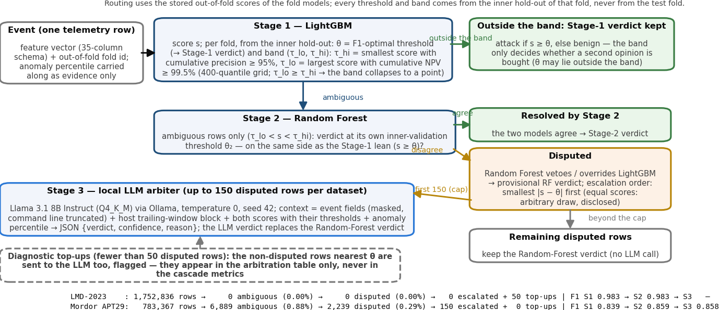
Figure 2. Software block diagram of the cascade and the LLM arbitration: accepted Stage-1 decisions, the ambiguous band, Random-Forest agreement and disputes, the escalation cap and the diagnostic top-ups; counts from the run.

3.2 Multi-Stage/Model Cascading Architecture Accuracy
Table 11. Cascade performance after each stage (out-of-fold, routed on the stored scores) and the perfect-arbiter upper bound.
Dataset | System | F1 | FPR | FNR | FP | FN
LMD-2023 | Stage 1 — LightGBM at its inner-validation threshold | 0.983 | 0.21% | 0.99% | 3,398 | 1,405
LMD-2023 | Stage 2 — + Random Forest on the ambiguous band (0.00% ambiguous, 0.00% disputed) | 0.983 | 0.21% | 0.99% | 3,398 | 1,405
LMD-2023 | Stage 3 — not applicable: no disputed rows (the 50 LLM calls are top-ups, Table 14) | — | — | — | — | —
LMD-2023 | Upper bound — a perfect arbiter on every disputed row | 0.983 | 0.21% | 0.99% | 3,398 | 1,405
Mordor | Stage 1 — LightGBM at its inner-validation threshold | 0.839 | 0.77% | 13.52% | 5,784 | 3,994
Mordor | Stage 2 — + Random Forest on the ambiguous band (0.88% ambiguous, 0.29% disputed) | 0.859 | 0.52% | 14.72% | 3,901 | 4,350
Mordor | Stage 3 — + LLM arbitration of 150 disputed rows | 0.858 | 0.53% | 14.67% | 4,010 | 4,334
Mordor | Upper bound — a perfect arbiter on every disputed row | 0.866 | 0.52% | 13.52% | 3,901 | 3,994
Mordor | Upper bound — a perfect arbiter on the 150 escalated rows only | 0.860 | 0.52% | 14.67% | 3,901 | 4,334
The gain differs between the datasets because of the band. On LMD-2023 the two criteria cross in every fold: the precision target is met at a score no higher than the NPV limit (§3.1), so the band collapses to a point (0.44–0.64, median 0.50), no row reaches Stage 2 (0 ambiguous) and F1 stays at 0.983. On Mordor the band holds 6,889 rows (0.88%) and the Random Forest disagrees with LightGBM on 2,239 of them (0.29% of all rows) — not evenly: fold 0’s band is collapsed (the two-round model of §1.5), fold 4, the dense-burst fold, holds 55% of the disputed rows, and the Stage-2 change in F1 per fold is +0.000 / +0.018 / −0.002 / +0.009 / +0.030; Stage 2 raises F1 from 0.839 to 0.859, mainly through the FPR (0.77% → 0.52%, 1,883 fewer FP) at a small cost in FNR (13.52% → 14.72%). Against the 95% / 99.5% construction targets, the Mordor attack verdicts accepted outside the band reach precision 92.4% out-of-fold and the benign verdicts NPV 99.47%; after Stage 2 all attack verdicts have precision 86.6% and all benign verdicts NPV 99.42% (LMD: 97.6% and 99.91%). A perfect arbiter on every disputed row would reach F1 0.866, at most 0.007 above Stage 2, because the disputed rows are 0.29% of the data — and at the 150-row budget actually escalated a perfect arbiter reaches 0.8596 (+0.0003 over Stage 2’s 0.8593), the whole room Stage 3 had. Of the errors that remain under a perfect arbiter, all 3,994 false negatives and 1,869 false positives lie outside the band (confident verdicts no stage revisits), but 2,032 false positives are band rows both models called “attack”: the Random Forest’s confirmation inside the band is weak evidence (precision 56%, 2,618 of 4,650), whereas its vetoes were right 84% of the time (1,883 of 2,239), so a third stage that could also overturn confirmations would have more room than one restricted to disputes (Figure 9). Stage 3 is therefore judged in Part 4 as an arbiter on the escalated rows (does it beat the Random-Forest verdict it replaces?), not by an end-to-end F1 gain bounded by 0.007.

Part 4: Local LLM Configuration, Prompt Design & Evaluation

4.1 Local Model Configuration & Runtime Constraints
Table 12. Local LLM configuration.
Item | Value
Model, quantization & memory | llama3.1:8b-instruct-q4_K_M (Meta Llama 3.1 8B Instruct from the Ollama library); Q4_K_M 4-bit GGUF, 8.0B parameters, ≈4.9 GB on disk; resident while serving: 5.6 GB (ollama ps; 100% CPU, 4,096-token context, no GPU)
Serving backend & inference parameters | Ollama 0.34.4, /api/chat with JSON-format responses, one call per event; temperature = 0, top_p = 0.9, max output tokens = 512, seed = 42
Observed cost | LMD-2023: 28.2 s per call, 59 output tokens, 50 + 50 × 4 prompts; Mordor: 26.0 s per call, 65 output tokens, 150 + 60 × 4 prompts; 599 model calls in 4.0 h wall clock (41 unchanged no-opinion prompts served from the interrupted first run’s cache)
Table 12 specifies the arbiter: the largest instruction-tuned model judged to run on the laptop CPU at workable latency (pre-registered in config.py), with a 4,096-token context (prompts average 612 tokens, answers 63). Temperature 0 with a fixed seed should make verdicts reproducible (not re-tested); top_p is then inert.

4.2 System Prompt & Telemetry Injection Template
The system prompt fixes the role, the target-class definition and four rules; the last fixes the answer as one JSON object (verdict, confidence, one-sentence reason) — explainable, but not the free chain-of-thought reasoning the brief suggests, chosen for parse reliability and CPU latency; no reasoning-first prompt was tested (§4.3). The user template (m3pkg/llm.py, filled below) injects three generated blocks: the event itself (its applicable telemetry fields under the Milestone-2 placeholder and applicability masks, so LMD’s “0” placeholders and out-of-schema fields never reach the prompt; command line truncated to 160 characters, base64 blobs masked), the host’s trailing-window activity (rates, admin-port counts, fan-out, peers, users, lineage / credential / tool-transfer flags), and the model opinions (both scores with their thresholds, labelled as class-weighted outputs rather than probabilities, plus the anomaly percentile). The arbiter sees 19 of the 35 model inputs in words (Security-channel and entropy features are not verbalised) plus raw fields the models did not (command line, image names).
System prompt (verbatim):
You are a senior SOC analyst arbitrating between two intrusion-detection models.
Task: decide whether ONE Windows host telemetry event is part of LATERAL MOVEMENT (MITRE ATT&CK TA0008: remote
services such as SMB/RPC/WinRM/RDP, exploitation of remote services, pass-the-hash/ticket, lateral tool transfer)
or BENIGN activity.
Rules:
1. Judge only from the evidence given. Do not invent facts. Rates and counts are trailing per-host windows.
2. Lateral movement typically shows: inbound remote-service connections or logons from new peers, a service/WMI/WinRM
host process spawning an interpreter, tools written to admin shares or staging paths, credential-store access,
bursts of distinct destinations/admin ports. Broadcast/multicast chatter, routine service processes and
single connections to a known destination are usually benign.
3. The two model opinions are advisory; they can be wrong. Weigh them against the telemetry.
4. Answer with ONE JSON object and nothing else:
{"verdict": "LATERAL_MOVEMENT" or "BENIGN", "confidence": number between 0 and 1, "reason": "one sentence"}
User template filled for the first escalated Mordor event (headings = template, lines = generated) and the answer:
### Event
- event category: process_access (event id 10)
- host: NASHUA.dmevals.local
- time: 2020-05-02 03:12:47 UTC
- source process: psexesvc.exe
- target process / server: python.exe
- granted access mask: 0x1fffff

### Host activity in the trailing windows
- events on this host in the last 60 s: 194 (process creations 2, network connections 3)
- admin-port connections in the last 60 s: 2 (inbound 2)
- distinct outbound destinations in the last 5 min: 1; distinct inbound unicast peers: 1
- distinct outbound destinations in the last hour: 7; distinct users in the last 60 s: 4
- flags: remote-exec parent=0, remote-exec after inbound admin-port=0, LOLBin image=0, suspicious command tokens=0, LSASS access=0, credential-read mask=1, executable dropped=0, run from staging path=0, first time this host contacted this destination=0

### Model opinions
- gradient-boosting model: lateral-movement score 0.33 on a 0-1 scale (its decision threshold is 0.33)
- random-forest model: lateral-movement score 0.34 on a 0-1 scale (its decision threshold is 0.39)
- (the two scores are class-weighted model outputs, not calibrated probabilities)
- unsupervised anomaly score: more anomalous than 97% of this environment's training traffic

### Question
Is this event part of lateral movement? Respond with the JSON object only.
→ verdict LATERAL_MOVEMENT, confidence 0.85, reason: The event involves a process (psexesvc.exe) accessing another process (python.exe), which is a suspicious activity, and the host has a high anomaly score and multiple indicators of lateral movement in the trailing windows. (label: attack)
Sensitivity to the content. 60 escalated Mordor events and 50 LMD ones (all top-ups) were re-queried under the four context modifications of Table 13 (in the swap each slot keeps its own threshold).
Table 13. LLM sensitivity to four context modifications (same events under every variant; flips = share of verdicts changed vs the full context; every answer parsed).
Context variant | LMD parsed/n | LMD acc. | LMD flips | LMD F1 | Mordor parsed/n | Mordor acc. | Mordor flips | Mordor F1
full context | 50/50 | 42.0% | — | 0.473 | 60/60 | 41.7% | — | 0.386
model opinions withheld | 50/50 | 22.0% | 28.0% | 0.049 | 60/60 | 93.3% | 51.7% | 0.846
host window withheld | 50/50 | 70.0% | 40.0% | 0.769 | 60/60 | 78.3% | 40.0% | 0.606
scores swapped (thresholds fixed) | 50/50 | 30.0% | 12.0% | 0.386 | 60/60 | 81.7% | 46.7% | 0.667
evidence lines shuffled | 50/50 | 34.0% | 16.0% | 0.459 | 60/60 | 33.3% | 8.3% | 0.355
The flip rates of Table 13 are sensitivities to specific modifications, not a reading of the model’s reasoning: a low rate can mean an unused or redundant block or nearly constant verdicts; the swap is asymmetric: on 45 of the 60 Mordor rows it moves the gradient-boosting slot below its threshold while the Random-Forest slot changes side once (a displayed tie), so “swapped” is confounded with “no model above threshold”; shuffling alone flips 8%–16%. On the same 60 Mordor rows the no-opinion variant reaches 93.3% (F1 0.846), above the margin (85.0%) and anomaly (80.0%) rules on the displayed numbers; on LMD it drops to 22%.

4.3 LLM Arbitration Performance
Table 14. Arbitration on the escalated rows: the LLM against the two model verdicts and label-free rules on the same rows. Model verdicts use full-precision scores (as the cascade does); rules use the numbers as displayed in the prompt (two decimals, integer percentile; a score shown at its threshold counts as positive); full-precision scores: margin rule 88.0% / 93.3%, anomaly rule 36.0% / 91.3% (LMD-2023 / Mordor).
Dataset | Decision source | n | Prec. | Rec. | F1 | FPR | FNR | Acc.
LMD-2023 | LightGBM verdict (the cascade’s actual verdict here) | 50 | 0.313 | 0.152 | 0.204 | 64.7% | 84.8% | 0.220
LMD-2023 | Random-Forest verdict (not consulted here) | 50 | 0.909 | 0.909 | 0.909 | 17.6% | 9.1% | 0.880
LMD-2023 | rule: follow the model further from its own threshold | 50 | 0.909 | 0.909 | 0.909 | 17.6% | 9.1% | 0.880
LMD-2023 | rule: attack iff anomaly percentile ≥ 0.99 | 50 | 0.571 | 0.242 | 0.340 | 35.3% | 75.8% | 0.380
LMD-2023 | rule: constant “attack” | 50 | 0.660 | 1.000 | 0.795 | 100.0% | 0.0% | 0.660
LMD-2023 | LLM verdict (full context) | 50 | 0.591 | 0.394 | 0.473 | 52.9% | 60.6% | 0.420
Mordor | LightGBM verdict (attack on every disputed row) | 150 | 0.107 | 1.000 | 0.193 | 100.0% | 0.0% | 0.107
Mordor | Random-Forest verdict (benign on every disputed row) | 150 | 0.000 | 0.000 | 0.000 | 0.0% | 100.0% | 0.893
Mordor | rule: follow the model further from its own threshold | 150 | 0.667 | 0.375 | 0.480 | 2.2% | 62.5% | 0.913
Mordor | rule: attack iff anomaly percentile ≥ 0.99 | 150 | 0.450 | 0.563 | 0.500 | 8.2% | 43.8% | 0.880
Mordor | LLM verdict (full context) | 150 | 0.128 | 1.000 | 0.227 | 81.3% | 0.0% | 0.273
On LMD-2023 the 50 escalations are near-threshold top-ups, so the cascade’s verdict on them is LightGBM’s (accuracy 22.0%) and nothing is replaced; the LLM said “attack” on 44% of them, accuracy 42.0% (F1 0.473): above LightGBM and the anomaly rule (38.0%), far below the Random Forest (88.0%, not consulted there; the margin rule follows it) and below a constant “attack” answer (66.0%, their attack share). On Mordor the LLM answered all 150 escalated disputed rows, “attack” on 83% of them: accuracy 27.3% (F1 0.227) — below the Random-Forest verdict it would replace (accuracy 89.3%; F1 0 by construction, every disputed row being a veto) and below the anomaly rule on the same displayed numbers (accuracy 88.0%, F1 0.500). A prompt limitation: at two decimals the gradient-boosting score was shown equal to its threshold on 43 of the 50 LMD top-ups and 23 of the 150 Mordor rows (the Random-Forest score on one), so those rows did not show which side of the threshold that model was on; an explicit verdict beside each score would remove the ambiguity, more decimals alone may not (three would still leave 25 on LMD-2023). The Part-4 result is negative: this local LLM is not a useful arbiter (on Mordor below the verdict it replaces and both label-free rules, on LMD far below the Random Forest), while withholding the opinion block lifts the 60-row Mordor subset from 42% to 93% (Table 13); no chain-of-thought variant was tested, and Stage 3 stays on record, unadopted.

References (numbering as in Milestone 2; only the entries cited here)
[1] T. Bai, H. Bian, M. A. Salahuddin, A. Abou Daya, N. Limam, R. Boutaba, “RDP-based Lateral Movement detection using Machine Learning,” Computer Communications, vol. 165, pp. 9–19, 2021.
[2] C. Smiliotopoulos et al., “On the detection of lateral movement through supervised machine learning and an open-source tool to create turnkey datasets from Sysmon logs,” Int. J. Inf. Secur. 22:1893–1919, 2023.
[3] C. Smiliotopoulos, G. Kambourakis, “Machine Learning for Lateral Movement Detection using Sysmon Logs: An Empirical Comparison of Imbalanced and Resampled Data,” Int. J. Inf. Secur. 25:38, 2026.
[4] C. Smiliotopoulos, G. Kambourakis, C. Kolias, S. Gritzalis, “Assessing the detection of lateral movement through unsupervised learning techniques,” Comput. Secur., vol. 149, art. 104190, 2025.
[5] D. Kushwaha et al., “Lateral Movement Detection Using User Behavioral Analysis,” arXiv:2208.13524, 2022.
[11] D. C. Le, N. Zincir-Heywood, “Anomaly Detection for Insider Threats Using Unsupervised Ensembles,” IEEE TNSM, vol. 18, no. 2, pp. 1152–1164, 2021.

Appendix — Supporting figures
Generated by run_m3.py --stage collect from the results files; Figures 3–6 plot the sensitivity sweep behind Table 4, Figures 7–9 the numbers of Tables 5, 9 and 11, Figure 10 those of Table 13; the appendix is not counted as report pages.
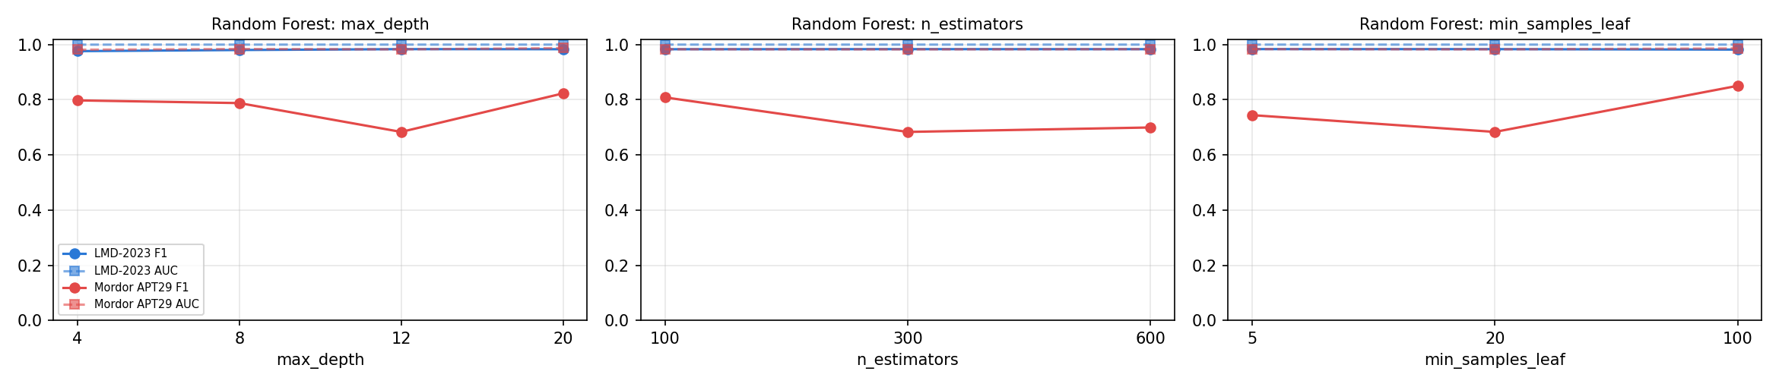
Figure 3. Random Forest sensitivity curves on fold 0: F1 (solid) and ROC-AUC (dashed) per hyper-parameter value, both datasets.
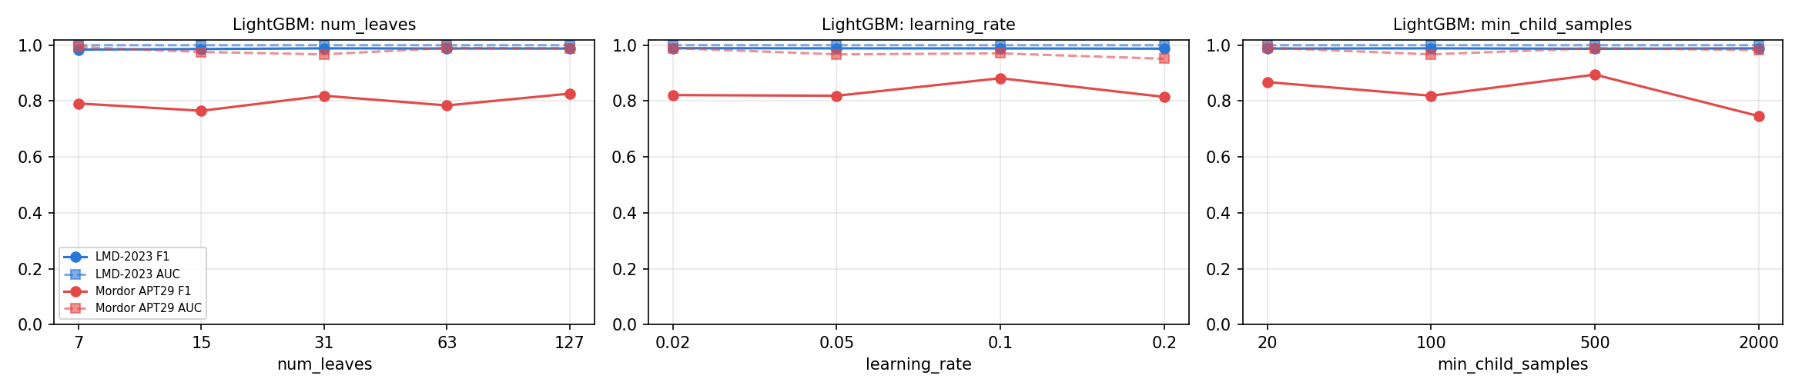
Figure 4. LightGBM sensitivity curves.
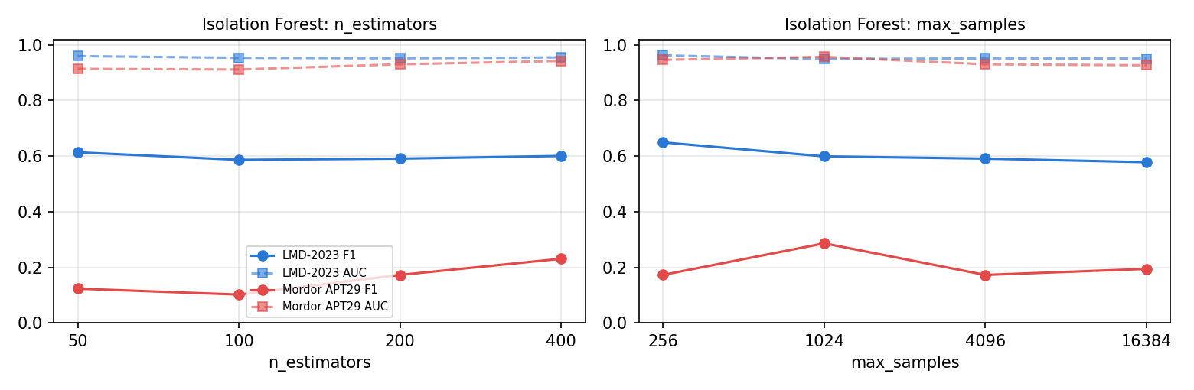
Figure 5. Isolation Forest sensitivity curves.
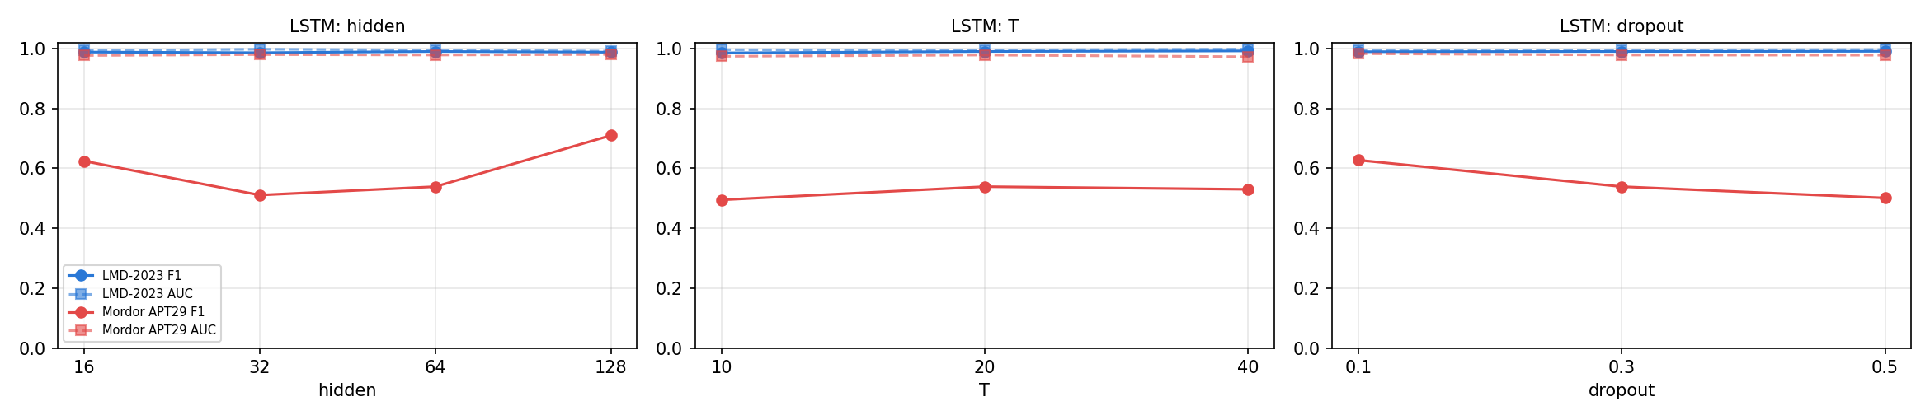
Figure 6. LSTM sensitivity curves.
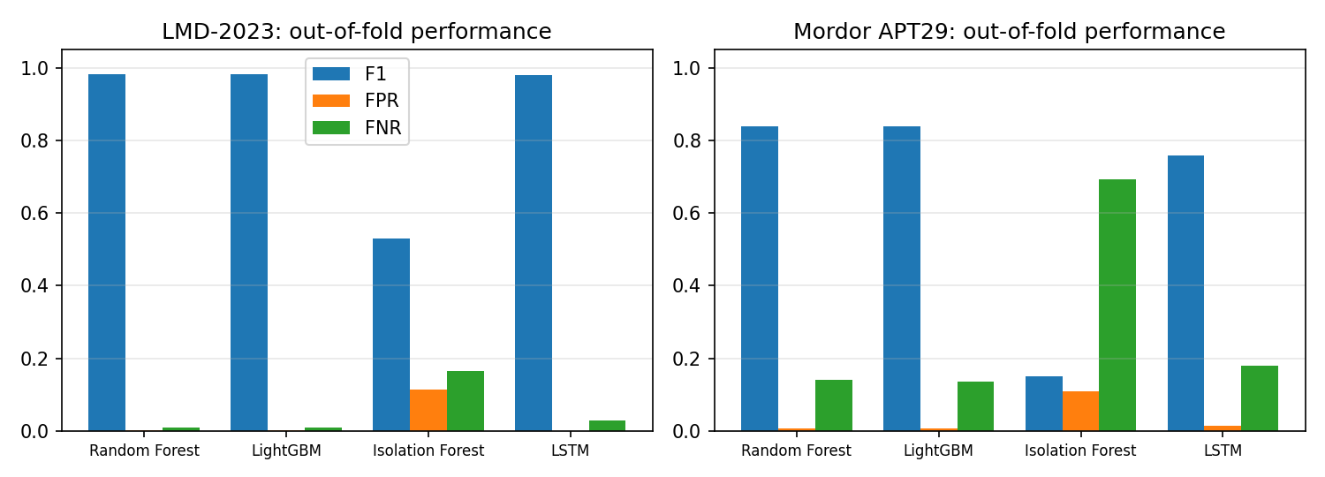
Figure 7. Out-of-fold F1 / FPR / FNR of the four models per dataset.
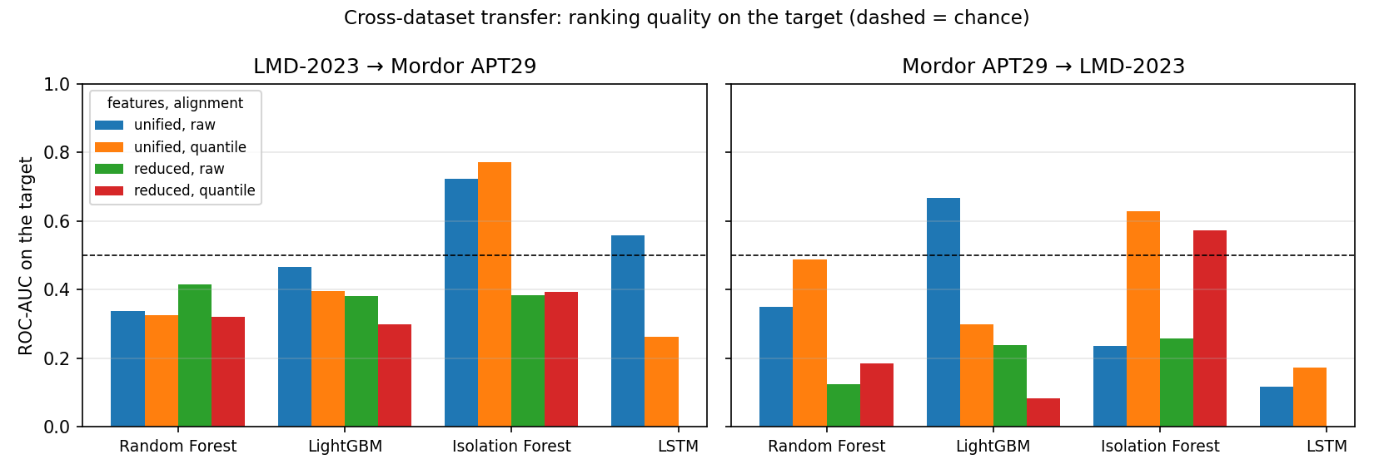
Figure 8. Cross-dataset transfer: ROC-AUC on the target for every model, feature set and alignment (dashed line = chance; below it the source model ranks the target’s attack rows below its benign rows).
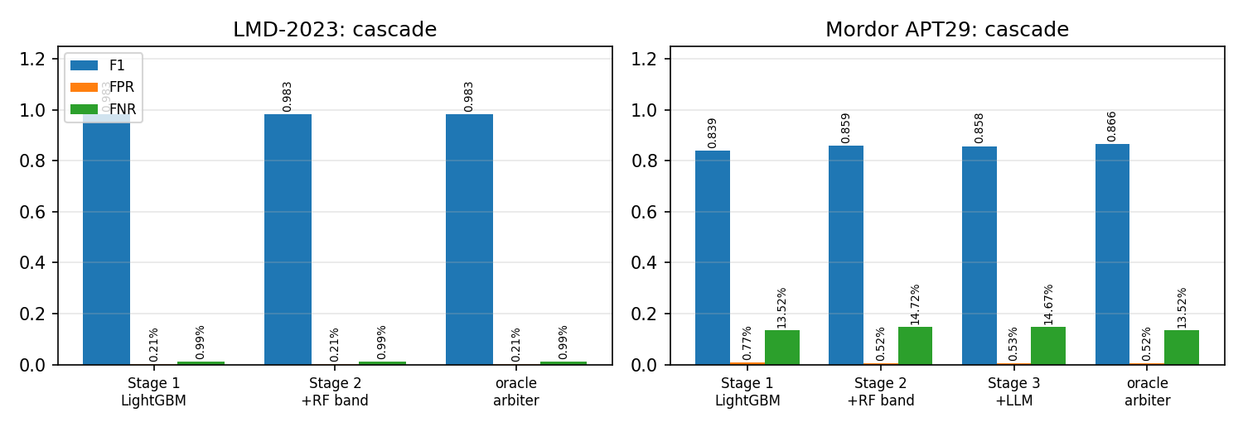
Figure 9. Cascade metrics after each stage and the perfect-arbiter upper bound.
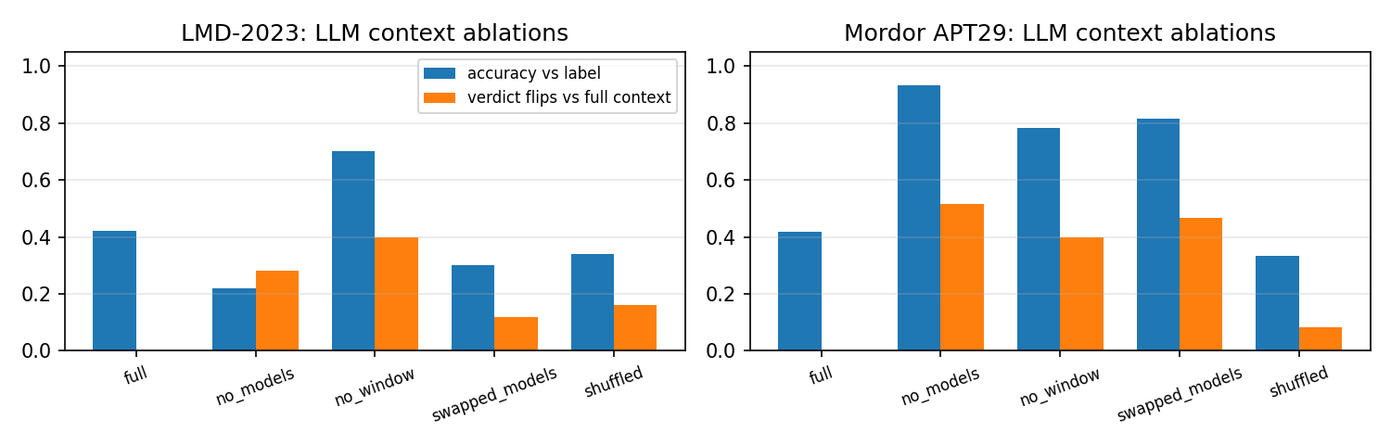
Figure 10. LLM accuracy and verdict-flip rate under the context ablations.

