Contents
FG Detection BLE Gas Application – System Requirements 2
1. Business Purpose 2
2. User Workflow 2
2.1 Application Launch 2
2.2 BLE Device Connection 2
2.3 Passkey Authentication 2
2.4 Main Dashboard Access 2
2.5 Text-based sketch 3
3. Main Application Layout 4
4. Functional Tabs 4
4.1 Alert Status Tab 4
4.2 Environmental Sensing Tab 4
4.3 Device Control Tab 4
4.4 Device Settings Tab 5
4.5 Device Info Tab 5
4.6 Generic Access Tab 5
5. BLE Behavior Summary 5
6. Operating Constraints 6
8. Future Enhancements 6
9. Revision History 6

FG Detection BLE Gas Application – System Requirements

1. Business Purpose
The FG Detection BLE Gas Application is a mobile interface designed for real-time monitoring and configuration of gas detection devices.
The application enables direct communication with FG Detection hardware via Bluetooth Low Energy (BLE) and Wi-Fi, allowing users to:
- View live gas readings
- Monitor alert status
- Configure operational parameters
- Access device information
The system supports early detection of hazardous gas levels and provides immediate feedback to the user via live alerts and sensor updates.

2. User Workflow

2.1 Application Launch
The user launches the mobile application on a supported smartphone.

2.2 BLE Device Connection
The user initiates a Bluetooth connection by tapping the Connect button.
The app scans for nearby gas detector and connect to the device that found.

2.3 Passkey Authentication
After successful connection, the user is prompted to enter a passkey.
Only upon valid passkey entry, the system unlocks additional BLE services and navigates the user to the main dashboard.

2.4 Main Dashboard Access
Once authenticated, the user reaches the main dashboard, where all monitoring and control features are accessible through a tab-based interface.

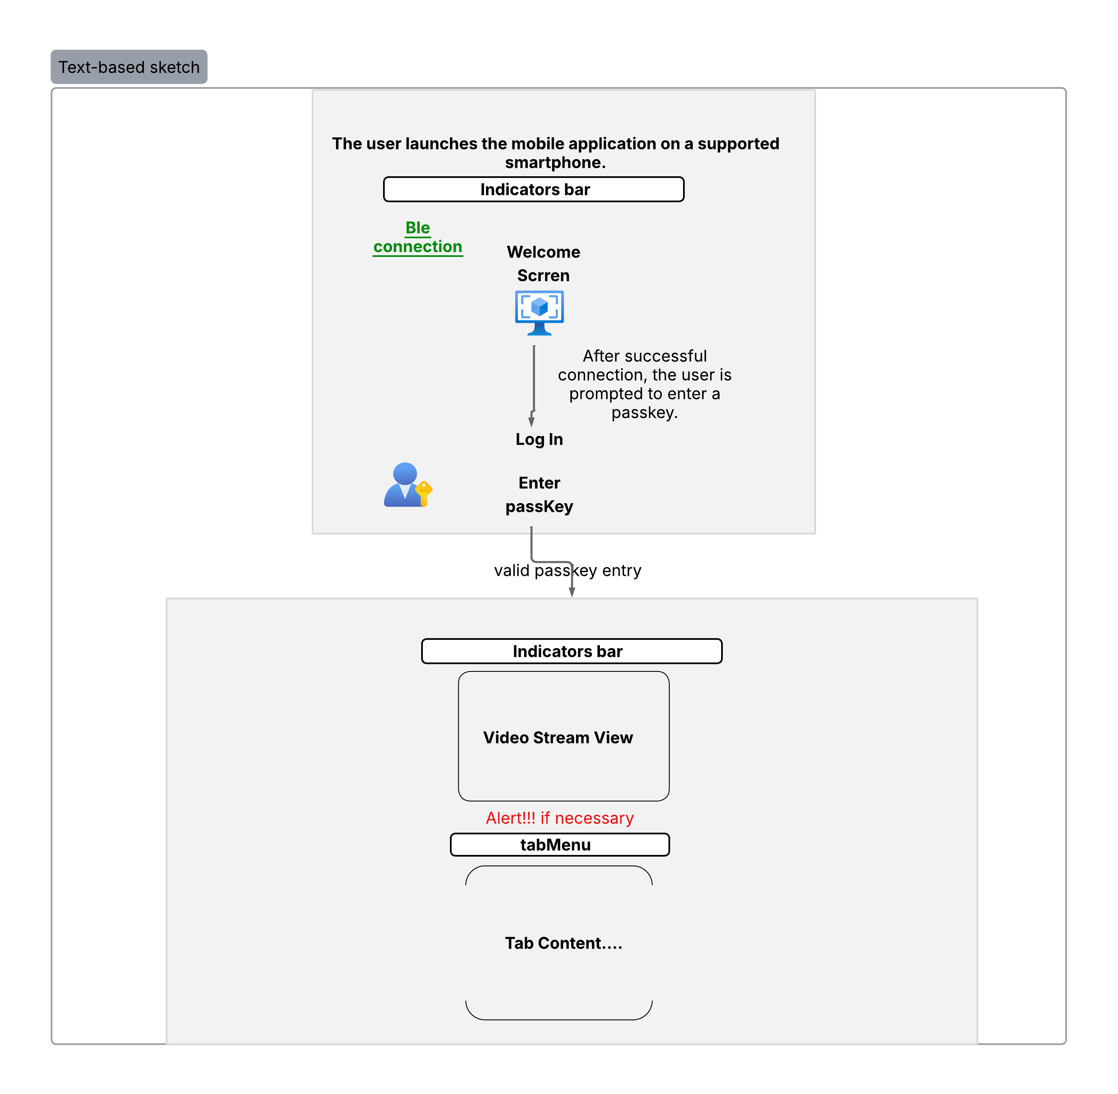
2.5 Text-based sketch

3. Main Application Layout
The app interface consists of two main sections:
Upper section: Displays a live video stream from the monitored area.
Lower section: Contains functional tabs for navigating between features.

4. Functional Tabs

4.1 Alert Status Tab
Continuously displays the device’s alert state.
The alert indicator remains visible across all app screens, regardless of which tab is active.
It updates in real time based on signals from the detector.

4.2 Environmental Sensing Tab
Displays real-time sensor data from the connected device:
- Gas concentration (%LEL)
- Board temperature (°C)
- Measurement interval (editable and pushed to device)

4.3 Device Control Tab
Provides on-device mode switching:
- Normal Mode
- Alignment Mode
- Zero Calibration Mode
Writes control commands via the Device Control/Media Control Point characteristic and visually updates status after execution.

4.4 Device Settings Tab
Allows full configuration of hardware behavior parameters:
- Full Scale - Maximum measurable value of the sensor.
- Alarm Level - Threshold triggering critical alert.
- Warning Level - Early alert before danger level.
- Lowest Operating Level - Minimum detectable gas concentration.
- Response Time
- Block Delay
- Gas Type selection - Choose which gas the sensor detects.
Values are written directly to BLE characteristics and re-fetched for live confirmation.

4.5 Device Info Tab
Provides static device metadata retrieved from the BLE Device Information Service:
- Manufacturer name
- Model number
- System ID

4.6 Generic Access Tab
Provides general device configuration information:
- Device name
- Appearance code
Pulled from the BLE Generic Access Service.

5. BLE Behavior Summary
Yet to be completed

6. Operating Constraints
Yet to be completed . This section will describe the technical and environmental constraints, such as:
Minimum supported Android/iOS version
Connectivity range
And so on.

8. Future Enhancements
Possible additions in future versions

9. Revision History
Version: v1.0
Date: 11.16.2025
Notes: Initial system requirements draft for mobile version
Should be a table later!

