null

null

2021-05-19

Table of Contents

## POM fraction amounts

### fPOM amounts

## Warning: Removed 1 rows containing missing values (geom_point).

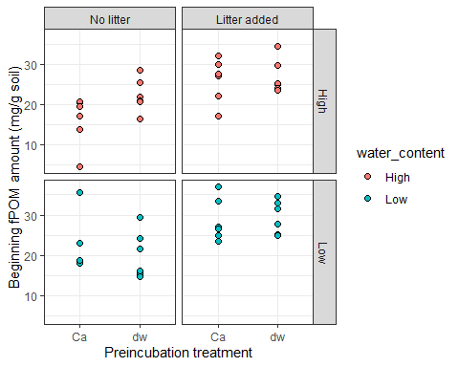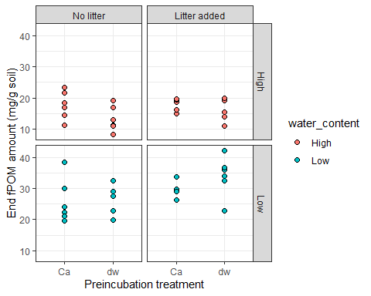

## Warning: Removed 1 rows containing missing values (geom_point).

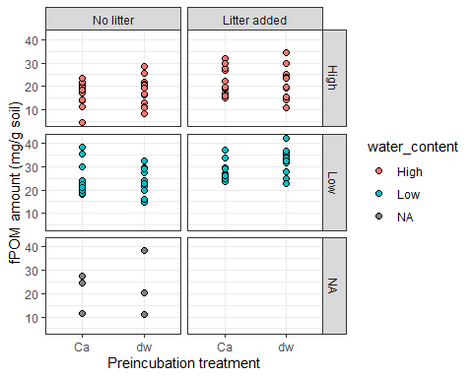

## Warning: Removed 1 rows containing non-finite values (stat_boxplot).  
  
## Warning: Removed 1 rows containing missing values (geom_point).

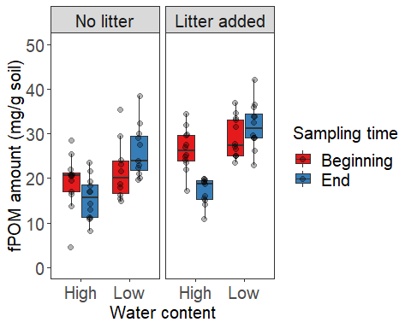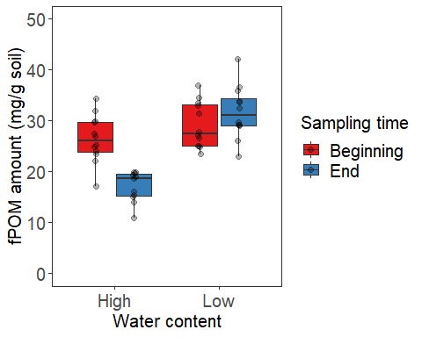

## Df Sum Sq Mean Sq F value Pr(>F)   
## sampling_point 1 56.8 56.8 1.641 0.203612   
## water_content 1 1423.0 1423.0 41.079 7.03e-09 ***  
## sampling_point:water_content 1 560.4 560.4 16.178 0.000122 ***  
## Residuals 88 3048.3 34.6   
## ---  
## Signif. codes: 0 '***' 0.001 '**' 0.01 '*' 0.05 '.' 0.1 ' ' 1  
## 1 observation deleted due to missingness

term

df

sumsq

meansq

statistic

p.value

sampling_point

1

56.8294

56.8294

1.6406

0.2036

water_content

1

1422.9797

1422.9797

41.0791

0.0000

sampling_point:water_content

1

560.4098

560.4098

16.1781

0.0001

Residuals

88

3048.3204

34.6400

NA

NA

## Df Sum Sq Mean Sq F value Pr(>F)   
## water_content 1 98.3 98.3 3.278 0.0774 .   
## litter 1 616.7 616.7 20.565 4.75e-05 ***  
## water_content:litter 1 0.1 0.1 0.003 0.9544   
## Residuals 42 1259.4 30.0   
## ---  
## Signif. codes: 0 '***' 0.001 '**' 0.01 '*' 0.05 '.' 0.1 ' ' 1  
## 1 observation deleted due to missingness

## Df Sum Sq Mean Sq F value Pr(>F)   
## water_content 1 1885.1 1885.1 81.169 2.3e-11 ***  
## litter 1 151.5 151.5 6.521 0.0144 *   
## water_content:litter 1 45.3 45.3 1.950 0.1700   
## Residuals 42 975.4 23.2   
## ---  
## Signif. codes: 0 '***' 0.001 '**' 0.01 '*' 0.05 '.' 0.1 ' ' 1

## Tukey multiple comparisons of means  
## 95% family-wise confidence level  
##   
## Fit: aov(formula = fPOM_dry_mg_g ~ sampling_point * water_content, data = filter(df, sampling_point != "initial" & litter != "No Litter"))  
##   
## $sampling_point  
## diff lwr upr p adj  
## End-Beginning -1.571892 -4.010748 0.866965 0.2036125  
##   
## $water_content  
## diff lwr upr p adj  
## Low-High 7.865664 5.426231 10.3051 0  
##   
## $`sampling_point:water_content`  
## diff lwr upr p adj  
## End:High-Beginning:High -6.573998 -11.071508 -2.076489 0.0013581  
## Beginning:Low-Beginning:High 2.926219 -1.623187 7.475625 0.3379977  
## End:Low-Beginning:High 6.229207 1.731698 10.726717 0.0026594  
## Beginning:Low-End:High 9.500218 4.903755 14.096680 0.0000031  
## End:Low-End:High 12.803206 8.258102 17.348309 0.0000000  
## End:Low-Beginning:Low 3.302988 -1.293474 7.899451 0.2432830

## Tukey multiple comparisons of means  
## 95% family-wise confidence level  
##   
## Fit: aov(formula = fPOM_dry_mg_g ~ water_content * litter, data = df_end)  
##   
## $water_content  
## diff lwr upr p adj  
## Low-High 12.80321 9.935318 15.67109 0  
##   
## $litter  
## diff lwr upr p adj  
## Litter added-No litter 3.625621 0.757733 6.493509 0.0144636  
##   
## $`water_content:litter`  
## diff lwr upr p adj  
## Low:No litter-High:No litter 10.659071 5.278032 16.040110 0.0000233  
## High:Litter added-High:No litter 1.646287 -3.734752 7.027326 0.8454454  
## Low:Litter added-High:No litter 16.277759 11.014999 21.540519 0.0000000  
## High:Litter added-Low:No litter -9.012784 -14.509557 -3.516011 0.0004278  
## Low:Litter added-Low:No litter 5.618688 0.237649 10.999727 0.0377459  
## Low:Litter added-High:Litter added 14.631472 9.250433 20.012511 0.0000000

## Tukey multiple comparisons of means  
## 95% family-wise confidence level  
##   
## Fit: aov(formula = fPOM_dry_mg_g ~ water_content * litter, data = df_beg)  
##   
## $water_content  
## diff lwr upr p adj  
## Low-High 2.926219 -0.3355921 6.18803 0.0773838  
##   
## $litter  
## diff lwr upr p adj  
## Litter added-No litter 7.322063 4.060252 10.58387 4.82e-05  
##   
## $`water_content:litter`  
## diff lwr upr p adj  
## Low:No litter-High:No litter 2.495017 -3.776833 8.766867 0.7129228  
## High:Litter added-High:No litter 7.248412 1.268438 13.228387 0.0119879  
## Low:Litter added-High:No litter 9.929932 3.949957 15.909906 0.0003596  
## High:Litter added-Low:No litter 4.753395 -1.518455 11.025245 0.1943781  
## Low:Litter added-Low:No litter 7.434915 1.163064 13.706765 0.0144923  
## Low:Litter added-High:Litter added 2.681520 -3.298455 8.661494 0.6305713

Ca treatment does not affect fPOM in any water content/litter treatnebt combination fPOM decreases from begininng to end of incubation at high water content This result fits delta13C-CO2 data that shows higher delta values at higher water content. fPOM somewhat increases at low water content - does low water content induce translocation of POM from occluded to free?? Isotope ratio can help identify pathway.

### oPOM amounts

## Warning: Removed 1 rows containing missing values (geom_point).

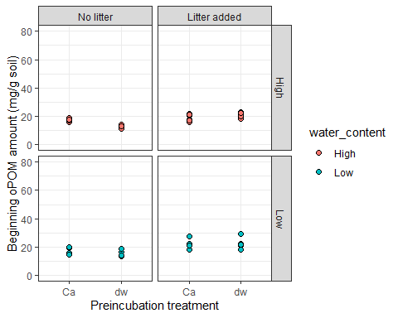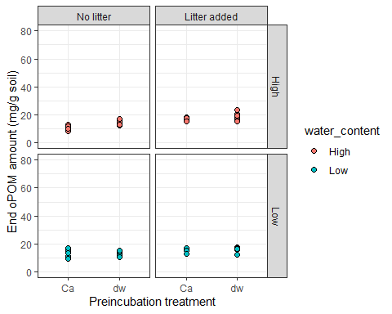

## Warning: Removed 1 rows containing missing values (geom_point).

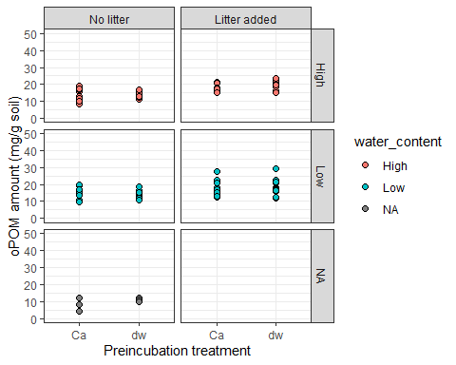

## Warning: Removed 1 rows containing non-finite values (stat_boxplot).  
  
## Warning: Removed 1 rows containing missing values (geom_point).

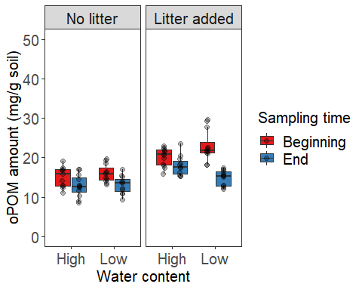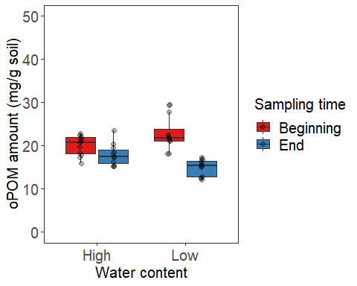

## Df Sum Sq Mean Sq F value Pr(>F)   
## water_content 1 2.5 2.5 0.185 0.6680   
## sampling_point 1 374.5 374.5 28.158 8.27e-07 ***  
## water_content:sampling_point 1 56.2 56.2 4.226 0.0428 *   
## Residuals 88 1170.4 13.3   
## ---  
## Signif. codes: 0 '***' 0.001 '**' 0.01 '*' 0.05 '.' 0.1 ' ' 1  
## 1 observation deleted due to missingness

## Df Sum Sq Mean Sq F value Pr(>F)   
## water_content 1 41.1 41.1 5.082 0.0295 *   
## litter 1 409.8 409.8 50.673 9.84e-09 ***  
## water_content:litter 1 10.9 10.9 1.347 0.2524   
## Residuals 42 339.7 8.1   
## ---  
## Signif. codes: 0 '***' 0.001 '**' 0.01 '*' 0.05 '.' 0.1 ' ' 1  
## 1 observation deleted due to missingness

## Df Sum Sq Mean Sq F value Pr(>F)   
## water_content 1 17.57 17.57 3.040 0.0886 .   
## litter 1 136.47 136.47 23.607 1.68e-05 ***  
## water_content:litter 1 30.72 30.72 5.314 0.0262 *   
## Residuals 42 242.79 5.78   
## ---  
## Signif. codes: 0 '***' 0.001 '**' 0.01 '*' 0.05 '.' 0.1 ' ' 1

## Tukey multiple comparisons of means  
## 95% family-wise confidence level  
##   
## Fit: aov(formula = oPOM_dry_mg_g ~ water_content * sampling_point, data = filter(df, sampling_point != "initial"))  
##   
## $water_content  
## diff lwr upr p adj  
## Low-High 0.3272239 -1.183976 1.838424 0.6680201  
##   
## $sampling_point  
## diff lwr upr p adj  
## End-Beginning -4.035133 -5.546333 -2.523933 8e-07  
##   
## $`water_content:sampling_point`  
## diff lwr upr p adj  
## Low:Beginning-High:Beginning 1.890532 -0.925771 4.7068351 0.3005418  
## High:End-High:Beginning -2.471825 -5.288128 0.3444783 0.1061894  
## Low:End-High:Beginning -3.707909 -6.524212 -0.8916060 0.0047373  
## High:End-Low:Beginning -4.362357 -7.178660 -1.5460538 0.0006130  
## Low:End-Low:Beginning -5.598441 -8.414744 -2.7821381 0.0000074  
## Low:End-High:End -1.236084 -4.052387 1.5802187 0.6600819

## Tukey multiple comparisons of means  
## 95% family-wise confidence level  
##   
## Fit: aov(formula = oPOM_dry_mg_g ~ water_content * litter, data = df_end)  
##   
## $water_content  
## diff lwr upr p adj  
## Low-High -1.236084 -2.666894 0.1947259 0.0885753  
##   
## $litter  
## diff lwr upr p adj  
## Litter added-No litter 3.441571 2.010761 4.872381 1.71e-05  
##   
## $`water_content:litter`  
## diff lwr upr p adj  
## Low:No litter-High:No litter 0.2498774 -2.4347623 2.9345170 0.9944966  
## High:Litter added-High:No litter 5.0839675 2.3993279 7.7686072 0.0000496  
## Low:Litter added-High:No litter 2.0620877 -0.5635416 4.6877171 0.1695169  
## High:Litter added-Low:No litter 4.8340901 2.0917097 7.5764706 0.0001522  
## Low:Litter added-Low:No litter 1.8122103 -0.8724293 4.4968500 0.2850381  
## Low:Litter added-High:Litter added -3.0218798 -5.7065194 -0.3372401 0.0219582

## Tukey multiple comparisons of means  
## 95% family-wise confidence level  
##   
## Fit: aov(formula = oPOM_dry_mg_g ~ water_content * litter, data = df_beg)  
##   
## $water_content  
## diff lwr upr p adj  
## Low-High 1.890532 0.1981251 3.582939 0.0294506  
##   
## $litter  
## diff lwr upr p adj  
## Litter added-No litter 5.975404 4.281395 7.669413 0  
##   
## $`water_content:litter`  
## diff lwr upr p adj  
## Low:No litter-High:No litter 0.874039 -2.369734 4.117812 0.8882667  
## High:Litter added-High:No litter 5.001265 1.825789 8.176740 0.0007288  
## Low:Litter added-High:No litter 7.823582 4.648106 10.999057 0.0000003  
## High:Litter added-Low:No litter 4.127226 0.951750 7.302701 0.0063155  
## Low:Litter added-Low:No litter 6.949543 3.774067 10.125018 0.0000038  
## Low:Litter added-High:Litter added 2.822317 -0.283359 5.927994 0.0866704

oPOM decreases from beginning to end in all conditions, especially in low water content when litter is added. Is this translocation to fPOM, or just preferentia decomposition of oPOM vs fPOM in low water content.

### Total POM amounts

## Warning: Removed 2 rows containing missing values (geom_point).

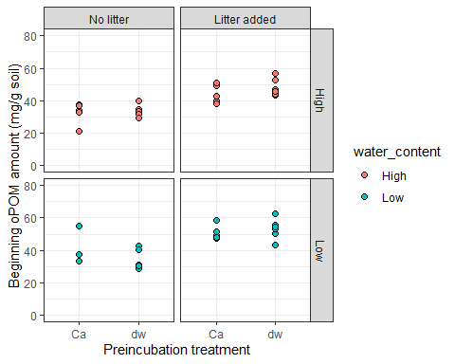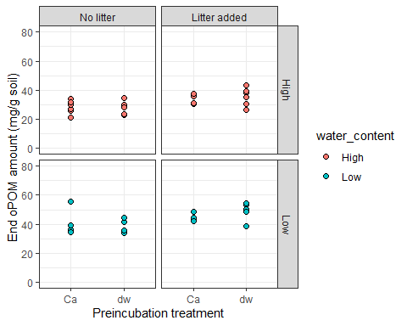

## Warning: Removed 2 rows containing missing values (geom_point).

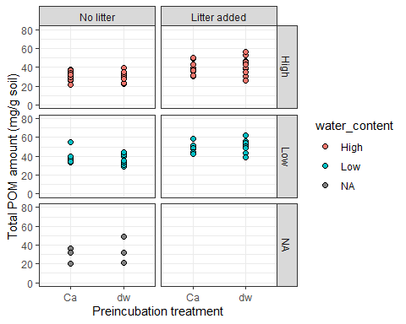

## Warning: Removed 2 rows containing non-finite values (stat_boxplot).  
  
## Warning: Removed 2 rows containing missing values (geom_point).

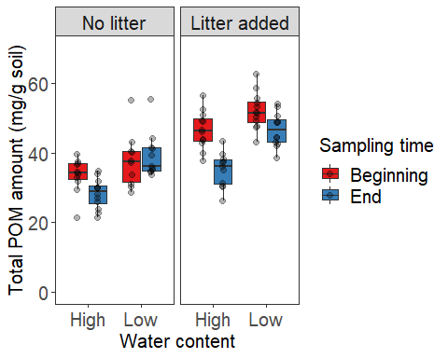

## Df Sum Sq Mean Sq F value Pr(>F)   
## sampling_point 1 708 707.6 11.822 0.0009 ***  
## water_content 1 1618 1618.5 27.040 1.31e-06 ***  
## sampling_point:water_content 1 228 228.1 3.811 0.0541 .   
## Residuals 87 5207 59.9   
## ---  
## Signif. codes: 0 '***' 0.001 '**' 0.01 '*' 0.05 '.' 0.1 ' ' 1  
## 2 observations deleted due to missingness

## Df Sum Sq Mean Sq F value Pr(>F)   
## water_content 1 307.9 307.9 8.972 0.00463 **   
## litter 1 2104.2 2104.2 61.311 1.14e-09 ***  
## water_content:litter 1 4.6 4.6 0.133 0.71698   
## Residuals 41 1407.1 34.3   
## ---  
## Signif. codes: 0 '***' 0.001 '**' 0.01 '*' 0.05 '.' 0.1 ' ' 1  
## 2 observations deleted due to missingness

## Df Sum Sq Mean Sq F value Pr(>F)   
## water_content 1 1538.7 1538.7 57.975 1.95e-09 ***  
## litter 1 575.5 575.5 21.682 3.22e-05 ***  
## water_content:litter 1 1.4 1.4 0.053 0.819   
## Residuals 42 1114.7 26.5   
## ---  
## Signif. codes: 0 '***' 0.001 '**' 0.01 '*' 0.05 '.' 0.1 ' ' 1

## Tukey multiple comparisons of means  
## 95% family-wise confidence level  
##   
## Fit: aov(formula = total_POM ~ sampling_point * water_content, data = filter(df, sampling_point != "initial" & litter != "No Litter"))  
##   
## $sampling_point  
## diff lwr upr p adj  
## End-Beginning -5.57747 -8.801655 -2.353284 0.0009003  
##   
## $water_content  
## diff lwr upr p adj  
## Low-High 8.434605 5.210419 11.65879 1.3e-06  
##   
## $`sampling_point:water_content`  
## diff lwr upr p adj  
## End:High-Beginning:High -8.802675 -14.7785944 -2.826755 0.0012313  
## Beginning:Low-Beginning:High 5.233001 -0.8104459 11.276447 0.1135642  
## End:Low-Beginning:High 2.764447 -3.2114730 8.740367 0.6211317  
## Beginning:Low-End:High 14.035675 7.9922287 20.079122 0.0000002  
## End:Low-End:High 11.567121 5.5912016 17.543041 0.0000131  
## End:Low-Beginning:Low -2.468554 -8.5120003 3.574893 0.7086643

## Tukey multiple comparisons of means  
## 95% family-wise confidence level  
##   
## Fit: aov(formula = total_POM ~ water_content * litter, data = df_end)  
##   
## $water_content  
## diff lwr upr p adj  
## Low-High 11.56712 8.501317 14.63293 0  
##   
## $litter  
## diff lwr upr p adj  
## Litter added-No litter 7.067192 4.001387 10.133 3.27e-05  
##   
## $`water_content:litter`  
## diff lwr upr p adj  
## Low:No litter-High:No litter 10.908949 5.1565577 16.661339 0.0000484  
## High:Litter added-High:No litter 6.730255 0.9778638 12.482646 0.0161557  
## Low:Litter added-High:No litter 18.339847 12.7138975 23.965796 0.0000000  
## High:Litter added-Low:No litter -4.178694 -10.0548062 1.697418 0.2426188  
## Low:Litter added-Low:No litter 7.430898 1.6785073 13.183289 0.0066996  
## Low:Litter added-High:Litter added 11.609592 5.8572012 17.361983 0.0000168

## Tukey multiple comparisons of means  
## 95% family-wise confidence level  
##   
## Fit: aov(formula = total_POM ~ water_content * litter, data = df_beg)  
##   
## $water_content  
## diff lwr upr p adj  
## Low-High 5.233001 1.70476 8.761241 0.0046344  
##   
## $litter  
## diff lwr upr p adj  
## Litter added-No litter 13.70289 10.16766 17.23812 0  
##   
## $`water_content:litter`  
## diff lwr upr p adj  
## Low:No litter-High:No litter 4.225168 -2.6287155 11.07905 0.3624866  
## High:Litter added-High:No litter 13.087552 6.5396767 19.63543 0.0000208  
## Low:Litter added-High:No litter 18.591389 12.0435136 25.13926 0.0000000  
## High:Litter added-Low:No litter 8.862383 2.1458659 15.57890 0.0054846  
## Low:Litter added-Low:No litter 14.366220 7.6497028 21.08274 0.0000062  
## Low:Litter added-High:Litter added 5.503837 -0.9001113 11.90779 0.1143847

Total POM (fPOM+oPOM) decrease in amount from beginning to end at high water content, but remain the same at low water content (although changes in each pool). This fits the delta 13C values and indicates POM is sensitive to decomposition at higher water contents. This does not mean C loss, it could mean relative stabilization after microbial processing.

## Warning: Removed 4 rows containing missing values (geom_point).

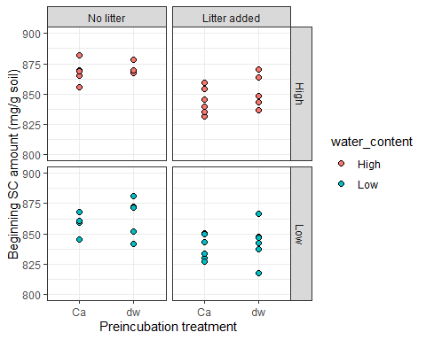

## Warning: Removed 2 rows containing missing values (geom_point).

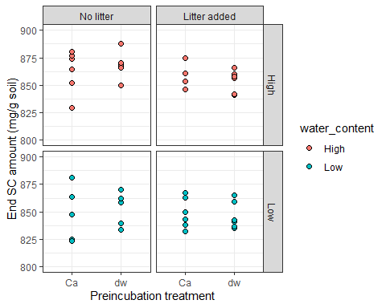

## Warning: Removed 6 rows containing missing values (geom_point).

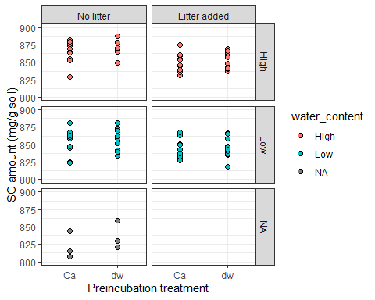

## Warning: Removed 6 rows containing non-finite values (stat_boxplot).

## Warning: Removed 6 rows containing missing values (geom_point).

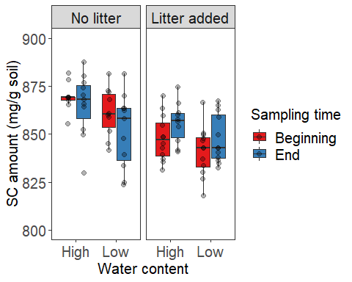

## Warning: Removed 1 rows containing non-finite values (stat_boxplot).

## Warning: Removed 1 rows containing missing values (geom_point).

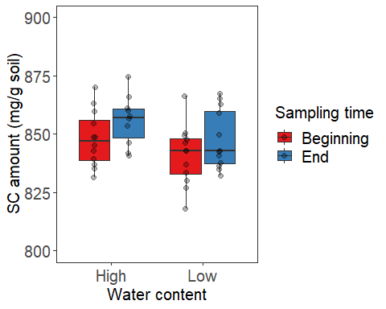

## Df Sum Sq Mean Sq F value Pr(>F)  
## water_content 1 7 6.6 0.004 0.951  
## sampling_point 1 79 79.0 0.045 0.832  
## water_content:sampling_point 1 673 673.3 0.387 0.536  
## Residuals 88 153218 1741.1   
## 1 observation deleted due to missingness

## Df Sum Sq Mean Sq F value Pr(>F)  
## water_content 1 407 406.7 0.416 0.523  
## litter 1 1578 1577.9 1.613 0.211  
## water_content:litter 1 2112 2112.2 2.159 0.149  
## Residuals 42 41094 978.4   
## 1 observation deleted due to missingness

## Df Sum Sq Mean Sq F value Pr(>F)  
## water_content 1 273 273.3 0.110 0.741  
## litter 1 1591 1591.4 0.643 0.427  
## water_content:litter 1 2845 2845.5 1.149 0.290  
## Residuals 42 103998 2476.1

## Tukey multiple comparisons of means  
## 95% family-wise confidence level  
##   
## Fit: aov(formula = SC_dry_mg_g ~ water_content * sampling_point, data = filter(df, sampling_point != "initial"))  
##   
## $water_content  
## diff lwr upr p adj  
## Low-High 0.5359547 -16.7547 17.82661 0.9510214  
##   
## $sampling_point  
## diff lwr upr p adj  
## End-Beginning 1.853826 -15.43683 19.14448 0.8317666  
##   
## $`water_content:sampling_point`  
## diff lwr upr p adj  
## Low:Beginning-High:Beginning 5.946525 -26.27670 38.16975 0.9626176  
## High:End-High:Beginning 7.264397 -24.95883 39.48762 0.9347420  
## Low:End-High:Beginning 2.389781 -29.83344 34.61300 0.9973847  
## High:End-Low:Beginning 1.317871 -30.90535 33.54109 0.9995569  
## Low:End-Low:Beginning -3.556745 -35.77997 28.66648 0.9915292  
## Low:End-High:End -4.874616 -37.09784 27.34861 0.9787985

## Tukey multiple comparisons of means  
## 95% family-wise confidence level  
##   
## Fit: aov(formula = SC_dry_mg_g ~ water_content * litter, data = df_end)  
##   
## $water_content  
## diff lwr upr p adj  
## Low-High -4.874616 -34.48724 24.738 0.741389  
##   
## $litter  
## diff lwr upr p adj  
## Litter added-No litter 11.75249 -17.86013 41.36511 0.427683  
##   
## $`water_content:litter`  
## diff lwr upr p adj  
## Low:No litter-High:No litter 10.358335 -45.20404 65.92071 0.9589227  
## High:Litter added-High:No litter 27.519642 -28.04273 83.08202 0.5526235  
## Low:Litter added-High:No litter 6.388183 -47.95289 60.72926 0.9890737  
## High:Litter added-Low:No litter 17.161307 -39.59609 73.91871 0.8499357  
## Low:Litter added-Low:No litter -3.970152 -59.53253 51.59222 0.9974846  
## Low:Litter added-High:Litter added -21.131458 -76.69383 34.43092 0.7402742

## Tukey multiple comparisons of means  
## 95% family-wise confidence level  
##   
## Fit: aov(formula = SC_dry_mg_g ~ water_content * litter, data = df_beg)  
##   
## $water_content  
## diff lwr upr p adj  
## Low-High 5.946525 -12.66807 24.56112 0.5226365  
##   
## $litter  
## diff lwr upr p adj  
## Litter added-No litter -11.72475 -30.35697 6.907467 0.2111025  
##   
## $`water_content:litter`  
## diff lwr upr p adj  
## Low:No litter-High:No litter 20.101516 -15.57639 55.779422 0.4424105  
## High:Litter added-High:No litter 1.840448 -33.08626 36.767156 0.9989844  
## Low:Litter added-High:No litter -5.188435 -40.11514 29.738273 0.9784619  
## High:Litter added-Low:No litter -18.261068 -53.18778 16.665640 0.5072766  
## Low:Litter added-Low:No litter -25.289951 -60.21666 9.636757 0.2284973  
## Low:Litter added-High:Litter added -7.028883 -41.18788 27.130112 0.9459215

