# Team

|  |
| --- |
| Felix The Cat |

* [DIMITAR_GOSHEV](http://telerikacademy.com/Users/DIMITAR_GOSHEV)
* [iliyan.tanev](http://telerikacademy.com/Users/iliyan.tanev)
* [rosenm](http://telerikacademy.com/Users/rosenm)
* [silvia.ghristova](http://telerikacademy.com/Users/silvia.ghristova)
* [vic.alexiev](http://telerikacademy.com/Users/vic.alexiev)

## Project purpose

Our project is a console implementation of the Pac-Man game. The purpose is to demonstrate the use of OOP concepts in game development, its advantages in terms of code reuse, improved maintainability, extensibility.

Figure 1 shows the class diagram.

ConsoleManager is the class which renders the objects to the console and controls the program logic. It contains a Pacman object and an an array of four Ghost objects. Both Pacman and Ghost inherit from the Actor abstract class. Each Actor object has coordinates which are kept in the Location struct. Pacman’s score is kept in a Score struct.

The Ghost class implements the IAutomotive interface via the Move() method. Each Ghost object contains its own moving strategy – an IMovingStrategy object which is used to calculate the route of the ghost. Different algorithms can be used here.

ConsoleManager has an IInputDevice field. The current implementation of the game uses the keyboard for user input (the arrow keys). Therefore a Keyboard class has been created which is used to raise the KeyPress events from the keyboard.

The whole maze is a two-dimensional array of MazeObject items. Each MazeObject has a type – Brick, EmptyCell, Pellet, PenDoor, PowerPellet. Each pellet adds points to Pac-Man’s score. The power pellets ensure extra lives so that Pac-Man can survive if a collision with a ghost occurs.

The PacmanException class is used to signal for errors in JustPacman project classes.

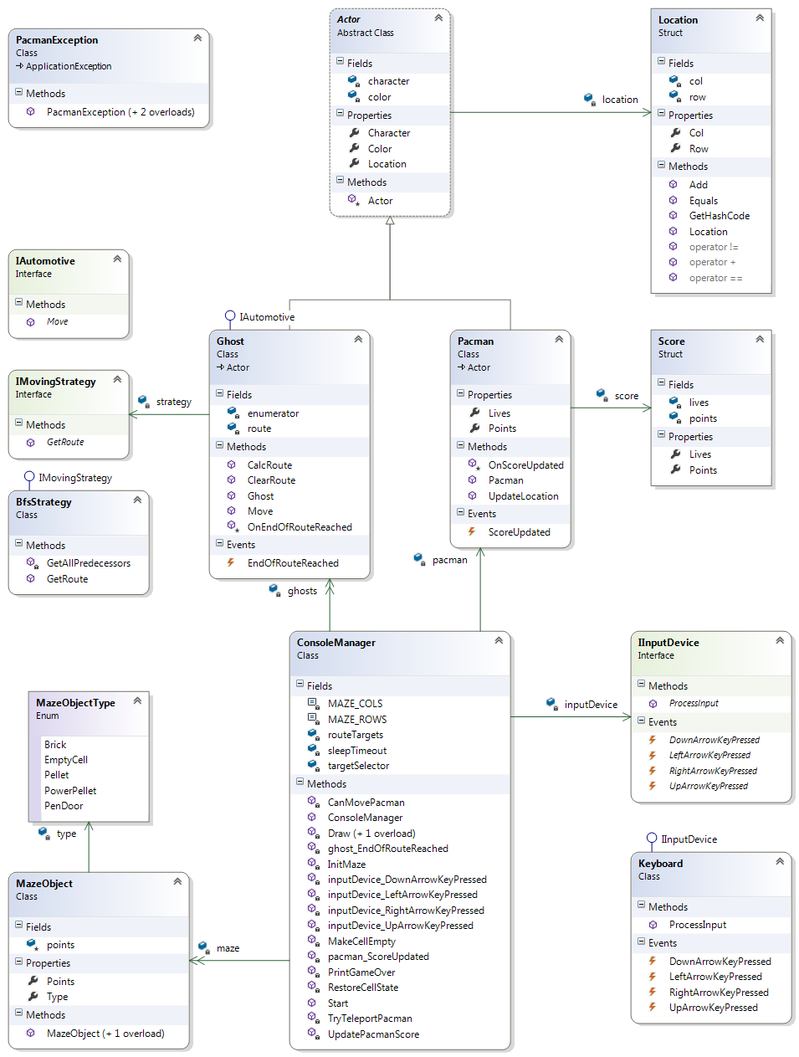

Figure 1 JustPacman Class Diagram

|  |  |  |  |  |  |  |  |  |  |  |  |  |  |  |  |  |  |  |  |  |  |  |  |  |  |  |  |  |  |  |  |  |  |  |  |  |  |  |  |
| --- | --- | --- | --- | --- | --- | --- | --- | --- | --- | --- | --- | --- | --- | --- | --- | --- | --- | --- | --- | --- | --- | --- | --- | --- | --- | --- | --- | --- | --- | --- | --- | --- | --- | --- | --- | --- | --- | --- | --- |
|  |  |  |  |  |  |  |  |  |  |  |  |  |  |  |  |  |  |  |  |  |  |  |  |  |  |  |  |  |  |  |  |  |  |  |  |  |  |  |  |
|  |  |  |  |  |  |  |  |  |  |  |  |  |  |  |  |  |  |  |  |  |  |  |  |  |  |  |  |  |  |  |  |  |  |  |  |  |  |  |  |
|  |  |  |  |  |  |  |  |  |  |  |  |  |  |  |  |  |  |  |  |  |  |  |  |  |  |  |  |  |  |  |  |  |  |  |  |  |  |  |  |
|  |  |  |  |  |  |  |  |  |  |  |  |  |  |  |  |  |  |  |  |  |  |  |  |  |  |  |  |  |  |  |  |  |  |  |  |  |  |  |  |
|  |  |  |  |  |  |  |  |  |  |  |  |  |  |  |  |  |  |  |  |  |  |  |  |  |  |  |  |  |  |  |  |  |  |  |  |  |  |  |  |
|  |  |  |  |  |  |  |  |  |  |  |  |  |  |  |  |  |  |  |  |  |  |  |  |  |  |  |  |  |  |  |  |  |  |  |  |  |  |  |  |
|  |  |  |  |  |  |  |  |  |  |  |  |  |  |  |  |  |  |  |  |  |  |  |  |  |  |  |  |  |  |  |  |  |  |  |  |  |  |  |  |
|  |  |  |  |  |  |  |  |  |  |  |  |  |  |  |  |  |  |  |  |  |  |  |  |  |  |  |  |  |  |  |  |  |  |  |  |  |  |  |  |
|  |  |  |  |  |  |  |  |  |  |  |  |  |  |  |  |  |  |  |  |  |  |  |  |  |  |  |  |  |  |  |  |  |  |  |  |  |  |  |  |
|  |  |  |  |  |  |  |  |  |  |  |  |  |  |  |  |  |  |  |  |  |  |  |  |  |  |  |  |  |  |  |  |  |  |  |  |  |  |  |  |
|  |  |  |  |  |  |  |  |  |  |  |  |  |  |  |  |  |  |  |  |  |  |  |  |  |  |  |  |  |  |  |  |  |  |  |  |  |  |  |  |
|  |  |  |  |  |  |  |  |  |  |  |  |  |  |  |  |  |  |  |  |  |  |  |  |  |  |  |  |  |  |  |  |  |  |  |  |  |  |  |  |
|  |  |  |  |  |  |  |  |  |  |  |  |  |  |  |  |  |  |  |  |  |  |  |  |  |  |  |  |  |  |  |  |  |  |  |  |  |  |  |  |
|  |  |  |  |  |  |  |  |  |  |  |  |  |  |  |  |  |  |  |  |  |  |  |  |  |  |  |  |  |  |  |  |  |  |  |  |  |  |  |  |
|  |  |  |  |  |  |  |  |  |  |  |  |  |  |  |  |  |  |  |  |  |  |  |  |  |  |  |  |  |  |  |  |  |  |  |  |  |  |  |  |
|  |  |  |  |  |  |  |  |  |  |  |  |  |  |  |  |  |  |  |  |  |  |  |  |  |  |  |  |  |  |  |  |  |  |  |  |  |  |  |  |
|  |  |  |  |  |  |  |  |  |  |  |  |  |  |  |  |  |  |  |  |  |  |  |  |  |  |  |  |  |  |  |  |  |  |  |  |  |  |  |  |
|  |  |  |  |  |  |  |  |  |  |  |  |  |  |  |  |  |  |  |  |  |  |  |  |  |  |  |  |  |  |  |  |  |  |  |  |  |  |  |  |
|  |  |  |  |  |  |  |  |  |  |  |  |  |  |  |  |  |  |  |  |  |  |  |  |  |  |  |  |  |  |  |  |  |  |  |  |  |  |  |  |
|  |  |  |  |  |  |  |  |  |  |  |  |  |  |  |  |  |  |  |  |  |  |  |  |  |  |  |  |  |  |  |  |  |  |  |  |  |  |  |  |
|  |  |  |  |  |  |  |  |  |  |  |  |  |  |  |  |  |  |  |  |  |  |  |  |  |  |  |  |  |  |  |  |  |  |  |  |  |  |  |  |
|  |  |  |  |  |  |  |  |  |  |  |  |  |  |  |  |  |  |  |  |  |  |  |  |  |  |  |  |  |  |  |  |  |  |  |  |  |  |  |  |
|  |  |  |  |  |  |  |  |  |  |  |  |  |  |  |  |  |  |  |  |  |  |  |  |  |  |  |  |  |  |  |  |  |  |  |  |  |  |  |  |

Figure 2 JustPacman matrix

## Project URL

<https://vic-alexiev.visualstudio.com/DefaultCollection/JustPacMan>

## References

1. <http://en.wikipedia.org/wiki/Pacman>

(Wikipedia’s article about Pac-Man)

1. <http://www.youtube.com/watch?v=cVH1mCc5EvU>

(Ms. Pacman demonstration)

1. <http://home.comcast.net/~jpittman2/pacman/pacmandossier.html>

(The Pac-Man Dossier by Jamey Pittman)