Cucumber structure

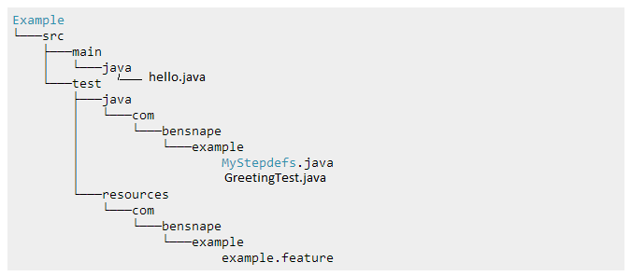

Step1. Create feature description

Step2. Create GreetingTest.java

Step3. Run GreetingTest.java

Step4. Get return in console like this

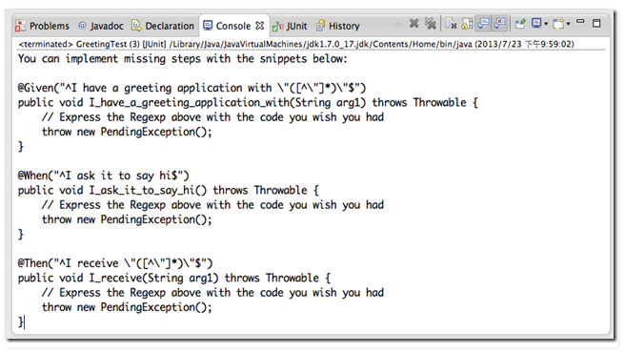

Step5. Copy paste to HelloStepdefs.java

Step6. Remove exceptions and fill out detailed code

Step 7. Run GreetingTest.java and fixed Hello.java and HelloStepdefs.java until pass