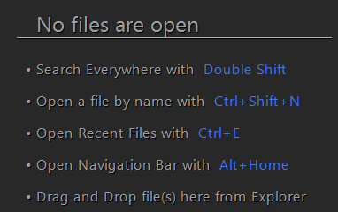

* Press **Ctrl+Alt+O**

Remove unnecessary import

**Ctrl+Alt+L**

**Format code**