Name : Bhavesh Padharia

Assignment: Scala Coding Assignment-1

1. Write a program to calculate student grade based on below rules:

A. 90 to 100 -> Grade A

B. 80 to 90 -> Grade B

C. 70 to 80 -> Grade C

D. Failure.

Code:

object student_grade {  
 def main(arg:Array[String]): Unit = {  
 *calculate_grade*(95)  
 }  
 def calculate_grade(percentage:Int): Unit = {  
 if(percentage > 90 && percentage <= 100){  
  
 *println*("Grade A")  
 }  
 else if(percentage > 80 && percentage <= 90){  
  
 *println*("Grade B")  
 }  
 else if(percentage > 70 && percentage <= 80){  
  
 *println*("Grade C")  
 }  
 else{  
 *println*("Failure")  
 }  
 }  
  
}

Output:

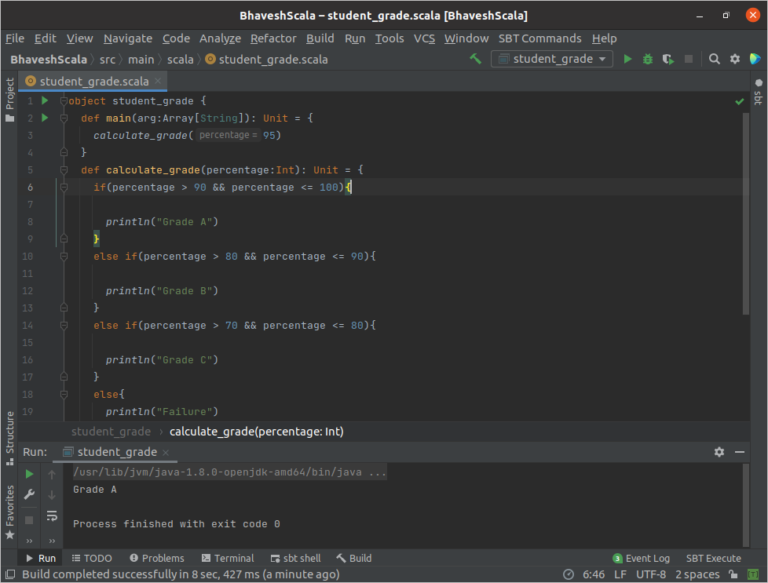

2. Write a Program to calculate maximum % scored student report from below data.

{id:101,name:raj,cmarks:45,pmarks:55,mmarks:67}

{id:102,name:rajesh,cmarks:65,pmarks:85,mmarks:77}

{id:103,name:suraj,cmarks:43,pmarks:55,mmarks:60}

{id:104,name:tom,cmarks:71,pmarks:65,mmarks:70}

Code:

class maximum_marks(id:Int, name:String, cmarks:Int, pmarks:Int, mmarks:Int){  
  
 def print_marks(): Unit = {  
  
 var sum: Int = 0  
 var average: Int = 0  
 sum = cmarks+pmarks+mmarks  
 average = sum / 3  
 *println*("My ID is: "+ this.id+" My name is: " +this.name+" The maximum % scored mark is: "+ average + "%")  
 }  
}  
object student_report {  
  
 def main(Args:Array[String]): Unit = {  
 var studentmark = new maximum_marks(101,"raj",45,55,67)  
 studentmark.print_marks()  
  
 var studentmark1 = new maximum_marks(102,"rajesh",65,85,77)  
 studentmark1.print_marks()  
  
 var studentmark2 = new maximum_marks(103,"suraj",43,55,60)  
 studentmark2.print_marks()  
  
 var studentmark3 = new maximum_marks(104,"tom",71,65,70)  
 studentmark3.print_marks()  
 }  
  
  
}

Output:

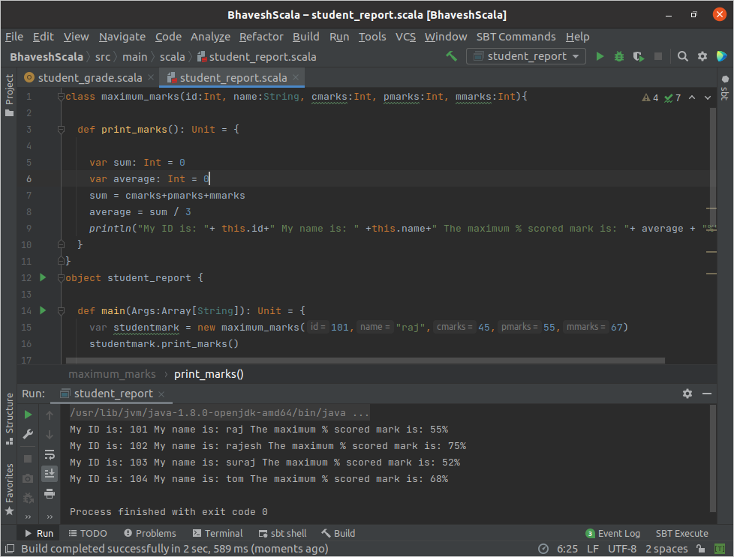

3. Write a program to perform sorting of below data based on id and name(create class, object and a method for sorting in util class)

{id:101,name:raj}

{id:121,name:rajesh}

{id:130,name:suraj}

{id:114,name:tom}

Code: