Name: Bhavesh Padharia

Spark Task-1

1. Count the number of black cards in deckofcards.txt

Step1: Load the deckofcards.txt file in spark

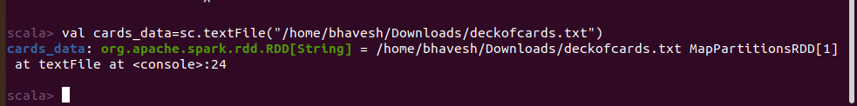

Step 2: Check data using collect()

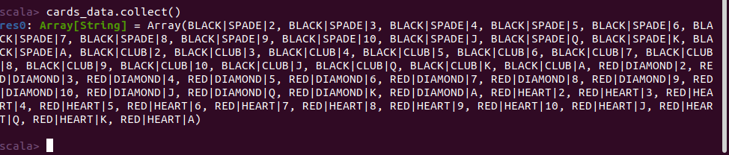

Step 3: Count number of rows of deckofcards datasets



Step 4: Filter out black cards only



Step 5: Count black cards from declofcards datasets



2. Count the number of Black and number of Queen cards in deckofcards.txt datasets

Step 1: Filter black Queen cards in deckofcards datasets

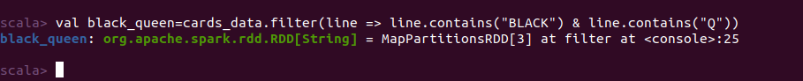

Step 2: Verify the Black Queen data

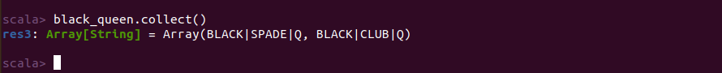

Step 3: Check number of black queen



Step 4: Count number of black queen

