HDFS TASK-1

1)create one dir:

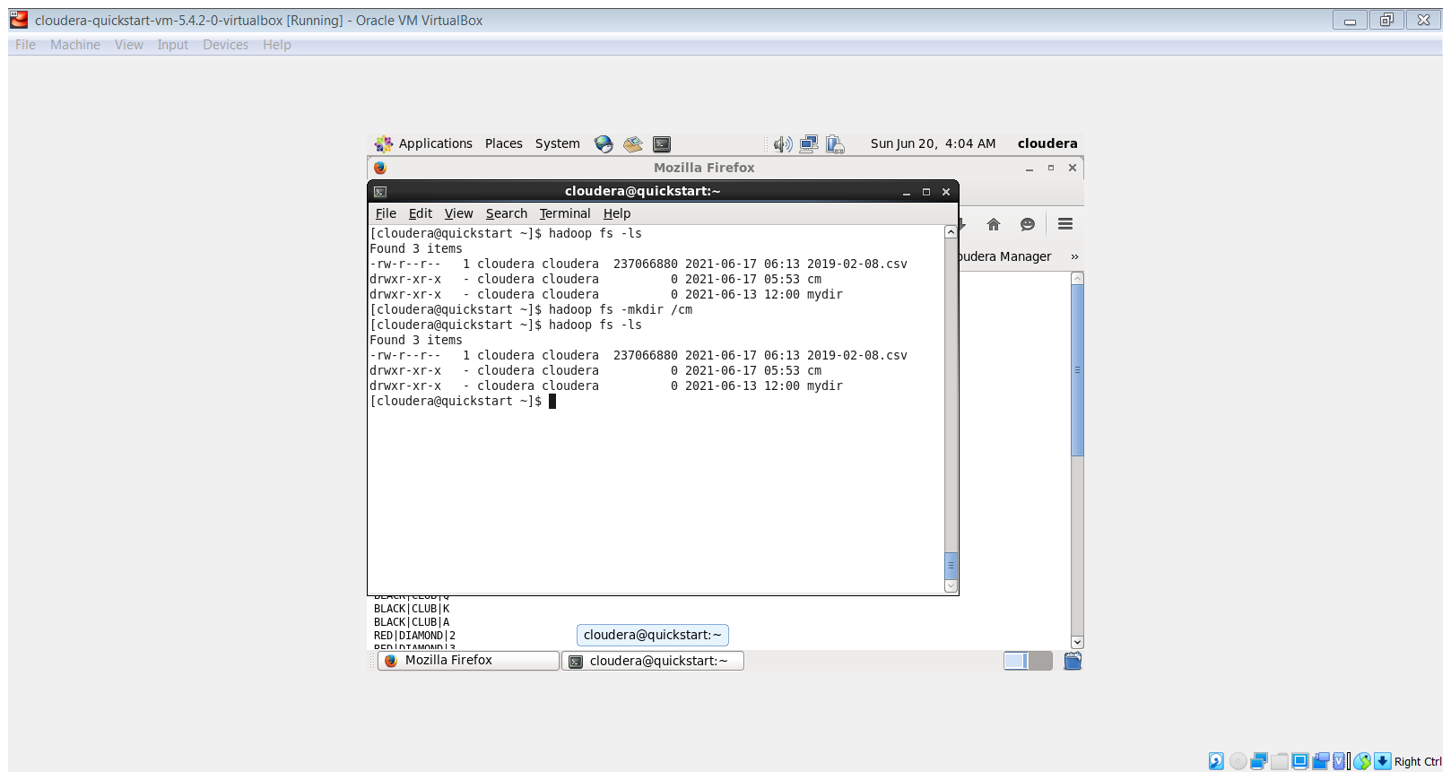

2)upload Github repo sampledata/deckofcards:

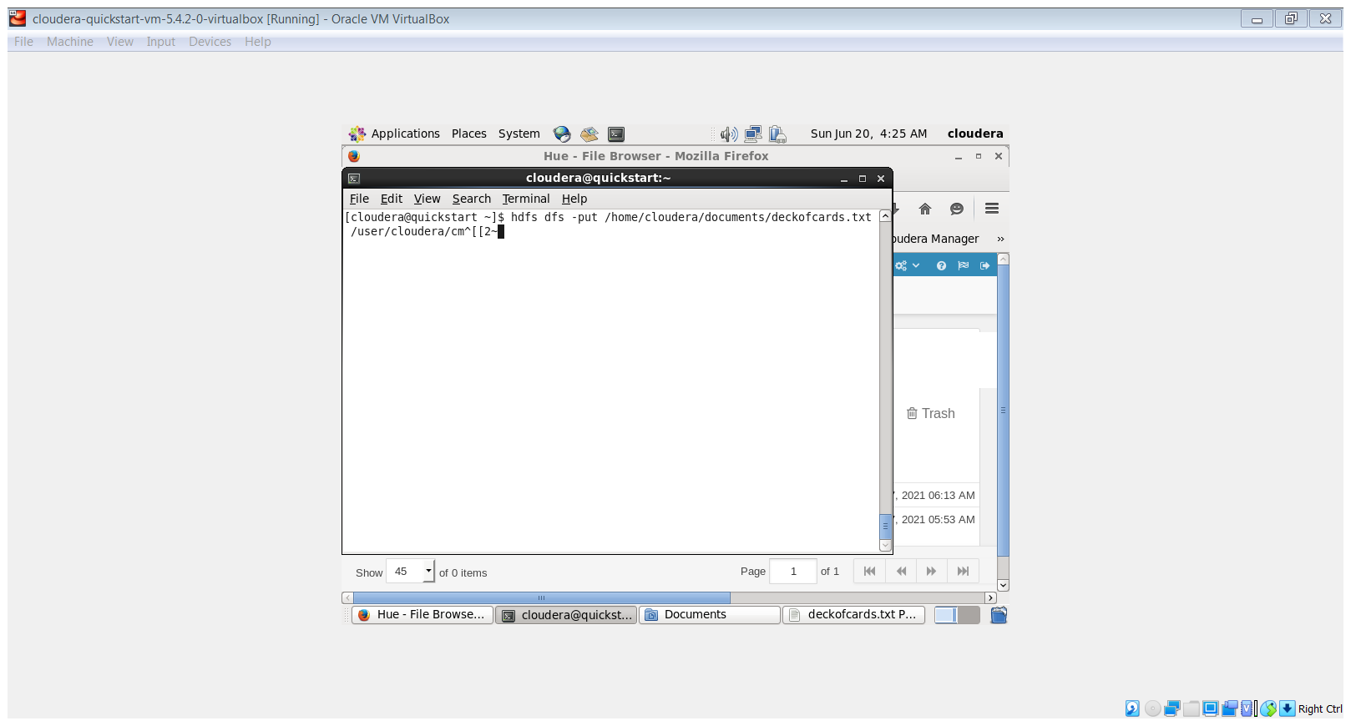

3) count the head 25 :

