
Workflow Process of Machine Shop
1.Workflow Chart – Primary Machine Shop
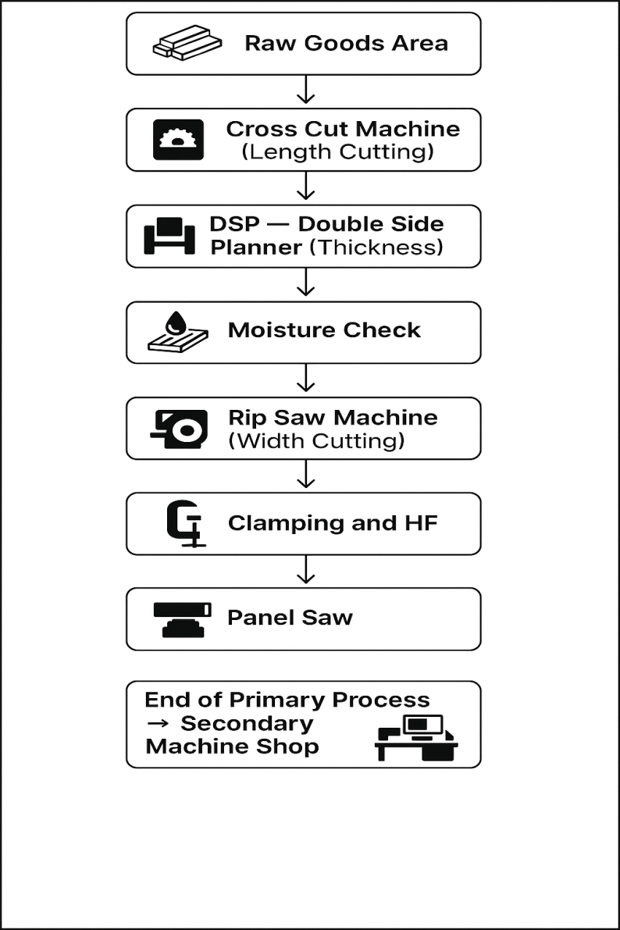

Primary Machine Shop – Workflow Steps
- Receive Wood from Raw Goods Area
  - Any wood issued from the wood store must be placed in the Raw Goods Area.
- Length Cutting – Cross Cut Machine
  - Cut planks to the required length as per the cutting list.
- Thickness Planning – DSP (Double Side Planner)
  - Process planks to achieve the required thickness.
- Moisture Check
  - Check moisture content of each plank and ensure it meets acceptable limits.
- Width Cutting – Rip Saw Machine
  - Cut planks to the required width as per the cutting list.
- Move to WIP Area
  - After rip saw cutting, planks must be moved to the WIP (Work-in-Progress) Area of the Primary Machine Shop.
- Send to Clamping / HF Press
  - If planks are combined to form wider panels, send them to Clamping or HF Press as applicable.
- Power Max Processing
  - All planks, which are wider in size, will move to the Power Max Machine for final thickness and sanding.
- Panel Saw Cutting
  - After Power Max processing, planks will move to the Panel Saw for final size cutting.

Secondary Machine Shop – Workflow Steps

Process as per Cutting List
- After Panel Saw cutting, planks/components will move to the applicable machine as per the cutting list requirements.
  - Moulder – Used to create decorative or functional profiles on edges and surfaces.
  - Router – Used for shaping, detailing, grooving, or making complex design cuts.
  - Tenon Machine – Used to create tenons for strong wood joints.
  - Mortiser – Used to create mortises (slots/holes) for joint assembly.
  - Grooving Machine – Used to cut straight grooves or channels in the wood.
  - Spindle Moulder – Used for curved profiling and shaping operations.
  - Edge Bander – Used to apply edge finish to panels.
  - Wide Belt Sander – Used to achieve smooth, uniform surfaces on wood panels by sanding with precision, ensuring accurate thickness and fine finishing.

