BEN-GURION UNIVERSITY OF THE NEGEV
FACULTY OF ENGINEERING SCIENCES
DEPARTMENT OF INDUSTRIAL ENGINEERING AND MANAGEMENT

Integrated Analysis and Optimization of Existing and Projected National Environmental Footprints System

THESIS SUBMITTED IN PARTIAL FULFILLMENT OF THE REQUIREMENTS FOR THE M.Sc DEGREE

By: Dor Chen

Supervised by: Prof. Raziel Riemer and Prof. Meidad Kissinger

September 2025

BEN-GURION UNIVERSITY OF THE NEGEV
FACULTY OF ENGINEERING SCIENCES
DEPARTMENT OF INDUSTRIAL ENGINEERING AND MANAGEMENT

Integrated Analysis and Optimization of Existing and Projected National Environmental Footprints System

THESIS SUBMITTED IN PARTIAL FULFILLMENT OF THE REQUIREMENTS FOR THE M.Sc DEGREE

By: Dor Chen

Supervised by: Prof. Raziel Riemer and Prof. Meidad Kissinger


Author: Dor Chen Date: 29.09.2025

Supervisor: Prof. Raziel Riemer Date: 29.09.2025
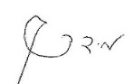
Supervisor: Prof. Meidad Kissinger Date: 29.09.2025

Chairman of Graduate Studies Committee: Prof. Gilad Ravid Date: 30.09.2025

September 2025

שינוי קצבי התקנה בהתאם למגמה עולמית
הוספת גרף שינוי מחיר כללי בהתאם לאחוזי מתחדשות
שטח לעלות ב10%

Abstract
Climate change mitigation requires rapid decarbonization of national power systems, yet the available pathways are strongly conditioned by economic, spatial and environmental constraints. Israel provides a critical case study, combining rapid demographic growth with ambitious climate targets and severe land limitations. Building on a general sustainability framework, this thesis develops an optimization-based electricity system model with hourly resolution (about 245,000 time steps, 2023–2050). The problem is formulated as a large-scale linear program that minimizes cumulative life-cycle greenhouse gas emissions subject to a cumulative budget—including a carbon cost of 200 NIS/tCO₂e—a cap on land available for solar deployment, annual build-rate limits, a reserve-margin requirement and hourly storage dynamics. A grid of 99 scenarios, combining nine budget levels (₪400–480×10⁹) and eleven land caps (100–850 km²), is analysed with and without the option of 3 GW of nuclear capacity.
The results show that land availability and the budget play distinct roles. Land determines the end state of the system: the renewable share in 2050 rises from about 50% at 400 km² to about 92% at 850 km², whereas additional budget beyond ₪410×10⁹ changes it by only a few percentage points. The budget determines the timing of the transition: at low budgets, an additional ₪20×10⁹ enables earlier deployment of solar PV and storage and reduces cumulative emissions by about 25%, while above about ₪450×10⁹ further budget has no effect. Once the land cap is reached, growing demand is met by gas and emissions rise again, indicating that land allocation must keep pace with demand.
For a fixed budget, increasing the renewable share from 50% to 91% leaves the direct cost of generation practically unchanged (0.273–0.276 NIS/kWh), whereas the fossil-dominated system is the most expensive in 2050 despite being cheaper in the early years. When the carbon cost is included, the social cost declines monotonically to about 0.290 NIS/kWh at 91% renewables. In all scenarios, about 32 GW of gas capacity is retained for reliability. Adding 3 GW of nuclear capacity reduces cumulative emissions by 36–184 MtCO₂e, with the largest benefit when land is scarce, indicating that firm low-carbon capacity acts as a partial substitute for land.
The contributions of this thesis are threefold. Methodologically, it demonstrates how optimization-based electricity models can extend footprint-oriented sustainability frameworks into decision-support tools. Empirically, it provides system-level insights into Israel’s electricity transition under interacting land, budget and reliability constraints. Analytically, it distinguishes the roles of land, budget and firm capacity in shaping the level and the timing of decarbonization. The findings indicate that deep decarbonization of the Israeli electricity sector is achievable at a similar direct cost, but depends on strategic land allocation, early investment and the planning of firm capacity. As a densely populated, land-constrained country with rapid demand growth, Israel provides a relevant prototype for deep decarbonization under spatial scarcity.
Keywords: Energy transition, Electricity sector, Linear optimization, Renewable integration, Land constraint, Battery storage, Nuclear energy, Carbon cost, Emissions accounting

Acknowledgments
I wish to express my deepest gratitude to my two advisors.
To Professor Raziel Riemer, thank you for your invaluable guidance, your patience, and your unwavering support throughout these years of work. In challenging times like these, I would not have managed without your steadfast belief in me. Your insights, your high standards, and your encouragement shaped both this thesis and me as an engineer. To Professor Meidad Kissinger, thank you for your expertise, your constructive feedback, and your perspective, which broadened my understanding of the field and strengthened this research.
To my lab friends and colleagues, thank you for the many hours we spent together thinking, laughing and sharing challenges together. Thank you for the countless moments of encouragement and friendship.
I would like also to thank the department members for their teaching, advice, and inspiration over the years, as well as the administrative staff for their dedication and efficiency, and the technical staff for their continuous support and problem-solving skills that helped keep everything moving forward.
To my parents, thanks for your endless love and for everything you have given me throughout the years, which provided me with the foundation and strength to continue this path. Above all, to my beloved wife Yael, thank you for your inspiration and for your unstoppable support during such complex years. To my two sweet children, Avigail and Nave, thank you for being my anchor and my greatest source of joy. Your smile, love, and presence gave meaning to every step of this journey. I hope that this work, in some small way, will help make your world better.

Table of Contents
Abstract 0
Table of Contents 3
1.Introduction 5
2.Method 8
2.1 The General Framework Model 8
2.2 Improvements – Simplified water model 10
2.3 Optimization model 12
2.4 Integration with External Models 20
3.Results 22
3.2 System feasibility space: land, budget and renewable penetration 24
3.3 Statistical relationships between key system indicators 26
3.4 Energy balance and demand coverage in 2050 28
3.5 Cost efficiency and system cost structure in 2050 – selected scenarios 29
3.6 Emissions in 2050 by source - selected scenarios 31
3.7 Installed capacities and infrastructure scale in 2050 – selected scenarios 33
3.8 Refined statistical relationships in the average system cost selected solution space 38
4.Discussion 39
4.1 Land and emissions as joint binding constraints 40
4.2 Economic efficiency and sensitivity to system constraints 41
4.3 Policy implications and system-level insights 44
4.4 Consistency with national-scale electricity planning studies 46
4.5 Limitations 47
4.6 Future research 49
5.Conclusions 50
6.References 52
Appendix 55

List of Figures
Figure 1 - Model scheme showing the inputs (left-hand side) and outputs from Cordova et al. (2024), 10
Figure 2- Water Scheme Model 12
Figure 3 - Integration of External Models with the General Framework 21
Figure 4 Generation mix, hourly resolution, winter week (January 2030) 22
Figure 5 - Generation mix, hourly resolution, summer week (June 2030) 23
Figure 6 Generation mix in hourly resolution 2030 55.6 RE% 24
Figure 7 - Feasible renewable penetration in 2050 as a function of system cost and solar land availability (3D mesh) 25
Figure 8 - Total emissions by source over all years, stacked, across all scenarios sorted by renewable share in 2050 26
Figure 9 - Pearson correlation matrix across all 101 modeled scenarios 27
Figure 10 Annual electricity demand coverage and generation mix in 2050 across all scenarios, 11.2% scenario is appliying currnet grid mix to 2050 28
Figure 11 - Average system cost in 2050 (NIS/kWh) for the selected scenarios 29
Figure 12 - Annual system cost in 2050 decomposed by source (OPEX + CAPEX + externalities) for the selected 31
Figure 13- Emissions in 2050 by generation source for the selected scenarios 32
Figure 14 - Total emissions in 2050 by source across all modeled scenarios sorted by renewable share 33
Figure 15 – Installed generation and storage capacities in 2050 across selected scenarios 34
Figure 16 - Battary Capacity 2050 4H model 35
Figure 17 - Battery energy level in winter 2050 36
Figure 18 - Battety energy level in winter 2050 36
Figure 19 - Installed capacity evolution across the planning horizon for a representative 90 RE% scenario 37
Figure 20 - Pearson correlation matrix across 13 selected scenarios 39
Figure 21 - Budget-only sensitivity of renewable share in 2050 (base scenario) 41
Figure 22 - Land-only sensitivity of renewable share in 2050 (base scenario) 42
Figure 23 - Joint budget and land sensitivity of renewable share in 2050 (base scenario) 43
Figure 24 - Average system cost in 2050 versus carbon intensity in 2050 for selected scenarios 45
Figure 25 - Correlation network 59

Introduction
Climate change is one of the defining challenges of the 21st century. The most recent Intergovernmental Panel on Climate Change (IPCC, 2023) assessment confirms that global mean surface temperatures have already risen by approximately 1.1°C above pre-industrial levels, primarily due to anthropogenic greenhouse gas emissions from fossil fuel combustion, land-use change, and industrial processes. Without rapid and far-reaching mitigation, the world is projected to overshoot the 1.5°C target enshrined in the Paris Agreement, with severe consequences for ecosystems, water resources, human health, and economic stability (Rockström et al., 2009; IPCC, 2023). Central to this challenge is the energy sector, the dominant source of global greenhouse gas emissions (IEA, 2022). Decarbonizing electricity systems is therefore both a global imperative and a prerequisite for economy-wide net-zero transitions.

To quantify environmental pressures and evaluate mitigation pathways, scholars have developed a range of footprint-based frameworks. The ecological footprint approach, pioneered by Wackernagel and Rees (1996), provided one of the earliest system-level metrics for assessing human demand relative to the planet’s biocapacity. Later work introduced specialized measures such as the carbon footprint (Wiedmann and Minx, 2008), water footprint (Hoekstra et al., 2011), and land footprint (Weinzettel et al., 2013). These indicators, typically grounded in life-cycle assessment (LCA) and material flow analysis (MFA), capture specific environmental dimensions and allow consistent accounting across scales. However, as the literature emphasizes, conventional footprint accounts have often been static and retrospective, and they may obscure displacements through trade, thus offering limited guidance for shaping future-oriented policy (Lenzen et al., 2007; Steen-Olsen et al., 2012).

To bridge this gap, recent research has increasingly embedded footprint analysis within scenario-based modeling and optimization frameworks. Scenario analysis enables exploration of alternative demographic, technological, and policy futures, while optimization provides a rigorous mathematical means to identify system configurations that minimize or balance impacts under constraints. Conceptually, the relationship between footprints and LCA has been clarified, providing a foundation for integrated modeling (Fang and Heijungs, 2015). Concrete applications increasingly combine footprint accounting with multi-objective optimization; for example, Li et al. (2020) applied an EF-based multi-objective optimization to assess cropland-use sustainability. In parallel, nexus studies synthesize cross-sector linkages among water, energy, and food systems and inform scenario design (Zhang et al., 2018). Mixed-Integer Linear Programming (MILP) has become a standard framework for designing least-cost or least-emission generation portfolios subject to operational and policy limits (Poncelet et al., 2016). At the same time, several large-scale long-term planning models adopt linear optimization formulations to balance temporal resolution, scenario breadth, and computational tractability (Deng & Lv, 2020). Methodological work has also emphasized transparency and reproducibility in energy-system optimization, advocating open data and open code practices alongside established frameworks such as MARKAL/TIMES (DeCarolis et al., 2020). This represents a paradigm shift: footprints are no longer treated solely as ex-post indicators, but also as active objectives and constraints within planning models.

Israel provides a compelling case for applying such approaches. The country faces rapid demographic growth, ambitious climate commitments, and severe land and water constraints. Population is projected to rise from 9.8 million in 2023 to more than 16 million by 2050 (CBS, 2019). At the same time, per-capita electricity demand is steadily increasing, while national policy targets a net-zero electricity sector by mid-century. Yet, as the Israel Electricity Authority’s Net Zero Outlook (NZO, 2021; 2023) emphasizes, the pathways to achieving these targets are fraught with trade-offs. Solar photovoltaics (PV) and battery storage are expected to dominate capacity expansion, but land availability is limited to about 850 km² (NZO Part B, 2021). In practice, this land envelope may include a combination of single-use and dual-use applications. However, in this study both categories are treated uniformly as a single land constraint to simplify the model structure and focus on system-level trade-offs. The NZO warns that under baseline assumptions, renewable penetration may be below official goals, unless structural measures such as nuclear deployment or demand-side interventions are implemented. These challenges underscore the need for optimization-based approaches that can reconcile emissions reduction, cost control, and land management in an integrated framework.
Beyond its specific national context, Israel serves as a structurally informative case for other land-constrained and densely populated countries seeking deep decarbonization. As renewable-dominated systems require substantial spatial allocation, countries with limited territory face sharper trade-offs between land use, infrastructure scale, and emissions reduction. Studying such a system therefore provides insight into structural constraints that may become increasingly relevant in densely populated regions.

A foundational contribution in this direction was made by Cordova (2023), who developed a comprehensive national-scale sustainability model for Israel. That framework integrated population growth, energy demand, food consumption, water use, and land occupation into a consistent footprint accounting system, producing projections across multiple scenarios. By disentangling the contributions of demographic growth, rising per-capita consumption, and mitigation measures, the model demonstrated that while technological and behavioral interventions (e.g., renewable deployment, dietary shifts, transport efficiency) can substantially reduce pressures, demographic expansion remains the dominant force driving future increases in land, water, and GHG footprints. A subsequent publication (Cordova et al., 2024) reinforced this conclusion, showing that even advanced technological pathways cannot deliver net-zero emissions by 2050 if demographic expansion is not addressed. Their analysis highlighted the critical need to incorporate demographic realities into energy and resource planning.

Building on this foundation, the present thesis advances the analysis by focusing on the electricity sector, Israel’s single largest source of greenhouse gas emissions, and by raising the temporal and technical resolution of the modeling. Specifically, it refines the general framework into an optimization-enabled tool, representing electricity generation, storage, and curtailment with hourly granularity (~245,000 hours over 2023–2050). This allows explicit treatment of variability in solar generation, the operation of storage, and the pace of capacity expansion through annual build-rate limits. By framing the problem as a large-scale linear program, the model endogenously determines capacity additions and generation mixes that minimize cumulative emissions subject to land, budget, build-rate and reliability constraints. In doing so, the framework evolves from scenario exploration to optimization-based decision support, directly informing policy debates on feasible pathways for Israel’s electricity transition.

From this motivation, the thesis addresses three guiding research questions:

- What is the effect of available land and budget on the feasible electricity mix in Israel when the system is optimized for minimum greenhouse gas emissions?

- What are the trade-offs between cost, emissions and renewable penetration when the system is optimized at hourly resolution?

- How do key modeling assumptions and structural constraints influence capacity expansion trajectories and renewable integration outcomes?

The contributions of this thesis are threefold. Methodologically, it extends existing sustainability frameworks by implementing an optimization with hourly granularity and time-varying emission factors. Empirically, it assesses the ability of Israel’s electricity sector to rely mostly on renewable energy, while quantifying the effects of the available budget and land area. By combining global perspectives with a detailed national case study, the thesis aims to generate insights of both scientific and policy relevance.

The remainder of this thesis is organized as follows. Chapter 2 presents the methodological foundations: first, the general framework model developed by Cordova; second, the improvements introduced here, particularly in the electricity module; third, the optimization model extending the framework to hourly resolution; and finally, its integration with external data sources (the ROTH model and the NZO datasets). Chapter 3 reports the results, including the hourly system behavior, the full scenario space, the representative scenarios and the nuclear variants. Chapter 4 provides the discussion, situating the findings within broader policy and academic contexts and addressing limitations and future research. Chapter 5 summarizes the main conclusions. References are listed in Chapter 6, and the Appendix provides supplementary material, including the model parameters and the numerical results underlying the main figures.

Method

2.1 The General Framework Model
The general model, as developed in Cordova’s thesis and in "Effects of demographic and technological trends on the mitigation of Israel’s environmental footprint" by Cordova et al. (2024), establishes a national-scale framework to evaluate Israel’s environmental footprint across multiple consumption sectors. The model was implemented in MATLAB, with baseline data collected and organized in Excel spreadsheets that serve as the input foundation for the simulations.

The model uses baseline data for the year 2017, including population size, energy generation by source, transportation mileage, food and water consumption, and construction activity. These baseline values combined with equations for trends enable projecting future demands and environmental impacts.
These trends are demographic growth, increased per-capita electricity use, changes in transportation mileage, and projected reliance on desalinated water. These trends are based on official national statistics data and international projections (Central Bureau of Statistics of Israel, Ministry of Energy, Water and Transportation, 2017).
To evaluate mitigation potential, the model defines a set of factors and scenarios. Factors represent technological or behavioral measures—such as expansion of renewable electricity, reduction in food waste, dietary shifts away from beef, and increased use of public transport. Scenarios are combinations of these factors, constructed to represent different levels of ambition: a no-policy baseline, a moderate pathway aligned with government targets, and an advanced pathway reflecting international climate goals.

Several modeling assumptions are embedded in this framework. For example, electricity generation is assumed to rely primarily on solar PV, with improvements in land-use efficiency until 2050; water demand grows with population, with desalination providing an increasing share; and dietary composition is assumed to remain stable except where explicitly altered by mitigation factors. Land, water, and GHG coefficients are derived from life-cycle assessment and material flow analysis and are applied consistently across all categories.

The model outputs are expressed as three environmental footprints: greenhouse gas emissions, land use, and water consumption. These outputs are calculated both on a domestic scale (impacts within Israel’s borders) and on a global scale (embodied impacts from imports such as food or fuel).

Finally, the General Framework model enables analysis of the effect of different factors. Using both single-factor and combined analyses, it disentangles the contribution of population growth, consumption increases, and mitigation measures. Results show that while technological and behavioral measures (renewables, food waste reduction, transportation efficiency) can substantially reduce emissions, demographic growth and rising per-capita demand remain dominant forces driving future increases in land, water, and GHG footprints.

While this general framework provides a comprehensive national-level perspective, it was designed mainly for scenario analysis and lacked certain flexibility for extension and integration. For example, some sub-models, particularly the water module, were based on simplified assumptions and could not fully capture the dynamics required for more detailed analysis. Accordingly, the present work builds upon this foundation by reconstructing the water module, refining specific assumptions, and introducing several improvements that enable further analysis. In addition, the model was adapted to allow integration with external data sources, including a direct API connection to the NZO platform for financial inputs, and was expanded with an optimization component aimed at minimizing emissions. 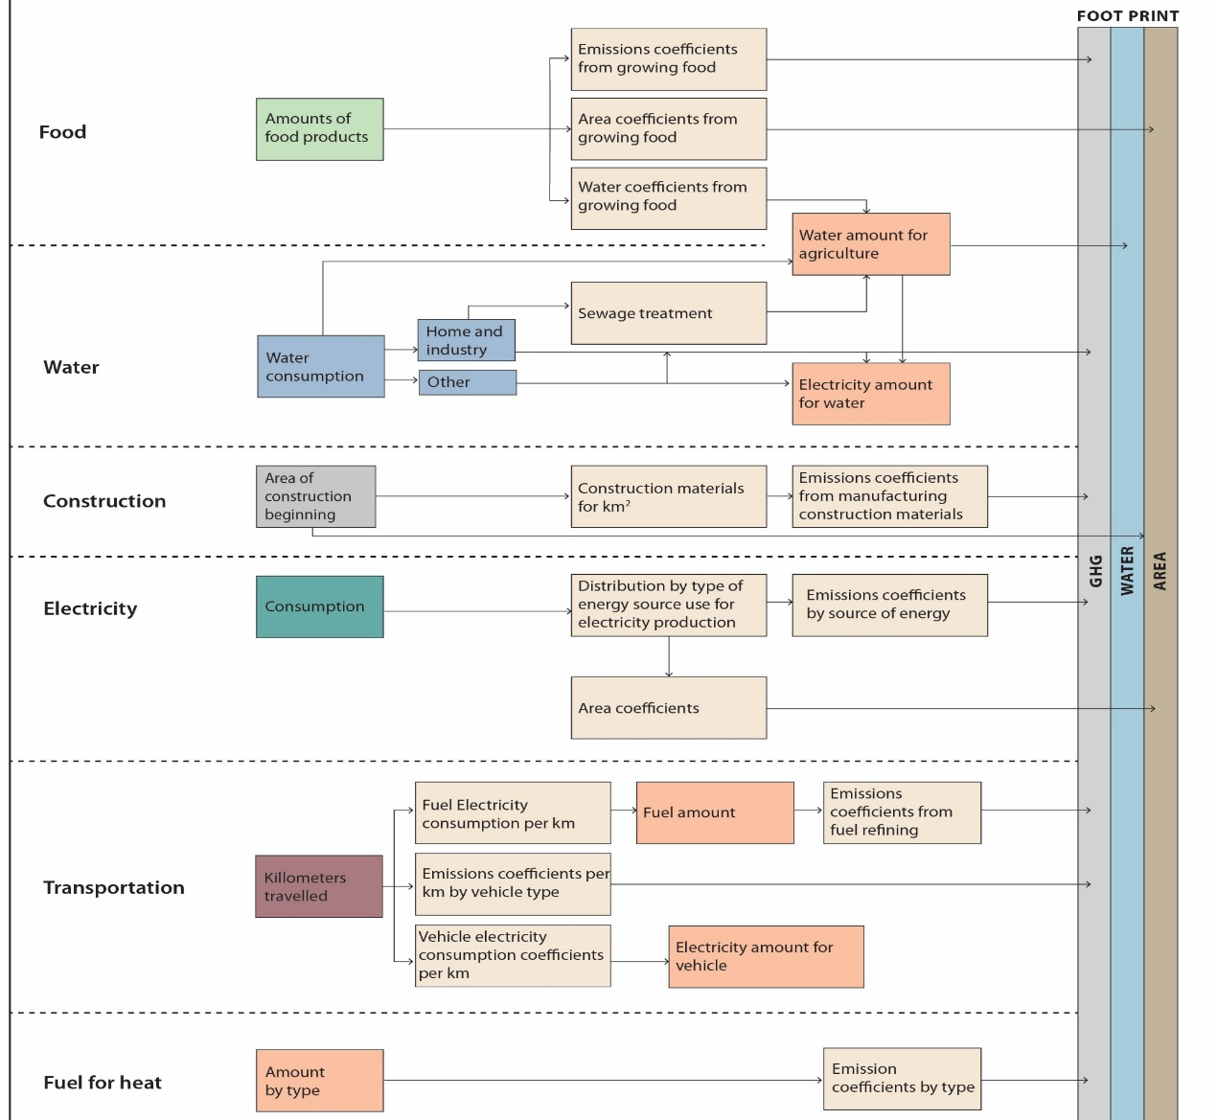
Figure 1 - Model scheme showing the inputs (left-hand side) and outputs from Cordova et al. (2024),

2.2 Improvements – Simplified water model
The water model for Israel was developed to provide a simplified yet comprehensive representation of the national water system, enabling projections of demand, supply, and related environmental impacts up to 2050. The model was implemented in MATLAB, with Excel-based datasets from the Israel Water Authority, the Central Bureau of Statistics, and Mekorot serving as the baseline inputs. Its structure is based on a clear mapping of consumers and suppliers, where balance between the two sides ensures that projected demand is consistently met by adequate supply.

Model Assumptions. Several key assumptions underpin the framework. It's assumed that supply always meets demand, with desalination bridging any gaps. Agricultural demand is projected to grow proportionally with population, while the share of freshwater allocated to agriculture remains fixed at approximately 35% of total use. Natural freshwater availability is expected to decline by 25% by 2050 due to climate-driven reductions in precipitation and recharge rates. Wastewater reuse is fixed at 66% of household and industrial freshwater use. Water supply to neighboring countries increases with Palestinian population growth, while brackish and reservoir water use is held constant at ~250 million cubic meters (MCM) annually. Physical losses (“depreciation”) are modeled as 3% of consumption, while external shocks such as price changes, imports, exports, or geopolitical events are excluded.

Consumers. Four major categories of consumers are defined: (1) domestic and industrial consumption, stable at ~110 m³ per capita annually; (2) agricultural consumption, modeled per capita, with recent declining trends incorporated into the projections (~136 m³ per capita, with 65% supplied by non-freshwater); (3) water supplied to neighbors, governed by agreements with Jordan (currently 90 MCM) and variable Palestinian allocations based on demographic growth; and (4) water returned to nature, approximated at 1% of demand using schematic forecasts from Mekorot.

Suppliers. Water supply is derived from: (1) desalination, acting as the balancing factor to ensure demand is met; (2) natural freshwater, projected to decline linearly by 25% to 2050; (3) treated wastewater, maintained at 66% reuse; and (4) brackish and reservoir water, fixed at 250 MCM per year.

Mathematical Representation.
The central assumption is:
$$D\left(t\right)+G\left(t\right)+W\left(t\right)+B(t)=H\left(t\right)+A\left(t\right)+F.N\left(t\right)+T.N\left(t\right)$$
where D(t) is desalinated water, G(t) groundwater, W(t) treated wastewater, and B(t) brackish and reservoir water; while on the demand side, H(t) is domestic and industrial consumption, A(t) agriculture, F.N(t) water for neighbors, and T.N(t) water for nature.

Model Validation. The model was validated against real-world data for 2020. For example, predicted agricultural water use in 2020 was 1,260 MCM compared to the actual Water Authority figure of 1,195 MCM – a difference of only 5.4%. Similarly, predictions for domestic and industrial use matched observed data almost exactly. This validation indicates that the simplified framework is robust enough to capture key dynamics of Israel’s water system.

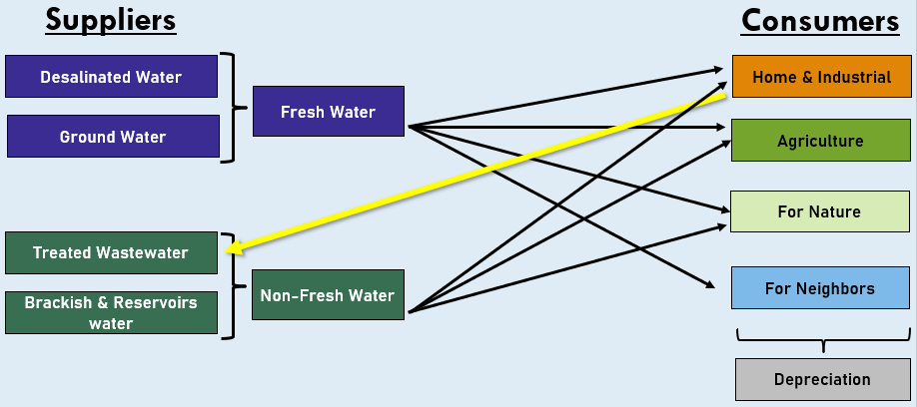
Figure 2- Water Scheme Model

2.3 Optimization model

Case Study and Scope
The optimization problem focuses on Israel’s national power system over a multi-year horizon (2023–2050), with 2050 serving as the benchmark year for evaluating long-term outcomes. The year 2050 is widely adopted in international and national energy planning frameworks as a milestone for deep decarbonization, including the Paris Agreement and multiple Net Zero strategies. Farming the analysis around this target year therefore allows for direct alignment with established policy objectives and comparability with other studies.
Hourly electricity demand is derived from real load data (Noga - Israel Independent System Operator, 2023) as the base demand and extended using the total predicted yearly demand from Cordova et al. (2024), for the entire horizon (~245,000 hours). Using an hourly resolution ensures that both seasonal and intraday variability are accurately represented. This level of granularity captures critical dynamics such as peak loads, renewable intermittency, and the operational role of battery storage—features that coarser annual or daily averages cannot reliably reflect. Moreover, it enables policy-relevant insights that are specific and actionable, such as the timing of potential shortages or surpluses, rather than only high-level trends.
Five technologies are represented: nuclear, solar PV, natural gas, coal, and battery storage. Initial installed capacities correspond to 2023 values (5.9 GW solar, 11.7 GW gas, 5.6 GW coal, 0.37 GW battery, and 0 GW nuclear). Costs, emission factors, and technical parameters were collected from multiple sources including the ROTH Model, NREL, Israel Electricity Authority, Lazard cost reports, and NZO datasets. Notably, life-cycle emission factors for solar and battery are treated as time-dependent, reflecting upstream decarbonization trends. Solar expansion is limited by a land-use cap, which is varied across scenarios between 100 and 850 km²; the upper bound follows the NZO estimate of land available for utility-scale PV (NZO Part B, 2021).
Electricity demand trajectories are derived from the General Framework Model described in Section 2.1, which defines national-scale scenarios for Israel’s demographic, technological, and behavioral trends. All optimization runs use the annual electricity demand trajectory of the 103.1% increase scenario of the General Framework Model, rising from 77.6 TWh in 2023 to 177 TWh in 2050, thereby ensuring full consistency between the national-level demand drivers defined in the General Framework Model and the electricity system optimization module.
The hourly load profile from Noga (2023) is used to preserve the characteristic daily and seasonal demand pattern, while the total annual demand is adjusted each year according to the growth trajectory defined by the corresponding framework scenario. This approach guarantees that the optimization model remains internally coherent with the broader system-level framework from which its demand inputs are derived.
Modeling Environment

To implement the optimization framework, we relied on MATLAB as the primary modeling environment. MATLAB provided a flexible platform for managing large datasets, structuring the scenario workflow, and integrating the solver routines within a reproducible pipeline. Before settling on a final solver, we evaluated several alternative approaches to balance tractability, accuracy, and computational efficiency.
- fmincon / fminunc and MATLAB’s built-in LP solver (linprog) were first considered. fmincon is designed for general nonlinear problems and does not exploit the sparse linear structure of the model, while linprog did not scale to a problem of this size (several million variables and constraints) within reasonable run times.
- Genetic Algorithms were also explored, given their capacity to handle discrete choices and non-linearities. While they offered some flexibility, they suffered from slow convergence and lacked guarantees of optimality, making them ill-suited for policy-relevant analysis where reproducibility and verifiable results are essential.
- Gurobi Optimizer was ultimately chosen. Gurobi is widely recognized as one of the leading solvers for large-scale linear programming (LP), offering advanced presolve techniques and certified optimality. The problem was solved with the barrier (interior-point) method followed by crossover, which returns an exact vertex solution; numerically robust settings (NumericFocus = 1, homogeneous barrier) were used to ensure reliable convergence near the feasibility boundary at low budgets. Each scenario comprises approximately 4 million variables and 7 million constraints.
The adoption of Gurobi ensured that the optimization results were not only computationally efficient but also analytically rigorous. By combining MATLAB’s modeling flexibility with Gurobi’s state-of-the-art LP capabilities, we were able to achieve solutions that are technically robust, reproducible, and directly relevant for informing long-term energy policy.

Methodology Overview

The modeling workflow unfolded through six sequential steps, each designed to translate the conceptual research problem into a solvable optimization framework:
- Demand preparation – Hourly electricity demand was compiled from historical load data and extended across the full multi-decadal horizon. This ensured that both seasonal cycles and long-term growth trends were accurately represented.
- Technology parameters – Key characteristics for each generation technology were incorporated, including solar capacity factors, time-varying life-cycle emission factors for PV and batteries, and economic parameters such as
Capital Expenditures (CAPEX) and Operational Expenditures (OPEX). To accurately reflect the time value of money over the multi-decade planning horizon, the entire economic evaluation framework is discounted to Present Value (PV). Specifically, OPEX is disaggregated into Fixed OPEX (capacity-based) and Variable OPEX (generation-based), both of which are discounted annually at a rate of 6%. CAPEX is converted into an annual payment using a technology-specific Capital Recovery Factor, CRF = r(1+r)^L / ((1+r)^L − 1), with r = 6% and lifetimes L of 60 years (nuclear), 30 years (solar PV, gas and coal) and 20 years (battery). Annual payments start in the year of construction and are counted until the end of the horizon (2050), each discounted to present value.
The hourly solar capacity factor profile is derived from the ROTH model, which in turn is based on NREL photovoltaic performance data for single-axis tracking utility-scale PV systems located in Be’er Sheva, using meteorological conditions representative of the year 2023.
Operational expenditure (OPEX) represents all recurring costs associated with electricity generation and storage, excluding capital investment. These include fixed and variable operation and maintenance costs, fuel expenses where applicable, auxiliary electricity consumption and generation efficiency losses. Battery charging and discharging losses are represented physically through the round-trip efficiency parameters rather than as a cost.

Capital expenditure (CAPEX) represents upfront investment costs required to install generation and storage capacity. These include equipment and balance-of-system costs, engineering, procurement and construction (EPC), grid connection, civil works, owner’s costs, and contingency allowances.
Furthermore, construction and generation costs vary over the years according to Net Zero Outlook (NZO) forecasts.
- Variable definition – Decision variables were formulated to represent generation, capacity expansion, installed capacity, storage state, charging and discharging flows, curtailment, and cumulative system cost. Together, these variables capture the operational and investment choices of the system.
- Constraint assembly – A comprehensive set of constraints was introduced to enforce demand balance, investment dynamics, capacity-to-dispatch limits, land and budget ceilings, annual build-rate limits, a reserve-margin requirement at critical hours, and storage balance. These conditions ensured technical feasibility and policy relevance.
- Objective function – The optimization was designed to minimize cumulative life cycle GHG emissions across the entire horizon, reflecting the central policy priority of deep decarbonization.
- Solution procedure – The problem was formulated as a large-scale LP and solved using Gurobi’s barrier method followed by crossover, ensuring convergence to robust and reproducible solutions.
Taken together, these steps established a transparent and replicable framework that links empirical data, technical assumptions, and policy constraints within a single optimization structure.
The modular structure of the model allows it to be readily adapted to alternative objective functions and policy scenarios beyond those examined in this study.

Mathematical Formulation

This study formulates the long-term evolution of Israel’s electricity system as a large-scale linear optimization problem. The formulation is designed to capture the dominant structural trade-offs governing emissions reduction, capacity expansion, and system feasibility at national scale, while remaining computationally tractable over a multi-decade horizon with hourly resolution. Given the spatial and temporal scale of the problem (≈245,000-time steps), all decision variables are modeled as continuous, yielding a linear program (LP). This choice reflects the focus on system-level behavior rather than micro-level discreteness of individual assets.

Sets and Indices

Let
- $i∈I$denote the set of electricity system components and generation technologies (e.g., nuclear, solar PV, gas, coal, battery storage)
- $t∈\left\{1,…,T\right\}$denote the time index, where each $t$corresponds to an hourly time step
- $T$denote the total number of time steps spanning the planning horizon from 2023 to 2050

Parameters

The model is parameterized using exogenous inputs derived from the general framework model and the Net Zero Outlook datasets. Key parameters include:
- $D_{t}$: electricity demand at time $t$(MWh)
- ${\text{CF}}_{i,t}$: capacity factor for solar technology at time $t$
- $c_{i}^{cap},c_{i}^{fix_op},c_{i}^{var_op}$: capital, fixed operational, and variable operational cost coefficients, varying over time
- $e_{i,t}$: emissions intensity of generation technology $i$at time $t$
- $L^{max}$: maximum land availability for solar deployment
- $B^{max}$: cumulative system budget,
- $R_{i}$: maximum annual capacity addition of technology i (build-rate limit)
- $η^{\text{ch}},η^{\text{dis}}$: charging and discharging efficiencies for battery storage
- $H_{batt}$: battery storage duration representing the energy-to-power ratio (hours)
- $r$: discount rate
- $CRF_{i}$: capital recovery factor
- $df_{t}$ : yearly discount factor
- $RM$: reserve margin multiplier for system reliability
- $T_{y}^{crit}$: set of critical hours of year y used in the reserve-margin constraint
- $CarbonTax$: carbon cost applied to life-cycle emissions of all technologies within the budget constraint (200 NIS/tCO₂e)
- $α_{i}$: land-use intensity of technology $i$ (km²/MW); only solar PV is land-constrained, with $α_{solar}=0.0075$ km²/MW (≈133 MW/km²)
- $K_{i,0}$: initial installed capacity of technology $i$

Decision Variables

The optimization determines the following continuous decision variables:
- $U_{i,t}≥0$: electricity generation or discharge from technology $i$at time $t$(MWh),
- $Z_{i,t}≥0$: incremental capacity addition of technology $i$at time $t$

Derived Variables
- $K_{i,t}≥0$: installed capacity of technology $i$at time $t$(MW)
- $E_{t}≥0$: state of charge of the battery system at time $t$(MWh)
- ${\text{Ch}}_{t},{\text{Dis}}_{t}≥0$: battery charging flow (supplied by solar PV only) and discharging flow (${Dis}_{t}≡U_{batt,t}$)
- ${\text{Dump}}_{t}≥0$: curtailed solar generation
- $C_{t}≥0$: cumulative discounted system cost up to time $t$ (NIS)

Capacity additions $Z_{i,t}$are modeled as continuous variables. While this abstracts from the discreteness of individual projects, it is appropriate at the national planning scale and ensures numerical tractability over long horizons.

Objective Function

The objective is to minimize cumulative life-cycle greenhouse gas emissions from electricity generation over the entire planning horizon:

$$min\sum_{t=1}^{T}{\left[\sum_{i∈I∖\{solar\}}{e_{i,t}U_{i,t}}+e_{solar,t}{CF}_{t}K_{solar,t}\right]}$$
Life-cycle emissions of solar PV are attributed to all generated solar energy—delivered to the grid, stored in batteries, or curtailed—so that they depend only on installed solar capacity; emissions of battery storage are attributed to discharged energy, and those of nuclear, gas and coal to their generation.

This formulation prioritizes emissions minimization subject to physical, economic, and policy constraints, rather than cost minimization alone.
Economic costs, including capital expenditure (CAPEX) and operational expenditure (OPEX), are incorporated within the optimization through the cumulative budget constraint, thereby restricting the feasible solution space rather than directly driving the objective function. A carbon cost on the life-cycle emissions of all technologies is also included in the budget (see Budget Constraint), and is reported separately from direct costs in all cost indicators.

Constraints

Demand Balance

For every time step $t$, electricity demand must be met by generation:

$$\sum_{i∈I}{U_{i,t}}=D_{t}$$This equality enforces strict hourly supply-demand balance, ensuring that total generation, including storage discharge, exactly meets electricity demand in every time step.
Capacity Constraints

Solar Generation Split
Solar output can be delivered to the grid, used to charge the battery, or curtailed; the battery can be charged only from solar PV:
$$U_{solar,t}+{Ch}_{t}+{Dump}_{t}={CF}_{t}⋅K_{solar,t} ∀t$$

Generation of dispatchable technologies and battery discharge is limited by installed capacity (solar output is governed by the solar split above):

$$U_{i,t}≤K_{i,t}∀i,t$$

This constraint prevents dispatch beyond installed capacity and links short-term operation to long-term investment decisions.

Capacity Dynamics

Installed capacity evolves according to incremental additions:

$$K_{i,t}=K_{i,t-1}+Z_{i,t} ∀i,t>1$$

With $K_{i,0}$given as initial capacity.
This recursive structure connects investment decisions in one period to available generation capacity in all subsequent periods. Existing and newly built capacity is not retired within the planning horizon.

Build-rate Constraints

To reflect real-world construction, permitting, and supply-chain limitations, bounds are imposed on capacity expansion in each period:$$Z_{i,t}≤R_{i}∀i,t$$

These constraints limit the speed at which new generation capacity can be deployed, preventing unrealistically rapid build-out. In the main analysis, annual additions of solar PV and of battery storage follow a time-varying schedule that reflects the gradual scale-up of supply chains, permitting and grid connection: 2 GW per year until 2025, rising linearly to 3 GW per year in 2030, 5 GW per year in 2035 and 7 GW per year from 2040 onwards. Gas additions are limited to 5 GW per year; no new coal capacity is allowed, and nuclear additions (nuclear scenarios only) are limited to 3 GW. By restricting expansion rates, the model links long-term investment decisions to physically plausible development trajectories and ensures that decarbonization pathways remain consistent with institutional and logistical constraints. The influence of this assumption is examined in Section 3.8 by comparing the results with a constant limit of 4 GW per year.

Battery Dynamics

Battery storage follows standard inter-temporal balance equations:

$$E_{t}=E_{t-1}+η^{\text{ch}}{\text{Ch}}_{t}-\frac{1}{η^{\text{dis}}}{\text{Dis}}_{t}$$

With bounds on state of charge and an initial condition $E_{0}=0$.
This intertemporal balance equation explicitly links consecutive time steps. Electricity charged into the battery at time t increases the stored energy available at time t+1 (subject to charging efficiency), while discharged electricity reduces the stored energy accordingly. This formulation ensures energy conservation across time and enables surplus generation in one period to be shifted to future periods within the battery’s capacity limits.

Land Constraint

Total land occupied by solar installations is bounded:

$$α_{solar}⋅K_{solar,t}≤L_{max}$$

Where $α_{solar}$ converts installed capacity to land use.

Budget Constraint
To reflect the economic realities of long-term infrastructure planning, the system's total costs must not exceed a cumulative budget ceiling ($B_{max}$). Unlike a simple cash-flow sum, the constraint evaluates the Total Present Value (PV) of all system costs over the planning horizon.
The constraint ensures that the sum of discounted annualized Capital Expenditures (CAPEX), Operational Expenditures (OPEX), and external emission costs (Carbon Tax) remains within the budget:
$$\sum_{y=1}^{Y}{d}f_{y}⋅\left(CAPEX_{y}+OPEX_{y}+EXT_{y}\right)≤B_{max}$$
Where for each year $y∈\left\{1,...,Y\right\}$, $df_{y}={\left(1+r\right)}^{-\left(y-1\right)}$ is the discount factor. To bridge the hourly operational resolution with the annual economic evaluation, let $T_{y}$ denote the set of hours within year $y$, such that $t∈\left[\left(y-1\right)×8760+1,…,y×8760\right]$. The annual cost components are then calculated as follows:
- $CAPEX_{y}$: The annual capital payment for all capacity built up to year y, $CAPEX_{y}=\sum_{i}{\sum_{v≤y}{{CRF}_{i}⋅c_{i,v}^{cap}⋅ΔK_{i,v}}}$, where $ΔK_{i,v}$ is the capacity added in year v and $c_{i,v}^{cap}$ its unit capital cost in that year, using the Capital Recovery Factor ($CRF_{i}$).
- $OPEX_{y}$: The sum of Fixed OPEX and Variable OPEX. Fixed OPEX is proportional to the installed capacity at the year's end ($K_{i,y}$), while Variable OPEX is accumulated over all hourly generation within that year:
$$OPEX_{y}=\sum_{i}{\left(c_{i,y}^{fix_op}⋅K_{i,y}+\sum_{t∈T_{y}}{c_{i,y}^{var_op}}⋅U_{i,t}\right)}$$
where the fixed cost coefficient is expressed per MW of installed capacity per year and the variable cost coefficient per MWh. For solar PV, variable OPEX applies to total solar generation (${CF}_{t}⋅K_{solar,t}$), including stored and curtailed energy.
- $EXT_{y}$: The monetized external costs of greenhouse gas emissions, calculated by aggregating the life-cycle emissions of all technologies over the year (thermal and nuclear generation, total solar generation and battery discharge) and multiplying by a carbon price ($CarbonTax$ = 200 NIS/tCO₂e, constant over the horizon):
$$EXT_{y}=CarbonTax⋅\left[\sum_{i∈\{Nuc,Gas,Coal\}}{\sum_{t∈T_{y}}{e_{i}U_{i,t}}}+\sum_{t∈T_{y}}{\left(e_{solar,t}{CF}_{t}K_{solar,t}+e_{batt,t}{Dis}_{t}\right)}\right]$$
This constraint introduces an economy-wide trade-off between capital expansion, operational efficiency, and environmental externalities across the entire planning horizon.

Battery power and feasibility limits
Charging and discharging are constrained by both technical ratios and energy availability:

$${Ch}_{t}≤K_{batt,t}, {Dis}_{t}≤K_{batt,t}$$
$$E_{t}≤H_{batt}⋅K_{batt,t}, {Dis}_{t}≤η_{dis}⋅E_{t-1}$$
where K_batt,t denotes rated power (MW) and H_batt = 4 h is the energy-to-power ratio. The last condition prevents energy charged in hour t from being discharged within the same hour. Charging and discharging efficiencies are η_ch = 0.95 and η_dis = 0.90.
Must-run conditions
Nuclear plants must run at full installed capacity, while no minimum-load constraint is imposed on gas-fired generation:

$$U_{\text{nuc}}\left(t\right)=K_{\text{nuc}}\left(t\right)$$

Smart Reserve Margin (System Reliability) To ensure grid reliability under high shares of variable renewable energy, a smart reserve margin constraint was introduced. This constraint mandates that firm dispatchable capacity (nuclear, gas, and coal) must be sufficient to cover the net demand with an additional 20% safety margin ($RM=1.20$). Rather than enforcing this constraint across all hours of the year—which is computationally redundant—it is evaluated during a representative subset of critical hours ($T_{critical}$) for each year. These critical hours are identified dynamically and include the top absolute peak demand hours, as well as the top peak demand hours when solar generation is unavailable (i.e., nighttime). In each year, the ten highest-demand hours and the ten highest-demand hours with zero solar output are used. Battery storage is not counted as firm capacity.

$$K_{nuc,t}+K_{gas,t}+K_{coal,t}≥RM⋅\left(D_{t}-U_{solar,t}\right) ∀t∈T_{critical}$$

By rearranging the solar generation to the left-hand side, the model inherently guarantees that the combination of firm capacity and available solar generation meets 120% of the peak demand, thus safeguarding against sudden supply shortages

Capacity Expansion Windows (Build Constraints) In reality, large-scale energy infrastructure cannot be commissioned on a continuous, hourly basis. To reflect realistic planning, permitting, and construction cycles, capacity additions ($Z_{i,t}$) are restricted to designated build windows. For solar, gas, coal, and battery storage, capacity can only be added annually (i.e., at the end of every 8760-hour block), except in the final year of the horizon. Due to the exceptionally long development and construction timelines associated with nuclear power, its capacity additions are allowed only once every 20 years, which within the 2023–2050 horizon corresponds to a single build point at the end of 2042. Nuclear additions are enabled only in the nuclear scenarios; in the main scenario grid they are disabled. In all other intermediate hours, the capacity addition variables are strictly constrained to zero:

$$Z_{i,t}=0 \text{for }t∉T_{build}^{i}$$

Where $T_{build}^{i}$ represents the discrete allowable commissioning hours for technology $i$. This constraint prevents unrealistic fractional hourly builds and aligns the model's short-term operational resolution with long-term macroeconomic planning steps

Given that all decision variables are continuous and all constraints are linear, the resulting optimization problem is formulated as a large-scale linear program (LP). This modeling choice prioritizes tractability and system-level insight over micro-level discreteness, which is appropriate for national-scale long-term planning under structural uncertainty.

While Mixed-Integer Linear Programming (MILP) formulations are commonly used in generation expansion planning to represent discrete investment decisions, recent reviews note that large-scale, high-temporal-resolution models are frequently implemented as linear programs to balance model scope and computational feasibility (Deng & Lv, 2020). In this study, representing capacity expansion variables as continuous preserves the structural trade-offs between cost, land use, and emissions that form the core focus of the analysis, while enabling exploration of an extensive scenario ensemble.
Analyses

Our analysis proceeded in two stages. In the first stage, we constructed a structured grid of scenarios by fixing the annual build-rate limits and varying two economy-wide constraints: the cumulative budget (eight levels between ₪400×10^9 and ₪500×10^9: 400, 405, 410, 420, 430, 450, 470 and 500) and the land available for utility-scale solar deployment (eleven levels: 100 km², representing a low-land, fossil-dominated benchmark, and 400–850 km² in steps of 50 km²). This factorial design yields 88 scenarios, of which [N] are feasible. [Infeasible scenarios and their explanation – to be completed after the final runs.] In the main scenario grid, nuclear capacity additions are disabled; nuclear variants are analysed separately in Section 3.7.

In the second stage, we moved from breadth to depth. Because the optimization minimizes emissions rather than cost, every scenario uses its full budget, and the total cost of a scenario therefore equals its budget. To isolate the effect of land availability, one representative scenario was selected per land cap at a fixed budget of ₪420×10^9, the lowest budget at which all land caps between 400 and 850 km² are feasible and fully utilized; the 100 km² benchmark, which is infeasible at this budget, is represented at its lowest feasible budget (₪430×10^9). This yields eleven representative scenarios spanning renewable shares of [X]% and [X–X]% in 2050.
As defined in Section 2.3, the optimization minimizes cumulative life-cycle greenhouse gas emissions subject to budget and land constraints. The carbon cost included in the budget (200 NIS/tCO₂e) is reported separately from direct costs (CAPEX and OPEX) in all cost indicators, so that direct and social cost components can be examined explicitly.
In addition to these two stages, the economic optimum of the system was determined by solving the same model with total discounted cost—including CAPEX, OPEX and the carbon cost—as the objective and without a budget constraint, for selected land caps. The resulting least-cost system marks the lower bound of the budget range examined in the scenario grid (Section 3.8).

This two-tiered process broad exploration followed by selection of representative scenarios allowed us to balance coverage of the design space with depth of insight. Across both stages, each scenario was solved as an hourly, multi-year linear program that endogenously determined capacity additions, dispatch, and storage operation to minimize cumulative CO₂ emissions subject to demand balance, build-rate limits, storage dynamics, and economy-wide budget and land caps. For every run we extracted a harmonized set of indicators total cost, cumulative emissions, the 2050 technology mix and capacities, the renewables share in 2050, and solar land utilization ensuring consistency in cross-scenario comparisons.

2.4 Integration with External Models
As part of an attempt to extend the General Framework model with demand and cost realism, two external tools were incorporated: the ROTH 1.0 Power System Model (developed by Michael Roth) and the Net Zero Outlook (NZO) platform. Each serves a distinct role: Roth provides an hourly breakdown of electricity demand and technology contributions, while NZO supplies techno-economic estimates of generation and system costs. Both models are connected directly to our framework, rather than to each other, ensuring that all inputs and outputs were processed consistently.

Roth model.
The ROTH 1.0 Power System Model is an Excel-based simulation that decomposes annual electricity demand into hourly load trajectories and allocates generation across nuclear, solar PV, battery storage, and natural gas. It computes hourly balances, curtailment, and storage dynamics, and produces annual summaries of generation shares by technology. In our study, the General Framework model first provides annual demand forecasts and renewable-energy targets, which Roth then translates into detailed hourly profiles. These profiles are used to benchmark and validate the time-resolved demand and capacity requirements in our optimization runs.
NZO Datasets The Net Zero Outlook (NZO) is a non-profit initiative launched in 2019 to support Israel’s energy transition. While its cloud-hosted platform natively estimates the allocation of annual demand among generation sources, this study primarily leverages NZO's comprehensive techno-economic datasets to define the time-varying capital and operational cost trajectories (CAPEX and OPEX) for the different technologies. Importantly, NZO does not calculate greenhouse gas emissions; in this thesis, emissions are derived separately using life-cycle coefficients, and the actual hourly allocation of demand is performed endogenously by the optimization model
Integration Process Rather than relying on external models to sequentially compute generation balances and costs, this study introduces a centralized integration approach driven by the MATLAB-based optimization model. The interaction among the data sources and the core model proceeds as follows:
- Demand and Physical Foundations: The General Framework model prepares the long-term annual electricity demand projections. Simultaneously, the ROTH model is utilized to provide the foundational hourly profiles, specifically the normalized hourly demand shapes and the hourly solar capacity factors based on meteorological data.
- Economic Trajectories: The Net Zero Outlook (NZO) datasets are integrated to supply the dynamic techno-economic layer. Time-varying capital expenditures (CAPEX) and operational expenditures (OPEX) are extracted from NZO forecasts to reflect anticipated market trends and cost reductions over the planning horizon.
- Endogenous Optimization: These physical and economic inputs are fed directly into the hourly optimization model. Instead of relying on an external API to define how demand is met, the Gurobi solver endogenously calculates the optimal capacity expansion, hourly generation dispatch, and storage dynamics. This ensures that the generation balances strictly adhere to the defined system constraints (e.g., budget, land, reserve margins, and build-rate limits) while minimizing cumulative greenhouse gas emissions.
From this perspective, the General Framework and Roth models provide the demographic and physical baseline, NZO contributes the time-varying economic parameters, and the newly developed optimization model serves as the central computational engine that integrates them into a coherent, constraint-bound transition pathway.

Results

3.1 Hourly system behavior and operational patterns

To establish an operational understanding of the modeled electricity system, this section examines its hourly behavior across representative time slices and over the full planning horizon. Figures 4–6 present the hourly generation mix, storage activity, and demand coverage under different temporal perspectives, highlighting how system dynamics evolve across seasons and over time.

shows the hourly generation mix during a representative winter week in January 2050. During this period, solar generation is relatively moderate, with shorter daylight hours and lower peak output. As a result, gas-fired generation plays a dominant balancing role, particularly during evening and nighttime hours when solar production is unavailable. Battery discharge contributes primarily during peak demand hours, while charging activity remains limited due to reduced solar surplus. Curtailment is minimal in this period, reflecting the closer alignment between generation and demand under winter conditions.
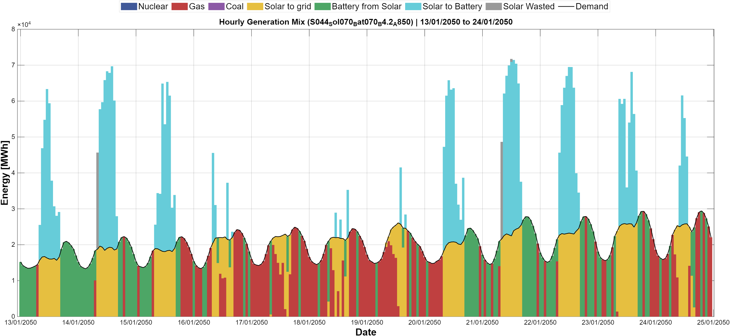
Figure 4 - Generation mix, hourly resolution, winter week (January 2050)
In contrast, Figure 4 illustrates the system's behavior during a representative summer week in June 2050. Solar generation reaches significantly higher levels, driven by longer daylight hours and higher capacity factors. This leads to pronounced midday surpluses, which are partially absorbed through battery charging. Battery discharge becomes a central mechanism for shifting solar energy from midday to evening and from one day to another. Despite this flexibility, visible levels of solar curtailment emerge during peak production hours, indicating that storage capacity and demand-side absorption are insufficient to fully utilize all available solar output. Gas generation is substantially reduced during daylight hours and is primarily dispatched during nighttime and residual balancing periods.
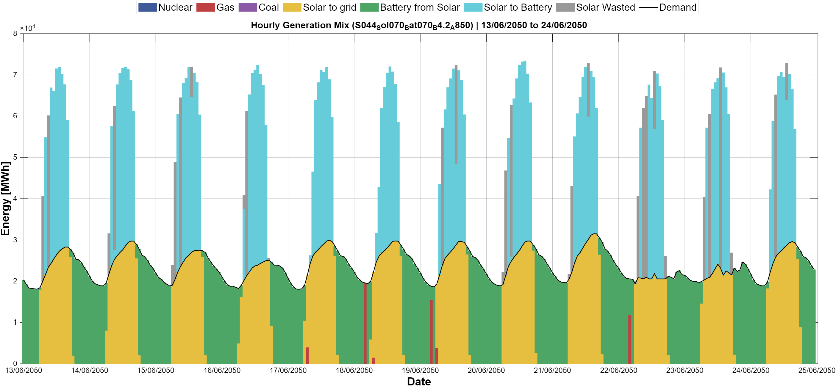
Figure 3 - Generation mix, hourly resolution, summer week (June 2050)
Figure 5 presents the hourly generation mix for a representative year (2050), illustrating system operation over 8,760 hourly time steps under a high-renewable configuration. The figure highlights the dominant role of solar generation during daytime hours, alongside pronounced daily and seasonal variability. Battery activity emerges as a central balancing mechanism, charging primarily during periods of high solar output and discharging during evening and night hours when solar generation declines. Gas-fired generation persists as a residual dispatchable resource, contributing mainly during periods of low renewable availability and increased demand. Seasonal patterns are clearly visible, with extended summer periods characterized by sustained solar surpluses and increased levels of curtailment, and winter periods showing greater reliance on dispatchable generation and storage discharge. Importantly, the figure demonstrates that high renewable penetration does not eliminate temporal variability in the system. Instead, variability is redistributed across technologies, with storage and curtailment becoming integral components of system balancing rather than marginal features.
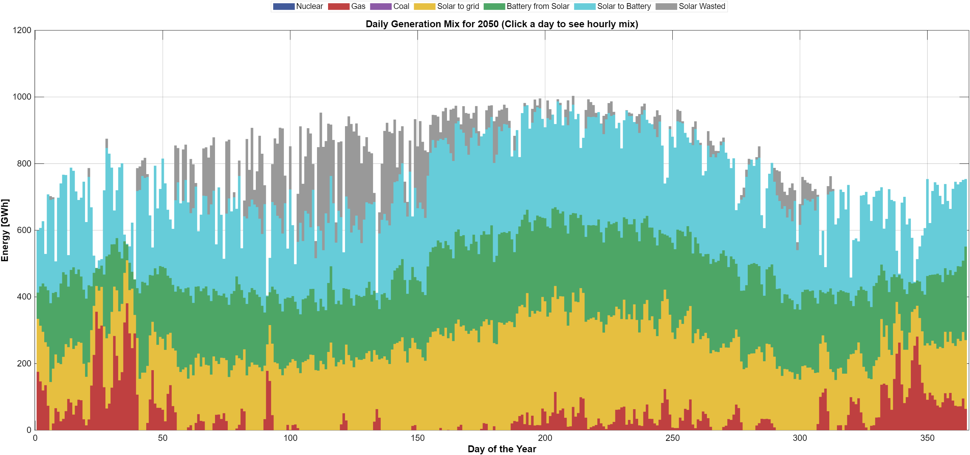
Figure 4 Generation mix in hourly resolution 2050 90 RE%
Taken together, the hourly results demonstrate that high renewable penetration fundamentally reshapes system operation rather than smoothing it. Temporal mismatches between generation and demand remain a defining feature, particularly under high solar deployment. Battery storage mitigates these mismatches by reallocating energy across hours yet cannot fully eliminate surplus generation during peak solar periods. These operational patterns provide essential context for the system-level relationships between land use, cost, renewable penetration, and emissions examined in the following sections.

3.2 System feasibility space: land, cost and renewable penetration

This section examines the relationship between renewable penetration in 2050 and the two system-level constraints that define the feasible solution space: the cumulative budget and the available solar land. Figure 6 presents the renewable share in 2050 as a function of the cumulative budget and the upper bound on solar land deployment, both as a heatmap in which each cell corresponds to one scenario and as a three-dimensional mesh. A numerical table of Figure 6 is found in the appendices.
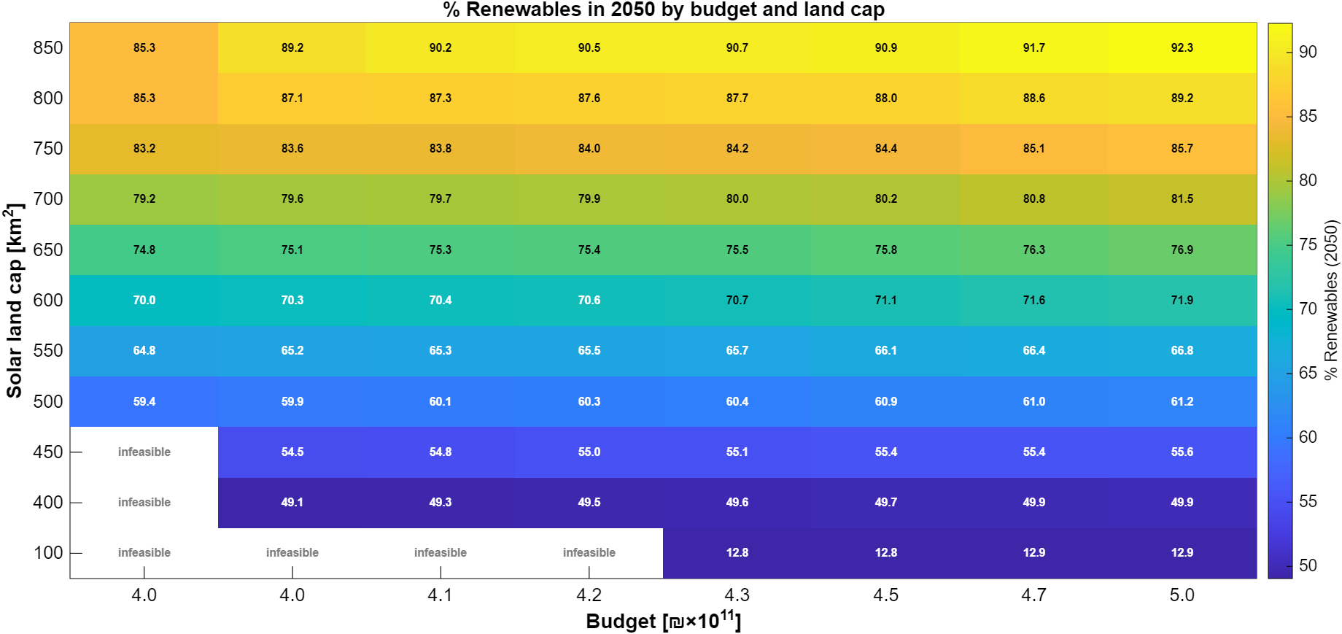

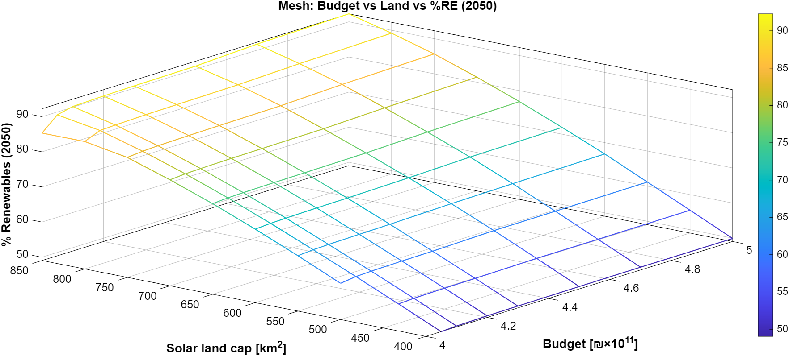
Figure 5 - Feasible renewable penetration in 2050 as a function of the cumulative budget and solar land availability (heatmap and 3D mesh)

Land availability is the primary driver of renewable penetration. Along the land axis, the renewable share in 2050 increases from about 50% at 400 km² to about 92% at 850 km², whereas for a given land cap it changes by only one to four percentage points along the budget axis once the budget exceeds ₪410×10⁹. The low-land benchmark (100 km²) remains at about 13% renewables in 2050, close to the current share of renewables in the Israeli electricity mix.
The budget is a binding constraint mainly at the lower end of the examined range. Above approximately ₪450×10⁹ the surface becomes flat: additional budget yields no further increase in the renewable share. In this region the binding constraints are the land cap and the annual build-rate limit of battery storage, which is reached in every year of the horizon (about 108 GW of battery power in 2050). Conversely, at the lowest budget (₪400×10⁹) the land caps of 700–850 km² are not fully utilized, and the renewable share is limited to 77% by the budget rather than by land.
Five of the 99 scenarios are infeasible: the 100 km² land cap with budgets of ₪400–420×10⁹, and the 400 and 450 km² land caps with a budget of ₪400×10⁹. In these cases the budget cannot cover the required capacity expansion together with the fuel and carbon costs of the remaining gas generation. Notably, once its carbon cost is included, the fossil-dominated system requires a larger budget (at least ₪430×10⁹) than systems with more than 85% renewables (₪410×10⁹).
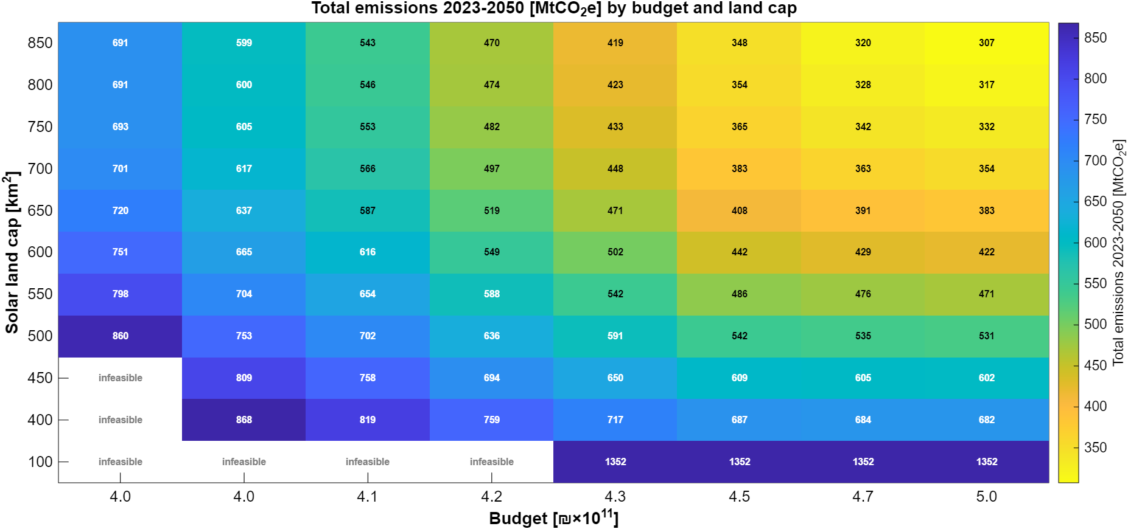
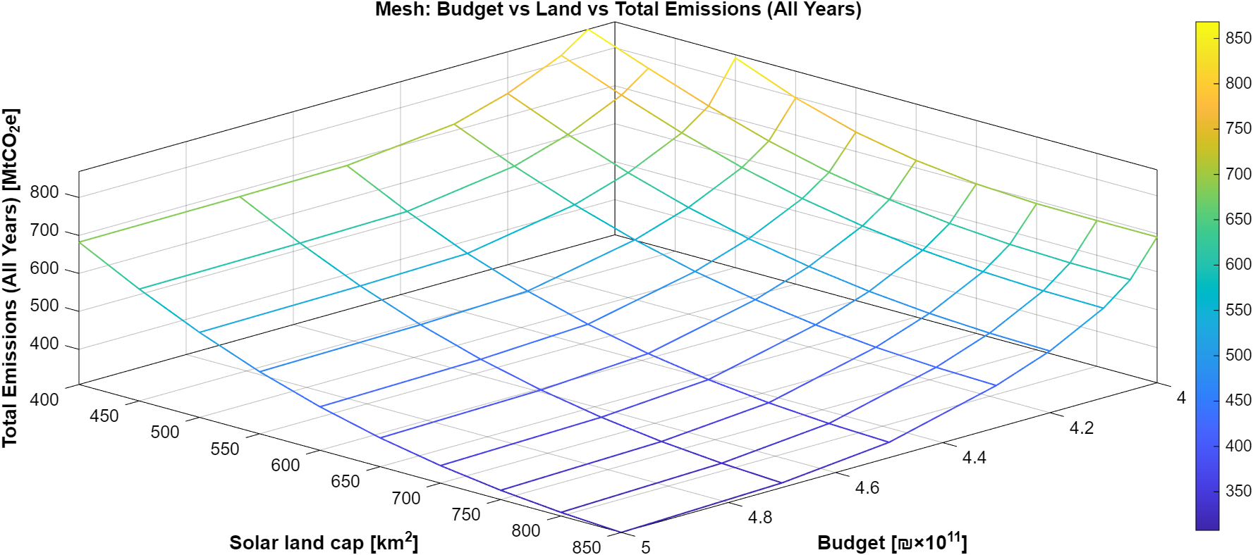
Figure 6 - Total cumulative emissions (all years) as a function of the cumulative budget and solar land availability (3D mesh).

While Figure 6 focuses on the renewable share in the target year, Figure 7 shows the corresponding cumulative emissions over the full horizon (2023–2050), again as a heatmap and as a mesh. Cumulative emissions range from about 1,355 MtCO₂e in the low-land benchmark to about 490 MtCO₂e at 850 km² and budgets of ₪450×10⁹ or more. Base-year (2023) emissions in the model are 33.2 MtCO₂e.
In contrast to the 2050 renewable share, cumulative emissions respond strongly to the budget at the low end of the range. At 500 km², for example, raising the budget from ₪400×10⁹ to ₪420×10⁹ lowers cumulative emissions from about 878 to about 656 MtCO₂e (−25%), while the renewable share in 2050 increases only from 59.0% to 60.7%. The additional budget allows solar and storage capacity to be built earlier, within the build-rate limits, and thereby displaces gas-fired generation in the intermediate decades. Early investment therefore matters for cumulative emissions even when the end-state system is constrained by land. This effect saturates above approximately ₪440–450×10⁹.
Overall, Figures 6 and 7 define the envelope within which all modeled scenarios operate. Renewable penetration emerges from the interaction between land and budget, with land as the dominant constraint for the end-state system and the budget as the dominant factor for the timing of the transition and hence for cumulative emissions.

3.3 Energy balance and demand coverage in 2050
This section examines how electricity demand in 2050 is met across the full set of modeled scenarios, focusing on the composition of annual energy supply and the role of different technologies in covering demand. Figure 8 presents the annual electricity balance in 2050, showing the contributions of solar generation, gas-fired generation, battery discharge, and curtailed energy across all scenarios.

Despite identical demand levels, the figure reveals substantial variation in how demand is supplied. Scenarios with lower renewable penetration rely predominantly on gas generation, with solar contributing a smaller share and storage playing a limited role. Curtailment in these cases is negligible, reflecting the close alignment between generation and demand under fossil-dominated configurations.

As renewable penetration increases, solar generation becomes the dominant source of electricity. This shift is accompanied by a growing contribution from battery discharge, indicating the increasing importance of storage in redistributing solar energy across time. At the same time, curtailed solar energy emerges as a significant component in high-renewable scenarios, reflecting the structural surplus generated during periods of high solar output that cannot be fully absorbed by demand or storage.

The figure also illustrates that increases in renewable penetration do not translate into proportional reductions in dispatchable generation. Gas-fired generation remains present across most scenarios, albeit at declining levels, serving as a residual balancing source during periods when solar and storage are insufficient. This highlights that even under high renewable shares, demand coverage relies on a combination of variable generation, storage, and dispatchable capacity.
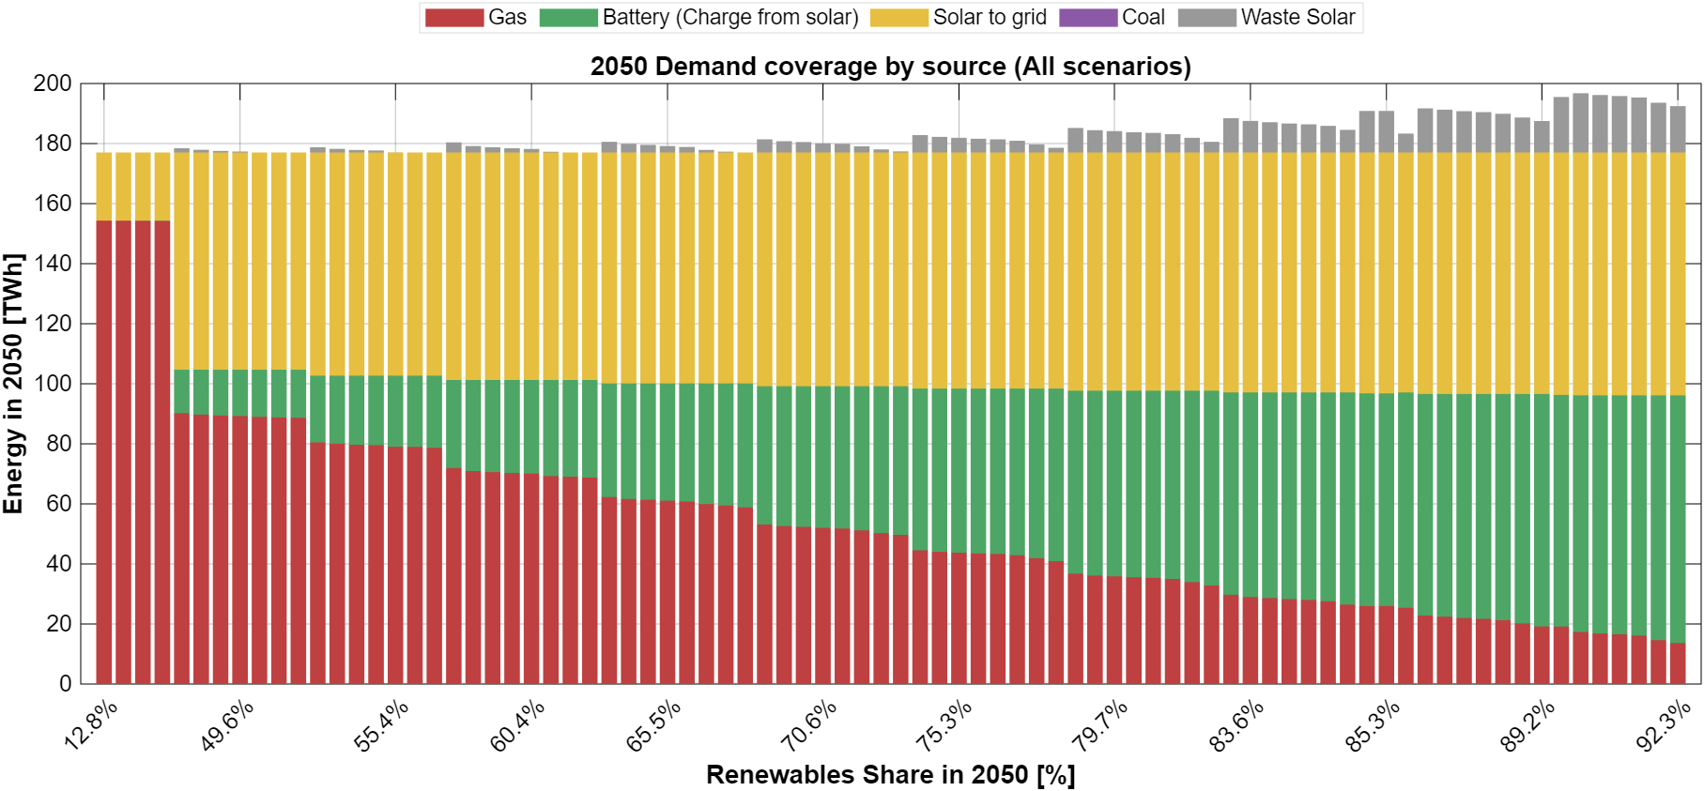
Figure 7 - Annual electricity demand coverage and generation mix in 2050 across all scenarios

Figure 8 shows that meeting electricity demand in 2050 involves a reconfiguration of the supply mix rather than a simple substitution of technologies. Higher renewable penetration is associated with increased solar deployment, expanded storage utilization, and rising curtailment, while dispatchable generation continues to play a complementary role. These aggregate energy balance outcomes provide the basis for examining the corresponding infrastructure requirements and capacity levels in the following section.

3.4 System cost structure in 2050 – representative scenarios

Following the characterization of the full scenario space, the analysis now focuses on a set of representative scenarios. As described in Section 2.3, the representative scenarios share a fixed budget of ₪420×10⁹—the lowest budget at which all land caps between 400 and 850 km² are feasible and fully utilized—and differ only in land availability. The low-land benchmark (100 km²), which is infeasible at this budget, is represented at its lowest feasible budget (₪430×10⁹). The resulting eleven scenarios span renewable shares of 12.8% (100 km²) and 49.6–91.0% (400–850 km²) in 2050, in steps of about five percentage points.
The average system cost reported in this section is the cost of the generation system only: the annual capital payments (CAPEX) and the fixed and variable operating costs (OPEX) of generation and storage in 2050, divided by the electricity delivered in that year, in undiscounted 2050 NIS. It does not include transmission and distribution networks, system services, taxes or retail margins, and is therefore considerably lower than the retail electricity tariff (about half a shekel per kWh today). The carbon cost included in the budget (200 NIS/tCO₂e) is shown separately.

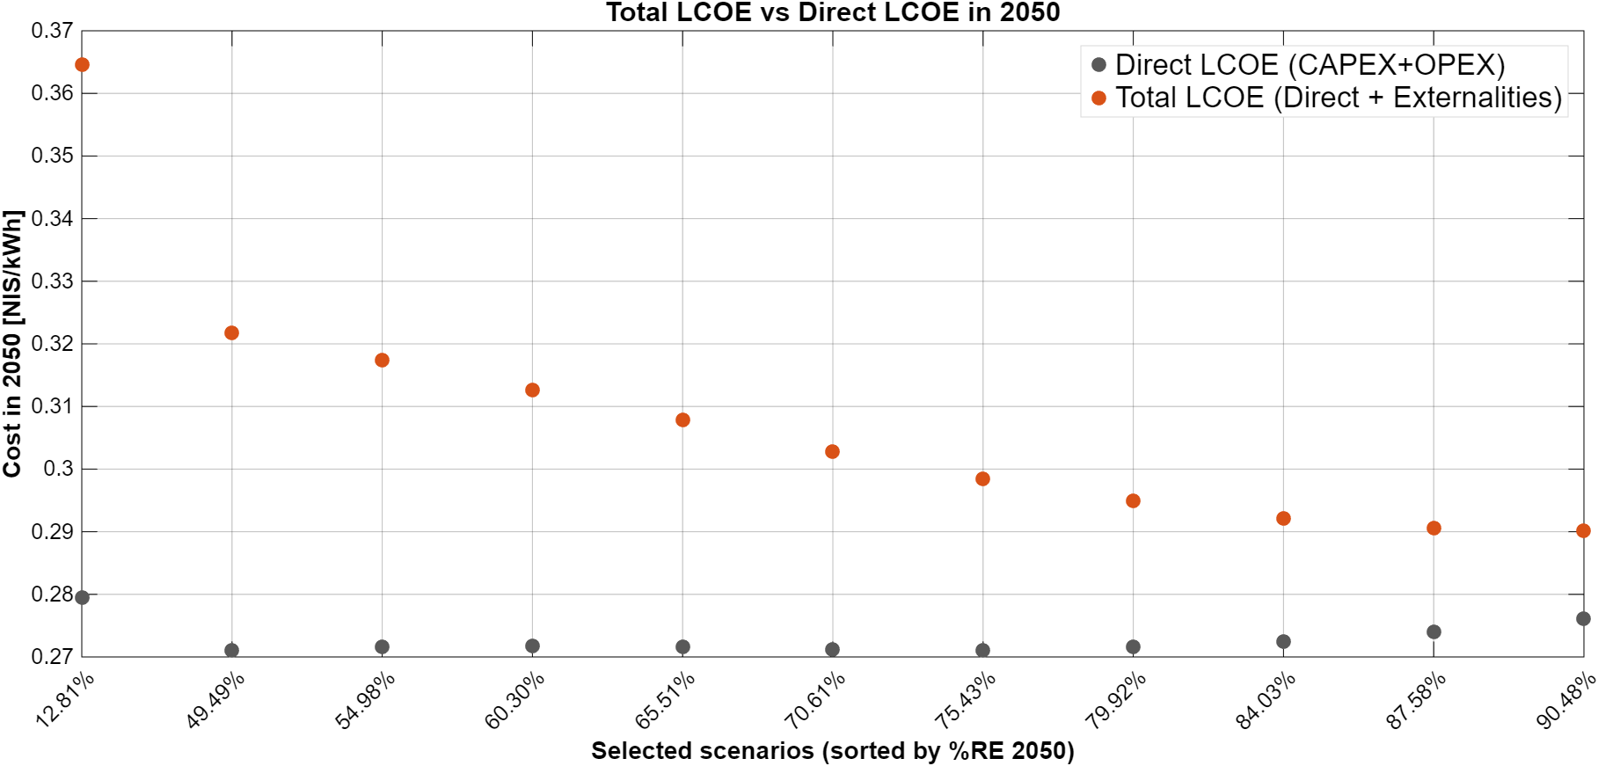
Figure 8 - Direct average system cost (CAPEX + OPEX) and total average system cost (direct + carbon cost) in 2050 – representative scenarios

Figure 9 shows the direct average system cost in 2050. The fossil-dominated benchmark (12.8% renewables) has the highest direct cost, about 0.279 NIS/kWh. For renewable shares between 49.6% and 84.5% the direct cost is almost constant at 0.273–0.274 NIS/kWh, and it rises slightly to 0.275–0.276 NIS/kWh at 88–91%. Since all representative scenarios between 400 and 850 km² share the same budget, the result can be read as follows: for the same budget, more land raises the renewable share in 2050 from 50% to 91% at a practically unchanged direct cost per kWh.
The high direct cost of the fossil-dominated system in 2050 results from the rising variable cost of gas generation, which almost doubles over the horizon (from about 115 to about 231 NIS/MWh). Over the full horizon the picture differs: in present-value terms, the cumulative direct cost (CAPEX and OPEX) of the benchmark is about ₪310×10⁹, compared with about ₪345×10⁹ in the 400 km² scenario. Fossil-heavy systems are therefore cheaper in the early years but become the most expensive by 2050; the difference in total budget is accounted for by the carbon cost (about ₪120×10⁹ in the benchmark versus ₪60–75×10⁹ in the representative renewable scenarios).
Figure 9 also shows the total (social) average system cost, i.e. the direct cost plus the carbon cost. The carbon cost amounts to about 0.085 NIS/kWh in the benchmark, about 0.05 NIS/kWh at 50% renewables and about 0.014 NIS/kWh at 91%. As a result, the total average system cost declines monotonically from about 0.364 NIS/kWh in the benchmark to about 0.323 NIS/kWh at 50% renewables and to about 0.290 NIS/kWh at 91%: once the carbon cost is accounted for, the cleanest representative system is also the cheapest.
Figure 10 decomposes the annual system cost in 2050 into CAPEX, OPEX and carbon cost by technology. The total annual cost declines from about ₪64×10⁹ in the benchmark to about ₪57×10⁹ at 50% renewables and about ₪51×10⁹ at 91%. At low renewable shares the system is OPEX-dominated: gas operating costs alone amount to about ₪41×10⁹ in the benchmark. As the renewable share increases, gas OPEX falls to about ₪9×10⁹ at 91%, while capital payments for solar PV (about ₪19×10⁹) and battery storage become the dominant cost components, and the carbon cost falls from about ₪15×10⁹ to about ₪2×10⁹. Deep decarbonization therefore changes the structure of the electricity system from an OPEX- and emissions-intensive system into a capital-intensive, low-emission infrastructure, at a similar direct cost per kWh.

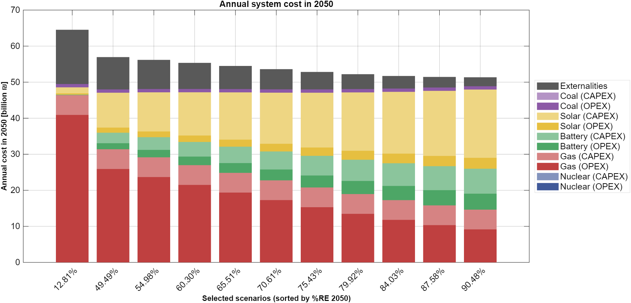
Figure 9 - Annual system cost in 2050 decomposed by source (OPEX + CAPEX + carbon cost) for the representative scenarios

Figure 19 (Section 4.2) presents the same cost results against the carbon intensity of electricity supply in 2050, which provides a direct view of the cost of reducing emissions within the representative set.
The results of the nuclear variants are presented in Section 3.7.

3.5 Emissions in 2050 by source - representative scenarios
This subsection examines the emissions outcomes in the target year 2050 for the representative scenarios, focusing on the composition of emissions by generation source. While the previous section characterized cumulative emissions across the full modeling horizon, the present analysis isolates the end-state emissions profile, which is of direct relevance to net-zero policy targets.

Figure 11 presents greenhouse gas emissions in 2050 disaggregated by source for the representative scenarios, ordered by increasing renewable share. A clear monotonic decline in total emissions is observed as renewable penetration increases. This reduction is driven almost entirely by the displacement of gas-fired generation, which remains the dominant source of emissions across all scenarios in which it is present.
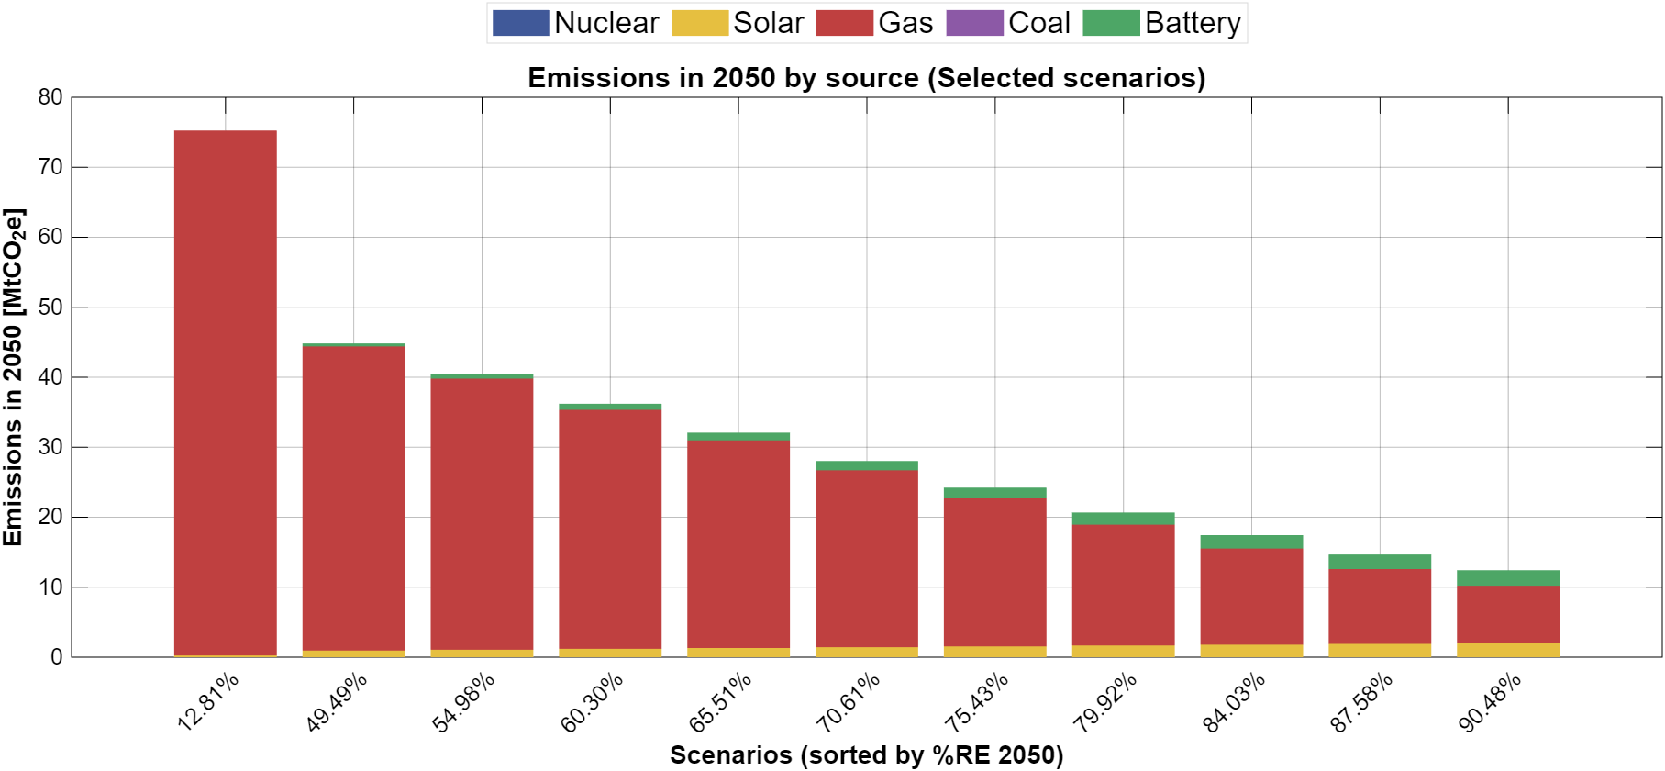
Figure 10- Emissions in 2050 by generation source for the representative scenarios

Emissions in 2050 decrease from about 75 MtCO₂e in the fossil-dominated benchmark to about 45 MtCO₂e at 50% renewables and to about 12 MtCO₂e at 91%. Gas remains the dominant source of emissions in all scenarios. Life-cycle emissions of solar PV and battery storage are small but not zero; their absolute level grows with installed capacity, and at 91% renewables they account for about one third of the residual emissions (about 4 MtCO₂e).
The results indicate that intermediate renewable targets already deliver substantial emissions reductions, while near-zero emissions in the electricity sector require pushing renewable penetration to the upper end of the feasible space, which in turn depends on the availability of land for solar deployment.

3.6 Installed capacities and infrastructure scale in 2050 – representative scenarios

This section examines the generation and storage capacities installed in 2050 in the representative scenarios, and how capacity expansion translates into operational system behavior.
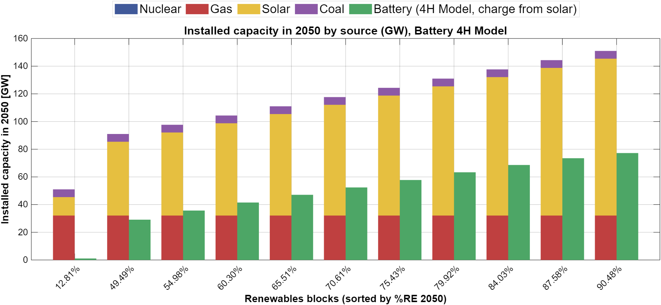
Figure 11 – Installed generation and storage capacities in 2050 across the representative scenarios

Figure 12 presents the installed capacities of the main system components in 2050 in the representative scenarios. Solar PV constitutes the largest share of installed capacity in all scenarios except the low-land benchmark, and its capacity is determined directly by the land cap (about 133 MW per km²): it grows from about 13 GW in the benchmark to 53 GW at 400 km² and 113 GW at 850 km². Battery storage increases systematically with the renewable share, from about 33 GW at 50% to about 82 GW at 91%, reflecting the growing need to shift solar energy from midday to evening and night hours.
About 20 GW of new gas capacity is built in all scenarios, so that gas capacity reaches about 32 GW in 2050 regardless of the renewable share. This capacity is determined by the reserve-margin requirement during critical hours, in which solar output is zero and battery storage is not counted as firm capacity. Gas therefore remains a central reliability resource even in scenarios in which it supplies only about 10% of annual demand.

Beyond installed capacity levels, the operational behavior of battery storage provides additional insight into system dynamics. Figures 13 and 14 illustrate the battery state-of-charge trajectories for a representative high-renewable scenario
(RE ≈ 88%) during the winter (Figure 13) and summer (Figure 14) periods of 2050. In summer, battery operation is characterized by pronounced daily charge–discharge cycles, with charging during midday solar surpluses and discharging during evening and nighttime demand peaks. These patterns demonstrate that storage primarily functions as an intra-day balancing mechanism, rather than as a means of seasonal energy shifting.
In winter, battery operation exhibits greater variability and longer discharge events. Extended periods of low solar availability lead to multi-day depletion episodes, during which the battery approaches low state-of-charge levels. This behavior indicates that even substantial storage capacity cannot fully eliminate temporal mismatches between generation and demand, particularly during prolonged low-renewable periods. Instead, storage mitigates but does not resolve these structural imbalances, reinforcing the continued need for dispatchable backup capacity.
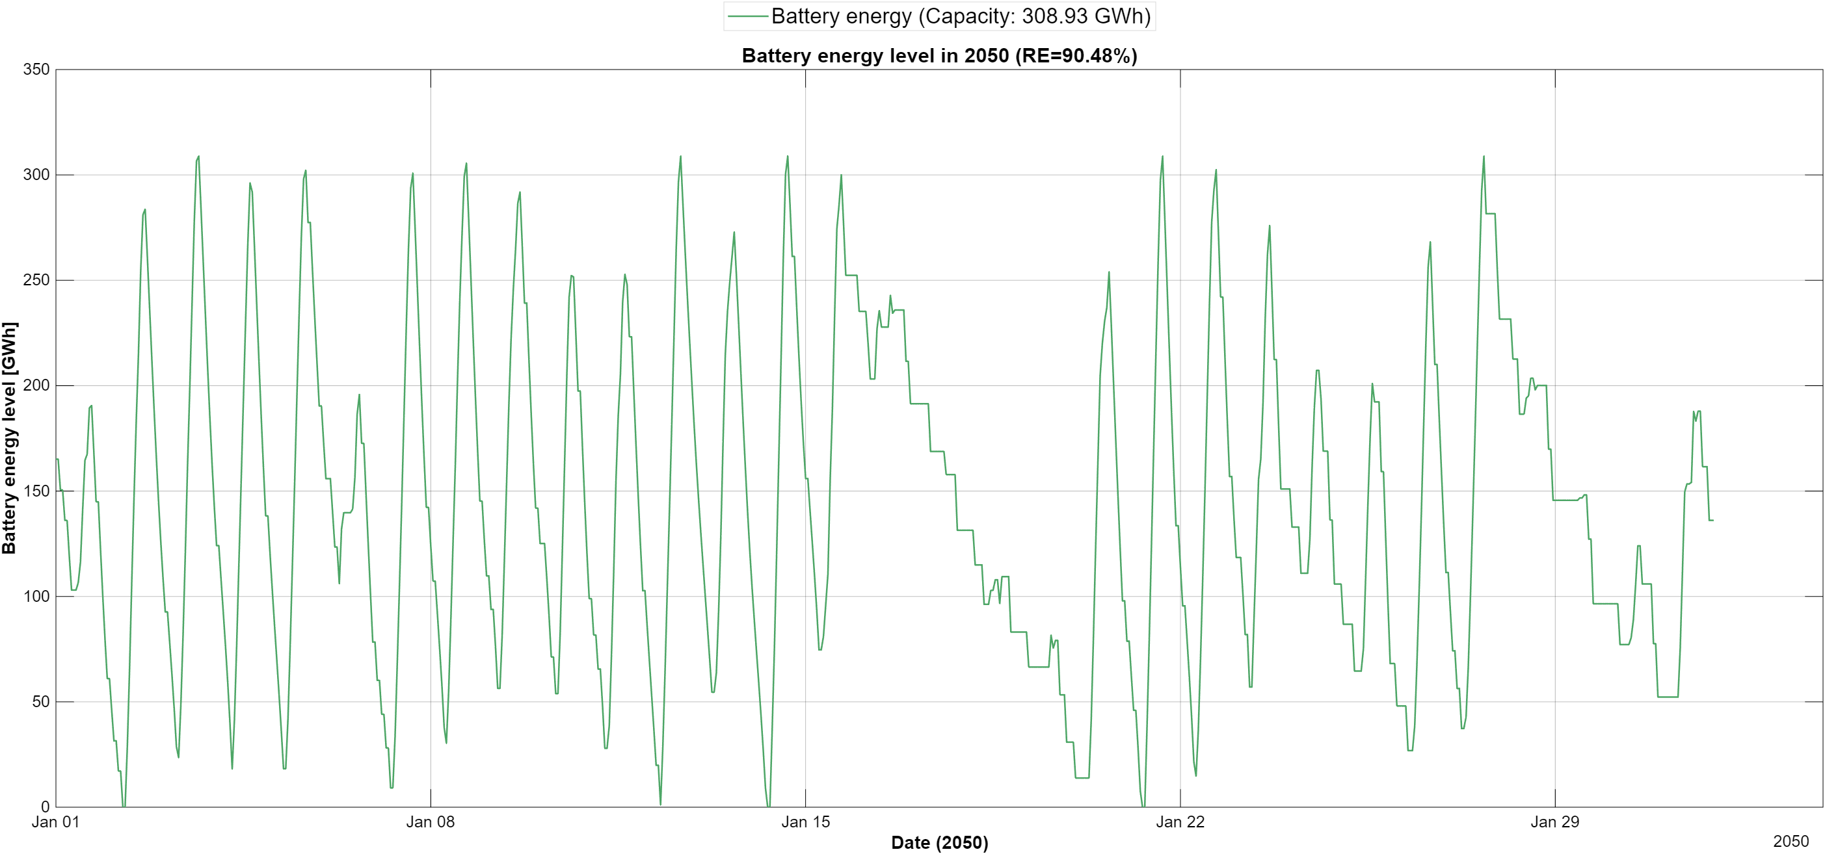
Figure 12 - Battery energy level in winter 2050

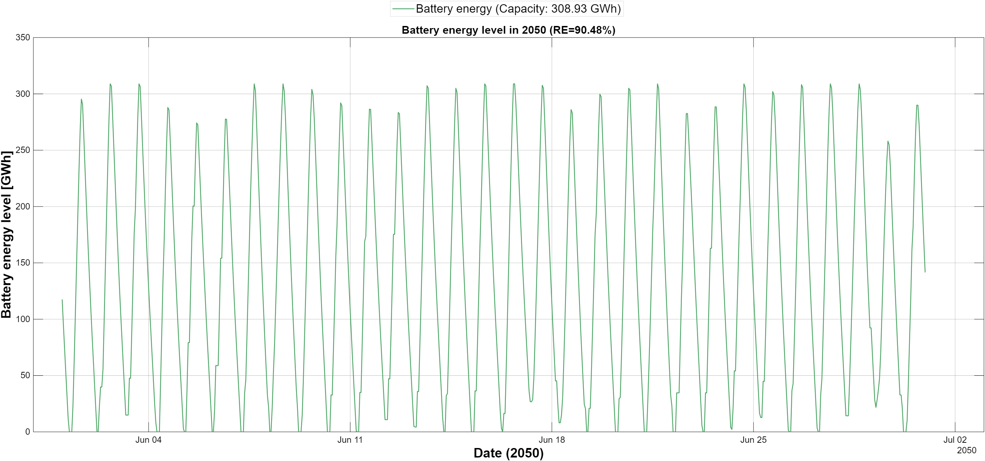
Figure 13 - Battery energy level in summer 2050

While the previous figures focus on end-year infrastructure, Figure 15 illustrates the temporal evolution of installed capacity for a representative high-renewable scenario. Capacity expansion follows a gradual and cumulative trajectory over the planning horizon, in line with the annual build-rate limits and the budget constraint, with no abrupt build-out at the end of the horizon.
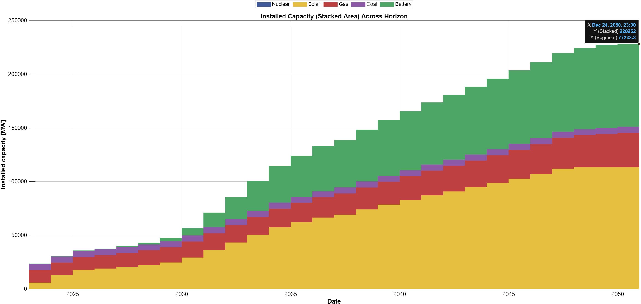
Figure 14 - Installed capacity evolution across the planning horizon for a representative 88% scenario
The continued presence of gas capacity reflects its role as a flexibility and reliability resource rather than a primary energy supplier. Even in scenarios with high renewable shares, dispatchable capacity is retained to address periods of low renewable availability and system stress, emphasizing that decarbonization does not eliminate the need for firm capacity.

Overall, this section shows that pathways to high renewable penetration are characterized by large solar deployment determined by land availability, rapidly growing battery storage, and a stable fleet of gas capacity required for reliability. Storage mitigates but does not eliminate the need for dispatchable backup capacity.

3.7 Nuclear scenarios
To examine the role of firm low-carbon capacity, the full scenario grid was repeated with nuclear additions enabled, using the same model, parameters and solver settings. In these scenarios up to 3 GW of nuclear capacity can be built at a single build point at the end of 2042 and is operated as must-run baseload. In all 97 feasible nuclear scenarios the model builds the maximum allowed capacity (3 GW), which supplies about 26 TWh per year, roughly 15% of demand in 2050. Nuclear capacity replaces gas one-for-one in the reserve-margin requirement, so that gas capacity in 2050 is about 29 GW instead of about 32 GW.
Nuclear also enlarges the feasible space. Three scenarios that are infeasible without nuclear—the 400 and 450 km² land caps at ₪400×10⁹ and the 100 km² land cap at ₪420×10⁹—become feasible, and only the two lowest budgets at 100 km² remain infeasible. Because nuclear displaces gas generation in 2043–2050, it saves fuel and carbon costs within the budget, which can then be used for additional solar and storage capacity. Note that in the nuclear scenarios the reported share of generation includes nuclear and is therefore a low-carbon share rather than a renewable share.
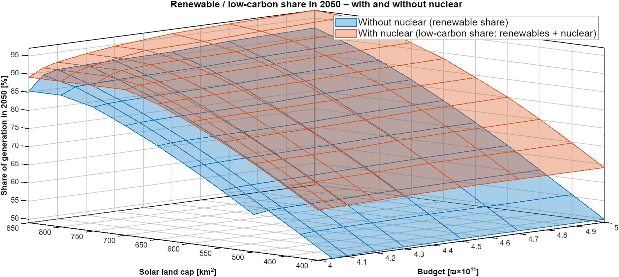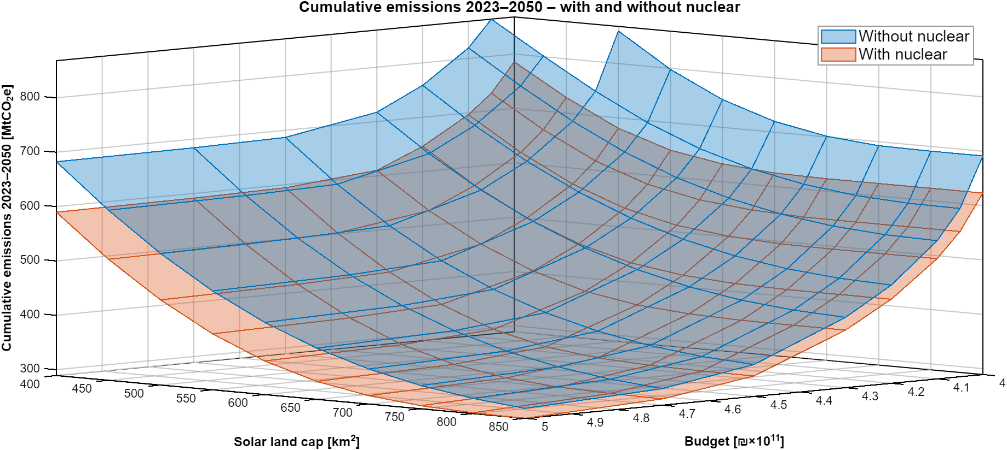
Figure 15 - Renewable / low-carbon share in 2050 (top) and cumulative emissions 2023–2050 (bottom) as a function of the cumulative budget and solar land availability, with and without nuclear
Figure 15 compares the two scenario grids. The low-carbon surface with nuclear lies above the renewable surface without nuclear across the entire space, but the gap narrows with land availability: in the representative scenarios it amounts to about 14 percentage points at 400 km² (63.8% versus 49.6%) and about 5 points at 850 km² (96.1% versus 91.0%). At large land caps a growing part of the nuclear output coincides with hours of solar surplus, so that its marginal contribution decreases. The emissions surfaces show the same pattern in reverse, and both pairs of surfaces flatten at the same budget level, indicating that nuclear does not remove the land and build-rate limits that determine saturation.

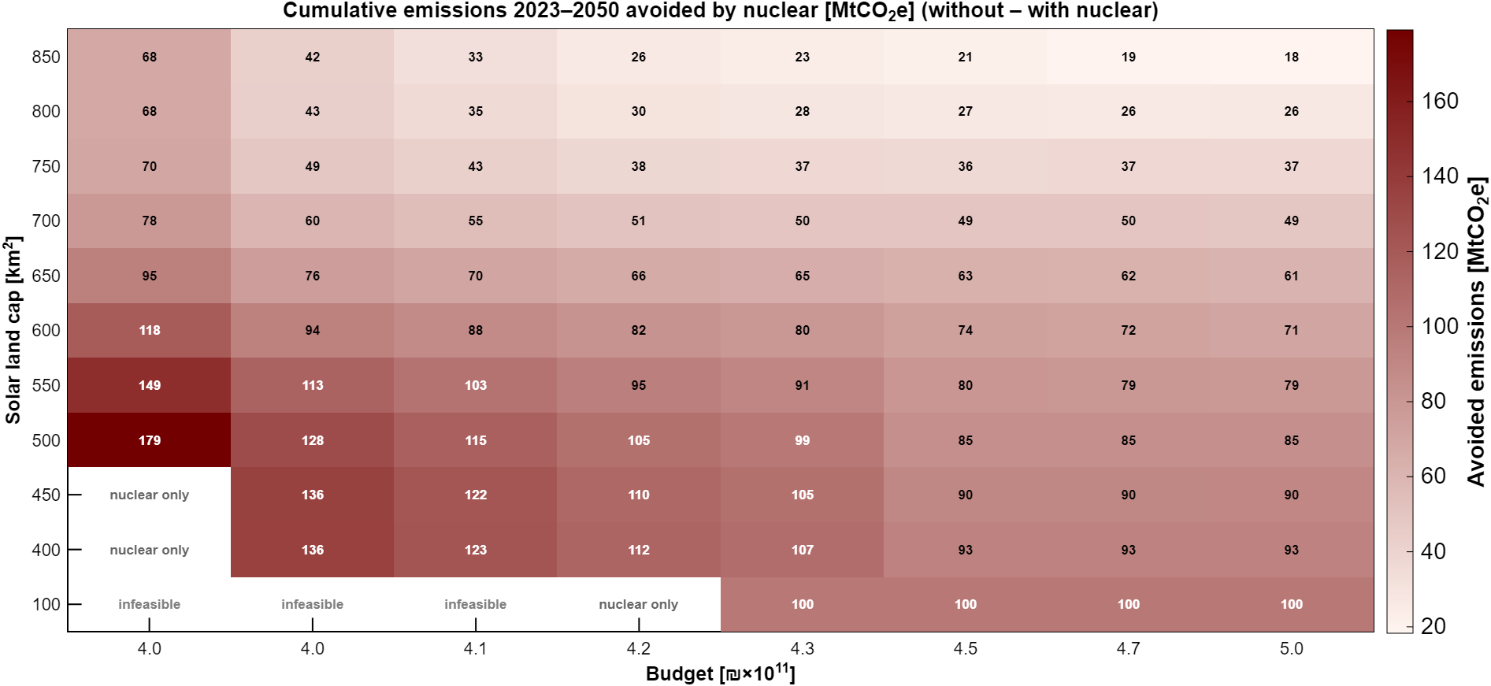
Figure 16 - Cumulative emissions 2023–2050 avoided by nuclear [MtCO₂e] (difference between the scenarios without and with nuclear) for each budget and land cap
Figure 16 shows the cumulative emissions avoided by nuclear in every cell of the grid. Nuclear reduces emissions in all 94 cells that are feasible in both runs, by between 36 and 184 MtCO₂e. Two patterns stand out. First, for budgets of ₪430×10⁹ and above, the avoided emissions decline steadily with land availability, from about 100 MtCO₂e at 100 km² and about 93 MtCO₂e at 400 km² to about 38 MtCO₂e at 850 km²; in relative terms, nuclear reduces cumulative emissions by about 12% at 400 km² but only by about 7% at 850 km². Nuclear thus acts as a partial substitute for land. Second, the largest reductions (121–184 MtCO₂e) occur at the lowest budget, where the costs saved by nuclear relax the binding budget constraint and allow more renewable capacity to be built earlier.
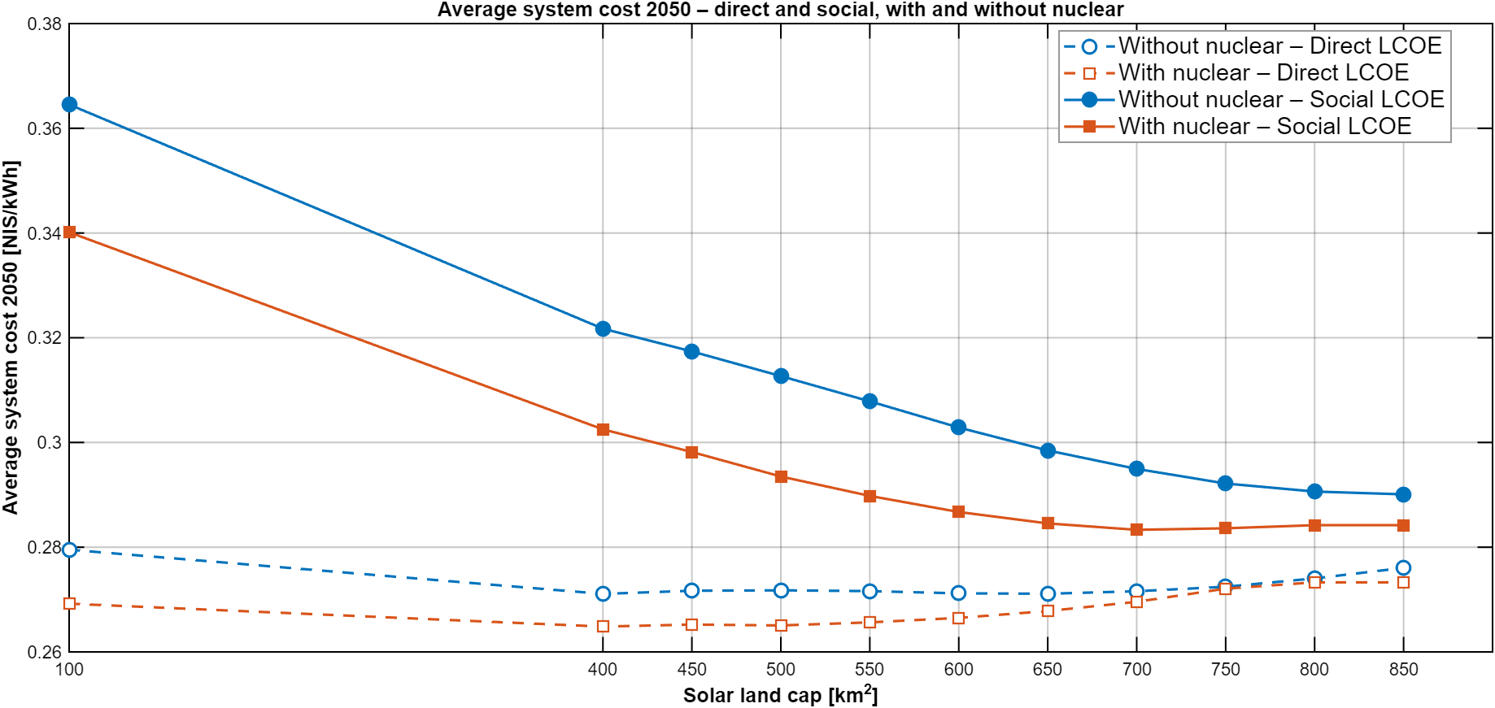
Figure 17 - Direct and social average system cost in 2050 (direct cost plus carbon cost at 200 NIS/tCO₂e) for the representative scenarios with and without nuclear
Figure # compares the average system cost in 2050 of the representative scenarios. In direct terms, nuclear lowers the cost when land is scarce—about 0.269 versus 0.279 NIS/kWh at 100 km² and about 0.268 versus 0.273 NIS/kWh at 400–550 km²—while above about 750 km² the system with nuclear becomes slightly more expensive (about 0.277–0.280 versus 0.275–0.276 NIS/kWh), since nuclear output increasingly overlaps with solar generation. In social terms, which include the carbon cost, the system with nuclear is cheaper across the whole range: about 0.340 versus 0.364 NIS/kWh at 100 km² and about 0.305 versus 0.323 NIS/kWh at 400 km², with the gap narrowing to about 0.002 NIS/kWh at 850 km². With nuclear, the social cost reaches its minimum of about 0.285 NIS/kWh at 700–750 km², whereas without nuclear it continues to decline up to 850 km² (0.290 NIS/kWh).
Overall, the nuclear scenarios indicate that a limited amount of firm low-carbon capacity is most valuable when land for solar deployment is scarce: it substantially reduces cumulative emissions and costs at small land caps, while its additional benefit diminishes as land availability increases. In 2050, nuclear lowers emissions from about 45 to 33 MtCO₂e at 400 km² and from about 12 to 8 MtCO₂e at 850 km².

3.8 Sensitivity analyses
This section examines how the main results depend on two key assumptions—the pace at which capacity can be built and the land available for solar deployment—and locates the economic optimum of the system.

3.8.1 Build-rate assumptions
The main analysis assumes a time-varying build-rate schedule for solar PV and battery storage (Section 2.3). To assess the role of this assumption, the full scenario grid was also solved with a constant build-rate limit of 4 GW per year (budgets of ₪400–480×10⁹ and land caps of 100 and 400–850 km²). With the constant limit, the renewable share in 2050 saturates at about 92% at 850 km², and additional budget above about ₪450×10⁹ yields no further reduction in emissions, because battery storage reaches its build-rate limit in every year of the horizon. At the lowest budget (₪400×10⁹), land caps of 700–850 km² are not fully utilized and the renewable share is limited to about 77%; five scenarios are infeasible.
[Comparison with the main analysis – to be completed after the final runs: differences in renewable share, cumulative emissions, feasibility and the budget at which saturation occurs.]
[Insert figure: cumulative emissions vs. budget under the constant (4 GW/yr) and time-varying build-rate limits]
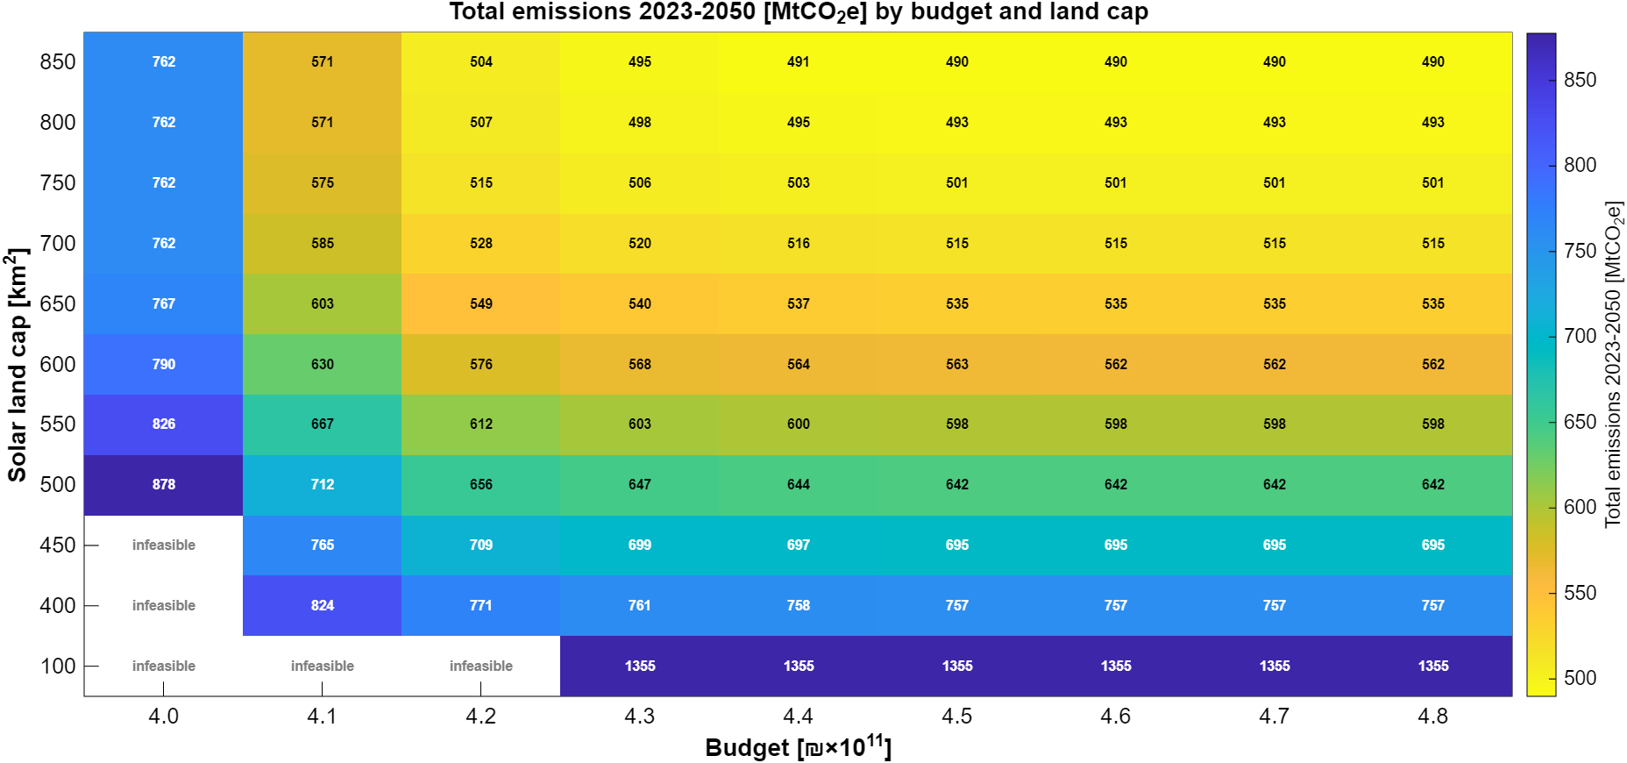
Figure # - Cumulative emissions 2023–2050 as a function of the budget under a constant build-rate limit of 4 GW per year and under the time-varying schedule (selected land caps)

###the 4G results:

3.1 Hourly system behavior and operational patterns

To establish an operational understanding of the modeled electricity system, this section examines its hourly behavior across representative time slices and over the full planning horizon. Figures 4–6 present the hourly generation mix, storage activity, and demand coverage under different temporal perspectives, highlighting how system dynamics evolve across seasons and over time.

shows the hourly generation mix during a representative winter week in January 2050. During this period, solar generation is relatively moderate, with shorter daylight hours and lower peak output. As a result, gas-fired generation plays a dominant balancing role, particularly during evening and nighttime hours when solar production is unavailable. Battery discharge contributes primarily during peak demand hours, while charging activity remains limited due to reduced solar surplus. Curtailment is minimal in this period, reflecting the closer alignment between generation and demand under winter conditions.
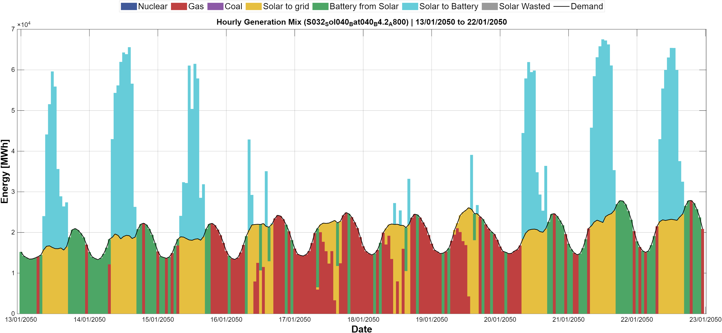
Figure 4 - Generation mix, hourly resolution, winter week (January 2050)
In contrast, Figure 4 illustrates the system's behavior during a representative summer week in June 2050. Solar generation reaches significantly higher levels, driven by longer daylight hours and higher capacity factors. This leads to pronounced midday surpluses, which are partially absorbed through battery charging. Battery discharge becomes a central mechanism for shifting solar energy from midday to evening and from one day to another. Despite this flexibility, visible levels of solar curtailment emerge during peak production hours, indicating that storage capacity and demand-side absorption are insufficient to fully utilize all available solar output. Gas generation is substantially reduced during daylight hours and is primarily dispatched during nighttime and residual balancing periods.
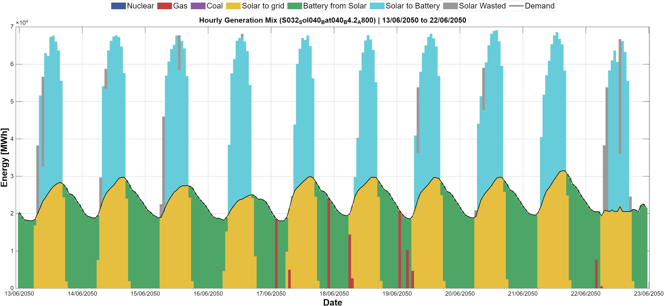
Figure 3 - Generation mix, hourly resolution, summer week (June 2050)
Figure 5 presents the hourly generation mix for a representative year (2050), illustrating system operation over 8,760 hourly time steps under a high-renewable configuration. The figure highlights the dominant role of solar generation during daytime hours, alongside pronounced daily and seasonal variability. Battery activity emerges as a central balancing mechanism, charging primarily during periods of high solar output and discharging during evening and night hours when solar generation declines. Gas-fired generation persists as a residual dispatchable resource, contributing mainly during periods of low renewable availability and increased demand. Seasonal patterns are clearly visible, with extended summer periods characterized by sustained solar surpluses and increased levels of curtailment, and winter periods showing greater reliance on dispatchable generation and storage discharge. Importantly, the figure demonstrates that high renewable penetration does not eliminate temporal variability in the system. Instead, variability is redistributed across technologies, with storage and curtailment becoming integral components of system balancing rather than marginal features.
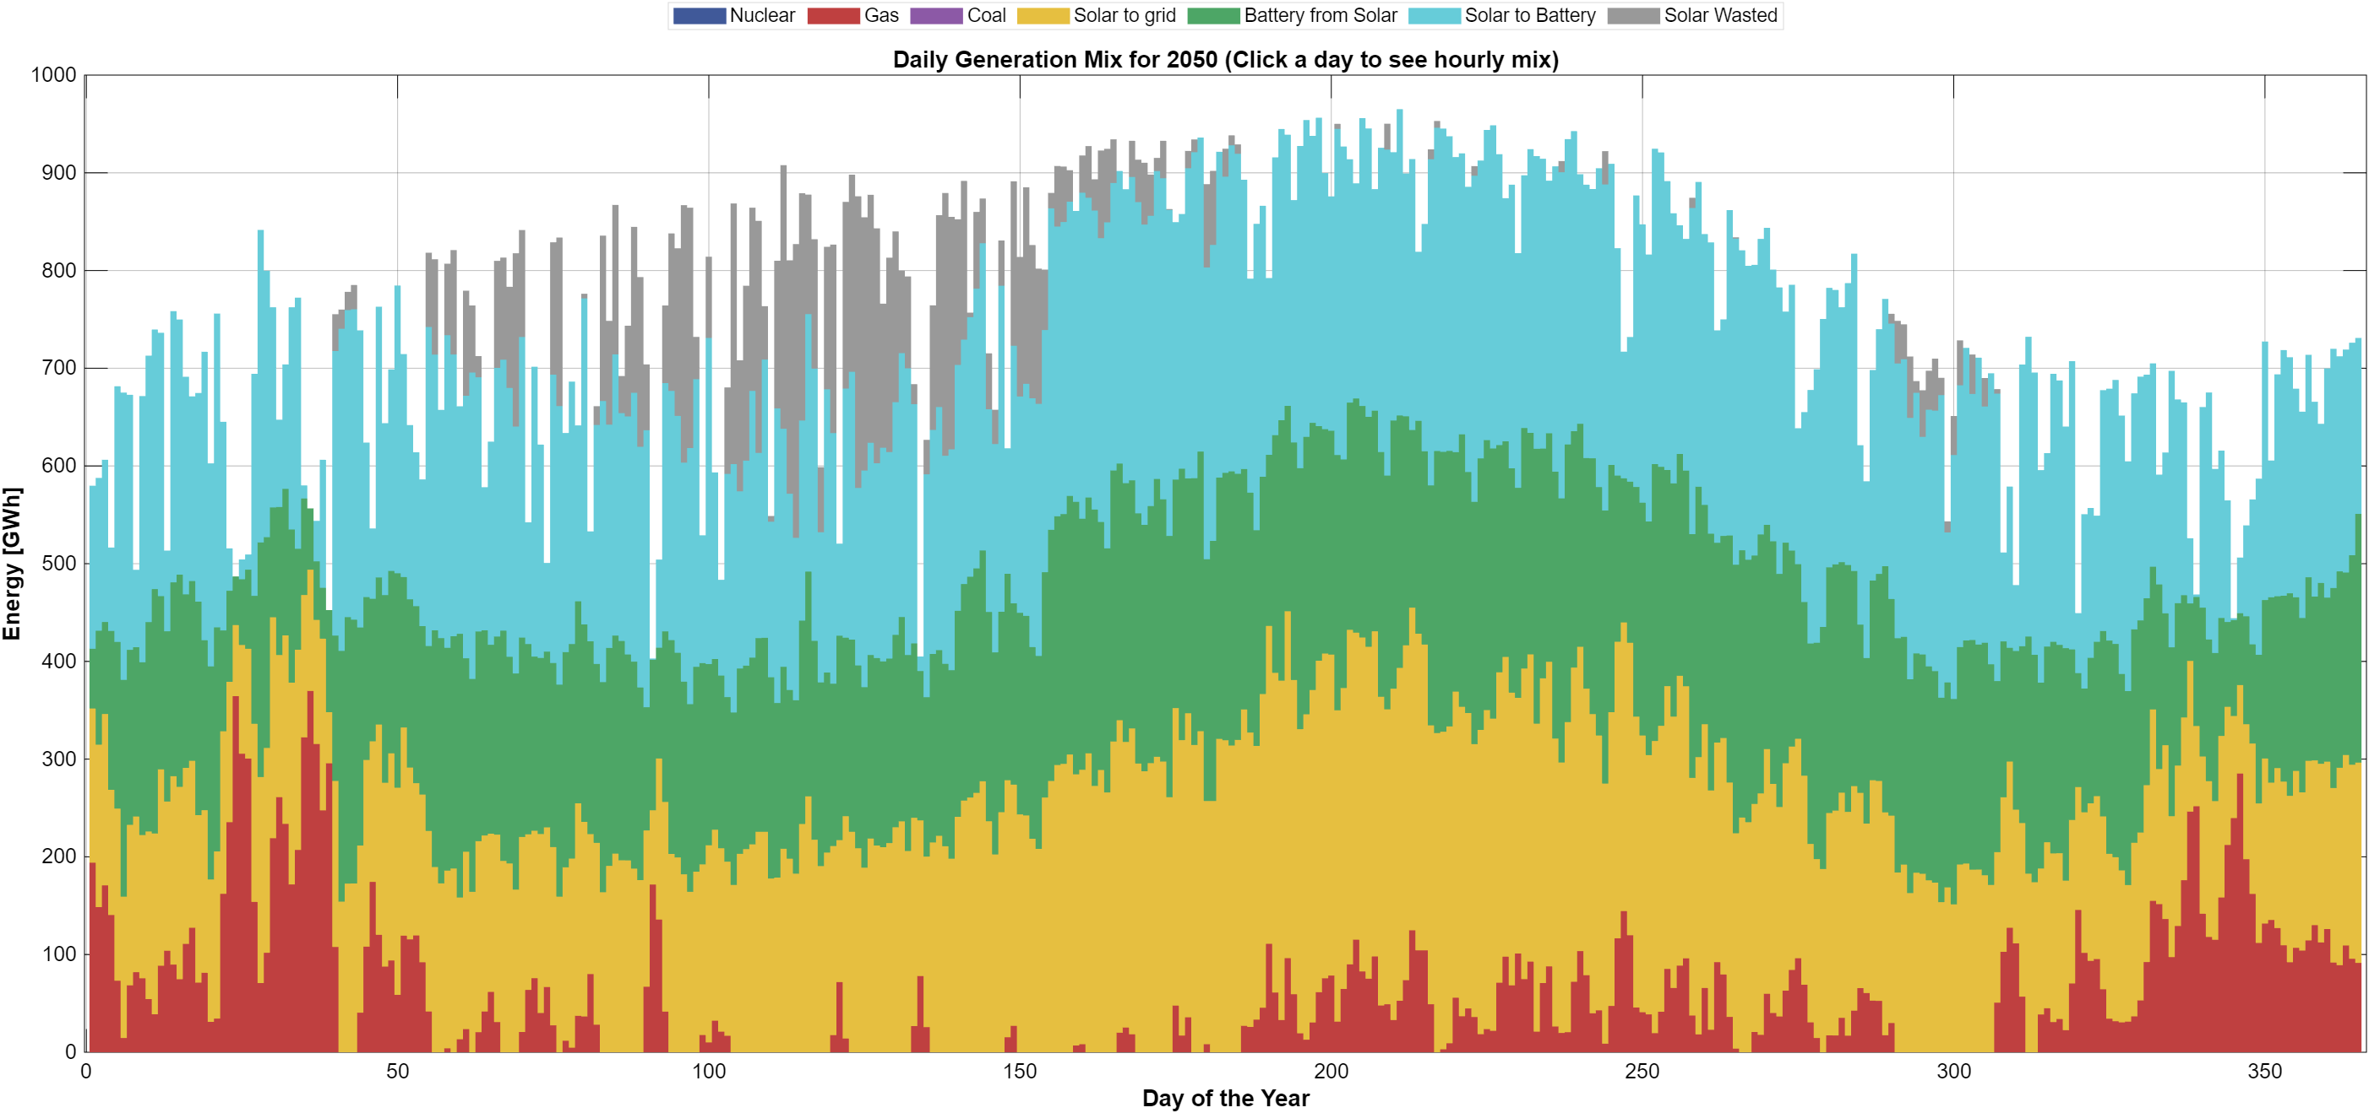
Figure 4 Generation mix in hourly resolution 2050 88 RE%
Taken together, the hourly results demonstrate that high renewable penetration fundamentally reshapes system operation rather than smoothing it. Temporal mismatches between generation and demand remain a defining feature, particularly under high solar deployment. Battery storage mitigates these mismatches by reallocating energy across hours yet cannot fully eliminate surplus generation during peak solar periods. These operational patterns provide essential context for the system-level relationships between land use, cost, renewable penetration, and emissions examined in the following sections.

3.2 System feasibility space: land, cost and renewable penetration

This section examines the relationship between renewable penetration in 2050 and the two system-level constraints that define the feasible solution space: the cumulative budget and the available solar land. Figure 6 presents the renewable share in 2050 as a function of the cumulative budget and the upper bound on solar land deployment, both as a heatmap in which each cell corresponds to one scenario and as a three-dimensional mesh. A numerical table of Figure 6 is found in the appendices.
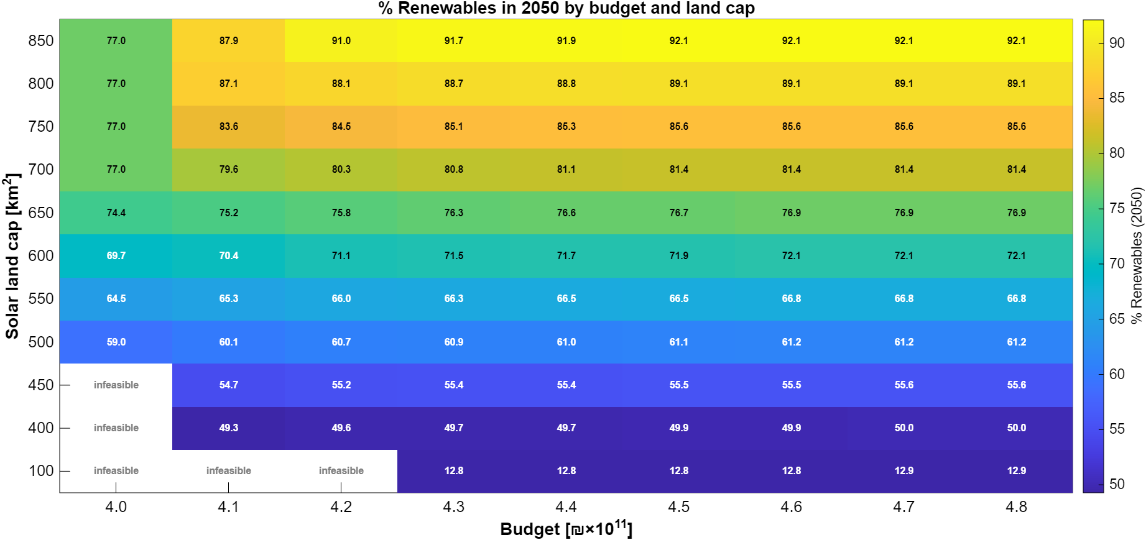

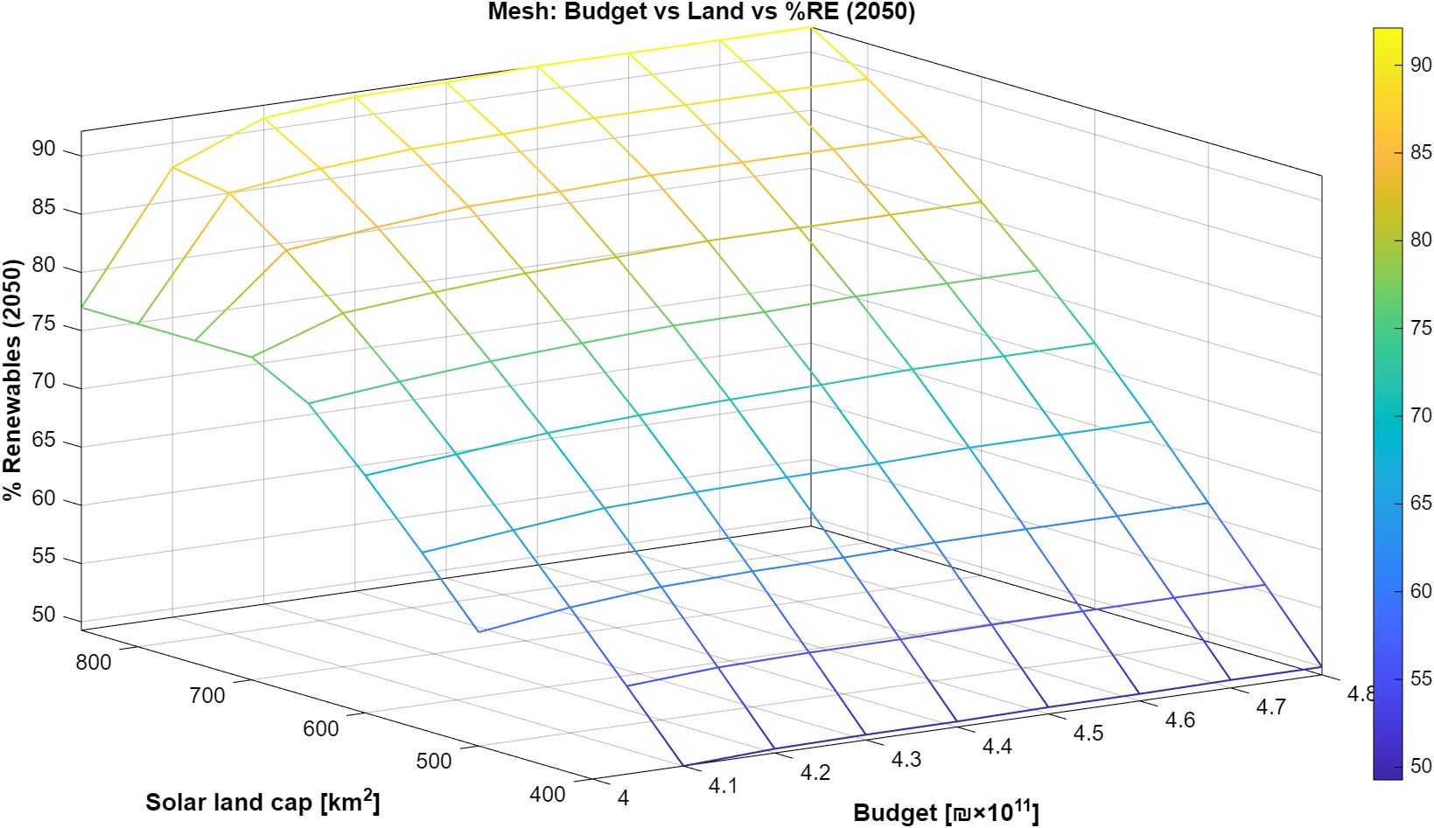
Figure 5 - Feasible renewable penetration in 2050 as a function of the cumulative budget and solar land availability (heatmap and 3D mesh)

Land availability is the primary driver of renewable penetration. Along the land axis, the renewable share in 2050 increases from about 50% at 400 km² to about 92% at 850 km², whereas for a given land cap it changes by only one to four percentage points along the budget axis once the budget exceeds ₪410×10⁹. The low-land benchmark (100 km²) remains at about 13% renewables in 2050, close to the current share of renewables in the Israeli electricity mix.
The budget is a binding constraint mainly at the lower end of the examined range. Above approximately ₪450×10⁹ the surface becomes flat: additional budget yields no further increase in the renewable share. In this region the binding constraints are the land cap and the annual build-rate limit of battery storage, which is reached in every year of the horizon (about 108 GW of battery power in 2050). Conversely, at the lowest budget (₪400×10⁹) the land caps of 700–850 km² are not fully utilized, and the renewable share is limited to 77% by the budget rather than by land.
Five of the 99 scenarios are infeasible: the 100 km² land cap with budgets of ₪400–420×10⁹, and the 400 and 450 km² land caps with a budget of ₪400×10⁹. In these cases the budget cannot cover the required capacity expansion together with the fuel and carbon costs of the remaining gas generation. Notably, once its carbon cost is included, the fossil-dominated system requires a larger budget (at least ₪430×10⁹) than systems with more than 85% renewables (₪410×10⁹).
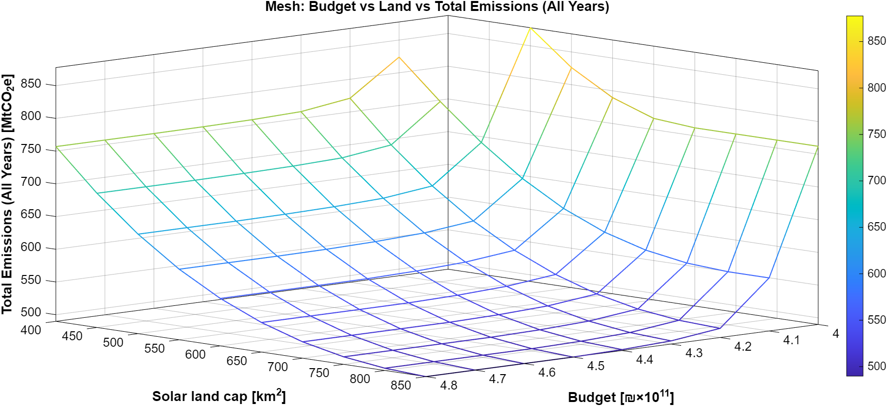
Figure 6 - Total cumulative emissions (all years) as a function of the cumulative budget and solar land availability (3D mesh).

While Figure 6 focuses on the renewable share in the target year, Figure 7 shows the corresponding cumulative emissions over the full horizon (2023–2050), again as a heatmap and as a mesh. Cumulative emissions range from about 1,355 MtCO₂e in the low-land benchmark to about 490 MtCO₂e at 850 km² and budgets of ₪450×10⁹ or more. Base-year (2023) emissions in the model are 33.2 MtCO₂e.
In contrast to the 2050 renewable share, cumulative emissions respond strongly to the budget at the low end of the range. At 500 km², for example, raising the budget from ₪400×10⁹ to ₪420×10⁹ lowers cumulative emissions from about 878 to about 656 MtCO₂e (−25%), while the renewable share in 2050 increases only from 59.0% to 60.7%. The additional budget allows solar and storage capacity to be built earlier, within the build-rate limits, and thereby displaces gas-fired generation in the intermediate decades. Early investment therefore matters for cumulative emissions even when the end-state system is constrained by land. This effect saturates above approximately ₪440–450×10⁹.
Overall, Figures 6 and 7 define the envelope within which all modeled scenarios operate. Renewable penetration emerges from the interaction between land and budget, with land as the dominant constraint for the end-state system and the budget as the dominant factor for the timing of the transition and hence for cumulative emissions.

3.3 Energy balance and demand coverage in 2050
This section examines how electricity demand in 2050 is met across the full set of modeled scenarios, focusing on the composition of annual energy supply and the role of different technologies in covering demand. Figure 8 presents the annual electricity balance in 2050, showing the contributions of solar generation, gas-fired generation, battery discharge, and curtailed energy across all scenarios.

Despite identical demand levels, the figure reveals substantial variation in how demand is supplied. Scenarios with lower renewable penetration rely predominantly on gas generation, with solar contributing a smaller share and storage playing a limited role. Curtailment in these cases is negligible, reflecting the close alignment between generation and demand under fossil-dominated configurations.

As renewable penetration increases, solar generation becomes the dominant source of electricity. This shift is accompanied by a growing contribution from battery discharge, indicating the increasing importance of storage in redistributing solar energy across time. At the same time, curtailed solar energy emerges as a significant component in high-renewable scenarios, reflecting the structural surplus generated during periods of high solar output that cannot be fully absorbed by demand or storage.

The figure also illustrates that increases in renewable penetration do not translate into proportional reductions in dispatchable generation. Gas-fired generation remains present across most scenarios, albeit at declining levels, serving as a residual balancing source during periods when solar and storage are insufficient. This highlights that even under high renewable shares, demand coverage relies on a combination of variable generation, storage, and dispatchable capacity.
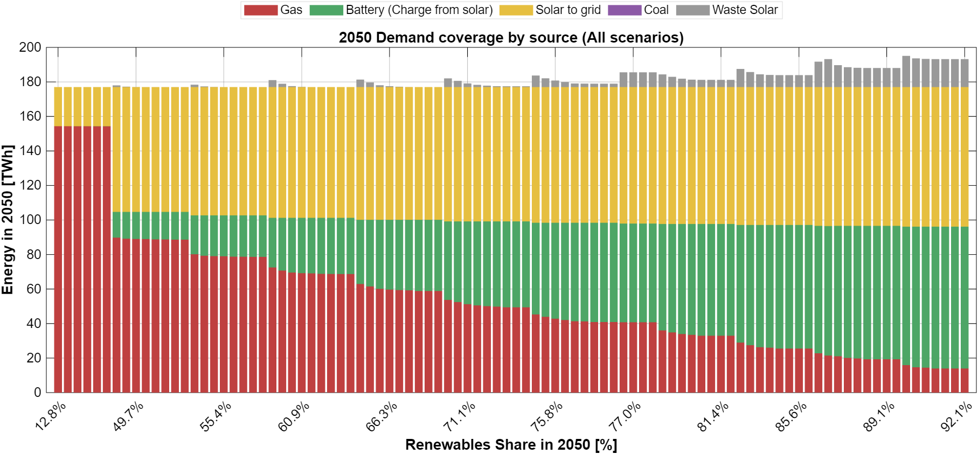
Figure 7 - Annual electricity demand coverage and generation mix in 2050 across all scenarios

Figure 8 shows that meeting electricity demand in 2050 involves a reconfiguration of the supply mix rather than a simple substitution of technologies. Higher renewable penetration is associated with increased solar deployment, expanded storage utilization, and rising curtailment, while dispatchable generation continues to play a complementary role. These aggregate energy balance outcomes provide the basis for examining the corresponding infrastructure requirements and capacity levels in the following section.

3.4 System cost structure in 2050 – representative scenarios

Following the characterization of the full scenario space, the analysis now focuses on a set of representative scenarios. As described in Section 2.3, the representative scenarios share a fixed budget of ₪420×10⁹—the lowest budget at which all land caps between 400 and 850 km² are feasible and fully utilized—and differ only in land availability. The low-land benchmark (100 km²), which is infeasible at this budget, is represented at its lowest feasible budget (₪430×10⁹). The resulting eleven scenarios span renewable shares of 12.8% (100 km²) and 49.6–91.0% (400–850 km²) in 2050, in steps of about five percentage points.
The average system cost reported in this section is the cost of the generation system only: the annual capital payments (CAPEX) and the fixed and variable operating costs (OPEX) of generation and storage in 2050, divided by the electricity delivered in that year, in undiscounted 2050 NIS. It does not include transmission and distribution networks, system services, taxes or retail margins, and is therefore considerably lower than the retail electricity tariff (about half a shekel per kWh today). The carbon cost included in the budget (200 NIS/tCO₂e) is shown separately.

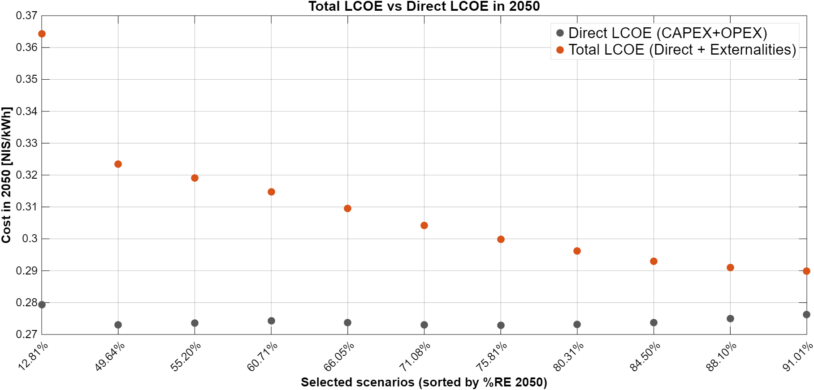
Figure 8 - Direct average system cost (CAPEX + OPEX) and total average system cost (direct + carbon cost) in 2050 – representative scenarios

Figure 9 shows the direct average system cost in 2050. The fossil-dominated benchmark (12.8% renewables) has the highest direct cost, about 0.279 NIS/kWh. For renewable shares between 49.6% and 84.5% the direct cost is almost constant at 0.273–0.274 NIS/kWh, and it rises slightly to 0.275–0.276 NIS/kWh at 88–91%. Since all representative scenarios between 400 and 850 km² share the same budget, the result can be read as follows: for the same budget, more land raises the renewable share in 2050 from 50% to 91% at a practically unchanged direct cost per kWh.
The high direct cost of the fossil-dominated system in 2050 results from the rising variable cost of gas generation, which almost doubles over the horizon (from about 115 to about 231 NIS/MWh). Over the full horizon the picture differs: in present-value terms, the cumulative direct cost (CAPEX and OPEX) of the benchmark is about ₪310×10⁹, compared with about ₪345×10⁹ in the 400 km² scenario. Fossil-heavy systems are therefore cheaper in the early years but become the most expensive by 2050; the difference in total budget is accounted for by the carbon cost (about ₪120×10⁹ in the benchmark versus ₪60–75×10⁹ in the representative renewable scenarios).
Figure 9 also shows the total (social) average system cost, i.e. the direct cost plus the carbon cost. The carbon cost amounts to about 0.085 NIS/kWh in the benchmark, about 0.05 NIS/kWh at 50% renewables and about 0.014 NIS/kWh at 91%. As a result, the total average system cost declines monotonically from about 0.364 NIS/kWh in the benchmark to about 0.323 NIS/kWh at 50% renewables and to about 0.290 NIS/kWh at 91%: once the carbon cost is accounted for, the cleanest representative system is also the cheapest.
Figure 10 decomposes the annual system cost in 2050 into CAPEX, OPEX and carbon cost by technology. The total annual cost declines from about ₪64×10⁹ in the benchmark to about ₪57×10⁹ at 50% renewables and about ₪51×10⁹ at 91%. At low renewable shares the system is OPEX-dominated: gas operating costs alone amount to about ₪41×10⁹ in the benchmark. As the renewable share increases, gas OPEX falls to about ₪9×10⁹ at 91%, while capital payments for solar PV (about ₪19×10⁹) and battery storage become the dominant cost components, and the carbon cost falls from about ₪15×10⁹ to about ₪2×10⁹. Deep decarbonization therefore changes the structure of the electricity system from an OPEX- and emissions-intensive system into a capital-intensive, low-emission infrastructure, at a similar direct cost per kWh.

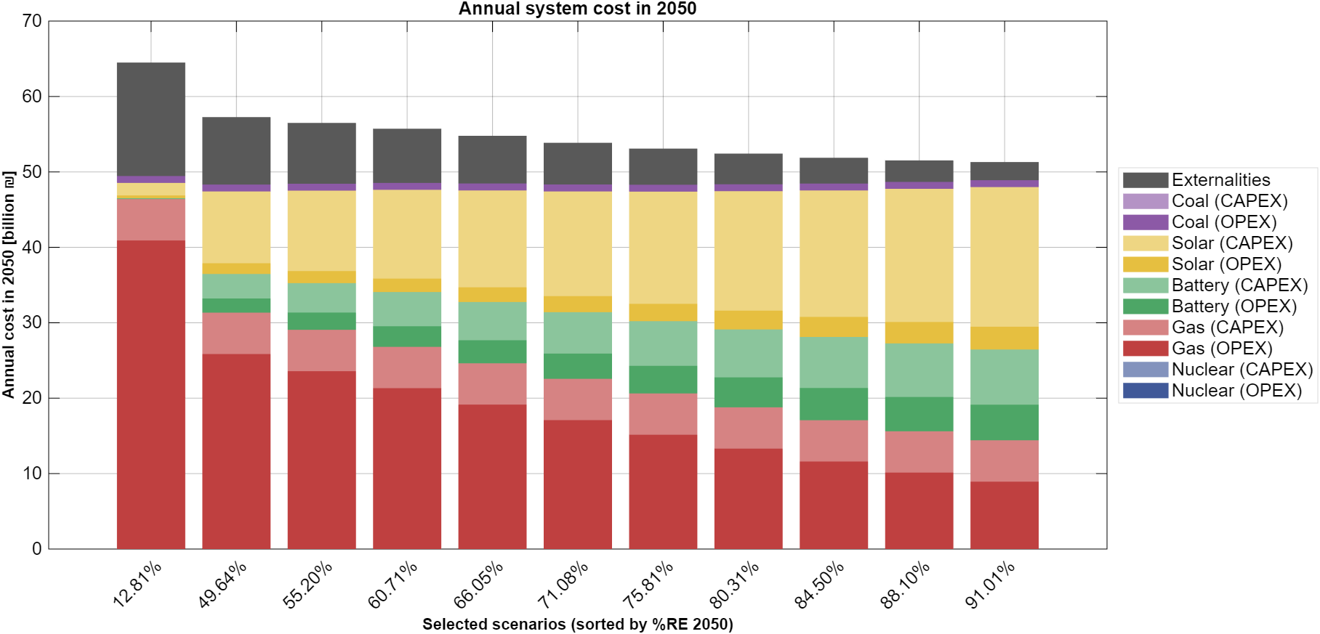
Figure 9 - Annual system cost in 2050 decomposed by source (OPEX + CAPEX + carbon cost) for the representative scenarios

Figure 19 (Section 4.2) presents the same cost results against the carbon intensity of electricity supply in 2050, which provides a direct view of the cost of reducing emissions within the representative set.
The results of the nuclear variants are presented in Section 3.7.

3.5 Emissions in 2050 by source - representative scenarios
This subsection examines the emissions outcomes in the target year 2050 for the representative scenarios, focusing on the composition of emissions by generation source. While the previous section characterized cumulative emissions across the full modeling horizon, the present analysis isolates the end-state emissions profile, which is of direct relevance to net-zero policy targets.

Figure 11 presents greenhouse gas emissions in 2050 disaggregated by source for the representative scenarios, ordered by increasing renewable share. A clear monotonic decline in total emissions is observed as renewable penetration increases. This reduction is driven almost entirely by the displacement of gas-fired generation, which remains the dominant source of emissions across all scenarios in which it is present.
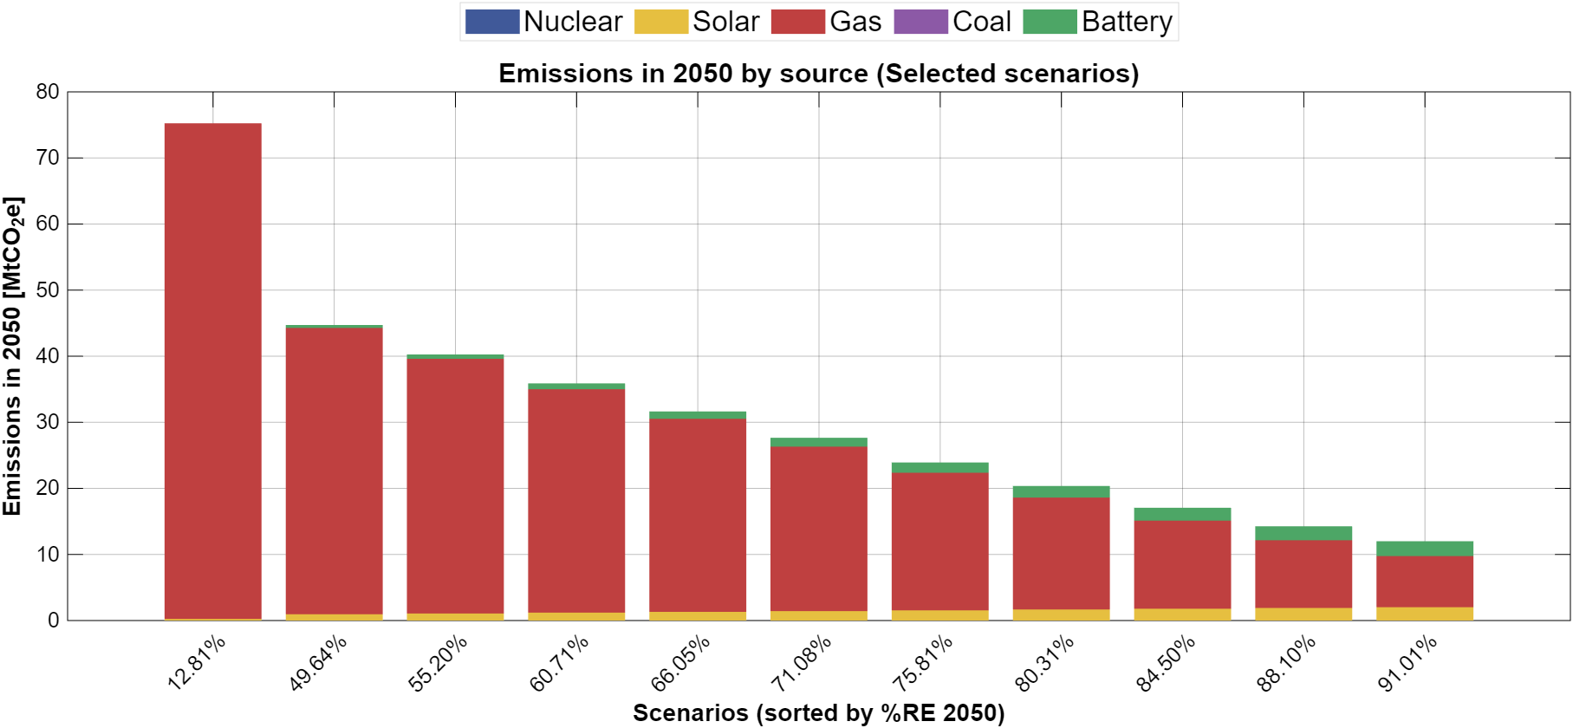
Figure 10- Emissions in 2050 by generation source for the representative scenarios

Emissions in 2050 decrease from about 75 MtCO₂e in the fossil-dominated benchmark to about 45 MtCO₂e at 50% renewables and to about 12 MtCO₂e at 91%. Gas remains the dominant source of emissions in all scenarios. Life-cycle emissions of solar PV and battery storage are small but not zero; their absolute level grows with installed capacity, and at 91% renewables they account for about one third of the residual emissions (about 4 MtCO₂e).
The results indicate that intermediate renewable targets already deliver substantial emissions reductions, while near-zero emissions in the electricity sector require pushing renewable penetration to the upper end of the feasible space, which in turn depends on the availability of land for solar deployment.

3.6 Installed capacities and infrastructure scale in 2050 – representative scenarios

This section examines the generation and storage capacities installed in 2050 in the representative scenarios, and how capacity expansion translates into operational system behavior.
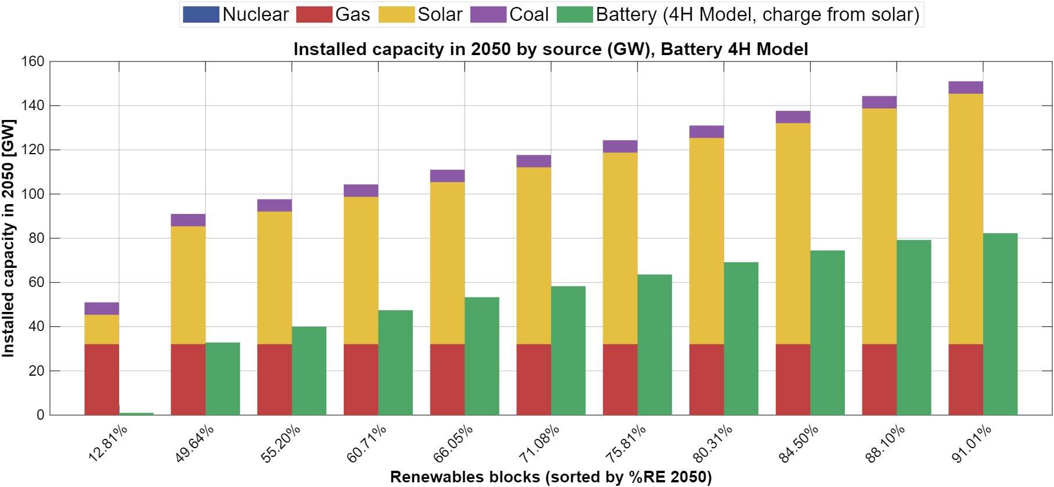
Figure 11 – Installed generation and storage capacities in 2050 across the representative scenarios

Figure 12 presents the installed capacities of the main system components in 2050 in the representative scenarios. Solar PV constitutes the largest share of installed capacity in all scenarios except the low-land benchmark, and its capacity is determined directly by the land cap (about 133 MW per km²): it grows from about 13 GW in the benchmark to 53 GW at 400 km² and 113 GW at 850 km². Battery storage increases systematically with the renewable share, from about 33 GW at 50% to about 82 GW at 91%, reflecting the growing need to shift solar energy from midday to evening and night hours.
About 20 GW of new gas capacity is built in all scenarios, so that gas capacity reaches about 32 GW in 2050 regardless of the renewable share. This capacity is determined by the reserve-margin requirement during critical hours, in which solar output is zero and battery storage is not counted as firm capacity. Gas therefore remains a central reliability resource even in scenarios in which it supplies only about 10% of annual demand.

Beyond installed capacity levels, the operational behavior of battery storage provides additional insight into system dynamics. Figures 13 and 14 illustrate the battery state-of-charge trajectories for a representative high-renewable scenario
(RE ≈ 88%) during the winter (Figure 13) and summer (Figure 14) periods of 2050. In summer, battery operation is characterized by pronounced daily charge–discharge cycles, with charging during midday solar surpluses and discharging during evening and nighttime demand peaks. These patterns demonstrate that storage primarily functions as an intra-day balancing mechanism, rather than as a means of seasonal energy shifting.
In winter, battery operation exhibits greater variability and longer discharge events. Extended periods of low solar availability lead to multi-day depletion episodes, during which the battery approaches low state-of-charge levels. This behavior indicates that even substantial storage capacity cannot fully eliminate temporal mismatches between generation and demand, particularly during prolonged low-renewable periods. Instead, storage mitigates but does not resolve these structural imbalances, reinforcing the continued need for dispatchable backup capacity.
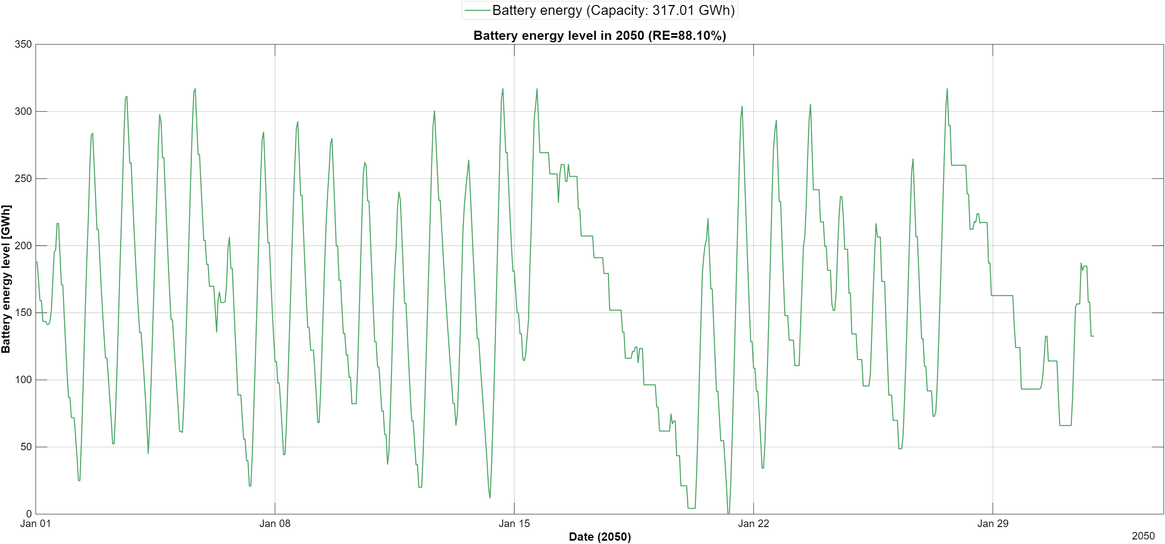
Figure 12 - Battery energy level in winter 2050

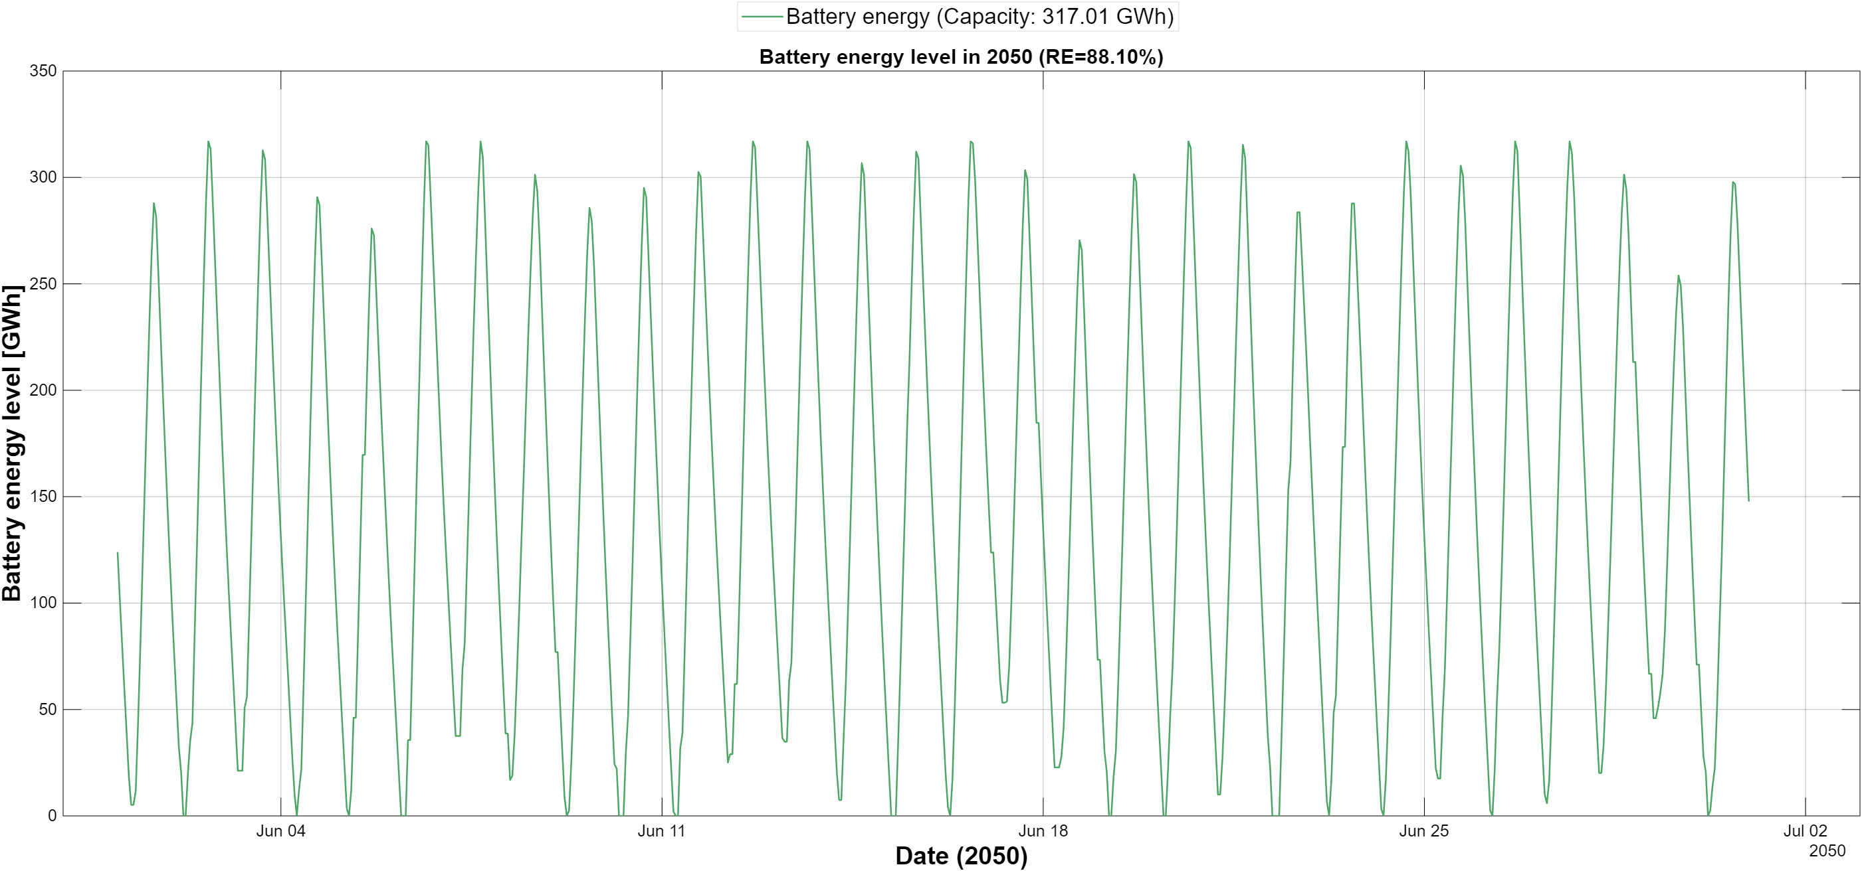
Figure 13 - Battery energy level in summer 2050

While the previous figures focus on end-year infrastructure, Figure 15 illustrates the temporal evolution of installed capacity for a representative high-renewable scenario. Capacity expansion follows a gradual and cumulative trajectory over the planning horizon, in line with the annual build-rate limits and the budget constraint, with no abrupt build-out at the end of the horizon.
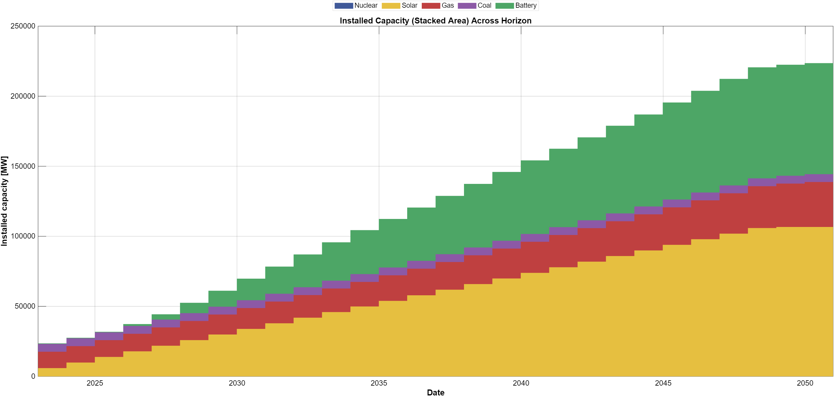
Figure 14 - Installed capacity evolution across the planning horizon for a representative 88% scenario
The continued presence of gas capacity reflects its role as a flexibility and reliability resource rather than a primary energy supplier. Even in scenarios with high renewable shares, dispatchable capacity is retained to address periods of low renewable availability and system stress, emphasizing that decarbonization does not eliminate the need for firm capacity.

Overall, this section shows that pathways to high renewable penetration are characterized by large solar deployment determined by land availability, rapidly growing battery storage, and a stable fleet of gas capacity required for reliability. Storage mitigates but does not eliminate the need for dispatchable backup capacity.

3.7 Nuclear scenarios
To examine the role of firm low-carbon capacity, the full scenario grid was repeated with nuclear additions enabled, using the same model, parameters and solver settings. In these scenarios up to 3 GW of nuclear capacity can be built at a single build point at the end of 2042 and is operated as must-run baseload. In all 97 feasible nuclear scenarios the model builds the maximum allowed capacity (3 GW), which supplies about 26 TWh per year, roughly 15% of demand in 2050. Nuclear capacity replaces gas one-for-one in the reserve-margin requirement, so that gas capacity in 2050 is about 29 GW instead of about 32 GW.
Nuclear also enlarges the feasible space. Three scenarios that are infeasible without nuclear—the 400 and 450 km² land caps at ₪400×10⁹ and the 100 km² land cap at ₪420×10⁹—become feasible, and only the two lowest budgets at 100 km² remain infeasible. Because nuclear displaces gas generation in 2043–2050, it saves fuel and carbon costs within the budget, which can then be used for additional solar and storage capacity. Note that in the nuclear scenarios the reported share of generation includes nuclear and is therefore a low-carbon share rather than a renewable share.
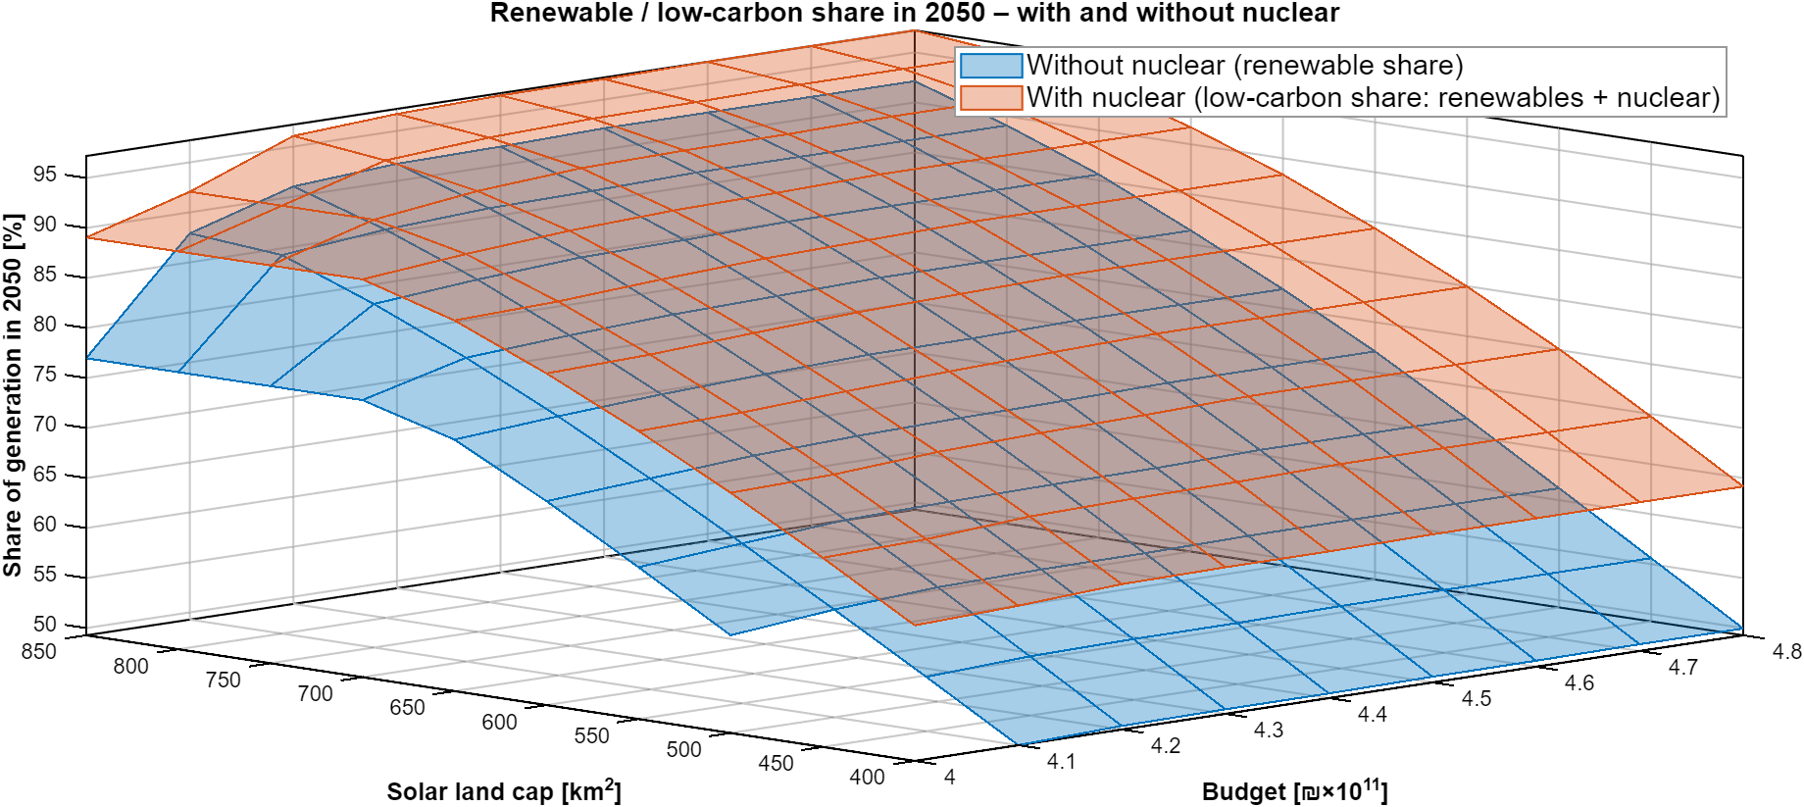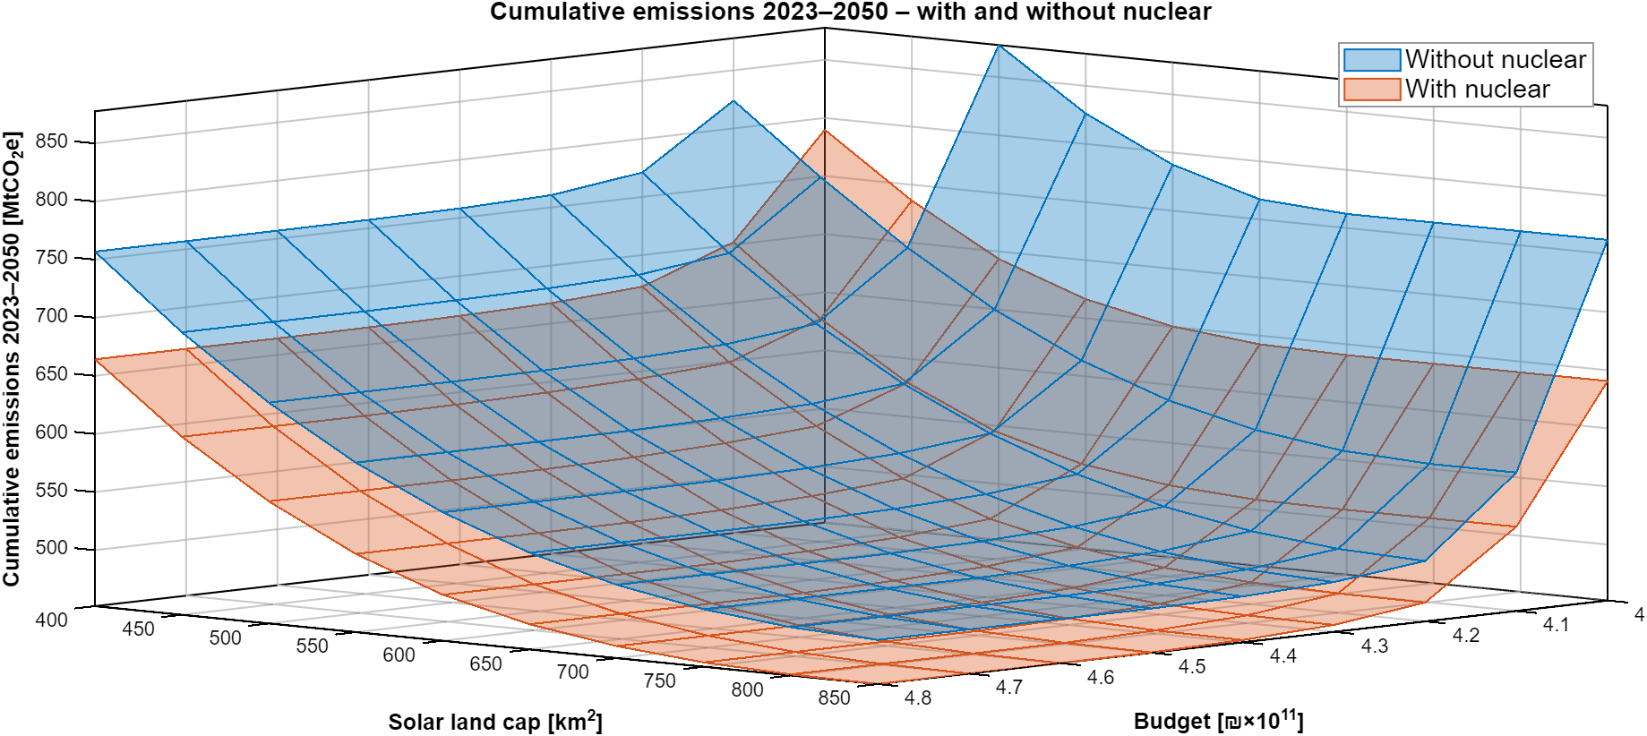
Figure 15 - Renewable / low-carbon share in 2050 (top) and cumulative emissions 2023–2050 (bottom) as a function of the cumulative budget and solar land availability, with and without nuclear
Figure 15 compares the two scenario grids. The low-carbon surface with nuclear lies above the renewable surface without nuclear across the entire space, but the gap narrows with land availability: in the representative scenarios it amounts to about 14 percentage points at 400 km² (63.8% versus 49.6%) and about 5 points at 850 km² (96.1% versus 91.0%). At large land caps a growing part of the nuclear output coincides with hours of solar surplus, so that its marginal contribution decreases. The emissions surfaces show the same pattern in reverse, and both pairs of surfaces flatten at the same budget level, indicating that nuclear does not remove the land and build-rate limits that determine saturation.

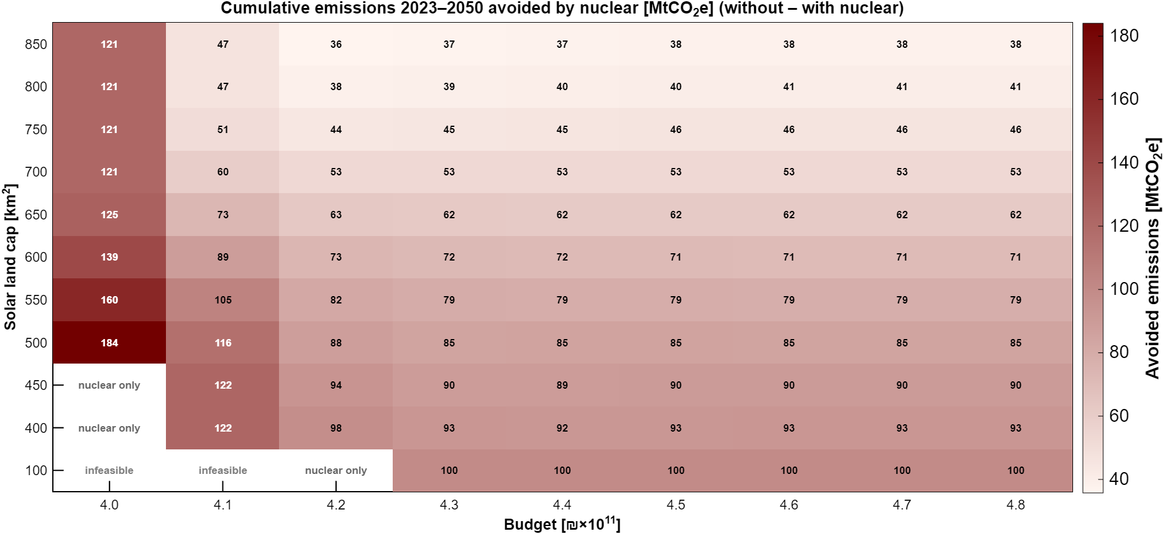
Figure 16 - Cumulative emissions 2023–2050 avoided by nuclear [MtCO₂e] (difference between the scenarios without and with nuclear) for each budget and land cap
Figure 16 shows the cumulative emissions avoided by nuclear in every cell of the grid. Nuclear reduces emissions in all 94 cells that are feasible in both runs, by between 36 and 184 MtCO₂e. Two patterns stand out. First, for budgets of ₪430×10⁹ and above, the avoided emissions decline steadily with land availability, from about 100 MtCO₂e at 100 km² and about 93 MtCO₂e at 400 km² to about 38 MtCO₂e at 850 km²; in relative terms, nuclear reduces cumulative emissions by about 12% at 400 km² but only by about 7% at 850 km². Nuclear thus acts as a partial substitute for land. Second, the largest reductions (121–184 MtCO₂e) occur at the lowest budget, where the costs saved by nuclear relax the binding budget constraint and allow more renewable capacity to be built earlier.
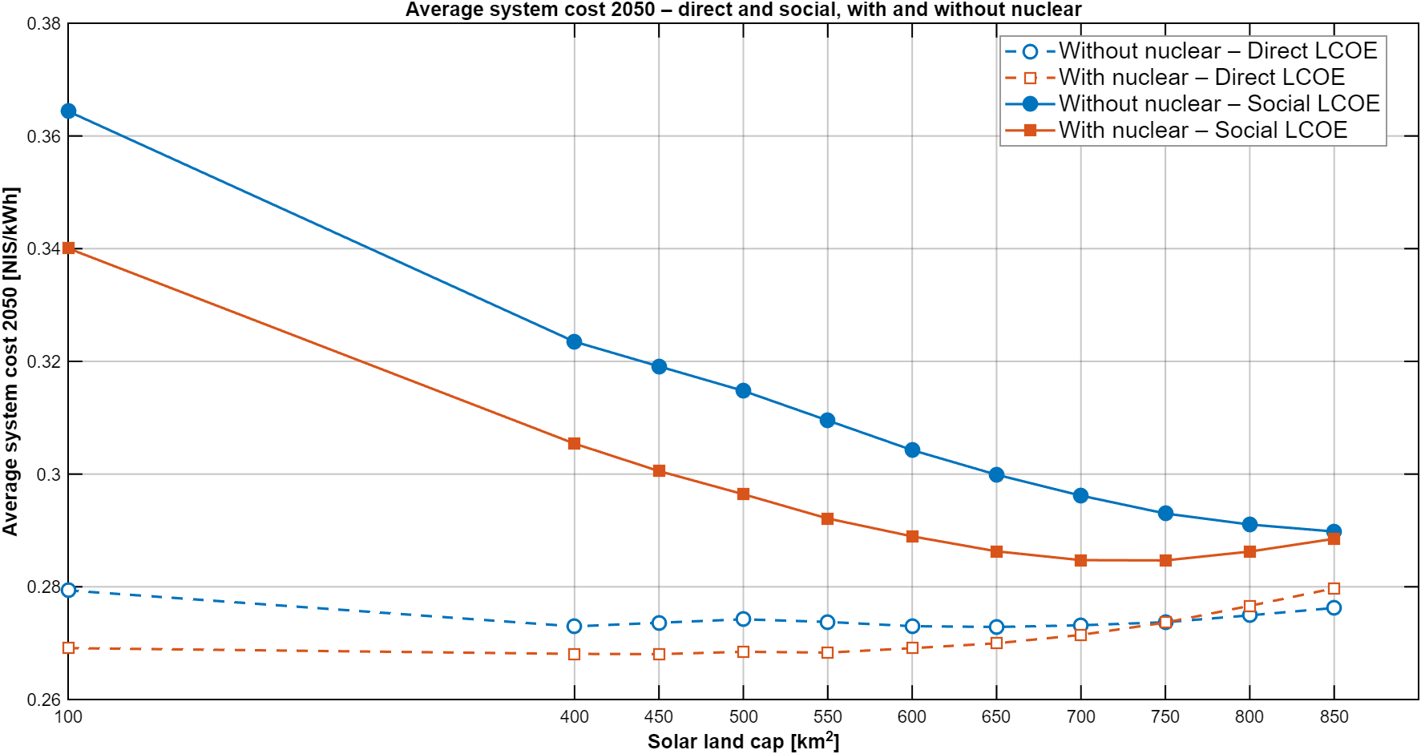
Figure 17 - Direct and social average system cost in 2050 (direct cost plus carbon cost at 200 NIS/tCO₂e) for the representative scenarios with and without nuclear
Figure # compares the average system cost in 2050 of the representative scenarios. In direct terms, nuclear lowers the cost when land is scarce—about 0.269 versus 0.279 NIS/kWh at 100 km² and about 0.268 versus 0.273 NIS/kWh at 400–550 km²—while above about 750 km² the system with nuclear becomes slightly more expensive (about 0.277–0.280 versus 0.275–0.276 NIS/kWh), since nuclear output increasingly overlaps with solar generation. In social terms, which include the carbon cost, the system with nuclear is cheaper across the whole range: about 0.340 versus 0.364 NIS/kWh at 100 km² and about 0.305 versus 0.323 NIS/kWh at 400 km², with the gap narrowing to about 0.002 NIS/kWh at 850 km². With nuclear, the social cost reaches its minimum of about 0.285 NIS/kWh at 700–750 km², whereas without nuclear it continues to decline up to 850 km² (0.290 NIS/kWh).
Overall, the nuclear scenarios indicate that a limited amount of firm low-carbon capacity is most valuable when land for solar deployment is scarce: it substantially reduces cumulative emissions and costs at small land caps, while its additional benefit diminishes as land availability increases. In 2050, nuclear lowers emissions from about 45 to 33 MtCO₂e at 400 km² and from about 12 to 8 MtCO₂e at 850 km².

3.8 Sensitivity analyses
This section examines how the main results depend on two key assumptions—the pace at which capacity can be built and the land available for solar deployment—and locates the economic optimum of the system
the end of the 4 g result #####

3.8.2 Beyond the land limits
To explore the technical limits of the system, an extended grid was solved with land caps of up to 1,200 km², budgets of up to ₪540×10⁹ and a build-rate schedule that rises to 9 GW per year in 2050. These assumptions exceed the land availability and deployment rates considered realistic in the main analysis and are therefore used to identify the boundaries of the solution space rather than as policy scenarios.
Under these assumptions, renewable shares above 95% become feasible without nuclear: about 95% is reached at ₪470×10⁹ with 1,000 km², and about 98% at ₪540×10⁹ with 1,200 km². Land use increases with the budget: at ₪400×10⁹ only about 780 km² are used even when more land is available, rising to about 950 km² at ₪450×10⁹ and to more than 1,100 km² at ₪500–540×10⁹. Land and budget therefore act as complements at high renewable shares—additional land is valuable only if the budget to develop it is also available.
[Insert figure: renewable share in 2050 by budget and land cap – extended grid (heatmap)]
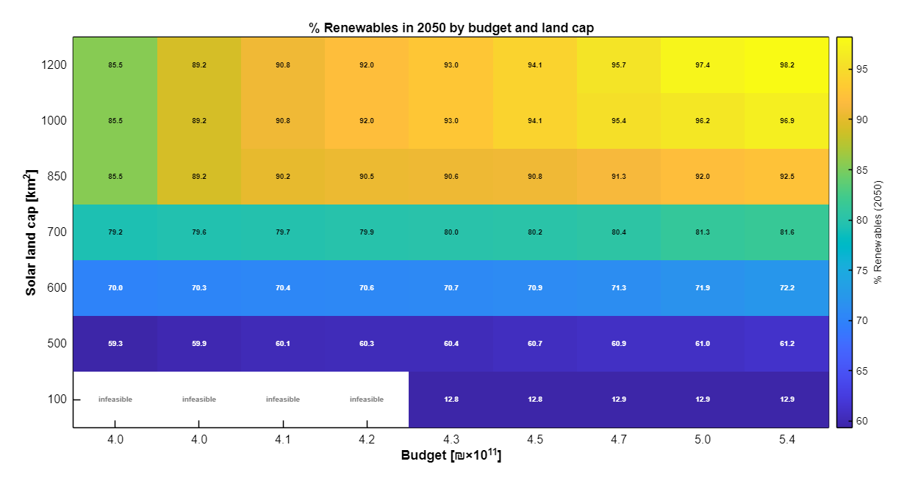
Figure # - Renewable share in 2050 by budget and land cap in the extended grid (land caps up to 1,200 km², budgets up to ₪540×10⁹, build-rate schedule rising to 9 GW per year)
Above approximately ₪470–500×10⁹, however, additional budget yields only small reductions in cumulative emissions (less than 10 MtCO₂e per ₪10×10⁹) and is invested mainly in battery storage, whose capacity increases from about 87 GW at ₪470×10⁹ to about 160–175 GW at ₪540×10⁹, while the average system cost in 2050 (including the carbon cost) rises from about 0.31 to about 0.38 NIS/kWh. About 32 GW of gas capacity is retained for reliability in all scenarios, even at 98% renewables. These results indicate an upper economic limit of the examined range at about ₪470–500×10⁹, beyond which further decarbonization through solar PV and batteries alone becomes increasingly inefficient.
[Insert figure: cumulative emissions vs. budget, one line per land cap – extended grid]
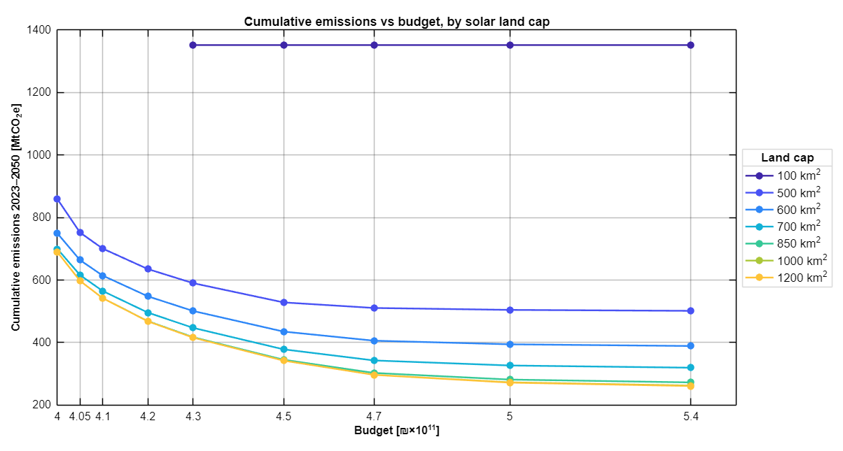
Figure # - Cumulative emissions 2023–2050 as a function of the budget for each land cap in the extended grid
[Insert figure (optional): battery capacity and average system cost in 2050 vs. budget – extended grid]
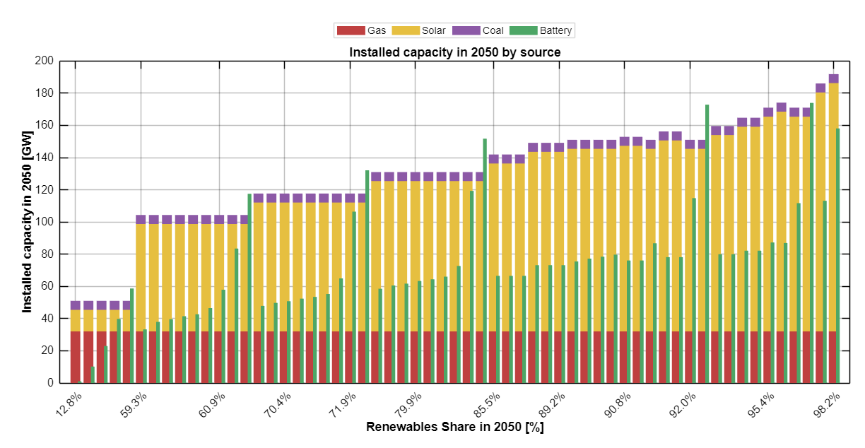
Figure # - Battery capacity and average system cost in 2050 as a function of the budget in the extended grid

3.8.3 The economic optimum
To locate the economic optimum, the model was solved with total discounted cost—CAPEX, OPEX and the carbon cost—as the objective and without a budget constraint. Under the main build-rate schedule, the least-cost system has a total cost of about ₪398×10⁹, uses about 700 km² of land even when more land is available, and reaches about 79% renewables in 2050, with cumulative emissions of about 820 MtCO₂e. When land is restricted below this level, the minimum cost increases—to about ₪398.4×10⁹ at 600 km² and ₪399.5×10⁹ at 500 km²—while the renewable share decreases and emissions increase. Up to about 700 km², additional land therefore lowers both cost and emissions; beyond this level it no longer affects the least-cost solution. For the fossil-dominated benchmark (100 km²), the minimum cost is about ₪426×10⁹, which explains why this land cap is infeasible at lower budgets.
The economic optimum depends on the build-rate assumption: with a constant limit of 4 GW per year, it lies at a similar cost (about ₪399×10⁹) but at lower land use (about 620 km²) and a lower renewable share (about 70%), since the higher build rates allowed later in the horizon are not available. With the option of 3 GW of nuclear capacity, the economic optimum decreases to about ₪395×10⁹, builds the maximum nuclear capacity and uses about 590 km² of land; under the cost assumptions of this study, nuclear capacity is therefore also economically attractive, although this result depends strongly on the assumed capital cost of nuclear power.
The economic optimum marks the lower bound of the budget range examined in the scenario grid. A budget only slightly above it leads to substantially lower cumulative emissions: at 1,000 km², a budget of ₪400×10⁹—about 0.5% above the economic optimum—reduces cumulative emissions from about 820 to about 690 MtCO₂e (−16%), because investment in solar PV and storage is brought forward rather than postponed towards the end of the horizon, when capital costs are lower. [Main-analysis comparison – to be completed after the final runs.]
[Insert figure (optional): cumulative emissions vs. budget with the economic optimum marked for each land cap]
Figure # - Cumulative emissions 2023–2050 as a function of the budget, starting from the economic optimum, for selected land caps

Discussion

4.1 Land and budget: two distinct roles
The results show that land availability and the cumulative budget play distinct roles in the decarbonization of the Israeli power sector. Land availability determines the end state of the system: the renewable share in 2050 rises from about 50% at 400 km² to about 92% at 850 km², whereas, once the budget exceeds ₪410×10⁹, additional budget changes the 2050 renewable share by only a few percentage points (Figure 6).
The budget, in contrast, primarily determines the timing of the transition and therefore the cumulative emissions. Figure 19 shows cumulative emissions over 2023–2050 as a function of the budget for each land cap. For every land cap, emissions fall steeply between ₪400×10⁹ and about ₪430×10⁹ and then flatten. At 500 km², for example, an additional ₪20×10⁹ reduces cumulative emissions by about 25% (from 878 to 656 MtCO₂e), although the renewable share in 2050 increases by less than two percentage points. The additional budget allows solar and storage capacity to be built earlier, within the annual build-rate limits, so that gas generation is displaced over more years of the horizon. The vertical spacing between the lines reflects the effect of land: at a given budget, each additional 50 km² lowers cumulative emissions by about 45–60 MtCO₂e at small land caps, but by less than 10 MtCO₂e between 800 and 850 km².
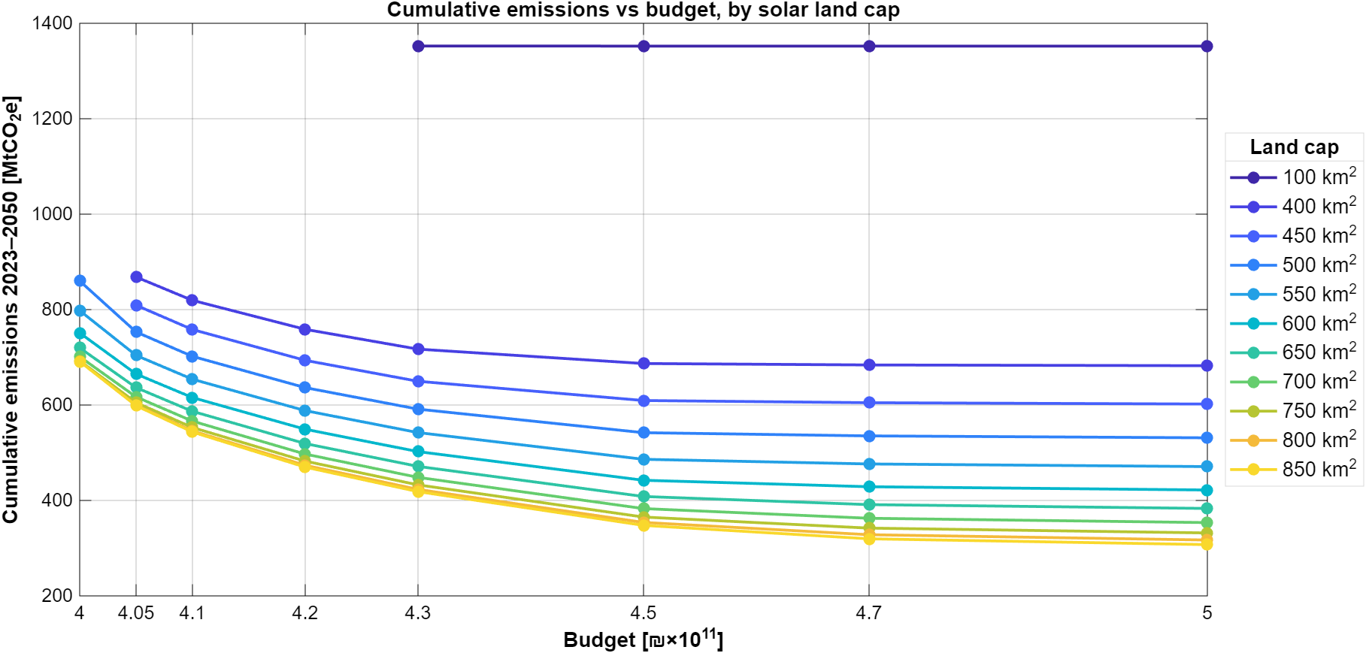 Figure 18 - Cumulative emissions 2023–2050 as a function of the cumulative budget for each solar land cap (scenarios without nuclear)
Two regimes can therefore be distinguished. At low budgets the system is budget-limited: the land cap is not fully used and the speed of deployment, and hence cumulative emissions, depends on the available budget. At higher budgets the system becomes land- and build-rate-limited: the end state is determined by the land cap, and at the highest budgets battery storage reaches its annual build-rate limit in every year of the horizon. Above about ₪450×10⁹, additional budget yields no further emissions reductions.
This distinction has a direct implication for target setting. A renewable share target for 2050 captures only the end state of the system, which is governed mainly by land. Cumulative emissions, which ultimately determine the climate impact, depend to a large extent on the trajectory, and therefore on the timing and financing of early investment. Both dimensions need to be addressed: land allocation determines how far the system can be decarbonized, and early investment determines how much is emitted on the way.

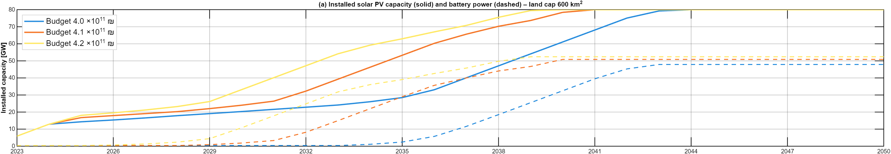
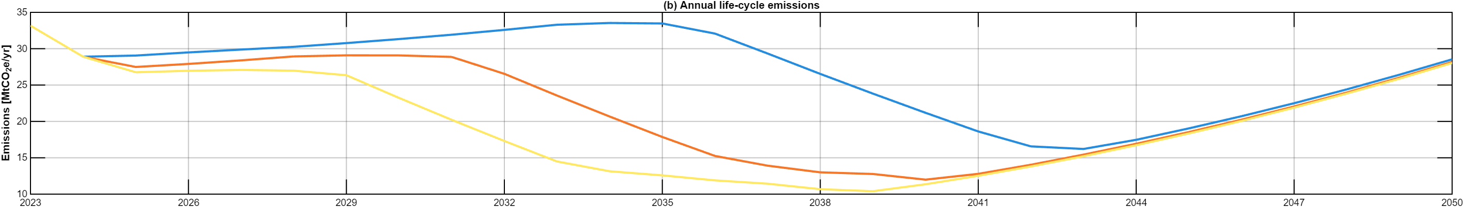
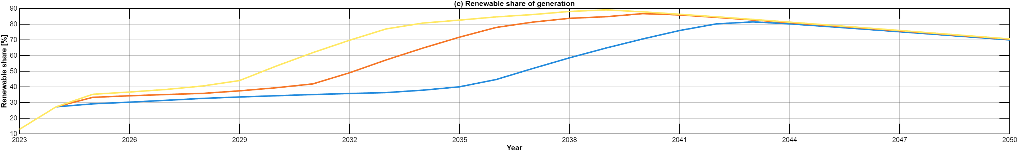
Figure 19 – Installed solar PV and battery capacity (a), annual life-cycle emissions (b) and renewable share of generation (c) over 2023–2050 for a fixed solar land cap of 600 km² and budgets of ₪400–480×10⁹ (scenarios without nuclear).
To illustrate how the budget shapes the trajectory of the transition, Figure 19 shows the evolution of installed capacity, annual emissions and the renewable share over 2023–2050 for a fixed land cap of 600 km² and five budget levels. In all five cases the land cap is fully utilized by 2050 (about 80 GW of solar PV), and the renewable share in 2050 varies only between 69.7% and 72.1%. The end state of the system is therefore practically independent of the budget.
The trajectories leading to this end state, however, differ substantially. For budgets of ₪410×10⁹ and above, solar PV is deployed at the maximum annual build rate and the land cap is reached around 2042; the budget mainly affects the timing and size of battery deployment, which starts in 2023–2024 at the highest budgets, around 2029 at ₪410×10⁹ and only around 2034 at ₪400×10⁹. At the lowest budget, solar deployment is also slowed during the first decade, and the land cap is reached only around 2047. As a result, by 2035 the renewable share reaches about 75% at budgets of ₪420×10⁹ and above, compared with about 67% at ₪410×10⁹ and 46% at ₪400×10⁹, and annual emissions in that year are about 16, 20 and 30 MtCO₂e, respectively. The area between the emission curves corresponds to the difference in cumulative emissions: raising the budget from ₪400×10⁹ to ₪420×10⁹ reduces cumulative emissions from about 790 to about 576 MtCO₂e (−27%). Beyond ₪440×10⁹ the emission trajectories nearly coincide (563 and 562 MtCO₂e at ₪440×10⁹ and ₪480×10⁹): the additional budget is used mainly for battery capacity, which at ₪480×10⁹ grows at its maximum build rate to about 108 GW in 2050 without a noticeable effect on emissions.
The figure also reveals a feature that is hidden by the 2050 snapshot. Once the land cap is reached, no further solar capacity can be added, while electricity demand continues to grow. The additional demand is met by gas-fired generation, so that annual emissions rise again from a minimum of about 12–15 MtCO₂e around 2041–2042 to about 27–29 MtCO₂e in 2050, and the renewable share declines from a peak of about 86% to about 72%. The renewable share in 2050 therefore understates the level reached earlier in the horizon. In a growing system, land availability limits not only the end state but also the ability of renewable supply to keep pace with demand; maintaining a high renewable share requires a continuous expansion of the land allocated to solar deployment, or additional firm low-carbon capacity, over time.

4.2 The cost of decarbonization
For a fixed budget, increasing the renewable share in 2050 from 50% to 91% leaves the direct average system cost practically unchanged, at 0.273–0.276 NIS/kWh (Figure 9). Decarbonization therefore changes the structure of system costs rather than their level: gas operating costs fall from about ₪41×10⁹ per year in the fossil-dominated benchmark to about ₪9×10⁹ at 91% renewables, while capital payments for solar PV and battery storage become the dominant cost components (Figure 10). The fossil-dominated system has the highest direct cost in 2050 (about 0.279 NIS/kWh), because the variable cost of gas generation almost doubles over the horizon. Over the full horizon, its cumulative direct cost is lower than that of the renewable scenarios; its cost advantage is therefore front-loaded and depends on the assumed trajectory of gas prices.
Figure 20 relates the average system cost in 2050 to the carbon intensity of electricity supply in the representative scenarios. When the carbon cost is included (top panel), the relationship is monotonic: the cleanest system is also the cheapest, and the social cost falls from about 0.364 NIS/kWh in the benchmark to about 0.290 NIS/kWh at 91% renewables. In direct terms (bottom panel), carbon intensity can be nearly halved between 400 and 650 km² at practically unchanged cost; further decarbonization to 91% renewables halves carbon intensity again at an additional direct cost of about 1.2%. This implies an abatement cost of roughly 50 NIS/tCO₂e, well below the carbon cost applied in the model (200 NIS/tCO₂e) and below commonly used estimates of the social cost of carbon.

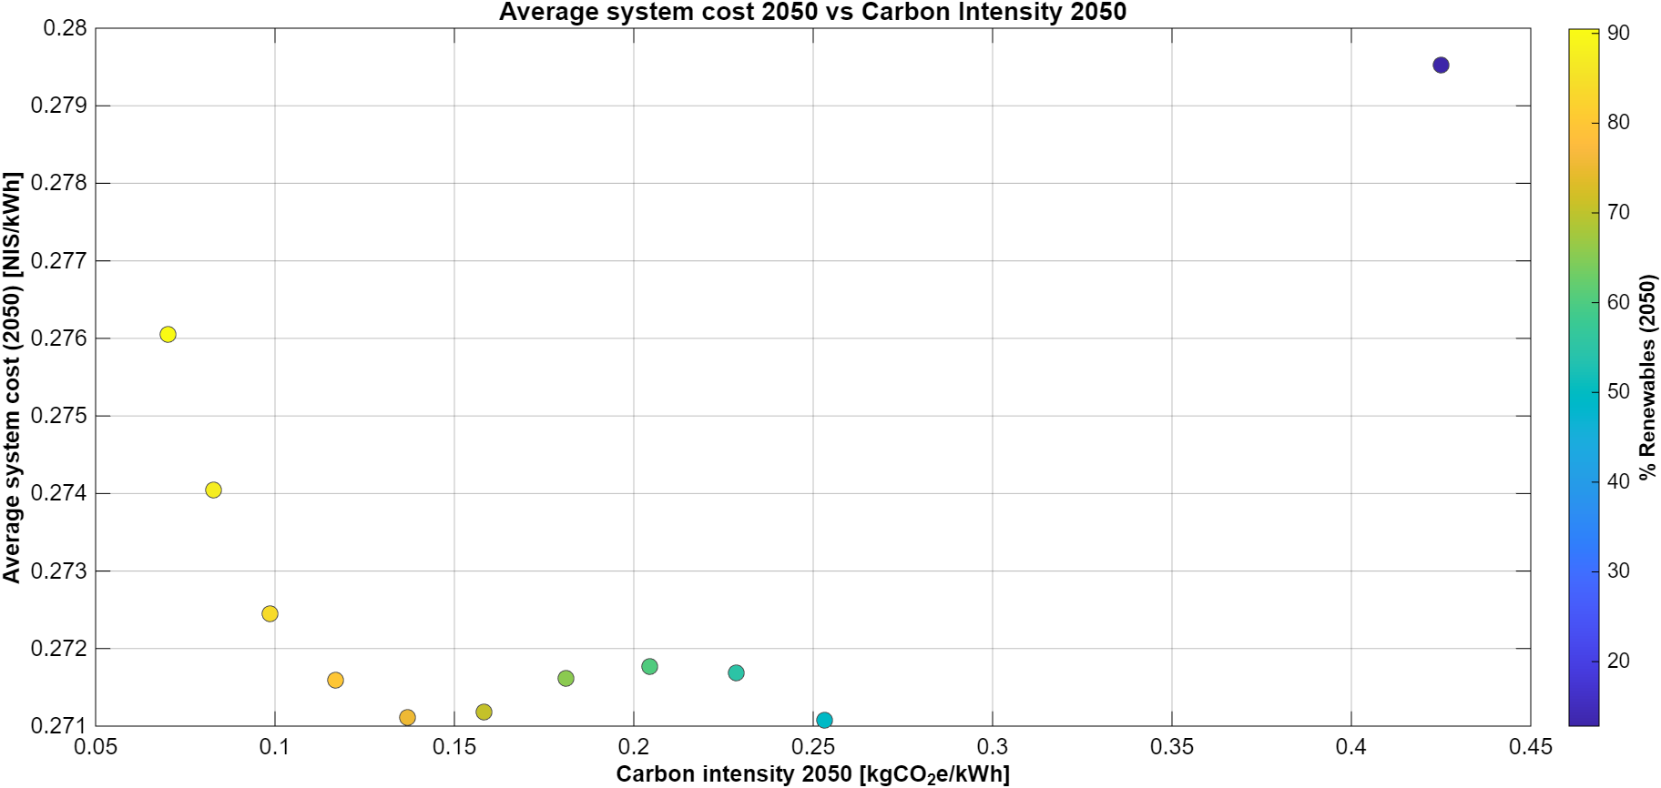
Figure 20 - Average system cost in 2050 versus carbon intensity in 2050 for the representative scenarios: social cost including the carbon cost (top) and direct cost (bottom)
These cost results should be interpreted with care. The average system cost covers the generation system only and excludes networks, system services and taxes. In addition, because the optimization minimizes emissions rather than cost, each scenario uses its full budget, so that differences between scenarios reflect the composition and timing of expenditure rather than the minimum cost of achieving a given emissions level. Finally, land is treated as a physical constraint and is not priced. The cost results are therefore best read as relative comparisons between system configurations under the same budget.

4.3 Reliability, firm capacity and the role of nuclear
In all scenarios, about 32 GW of gas capacity is maintained in 2050, determined by the reserve-margin requirement during critical hours in which solar output is zero and battery storage is not counted as firm capacity. At high renewable shares, gas supplies less than 10% of annual demand but remains essential as a capacity resource. The transition therefore shifts the role of gas from an energy supplier to a reliability reserve, which raises questions of how such rarely used capacity is financed and remunerated. The battery operation patterns support this interpretation: batteries are effective for intra-day shifting, but are depleted during multi-day periods of low solar output in winter.
The results also show diminishing returns of a system based on solar and storage alone. At 91% renewables, about 12 MtCO₂e are still emitted in 2050, roughly one third of which are life-cycle emissions of solar PV and batteries, and curtailment increases steadily with land availability. Near-zero emissions would therefore require additional low-carbon options beyond further solar deployment.
The nuclear scenarios illustrate the value of firm low-carbon capacity. In all feasible scenarios the model builds the maximum allowed 3 GW, which replaces gas capacity one-for-one and reduces cumulative emissions by 36–184 MtCO₂e (Figure 17). The benefit decreases with land availability—from about 12% of cumulative emissions at 400 km² to about 7% at 850 km²—so that nuclear acts as a partial substitute for land rather than as a complement to it. In social terms the system with nuclear is cheaper across the entire range, whereas in direct terms it is cheaper only when land is scarce (Figure 18). Its contribution is further limited by timing: nuclear capacity is available only from 2043, whereas additional solar capacity built earlier displaces gas generation over a longer period. Firm low-carbon capacity is therefore most valuable as a hedge for land-constrained futures, rather than as a substitute for early renewable deployment.

4.4 Policy implications
Several implications for long-term planning of the Israeli electricity sector follow from these results. First, land for solar deployment should be treated as a strategic resource. The land allocated to solar PV, whether in dedicated areas, dual-use solutions such as agrivoltaics, or the built environment, largely determines the decarbonization level that can be achieved by 2050.
Second, early investment matters. Since cumulative emissions depend strongly on how early renewable and storage capacity is built, policies that accelerate deployment in the coming decade—through financing, permitting and grid connection—have a larger climate effect than an equivalent effort concentrated near the target year. The annual build-rate limits, which become binding at higher budgets, point to the importance of supply chains, permitting capacity and grid integration as practical bottlenecks.
Third, the economic case for renewables is robust once the carbon cost is accounted for. With a carbon cost of 200 NIS/tCO₂e, the fossil-dominated system is both the most polluting and the most expensive, and a fossil-heavy pathway also exposes the system to the risk of rising gas prices. Carbon pricing or equivalent regulation therefore aligns the economic and environmental objectives of system planning.
Fourth, the retained gas fleet calls for explicit planning of firm capacity. Mechanisms that remunerate available capacity rather than energy, and the development of alternative firm low-carbon resources, will be needed as gas shifts to a reserve role. In this context, nuclear energy may serve as an option for land-constrained futures, provided that its timing and costs are compatible with the transition pathway.

4.5 Consistency with national-scale electricity planning studies
To assess the plausibility of the model outcomes, the results are compared with two independent national-scale planning efforts: the Net Zero Outlook (NZO) study and the long-term electricity planning scenarios of the Israeli Ministry of Energy. These studies rely on scenario-based planning rather than formal optimization; the purpose of the comparison is therefore to examine whether the resulting system characteristics are consistent in scale and structure, rather than to benchmark model performance.
The NZO study assumes an electricity demand for 2050 that is comparable to the demand trajectory used in this thesis (about 177 TWh). Both analyses identify solar PV as the dominant generation technology, supported by large-scale battery storage and a residual role for dispatchable generation. In the present results, the high-renewable representative scenarios include about 100–113 GW of solar PV, 75–82 GW of battery storage (four-hour duration) and about 32 GW of gas capacity in 2050, a structure that is consistent with the NZO pathways.
The Ministry of Energy scenarios assume a substantially higher demand of approximately 210 TWh in 2050, which leads to larger absolute capacities. When this difference in demand is taken into account, the qualitative structure remains similar: extensive solar deployment, significant storage and continued firm capacity. Taken together, these comparisons suggest that the main structural features identified in this thesis—the dominant role of solar PV, the importance of land availability, and the continued need for firm capacity—are not specific to the optimization framework but are shared by independent national planning studies.

4.6 Limitations
The results should be interpreted in light of several modeling choices and simplifications. Each scenario represents an optimal solution conditional on a specific set of exogenous parameters and constraints; the scenario grid explores a structured, policy-relevant subset of the solution space rather than all possible system designs.
Objective and cost interpretation. The model minimizes cumulative life-cycle emissions subject to a budget constraint and therefore uses the full budget in each scenario. Where the budget is not binding, the allocation of the remaining budget is not unique and may include capacity that does not reduce emissions. Reported costs thus reflect the allocation of a given budget rather than the least-cost system for a given emissions level; the fixed-budget selection of representative scenarios mitigates, but does not remove, this effect.
Demand and weather. A single demand trajectory and a single year of hourly demand and solar profiles (2023) are used throughout the horizon. Uncertainty in future demand and interannual weather variability, in particular prolonged low-solar periods, are not represented.
Costs and carbon pricing. Technology costs and fuel price trajectories are deterministic inputs. The carbon cost is constant at 200 NIS/tCO₂e over the horizon, whereas carbon prices and estimates of the social cost of carbon typically increase over time.
Capital stock. Investment costs are annualized using technology lifetimes of 30 years for solar PV and 20 years for battery storage and are counted until 2050, without residual value. Retirement and replacement are not modeled: batteries built early in the horizon would require replacement before 2050, which is not costed, and existing capacity—including 5.6 GW of coal—remains available throughout the horizon and contributes to the reserve margin, which reduces the gas capacity that needs to be built. Moreover, because payments beyond 2050 are not counted and no residual value is assigned, investments made late in the horizon appear cheaper within the budget, which may encourage the postponement of investment when the budget is tight.
Operational detail. The model does not include unit commitment, minimum stable load or ramping constraints for thermal units, and gas generation is therefore fully flexible. The optimization assumes perfect foresight over the full horizon. Since the model optimizes dispatch from the base year, modeled 2023 emissions (33.2 MtCO₂e) are lower than actual sector emissions, in which coal still plays a larger role.
Spatial and sectoral scope. Transmission and distribution constraints are not modeled, and land availability is represented as an aggregate area without accounting for competing land uses, environmental protection or public acceptance. The electricity sector is analysed in isolation from transport, heating and industry.
These limitations reflect deliberate choices aimed at balancing tractability with system-level insight. The results should be interpreted as comparative insights into system trade-offs rather than as forecasts of future system configurations.

4.7 Future research
Several directions could extend the present framework. First, a two-stage formulation that minimizes cost subject to the minimum achievable emissions would provide least-cost configurations for each emissions level and a direct estimate of abatement costs. Second, uncertainty in demand, technology costs, fuel and carbon prices, and weather could be addressed through multiple weather years and stochastic or robust optimization. Third, a more detailed representation of operation, including unit commitment, the retirement of coal and existing gas units, and battery replacement, would improve the realism of reliability and cost results.
Fourth, greater spatial resolution, including geographically explicit land availability and transmission constraints, would allow regional bottlenecks and the trade-off between centralized and distributed generation to be examined. Fifth, the portfolio of flexibility and firm low-carbon options could be broadened to include long-duration storage, demand response and alternative nuclear designs and timings. Finally, coupling the electricity model with transport, heating and industry would capture the effects of electrification on demand profiles and flexibility, and linking the framework to concrete policy instruments would allow a direct assessment of how regulatory choices shape feasible decarbonization pathways.

Conclusions

This thesis developed an hourly linear optimization model of the Israeli electricity system for 2023–2050 and applied it to a structured grid of 99 scenarios, combining nine levels of the cumulative budget with eleven levels of land available for solar deployment, with and without the option of 3 GW of nuclear capacity. The model minimizes cumulative life-cycle greenhouse gas emissions subject to a budget that includes a carbon cost of 200 NIS/tCO₂e, annual build-rate limits, a reserve-margin requirement and hourly storage dynamics.
The first main conclusion is that land and budget play distinct roles. Land availability determines the end state of the system: the renewable share in 2050 rises from about 50% at 400 km² to about 92% at 850 km², whereas additional budget beyond ₪410×10⁹ changes it by only a few percentage points. The budget, in contrast, determines the timing of the transition and therefore cumulative emissions. At low budgets, an additional ₪20×10⁹ allows solar and storage capacity to be built earlier and reduces cumulative emissions by about 25%, while above about ₪450×10⁹ further budget has no effect, as deployment is limited by land and by the annual build-rate limits. Moreover, once the land cap is reached, growing demand is met by gas and emissions rise again, so that land allocation must keep pace with demand growth.
The second conclusion concerns costs. For a fixed budget, increasing the renewable share in 2050 from 50% to 91% leaves the direct average cost of generation practically unchanged (0.273–0.276 NIS/kWh); decarbonization changes the structure of system costs—from fuel-intensive operating costs to capital investment in solar PV and storage—rather than their level. The fossil-dominated system is the most expensive in 2050, although it is cheaper in the early years of the horizon. Once the carbon cost is included, the cleanest representative system is also the cheapest, and the implied abatement cost of moving from about 76% to 91% renewables is roughly 50 NIS/tCO₂e.
The third conclusion concerns reliability and firm capacity. About 32 GW of gas capacity is retained in all scenarios to meet the reserve-margin requirement, even where gas supplies less than 10% of demand, and about 12 MtCO₂e are still emitted in 2050 at 91% renewables. Firm low-carbon capacity can reduce these limits: 3 GW of nuclear capacity reduces cumulative emissions by 36–184 MtCO₂e and lowers the social cost of the system across the entire range. Its benefit is, however, largest when land is scarce, so that nuclear acts as a partial substitute for land rather than as a substitute for early renewable deployment.
These findings carry clear policy implications: land for solar deployment should be treated as a strategic resource; early investment in solar and storage has a larger climate effect than investment concentrated near the target year; carbon pricing aligns the economic and environmental objectives of system planning; and the role of gas as a reliability reserve requires explicit planning and remuneration of firm capacity.
Methodologically, this work extends a footprint-oriented sustainability framework into an optimization-based decision-support tool that links land, budget, emissions and system cost at hourly resolution over a multi-decadal horizon. The results should be interpreted as comparative insights rather than forecasts, given the emission-minimizing objective, the single demand and weather trajectory and the simplified representation of operation and networks. Within these limits, the Israeli case—a densely populated, land-constrained country with rapid demand growth—provides a relevant prototype for deep decarbonization under spatial scarcity, and shows that such decarbonization is achievable at a similar direct cost, provided that land allocation, early investment and firm capacity are planned together.

References

- Central Bureau of Statistics. (2019). Population projections for Israel, 2017–2065. Jerusalem: CBS.
- Central Bureau of Statistics. (2022). Production and consumption of water. Jerusalem: CBS.
- Cordova, T. (2023). Integrated sustainability modeling for Israel [Master’s thesis, Ben-Gurion University of the Negev].
- Cordova, T., Kissinger, M., & Riemer, R. (2024). Effects of demographic and technological trends on the mitigation of Israel’s environmental footprint. Nature Sustainability, 7(2), 120–128. https://doi.org/10.1038/s41893-023-01234-5
- DeCarolis, J. F., Hunter, K., & Sreepathi, S. (2020). The TEMOA energy system model: Balancing flexibility and performance in open-source energy modeling. Energy Policy, 137, 111123. https://doi.org/10.1016/j.enpol.2019.111123
- • Dunn, J. B., Gaines, L., Kelly, J. C., James, C., & Gallagher, K. G. (2015). The significance of Li-ion batteries in electric vehicle life-cycle energy and emissions and recycling’s role in its reduction. Energy & Environmental Science, 8(1), 158–168. https://doi.org/10.1039/C4EE03029J
- Fang, K., & Heijungs, R. (2015). Rethinking the relationship between footprints and LCA. Sustainability, 7(1), 1148–1169. https://doi.org/10.3390/su7011148
- Hoekstra, A. Y., Chapagain, A. K., Aldaya, M. M., & Mekonnen, M. M. (2011). The Water Footprint Assessment Manual: Setting the global standard. Earthscan.
- Intergovernmental Panel on Climate Change (IPCC). (2023). Climate Change 2023: Synthesis Report. Geneva: IPCC.
- International Energy Agency (IEA). (2022). World Energy Outlook 2022. Paris: IEA.
- International Energy Agency (IEA). (2023). World Energy Outlook 2023. Paris: IEA.
- • Lazard. (2024). Levelized Cost of Energy and Levelized Cost of Storage (LCOE+). New York: Lazard.
- Lenzen, M., Murray, S. A., Sack, F., & Wiedmann, T. (2007). Shared producer and consumer responsibility – Theory and practice. Ecological Economics, 61(1), 27–42. https://doi.org/10.1016/j.ecolecon.2006.05.018
- Li, X., Zhou, Y., Wang, X., & Chen, Y. (2020). An ecological footprint approach for cropland-use sustainability based on multi-objective optimization modelling. Journal of Environmental Management, 272, 111091. https://doi.org/10.1016/j.jenvman.2020.111091
- Mekorot. (2021). Water forecast in Israel 2050. Tel Aviv: Mekorot Water Company.
- National Renewable Energy Laboratory (NREL). (2021). Storage Futures Study. Golden, CO: NREL.
- Net Zero Outlook (NZO). (2021). 95% by 2050. Israel Electricity Authority.
- Net Zero Outlook (NZO). (2023). Net Zero Outlook update 2023. Israel Electricity Authority.
- Pellow, M. A., Ambrose, H., Mulvaney, D., Betita, R., & Shaw, S. (2020). Research gaps in environmental life cycle assessments of lithium-ion batteries for grid-scale stationary storage systems. Renewable and Sustainable Energy Reviews, 125, 109879. https://doi.org/10.1016/j.rser.2020.109879
- Poncelet, K., Delarue, E., Six, D., Duerinck, J., & D’haeseleer, W. (2016). Impact of the level of temporal and operational detail in energy-system planning models. Applied Energy, 162, 631–643. https://doi.org/10.1016/j.apenergy.2015.10.100
- Steen-Olsen, K., Weinzettel, J., Cranston, G., Ercin, A. E., & Hertwich, E. G. (2012). Carbon, land, and water footprint accounts for the European Union: Consumption, production, and displacements through international trade. Environmental Science & Technology, 46(20), 10883–10891. https://doi.org/10.1021/es301949t
- United Nations Economic Commission for Europe (UNECE). (2021). Life Cycle Assessment of Electricity Generation Options. Geneva: UNECE.
- Wackernagel, M., & Rees, W. E. (1996). Our ecological footprint: Reducing human impact on the Earth. New Society Publishers.
- Water Authority. (2022). Water consumption in Israel 2021. Tel Aviv: Israel Water Authority.
- Weinzettel, J., Hertwich, E. G., Peters, G. P., Steen-Olsen, K., & Galli, A. (2013). Affluence drives the global displacement of land use. Global Environmental Change, 23(2), 433–438. https://doi.org/10.1016/j.gloenvcha.2012.11.008
- Wiedmann, T., & Minx, J. (2008). A definition of “carbon footprint”. In C. C. Pertsova (Ed.), Ecological Economics Research Trends (pp. 1–11). Nova Science Publishers.
- Worldometer. (2023). Palestinian population growth forecast. Retrieved from https://www.worldometers.info

Appendix

Appendix A - Model assumptions
Data Inputs, Forecast Assumptions, and Model Parameterization
This appendix documents the data inputs, forecasting assumptions, and key parameter values underlying the electricity system optimization model described in Section 2.3. The objective is to ensure transparency regarding the empirical foundations and modeling choices that shape the optimization results, while avoiding repetition of the mathematical formulation or implementation details.
A.1 Electricity Demand and Solar Generation Profiles
Hourly electricity demand is based on the observed national load profile for Israel in 2023, as reported by Noga, the Israeli Independent System Operator. This profile preserves the characteristic intraday and seasonal structure of electricity consumption. To extend demand across the full planning horizon (2023–2050), total annual electricity demand is scaled year by year according to the Moderate (MODERATE) scenario of the General Framework Model described in Section 2.1. Under this approach, the hourly demand shape remains fixed, while the annual total demand evolves in line with projected demographic, technological, and economic trends.
Annual electricity demand rises from about 77.6 TWh in 2023 to about 177 TWh in 2050.
Hourly solar electricity generation is represented using a normalized capacity factor profile derived from the ROTH model for Israel. The ROTH model is based on NREL photovoltaic performance data for single-axis tracking utility-scale PV systems located in Be’er Sheva, using meteorological conditions representative of the year 2023. This profile reflects high-irradiation conditions typical of southern Israel, where large-scale PV deployment is concentrated. The same hourly capacity factor profile is applied uniformly across all years of the planning horizon, implying that interannual variation in solar output arises solely from changes in installed capacity rather than from meteorological variability or changes in panel performance over time.
A.2 Emission Factors and Technological Improvement Assumptions
Life-cycle greenhouse gas emission factors are specified for each generation technology and expressed in units of tCO₂ per MWh of electricity delivered to the grid. Baseline emission factors applied in the model are:
- Nuclear: 0.012 tCO₂/MWh
- Solar PV: 0.0260 tCO₂/MWh in 2023, declining to 0.0105 tCO₂/MWh in 2050 (time-dependent)
- Natural gas: 0.486 tCO₂/MWh
- Coal: 0.900 tCO₂/MWh
- Battery storage: 0.0375 tCO₂/MWh in 2023, declining to 0.0280 tCO₂/MWh in 2050 (time-dependent)
These values are consistent with life-cycle emission ranges reported in Cordova et al. (2024) and UNECE (2021).
For solar photovoltaic generation, emissions are modeled as time-dependent life-cycle emissions, taken year by year from the ROTH model workbook. The emission factor declines from 0.0260 tCO₂/MWh in 2023 to 0.0105 tCO₂/MWh in 2050 (about −60%), reflecting continued decarbonization of upstream manufacturing processes, electricity inputs and global supply chains (Cordova, Kissinger, & Riemer, 2024). Solar life-cycle emissions are attributed to all generated solar energy, including energy that is stored or curtailed.
Battery storage emissions are likewise treated as time-dependent life-cycle emissions associated with electricity discharged from the battery system. The emission factor declines from 0.0375 tCO₂/MWh in 2023 to 0.0280 tCO₂/MWh in 2050, an improvement of 30% relative to the 2017 reference value of 0.040 tCO₂/MWh. This assumption is supported by life-cycle assessment studies of lithium-ion batteries in grid-scale applications (Dunn et al., 2015; Pellow et al., 2020).
A.3 Cost Structure and Economic Assumptions
The model distinguishes three cost components for each technology, all specified as annual time series for 2023–2050 based on NZO forecasts and compiled in the model input workbook: fixed operating costs (NIS per MW of installed capacity per year), variable operating costs (NIS per MWh generated, including fuel costs for thermal plants) and capital costs (NIS per MW of installed capacity). Battery charging and discharging losses are represented physically through the round-trip efficiency rather than as a cost. The operating cost parameters (fixed; variable) are, for 2023 and 2050:
- Nuclear: fixed 540,000 NIS/MW-yr; variable 12 NIS/MWh (constant over the horizon)
- Solar PV: fixed 55,000 NIS/MW-yr in 2023, declining to 26,650 NIS/MW-yr in 2050; variable cost negligible
- Natural gas: fixed 164,000 NIS/MW-yr; variable 115 NIS/MWh in 2023, rising to 231 NIS/MWh in 2050
- Coal: fixed 164,000 NIS/MW-yr; variable 150 NIS/MWh (constant)
- Battery storage: fixed 57,400 NIS/MW-yr; variable cost negligible
These values are informed by Lazard LCOE+ (2024) cost estimates and are consistent with the operational cost definitions adopted in UNECE life-cycle assessment guidelines (UNECE, 2021).
CAPEX values, expressed in NIS per MW of installed capacity, represent upfront investment costs only. These include equipment costs, balance-of-system components, engineering procurement and construction (EPC), grid connection, civil works, owner’s costs, and contingency allowances. The CAPEX values used in the model are:
- Nuclear: 23,500,000 NIS/MW in 2023, declining to 15,700,000 NIS/MW in 2050
- Solar PV: 3,100,000 NIS/MW in 2023, declining to 1,720,000 NIS/MW in 2050
- Natural gas: 3,700,000 NIS/MW (constant)
- Coal: 15,000,000 NIS/MW (constant; no new coal capacity is allowed)
- Battery storage: 1,300,000 NIS/MW in 2023, declining to 800,000 NIS/MW in 2050 (four-hour system)
These assumptions are based on Lazard LCOE+ (2024) and UNECE LCA (2021), ensuring consistency between economic and life-cycle system boundaries.
CAPEX is annualized using technology-specific capital recovery factors with a discount rate of 6% and lifetimes of 60 years for nuclear, 30 years for solar PV, gas and coal, and 20 years for battery storage. Annual payments are counted from the year of construction until 2050 and discounted to present value; no residual value is assigned beyond 2050.
A.4 Installed Capacity, Storage Configuration, and Land Use
Initial installed capacities for all technologies correspond to reported values for Israel in 2023, as published by the Israeli Electricity Authority. These initial conditions anchor the optimization model in the observed structure of the current electricity system.
Initial installed capacities in 2023 are: nuclear 0 MW, solar PV 5,900 MW, natural gas 11,700 MW, coal 5,600 MW and battery storage 369 MW.
Battery storage is modeled with an energy-to-power ratio of four hours, meaning that each MW of installed battery power can deliver up to 4 MWh of electricity. Four-hour lithium-ion battery systems represent the dominant configuration for grid-scale storage worldwide and are widely adopted in both capacity expansion models and energy policy analyses (NREL, 2021; IEA, 2023; Lazard, 2024).
Charging and discharging efficiencies are 0.95 and 0.90, respectively, corresponding to a round-trip efficiency of about 86%. Batteries can be charged from solar PV only.
Solar deployment is constrained by land availability. A land-use coefficient of 0.0075 km² per MW of installed solar capacity is applied, consistent with empirical estimates for utility-scale photovoltaic installations in Israel. This parameter is based on Cordova et al. (2024) and captures the spatial constraints that critically shape long-term solar deployment in a land-constrained national system.
A.5 Capacity Expansion Unit Size and Scenario Structure
Capacity expansion decisions are modeled as continuous variables at the national planning scale. Each technology is associated with a minimum capacity expansion unit size that reflects realistic project scales and construction practices:
- Nuclear: 1,000 MW per unit
- Solar PV: 100 MW per unit
- Natural gas: 100 MW per unit
- Coal: 100 MW per unit
- Battery storage: 100 MW per unit
Annual expansion is limited by technology-specific build-rate limits: for solar PV and for battery storage, a time-varying schedule of 2 GW per year until 2025, 3 GW per year in 2030, 5 GW per year in 2035 and 7 GW per year from 2040 onwards (linearly interpolated between these years); for natural gas, up to 50 units (5 GW) per year; no new coal capacity is allowed. Nuclear capacity (nuclear scenarios only) can be added at a single build point at the end of 2042, up to 3 units (3 GW). Existing and new capacity is not retired within the horizon. System reliability is ensured by a reserve margin of 20% over net demand at critical hours—the ten highest-demand hours and the ten highest-demand hours without solar output in each year—in which nuclear, gas and coal capacity are counted as firm.
Scenario analysis is conducted by varying two system-level constraints: the cumulative budget (₪400, 405, 410, 420, 430, 450, 470 and 500×10⁹) and the land available for solar deployment (100 km² and 400–850 km² in steps of 50 km²), which yields 88 scenarios; the full grid is solved both without and with the nuclear option. Each scenario is solved independently as a multi-year, hourly linear optimization problem that minimizes cumulative life-cycle greenhouse gas emissions subject to demand balance, technical feasibility, and the budget and land constraints. Two additional scenario sets are used as sensitivity analyses (Section 3.8): the grid solved with a constant build-rate limit of 4 GW per year for solar PV and battery storage (budgets of ₪400–480×10⁹ in steps of ₪10×10⁹; land caps of 100 and 400–850 km²), and an extended grid with land caps of up to 1,200 km², budgets of up to ₪540×10⁹ and a build-rate schedule rising to 9 GW per year in 2050. The economic optimum is obtained by minimizing total cost without a budget constraint.

A.6 Carbon Cost Accounting

In addition to CAPEX and OPEX, the cumulative budget includes a carbon cost of 200 NIS per tCO₂e, applied to the life-cycle emissions of all technologies (thermal and nuclear generation, total solar generation and battery discharge) and discounted in the same way as the other cost components. This value corresponds to about 54 USD/tCO₂e and lies within the range of 50–100 USD/tCO₂e (2020 prices) reported in the literature for the social cost of carbon, with higher values increasingly recommended for mid-century assessments. The carbon cost is held constant over the horizon. Because it is part of the budget constraint, it affects the optimization: emissions-intensive generation consumes part of the budget that would otherwise be available for investment. In all cost indicators, the carbon cost is reported separately from direct costs (CAPEX and OPEX), so that direct and social costs can be compared. End-of-life costs of solar PV and battery storage are not included.

Appendix B - Renewable share in 2050 (%) by budget and land cap (data of Figure 6)

Land cap [km²] \ Budget [₪×10⁹] | 400 | 410 | 420 | 430 | 440 | 450 | 460 | 470 | 480
100 | infeasible | infeasible | infeasible | 12.8 | 12.8 | 12.8 | 12.8 | 12.9 | 12.9
400 | infeasible | 49.3 | 49.6 | 49.7 | 49.7 | 49.9 | 49.9 | 50.0 | 50.0
450 | infeasible | 54.7 | 55.2 | 55.4 | 55.4 | 55.5 | 55.5 | 55.6 | 55.6
500 | 59.0 | 60.1 | 60.7 | 60.9 | 61.0 | 61.1 | 61.2 | 61.2 | 61.2
550 | 64.5 | 65.3 | 66.0 | 66.3 | 66.5 | 66.5 | 66.8 | 66.8 | 66.8
600 | 69.7 | 70.4 | 71.1 | 71.5 | 71.7 | 71.9 | 72.1 | 72.1 | 72.1
650 | 74.4 | 75.2 | 75.8 | 76.3 | 76.6 | 76.7 | 76.9 | 76.9 | 76.9
700 | 77.0 | 79.6 | 80.3 | 80.8 | 81.1 | 81.4 | 81.4 | 81.4 | 81.4
750 | 77.0 | 83.6 | 84.5 | 85.1 | 85.3 | 85.6 | 85.6 | 85.6 | 85.6
800 | 77.0 | 87.1 | 88.1 | 88.7 | 88.8 | 89.1 | 89.1 | 89.1 | 89.1
850 | 77.0 | 87.9 | 91.0 | 91.7 | 91.9 | 92.1 | 92.1 | 92.1 | 92.1

Appendix D - Simplified water model for Israel

As the water model is only part of a larger model, our goal was to build a simple model that maps the relationships between suppliers and consumers (Figure 1) to enable the prediction of the general trends for water use. The model was developed using data from the Israel Bureau of Statistics, the Water Authority, and Israel's main water-providing company (Mekorot, 2021).
Figure S6: Relationship between water suppliers and consumers
Model component definitions
Desalinated Water, $D\left(t\right)$ – Fresh water that comes from the desalination of sea water and brackish water.
Groundwater, $G\left(t\right)$ – Fresh water from aquifers, wells, springs, streams, and lakes.
Treated Wastewater, $W\left(t\right)$ – Wastewater treated at different levels and is not intended for drinking.
Brackish and Reservoir Water, $B\left(t\right)$ – Water from reservoirs and brackish springs and water stored in reservoirs from floods, which are not intended for drinking.
Home and Industrial, $H\left(t\right)$ – Fresh and non-freshwater consumption for private homes and industries.
Agriculture, $A\left(t\right)$ – Fresh and non-freshwater consumption for agricultural needs.
For Nature, $F.N\left(t\right)$ – Water returned to nature.
For Neighbors, $T.N\left(t\right)$ - Fresh water for consumption outside of Israel.

Model assumptions
• The amount of water provided by the water sources is meets the demand.
• The amount of water that will be used for agriculture will increase linearly in relation to population size.
• Owing to global warming, the amount of natural fresh water will decrease by 25% by 2050.
• The relative amount of fresh water used for agriculture out of the total water used will remain the same as in recent years (35%).
• Water supply to neighboring countries will increase according to the growth of the Palestinian population.
• The amount of wastewater reused is 66%.
• The influence of external events such as changes in prices, imports or exports, and geopolitical events were not considered.
•There is no consideration for economic or physical constraints such as the area required for construction of a desalination plant.
• Modeling depreciation is based on the Water Authority's estimates that the depreciation is approximately 3% of the total consumption.
• The amount of use of brackish and reservoir water will not increase or decrease over the years.

Results. Under the baseline assumptions, total water demand grows from ~2.6 billion m³ in 2023 to ~4.2 billion m³ in 2050, driven largely by demographic growth (population from 9.8 to 16.5 million). Desalination becomes the dominant supply source, increasing from 600 MCM in 2023 to ~1.9 billion m³ in 2050, while natural freshwater declines from ~900 to ~685 MCM. Wastewater reuse rises modestly with demand, while brackish and reservoir water remain constant.

Alternative Scenarios. The model also allows for testing policy-relevant alternatives. For instance, if agricultural expansion capped at +20% by 2050 rather than growing proportionally with population, agricultural water use in 2050 decreases by more than 25% relative to baseline. This reduces desalination requirements by over 10% and mitigates the associated energy and emission burdens. Such analysis highlights the importance of agricultural policy choices for the future balance of the water system.

Model of suppliers and consumers
Our model is based on two components, suppliers, and consumers, where the supplies must meet the demand of the consumers and all components are a function of the target year (t). In the following equation, the consumers are on the right side of the equation, and the suppliers are on the left side:
$D\left(t\right)+G\left(t\right)+W\left(t\right)+B(t)=H\left(t\right)+A\left(t\right)+F.N\left(t\right)+T.N\left(t\right)$, (1)
where for suppliers, D(t) is desalinated water, G(t) is groundwater, W(t) is treated Wastewater, and B(t) is brackish and reservoir water; and for the consumers, H(t) is domestic and industrial fresh water, A(t) is agricultural consumption of fresh water only, F.N(t) is water for neighbors (Jordan, Gaza, and the West Bank), and T.N(t) is water supplied back to nature.

The results of the model according to the above assumptions as follows:
Model results in million cubic meters
2050 | 2040 | 2030 | 2023 | Year
1825 | 1509 | 1248 | 1092 | Home and Industrial | Consumption
2040 | 1744 | 1477 | 1320 | Agricultural | Consumption
277 | 240 | 210 | 193 | Water for Neighbors | Consumption
75 | 50 | 35 | 25 | Water for Nature | Consumption
4217 | 3543 | 2970 | 2630 | Total | Consumption
1820 | 1300 | 874 | 600 | Desalinated Water | Supply
871 | 941 | 1017 | 1070 | Groundwater | Supply
1278 | 1056 | 873 | 765 | Treated Wastewater | Supply
250 |  |  |  | Brackish and Reservoir Water | Supply
4219 | 3547 | 3014 | 2685 | Total | Supply
16.5 | 13.6 | 11.2 | 9.8 | Population size in millions

Model equations
Population growth
Based on the trend in the last 20 years in Israel, the model assumes a population growth of 1.92% (Central Bureau of Statistics, 2019). However, this assumption can change if the user wants to test other scenarios).
$$Pop_{j}=Pop_{0}*{\left(1+p_{g}\right)}^{n},$$ | (2)
where $Pop_{j}$ is the total population in year j, n is the difference in years between the baseline year (2017) and the target year, $p_{g}$ is the yearly change in population, and $Pop_{0}$ is the population in 2017 (8.8 million).
Water consumers
Home and industrial water
On the basis of data (Israel Water Authority, 2022), the water household consumption per capita (h.p.c.) is relatively stable at 110 m³ per year.
Thus, $H\left(t\right)=h.p.c*P\left(t\right)$,
where H(t) is the total water for home and industry, and P(t) is the population size at a given year.

Consumers
Home and Industrial
Home and industrial water consumption includes industrial consumption and therefore includes benign water and marginal water.
The average household consumption of fresh water has been stable over the last decade and a half at approximately 100 m³, including marginal water, which is approximately 110 m³ (Water Authority, 2022).
Fresh water accounts for 89% of the total home and industrial consumption per capita.
The consumption equation is as follows:
$$H\left(t\right)=h.p.c*P\left(t\right)$$
- H – the amount of home and industrial consumption in million cubic meters
- t – time, years
- h.p.c. - average household consumption per capita in cubic meters
- P – population size in millions
Agricultural Consumption
Agricultural consumption is calculated according to the size of the population and average consumption per capita for agriculture, which currently stands at approximately 136 m³ per capita for each year, of which approximately 65% is non-fresh water and the remaining is fresh water (Water Authority, 2022).
The average agricultural consumption per capita has been decreasing consistently in the last two decades. Based on the data from the Water Authority, the following prediction equation for average consumption per capita (a.p.c.) was fitted:
$a.p.c(t)= -10.79*\ln\left(t\right)+168.17 ; t>0$ ; t = 1 marks the year 2001 and so on. (3)
An R² value of 0.86 indicates a good fit to the data.
Using Equation 3, the total water for agricultural, A(t), is predicated:
$$A\left(t\right)=a.p.c*P(t)$$
Water for Neighbors
Water for neighbors is measured according to the quantities of water supplied to Jordan and the Palestinians and constitutes approximately 7% of Israel's total freshwater consumption.
The supply of water to Jordan is dictated by periodic agreements. Currently, 90 million m³ is supplied (Water Authority, 2022).
The supply of water to the Palestinians is also determined by agreements, but often with deviations where a quantity higher than agreed is provided.
On the basis of the behavior of the water supply to neighbors, in this model, we calculate the amount of water according to the growth of the Palestinian population only and by known agreements concluded with Jordan.
$$F.N\left(t\right)=p.p.c*P.P\left(t\right)+J$$
• F.N. – the amount of water for the neighbors in the MLC
• t – time, years
• p.p.c - average Palestinian consumption per capita supplied by Israel
• P.P - Palestinian population size in millions (Worldmeter, 2023)
• J - The amount of water supplied to Jordan according to an updated agreement.
Water for Nature
Water for nature is water returned into streams for various reasons such as ecology and infrastructure.
This water constitutes, on average, approximately 1% of the total consumption, and it is composed of fresh and non-fresh water (Water Authority, 2022).
In our model, we used past data and a schematic forecast from the Mekorot company (Mekorot, 2021).

Table 18 - Amount of water for nature in million cubic meters
Water consumption for nature in million cubic meters
2050 | 2040 | 2030 | 2023
75 | 50 | 35 | 25

Suppliers
Desalinated Water
As Israel is a relatively dry country, we assumed that the role of desalinated water is to bridge the gap between demand and supply. Therefore, this is how the required amounts of desalination are calculated (Water Authority, 2022).
Thus, we rearranged Equation 1 to forecast the amount of desalinated water required:
$$D\left(t\right)=0.89*H\left(t\right)+0.35*A\left(t\right)+F.N\left(t\right)+T.N\left(t\right)-G\left(t\right)$$
where for suppliers, D(t) is desalinated water and G(t) is ground water; and for consumers, H(t) is domestic and industrial fresh water only, A(t) is agricultural consumption of fresh water only, F.N(t) is water for neighbors (Jordan, Gaza, and the West Bank), and T.N(t) is water supplied to nature.

Groundwater
Owing to climate change, the supply of ground water is expected to decrease in the future because of a consistent decrease in the amount of precipitation, which makes it difficult to fill the water reservoir from which groundwater is drawn (Water Authority, 2022).
According to a forecast by the Mekorot company, by the year 2050, there will be a 5 percent decrease in the amount of precipitation, and this will reduce the filling volume in aquifers, lakes, etc. between 20 and 30 percent (Mekorot, 2021).
Therefore, in our model, we calculate a decrease in ground water supply in a linear manner with a target of a 25 percent reduction in natural water use in 2050.
Treated Wastewater
The percentage of the amount of wastewater that is reused has been relatively consistent in recent years at approximately 66% of the water supplied to homes and industries. However, this might change in the future because of technological improvements. In our model, we used 66% in the calculations. This water is currently used mostly for agriculture; therefore, in this scenario, we assume that there will be an increase in the use of water for agricultural purposes proportional to the population growth.

Brackish and Reservoir Water
Brackish water is a supplementary water source for various requirements where it mainly supports agricultural consumption. In recent years, the use of brackish water averages 220 million m³ per year.
Reservoir water is not fresh water used for a variety of uses such as water for agriculture and nature. The amount of this water varies according to the amount of annual precipitation and therefore cannot be predicted. In recent years, the use of this water has averaged 30 million m³ per year.
For brackish water, there is no plan to increase the pumping, which is relatively constant. Therefore, we chose to consider the amount of both brackish and reservoir water as a fixed figure of 250 million m³ per year (Mekorot, 2021).
References
- Water consumption in Israel 2021 (Water Authority,(2022
- Production and consumption of water (Central Bureau of Statistics, 2022)
- The Israeli population forecast (Central Bureau of Statistics, 2019)
- Palestinian population growth forecast (Worldometer, 2023)
- The water forecast in Israel (Mekorot, 2021)

Energy Use and Emissions.
A distinctive feature of the model is its link to the broader environmental framework, by explicitly incorporating the energy requirements and related GHG emissions of water provision. For example, desalinating 1 m³ of seawater requires ~3.5 kWh of electricity, pumping 1 m³ from natural sources ~0.5 kWh, and wastewater treatment ~0.65 kWh. These coefficients make the water model an integral part of the national carbon footprint analysis, connecting water demand not only to physical resources but also to energy use and emissions.

Appendix E - NZO API: Structure of Retrieved Data
Category | Fields Returned
Meta information | name, year
Installed capacities | solarCapacity, windCapacity, storageEnergy
Generation by source | coalGeneration, gasGeneration, solarGeneration, windGeneration
System indicators | storageUsage, renewableConsumption, renewableShare, curtailedEnergy
Economic outputs (NPV) | externalitiesCummulativeNPV, solarTotalCummulativeNPV, windTotalCummulativeNPV, storageTotalCummulativeNPV, gasTotalCummulativeNPV, totalCostCummulativeNPV

תקציר בעברית
התמודדות עם שינויי האקלים מחייבת דה־קרבוניזציה מהירה של מערכות ייצור החשמל הלאומיות, אולם מסלולי המעבר האפשריים מושפעים במידה רבה מאילוצים מבניים כלכליים, מרחביים וסביבתיים. ישראל מהווה מקרה בוחן ייחודי בהקשר זה, בשל שילוב של גידול דמוגרפי מואץ, יעדי אקלים שאפתניים, ומגבלות חריפות של זמינות קרקע. בהסתמך על מודל מסגרת לקיימות לאומית, תזה זו מפתחת מודל אופטימיזציה למערכת החשמל בישראל ברזולוציה שעתית (כ־245,000 צעדי זמן, לשנים 2023–2050). הבעיה מנוסחת כבעיית תכנות ליניארי רחבת היקף, שמטרתה מזעור פליטות גזי חממה מצטברות, בכפוף לאילוצים על זמינות קרקע סולארית, עלות מערכתית, דינמיקת אגירה ומגבלות תפעוליות.

התוצאות מראות באופן עקבי כי ייצור סולארי ואגירת אנרגיה בבטריות מהווים את הגורמים המרכזיים המאפשרים חדירה גבוהה של אנרגיות מתחדשות, בעוד שייצור מבוסס גז טבעי נותר כגורם איזון שיורי. שיעורי מתחדשות של כ־70–80% נמצאים כברי השגה מבחינה טכנית וכלכלית תחת ההנחות הנוכחיות. לעומת זאת, דחיפה מעבר לכ־90% מתחדשות כרוכה בהרחבה בלתי פרופורציונלית של תשתיות וקרקע סולארית במסגרת ההנחות והאילוצים שנבחנו במחקר זה, ומלווה בעלייה בעלויות המערכת וברמות אובדן אנרגיה. כאשר נבחנות רק העלויות הישירות של המערכת, תצורות מבוססות דלקים פוסיליים נראות זולות משמעותית ממערכות עתירות מתחדשות. עם זאת, כאשר נכללות במפורש העלויות החיצוניות של זיהום אוויר ופליטות גזי חממה, העלות הכוללת של מסלולים פוסיליים מתקרבת לרמות העלות של מערכות המגיעות לכ־90% מתחדשות. ממצא זה מדגיש כי יתרון העלות לכאורה תלוי בהרכב העלויות ובשיטת החשבונאות, ולא בהיקף ההוצאה הכולל בלבד.

לצורך מיקוד הניתוח בתצורות מערכת סבירות מבחינה כלכלית, נבחנה תת קבוצה של תרחישים המאופיינים בעלות מערכת ממוצעת נמוכה יחסית בכל רמת חדירה של מתחדשות. ניתוח זה מראה כי שיקולי יעילות כלכלית מגבילים בעיקר את קנה המידה של המערכת, כגון היקף התשתיות והקיבולות הנדרשות, ולא את ההרכב הבסיסי של טכנולוגיות הייצור. בכל התצורות היעילות כלכלית נשמר תפקיד דומיננטי לייצור סולארי, אגירה בבטריות ואיזון באמצעות גז, כאשר ההבדלים בעלות נובעים בעיקר מהיקף הפריסה ולא מהחלפת טכנולוגיות.

ניתוח רגישות מצביע על כך שזמינות משולבת של תקציב וקרקע סולארית מהווה את הגורם המגביל המרכזי להשגת שיעורי מתחדשות גבוהים מאוד. במסגרת מרחב התרחישים שנבחן, סביב רמת חדירה של כ־90% המתאימה להקצאה של כ־700–900 קמ"ר של קרקע סולארית ולתקרת עלות מערכתית בסדר גודל של (8–10)×10¹¹ ש"ח, הקלה באילוץ אחד בלבד אינה מאפשרת עלייה משמעותית נוספת בחדירת המתחדשות. מעבר לנקודה זו, תוספת תקציב ללא הרחבת קרקע, או הרחבת קרקע ללא גמישות תקציבית מקבילה, מניבה שיפורים שוליים בלבד. ממצאים אלו מדגישים את האופי המוצמד של האילוצים הכלכליים והמרחביים במסלולי דה־קרבוניזציה עמוקה.

תרומתה של תזה זו היא תלת ממדית: מבחינה מתודולוגית, היא מדגימה כיצד מודלים של אופטימיזציית מערכות חשמל יכולים להרחיב מסגרות קיימות של טביעת רגל סביבתית לכלי תומך החלטות תפעולי; מבחינה אמפירית, היא מספקת תובנות מקוריות ברמת המערכת לגבי מעבר משק החשמל בישראל תחת שילוב של אילוצים; ומבחינה אנליטית, היא מבהירה את התפקיד המשולב של קרקע, עלות ופליטות בעיצוב מסלולים אפשריים ויעילים לדה־קרבוניזציה. אף שישראל מהווה מקרה ייחודי בהיקפו ובמאפייניו, התנאים המבניים שלה – זמינות קרקע מוגבלת, ביקוש הולך וגדל ויעדי אקלים שאפתניים – משקפים אתגרים המשותפים למדינות רבות, ומקנים לממצאים רלוונטיות מעבר למקרה הבוחן הספציפי.

אוניברסיטת בן גוריון בנגב
הפקולטה למדעי ההנדסה
המחלקה לתעשייה וניהול

ניתוח משולב ואופטימיזציה של
מערכת טביעות רגל סביבתיות לאומיות קיימות וצפויות

מאת: דור חן
מנחה: פרופ' רזיאל רימר ופרופ' מידד קיסנג'ר

חתימת המחבר: דור חן תאריך: 28.9.2025
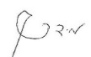
אישור המנחה: פרופ' רזיאל רימר תאריך: 28.9.2025
אישור המנחה: פרופ' מידד קיסינגר תאריך: 29.9.2025
אישור יו''ר ועדת תואר שני מחלקתית: פרופ' גלעד רביד תאריך: 30.9.2025

ספטמבר 2025

אוניברסיטת בן גוריון בנגב
הפקולטה למדעי ההנדסה
המחלקה לתעשייה וניהול

ניתוח משולב ואופטימיזציה של
מערכת טביעות רגל סביבתיות לאומיות קיימות וצפויות

מאת: דור חן
מנחים: פרופ' רזיאל רימר ופרופ' מידד קיסנג'ר

ספטמבר 2025

