### **Documentation for Language Syntax and Features**

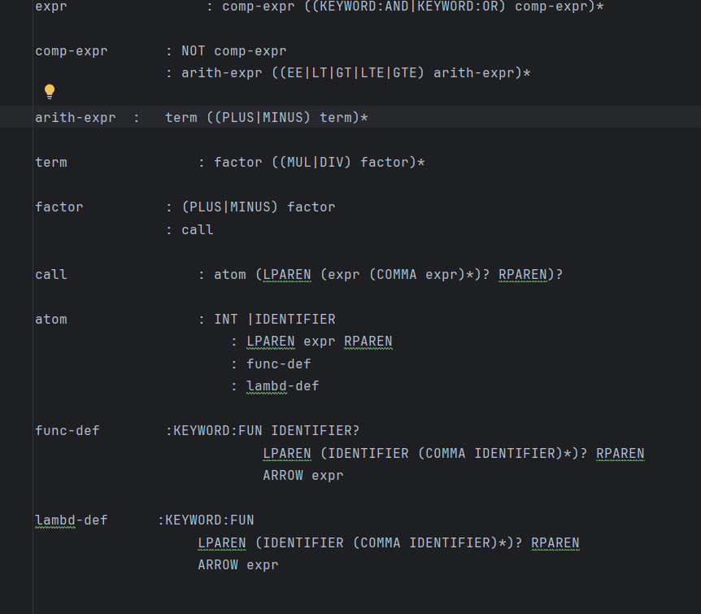

#### **1. Expressions (<expr>)**

1. An expression can be a comparison expression that may be combined with logical operators.
2. **Description:** This describes logical expressions where comparisons (<comp-expr>) are combined using logical AND or OR operators.
3. **Comparison Expressions (<comp-expr>)**
4. A comparison expression can be a negation or a comparison between arithmetic expressions.
5. **Description:** This handles negation of comparison expressions or comparisons between arithmetic expressions using operators like EE (equals), LT (less than), GT (greater than), LTE (less than or equal to), or GTE (greater than or equal to).
6. **Arithmetic Expressions (<arith-expr>)**
7. Arithmetic expressions consist of terms combined with addition or subtraction.

**Description:** This evaluates arithmetic operations with terms combined using addition (PLUS) or subtraction (MINUS).

1. **Terms (<term>)**
2. A term consists of factors combined with multiplication or division
3. **Description:** This evaluates multiplication (MUL) or division (DIV) operations between factors.
4. **Factors (<factor>)**
5. A factor can be a signed factor or a function call.
6. **Description:** This represents a factor that might be positive or negative, or a function call.
7. **Function Calls (<call>)**
8. A function call includes an atom followed by optional arguments enclosed in parentheses.
9. **Description:** This represents the invocation of a function or a procedure with optional arguments.
10. **Atoms (<atom>)**
11. Atoms are the basic building blocks of expressions, including literals, identifiers, or function definitions.
12. **Description:** Atoms can be integer literals, variable identifiers, parenthesized expressions, function definitions, or lambda expressions.
13. **Function Definitions (<func-def>)**
14. Defines a function with optional parameters and a body.
15. **Description:** This defines a function with an optional name, a list of parameters, and an expression as its body.
16. **Lambda Definitions (<lambd-def>)**
17. Defines a lambda function with parameters and a body.
18. **Description:** This defines an anonymous lambda function with a list of parameters and an expression as its body.

