Building a Real ETL Pipeline:
From a Power BI Dataset to an Analytics Warehouse
MongoDB → Apache Airflow → PostgreSQL
Project report · prepared by Eden Pozailov

Introduction
This project asked me to take a dataset that lives happily inside a Power BI report and turn it into a working data pipeline — the kind a real data team would run every night. The goal was to move the data through three very different systems: store the raw records in MongoDB, orchestrate the work with Apache Airflow, and land clean, query-ready tables in PostgreSQL. I treated it less like a homework exercise and more like a small production system, and I think that mindset is what shaped most of my decisions along the way.
What follows is the story of how I designed it, the choices I made (and why), the messy bits of the real data that I had to handle, and the results I got when I finally ran the whole thing end to end on a real Docker stack. I have tried to be honest about the trade-offs rather than pretend everything was clean from the start, because the interesting parts of data engineering usually live in the trade-offs.

The data I started from
The source is a Power BI sales model — a classic star: a central FactSales table surrounded by DimCustomer, DimProduct, DimGeography and DimDate. Once I exported the five tables to CSV and actually looked at them, the shape became concrete: 12,118 sales line items spread across 7,200 orders, 800 customers, 306 products, 30 geographies, and four years of activity (2021–2024). Every number in this report comes from that real data — nothing here is invented or rounded for effect.
Two things in the raw data immediately told me this was real and not a textbook sample: 35 sales rows had no customer attached, and 24 rows had a quantity of zero. I made a deliberate decision early on not to hide these — how I handled them is described later, and I think it is one of the more important parts of the project.

How I designed the warehouse, and why
I kept the target as a star schema rather than snowflaking it. The analytics the assignment cares about — revenue and profit by category, region, segment and year — are all single-hop joins from the fact table, so a star keeps the SQL flat and fast and the model easy to explain. Adding extra normalization layers would have bought me nothing here except more joins.
A detail I cared about: the keys. The source uses string business keys like O0000416, C00153 and P00034, so I kept the warehouse keys as TEXT instead of forcing integers — it removes a whole class of casting bugs. The fact grain is one row per sales line, identified naturally by (order_number, line_number), with SalesID as the primary key. I also added two small control tables, etl_run_audit and etl_watermark, which turned out to be the backbone of both my validation and my incremental logic.
Table | Primary key | Key attributes
dim_customer | customer_key | name, segment, gender, age, city, country
dim_product | product_key | product_name, category, brand
dim_geography | geography_key | city, region, country
dim_date | date_key (YYYYMMDD) | full_date, year, quarter, month, day
fact_sales | sales_id | order_number, line_number, quantity, unit_price, discount, sales_amount, total_cost, profit, amount_usd

The pipeline and the DAG
The orchestration is a single Airflow DAG, mongo_to_postgres_etl, with the Extract / Transform / Load stages broken into explicit tasks so that each step is visible and independently retryable: create_schema → extract_raw_documents → transform_documents → load_dimensions → load_facts → validate_load. I scheduled it daily, because an orders warehouse is a nightly-batch problem, not a streaming one — there is no intraday SLA that would justify the extra complexity.
For robustness I leaned on Airflow rather than writing my own scaffolding: configurable retries and an execution timeout in default_args, per-task logging, and max_active_runs=1 so two runs can never race on the same data. I deliberately avoided broad try/except blocks that swallow errors — if something is wrong I want the task to go red, not to quietly pass.
Task | What it does
create_schema | Creates the warehouse tables idempotently (safe to re-run).
extract_raw_documents | Reads new documents from MongoDB using a stored cursor.
transform_documents | Flattens the nested orders, normalizes values, screens out bad rows.
load_dimensions | Upserts the four dimensions.
load_facts | Syncs each order's lines, writes the audit row, advances the cursor.
validate_load | Runs the data-quality checks and fails the run if any break.

Transformations, and handling data that isn't perfect
The transform is where most of the thinking went. The raw Mongo documents are nested — an order header with an items[] array — so the first job is to flatten them into one fact row per line while pulling the dimension attributes alongside. I compute every monetary value with Python's Decimal type rather than floats, because money and binary floating point do not mix and the rounding errors would eventually show up in the validation totals.
Then there were the imperfections I mentioned. For the 35 orders with no customer, I didn't drop them — losing real sales would distort every revenue number — so I routed them to an explicit UNKNOWN customer in the dimension, which keeps the foreign keys honest while flagging the gap. For the 24 lines with a non-positive quantity, I quarantined them: they are excluded from the fact table and logged with a reason, rather than silently dropped or allowed to corrupt the aggregates. Choosing to surface bad data instead of hiding it is, to me, the difference between a script and a pipeline.

Incremental loading
I didn't want a pipeline that reloads everything every night, so the extract step is watermark-driven: it only pulls documents newer than the last processed cursor, and the loads use ON CONFLICT … DO UPDATE on the natural keys so re-running is always safe. To prove this actually works I ran it in two passes — an initial load of 2021–2023, then an incremental batch of 2024 — and finally replayed the initial batch a third time. The replay added zero new rows, which is exactly what idempotency should look like.

Results
After the full load the warehouse holds 12,094 fact rows across 7,193 distinct orders (the difference from 7,200 is the handful of orders whose only line was quarantined). Across the whole dataset that is about USD 23.5M in revenue and USD 8.2M in profit — a healthy ~34.8% margin. Every data-quality check passed.
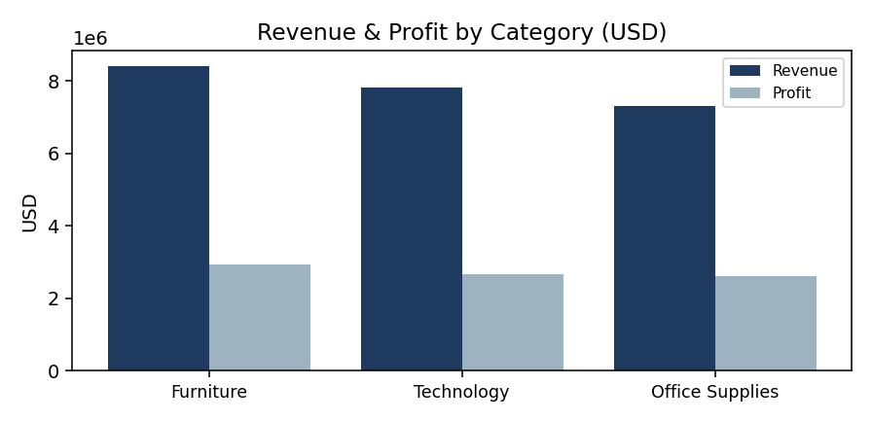
Category | Revenue (USD) | Profit (USD) | Units
Furniture | 8,416,490.62 | 2,927,643.41 | 22,804
Technology | 7,819,566.90 | 2,669,338.11 | 22,008
Office Supplies | 7,305,026.33 | 2,605,083.56 | 21,542

Revenue is strikingly stable year over year, which is reassuring — it tells me the date parsing and the yearly grouping are working correctly rather than dropping or double-counting periods.
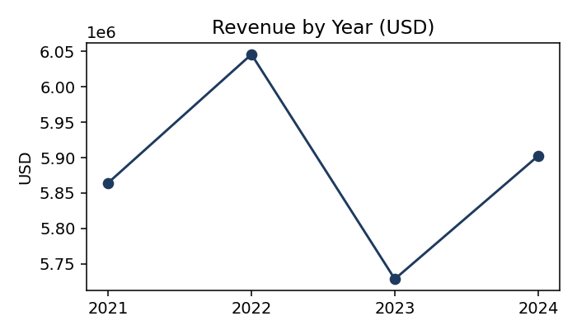

Running it for real (and what broke on the way)
Proving the pipeline runs is, honestly, where I learned the most. I executed the entire stack — MongoDB, Airflow and PostgreSQL together via Docker Compose — on GitHub Actions, so the run is reproducible and not just “it worked on my machine.” Getting there took a few iterations: I had to fix file permissions so the non-root Airflow user could read the mounted code and write its logs, and I had to wait for the scheduler to actually register the DAG before triggering it. Each failure taught me something concrete about how these containers really behave, and the final run goes green from build all the way through validation.
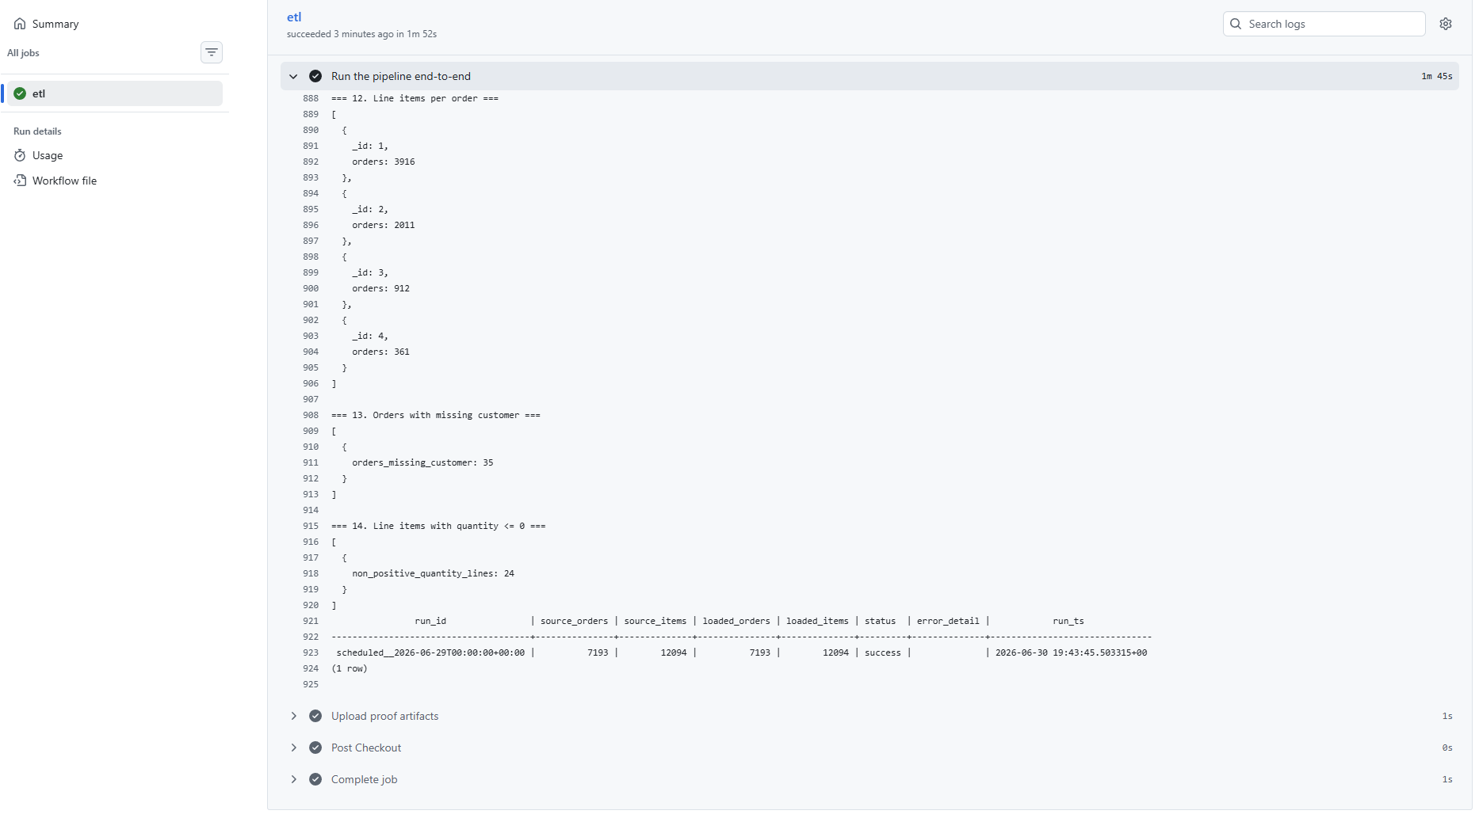
The run log proves the numbers: the etl_run_audit row reads source_orders 7,193, source_items 12,094, loaded_orders 7,193, loaded_items 12,094, status success — source equals target at both grains. The validation queries all returned zero, and the insight queries ran against the live MongoDB. Run: https://github.com/itaydlguy/ETLPlanProject/actions
Validation check | Result
Source vs loaded parity (orders & items) | OK — 7,193 / 12,094 on both sides
Null required fields in fact | 0
Orphaned product / customer / date / geography keys | 0
Non-positive quantity or negative amount | 0

What I would do next
If I kept going, the first thing I'd add is true Slowly-Changing-Dimension history on the customer and product tables — right now I overwrite (SCD Type 1), which is fine for this scope but loses the story of how a customer's segment changes over time. I'd also move the data passed between Airflow tasks out of XCom and into a staging table once the volumes grow, and add automated alerting on the validation step. None of these are needed for the assignment, but they're the natural next steps toward something I'd be comfortable running in production.

