***Test results:***

Z' noise's sigma=0.01, v' support=10.

|  |  |  |  |  |
| --- | --- | --- | --- | --- |
| Was trained on… | MSE | Normalized MSE | Needed Epochs | Generalization Error |
| X | 30.3121 | 0.0023 | 19 | 0.374247 |
| X-avg(X) | 25.6252 | 0.0020 | 24 | 0.309744 |
| **Z** | 0.0371 | **2.8649e-06** | 8 | 0.004386 |

Distribution of test's dataset and estimations after training:

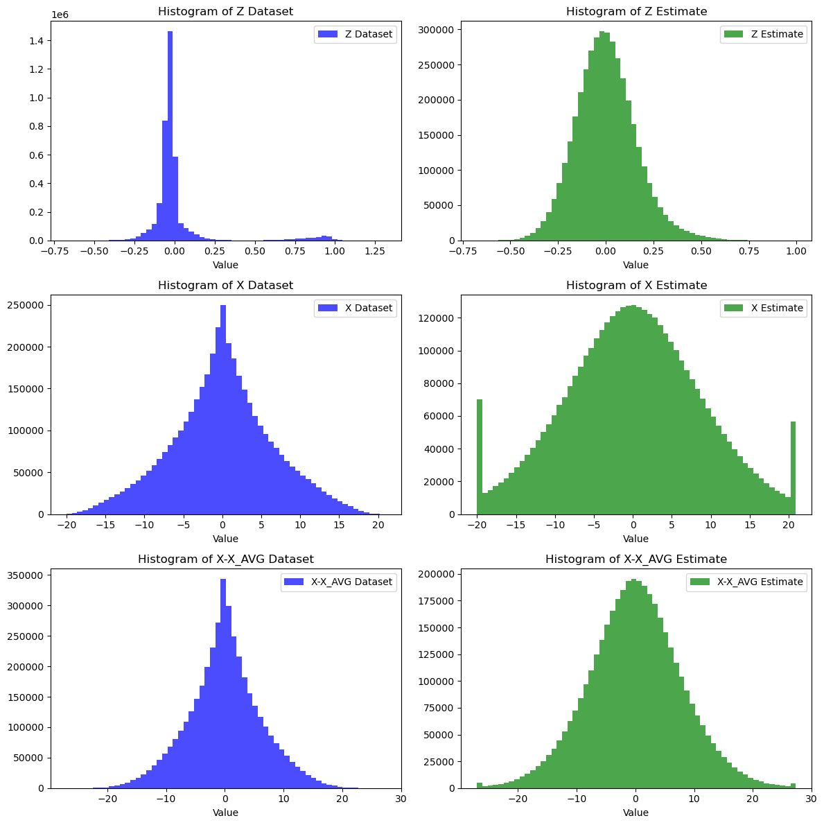

Show sparsity:

