***Test results:***

$$Z' noise's sigma=0.01, v' support=10$$

|  |  |  |  |  |
| --- | --- | --- | --- | --- |
| Was trained on… | MSE | Normalized MSE | Needed Epochs | Generalization Error |
| X | 30.3121 | 0.0023 | 19 | 0.374247 |
| X-avg(X) | 25.6252 | 0.0020 | 24 | 0.309744 |
| **Z** | 0.0371 | **2.8649e-06** | 8 | 0.004386 |

Distribution of test's dataset and estimations after training:

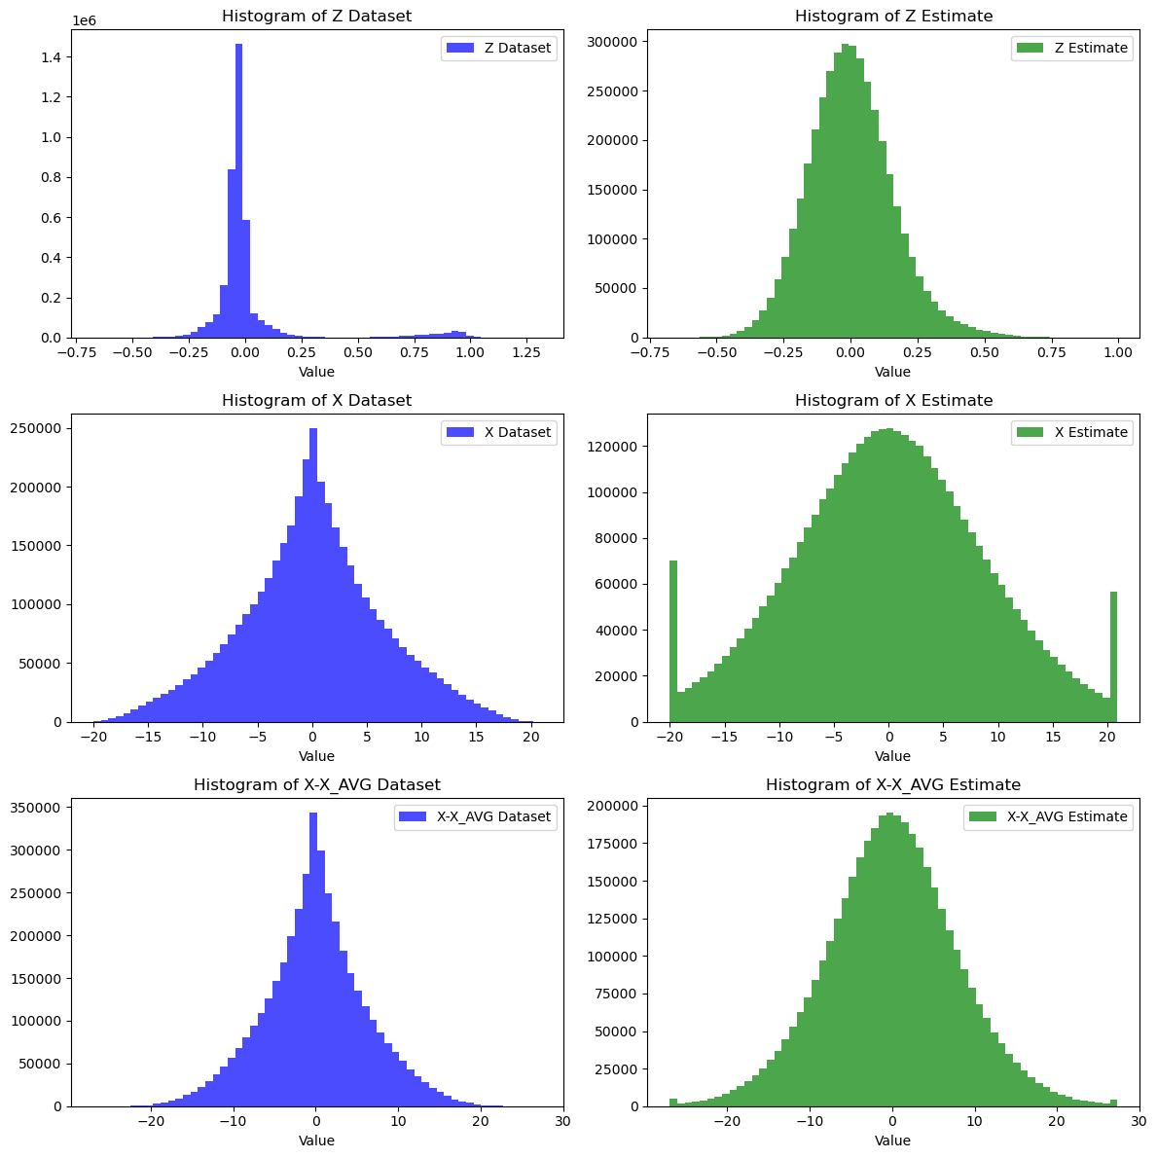

Show sparsity:

**Training on Z, test results:**

Comparing noise's sigma:

|  |  |  |  |  |  |
| --- | --- | --- | --- | --- | --- |
| Noise's sigma | V' support | MSE | Normalized MSE | Needed Epochs | Generalization Error |
| 0.1 | 10 | 0.0467 | 3.5839e-06 | 8 | 0.005325 |
| 0.02 | 10 | 0.0375 | 2.9000e-06 | 8 | 0.004442 |
| 0.005 | 10 | 0.0371 | 2.8690e-06 | 8 | 0.004360 |
| 0.001 | 10 | 0.0372 | 2.8686e-06 | 8 | 0.004329 |

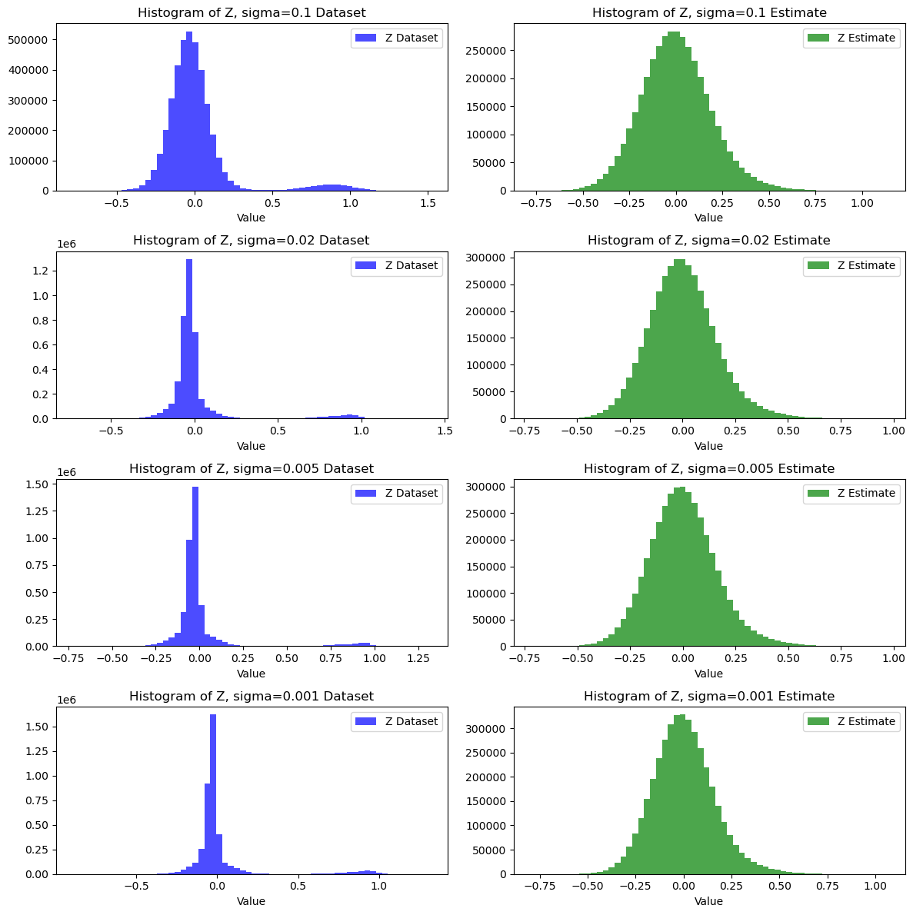

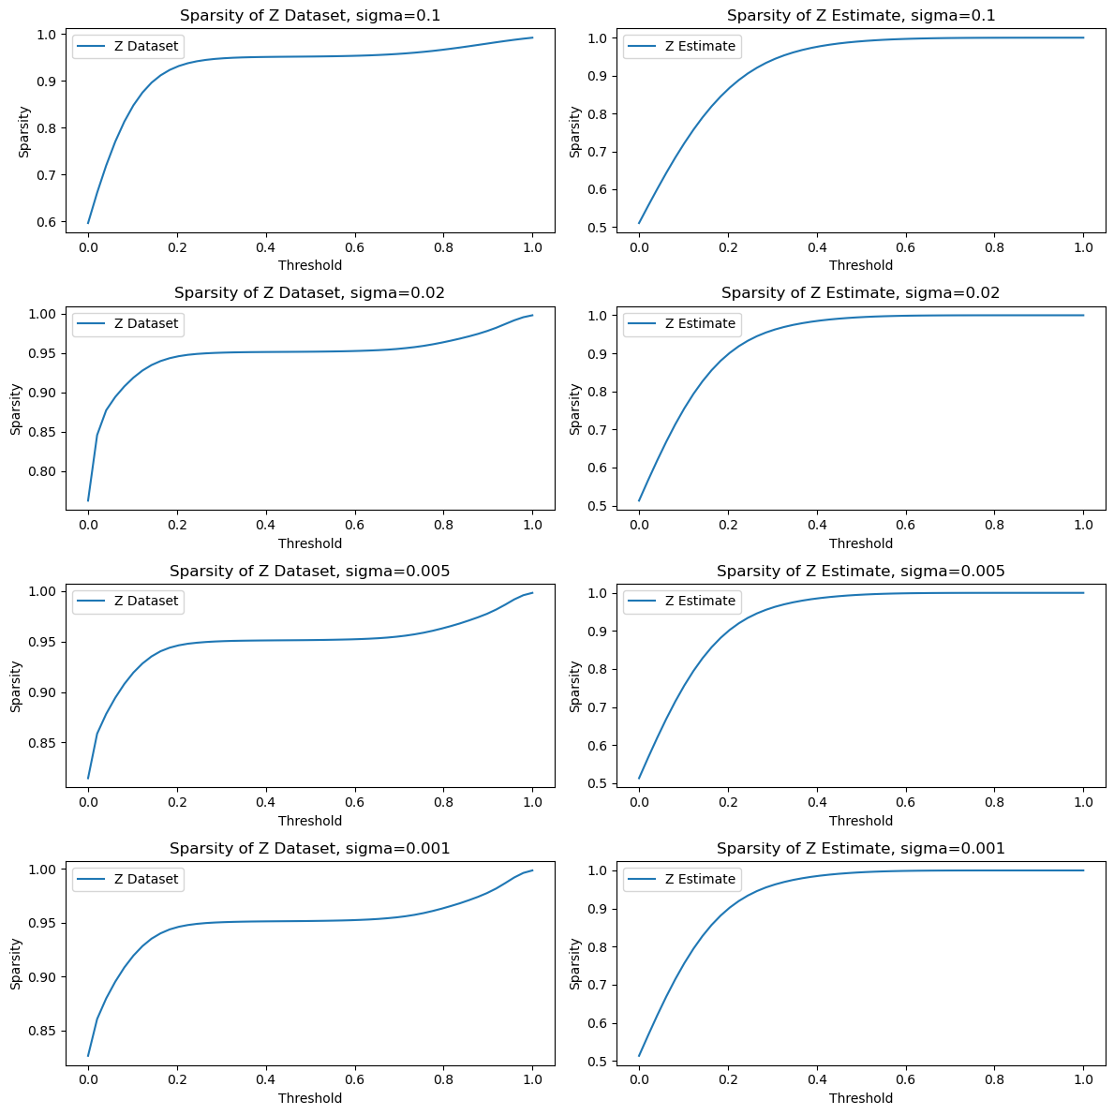

Comparing $v'$ support:

|  |  |  |  |  |  |
| --- | --- | --- | --- | --- | --- |
| Noise's sigma | V' support | MSE | Normalized MSE | Needed Epochs | Generalization Error |
| 0.01 | 100 | 0.0391 | 2.9912e-07 | 7 | 0.004081 |
| 0.01 | 20 | 0.0372 | 1.4415e-06 | 8 | 0.004362 |
| 0.01 | 5 | 0.0372 | 5.7693e-06 | 8 | 0.004300 |
| 0.01 | 1 | 0.0372 | 2.6942e-05 | 8 | 0.004348 |

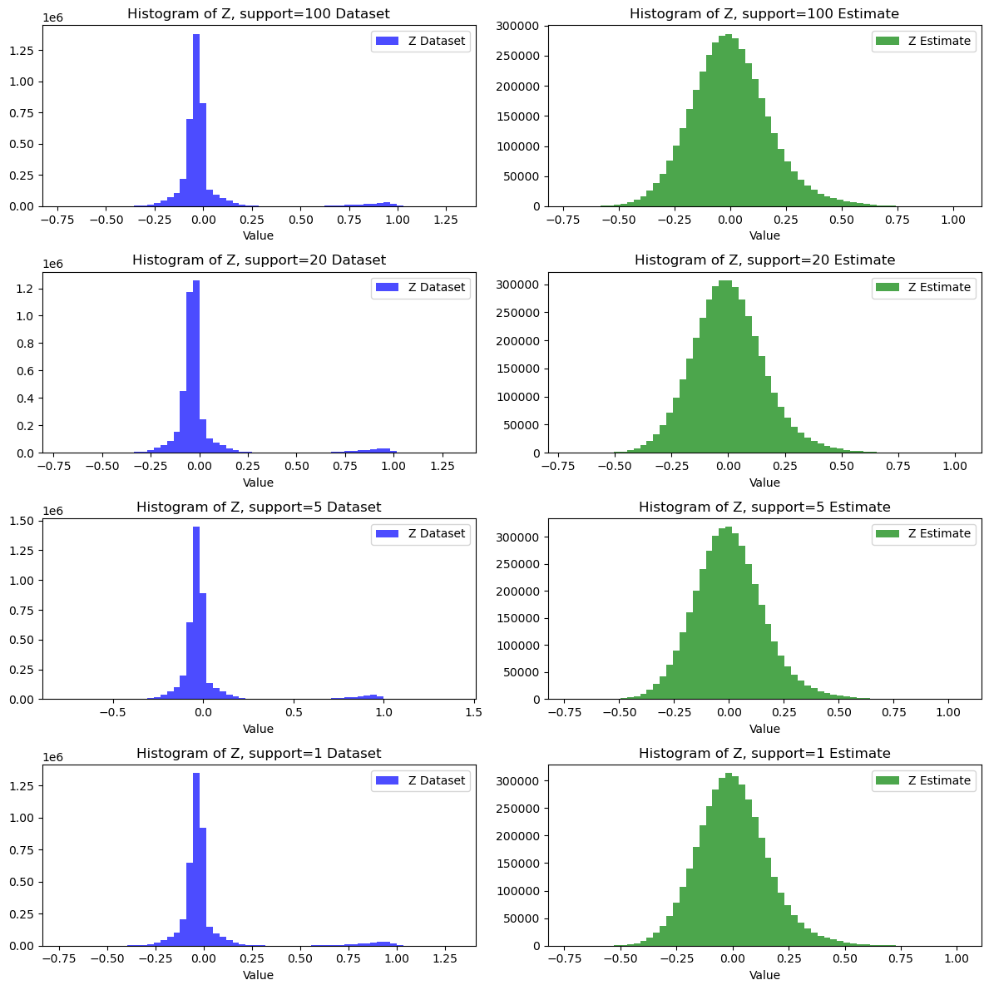

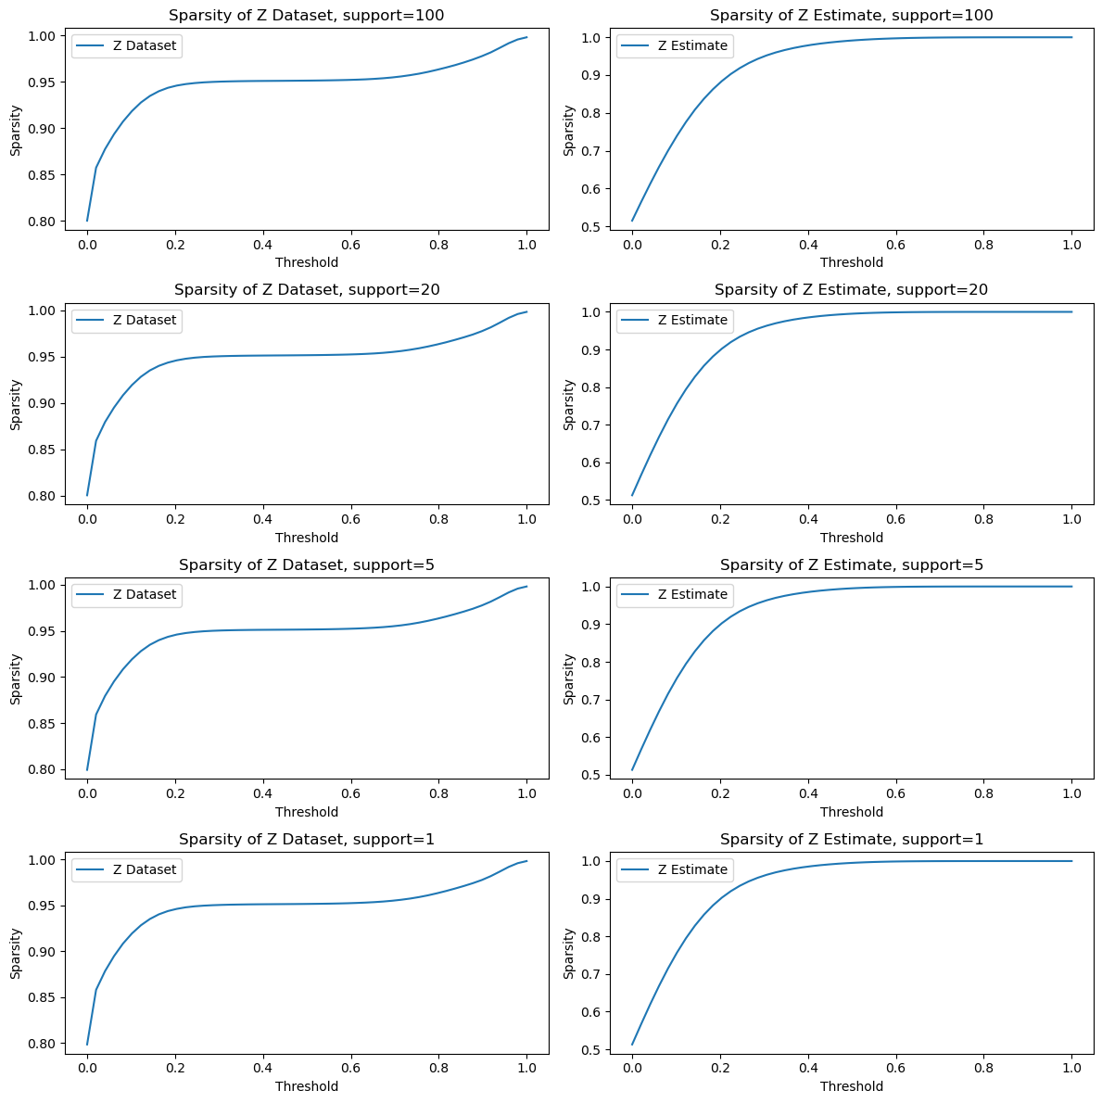

**Our robustness:**

Now, we'll check how well the test's results on different distribution in training: different sigma, and different v' support (which means, different signals energy):

$$Training with sigma=0.01, support=10, m=0.25n$$

|  |  |  |  |  |
| --- | --- | --- | --- | --- |
| Noise's sigma | V' support | MSE | Normalized MSE |  |
| **0.01** | **10** | **0.0371** | **2.8649e-06 (origin)** | **0** |
| 0.01 | 100 | 0.0372 | 2.8692e-07 | 0.122e-07 |
| 0.01 | 20 | 0.0372 | 1.4474e-06 | 0.0059e-06 |
| 0.01 | 5 | 0.0372 | 5.7243e-06 | 0.045e-06 |
| 0.01 | 1 | 0.0372 | 2.7410e-05 | 0.0468e-05 |
| 0.1 | 10 | 0.0466 | 3.6047e-06 | 0.0208e-06 |
| 0.02 | 10 | 0.0375 | 2.8865e-06 | 0.0135e-06 |
| 0.005 | 10 | 0.0372 | 2.8783e-06 | 0.0093e-06 |
| 0.001 | 10 | 0.0371 | 2.8577e-06 | 0.0109e-06 |

**Quality of compression:**

By CS theory, the number of measurements $m$ needs to be $m∝O\left(k⋅log\left(\frac{n}{k}\right)\right)$ when the signal (our innovation) is k sparse, and n is the length of the signal.

In our experiment, $n=400*10, k=\frac{n}{20}→m≈0.065n≈0.0625n=\frac{n}{16}.$

Let's see experimentally if we are close to the theory, by checking the normalized MSE result with different compression ratios:

$$Training with sigma=0.01, support=10, k=\frac{n}{20}:$$

|  |  |  |  |  |  |
| --- | --- | --- | --- | --- | --- |
| Compression ratio | MSE | Normalized by X MSE | Normalized by Z MSE | Needed Epochs | Generalization Error |
| $$\frac{1}{400}$$ | 0.0902 | 6.9651e-06 | 2e-4 | 7 | 0.009850 |
| $$\frac{1}{128}$$ | 0.0426 | 3.2632e-06 | 1e-4 | 12 | 0.000678 |
| $$\frac{1}{16}$$ | 0.0459 | 3.5346e-06 | 1e-4 | 11 | 0.005428 |
| $$\frac{1}{8}$$ | 0.0492 | 3.7978e-06 | 1e-4 | 9 | 0.005214 |
| $$\frac{1}{2}$$ | 0.0265 | 2.0568e-06 | 6.4603e-05 | 7 | 0.002855 |
| $\frac{1}{4}$ (baseline) | 0.0371 | 2.8649e-06 | 9.0671e-05 | 8 | 0.004386 |



