Appendix 5: Model Technical Specification

A5.1 Environmental Parameter Specifications
All environmental parameters were normalised to a 0–10 suitability scale through fuzzy membership transformations (ArcGIS Pro Spatial Analyst) prior to weighted summation. Distance-based parameters were computed using cost-distance analysis incorporating topographic travel time via Tobler’s hiking function (Tobler 1993; Herzog 2020). Table A5.1 lists each parameter’s classification, data source, transformation function type, and calibration values. Parameters excluded from the suitability summation are retained in the model as inputs to resource calculations (arable soils, vegetation, available pasture) or as intermediate derivations, but are not included as independent weighted terms to avoid overrepresenting annual rainfall, from which they are derived.
Parameter | Type | Source / Derivation | Fuzzy Function | Transformation Parameters | Included in Suitability Summation
Mean Annual Rainfall | Permanent Ecological | IMS station data; IDW interpolation | Linear | Min = 0 mm, Max = 100 mm | Yes
Slope | Permanent Ecological | JAXA ALOS PALSAR DEM (12.5 m) | FuzzySmall | Midpoint = 15°, Spread = 3 | Yes
Proximity to Arable Soils | Permanent Ecological | Israeli Geological Survey (loess & Hatzeva Fm.); cost-distance (Tobler) | — | — | No (collinear with annual rainfall)
Distance to Permanent Water Sources | Permanent Ecological | Topographic maps & field sources; cost-distance (Tobler) | FuzzySmall | Midpoint = 3 hrs walking, Spread = 1 | Yes
Vegetation Type | Permanent Ecological | Danin (1983); Ron et al. (2024) | — | — | No (used in pasture derivation only)
Distance to Tell el-Qudeirat | Permanent Anthropogenic | Site location; cost-distance (Tobler) | FuzzySmall | Midpoint = 4 hrs walking, Spread = 1 | Yes
Annual Rainfall | Annual Ecological | IMS historical records (Aug–Jul); IDW interpolation; min. 20 active stations | Linear | Min = 0 mm, Max = 100 mm | Yes
Available Pasture | Annual Ecological | Vegetation type × annual rainfall (multiplicative interaction) | — | — | No (collinear with annual rainfall)
Fertile Arable Soils (Seasonal) | Annual Ecological | Zonal rainfall totals on loess/Hatzeva polygons; cost-distance | — | Rainfall threshold: mean rainfall > 75 mm and 25th percentile rainfall > 60 mm | No (collinear with annual rainfall)
Multi-Annual Resource Exhaustion | Dynamic Anthropogenic | Accumulated from simulation: weighted degradation history + focal spatial smoothing | — | Temporal decay factor = 0.5; spatial radius = 5 km | Yes
Reuse Potential | Dynamic Anthropogenic | Accumulated from simulation: encampment and enclosure construction history | — | Recent constructions weighted higher than older ones | Yes
Table A5.1. Environmental parameter specifications: classification, data sources, fuzzy membership transformation functions, and inclusion in the weighted suitability summation. ‘Permanent’ parameters remain constant across all 75 simulation years; ‘Annual’ parameters update each year through stochastic rainfall selection; ‘Dynamic Anthropogenic’ parameters accumulate from simulated household activity.
Notes: FuzzySmall assigns maximum suitability (10) to low input values and minimum suitability (0) to high input values, using a sigmoidal decline; midpoint is the input value at suitability 0.5 and spread controls the steepness of the transition. Linear transformation maps raw values linearly between the specified minimum (suitability 0) and maximum (suitability 10). ‘—’ indicates that no fuzzy transformation is applied because the parameter is either binary, categorical, or derived through multiplicative interaction rather than normalised independently.

A5.2 Degradation and Carrying Capacity Equations
Household occupation degrades environmental suitability through two interacting mechanisms that together produce the landscape patchiness driving temporal cycling (Section 5.3.1). The first operates within each annual cycle: every time a household or nuclear family camp establishes a location, suitability values in the surrounding cells are reduced immediately, so that households placing later in the same year encounter an already-modified landscape. The second operates across years: each year's occupation pattern is added to a weighted cumulative record, so that areas with a longer history of repeated use carry persistent degradation that outlasts any single season.
Equations eq A5.1 and eq A5.2 formalise the within-year spatial degradation. Both apply identically in structure, differing only in the magnitude of the penalty term (D for household territories, P for nuclear family camps) and the spatial radius over which they operate.
Equations A5.1 and A5.2: Distance-based environmental degradation from household and nuclear family occupation. Where S'(x,y) is the updated suitability at cell (x,y), S(x,y) is the original suitability, D is the degradation factor, d(x,y) is Manhattan distance from the occupied cell, and P is the position degradation factor for the centre cell. Households use D = 0.5 and P = 0.9; nuclear family camps use D = 0.3 and P = 0.5. Minimum suitability is 0.0001.
$$eq 4.1: S^{'}\left(x,y\right)=\max\left(S\left(x,y\right)-\frac{D}{d\left(x,y\right)}, 0.0001\right)$$
$$eq 4.2: S^{'}\left(center\right)=\max\left(S\left(center\right)- P, 0.0001\right)$$
Equation eq A5.3 formalises the temporal decay function that weights each past year's contribution to the cumulative degradation record. The decay factor of 0.5 means that occupation two years ago exerts half the influence of occupation last year, and occupation five years ago exerts less than one-sixteenth of last year's influence, implementing an implicit landscape recovery process without requiring a separate recovery model.
Equation A5.3: Temporal decay weighting for inter-annual degradation. w(t) is the weight applied to occupation in year t, T is the current year, and (T-t) is years since occupation. The decay factor of 0.5 weights recent occupation more heavily, implementing implicit landscape recovery over time.
$$eq 4.3+2:w\left(t\right)= {0.5}^{T-t}$$
Table A5.2. Notation for degradation equations.
Symbol | Description
$$S(x,y)$$ | Suitability of cell $\left(x , y\right)$before degradation
$$S^{'}(x,y)$$ | Suitability of cell $\left(x , y\right)$after degradation
$$D$$ | Degradation intensity parameter for household territory (fixed at 0.5, weight 0.9)
$$P$$ | Direct centre penalty for nuclear family camp occupation
$$d(x,y)$$ | Distance from occupation centre to cell $\left(x , y\right)$in cell units
$$w(t)$$ | Temporal weight assigned to occupation in year $t$
$$T$$ | Current simulation year
$$t$$ | Year of past occupation being weighted
Cumulative weighted degradation from all past years is subsequently smoothed through spatial convolution over a 5 km radius using inverse-distance weighting, spreading degradation pressure beyond directly occupied cells to represent landscape-scale grazing and resource extraction impacts. The resulting stress surface feeds directly into the annual suitability raster as the "multi-annual resource exhaustion" parameter (Table A5.1), contributing to location selection decisions in subsequent years.

A5.3 Calibration Implementation Details
Calibration proceeded in two phases. Prior to formal optimisation, exploratory manual runs were conducted to develop intuition about model sensitivity and verify basic model behaviour. These initial runs confirmed that the model could produce qualitatively plausible outputs, identified parameters with strong versus weak effects on pattern matching, and resolved technical implementation issues before committing computational resources to systematic optimisation. Exploratory runs revealed, for example, that annual rainfall weights required substantial influence to generate appropriate temporal cycling, while some parameters initially considered were later excluded as redundant given their minimal additional pattern-matching contribution.
Formal optimisation employed Optuna (Akiba et al. 2019) with the Tree-structured Parzen Estimator (TPE) sampler for adaptive parameter space exploration (Watanabe 2023). TPE constructs probabilistic models of promising versus unpromising regions of parameter space based on previous trial outcomes, concentrating subsequent sampling in areas likely to yield improved objective scores. A MedianPruner terminated trials early when intermediate results indicated unlikely improvement over previous trials, reducing computational waste on unpromising parameter combinations. Together, these algorithmic choices balance exploration of diverse parameter combinations against exploitation of promising regions.
Formal optimisation executed 200 trials (143 completing fully and 57 pruned by early stopping). With four workers running trials in parallel, each completing trial required a mean of approximately 8.4 hours of wall-clock time (range: 3.0–19.8 hours), reflecting the ten-replicate structure and 75-year simulation length per replicate. Total wall-clock computation across the optimisation campaign spanned approximately 12–13 days.
Reproducibility. Random seeds were generated deterministically as $seed=(t×100)+i$, where $t$is the trial number and $i$is the replicate index, ensuring full reproducibility while maintaining independence between replicates within each trial. The seven integer weights sampled during each trial were normalised to proportional values by dividing each by their sum before application; for example, sampled values [3, 0, 5, 2, 1, 4, 6] normalise to [0.143, 0.000, 0.238, 0.095, 0.048, 0.190, 0.286], ensuring weights represent relative environmental preferences rather than absolute scaling factors.

A5.4 Full Model Parameter Reference
Table A5.4 provides a comprehensive reference for all fixed and calibrated parameters used in the model. Parameters are grouped by functional category. 'Assumed' in the Source column indicates that no direct empirical basis was available for the specific value; these parameters were set through logical reasoning about pastoral systems and model behaviour, and their influence on outputs is assessed through sensitivity analysis (Section 5.6). Parameters listed under 'Calibrated' in the Environmental Suitability Weights group were determined through Optuna optimisation as described in Sections 5.5.2 and A5.3; their values are reported in Section 5.5.4.
Parameter | Value / Range | Units | Description | Source / Justification | Section
Spatial Configuration
Cell size | 250 × 250 | m (6.25 ha) | Spatial resolution of grid cells | Balances computational efficiency and environmental heterogeneity; aligns with survey coordinate accuracy (~100–500 m) | 5.2.1
Grid dimensions | 318 × 280 | cells | Total model extent (3,251.54 km²) | Natural topographic boundaries of Negev Highlands; western limit imposed by Israel–Egypt border (data constraint) | 5.2.1
Environmental Suitability Weights (calibrated via Optuna — see A5.3)
Mean annual rainfall weight | 0–7 (integer, calibrated) | relative weight | Importance of long-term rainfall in location selection | IMS station data; IDW interpolation | 5.2.1.2, 5.5.2
Slope suitability weight | 0–7 (integer, calibrated) | relative weight | Importance of terrain slope in location selection | JAXA ALOS PALSAR DEM (12.5 m) | 5.2.1.2, 5.5.2
Distance to Tell el-Qudeirat weight | 0–7 (integer, calibrated) | relative weight | Importance of proximity to central place | Tobler's hiking function (cost-distance) | 5.2.1.2, 5.5.2
Distance to permanent water weight | 0–7 (integer, calibrated) | relative weight | Importance of water access in location selection | Tobler's hiking function (cost-distance) | 5.2.1.2, 5.5.2
Annual rainfall weight | 0–7 (integer, calibrated) | relative weight | Importance of current-year rainfall | IMS observed years; IDW interpolation | 5.2.1.2, 5.5.2
Reuse potential weight | 0–7 (integer, calibrated) | relative weight | Importance of previously occupied sites | Model-generated from occupation history | 5.2.1.2, 5.5.2
Multi-annual stress weight | 0–7 (integer, calibrated) | relative weight | Importance of cumulative degradation avoidance | Model-generated (see A5.2) | 5.2.1.2, 5.5.2
Degradation Parameters
Household degradation intensity (D) | 0.5 | dimensionless | Distance-based degradation intensity for household territories | Assumed | 5.3.1
Household centre penalty (P) | 0.9 | dimensionless | Direct centre-cell degradation intensity for household camp | Assumed | 5.3.1
Nuclear family degradation intensity (D) | 0.3 | dimensionless | Distance-based degradation intensity for nuclear family camps | Assumed | 5.3.1
Nuclear family centre penalty (P) | 0.5 | dimensionless | Direct centre-cell degradation intensity for nuclear family camp | Assumed | 5.3.1
Temporal decay factor | 0.5 | dimensionless | Exponential decay weight for cumulative degradation by year | Assumed (implicit recovery rate) | 5.3.1
Spatial smoothing radius | 5 | km (20 cells) | Diffusion distance for cumulative degradation | Assumed (grazing impact range) | 5.3.1
Minimum suitability floor | 0.0001 | dimensionless | Floor value preventing complete suitability collapse | Assumed | 5.3.1
Carrying Capacity
Medium pasture quality reference | 5 | 0–10 scale | Reference suitability value for carrying capacity calculation | Literature-based standard | 5.3.2
Pasture carrying capacity | 1.125 | goats / cell | Livestock support per 250 m cell at medium quality pasture | Ethnographic (Rosen & Finkelstein 1992) | 5.3.2
Carrying capacity evaluation radius | 25 | cells (~6.25 km) | Spatial zone for pastoral productivity assessment | Assumed | 5.3.2, 5.3.2
Household Economic Parameters
Initial flock size | ~105 per nuclear family (~1,050 per household) | goats | Starting livestock holdings | Modified from Rosen & Finkelstein (1992) | 5.2.2, 5.3.2
Livestock per capita subsistence requirement | 18 | goats / person | Minimum herd per person for subsistence (diversified economy) | Modified from Rosen & Finkelstein (1992) | 5.2.2, 5.3.2
Per capita consumption | 1.2 | surplus units / person / year | Non-subsistence household expenses | Assumed | 5.3.2
Agricultural offset | Up to 40% | % reduction | Reduction in livestock subsistence requirement where agriculture possible | Rosen & Finkelstein (1992); Günther et al. (2021) | 5.3.2
Stress maintenance cost | 15% × stress ratio | % of herd | Penalty when herd exceeds local carrying capacity | Assumed | 5.3.2
Annual surplus decay | 30% | % per year | Baseline resource spoilage and gradual consumption | Assumed | 5.3.2
Large surplus decay (progressive) | 5–25% | % per year | Additional decay above 100 surplus units (storage limits, redistribution pressure) | Assumed | 5.3.2
Maximum herd growth rate | Up to 20% | % per year | Annual herd growth under favourable conditions; diminishing returns approaching 1,000 animals | Literature-based | 5.3.2
Herd decline rate | 10–30% | % per year | Decline when carrying capacity insufficient; scaled by resource deficit | Literature-based | 5.3.2
Maximum herd size | 1,000 | animals | Upper cap for herd growth (diminishing returns threshold) | Assumed | 5.3.2
Crisis Response Parameters
Crisis surplus threshold | 10 | surplus units | Surplus level triggering emergency livestock conversion | Assumed | 5.3.4
Emergency livestock conversion rate | 1 livestock → 0.3 surplus | ratio | Unfavourable distressed-sale conversion rate | Assumed | 5.3.4
Minimum reserve herd (crisis) | 18 animals / person, capped at 100 | animals | Minimum herd protected during emergency conversion | Assumed | 5.3.4
Livestock acquisition threshold | Surplus >80 and herd <600 | units / animals | Conditions triggering opportunistic herd rebuilding; invests up to 20% of surplus, max 40 units | Assumed | 5.3.4
Livestock acquisition rate | 0.3 surplus → 1 livestock | ratio | Premium cost of purchasing animals | Assumed | 5.3.4
Household extinction: surplus | <0 | surplus units | Household failure threshold (surplus) | Assumed | 5.3.4
Household extinction: livestock | <15 | animals | Household failure threshold (herd) | Assumed | 5.3.4
Spatial and Territorial Parameters
Base territory radius | 20 | cells (~5 km) | Standard territory size under favourable conditions (quality >5.0) | Assumed (pastoral ranging) | 5.3.1
Expanded territory radius (poor conditions) | 30 | cells (~7.5 km) | Territory when environmental quality <3.5 | Assumed (increased ranging needs) | 5.3.1
Moderate territory radius | 25 | cells (~6.25 km) | Territory when environmental quality 3.5–5.0 | Assumed | 5.3.1
Territorial overlap threshold | 25% | % of cells | Maximum acceptable territory overlap before location rejected | Assumed (cooperative coexistence) | 5.3.1, 5.3.1
Nuclear family camp radius | 11 | cells (~2.75 km) | Impact zone for nuclear family sub-camps | Assumed | 5.3.1
Enclosure Construction Parameters
Base prosperity threshold (enclosure eligibility) | 0.6 | dimensionless | Minimum prosperity index to qualify for enclosure activity | Assumed | 5.3.3
High prosperity threshold (new construction) | 0.8 | dimensionless | Minimum prosperity index to build a new enclosure | Assumed | 5.3.3
Minimum manpower — reuse | ≥15 | persons | Required workforce to reuse existing enclosure | Assumed | 5.3.3
Minimum manpower — new construction | ≥30 | persons | Required workforce to build new enclosure | Assumed | 5.3.3
Enclosure reuse cost (manpower) | 10 | persons | Labour investment to reuse existing structure | Assumed | 5.3.3
Enclosure reuse cost (surplus) | 6 | surplus units | Resource investment to reuse existing structure | Assumed | 5.3.3
New enclosure cost (manpower) | 20 | persons | Labour investment to construct new enclosure | Assumed | 5.3.3
New enclosure cost (surplus) | 25 | surplus units | Resource investment to construct new enclosure | Assumed | 5.3.3
Manpower recovery after construction | 90% | % returned | Proportion of manpower cost recovered after construction completes | Assumed | 5.3.3
Enclosure reuse window — own constructions | 35 | years | Maximum age of household's own enclosures eligible for reuse | Assumed | 5.3.3
Enclosure reuse window — others' enclosures | 25 | years | Maximum age of other households' enclosures eligible for reuse | Assumed | 5.3.3
Others' enclosure reuse weighting | 80% | % of own weighting | Priority discount for reusing another household's enclosure | Assumed | 5.3.3
Enclosure selection stochastic variation | ±20% | % | Random variation in enclosure selection probability | Assumed | 5.3.3
Memory and Territorial Attachment Parameters
Territorial centre weighting — previous | 90% | % contribution | Weight of previous centre in updating home-range focus | Assumed | 5.3.1
Territorial centre weighting — current | 10% | % contribution | Weight of current year's location in updating home-range focus | Assumed | 5.3.1
Territorial centre Gaussian peak bonus | +5.0 | suitability units | Maximum suitability bonus at home-range centre | Assumed | 5.3.1
Territorial centre Gaussian sigma | 50 | cells | Spatial spread of home-range centre attraction | Assumed | 5.3.1
Territory boundary bonus | 2.5 / (distance + 1) | suitability units | Distance-based bonus for cells near previous year's territory (up to 20 cells beyond edge) | Assumed | 5.3.1
Memory quality threshold | 5 | 0–10 scale | Quality value distinguishing positive from negative memory effects | Assumed | 5.3.1
Current-year location penalty | −0.5 | suitability units | Fixed penalty preventing immediate re-occupation of current year's location | Assumed | 5.3.1
Memory guaranteed retention | <15 | years | Memories younger than 15 years are always kept | Assumed (intergenerational knowledge) | 5.3.1
Memory median lifespan | ~19–20 | years | Older memories dropped stochastically (annual retention probability ≈ 15 ÷ age); few persist beyond ~two decades | Assumed | 5.3.1
Temporal Parameters
Simulation duration | 75 | years | Total modelled timespan (c. 980–830 BCE) | Iron Age IIA system duration (Ben-Yosef et al. 2021; Ben-Yosef 2023) | 5.2.3
Time step | 1 | year | Temporal resolution; each step represents one summer occupation season | Annual seasonal cycle | 5.2.3
Initial population | 9 | households | Starting number of household agents | Conservative carrying capacity estimate (Rosen & Finkelstein 1992); see Section 5.2.4 | 5.2.4

A5.5 Household Agent State Variables
Table A5.4. Full model parameter reference. Parameters are grouped by functional category. 'Assumed' indicates values set by logical reasoning or model design in the absence of direct empirical data. Calibrated suitability weights are reported in Section 5.5.4
Table A5.5 lists all state variables maintained by individual household agents throughout the simulation. Dynamic variables update during each annual cycle; static variables are set at initialization and remain fixed. Variable names correspond to implementation in the Mesa-based Python model (ter Hoeven et al. 2025).
Variable | Type | Units | Range | Dynamic / Static | Description | Section
flock_head | Integer | animals (goats) | ≥15 | Dynamic | Total livestock holdings | 5.2.2, 5.3.2
surplus | Float | abstract resource units | ≥0 | Dynamic | Accumulated economic resources available for investment and consumption | 5.2.2, 5.3.2
manpower | Integer | persons | ≥1 | Dynamic | Available workforce for herding, movement, and construction | 5.2.2
territory | List of coordinates | cell positions | Variable extent | Dynamic (annual reset) | Claimed spatial area; resets each year following repositioning | 5.2.2, 5.3.1
memory | List of tuples | [position, quality, year] | Variable length | Dynamic | Personal encampment history; subject to stochastic annual pruning | 5.2.2, 5.3.1
enc_memory | List of tuples | [position, year] | Variable length | Dynamic | Collective enclosure knowledge; includes own constructions and encountered enclosures | 5.2.2, 5.3.3
in_severe_crisis | Boolean | True / False | Binary | Dynamic | Crisis status flag; triggers emergency livestock conversion when True | 5.2.2, 5.3.4
own_suitability_raster | NumPy array | 0–10+ scale | 318 × 280 cells | Dynamic | Personalised landscape perception: global suitability modified by territorial attachment and memory adjustments | 5.2.2, 5.3.1
pos | Tuple (x, y) | grid coordinates | Within model bounds | Dynamic (annual reset) | Current camp location; reset to None at year end and re-selected at year start | 5.2.2
Table A5.5. Household agent state variables. All variables are dynamic unless noted. Variable names reflect Python implementation.

A5.6 Environment and Model-Level State Variables
Table A5.6 lists all environment-level and model-level state variables maintained by the simulation. Static rasters are loaded once at initialization from pre-processed GIS datasets; dynamic rasters update each annual cycle following household decision-making. All rasters share the 318 × 280 cell grid defined in Section 5.2.1.
Variable | Type | Units | Range | Dynamic / Static | Description | Section
year | Integer | years | 0–74 | Dynamic | Current simulation year; drives annual cycle execution and stochastic rainfall selection | 5.2.3
suitability_raster | 2D NumPy array | 0–10+ scale | 318 × 280 | Dynamic (annual update) | Overall environmental suitability combining all weighted parameters; drives household location selection | 5.2.1.2
return_raster | 2D NumPy array | 0+ scale | 318 × 280 | Dynamic (annual update) | Reuse potential surface accumulating past encampment and enclosure history; weighted toward recent constructions | 5.2.1.2
stress_ras | 2D NumPy array | 0–10 scale | 318 × 280 | Dynamic (annual update) | Cumulative human degradation pressure; weighted temporal accumulation spatially smoothed over 5 km radius (see A5.2) | 5.2.1.2, 5.3.1
veg_ras | 2D NumPy array | 0–10 scale | 318 × 280 | Dynamic (annual update) | Annual vegetation/pasture suitability; multiplicative interaction of vegetation type and selected rainfall year | 5.2.1.2
ag_ras | 2D NumPy array | 0–10 scale | 318 × 280 | Dynamic (annual update) | Annual agricultural potential; cost-distance to seasonally cultivable soils given selected rainfall year | 5.2.1.2
target_raster | 2D NumPy array | 0+ (cumulative counts) | 318 × 280 | Dynamic (annual accumulation) | Spatial activity tracker accumulating household occupation signals across all 75 years; forms basis for simulated site classification | 5.2.1.2
place_raster | 2D NumPy array | 0 / 1 (binary) | 318 × 280 | Static | Valid placement mask; restricts agent activity to Israeli portion of Negev Highlands where environmental data coverage is complete | 5.2.1, 5.2.1.2
enclosures | List | [position, year, agent_id] | Variable length | Dynamic | Registry of all constructed enclosures; queried during enclosure search and reuse decisions | 5.2.1.2, 5.3.3
territories | List of lists | nested cell coordinates | Variable length | Dynamic (annual reset) | Registry of all active household territories for the current year; used in overlap evaluation | 5.2.1.2, 5.3.1
mean_annual_rainfall | 2D NumPy array | mm | 318 × 280 | Static | Long-term average precipitation derived from IMS station data via IDW interpolation | 5.2.1.2
slope | 2D NumPy array | degrees | 318 × 280 | Static | Terrain slope derived from JAXA ALOS PALSAR DEM (12.5 m) | 5.2.1.2
kb_distance | 2D NumPy array | hours walking | 318 × 280 | Static | Cost-distance to Tell el-Qudeirat via Tobler's hiking function | 5.2.1.2
pw_distance | 2D NumPy array | hours walking | 318 × 280 | Static | Cost-distance to nearest permanent water source via Tobler's hiking function | 5.2.1.2
annual_rainfall | 2D NumPy array | mm | 318 × 280 | Dynamic (annual update) | Stochastically selected historical rainfall year; updated each simulation year from IMS records | 5.2.1.2
arable_soil_distance | 2D NumPy array | hours walking | 318 × 280 | Dynamic (annual update) | Cost-distance to seasonally fertile soils; recalculated each year based on selected rainfall threshold | 5.2.1.2
Table A5.6. Environment and model-level state variables. Static variables are set at initialization; dynamic variables update each simulation year. All 2D NumPy arrays share the 318 × 280 cell spatial extent.

A5.7 Sensitivity Analysis — Full Results
This appendix reports the complete methodological specifications, numeric results, and spatial figures for all four sensitivity tests described in Section 5.6. Tests are presented in the order discussed in the main text.

A5.7.1 Null Weight Baseline
To establish a performance baseline against which the calibrated solution could be evaluated, 30 model iterations were executed using a null weight configuration in which all seven environmental suitability parameters received equal weights (each 1/7 ≈ 0.143). This configuration represents the absence of any preferential environmental structure in household location selection: no parameter is considered more or less important than any other. The null design deliberately excludes the calibrated preference structure to test whether the optimisation process identified a genuinely informative parameter combination or merely converged on a solution achievable by any weighting scheme. Each iteration used a distinct random seed following the same deterministic seed generation procedure as calibration (seed = trial × 100 + iteration). Performance was measured using the same composite objective function as calibration (spatial error + ratio error / 2).
Table A5.7. Results of the null weight baseline test.
Statistic | Value
Mean error | 0.3182
95% CI lower | 0.3088
95% CI upper | 0.3277
Minimum | ~0.28
Maximum | ~0.39
Best calibrated | 0.2013
Improvement | 36.7%

The best calibrated trial score of 0.2013 falls entirely outside the null distribution (Figure A5.1). The gap of 0.117 error units between the calibrated solution and the null mean confirms that the optimised parameter structure captures meaningful environmental signal that an uninformed equal-weight model cannot replicate.
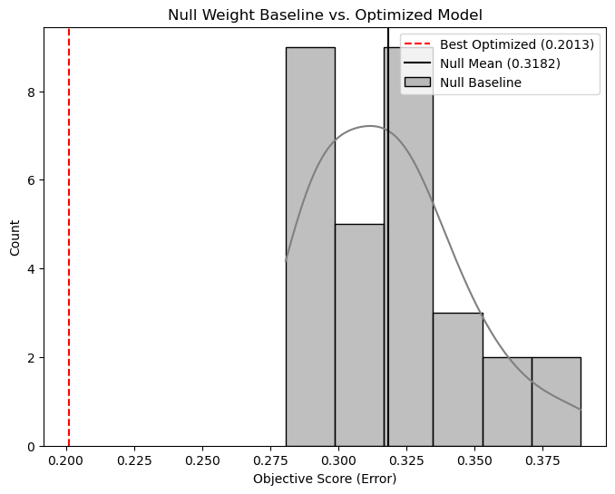
Figure A5.1: Histogram of null baseline composite scores (n=30) with best calibrated score (0.2013) marked as vertical dashed line. Null mean (0.3182) marked separately.

A5.7.2 Temporal Horizon
To test whether the 75-year simulation duration represents an appropriate and stable configuration, a single extended run was executed for 150 years using the calibrated weights from the best trial. Model state was evaluated at ten-year intervals by converting the accumulated target raster to a GeoDataFrame and computing the composite objective score against the archaeological calibration dataset. Three metrics were recorded at each checkpoint: total composite score, spatial error (1 − IoU of standard deviational ellipses), and ratio error (absolute difference in enclosed compound proportions). A single run rather than multiple iterations was used for this test given its exploratory diagnostic purpose and the substantial computational cost of 150-year simulations.
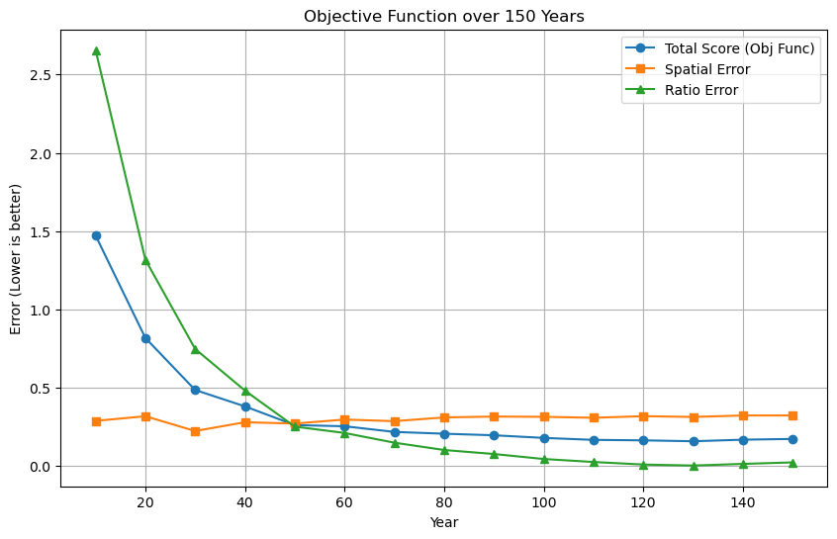
Spatial outputs were additionally inspected visually at years 100 and 150 to assess whether metric trends corresponded to archaeologically plausible spatial distributions, following the visual plausibility criterion discussed in Section 5.6.
Figure A5.2: Line plot showing total composite score, spatial error, and ratio error across all 15 checkpoints from year 10 to year 150.
Composite error declined steeply from year 10 to year 75, driven primarily by ratio error convergence as enclosure construction events accumulated. Spatial error remained relatively stable throughout (0.27–0.32). Beyond year 75, apparent metric improvement is driven entirely by continued ratio error reduction toward near-zero saturation; spatial error begins a gradual upward drift from year 100 onward. Visual inspection of spatial outputs at years 100 and 150 reveals near-complete coverage of the valid placement area by simulated activity, consistent with progressive landscape saturation rather than sharpening spatial correspondence (Figures A5.2–A5.3).
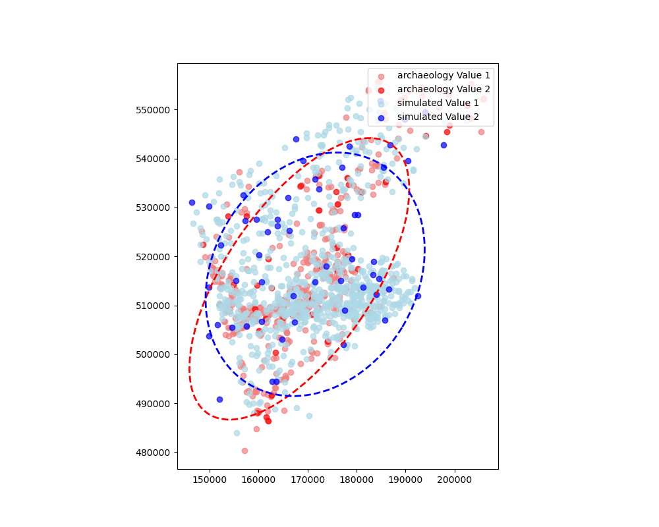
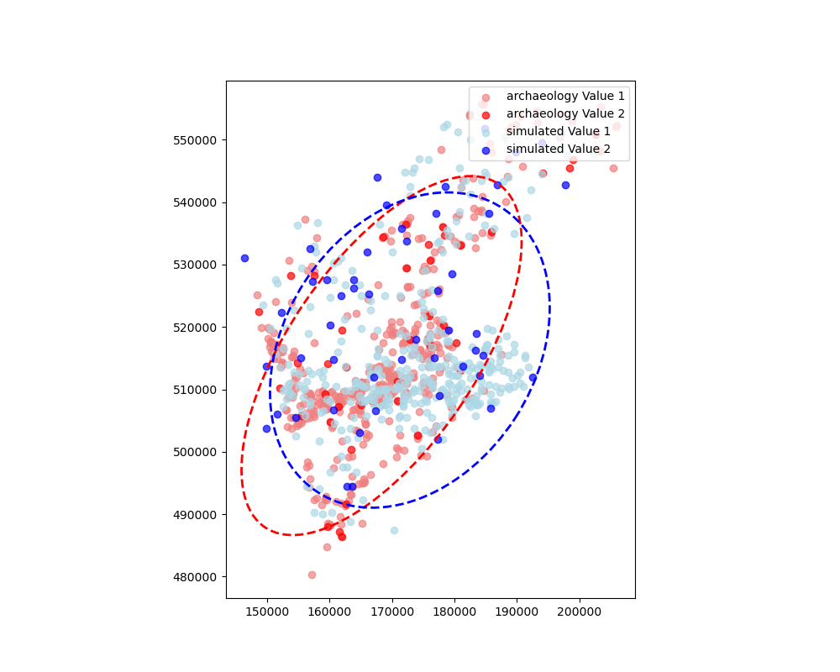
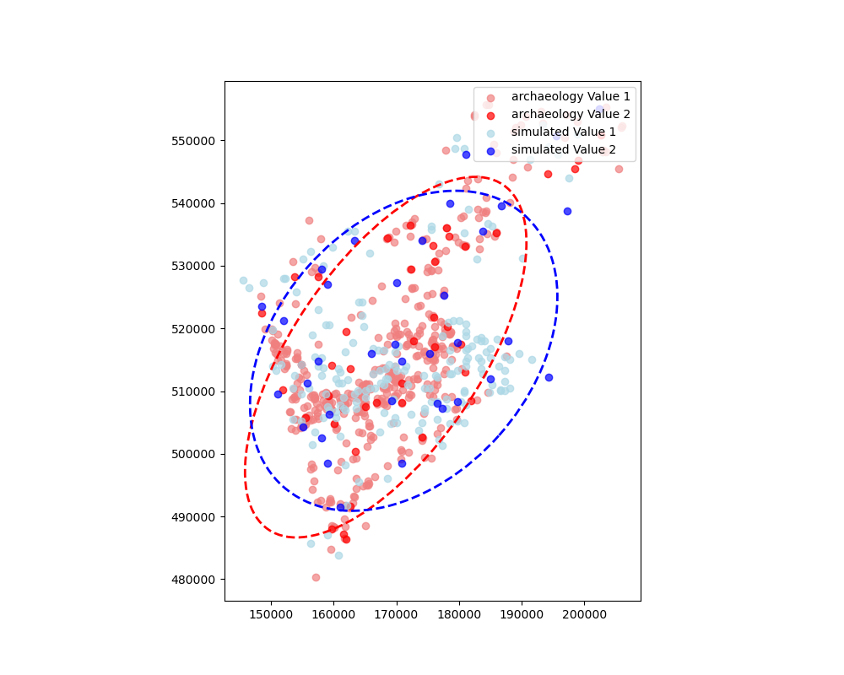
75 years
100 years
150 years
Figure A5.3: Spatial ellipse comparison at years 75, 100, 150 — archaeological distribution (red) versus simulated distribution (blue)

A5.7.3 Population Size
To assess sensitivity to the number of household agents, three alternative population sizes were tested: 5, 15, and 20 agents, compared against the calibrated baseline of 9 agents. Each configuration was run for five iterations using calibrated weights and the standard 75-year duration. Random seeds were assigned using the same deterministic procedure as calibration. Performance was evaluated using the composite objective function. Spatial outputs from each configuration were additionally inspected visually to assess distributional plausibility, given the objective function limitation identified in Section 5.6.
At 5 agents, performance degrades substantially: the sparse household population generates too few occupation events to match the regional archaeological distribution and too few enclosure constructions to approach the 1:13.3 target ratio. At 15 and 20 agents, metric scores improve beyond the nine-agent baseline, but visual inspection reveals this to be artefactual: simulated activity covers practically the entire valid landscape uniformly, with no meaningful spatial clustering corresponding to the observed archaeological concentration (Figures A5.4–A5.5). The nine-agent configuration produces the most spatially coherent output across the tested range.
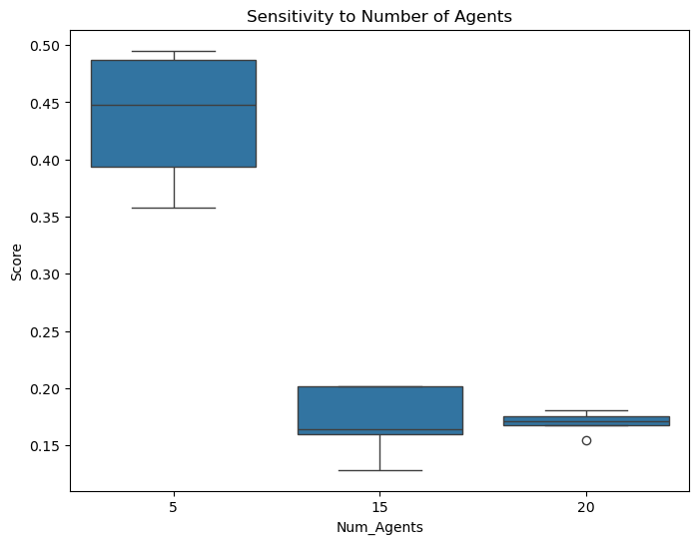
Figure A5.4: Boxplot of composite scores for 5, 15, and 20 agents.

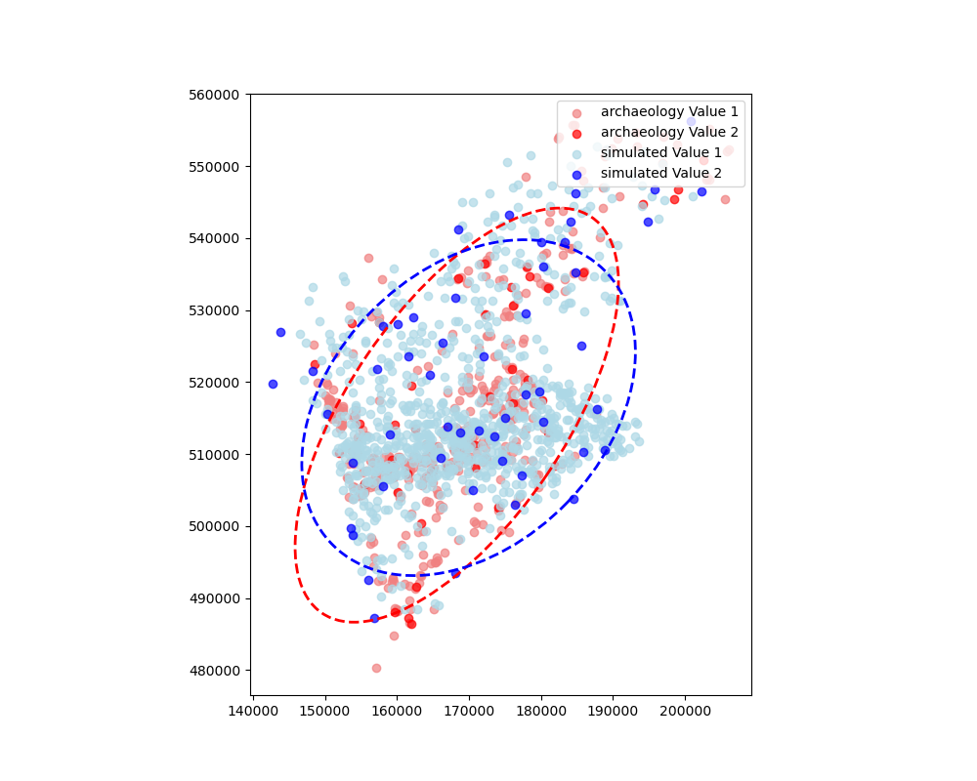
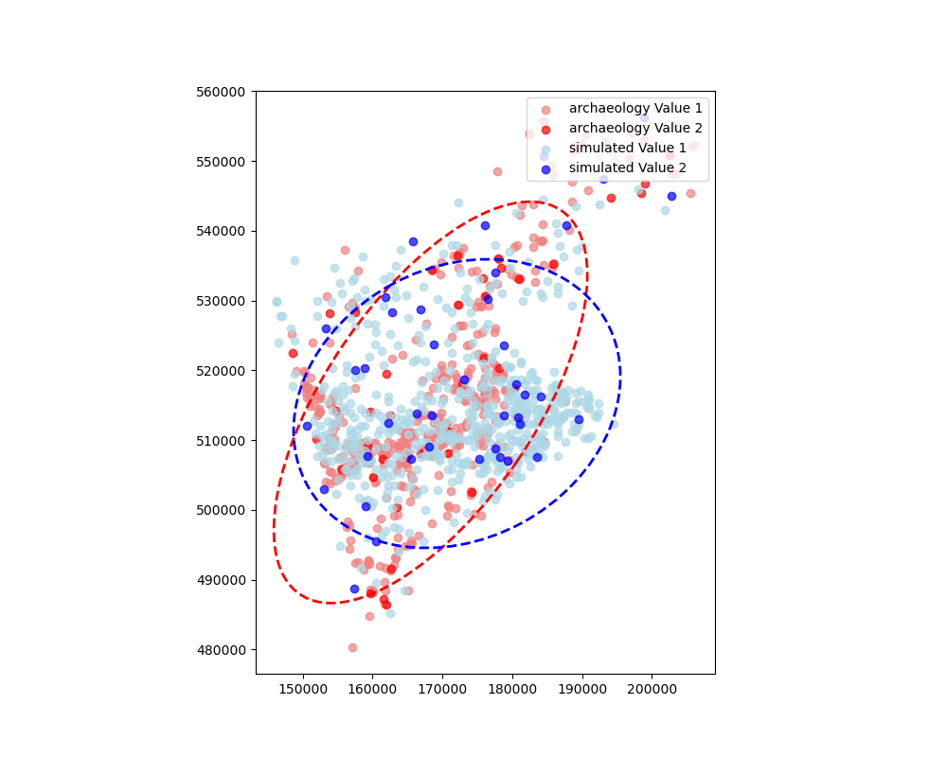

9 agents
15 agents
20 agents
Figure A5.5: Spatial ellipse comparison at 9, 15, 20 agents — archaeological distribution (red) versus simulated distribution (blue)

A5.7.4 Territory Flexibility
To test the contribution of annual landscape-scale repositioning to model performance, two territorial modes were compared. In the default flexible mode, households select new camp locations across the full valid landscape at the start of each year based on updated environmental suitability, accumulated memory, and territorial competition, as described in Section 5.3.1. In the fixed-territory mode, households were assigned territories at initialisation and did not reposition across the landscape in subsequent years; however, within-territory cell selection remained fully operative, meaning households continued to respond to local suitability gradients and degradation within their assigned area. Both modes used identical calibrated weights and the standard 75-year duration. Five iterations were run for each mode using distinct random seeds.
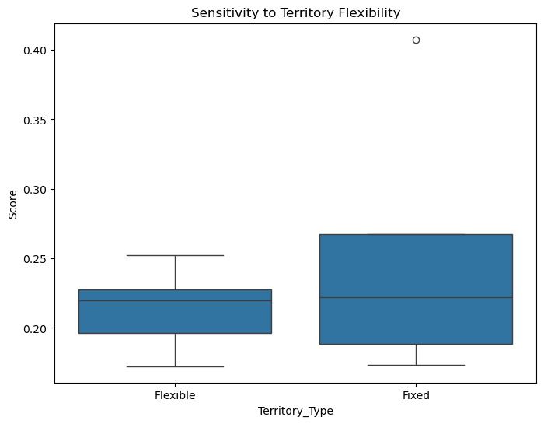
The flexible configuration produced lower mean error and substantially tighter variance. The fixed mode's higher variance reflects dependence on stochastic initial placement: without annual landscape-scale repositioning, outcomes are determined largely by where households happen to be placed at initialisation, producing both near-competitive and substantially degraded results across runs. The considerable distributional overlap between modes reflects the partial behavioural similarity noted in Section 5.6: the fixed mode retains full intra-territorial flexibility, and households assigned to environmentally suitable initial locations can generate plausible patterns without inter-annual movement.
Figure A5.6: Boxplot comparing composite scores for flexible and fixed territory modes across five iterations each.

