Claude Code Workshop Setup — Mac
Wharton AI Club | Claude Code Zero to Hero

Step 1: Download Claude
Download the Claude desktop app and sign in with your account. Should look like this:
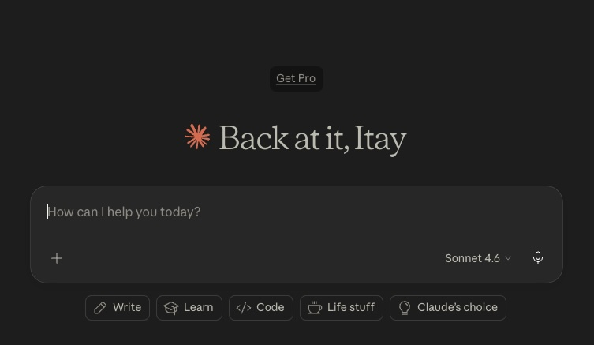
Claude desktop app before upgrading to a paid plan.

Step 2: Upgrade to Pro
Inside the app, upgrade your account to Claude Pro. This is the subscription level needed for Claude Code during the workshop.

Claude plan selection screen.

Step 3: Install Git on Mac
The fastest option is to install Apple’s Xcode Command Line Tools. Open Terminal (Command + Space + “Terminal”) and run the command below. You can also install Git from https://git-scm.com/install.
xcode-select --install

Git installation prompt.

Step 4: Fully quit Claude, then reopen it
Do not just close the Claude window. Use the menu bar or dock to fully quit the app, then open again.
If you only close the window, Claude may not detect the new Git installation.

Step 5: (Optional) Bypass permissions for faster work
Go to Settings Claude Code Allow bypass permissions

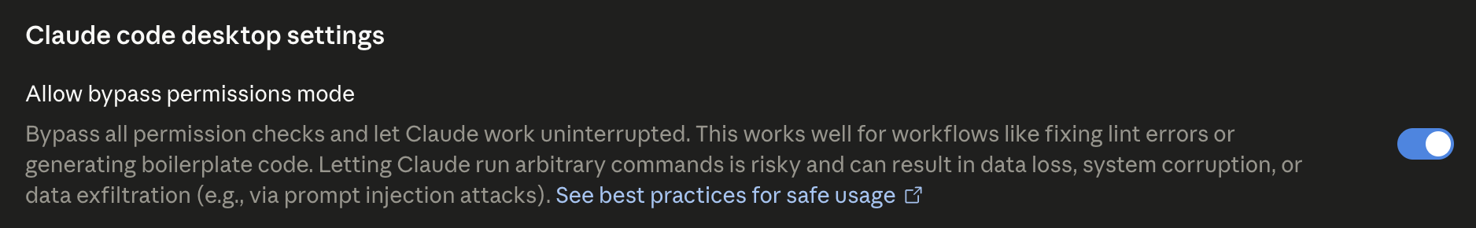

Let’s build!

