Claude Code Workshop Setup — Windows
Wharton AI Club | Claude Code Zero to Hero

Step 1: Download Claude
Download the Claude desktop app and sign in with your account. Should look like this:
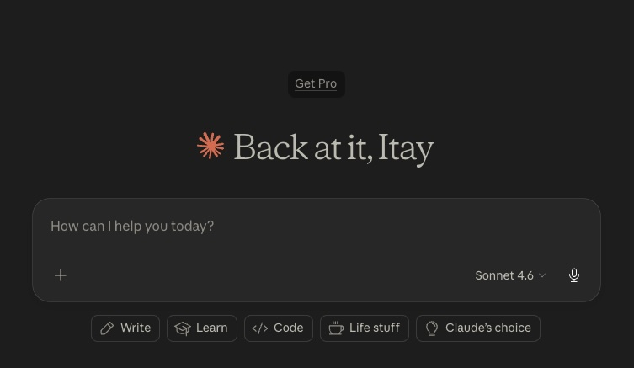
Claude desktop app before upgrading to a paid plan.

Step 2: Upgrade to Pro
Inside the app, upgrade your account to Claude Pro. This is the subscription level needed for Claude Code during the workshop.

Claude plan selection screen.

Step 3: Install Git for Windows
Go to https://git-scm.com/install and download Git for Windows (“Click here to download”). The default installer settings are fine for this workshop setup
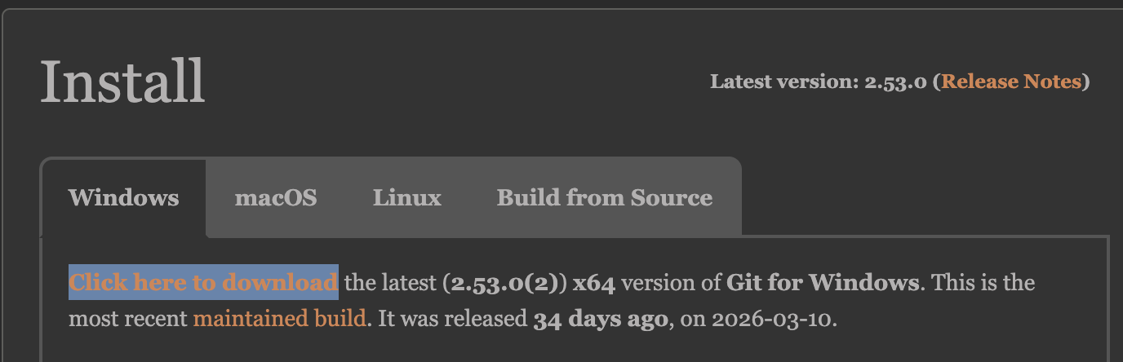
Git installation prompt for Windows setup.

Step 4: Fully quit Claude, then reopen it
Do not just close the Claude window. Use the system tray to fully quit the app, then launch it again.
If you only close the window, Claude may not detect the new Git installation.

Step 5: (Optional) Bypass permissions for faster work
Go to Settings Claude Code Allow bypass permissions

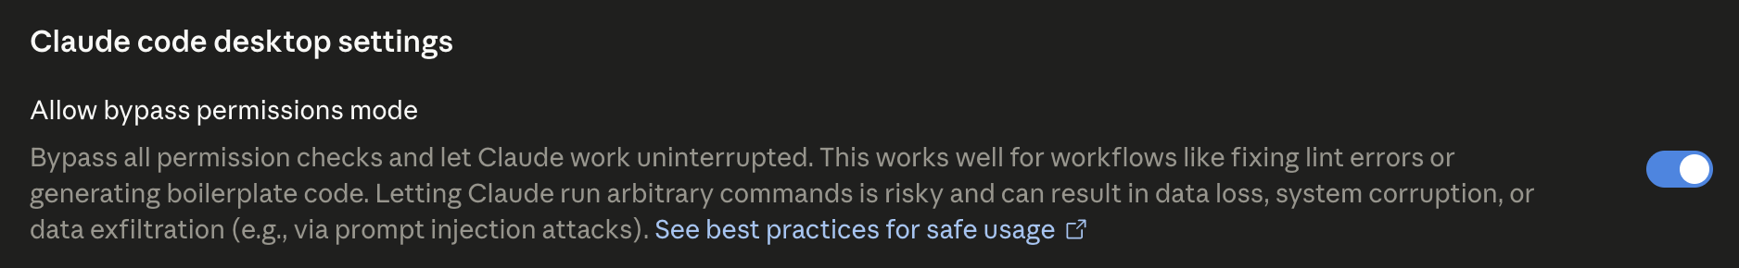

Let’s build!

