**BKT Results and Graphs**

The following graphs and data are based on collected data from the PDF files for the company: BKT

# ESG COLLECTED DATA TABLE:

|  |  |  |  |
| --- | --- | --- | --- |
| Year | ESG | ESG Board | ESG Executive |
| 2012 | 0 | 0 | 0 |
| 2013 | 0 | 0 | 0 |
| 2014 | 6 | 0 | 0 |
| 2015 | 5 | 0 | 0 |
| 2016 | 5 | 0 | 0 |
| 2017 | 5 | 0 | 0 |
| 2018 | 3 | 0 | 0 |
| 2019 | 3 | 0 | 0 |
| 2020 | 9 | 0 | 0 |
| 2021 | 18 | 2 | 0 |
| 2022 | 14 | 0 | 1 |

# ESG GRAPH:

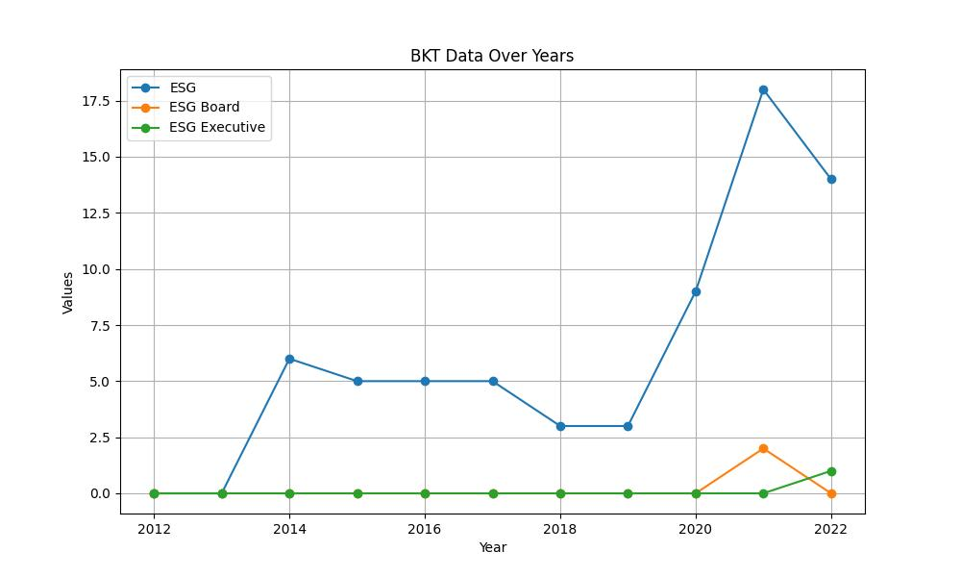

# GENDER COLLECTED DATA TABLE:

|  |  |  |  |
| --- | --- | --- | --- |
| Year | Gender | Gender/Woman Board | Gender/Woman Executive |
| 2012 | 0 | 0 | 0 |
| 2013 | 0 | 0 | 0 |
| 2014 | 18 | 7 | 0 |
| 2015 | 6 | 2 | 1 |
| 2016 | 19 | 4 | 1 |
| 2017 | 21 | 6 | 1 |
| 2018 | 10 | 5 | 1 |
| 2019 | 7 | 5 | 2 |
| 2020 | 9 | 7 | 1 |
| 2021 | 6 | 3 | 1 |
| 2022 | 6 | 2 | 1 |

# GENDER GRAPH:

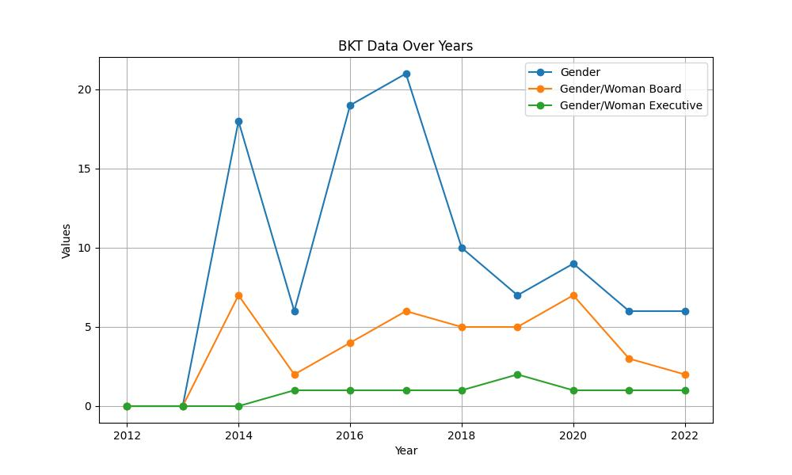

# INCLUSIVITY COLLECTED DATA TABLE:

|  |  |  |  |
| --- | --- | --- | --- |
| Year | Inclusivity | Inclusivity Board | Inclusivity Executive |
| 2012 | 0 | 0 | 0 |
| 2013 | 0 | 0 | 0 |
| 2014 | 4 | 0 | 0 |
| 2015 | 5 | 0 | 0 |
| 2016 | 0 | 0 | 0 |
| 2017 | 1 | 0 | 0 |
| 2018 | 2 | 0 | 0 |
| 2019 | 6 | 1 | 0 |
| 2020 | 5 | 1 | 0 |
| 2021 | 5 | 1 | 0 |
| 2022 | 4 | 1 | 0 |

# INCLUSIVITY GRAPH:

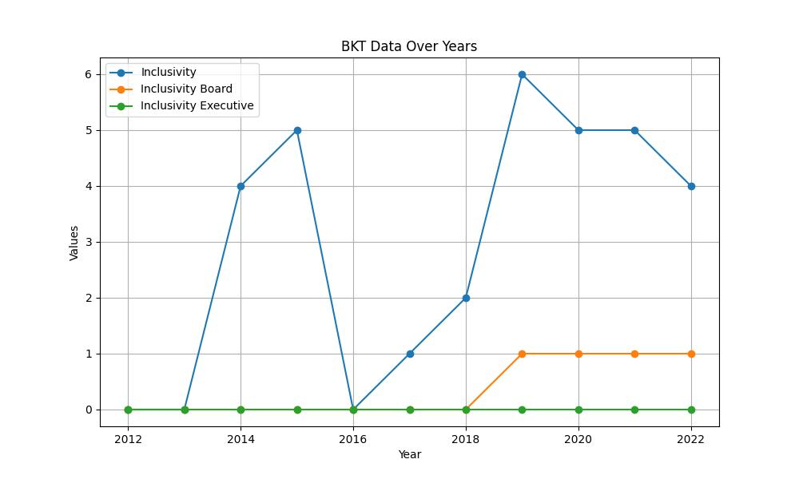

# SUSTAINABILITY COLLECTED DATA TABLE:

|  |  |  |  |
| --- | --- | --- | --- |
| Year | Sustainability | Sustainability Board | Sustainability Executive |
| 2012 | 14 | 0 | 0 |
| 2013 | 9 | 0 | 0 |
| 2014 | 85 | 1 | 1 |
| 2015 | 80 | 2 | 2 |
| 2016 | 248 | 4 | 0 |
| 2017 | 106 | 4 | 5 |
| 2018 | 98 | 2 | 1 |
| 2019 | 121 | 3 | 1 |
| 2020 | 117 | 2 | 1 |
| 2021 | 212 | 7 | 1 |
| 2022 | 221 | 2 | 1 |

# SUSTAINABILITY GRAPH:

