**CABK Results and Graphs**

The following graphs and data are based on collected data from the PDF files for the company: CABK

# ESG COLLECTED DATA TABLE:

|  |  |  |  |
| --- | --- | --- | --- |
| Year | ESG | ESG Board | ESG Executive |
| 2012 | 0 | 0 | 0 |
| 2013 | 0 | 0 | 0 |
| 2014 | 0 | 0 | 0 |
| 2015 | 0 | 0 | 0 |
| 2016 | 0 | 0 | 0 |
| 2017 | 0 | 0 | 0 |
| 2018 | 7 | 1 | 0 |
| 2019 | 40 | 4 | 0 |
| 2020 | 64 | 5 | 0 |
| 2021 | 104 | 10 | 1 |
| 2022 | 179 | 9 | 2 |

# ESG GRAPH:

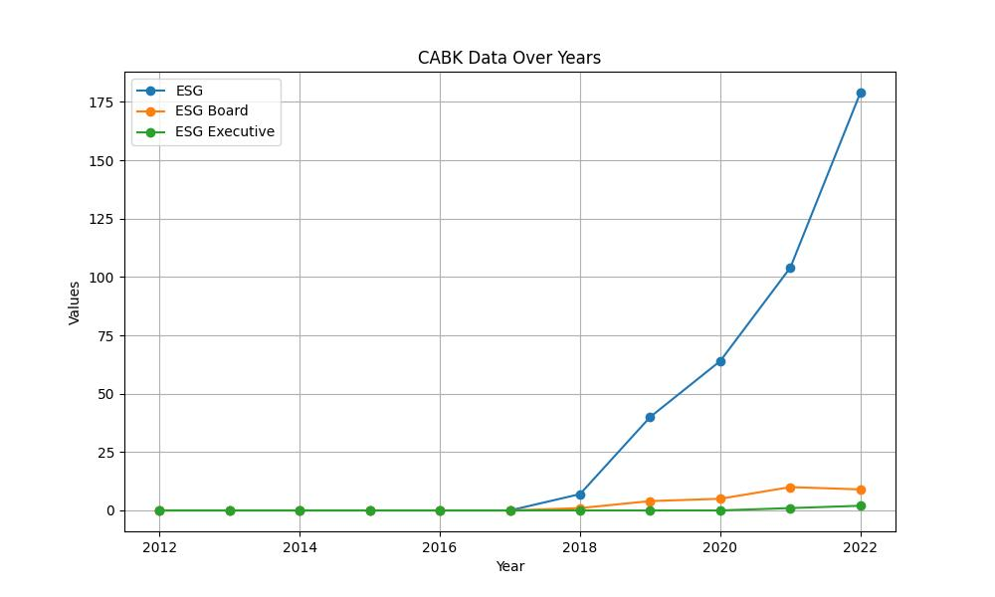

# GENDER COLLECTED DATA TABLE:

|  |  |  |  |
| --- | --- | --- | --- |
| Year | Gender | Gender/Woman Board | Gender/Woman Executive |
| 2012 | 4 | 5 | 4 |
| 2013 | 9 | 9 | 3 |
| 2014 | 7 | 9 | 5 |
| 2015 | 8 | 4 | 1 |
| 2016 | 14 | 16 | 5 |
| 2017 | 15 | 14 | 10 |
| 2018 | 38 | 15 | 4 |
| 2019 | 62 | 22 | 5 |
| 2020 | 67 | 20 | 6 |
| 2021 | 75 | 17 | 6 |
| 2022 | 94 | 21 | 4 |

# GENDER GRAPH:

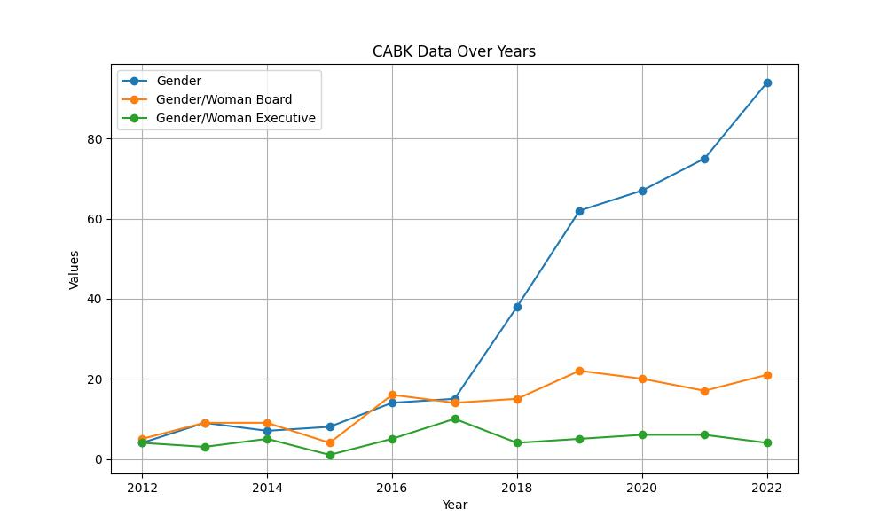

# INCLUSIVITY COLLECTED DATA TABLE:

|  |  |  |  |
| --- | --- | --- | --- |
| Year | Inclusivity | Inclusivity Board | Inclusivity Executive |
| 2012 | 1 | 0 | 0 |
| 2013 | 2 | 0 | 0 |
| 2014 | 2 | 0 | 0 |
| 2015 | 3 | 0 | 0 |
| 2016 | 6 | 0 | 0 |
| 2017 | 0 | 0 | 0 |
| 2018 | 3 | 0 | 0 |
| 2019 | 11 | 0 | 0 |
| 2020 | 14 | 2 | 2 |
| 2021 | 20 | 2 | 1 |
| 2022 | 24 | 0 | 0 |

# INCLUSIVITY GRAPH:

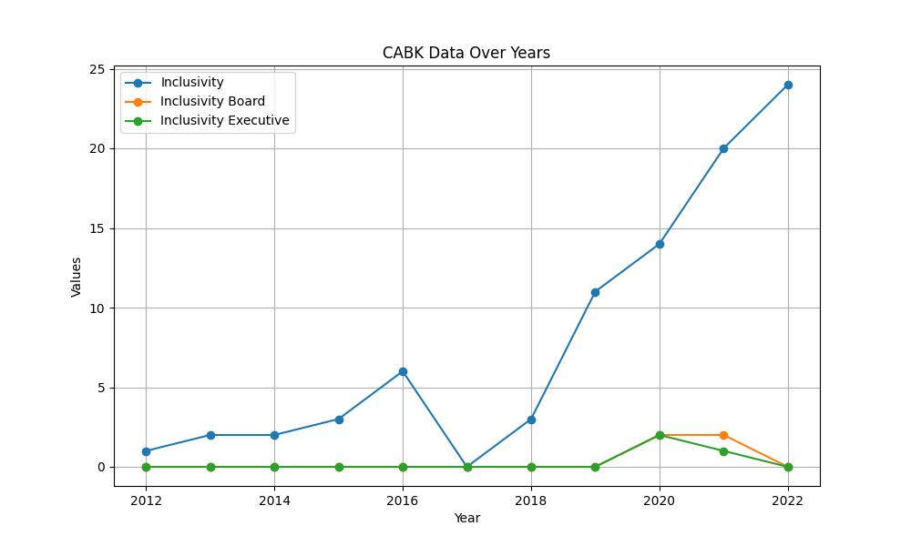

# SUSTAINABILITY COLLECTED DATA TABLE:

|  |  |  |  |
| --- | --- | --- | --- |
| Year | Sustainability | Sustainability Board | Sustainability Executive |
| 2012 | 15 | 1 | 0 |
| 2013 | 32 | 1 | 0 |
| 2014 | 28 | 0 | 2 |
| 2015 | 27 | 1 | 0 |
| 2016 | 38 | 2 | 2 |
| 2017 | 50 | 2 | 2 |
| 2018 | 94 | 3 | 2 |
| 2019 | 155 | 7 | 2 |
| 2020 | 221 | 11 | 6 |
| 2021 | 513 | 49 | 10 |
| 2022 | 752 | 61 | 13 |

# SUSTAINABILITY GRAPH:

