**IAG Results and Graphs**

The following graphs and data are based on collected data from the PDF files for the company: IAG

# ESG COLLECTED DATA TABLE:

|  |  |  |  |
| --- | --- | --- | --- |
| Year | ESG | ESG Board | ESG Executive |
| 2012 | 0 | 0 | 0 |
| 2013 | 0 | 0 | 0 |
| 2014 | 0 | 0 | 0 |
| 2015 | 0 | 0 | 0 |
| 2016 | 2 | 0 | 0 |
| 2017 | 0 | 0 | 0 |
| 2018 | 0 | 0 | 0 |
| 2019 | 0 | 0 | 0 |
| 2020 | 9 | 0 | 0 |
| 2021 | 52 | 7 | 1 |
| 2022 | 50 | 5 | 3 |

# ESG GRAPH:

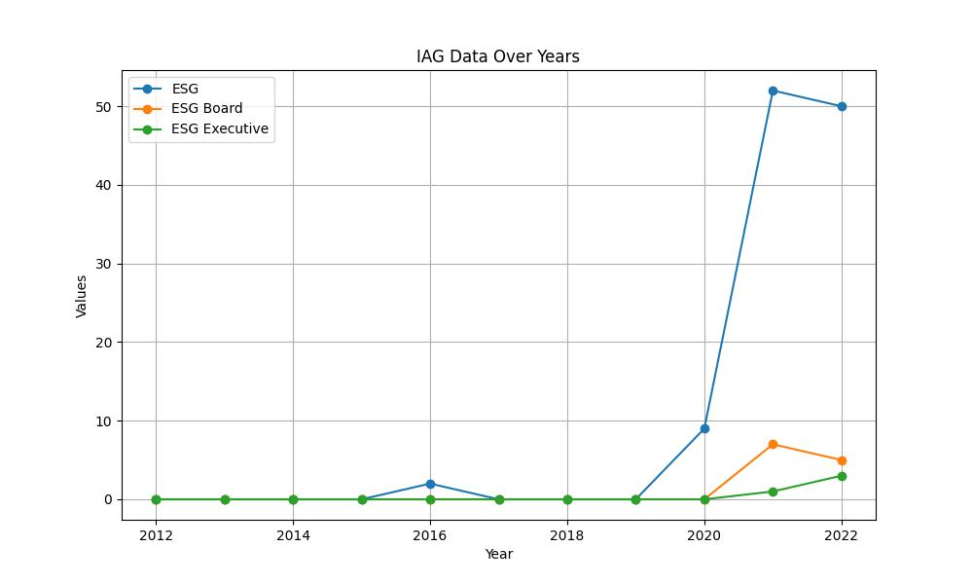

# GENDER COLLECTED DATA TABLE:

|  |  |  |  |
| --- | --- | --- | --- |
| Year | Gender | Gender/Woman Board | Gender/Woman Executive |
| 2012 | 4 | 8 | 1 |
| 2013 | 12 | 19 | 3 |
| 2014 | 14 | 17 | 5 |
| 2015 | 19 | 22 | 3 |
| 2016 | 30 | 24 | 7 |
| 2017 | 12 | 8 | 3 |
| 2018 | 25 | 6 | 6 |
| 2019 | 74 | 19 | 19 |
| 2020 | 55 | 27 | 24 |
| 2021 | 46 | 10 | 11 |
| 2022 | 41 | 11 | 11 |

# GENDER GRAPH:

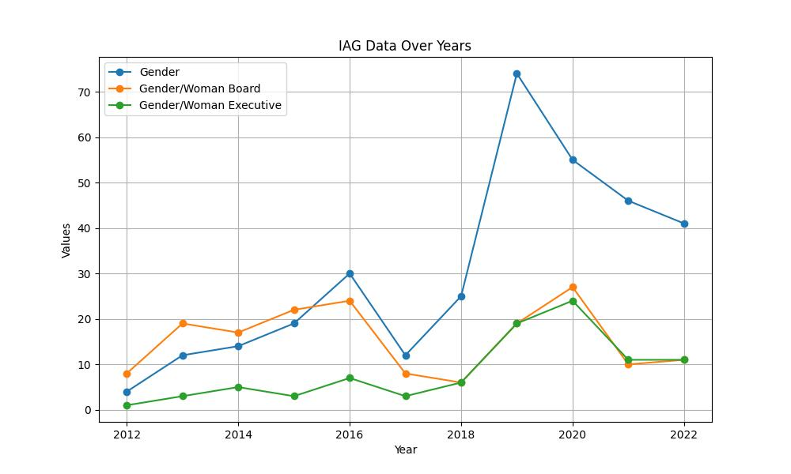

# INCLUSIVITY COLLECTED DATA TABLE:

|  |  |  |  |
| --- | --- | --- | --- |
| Year | Inclusivity | Inclusivity Board | Inclusivity Executive |
| 2012 | 0 | 0 | 0 |
| 2013 | 1 | 0 | 0 |
| 2014 | 1 | 1 | 0 |
| 2015 | 2 | 2 | 0 |
| 2016 | 2 | 1 | 0 |
| 2017 | 1 | 1 | 0 |
| 2018 | 0 | 0 | 0 |
| 2019 | 1 | 1 | 0 |
| 2020 | 1 | 1 | 0 |
| 2021 | 13 | 0 | 0 |
| 2022 | 20 | 2 | 0 |

# INCLUSIVITY GRAPH:

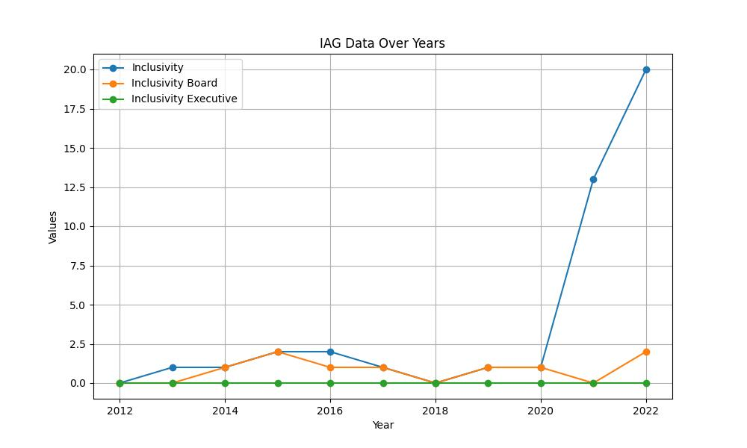

# SUSTAINABILITY COLLECTED DATA TABLE:

|  |  |  |  |
| --- | --- | --- | --- |
| Year | Sustainability | Sustainability Board | Sustainability Executive |
| 2012 | 20 | 1 | 1 |
| 2013 | 33 | 0 | 1 |
| 2014 | 43 | 2 | 0 |
| 2015 | 93 | 3 | 0 |
| 2016 | 112 | 4 | 1 |
| 2017 | 126 | 4 | 0 |
| 2018 | 141 | 4 | 1 |
| 2019 | 282 | 12 | 0 |
| 2020 | 402 | 16 | 0 |
| 2021 | 481 | 23 | 2 |
| 2022 | 460 | 24 | 7 |

# SUSTAINABILITY GRAPH:

