**INM Results and Graphs**

The following graphs and data are based on collected data from the PDF files for the company: INM

# ESG COLLECTED DATA TABLE:

|  |  |  |  |
| --- | --- | --- | --- |
| Year | ESG | ESG Board | ESG Executive |
| 2012 | 0 | 0 | 0 |
| 2013 | 0 | 0 | 0 |
| 2014 | 0 | 0 | 0 |
| 2015 | 0 | 0 | 0 |
| 2016 | 0 | 0 | 0 |
| 2017 | 11 | 1 | 0 |
| 2018 | 50 | 0 | 0 |
| 2019 | 177 | 4 | 4 |
| 2020 | 202 | 13 | 8 |
| 2021 | 167 | 8 | 3 |
| 2022 | 172 | 10 | 4 |

# ESG GRAPH:

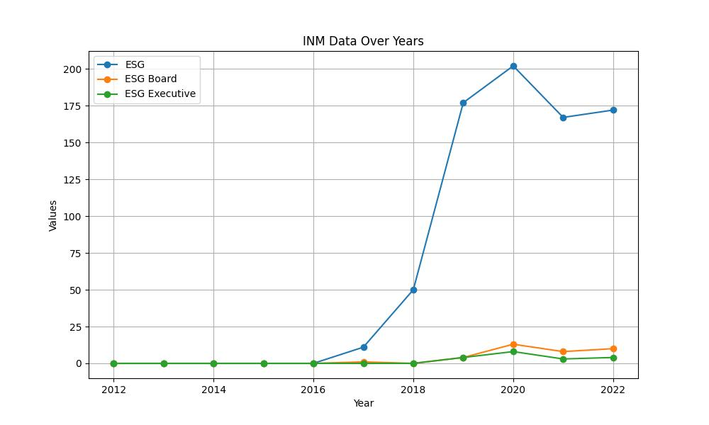

# GENDER COLLECTED DATA TABLE:

|  |  |  |  |
| --- | --- | --- | --- |
| Year | Gender | Gender/Woman Board | Gender/Woman Executive |
| 2012 | 0 | 0 | 0 |
| 2013 | 0 | 0 | 0 |
| 2014 | 0 | 0 | 0 |
| 2015 | 0 | 0 | 0 |
| 2016 | 0 | 0 | 0 |
| 2017 | 17 | 9 | 2 |
| 2018 | 19 | 10 | 2 |
| 2019 | 36 | 22 | 2 |
| 2020 | 55 | 23 | 0 |
| 2021 | 51 | 14 | 3 |
| 2022 | 61 | 20 | 7 |

# GENDER GRAPH:

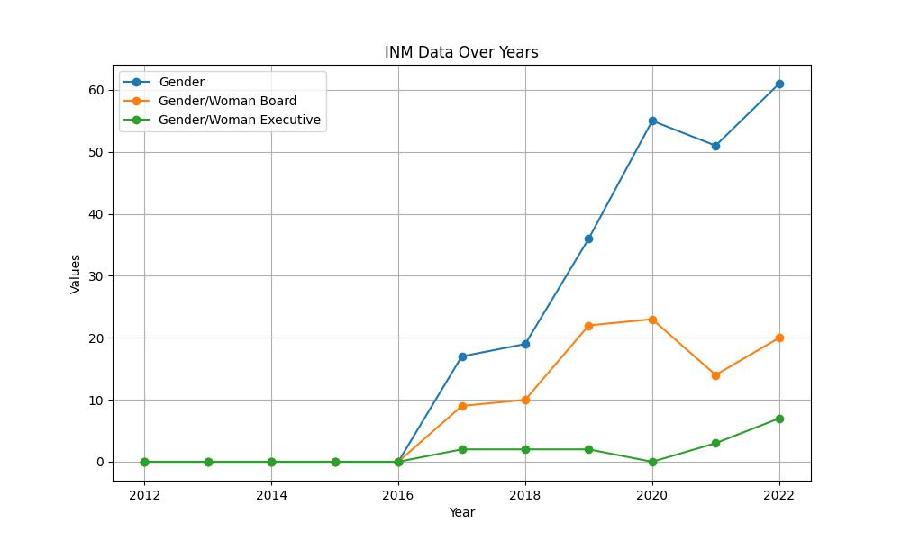

# INCLUSIVITY COLLECTED DATA TABLE:

|  |  |  |  |
| --- | --- | --- | --- |
| Year | Inclusivity | Inclusivity Board | Inclusivity Executive |
| 2012 | 0 | 0 | 0 |
| 2013 | 0 | 0 | 0 |
| 2014 | 0 | 0 | 0 |
| 2015 | 0 | 0 | 0 |
| 2016 | 0 | 0 | 0 |
| 2017 | 3 | 0 | 0 |
| 2018 | 2 | 0 | 0 |
| 2019 | 1 | 0 | 0 |
| 2020 | 0 | 0 | 0 |
| 2021 | 5 | 0 | 0 |
| 2022 | 11 | 0 | 0 |

# INCLUSIVITY GRAPH:

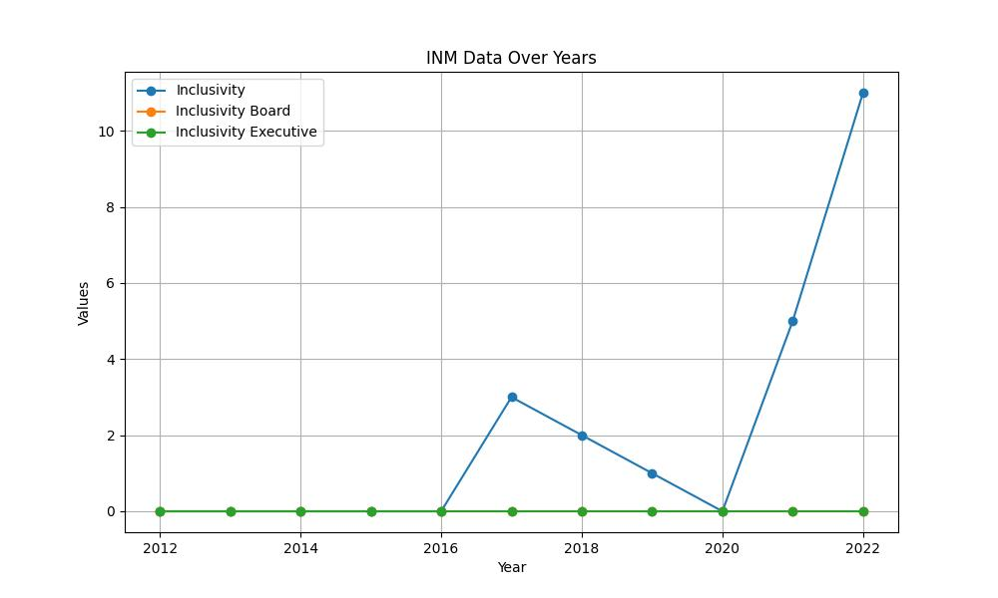

# SUSTAINABILITY COLLECTED DATA TABLE:

|  |  |  |  |
| --- | --- | --- | --- |
| Year | Sustainability | Sustainability Board | Sustainability Executive |
| 2012 | 0 | 0 | 0 |
| 2013 | 0 | 0 | 0 |
| 2014 | 0 | 0 | 0 |
| 2015 | 0 | 0 | 0 |
| 2016 | 0 | 0 | 0 |
| 2017 | 98 | 2 | 0 |
| 2018 | 132 | 3 | 2 |
| 2019 | 317 | 4 | 1 |
| 2020 | 376 | 26 | 6 |
| 2021 | 359 | 24 | 4 |
| 2022 | 365 | 21 | 6 |

# SUSTAINABILITY GRAPH:

