**NTGY Results and Graphs**

The following graphs and data are based on collected data from the PDF files for the company: NTGY

# ESG COLLECTED DATA TABLE:

|  |  |  |  |
| --- | --- | --- | --- |
| Year | ESG | ESG Board | ESG Executive |
| 2012 | 0 | 0 | 0 |
| 2013 | 0 | 0 | 0 |
| 2014 | 0 | 0 | 0 |
| 2015 | 0 | 0 | 0 |
| 2016 | 0 | 0 | 0 |
| 2017 | 4 | 0 | 0 |
| 2018 | 14 | 0 | 0 |
| 2019 | 16 | 0 | 0 |
| 2020 | 49 | 1 | 0 |
| 2021 | 84 | 2 | 0 |
| 2022 | 101 | 2 | 2 |

# ESG GRAPH:

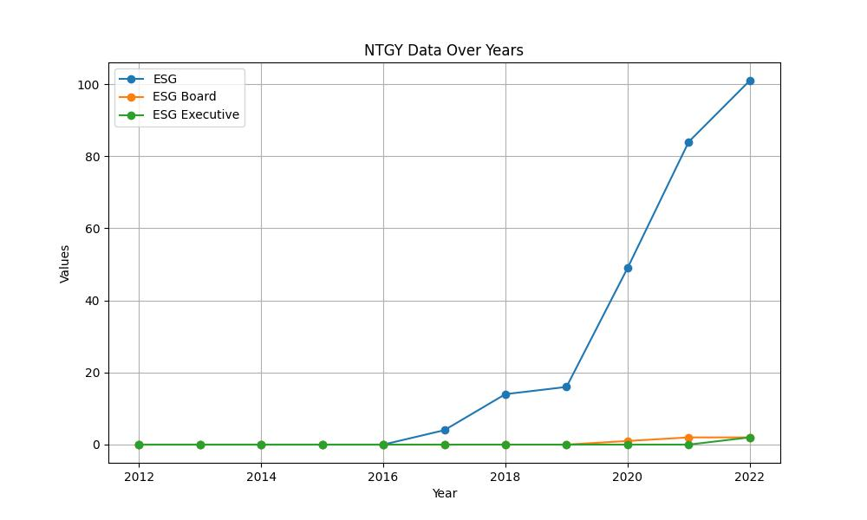

# GENDER COLLECTED DATA TABLE:

|  |  |  |  |
| --- | --- | --- | --- |
| Year | Gender | Gender/Woman Board | Gender/Woman Executive |
| 2012 | 0 | 0 | 0 |
| 2013 | 0 | 0 | 0 |
| 2014 | 0 | 0 | 0 |
| 2015 | 0 | 0 | 0 |
| 2016 | 0 | 0 | 0 |
| 2017 | 2 | 0 | 0 |
| 2018 | 13 | 0 | 0 |
| 2019 | 18 | 1 | 1 |
| 2020 | 61 | 12 | 4 |
| 2021 | 70 | 8 | 4 |
| 2022 | 77 | 9 | 7 |

# GENDER GRAPH:

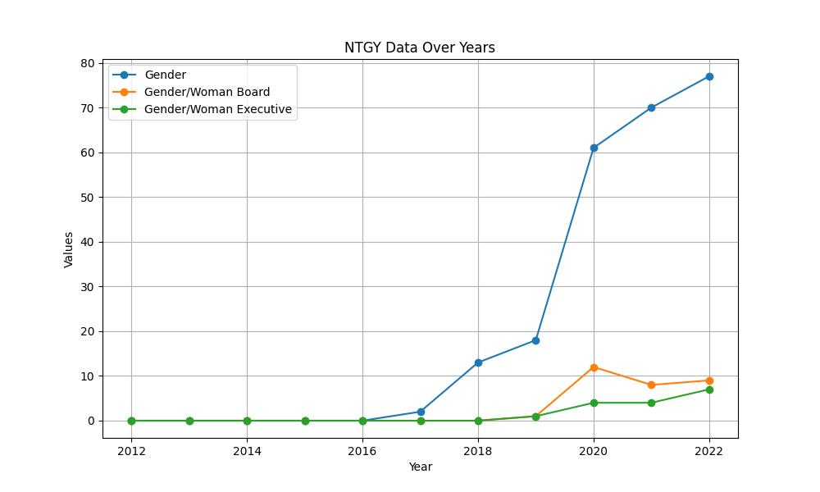

# INCLUSIVITY COLLECTED DATA TABLE:

|  |  |  |  |
| --- | --- | --- | --- |
| Year | Inclusivity | Inclusivity Board | Inclusivity Executive |
| 2012 | 0 | 0 | 0 |
| 2013 | 0 | 0 | 0 |
| 2014 | 0 | 0 | 0 |
| 2015 | 0 | 0 | 0 |
| 2016 | 0 | 0 | 0 |
| 2017 | 2 | 0 | 0 |
| 2018 | 2 | 0 | 0 |
| 2019 | 1 | 0 | 0 |
| 2020 | 11 | 0 | 0 |
| 2021 | 15 | 0 | 0 |
| 2022 | 19 | 0 | 0 |

# INCLUSIVITY GRAPH:

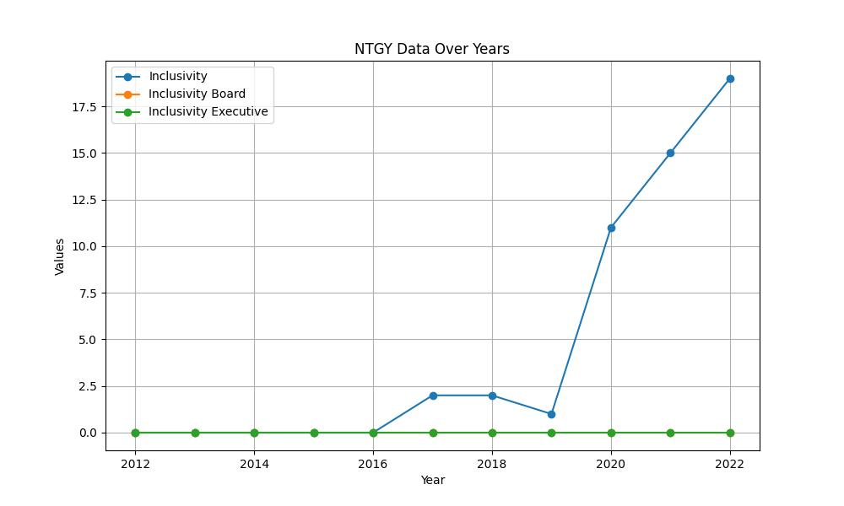

# SUSTAINABILITY COLLECTED DATA TABLE:

|  |  |  |  |
| --- | --- | --- | --- |
| Year | Sustainability | Sustainability Board | Sustainability Executive |
| 2012 | 0 | 0 | 0 |
| 2013 | 0 | 0 | 0 |
| 2014 | 0 | 0 | 0 |
| 2015 | 0 | 0 | 0 |
| 2016 | 0 | 0 | 0 |
| 2017 | 46 | 1 | 0 |
| 2018 | 63 | 2 | 0 |
| 2019 | 68 | 3 | 0 |
| 2020 | 418 | 28 | 3 |
| 2021 | 630 | 29 | 6 |
| 2022 | 696 | 23 | 13 |

# SUSTAINABILITY GRAPH:

