**SAN Results and Graphs**

The following graphs and data are based on collected data from the PDF files for the company: SAN

# ESG COLLECTED DATA TABLE:

|  |  |  |  |
| --- | --- | --- | --- |
| Year | ESG | ESG Board | ESG Executive |
| 2012 | 0 | 0 | 0 |
| 2013 | 0 | 0 | 0 |
| 2014 | 0 | 0 | 0 |
| 2015 | 0 | 0 | 0 |
| 2016 | 0 | 0 | 0 |
| 2017 | 0 | 0 | 0 |
| 2018 | 18 | 0 | 0 |
| 2019 | 35 | 1 | 0 |
| 2020 | 134 | 0 | 4 |
| 2021 | 231 | 7 | 5 |
| 2022 | 0 | 0 | 0 |

# ESG GRAPH:

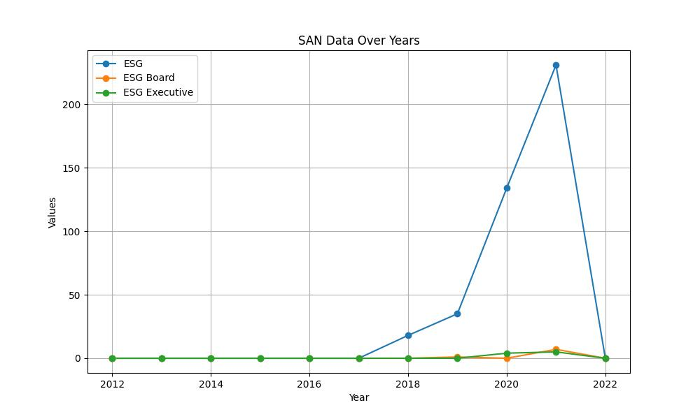

# GENDER COLLECTED DATA TABLE:

|  |  |  |  |
| --- | --- | --- | --- |
| Year | Gender | Gender/Woman Board | Gender/Woman Executive |
| 2012 | 1 | 9 | 2 |
| 2013 | 1 | 4 | 1 |
| 2014 | 6 | 8 | 4 |
| 2015 | 2 | 7 | 2 |
| 2016 | 9 | 11 | 2 |
| 2017 | 7 | 9 | 3 |
| 2018 | 58 | 14 | 4 |
| 2019 | 74 | 20 | 4 |
| 2020 | 83 | 18 | 9 |
| 2021 | 95 | 20 | 13 |
| 2022 | 0 | 0 | 0 |

# GENDER GRAPH:

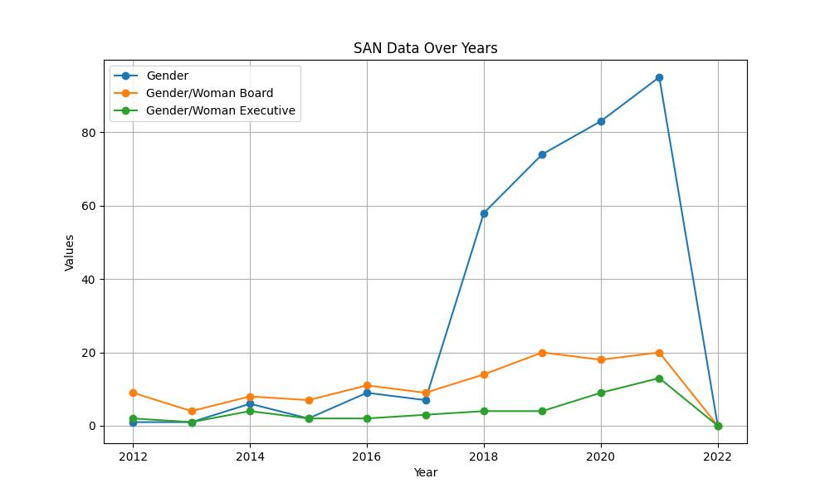

# INCLUSIVITY COLLECTED DATA TABLE:

|  |  |  |  |
| --- | --- | --- | --- |
| Year | Inclusivity | Inclusivity Board | Inclusivity Executive |
| 2012 | 0 | 0 | 0 |
| 2013 | 0 | 0 | 0 |
| 2014 | 1 | 0 | 0 |
| 2015 | 1 | 1 | 0 |
| 2016 | 4 | 1 | 0 |
| 2017 | 8 | 1 | 0 |
| 2018 | 50 | 2 | 2 |
| 2019 | 59 | 4 | 2 |
| 2020 | 100 | 3 | 6 |
| 2021 | 78 | 1 | 2 |
| 2022 | 0 | 0 | 0 |

# INCLUSIVITY GRAPH:

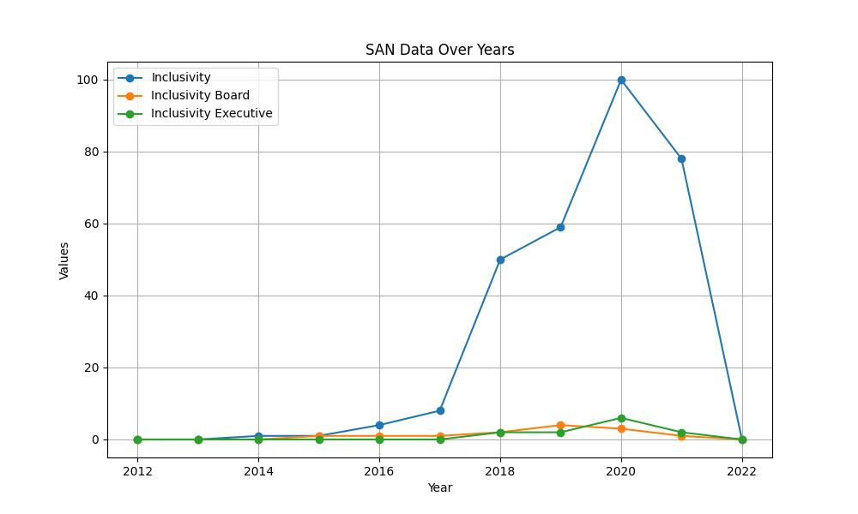

# SUSTAINABILITY COLLECTED DATA TABLE:

|  |  |  |  |
| --- | --- | --- | --- |
| Year | Sustainability | Sustainability Board | Sustainability Executive |
| 2012 | 34 | 3 | 1 |
| 2013 | 27 | 2 | 1 |
| 2014 | 45 | 2 | 1 |
| 2015 | 56 | 10 | 1 |
| 2016 | 49 | 6 | 0 |
| 2017 | 89 | 13 | 0 |
| 2018 | 210 | 29 | 15 |
| 2019 | 323 | 36 | 19 |
| 2020 | 342 | 48 | 20 |
| 2021 | 443 | 44 | 21 |
| 2022 | 0 | 0 | 0 |

# SUSTAINABILITY GRAPH:

