**SGRE Results and Graphs**

The following graphs and data are based on collected data from the PDF files for the company: SGRE

# ESG COLLECTED DATA TABLE:

|  |  |  |  |
| --- | --- | --- | --- |
| Year | ESG | ESG Board | ESG Executive |
| 2012 | 0 | 0 | 0 |
| 2013 | 0 | 0 | 0 |
| 2014 | 0 | 0 | 0 |
| 2015 | 0 | 0 | 0 |
| 2016 | 0 | 0 | 0 |
| 2017 | 1 | 0 | 0 |
| 2018 | 1 | 0 | 0 |
| 2019 | 2 | 0 | 0 |
| 2020 | 4 | 0 | 0 |
| 2021 | 6 | 0 | 0 |
| 2022 | 0 | 0 | 0 |

# ESG GRAPH:

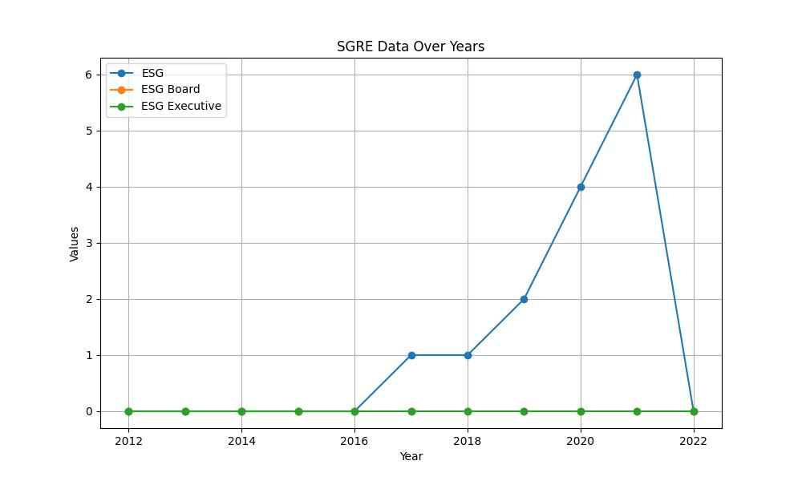

# GENDER COLLECTED DATA TABLE:

|  |  |  |  |
| --- | --- | --- | --- |
| Year | Gender | Gender/Woman Board | Gender/Woman Executive |
| 2012 | 0 | 0 | 0 |
| 2013 | 0 | 0 | 0 |
| 2014 | 0 | 0 | 0 |
| 2015 | 0 | 0 | 0 |
| 2016 | 0 | 0 | 0 |
| 2017 | 7 | 4 | 0 |
| 2018 | 16 | 3 | 0 |
| 2019 | 23 | 3 | 0 |
| 2020 | 4 | 1 | 1 |
| 2021 | 4 | 0 | 3 |
| 2022 | 0 | 0 | 0 |

# GENDER GRAPH:

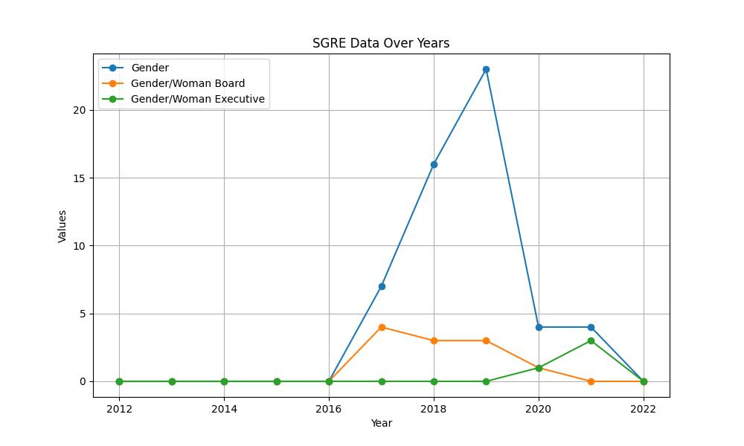

# INCLUSIVITY COLLECTED DATA TABLE:

|  |  |  |  |
| --- | --- | --- | --- |
| Year | Inclusivity | Inclusivity Board | Inclusivity Executive |
| 2012 | 0 | 0 | 0 |
| 2013 | 0 | 0 | 0 |
| 2014 | 0 | 0 | 0 |
| 2015 | 0 | 0 | 0 |
| 2016 | 0 | 0 | 0 |
| 2017 | 0 | 0 | 0 |
| 2018 | 2 | 0 | 0 |
| 2019 | 4 | 0 | 0 |
| 2020 | 5 | 1 | 1 |
| 2021 | 9 | 0 | 1 |
| 2022 | 0 | 0 | 0 |

# INCLUSIVITY GRAPH:

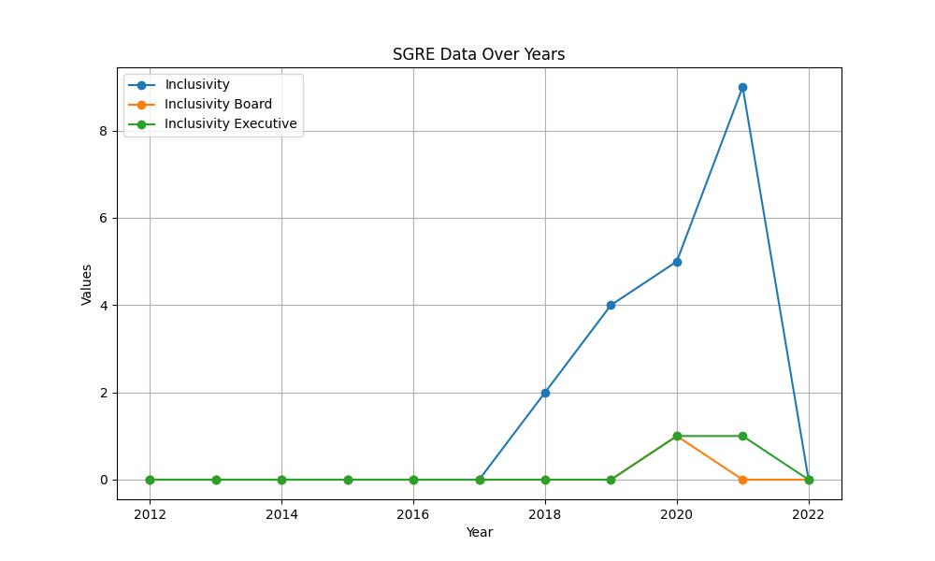

# SUSTAINABILITY COLLECTED DATA TABLE:

|  |  |  |  |
| --- | --- | --- | --- |
| Year | Sustainability | Sustainability Board | Sustainability Executive |
| 2012 | 0 | 0 | 0 |
| 2013 | 0 | 0 | 0 |
| 2014 | 0 | 0 | 0 |
| 2015 | 0 | 0 | 0 |
| 2016 | 0 | 0 | 0 |
| 2017 | 108 | 1 | 0 |
| 2018 | 118 | 1 | 0 |
| 2019 | 98 | 3 | 1 |
| 2020 | 37 | 1 | 0 |
| 2021 | 51 | 2 | 1 |
| 2022 | 0 | 0 | 0 |

# SUSTAINABILITY GRAPH:

