**TEF Results and Graphs**

The following graphs and data are based on collected data from the PDF files for the company: TEF

# ESG COLLECTED DATA TABLE:

|  |  |  |  |
| --- | --- | --- | --- |
| Year | ESG | ESG Board | ESG Executive |
| 2012 | 0 | 0 | 0 |
| 2013 | 0 | 0 | 0 |
| 2014 | 0 | 0 | 0 |
| 2015 | 0 | 0 | 0 |
| 2016 | 0 | 0 | 0 |
| 2017 | 0 | 0 | 0 |
| 2018 | 1 | 0 | 0 |
| 2019 | 10 | 0 | 1 |
| 2020 | 21 | 2 | 1 |
| 2021 | 86 | 2 | 2 |
| 2022 | 107 | 5 | 2 |

# ESG GRAPH:

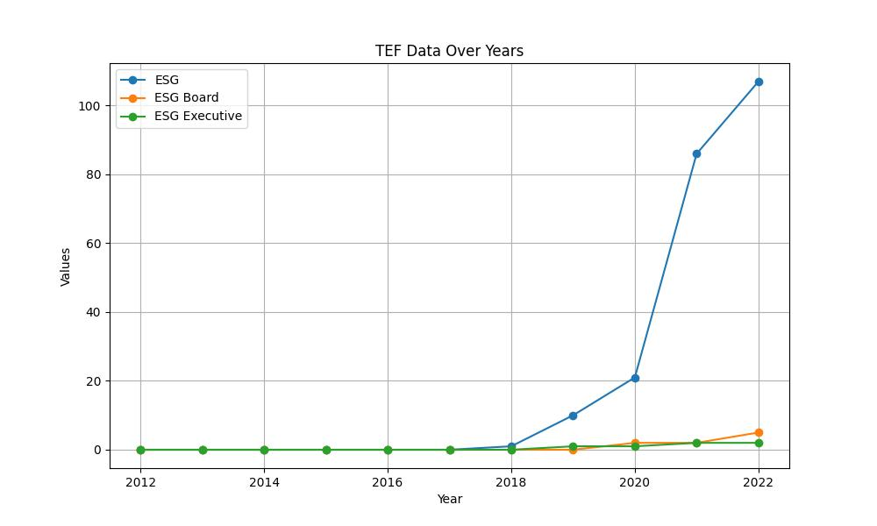

# GENDER COLLECTED DATA TABLE:

|  |  |  |  |
| --- | --- | --- | --- |
| Year | Gender | Gender/Woman Board | Gender/Woman Executive |
| 2012 | 3 | 2 | 0 |
| 2013 | 2 | 1 | 1 |
| 2014 | 3 | 2 | 0 |
| 2015 | 2 | 0 | 0 |
| 2016 | 4 | 4 | 2 |
| 2017 | 19 | 18 | 1 |
| 2018 | 59 | 18 | 7 |
| 2019 | 70 | 11 | 11 |
| 2020 | 77 | 12 | 12 |
| 2021 | 98 | 18 | 28 |
| 2022 | 112 | 25 | 16 |

# GENDER GRAPH:

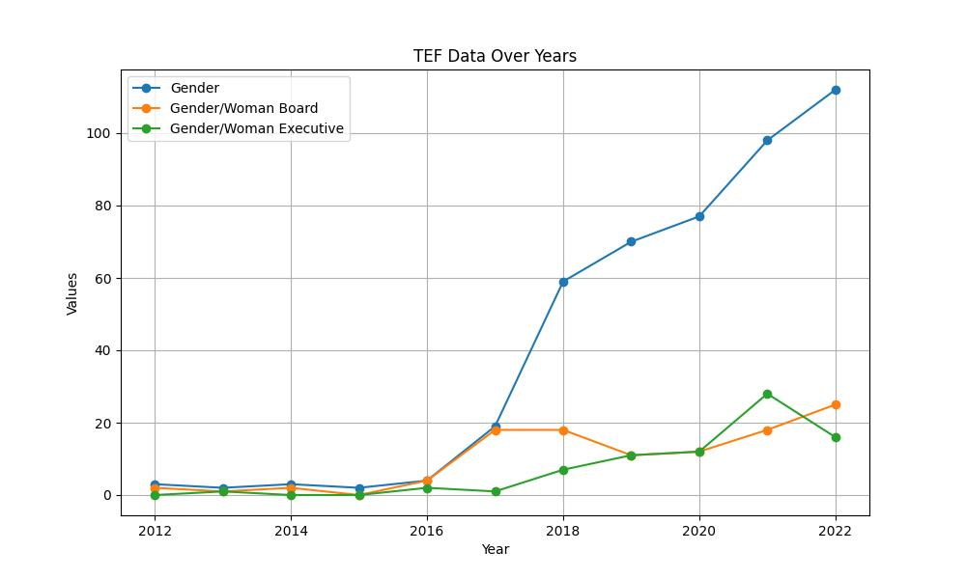

# INCLUSIVITY COLLECTED DATA TABLE:

|  |  |  |  |
| --- | --- | --- | --- |
| Year | Inclusivity | Inclusivity Board | Inclusivity Executive |
| 2012 | 0 | 0 | 0 |
| 2013 | 0 | 0 | 0 |
| 2014 | 40 | 0 | 0 |
| 2015 | 11 | 0 | 0 |
| 2016 | 2 | 0 | 0 |
| 2017 | 3 | 0 | 0 |
| 2018 | 18 | 0 | 0 |
| 2019 | 21 | 0 | 0 |
| 2020 | 37 | 1 | 2 |
| 2021 | 35 | 1 | 0 |
| 2022 | 36 | 1 | 1 |

# INCLUSIVITY GRAPH:

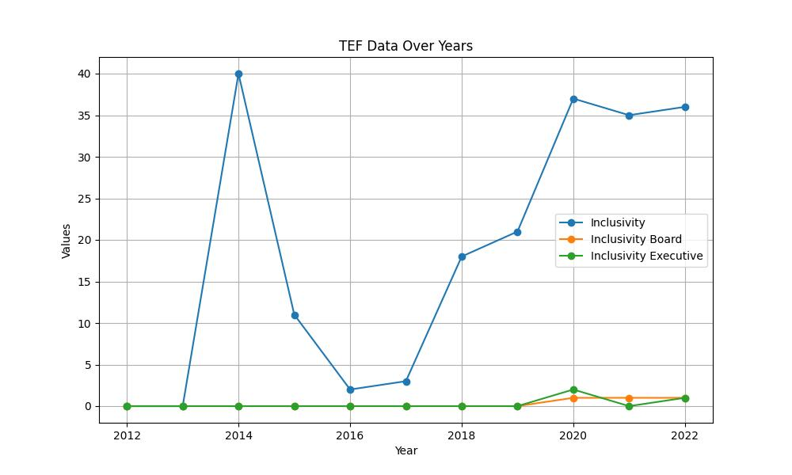

# SUSTAINABILITY COLLECTED DATA TABLE:

|  |  |  |  |
| --- | --- | --- | --- |
| Year | Sustainability | Sustainability Board | Sustainability Executive |
| 2012 | 47 | 2 | 0 |
| 2013 | 38 | 1 | 0 |
| 2014 | 11 | 0 | 0 |
| 2015 | 27 | 2 | 0 |
| 2016 | 43 | 0 | 0 |
| 2017 | 39 | 2 | 0 |
| 2018 | 152 | 4 | 5 |
| 2019 | 250 | 32 | 7 |
| 2020 | 361 | 35 | 10 |
| 2021 | 527 | 41 | 10 |
| 2022 | 681 | 37 | 6 |

# SUSTAINABILITY GRAPH:

