**all Results and Graphs**

The following graphs and data are based on collected data from the PDF files for the company: ALL

# ESG COLLECTED DATA TABLE:

|  |  |  |  |
| --- | --- | --- | --- |
| Year | ESG | ESG Board | ESG Executive |
| 2012 | 8 | 1 | 1 |
| 2013 | 3 | 0 | 0 |
| 2014 | 12 | 0 | 0 |
| 2015 | 14 | 0 | 0 |
| 2016 | 16 | 0 | 0 |
| 2017 | 41 | 0 | 3 |
| 2018 | 62 | 1 | 0 |
| 2019 | 169 | 8 | 2 |
| 2020 | 630 | 28 | 11 |
| 2021 | 1258 | 62 | 19 |
| 2022 | 1962 | 87 | 43 |

# ESG GRAPH:

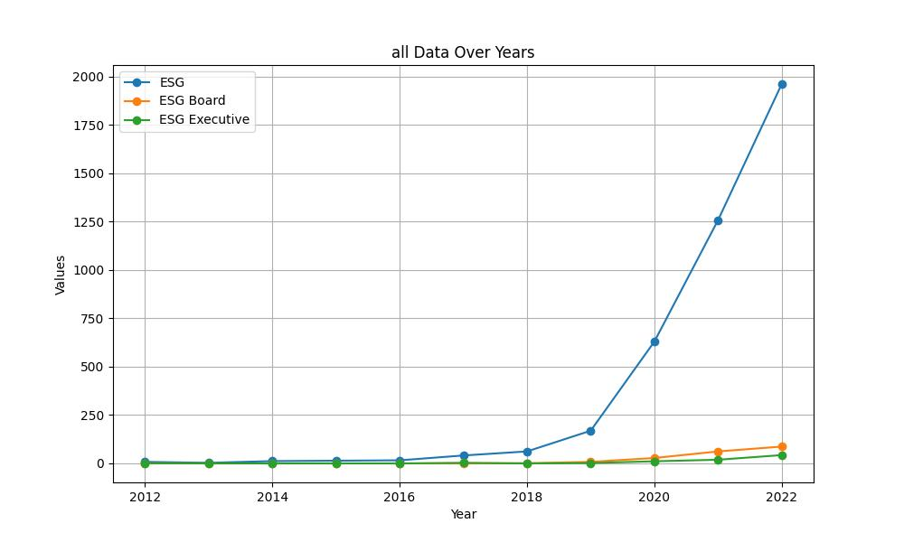

# GENDER COLLECTED DATA TABLE:

|  |  |  |  |
| --- | --- | --- | --- |
| Year | Gender | Gender/Woman Board | Gender/Woman Executive |
| 2012 | 88 | 44 | 14 |
| 2013 | 79 | 75 | 19 |
| 2014 | 147 | 103 | 20 |
| 2015 | 151 | 76 | 14 |
| 2016 | 197 | 118 | 24 |
| 2017 | 226 | 104 | 24 |
| 2018 | 418 | 125 | 37 |
| 2019 | 597 | 143 | 55 |
| 2020 | 647 | 154 | 78 |
| 2021 | 672 | 144 | 97 |
| 2022 | 880 | 187 | 79 |

# GENDER GRAPH:

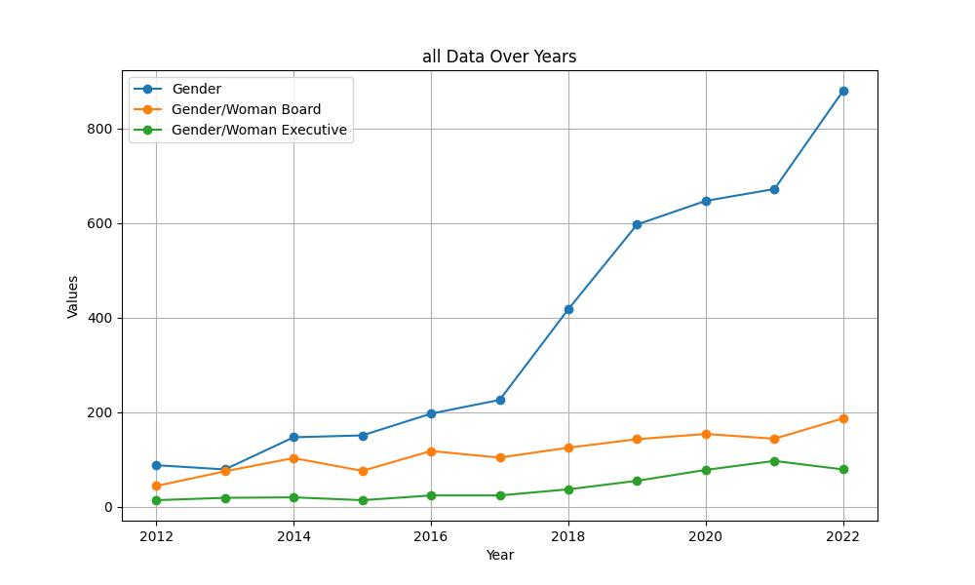

# INCLUSIVITY COLLECTED DATA TABLE:

|  |  |  |  |
| --- | --- | --- | --- |
| Year | Inclusivity | Inclusivity Board | Inclusivity Executive |
| 2012 | 19 | 2 | 0 |
| 2013 | 24 | 1 | 0 |
| 2014 | 68 | 3 | 0 |
| 2015 | 52 | 5 | 0 |
| 2016 | 41 | 2 | 0 |
| 2017 | 51 | 2 | 0 |
| 2018 | 93 | 2 | 2 |
| 2019 | 136 | 11 | 2 |
| 2020 | 227 | 11 | 12 |
| 2021 | 237 | 10 | 7 |
| 2022 | 248 | 14 | 4 |

# INCLUSIVITY GRAPH:

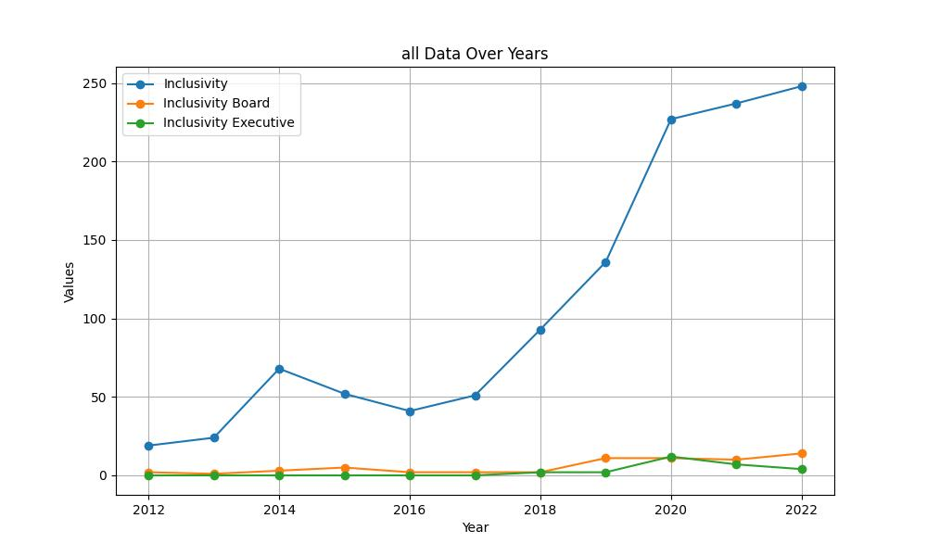

# SUSTAINABILITY COLLECTED DATA TABLE:

|  |  |  |  |
| --- | --- | --- | --- |
| Year | Sustainability | Sustainability Board | Sustainability Executive |
| 2012 | 763 | 19 | 6 |
| 2013 | 581 | 9 | 7 |
| 2014 | 597 | 14 | 7 |
| 2015 | 660 | 31 | 10 |
| 2016 | 1029 | 45 | 12 |
| 2017 | 937 | 50 | 17 |
| 2018 | 1671 | 119 | 63 |
| 2019 | 2381 | 175 | 63 |
| 2020 | 3243 | 251 | 87 |
| 2021 | 5051 | 301 | 95 |
| 2022 | 6727 | 341 | 100 |

# SUSTAINABILITY GRAPH:

