**Geog288CL Atmospheric Boundary Layer W2020**

**Homework #1 Due 17 January 2020**

1. Review the definition of adiabatic lapse rate and static stability. A good reference is Wallace and Hobbs Atmospheric Science: an introductory survey

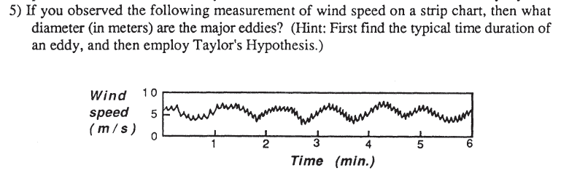

2)

1. Would there be a boundary layer on a planet that had an atmosphere. but that did not experience a diurnal variation of net radiation at the ground?
2. There are four radiosonde profiles in Gaucho Space named A, B, C and D. In each file, columns have time (s), Pressure level (hPa), Air Temperature (C), Relative Humidity (%), Wind Speed (knots), Wind Direction (degrees), Altitude (m) and Geopotential Height (m)

4a) For each sounding, compute the water vapor mixing ratio, potential temperature and virtual potential temperature. Use surface pressure the value at t=0

4b) For each sounding, make vertical profile plots of mixing ratio, temperature, virtual potential temperature and wind speeds. Limit the plots to elevations 0-3000 m so that variations can be better seen.

4c) Discuss each profile and identify (if possible) surface layer (SL), mixed layer (ML), stable boundary layer (SBL) and free atmosphere (FA)

4d) Estimate the top of the BL in each sounding

4e) Associate each sounding with early morning, noon, afternoon, late afternoon and night. Discuss and justify your answers.

Upload the results to Gaucho Space