**Geog288CL Atmospheric Boundary Layer W2020**

**Homework #2 Due 10 February 2020**

1. **We saw in Chapter 3 that:**

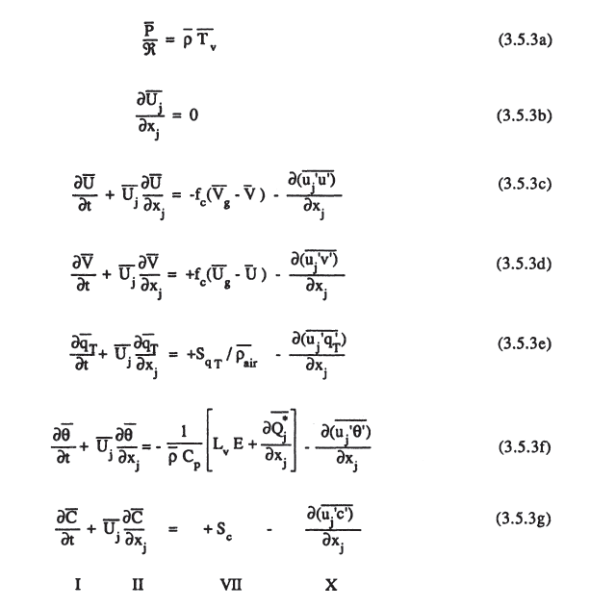

**We also saw that a simple model of the growth of convective BL expresses:**

$ρ Cp\frac{dθ}{dt}=-\frac{dH}{dz}$

**Explain each term in 3.5.3f and what assumptions you need make to get to equation (1)**

1. **Use the simple for the growth rate of a convective BL discussed in class to obtain expressions for BL height h(t) and mixed layer potential temperature θ (t), given that the surface heat flux is $H_{0}= H_{max}\sin{(\frac{πt}{12})}$ for 0 < t < 12, where t is time in hours. Your expression for θ (t) should not contain h.**
2. **Plot h(t) and θ (t) for 0 < t < 12, given that h(0) = 100 m and θ (0) = 20C, for:**
3. **A mildly stable atmosphere γθ = -2 C km-1**
4. **A more stable atmosphere γθ = -5 C km-1**

**Consider α = 0.2 ρ = 1.2 kg m-3 Cp = 1004 J kg-1 K-1**

1. **How sensitive is the final BL height to the initial height h(0)? You may determine this sensitivity either analytically or computationally.**

The final boundary layer height is inversely proportional to the initial height because the growth in the boundary layer depends on how efficiently the heat can be mixed within it, and this decreases with a deeper boundary layer.