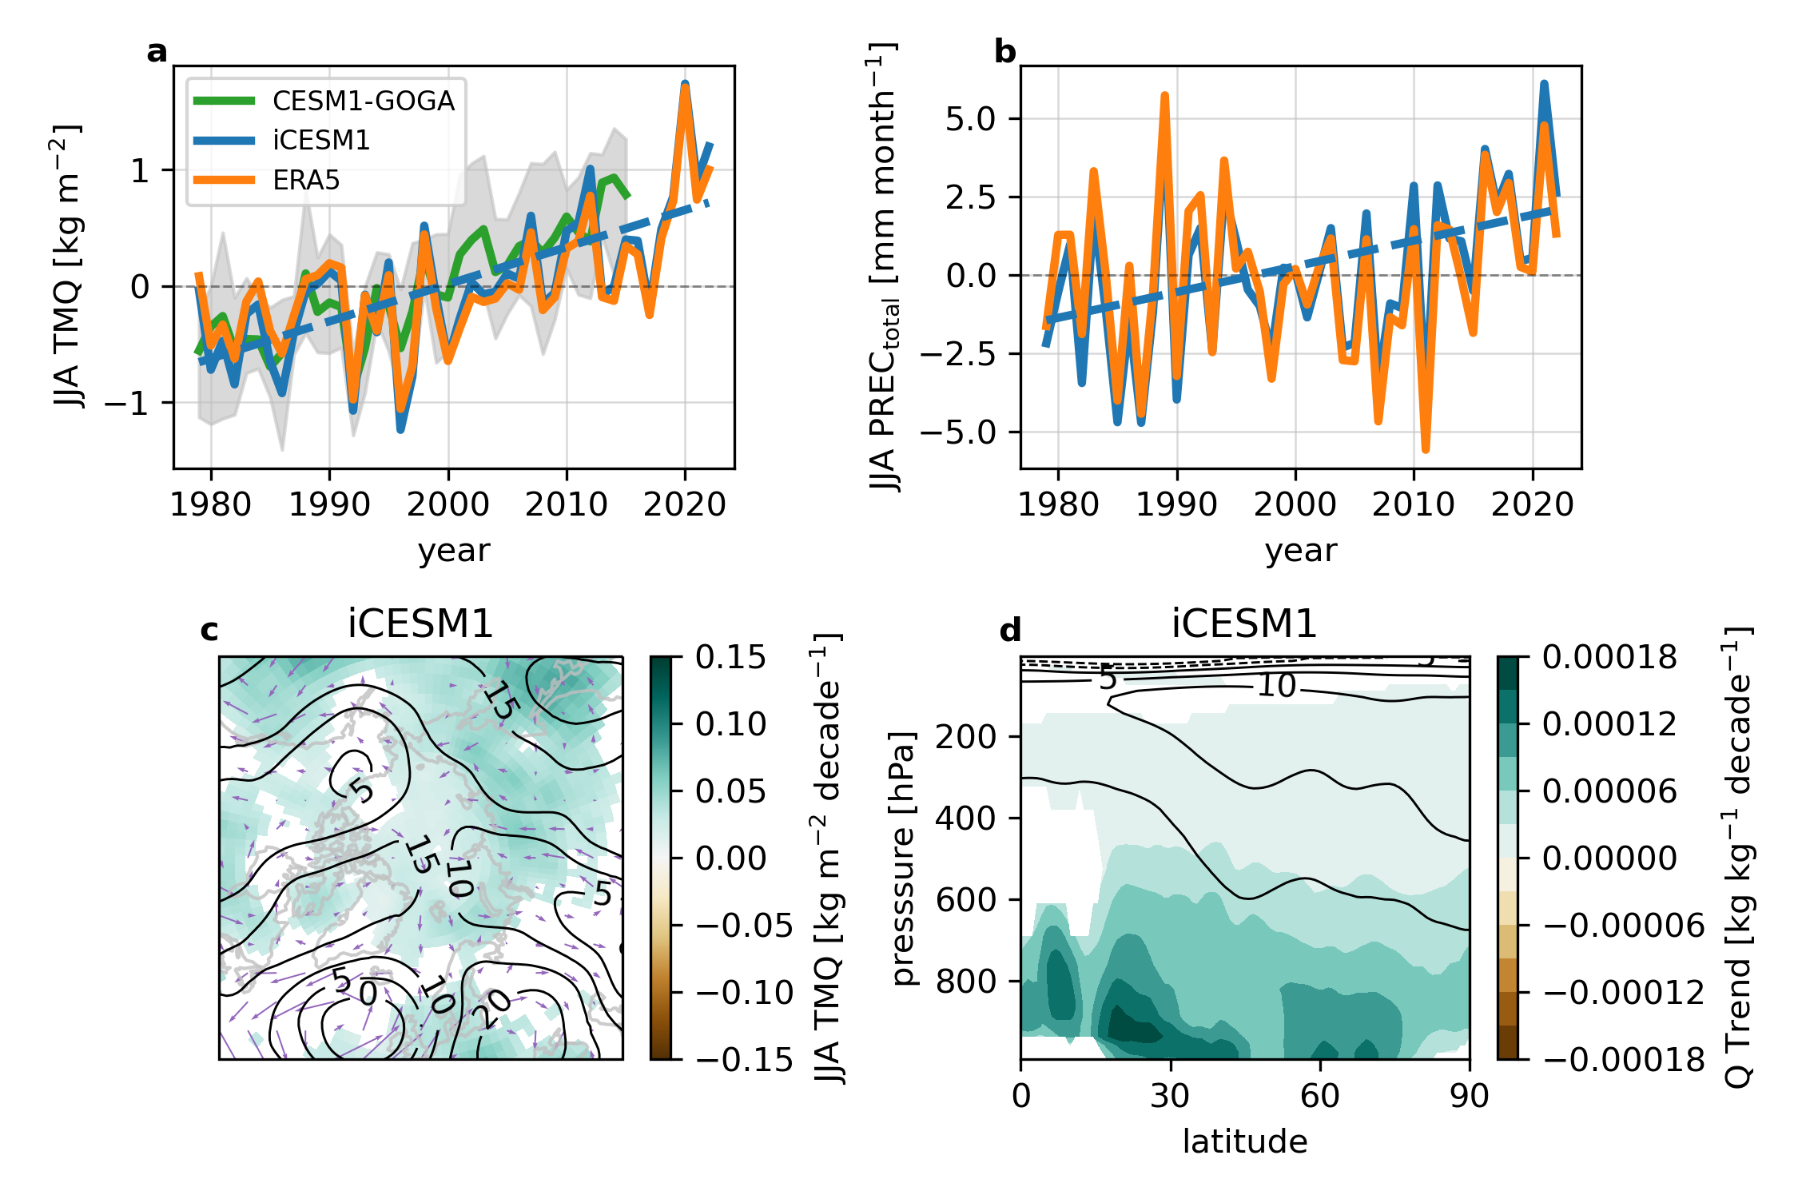

**Figure 1. Trends:** (a) JJA total column precipitable water (kg m-2) within the Arctic (70-90° N) from iCESM1 (blue) and ERA5 (orange). (b) JJA total precipitation (snow+rain, large-scale+convective) within the Arctic (70-90° N) from iCESM1 (blue) and ERA5 (orange). (c) 1979-2022 linear trends in total precipitable water (shading, kg m-2 decade-1), 200 hPa geopotential height (contour, m decade-1), and IVT (kg m-1 s-1 decade-1). (d) 1979-2022 linear trends in zonal mean specific humidity (shading, kg kg-1 decade-1) and geopotential height (contour, m decade-1).

**Figure 2. Regional contribution to Arctic water vapor:** (a) Root mean square error (kg kg-1) when each region is removed from the Arctic total column water vapor and (b) linear decadal trends (1979-2022, 10-4 kg kg-1 decade-1) in Arctic (70-90° N) total column water vapor sourced from each of the 54 tagged source regions. Numbers indicated the source region number.

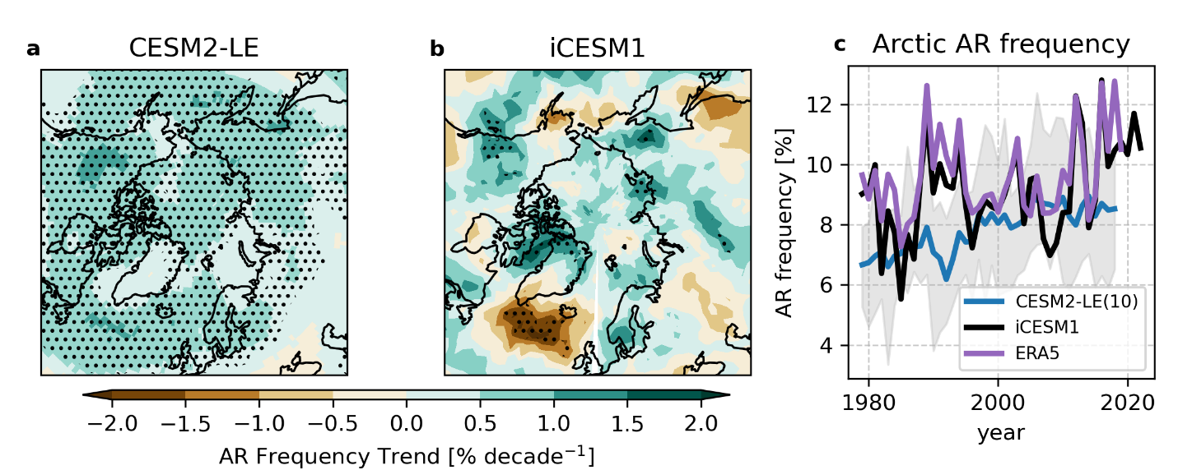

**Figure 3. Atmospheric Rivers:** Linear trends in (a) a 10-member mean from the CESM2-LE and (b) iCESM1 JJA atmospheric river (AR) frequency from 1981-2022. (c) Area-weighted average of JJA AR frequency within the Arctic (70-90° N) from the iCESM1 (black) and ERA5 (purple).

**Figure 4. Regional contribution to the Arctic summertime water vapor feedback:** (a) Vertical structure of Arctic (70-90° N) water vapor feedback (W m-2 K-1), computed by removing water vapor from each tagged source region (x-axis). (b) Total column integrated water vapor feedback (W m-2) computed by removing water vapor sourced from each region. Region numbers in (a) are shown in panel (b).

**Figure 5. Source and pathway for key region in northeastern Canada.**

(a) Vertical structure of moistening (kg kg-1 decade-1) associated with 9 smaller tagging regions within region 47. (b) The linear trends (1981-2022) in Arctic total column WV (kg m-2 decade-1) originating from the 9 smaller regions within northeastern Canada. (c) The linear trends (1981-2022) in soil moisture (cm3 mm-3 decade-1).

**Figure 6. A North American land capacitor effect.**

(a) Linear trends (1981-2022) in total precipitation (mm day-1 decade-1) over region 41 from regions in the Northern Hemisphere (regions 25-54). (b) Linear trends (1981-2022) in precipitation (mm day-1 decade-1) over the Arctic from regions in the Northern Hemisphere (regions 25-54). Shading only shows significant trends at the 95% confidence level. Dashed blue lines denote region 35 (Caribbean Sea) and region 47 (northeastern Canada).

**Supplementary Figures:**

**Supplementary Figure 1. Major moisture transport pathways:** (a) Trends in zonal mean (180-320° W) water vapor transport from North American land-based sources (shading, kg m-1 s-1 decade-1) and equivalent potential temperature (red contours, K decade-1). Green shading indicates poleward (right) transport. Black contours show 1979-2022 mean isotherms. (b) Trends in zonal mean (340-160° W) water vapor transport (shading) and equivalent potential temperature (red contours). Black contours show mean isotherms. (b) Trends in zonal mean (180-320° E) water vapor transport from Eurasian land-based sources (shading, kg m-1 s-1 decade-1) and equivalent potential temperature (red contours, K decade-1). Black contours show 1979-2022 mean isotherms.

**Supplementary Figure 2. Zonal mean water vapor feedback:** The zonal mean water vapor feedback (W m-2) in iCESM1 using the (a) ERA5 or (b) CAM5 radiative kernels and (c) the difference between the two approaches.

**Supplementary Figure 3.**

**Figure 6. A North American land capacitor effect:** 1981-2022 trends in (a) MAM and (b) JJA total precipitation (mm day-1 decade-1) from outside of region 47 (remote). (c) 1981-2022 trends in total column soil moisture (mm3 mm-3 decade-1) from the iCESM1 nudged simulations. (d) 1981-2022 trends in JJA total precipitation (mm day-1 decade-1) from region 47 outlined in red. Note the scale in panel (d) is 1/3 of those in panels (a) and (b). The red box indicates region 47 from Figure 2 and 5.