* Npm init : this will create a package.json file.

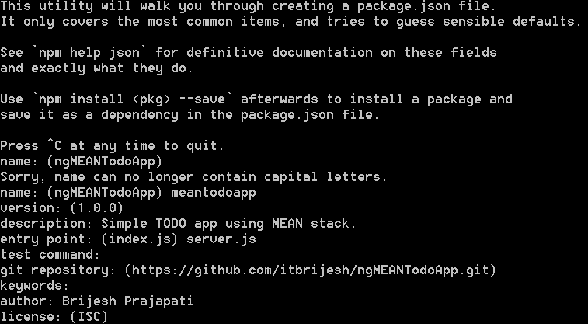

* Npm install express mongojs ejs body-parser –save
* Create a server.js

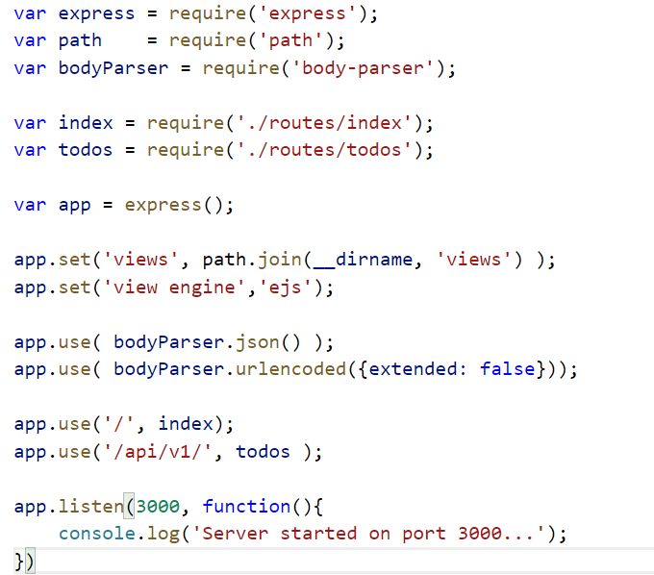

* Create a folders ‘routes’ and ‘views’.
* Inside routes -> create index.js

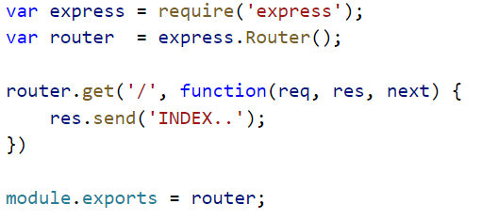

* Inside routes -> create todos.js

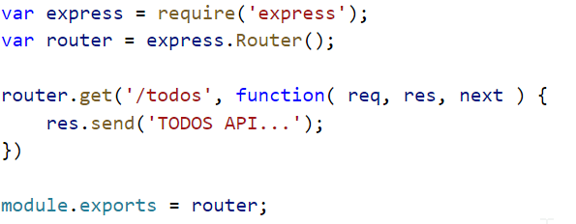

* Start the server : node server
* Access URLs : http://localhost:3000 and <http://localhost:3000/api/v1/todos>
* Create an account in <http://mlab.com>
* Create MongoDB Deployment
* Create database user
* 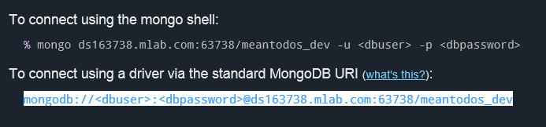
* Now load mongojs module and create variables to access the above database.

Add below code in todos.js



* Access todos from mongo db and send response

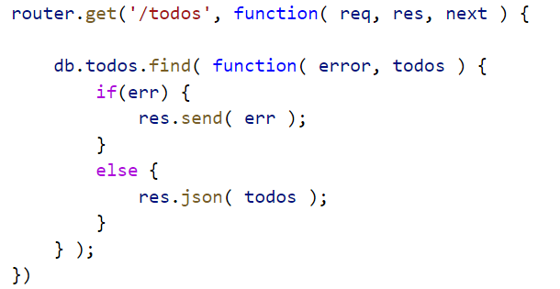

* Get a TODO by id

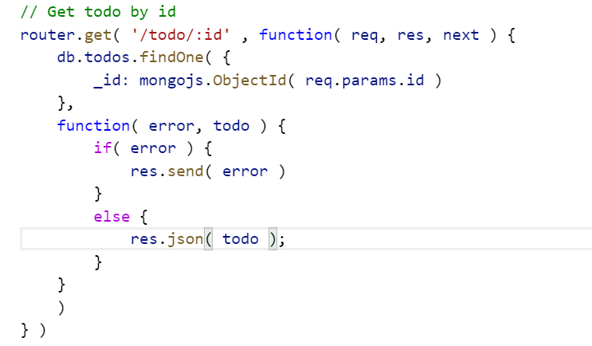

* Update a todo
* Delete a todo
* Setting up Angular JS
* Create a new folder client and setup Angular JS 2 final version
* Configure this client folder in View Engine (server.js) to render html files instead of ejs files.
* Change views/ index.ejs -> index.html
* Copy index.html code of Angular JS to view/ index.html
* Modify index.js to render index.html files.

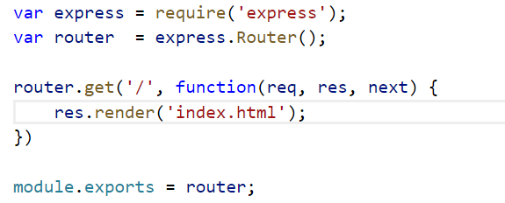

* Modify server.js to render html file as ejs file

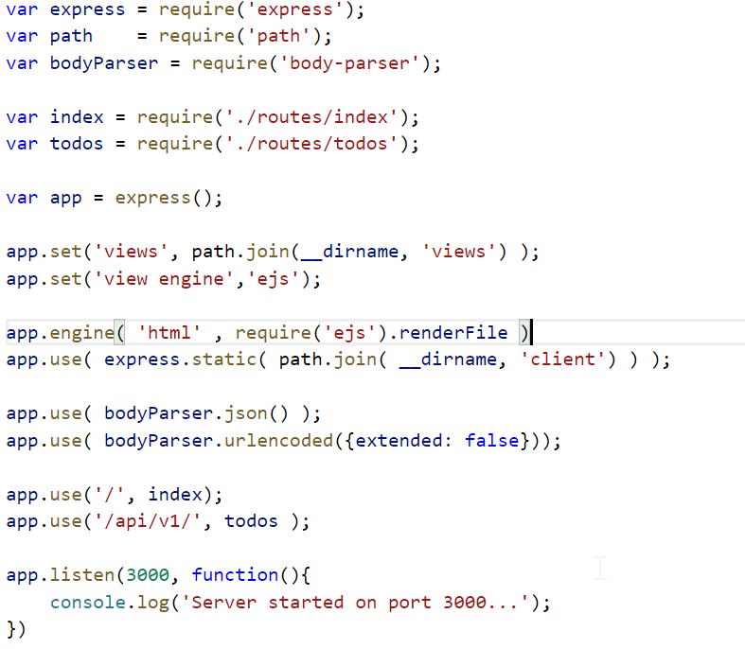

* Start the node server using : node server
* Start the angular/npm server in listening mode : npm run tsc –w
* Access the url at <http://localhost:3000/>
* Install bower which is client side package manager tool : npm install bower
* Create a .bowerrc file with below content

{

"directory": "client/bower_components"

}

* Bower : is a dependency management tool specially used for front-end technologies.
* Install bootstrap using bower: bower install bootstrap --save