

aqpia¿uutgl (Annual Leavej mLon\T Lufiñ (Sick Leave) tr0\ms\utu Forgor FP)
Min nrMLna n> n (Maternity Leave) iGutd fl (OT) \0 m@ c\â d (Early) v IG J¿a n (Chan ging day off rule n fitruru (Special Leave) snuJn (Late)
 |  | ñssig/»yutWoñ: | 0.5ig | 4 t§
 | Admin |  | 
 | 21-09-2026 | ប្រចាំឆ្នាំ a/tef{j ss | N/A
 | N/A |  | N/A | N/A
 | tt harus ’13:00 | ថ្ងៃសរុប 17:00 | iiTia cJju•. 4h
 | tidiedruelm•. N/A | ថ្ងៃ toF\j elm•. N/A | iiTia cJJcJsu•. N/A
 | 
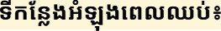 | N/A
 | N/A |  | N/A

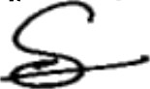
inn: (Name) w ntrum (Signature)
tGtam (Date)

21-09-2026

21-09-2026

