Supporting migrants along the shores of northern France – Activities – Red Cross EU Office
noborders.org.uk
What We Do | Aid & Support for Refugees | Care4Calais
Close the camps > English – About
http://migreurop.org/article643.html?lang=fr
“They treat us like criminals”: racism at the France-UK border - Free Movement
Asylum is a front line for racial justice - Refugee Action
Secours Catholique - Caritas France
Refugee Women's Centre | Calais Appeal
Donate For Calais | Calais Appeal
People crossing the English Channel in small boats - Migration Observatory
UK government

Asylum in Europe
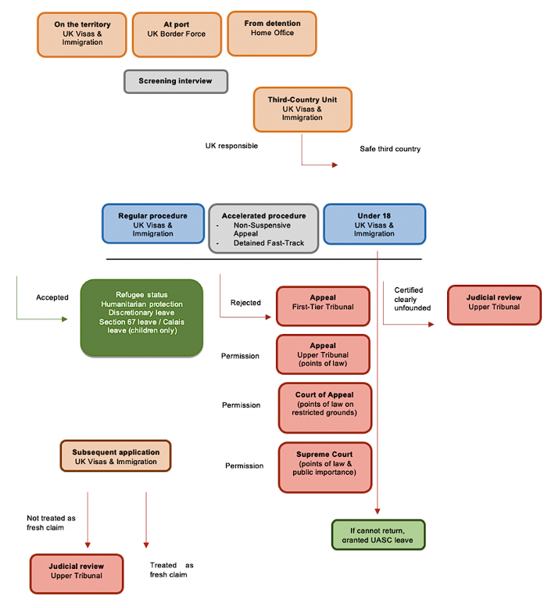
Flow chart - Asylum Information Database | European Council on Refugees and Exiles
New typical asylum process for individuals who arrive in the UK: at a glance
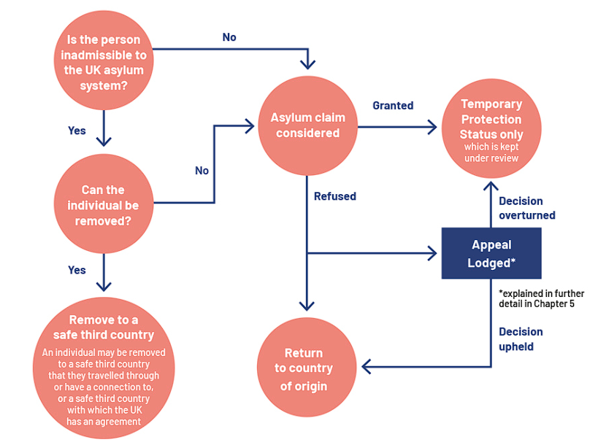
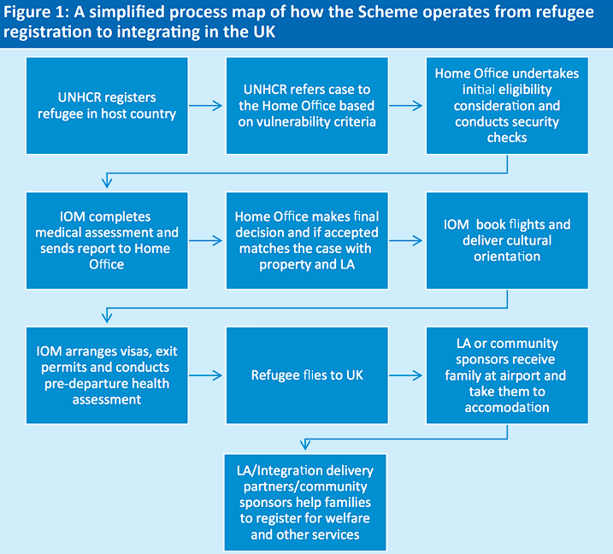
Does the uk government fund charities or NGO's that facilitate migration into...
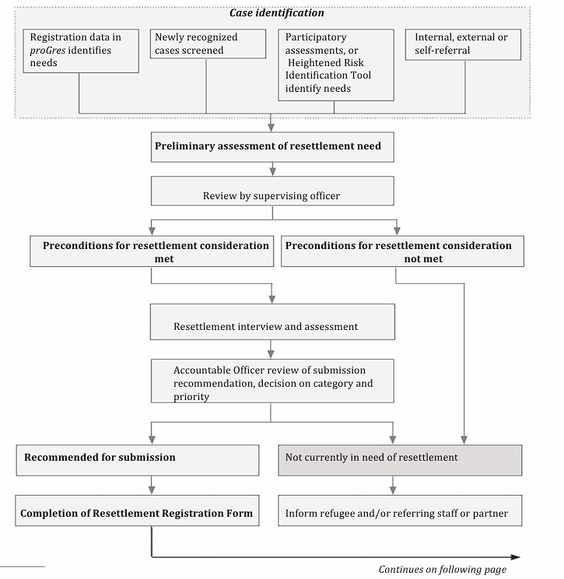
Microsoft Word - shifted RESETTLEMENT FLOW CHART.doc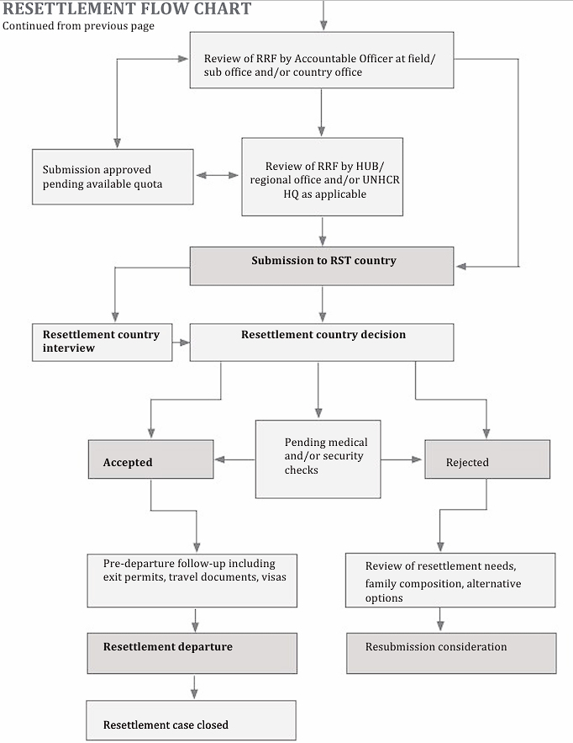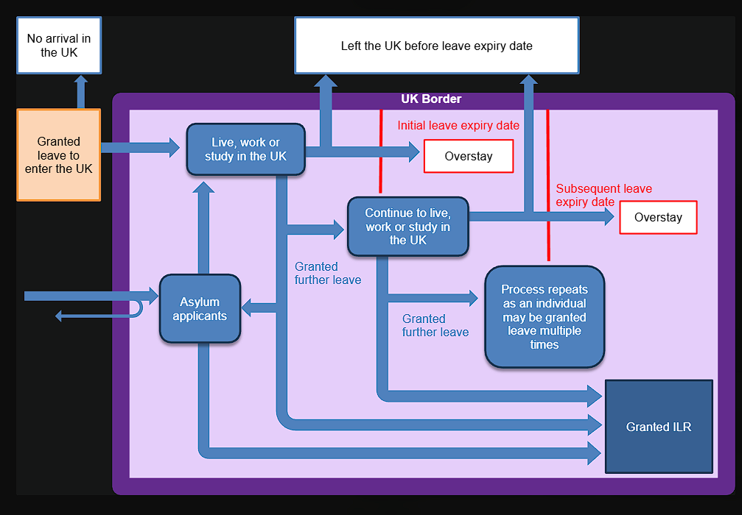
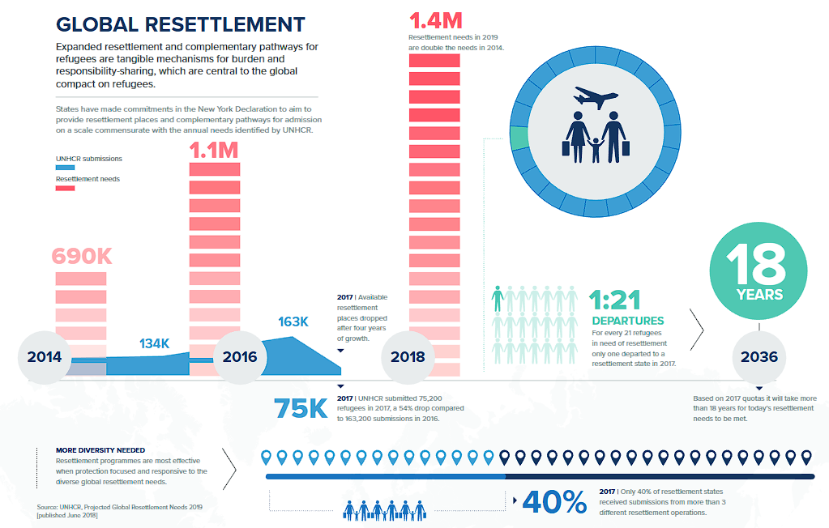
Global Resettlement Infographic | UNHCR
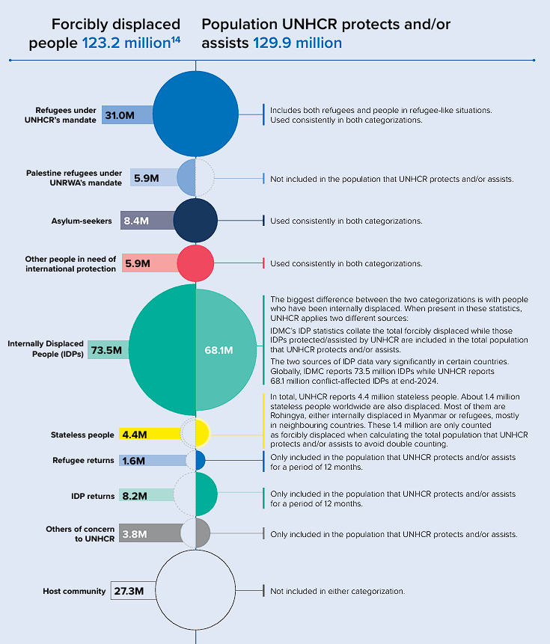
Global Trends 2024
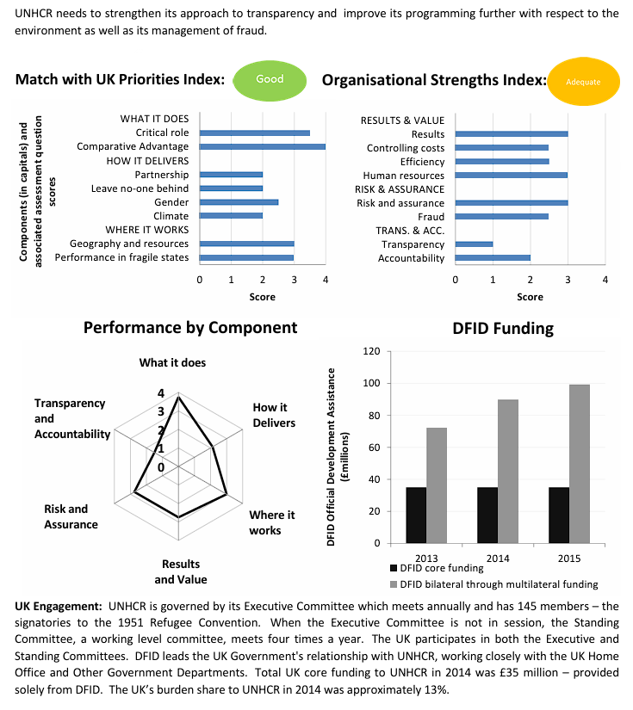
MDR 2016: United Nations High Commission for Refugees Review

