**SRS**

# Project Abstract

The project will deal with the analysis of data in the gaming industry. Data Analysis is known to increase customer engagement and improve business. This paper will focus on the use of data on the Steam website. The gathered data will be used to show how large companies like Steam use people’s data to provide more appealing recommendations for their user’s.

# Introduction

The project was chosen because it is felt the effect of data analysis is changing the world of games and business. It is a fascinating topic with a lot to research. The topic was selected because a lot people do not even realise the amount of data being collected on each of them, let alone the use companies and websites have for this data. The gaming industry is small relative to the world of business but the use of new technologies is something constantly at the for front pf the games industry.

# Background

Research has been done on Steam’s website API to see what public data can be used to analyse. Thankfully the public developer API has detailed information set on everyone who has their steam account set to public.

Other research papers considered (AndersDrachen, Unknown)3b to give me inspiration for my report.

This chapter (AndersDrachen, Unknown) of the game data mining paper mentions some very interesting ideas and topics that we will be researching in further detail.

# Project Description

The finished project is the fully functioning user analytics program. The program can be run in two ways.

1. The user can input their own made up data i.e. Age bracket, gender, type of games liked, most recent purchase, favourite brand. The program will then output a list of recommended games based on the data inputted.
2. The user can run a selected program. This pulls random information from an API and displays the user information and the targeted advertisements for them.

The Technical learning is deep. The manipulation of an API has not been covered before. The use of C++ along with Json data is a new skill also. The opportunity to learn about how industry uses people’s data to target them is a large shock. The amount of personal data publicly available from thousands of unsuspecting people.

The personal learning was extremely valuable also. The ability to manage and complete a full project with documentation over a period of nine months. Completing four other college modules along with this project extremely good practice for time management and efficiency within work. It shows how much work can be done in an organised environment.

# Overview

*Philosophy*

Philosophical point #1

The project is a relatively new idea. The concept of data analytics has only recently come into focus within the general public. The focus on the gaming industry has been even less intense and therefor this project is somewhat new.

Philosophical point #2

The project

# Define the Application

The application is a simulator. The app will accept data and produce results based on user information. The product will have two modes. 1.The user can call data from a website API and try to recreate the profiling done on steam. 2.The user can input their own data and the app will return results based on the inputted data.

The product is a look into how people’s data is used to make websites more specific and attractive to each user.

# What is the application supposed to do?

1. Read data from the Steam API.
2. Select a numbered amount of profiles.
3. Analyse each profile separately based on the data.
4. Produce unique adds for each profile based on their info.
5. Allow the user to input data based to produce targeted adds
6. Weight adjustment for each primary variable. (allowing the user to give greater weight to certain information such as age, gender, nationality).

# Who is going to be using this application?

This is a research application. The application is going to assessed by examiners. It has no commercial users.

# Context Diagram and Use Cases

# Metrics

Does the application represent different accounts with different results?

Do the results appear to make sense vs the profiles they are targeted towards.

Does the app have a second mode to allow the user to

1. Input their own data
2. Adjust the weighting of the application to produce new results.

# Is there a precedent for this application? (Your inspiration):

I think the topic of data analysis is very interesting and will have a large effect on all of our futures.

# Design Manual

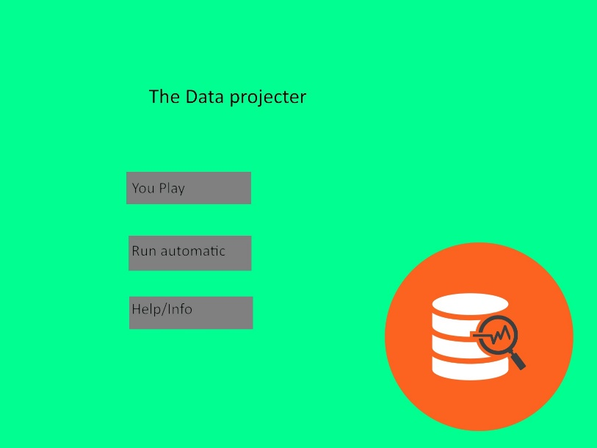

This a rough example of how the main menu will look. There is access to both the user input version “You Play” and, the automatic analysis “Run automatic” where the user selects a sample size from steam.

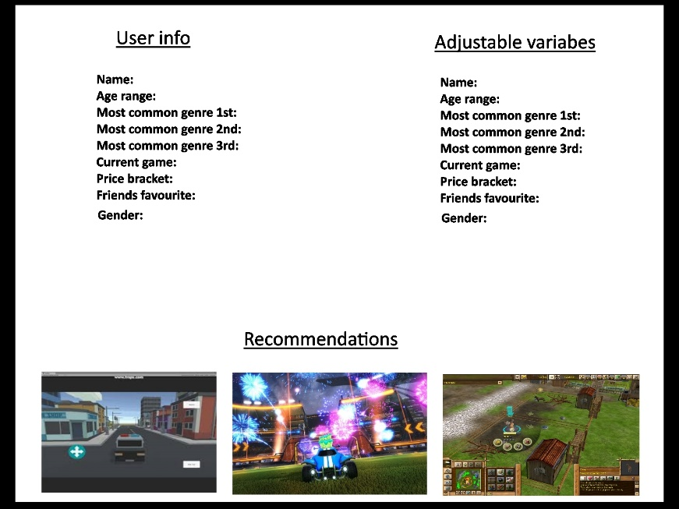

This is a possible example of how the application will be represented on screen. The weighting of each of the variables will be viewable on the screen. The variable weights will be changeable by the user to view the effect it has on the algorithm. The User can input their own details in too. This will also have an effect on the recommendations output.

On the automatic mode all the information and variables will be locked. The data will be represented to the user but the user cannot interact.

# Project Milestones

1. Project proposal due October 31st
2. Research Report due November 31st
3. Presentation due 11th of December
4. SRS and TDD due December 14th
5. Have started programming the API manipulation by December 14th

# Project Review and Conclusions