How to get to a video image picture

If you look out on the video log server, there is a video index file for each of the districts.

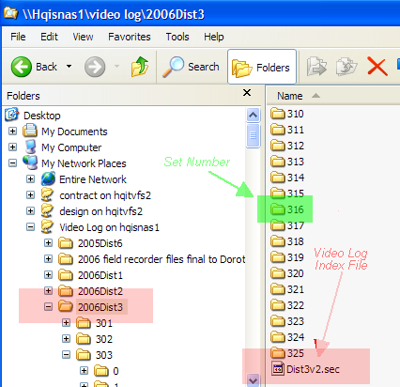

This index file is a text file with fields delimitated by "!".

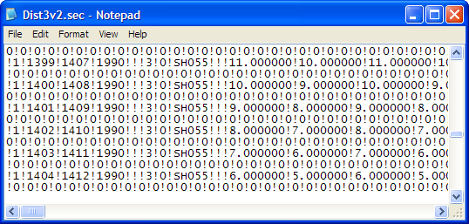
Fields of interest from the video log index file are:

Field | Name
5 | Route Segment Code
8 | District
10 | Route
13 | Begin Mile Post
14 | End Mile Post
17 | Direction (Increasing MP or Decreasing MP)
41 | Vehicle Length
42 | Set Number
43 | Image Start Frame Number
44 | Image End Frame Number

This video index file is imported into a table within MS Access that looks like this:

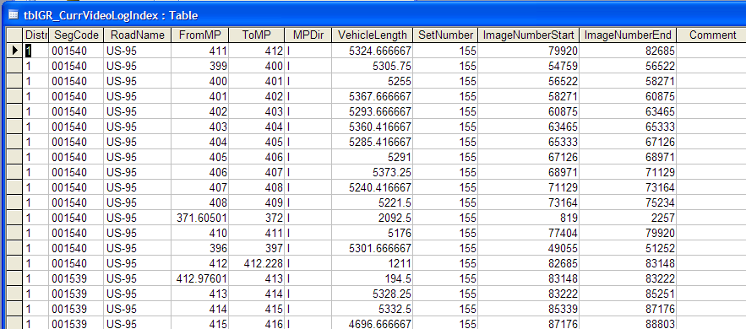

The set number tells where a range of images are located out on the drives. I manually create a table that locates the directory of each set number that looks like this:

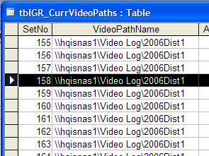

The actual video log images are store in sub directories under each set number.

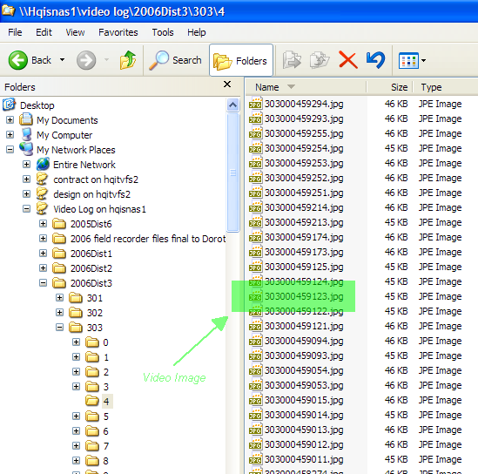

The video log picture name can be broken down as shown below.
303000459123.jpg
Set Number
Image Frame
View

Given a segment code and mile post, there is a function to search through the video log index file to find a record that the mile post fits between. From this record, the set number is identified which also contains the begin/end frame and mile post for that set number.

Given the start and end frame for a mile post range for a set number, the following routine is used to calculate the file name for the image (Note this assumes the vehicle is traveling at the same rate for this segment. If an invalid name is generated, the routine add a few feet to the milepost and calculates the next name until a valid name is returned):

Public Function fncCreatePictureName(stDir As String, dblMP As Double, intView As Integer) As String
' Create target picture name
Dim dblDist As Double
Dim dblDistFrm As Double
Dim dblFrameNum As Double
Dim dblTargetFrame As Double
Dim dblHours As Double
Dim dblMinutes As Double
Dim dblSeconds As Double
Dim dblFrame As Double
Dim strFName As String

If stDir = "I" Then
dblDist = (dblMP - rsVideoIndex![FromMP]) * 5280
Else
dblDist = (rsVideoIndex![FromMP] - dblMP) * 5280
End If
dblDistFrm = rsVideoIndex![VehicleLength] / (rsVideoIndex![ImageNumberEnd] - rsVideoIndex![ImageNumberStart])
dblFrameNum = dblDist / dblDistFrm
dblTargetFrame = rsVideoIndex![ImageNumberStart] + dblFrameNum
dblHours = Int(dblTargetFrame / (3600# * 30#))
dblMinutes = Int(dblTargetFrame / (60# * 30#) - dblHours * 60#)
dblSeconds = 60# * (Int(dblTargetFrame / 30#) / 60#) - dblMinutes * 60# - [dblHours] * 3600#
dblFrame = Int(30 * (dblTargetFrame / 30 - Int(dblTargetFrame / 30#)))
strFName = "\" & rsVideoIndex!SetNumber & "\" & ((dblHours * 60#) + dblMinutes) _
& "\" & rsVideoIndex!SetNumber & Format(dblHours, "00") _
& Format(dblMinutes, "00") & Format(dblSeconds, "00") _
& Format(dblFrame, "00") & intView & ".jpg"

fncCreatePictureName = strFName
End Function

