Logic Document for Control Service Load Balance

|  |  |  |  |
| --- | --- | --- | --- |
| **Version#** | **ImplementedBy** | **RevisionDate** | **Reason** |
| 1.0 | *Angela Yu* | *09/06/2011* | draft |
| 2.0 | *Eric Cheng* | *03/26/2012* | Translated |
|  |  |  |  |

# Load Balance of DocAve Control Service

## Prerequisite

### Configure DocAve Control Load Balance environment correctly, that is installing multiple Control Services which point to the same Control DB.

## Function Brief Introduction

### To resolve the issue that using a single Control service is not stable, DocAve introduces the concept of multiple Control services based on Load Balance. If one Control service is Down due to a certain reason, the others can continue to work.

### The Windows Network Load Balanced mechanism has two characteristics, which are Reliability and Performance. DocAve realizes these two characteristics based on those of Windows Network Load Balanced environment.

### **\*Note**: Because the logic of realizing the Performance characteristic of the DocAve Schedule Job is restricted, the Performance characteristic of the DocAve Schedule Job cannot be realized for now. Refer to Basic Logic for more information.

## GUI Logic

### Configure DocAve Control Load Balance in Windows Network Load Balanced Environment

#### Windows load balance has been configured for environments A and B. The public IP is IP01, environment A’s IP is IP02, environment B’s IP is IP03.

#### Install DocAve Control01 in environment A. Enter **IP02**/machine name in Control host.

#### Install DocAve Control02 in environment B. Enter **IP03**/machine name in Control host.

#### **\*Note**: The Control database is the one that Control01 points to. Passphrase is the one that generated by the first Control service**.**

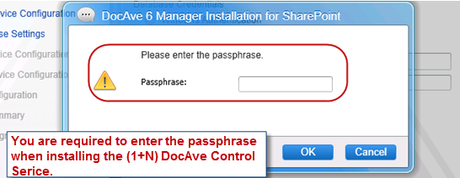

#### When installing the other services, they all point to the public IP **IP01**. The environment we configured just now is DocAve Control Service Load Balance based on Windows NLB.

### Configure DocAve Control Service Load Balance in the Environment which is not Windows Network Load Balanced

#### Environment A has its own IP which is IP01, and environment B has its own IP which is IP02.

#### Install DocAve Control01 in environment A using its own IP01/machine name.

#### Install DocAve Control02 in environment B using its own IP02/machine name

#### **\*Note**: The Control service database is the one specified for Control01. Passphrase is the one that generated by the first Control service.

#### When installing the other services, they can point to IP01 or IP02. The environment we configured just now is DocAve Control Service Load Balance.

## Basic Logic

### **Logic Used when Configuring DocAve Control Service Load Balance in Windows Network Load Balanced Environment:** All the Control services which point to the same Control database will participate in the Network Load Balanced logic.

#### DocAve load balance topology01

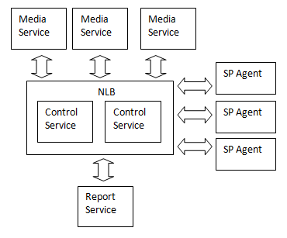

#### The customer can use IP01 to access DocAve 6 and perform the operations. **Window Network Load Balanced will deal with the received request and decide to send it to which node.** The Control Service of the node which is selected by Network Load Balancedresponds to the relevant request.

* If you use IP02(03), all the operations in DocAve GUI will be sent by the Control service of IP02(03) and Windows Network Load Balanced will not intervene.

#### After receiving the request, Agent begins to work and return the result to Control service. Because the Agent is registered using the public IP IP01, Agent will send the request to the public IP. According to the characteristic, Network Load Balanced will deal with the request automatically and choose the optimum Control service to respond to the received message. The chosen Control service then reacts to the corresponding Agent.

#### The Network Load Balanced will deal with the request automatically and choose to send the request to which node. If no DocAve Control service is installed on that environment, the request will be abandoned.

* If the customer’s Windows load balance is consist of N environments, and he only installs DocAve Control service on X(X<N) environments, it has effects over DocAve functionalities.
* If some Control services went down in the Network Load Balanced environment, it has effects over DocAve functionalities.

**To avoid the effects above, shut down the machines described above or disconnect them from the network.**

#### These requests include (more than the following): The interaction logic on DocAve GUI and the background (such as save plan, load plan, etc.), the request sent by Agent, DocAve Media service and the other services (such as sending Job progress, sending Job Report, etc.). We cannot decide to send the request to which node, and according to the current practical situation, Network Load Balanced does not check whether the IIS site is available. It sends the request as long as the network is available.

#### Known Issues: In the Network Load Balanced environment, all the Control Services collaborate and work together; they are shown as one to the customer. So all the logics related with local files and the memory status might encounter issues. For example, Job Report is stored in local drive currently and it might be stored to UNC path in the future.

### **The Logic when Dealing with the Schedule Job:** Only the Active Control service deals with DocAve Schedules.

#### The first started Control Service will turn to Active. This status is saved in Control database.

#### Whenever a new Control Service starts and finds there is already an Active Control, it will set its status as Waiting.

#### Control Service checks the status of all the Control Services in database every 30s. If it finds there is an Active Control service which has not expired, it will only update its timestamp.

#### If the Active Control service is expired, its status will be set as Down. And then it selects one Control Service from all the Waiting Control Services and activates it. (It will select the Control service with least loads according to LoadBalanceFactor. Currently the LoadBalanceFactor does not work, so the selection can be regarded as a random one.)

#### If a Waiting Control service finds its status is set as Active when checking the database, it will start the Schedule Service on its own server.

#### If an Active Control service finds its status is set as Down when checking the database (little probability), it will stop its Schedule Service to make sure in all the environments there is only one Control Server that is Active and has started the Schedule Service.