GRAV Store Employee Quick Help
  - Find an answer and complete one task without reading the full handbook
This guide is for employees who need to complete Store and Purchase work quickly and correctly. It is not designed to be read from beginning to end. Start with your question, role or current screen, then open only the task card you need.
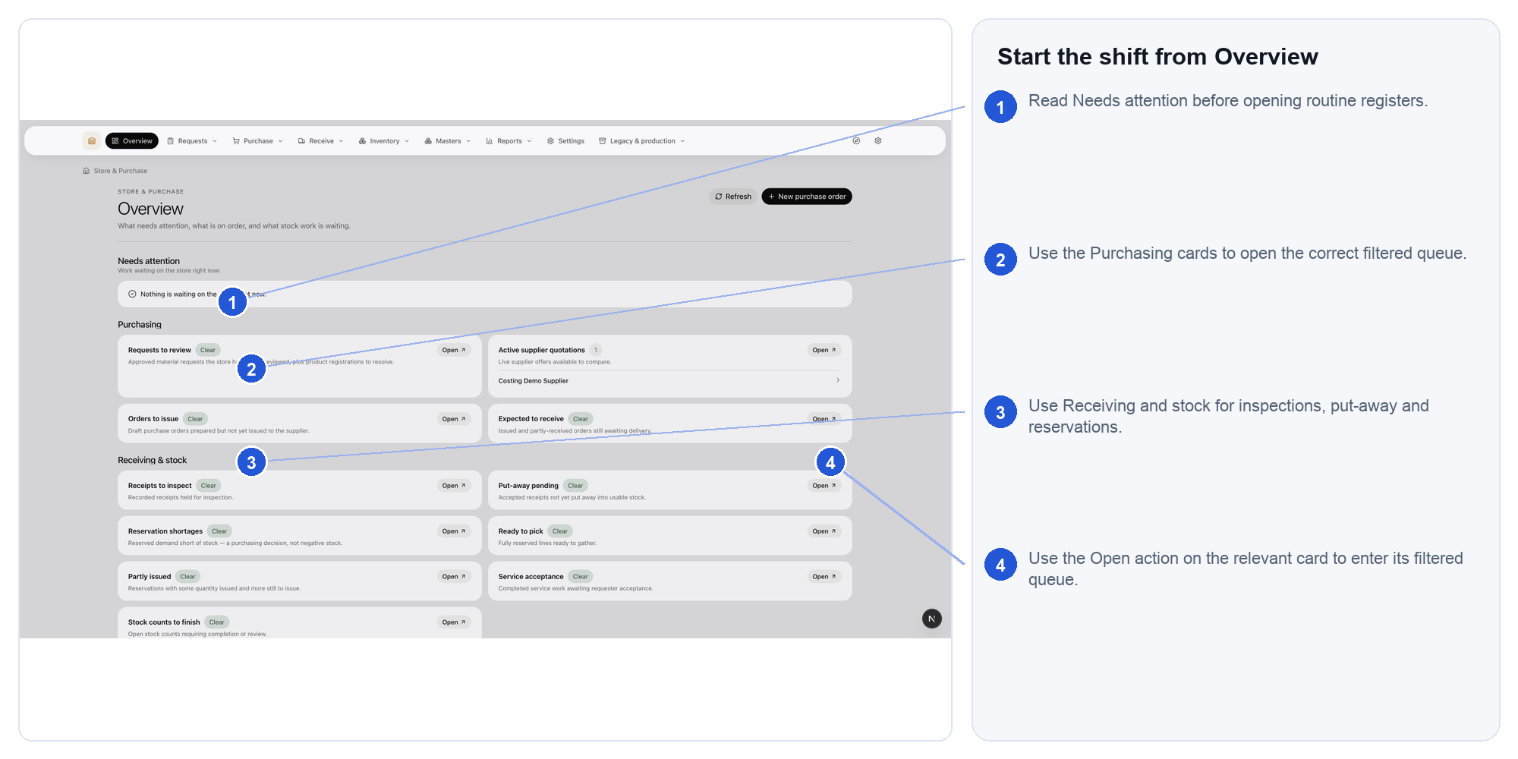

Daily rule
Search first, verify the exact business record, perform one controlled action, then confirm the resulting status or movement.
Detailed policy and unusual cases remain in the GRAV Store and Purchase Complete User Guide.

Find an answer in 30 seconds
Use whichever starting point matches what you know. Word search and the Navigation pane work throughout this guide.
What you know | What to do | Example
Your goal | Search the verb or object, then open the matching task card. | receive, return, supplier, count, valuation
Your role | Open My work by role and follow only your normal queue. | requester, buyer, receiver, inventory controller
Your current screen | Search the visible page title exactly as it appears. | Goods receipts, Stock exceptions, Materials
An error message | Search a distinctive phrase from the message and use Problem to action. | unit conversion, insufficient stock, staff record
A document number | Open the owning register and search the exact number. | request, PO, receipt, service order

Do not browse module names at random
- A new need always begins in Request desk, not in a legacy register.
- Physical goods use Purchase orders and Goods receipts.
- Non-stock work uses Service orders and requester acceptance; it creates no stock.
- Quantity changes belong to receiving, issue, return, transfer, count or correction workflows - not master forms.
- Budget mapping and Accounting actuals are connected controls, not fields employees should invent while handling stock.

Goal index
I want to | Open | Search words
See what needs attention | Card 01 Overview | shift, urgent, queue
Find an approved need | Cards 02 to 04 | request, required items, classify
Issue or return material | Cards 05, 06 and 12 | issue, return, credit stock
Buy physical goods | Cards 07 and 08 | purchase order, supplier, PO
Receive and inspect goods | Card 09 | receipt, GRN, quarantine, reject
Order and accept a service | Card 10 | service order, completion, rework
Reserve or pick stock | Card 11 | reservation, available, picked
Count or investigate stock | Cards 13 to 15 | count, movement, exception
Print a traceable label | Card 16 | lot, barcode, label
Find or create master data | Cards 17 to 25 | material, product, supplier, offer, unit, warehouse
Read operational reports | Cards 26 to 29 | request report, movement, exception, value
Change Store settings | Card 30 | address, PDF, settings
Find historical purchase forms | Card 31 | legacy, old purchase form, history
Card numbers in this guide are stable lookup identifiers. Search CARD plus the two-digit number, or search the page title shown in the Open column.

My work by role
Role | Start here | Normal work | Stop and escalate when
Requester | Request desk | Raise and follow a need; provide purpose and required date; accept completed services. | The request identity, quantity or service result is wrong.
Approver | Request detail | Confirm business need, timing and scope; approve or refuse with a reason. | Evidence, authority or budget result is unclear.
Buyer | Request desk / Purchase orders | Source approved demand; compare offers; prepare and issue supplier documents. | Supplier, unit, tax, price or budget evidence is incomplete.
Store receiver | Overview / Goods receipts | Match arrival to PO; record quantity and condition; quarantine or put away. | PO line, unit, location or condition cannot be verified.
Inventory controller | Reservations / Counts / Exceptions | Reserve, pick, issue, return, count and resolve evidence breaks. | A correction would require editing posted history or making stock negative.
Manager | Overview / Reports | Prioritise queues, review exceptions and confirm handoffs have owners. | Operational and financial records disagree without evidence.
Finance reader | Valuation / source documents | Read management value with coverage; match commercial and accounting evidence. | Missing evidence is being treated as zero cost.
Administrator | Masters / Settings | Maintain controlled identities, units, locations and future defaults. | A change could rewrite or misclassify historical work.

Start and finish the shift

Start of shift
- Open Overview and read Needs attention before routine registers.
- Open the highest-priority filtered queue from its card.
- Check receipts awaiting inspection, put-away pending, reservation shortages and stock exceptions.
- Read yesterday's unresolved notes and confirm ownership before creating new work.

Before every stock-changing action
- Verify document number, item, variant, quantity, unit and physical location.
- Confirm the screen's action matches the real event: receive, reserve, pick, issue, return, transfer, count or correct.
- Submit once. If the response is uncertain, refresh and inspect history before trying again.

End of shift
- No accepted receipt remains without a known location unless it is deliberately quarantined.
- Picked material is either issued, returned to usable stock or left with a named owner.
- Open counts and unresolved exceptions have a reason and next owner.
- The physical handover agrees with the system's visible queues.

CARD 01 Start the shift from Overview
Open: Overview
Use this when: At the start of a shift or whenever you need to decide what requires attention next.
Steps: 1. Read Needs attention before opening routine registers. 2. Use the Purchasing cards to open the correct filtered queue. 3. Use Receiving and stock for inspections, put-away and reservations. 4. Use the Open action on the relevant card to enter its filtered queue.
Expected result: You enter the correct filtered queue and know which work owns the next action.
If blocked: If a card and its register disagree, refresh once and use the register as the working record.

CARD 02 Review approved demand in Request desk
Open: Requests > Request desk
Use this when: An approved material or service need must be reviewed and routed to stock, purchase or service fulfilment.
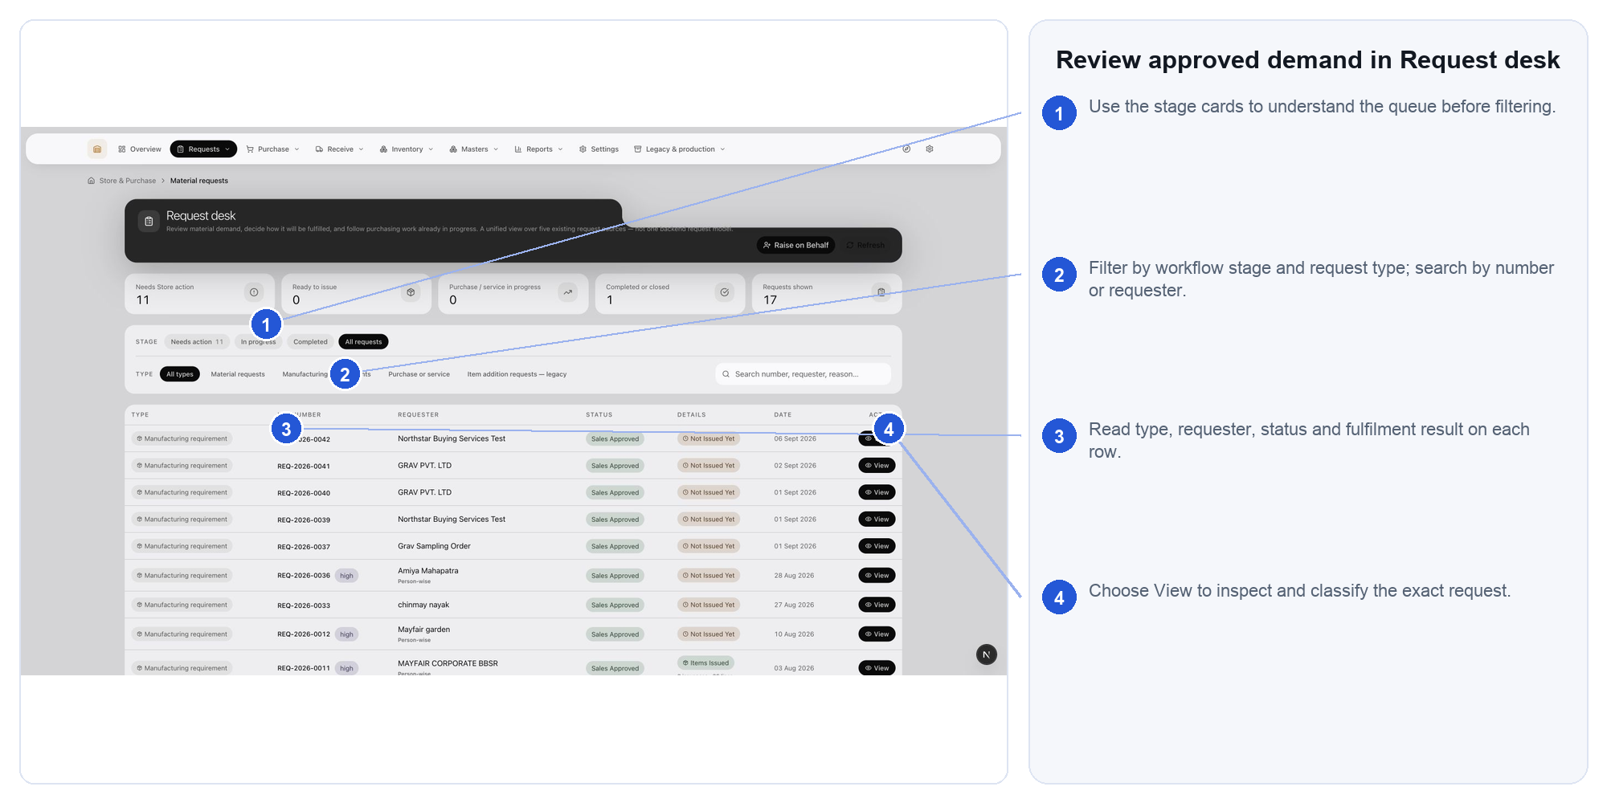
Steps: 1. Use the stage cards to understand the queue before filtering. 2. Filter by workflow stage and request type; search by number or requester. 3. Read type, requester, status and fulfilment result on each row. 4. Choose View to inspect and classify the exact request.
Expected result: The correct request is open and its fulfilment path is visible.
If blocked: If the request is missing, verify company, date, requester and stage before escalating.

CARD 03 Inspect a request before acting
Open: Requests > Request desk > View request
Use this when: Before reserving, issuing, buying or ordering a service against a request.
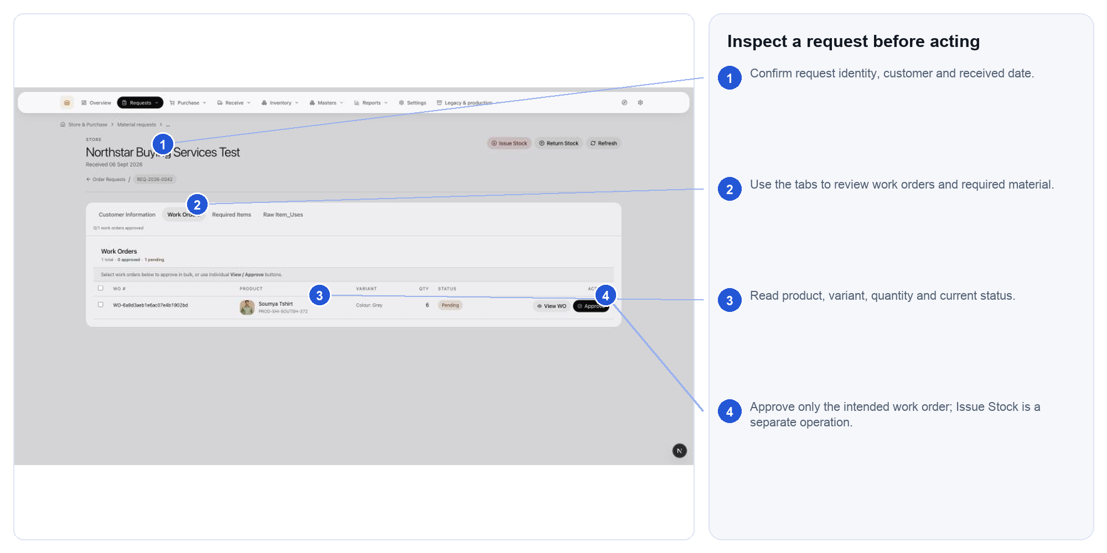
Steps: 1. Confirm request identity, customer and received date. 2. Use the tabs to review work orders and required material. 3. Read product, variant, quantity and current status. 4. Approve only the intended work order; Issue Stock is a separate operation.
Expected result: Every action is based on the request's current approval, identity and required date.
If blocked: If actions are hidden, check status and role; do not use another person's sign-in.

CARD 04 Check required material lines
Open: Request detail > Required Items
Use this when: The request contains product demand that must be translated into exact material and variant requirements.
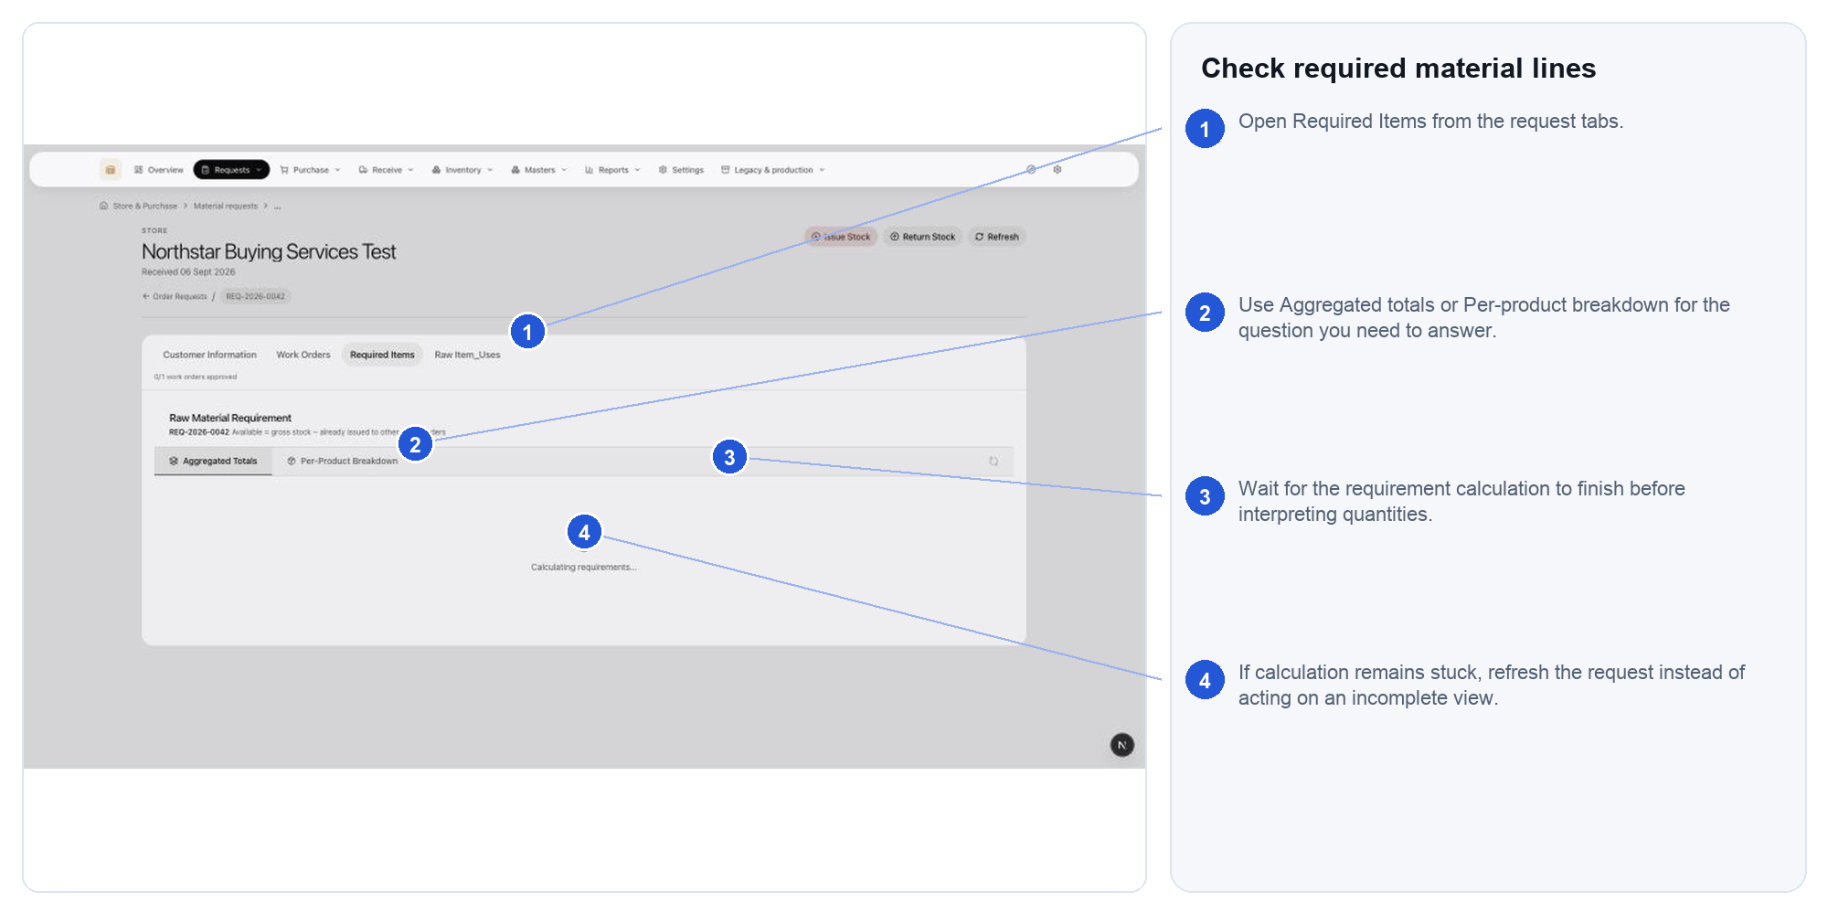
Steps: 1. Open Required Items from the request tabs. 2. Use Aggregated totals or Per-product breakdown for the question you need to answer. 3. Wait for the requirement calculation to finish before interpreting quantities. 4. If calculation remains stuck, refresh the request instead of acting on an incomplete view.
Expected result: Requested descriptions point to the correct material, variant, quantity and unit.
If blocked: If calculation remains incomplete, refresh the request and do not act on partial quantities.

CARD 05 Record stock leaving Store
Open: Request detail > Issue Stock
Use this when: Approved material is physically leaving Store for a known request or work context.
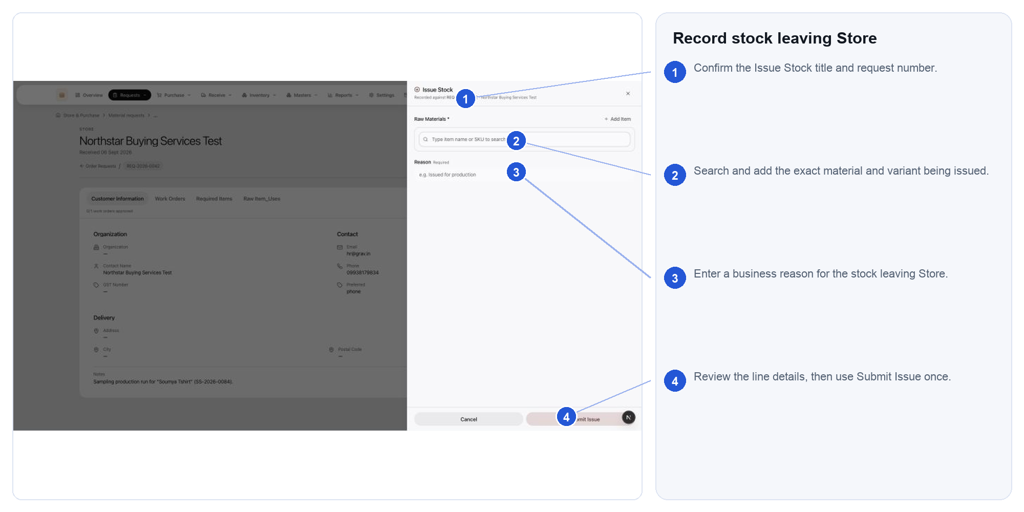
Steps: 1. Confirm the Issue Stock title and request number. 2. Search and add the exact material and variant being issued. 3. Enter a business reason for the stock leaving Store. 4. Review the line details, then use Submit Issue once.
Expected result: One traceable stock-out is recorded against the correct request.
If blocked: If stock or a conversion is missing, stop; correct availability or master data first.

CARD 06 Return unused issued material
Open: Request detail > Return Stock
Use this when: Unused material previously issued is physically returning to Store.
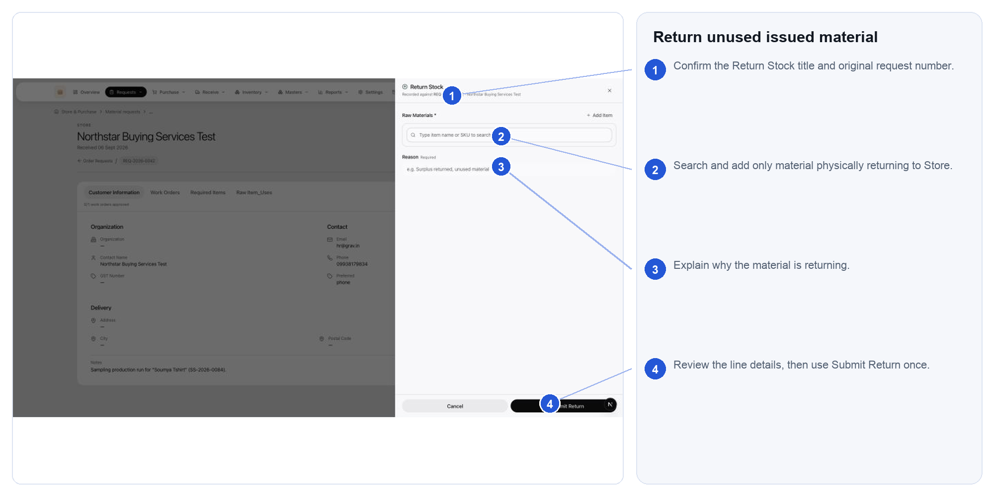
Steps: 1. Confirm the Return Stock title and original request number. 2. Search and add only material physically returning to Store. 3. Explain why the material is returning. 4. Review the line details, then use Submit Return once.
Expected result: Returned quantity reaches the correct usable or non-usable location with a reason.
If blocked: If the original issue cannot be identified, do not credit an arbitrary item.

CARD 07 Monitor physical-goods purchase orders
Open: Purchase > Purchase orders
Use this when: You need to find, monitor, issue, receive against or investigate a physical-goods order.
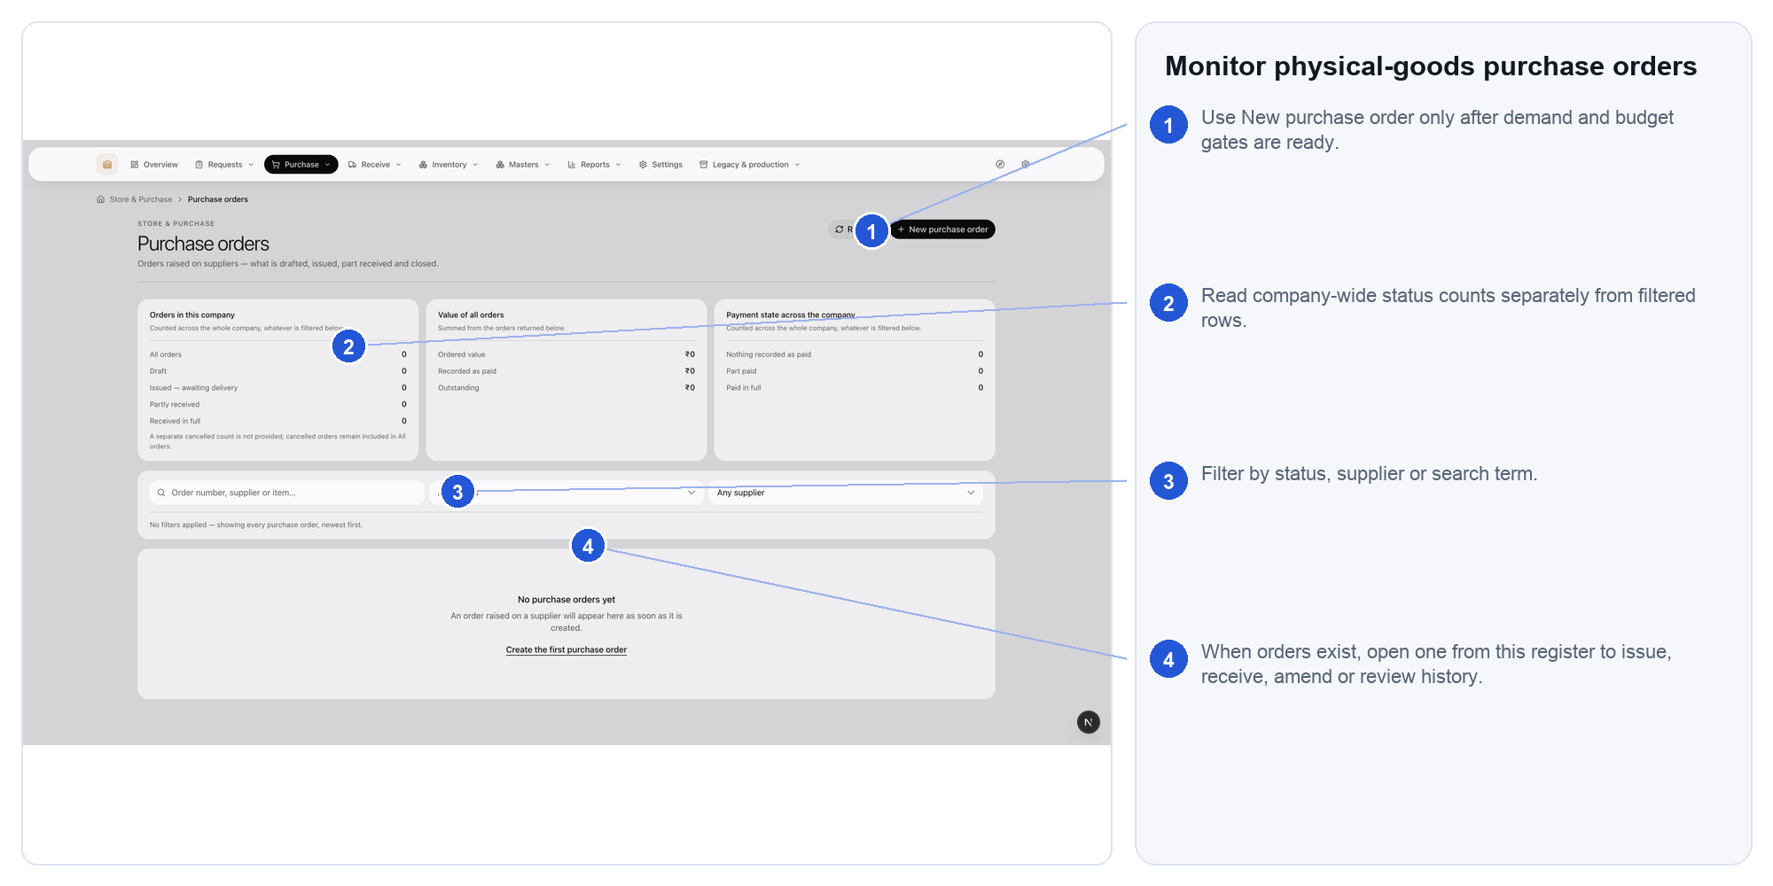
Steps: 1. Use New purchase order only after demand and budget gates are ready. 2. Read company-wide status counts separately from filtered rows. 3. Filter by status, supplier or search term. 4. When orders exist, open one from this register to issue, receive, amend or review history.
Expected result: The order and its next operational action are identified.
If blocked: If an issued order is wrong, use the supported amendment or cancellation path; do not overwrite history.

CARD 08 Create a purchase-order draft
Open: Purchase > Purchase orders > New purchase order
Use this when: Approved demand is ready to become a supplier-facing order for physical goods.
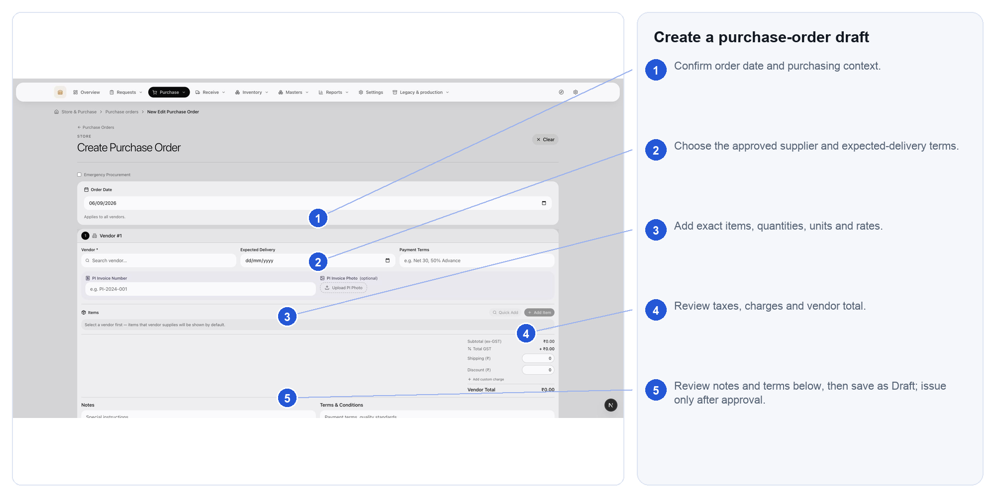
Steps: 1. Confirm order date and purchasing context. 2. Choose the approved supplier and expected-delivery terms. 3. Add exact items, quantities, units and rates. 4. Review taxes, charges and vendor total. 5. Review notes and terms below, then save as Draft; issue only after approval.
Expected result: A reviewable draft exists; issuing remains a separate controlled decision.
If blocked: If demand, supplier, budget or unit evidence is incomplete, keep the order in Draft.

CARD 09 Receive goods against the purchase order
Open: Receive > Goods receipts
Use this when: Goods have arrived against a purchase order and require quantity and condition recording.
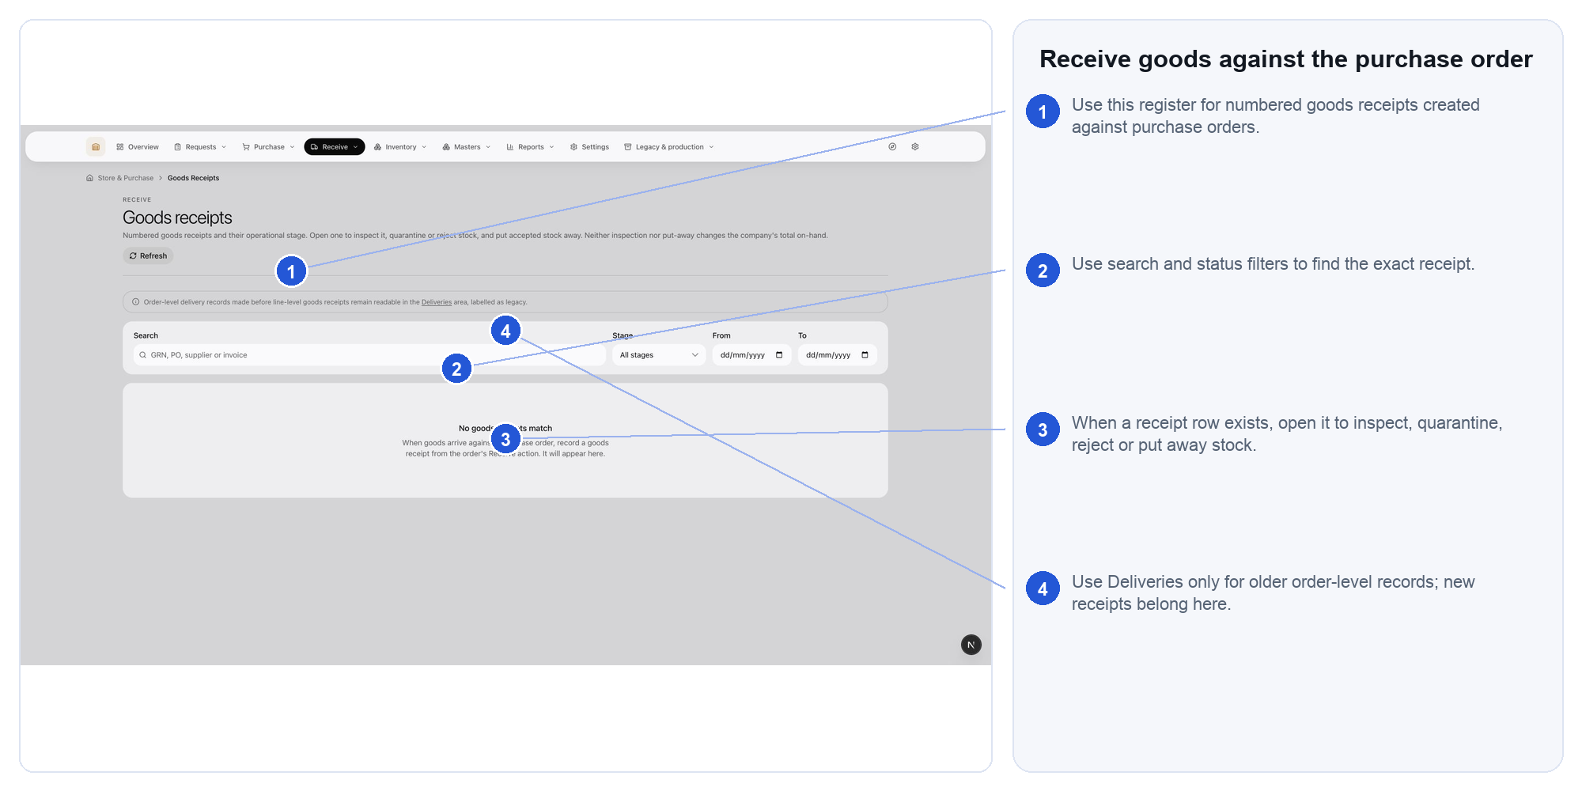
Steps: 1. Use this register for numbered goods receipts created against purchase orders. 2. Use search and status filters to find the exact receipt. 3. When a receipt row exists, open it to inspect, quarantine, reject or put away stock. 4. Use Deliveries only for older order-level records; new receipts belong here.
Expected result: Accepted, quarantined and rejected quantities remain separate and traceable.
If blocked: If the PO line, unit or location is unclear, quarantine or pause instead of guessing.

CARD 10 Track non-stock service work
Open: Purchase > Service orders
Use this when: Non-stock work is issued to a supplier and must be followed through completion and requester acceptance.
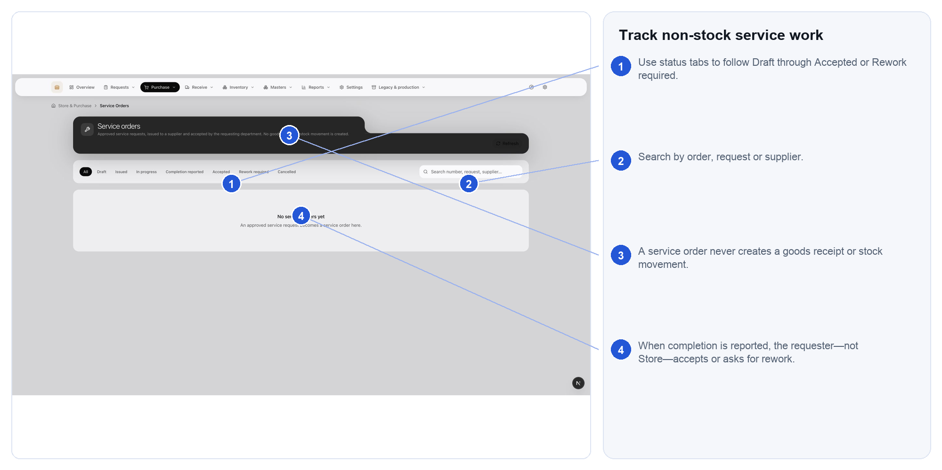
Steps: 1. Use status tabs to follow Draft through Accepted or Rework required. 2. Search by order, request or supplier. 3. A service order never creates a goods receipt or stock movement. 4. When completion is reported, the requester—not Store—accepts or asks for rework.
Expected result: Accepted service evidence is ready for Accounting without creating stock or a goods receipt.
If blocked: If completion cannot be accepted, the requester should ask for rework with a reason.

CARD 11 Reserve, pick and issue material
Open: Inventory > Reservations and picking
Use this when: Approved demand should be promised, picked and then issued from usable stock.
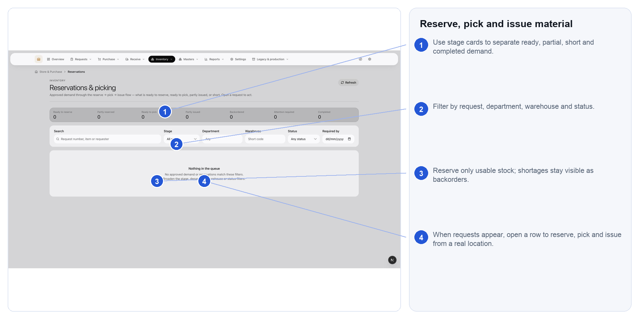
Steps: 1. Use stage cards to separate ready, partial, short and completed demand. 2. Filter by request, department, warehouse and status. 3. Reserve only usable stock; shortages stay visible as backorders. 4. When requests appear, open a row to reserve, pick and issue from a real location.
Expected result: Usable stock is promised and picked without hiding shortages or issuing twice.
If blocked: If availability is short, leave the shortage visible; never make stock negative.

CARD 12 Use the Issues and returns workspace
Open: Inventory > Issues and returns
Use this when: You need the operational workspace for a stock-out or an internal stock return.
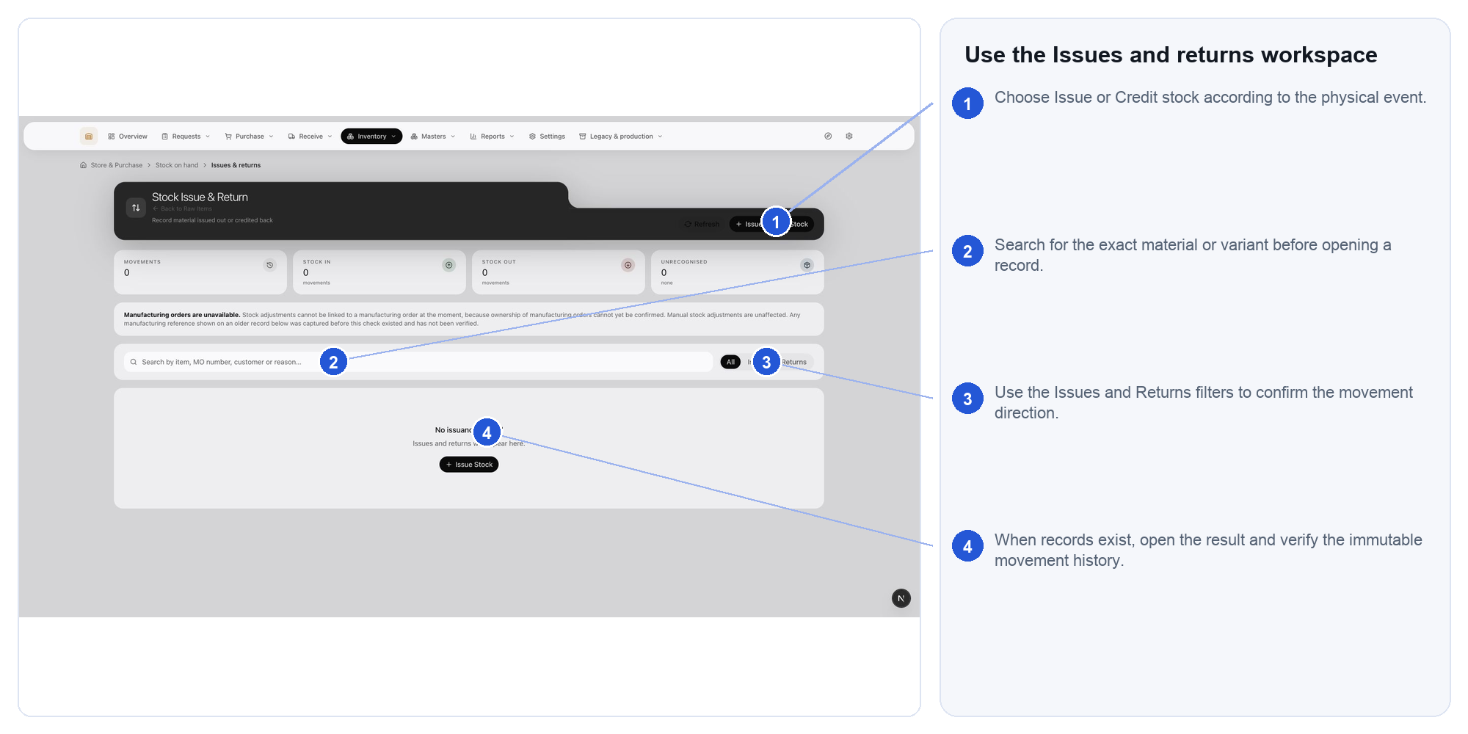
Steps: 1. Choose Issue or Credit stock according to the physical event. 2. Search for the exact material or variant before opening a record. 3. Use the Issues and Returns filters to confirm the movement direction. 4. When records exist, open the result and verify the immutable movement history.
Expected result: Direction, item, variant, quantity, unit and reason match the physical event.
If blocked: If the physical event and selected direction differ, cancel before submitting.

CARD 13 Start and complete a stock count
Open: Inventory > Stock counts
Use this when: Recorded stock must be checked against a physical location and differences controlled.
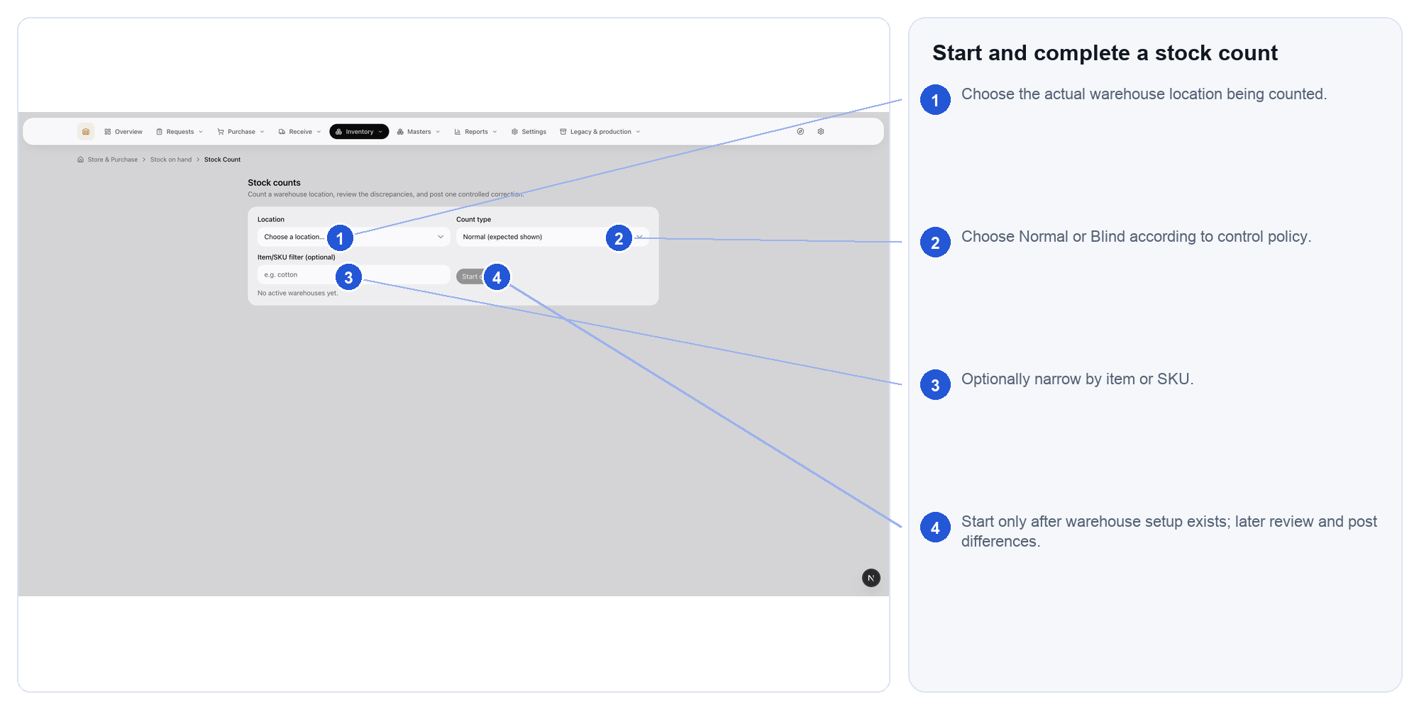
Steps: 1. Choose the actual warehouse location being counted. 2. Choose Normal or Blind according to control policy. 3. Optionally narrow by item or SKU. 4. Start only after warehouse setup exists; later review and post differences.
Expected result: Observations and approved corrections remain auditable.
If blocked: If warehouse structure is missing, ask an administrator to configure it before counting.

CARD 14 Investigate stock movement history
Open: Inventory > Stock movements
Use this when: You need to explain how an item's recorded quantity changed.
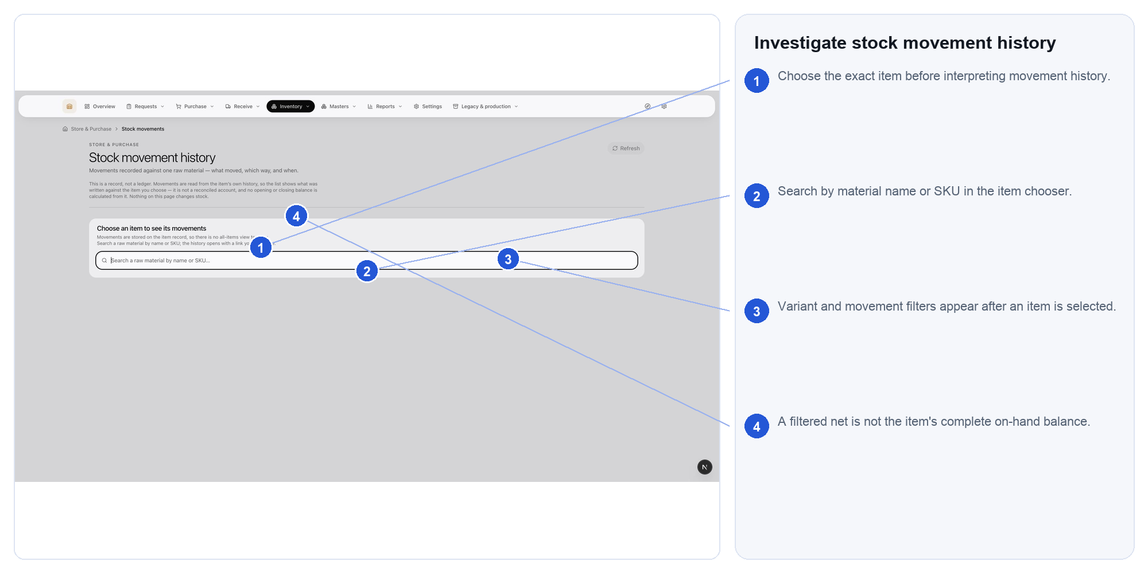
Steps: 1. Choose the exact item before interpreting movement history. 2. Search by material name or SKU in the item chooser. 3. Variant and movement filters appear after an item is selected. 4. A filtered net is not the item's complete on-hand balance.
Expected result: The source document and movement chain explain the quantity change.
If blocked: If the chain is suspicious, open the source record; never edit a posted movement.

CARD 15 Resolve stock exceptions
Open: Inventory > Stock exceptions
Use this when: The system reports a negative balance, placement mismatch or broken stock evidence chain.
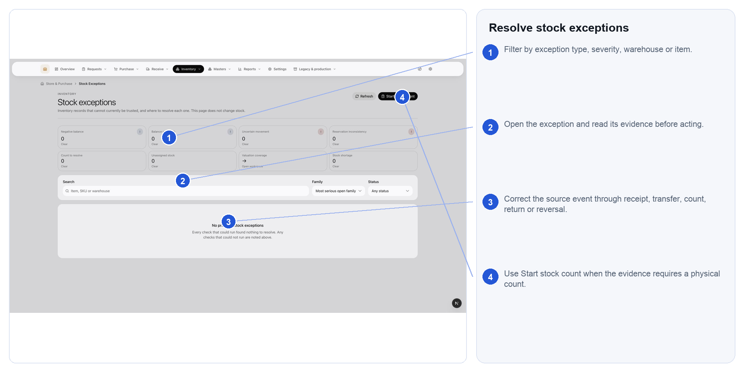
Steps: 1. Filter by exception type, severity, warehouse or item. 2. Open the exception and read its evidence before acting. 3. Correct the source event through receipt, transfer, count, return or reversal. 4. Use Start stock count when the evidence requires a physical count.
Expected result: The source condition is corrected without rewriting posted history.
If blocked: If evidence is insufficient, start a controlled physical count rather than clearing the warning.

CARD 16 Create traceable lot labels
Open: Inventory > Lot labels and barcodes
Use this when: A stored quantity needs a traceable printed label or barcode.
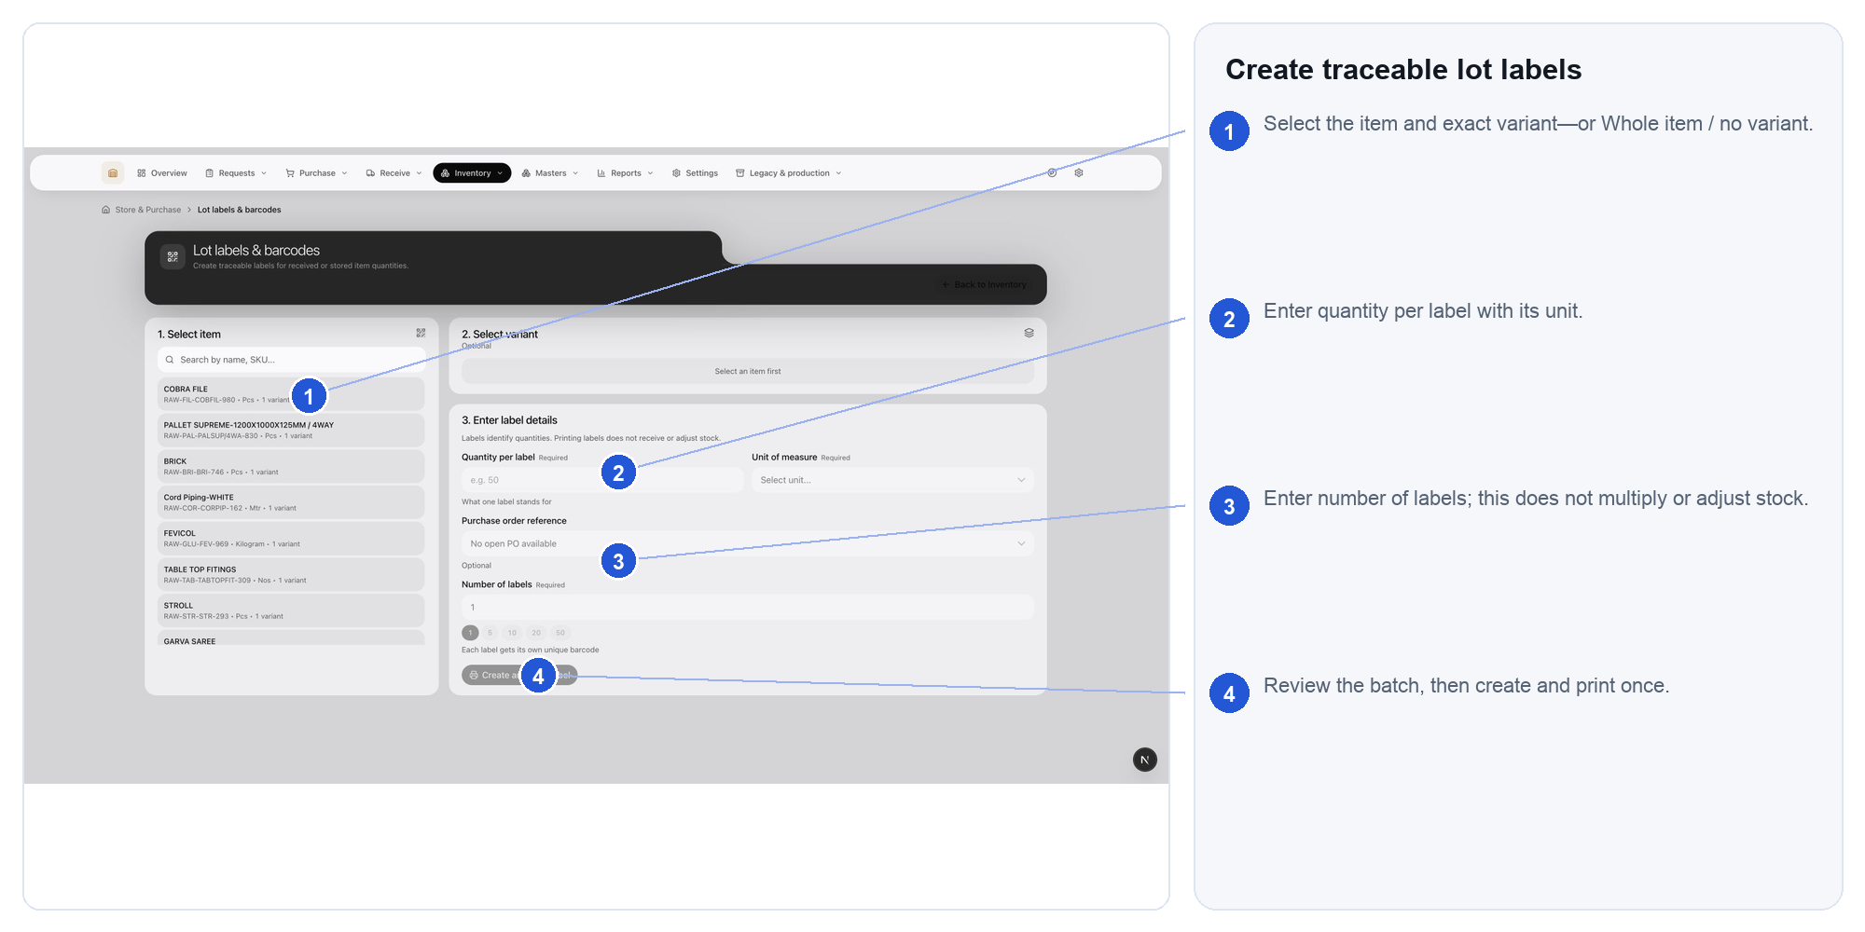
Steps: 1. Select the item and exact variant—or Whole item / no variant. 2. Enter quantity per label with its unit. 3. Enter number of labels; this does not multiply or adjust stock. 4. Review the batch, then create and print once.
Expected result: Each label identifies a real quantity without changing inventory.
If blocked: Reprinting does not create stock; if quantity is wrong, correct the underlying transaction.

CARD 17 Use the Materials register
Open: Masters > Materials
Use this when: You need to find or review a stock-tracked input item without changing its quantity.
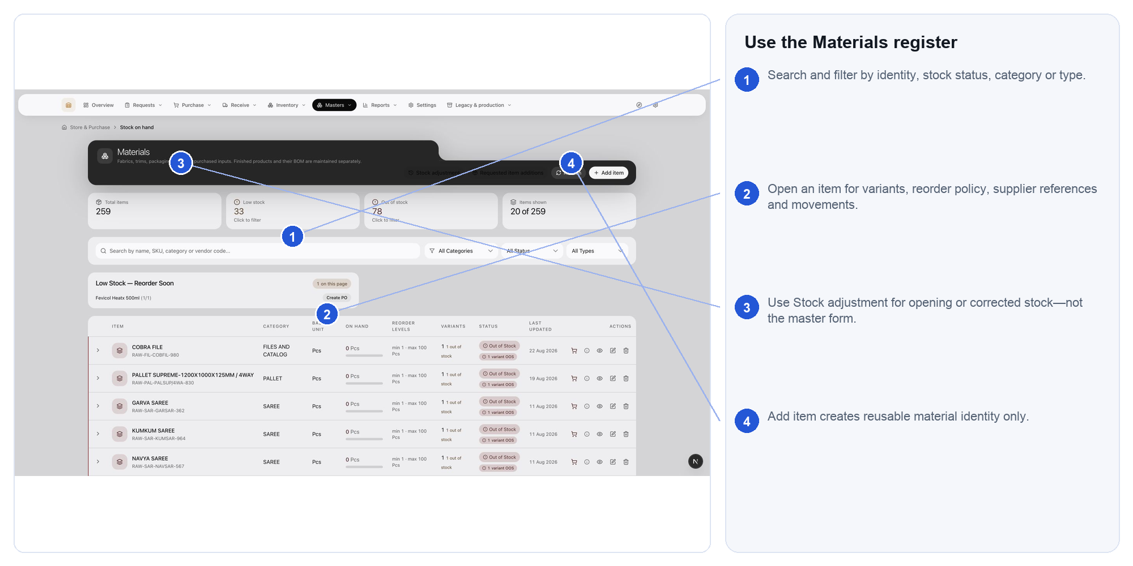
Steps: 1. Search and filter by identity, stock status, category or type. 2. Open an item for variants, reorder policy, supplier references and movements. 3. Use Stock adjustment for opening or corrected stock—not the master form. 4. Add item creates reusable material identity only.
Expected result: The existing material is found or a genuine master-data gap is confirmed.
If blocked: If an item looks similar, compare code, variant and base unit before creating another.

CARD 18 Create a material master record
Open: Masters > Materials > Add item
Use this when: A genuinely new reusable material identity is required and no duplicate exists.
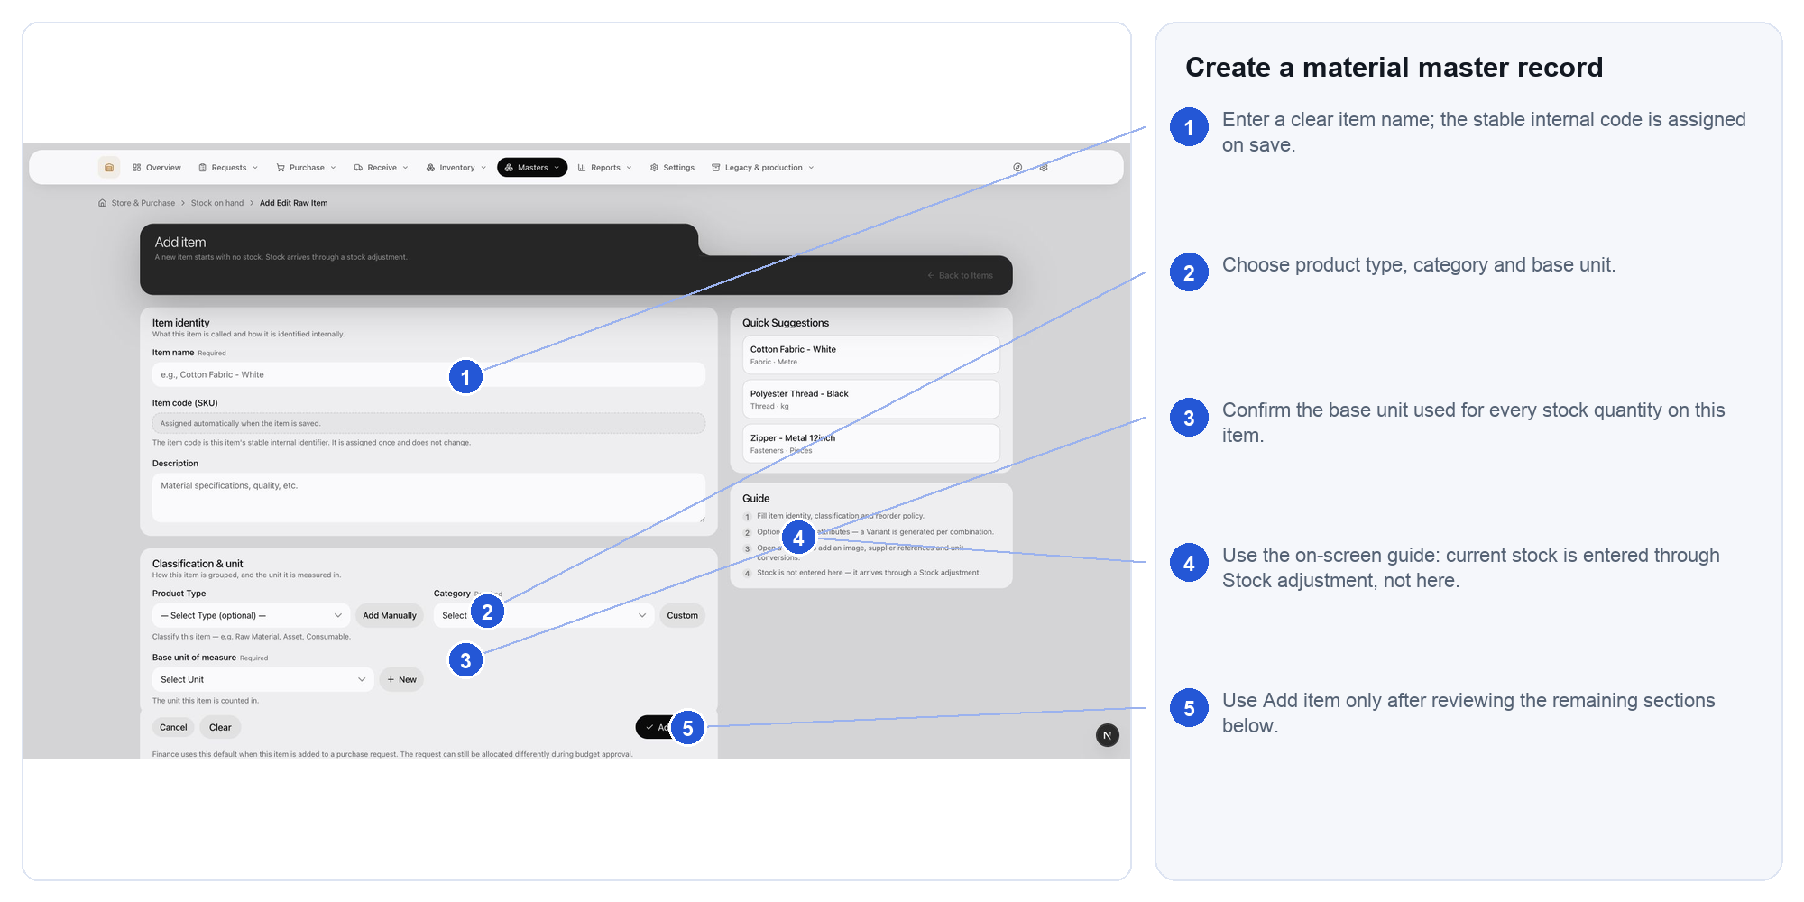
Steps: 1. Enter a clear item name; the stable internal code is assigned on save. 2. Choose product type, category and base unit. 3. Confirm the base unit used for every stock quantity on this item. 4. Use the on-screen guide: current stock is entered through Stock adjustment, not here. 5. Use Add item only after reviewing the remaining sections below.
Expected result: A stable material identity exists with no invented opening balance.
If blocked: If category, base unit or budget classification is uncertain, save nothing and ask the master-data owner.

CARD 19 Read finished products and BOM context
Open: Masters > Finished products and BOM
Use this when: You need production-owned finished-product identity or BOM context.
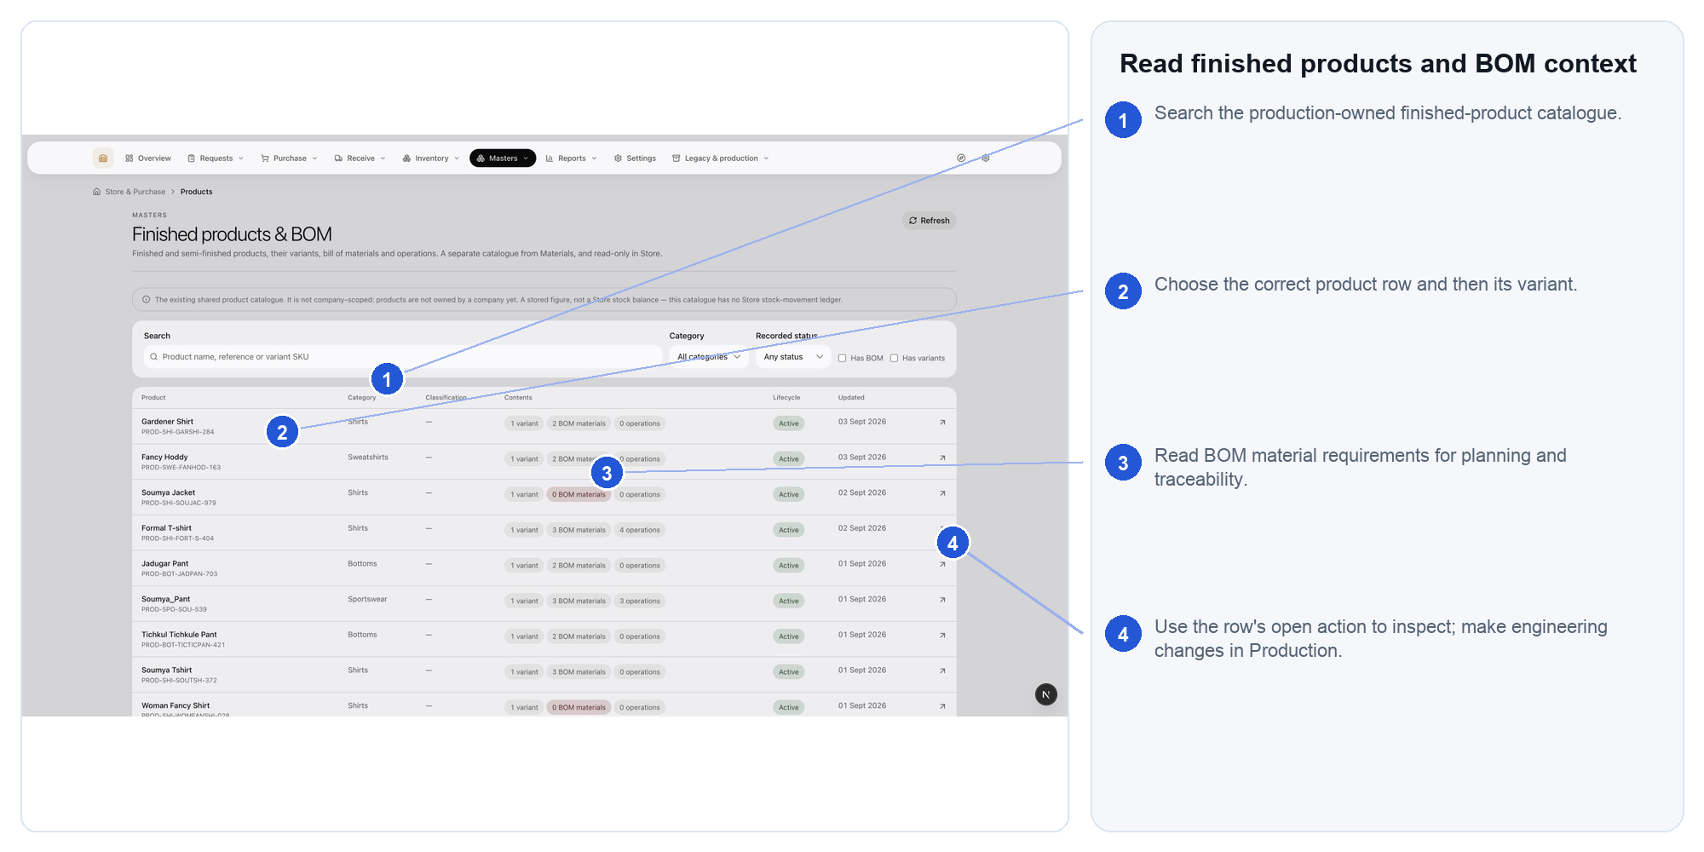
Steps: 1. Search the production-owned finished-product catalogue. 2. Choose the correct product row and then its variant. 3. Read BOM material requirements for planning and traceability. 4. Use the row's open action to inspect; make engineering changes in Production.
Expected result: The correct product and BOM are understood without duplicating production master data.
If blocked: Engineering changes belong in Production, not in the Store material master.

CARD 20 Maintain supplier identity
Open: Masters > Suppliers
Use this when: You need to find or maintain the legal and operational identity of a supplier.
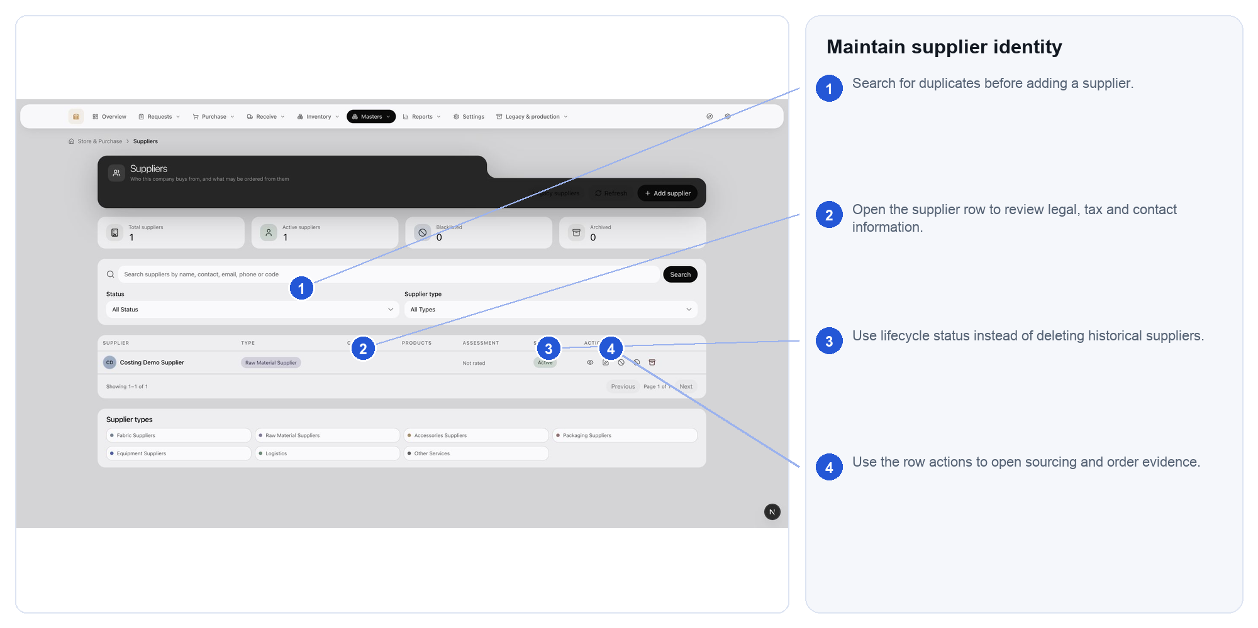
Steps: 1. Search for duplicates before adding a supplier. 2. Open the supplier row to review legal, tax and contact information. 3. Use lifecycle status instead of deleting historical suppliers. 4. Use the row actions to open sourcing and order evidence.
Expected result: Purchasing records refer to one controlled supplier identity.
If blocked: If a possible duplicate exists, resolve it before adding a new supplier.

CARD 21 Compare dated supplier offers
Open: Masters > Supplier offers
Use this when: A sourcing or costing decision needs dated commercial evidence from suppliers.
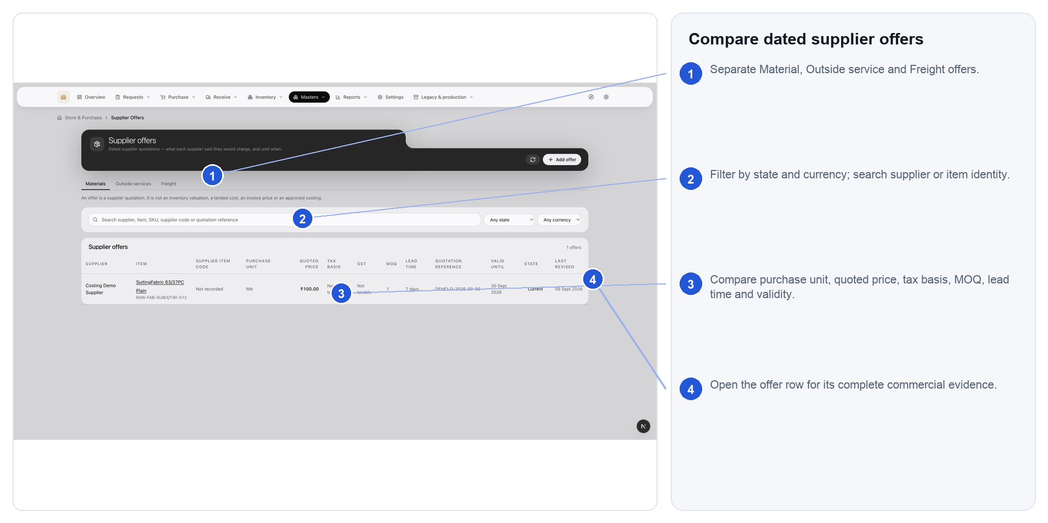
Steps: 1. Separate Material, Outside service and Freight offers. 2. Filter by state and currency; search supplier or item identity. 3. Compare purchase unit, quoted price, tax basis, MOQ, lead time and validity. 4. Open the offer row for its complete commercial evidence.
Expected result: The commercial decision is supported by comparable, current evidence.
If blocked: If validity or unit basis is missing, the offer is not comparable; obtain corrected evidence.

CARD 22 Record a supplier quotation
Open: Masters > Supplier offers > New offer
Use this when: A new quotation must be recorded against the exact supplier and item or service.
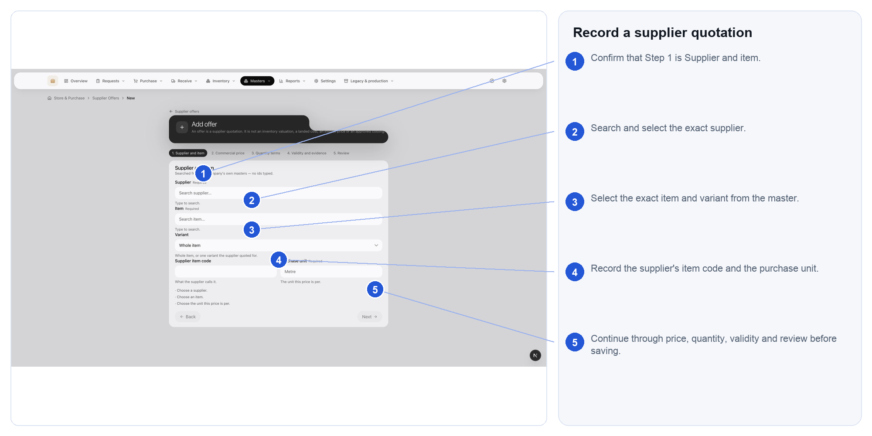
Steps: 1. Confirm that Step 1 is Supplier and item. 2. Search and select the exact supplier. 3. Select the exact item and variant from the master. 4. Record the supplier's item code and the purchase unit. 5. Continue through price, quantity, validity and review before saving.
Expected result: A dated and attributable quotation can support sourcing or costing.
If blocked: If supplier, currency, unit or validity is unknown, do not invent it.

CARD 23 Maintain units and conversions
Open: Masters > Units of measure
Use this when: A controlled unit or defensible conversion is missing from master data.
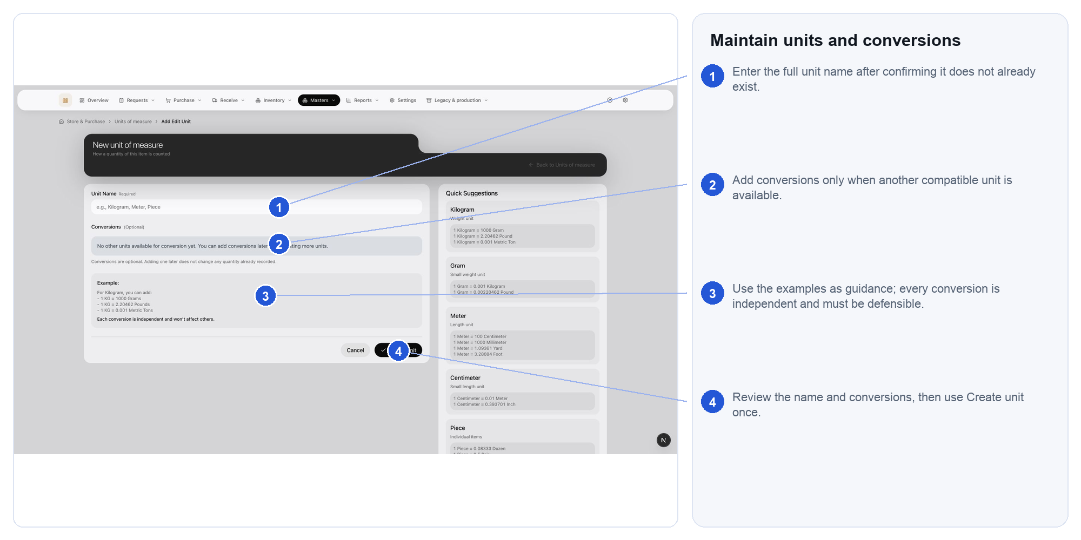
Steps: 1. Enter the full unit name after confirming it does not already exist. 2. Add conversions only when another compatible unit is available. 3. Use the examples as guidance; every conversion is independent and must be defensible. 4. Review the name and conversions, then use Create unit once.
Expected result: Quantities retain a valid and explainable measurement basis.
If blocked: If no valid conversion exists, add one only with defensible business evidence.

CARD 24 Review warehouses and operational locations
Open: Masters > Warehouses
Use this when: You need to review the company's physical facilities and operational locations.
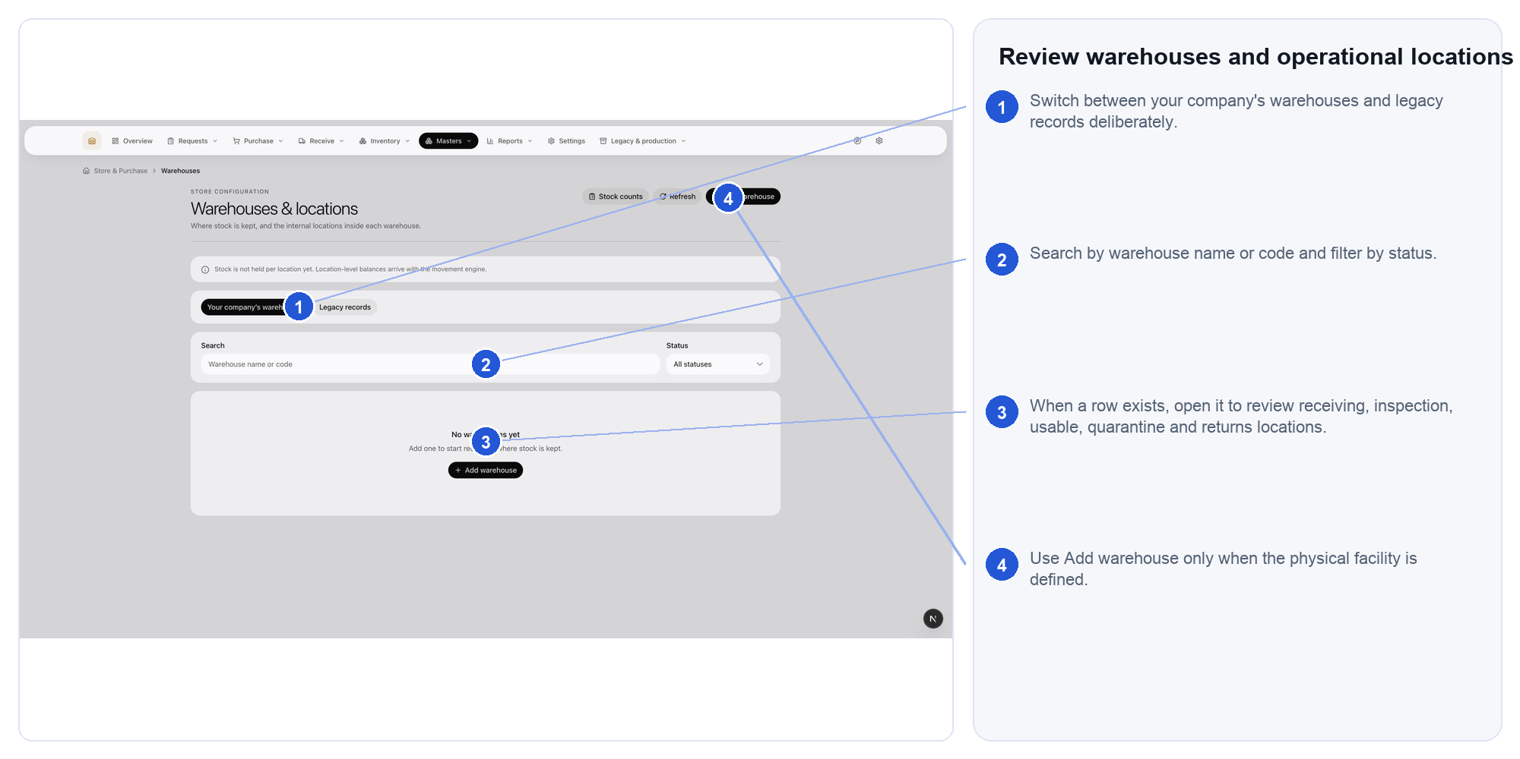
Steps: 1. Switch between your company's warehouses and legacy records deliberately. 2. Search by warehouse name or code and filter by status. 3. When a row exists, open it to review receiving, inspection, usable, quarantine and returns locations. 4. Use Add warehouse only when the physical facility is defined.
Expected result: Transactions can point to the place where stock physically exists.
If blocked: If a warehouse appears only under legacy records, ask the administrator before new use.

CARD 25 Create warehouse structure
Open: Masters > Warehouses > Add warehouse
Use this when: A real physical facility is ready to be represented in Store.
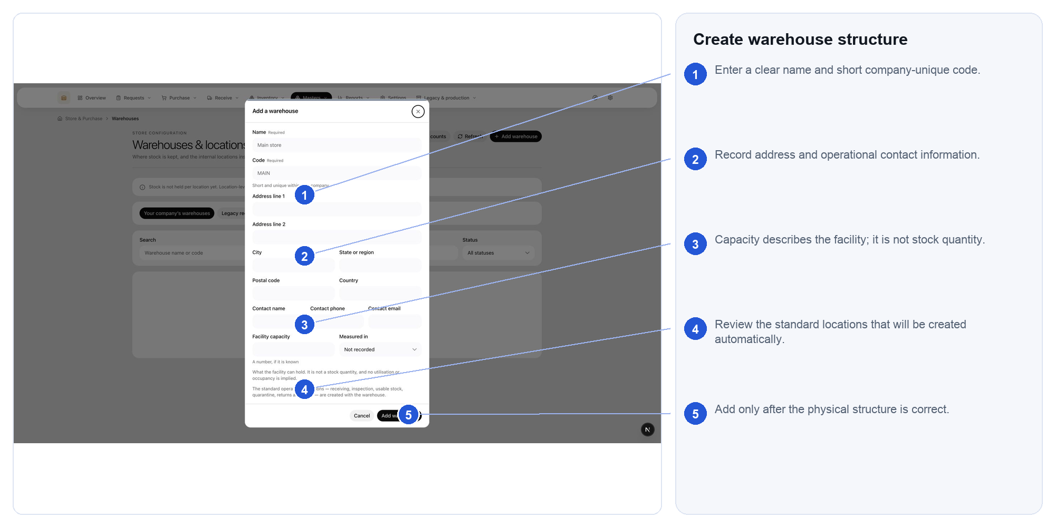
Steps: 1. Enter a clear name and short company-unique code. 2. Record address and operational contact information. 3. Capacity describes the facility; it is not stock quantity. 4. Review the standard locations that will be created automatically. 5. Add only after the physical structure is correct.
Expected result: The facility and its standard locations are ready for controlled use.
If blocked: Do not create a warehouse as a substitute for an internal bin or temporary stock state.

CARD 26 Trace demand in the material request register
Open: Reports > Request report
Use this when: You need to analyse demand, ageing or incomplete request fulfilment over a defined scope.
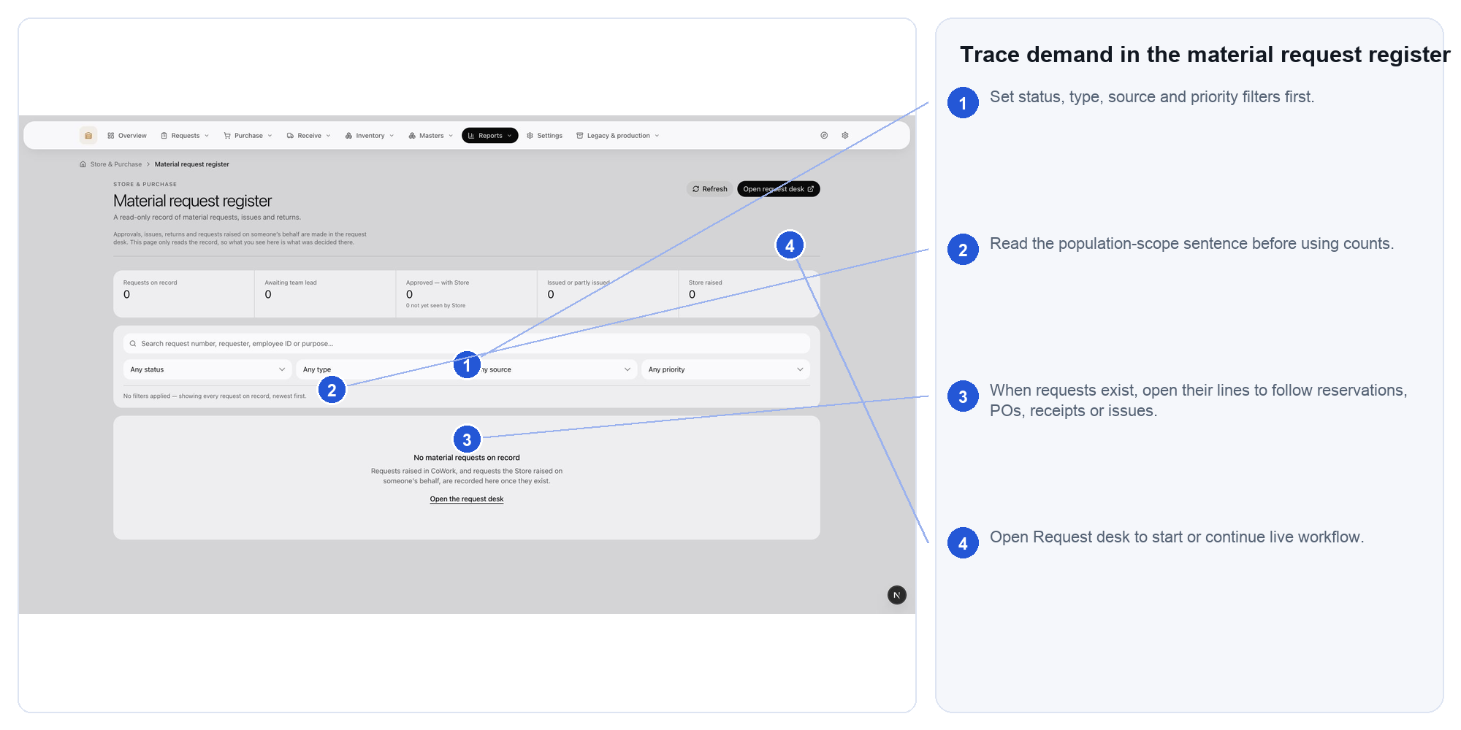
Steps: 1. Set status, type, source and priority filters first. 2. Read the population-scope sentence before using counts. 3. When requests exist, open their lines to follow reservations, POs, receipts or issues. 4. Open Request desk to start or continue live workflow.
Expected result: The result can be explained by its visible filters and source requests.
If blocked: If totals look unexpected, clear filters and read the population-scope sentence.

CARD 27 Use the movement report
Open: Reports > Movement report
Use this when: You need period-based movement activity or source-document reconciliation.
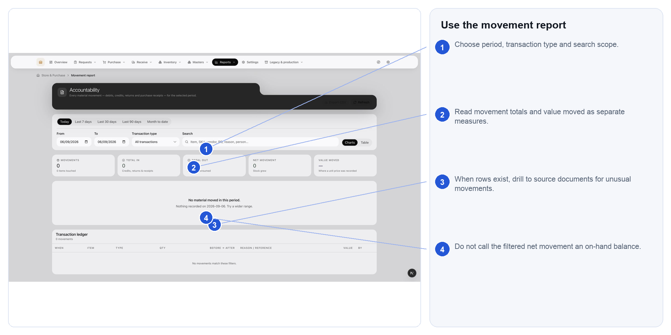
Steps: 1. Choose period, transaction type and search scope. 2. Read movement totals and value moved as separate measures. 3. When rows exist, drill to source documents for unusual movements. 4. Do not call the filtered net movement an on-hand balance.
Expected result: Movement activity is reconciled without combining unlike units.
If blocked: Do not treat filtered net movement as current on-hand stock.

CARD 28 Work the purchase exception queue
Open: Reports > Purchase exceptions
Use this when: Orders, receipts, bills or service records are overdue, mismatched or blocked.
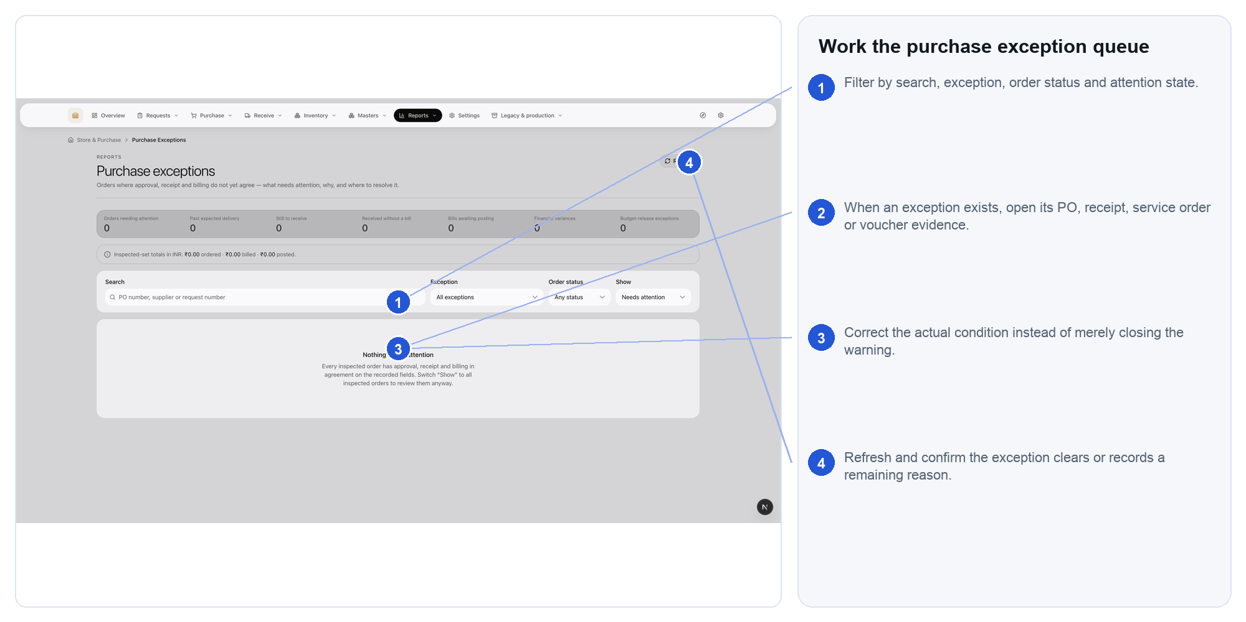
Steps: 1. Filter by search, exception, order status and attention state. 2. When an exception exists, open its PO, receipt, service order or voucher evidence. 3. Correct the actual condition instead of merely closing the warning. 4. Refresh and confirm the exception clears or records a remaining reason.
Expected result: The actual blocker has an owner and a verifiable resolution path.
If blocked: Correct the source record, then refresh; do not merely dismiss the symptom.

CARD 29 Review management inventory valuation
Open: Reports > Inventory valuation
Use this when: Management needs inventory value, evidence coverage and missing-cost visibility.
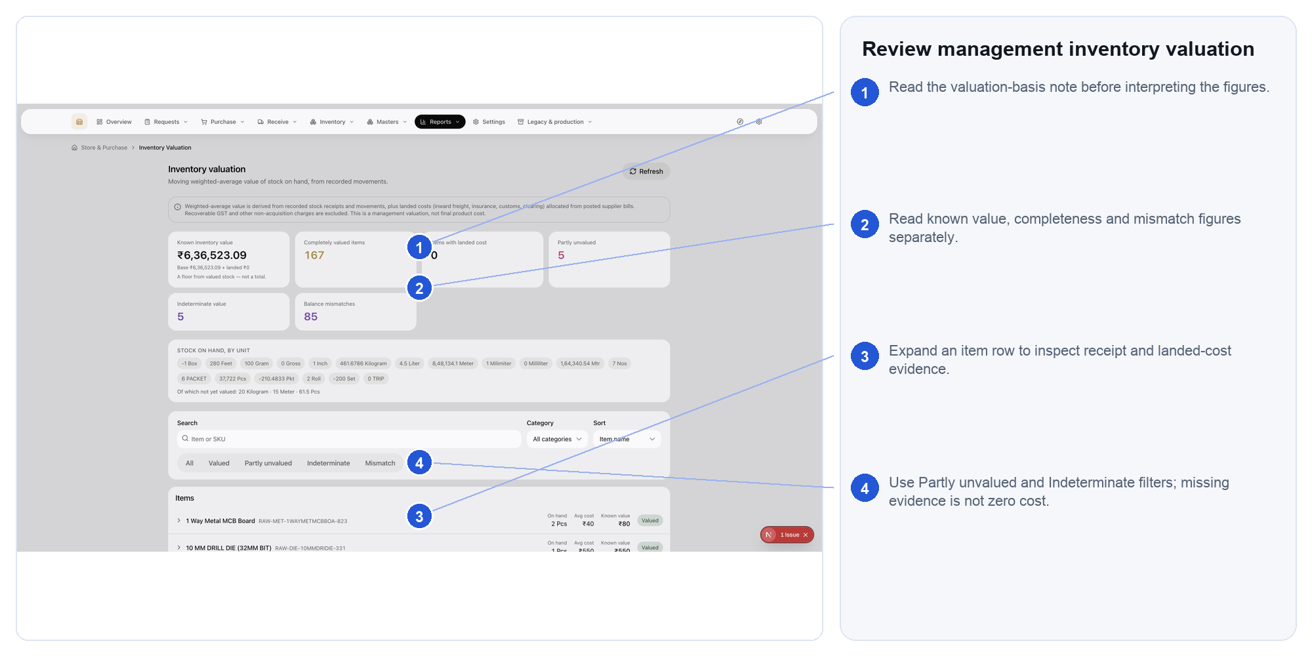
Steps: 1. Read the valuation-basis note before interpreting the figures. 2. Read known value, completeness and mismatch figures separately. 3. Expand an item row to inspect receipt and landed-cost evidence. 4. Use Partly unvalued and Indeterminate filters; missing evidence is not zero cost.
Expected result: Value is read together with method, coverage and limitations.
If blocked: Missing cost evidence is unknown, not zero; resolve receipt or landed-cost evidence.

CARD 30 Review Store operating settings
Open: Settings
Use this when: An administrator must change future Store document identity or operating defaults.
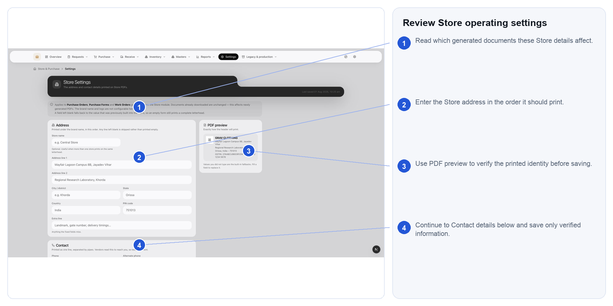
Steps: 1. Read which generated documents these Store details affect. 2. Enter the Store address in the order it should print. 3. Use PDF preview to verify the printed identity before saving. 4. Continue to Contact details below and save only verified information.
Expected result: The change is verified, documented and effective from a known point.
If blocked: If downstream document impact is unclear, do not save until Finance and Store owners agree.

CARD 31 Use legacy screens only for history
Open: Legacy and production > Purchase forms legacy
Use this when: Historical purchase-form evidence must be read; never use it to begin new work.
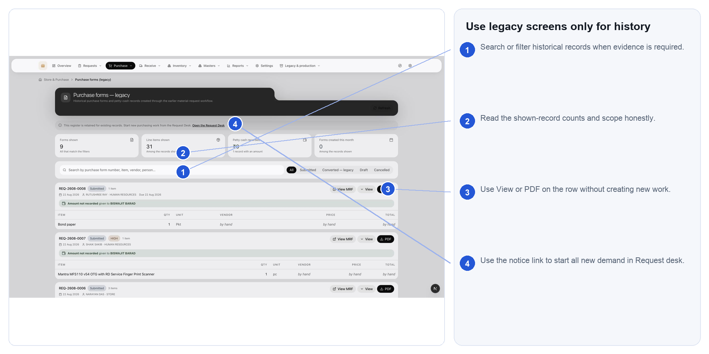
Steps: 1. Search or filter historical records when evidence is required. 2. Read the shown-record counts and scope honestly. 3. Use View or PDF on the row without creating new work. 4. Use the notice link to start all new demand in Request desk.
Expected result: Historical evidence remains readable while new work begins in Request desk.
If blocked: For new demand, leave this screen and use Request desk.

Problem to action
Search the exact words shown on screen. Do not repeatedly retry a refusal whose cause requires data, permission or another person's action.
Problem or message | What it usually means | What to do next
Nothing appears in a register | Filters, date scope, company scope or the wrong register may hide it. | Clear filters; search exact number; confirm status and owning register; refresh once.
Action is hidden | Your role, capability or the record's status does not permit it. | Confirm role and workflow state. Ask the owner; never use another login.
Staff record not linked | The sign-in can read some registers but cannot be named in an audited mutation. | Ask an administrator to link the account to the correct employee record.
Insufficient stock | Available usable stock is below the requested quantity. | Check reservations, location and variant; leave shortage visible or route to purchase.
Unit conversion missing | The requested and native units have no approved conversion. | Stop the transaction and ask the unit-master owner to add verified conversion evidence.
Item or variant not found | The request and master identities do not match. | Search code and variant; do not choose a similar name or create a duplicate casually.
Budget mapping unresolved | Finance has not mapped the item or service to a budget head. | Keep the commercial document in Draft and send the exact identity to Finance.
Budget unavailable | The mapped head does not have enough available budget or the check failed. | Do not bypass. Ask Budget or Finance to review allocation, period and commitment.
Receipt cannot be accepted | PO, quantity, inspection, unit or location evidence is incomplete. | Keep the receipt pending or quarantine the goods until the factual mismatch is resolved.
Service cannot be accepted | Completion evidence is missing or the requester disagrees. | Requester records rework required with a reason; Store does not create a GRN.

Problem to action continued
Problem or message | What it usually means | What to do next
Negative balance or stock exception | A source movement, placement or document chain needs investigation. | Open the exception, trace evidence, then correct by receipt, transfer, count, return or reversal.
Accepted stock has no location | Receipt exists but put-away is incomplete. | Use the receipt or put-away workflow; do not invent a warehouse on the movement.
Duplicate SKU or supplier | A similar master identity already exists. | Compare stable code, tax/legal identity, unit and lifecycle; merge or reactivate through the owner.
Valuation is partly unvalued | Some stock lacks sufficient receipt or cost evidence. | Expand affected items; repair receipt and landed-cost evidence. Unknown is not zero.
Totals differ after filtering | The screen is showing a selected population, not the whole company or balance. | Read the scope sentence and clear filters before reconciling totals.
Submit result is uncertain | The response may have been interrupted after the server acted. | Refresh and inspect status/history before resubmitting. Reuse retry only where the screen supports it.
Legacy record only | The evidence predates the current workflow or lacks current company structure. | Read it for history. Start all new demand in Request desk.
Page says retry but retry never helps | The refusal needs identity, master data, permission or another owner. | Capture the exact message and record number; send it to the owning team listed below.

Status words that matter
Area | Status | Employee meaning
Request | Pending approval | No fulfilment action should start yet.
Request | Approved | Store may classify and route lines according to authority.
Request | Reserved / Picked / Issued | Promised / physically staged / physically left Store - not interchangeable.
Purchase order | Draft | Editable preparation; not yet a supplier commitment.
Purchase order | Issued | Supplier-facing commitment; correct by supported amendment or cancellation.
Purchase order | Partly received / Completed | Some / all ordered physical quantities have valid receipt evidence.
Goods receipt | Pending inspection | Arrival recorded; quantity is not yet usable stock.
Goods receipt | Accepted / Quarantined / Rejected | Usable / isolated pending decision / not accepted into usable stock.
Service order | Completion reported | Supplier claims work is complete; requester must decide.
Service order | Accepted / Rework required | Requester accepts result / sends it back with a reason.
Stock count | Open / Posted / Cancelled | Counting in progress / approved differences recorded / no correction posted.
Valuation | Partly unvalued / Indeterminate | Some cost missing / evidence cannot support a reliable figure.

Who owns the next action
Issue | Primary owner | Send this evidence
Request purpose, quantity or approval | Requester or approver | Request number, line and required date
Item, variant, category or base unit | Material master owner | Item code, proposed correction and source evidence
Supplier identity or quotation | Buyer or sourcing | Supplier, offer date, currency, unit and validity
Budget head or availability | Budget or Finance | Request/PO, item or service identity, amount and period
Receipt quantity or condition | Store receiver | PO, receipt, line, physical count, photos where relevant
Warehouse or location | Inventory controller or administrator | Warehouse, location, item and physical position
Service result | Requester | Service order, completion evidence and rework reason
Supplier voucher, tax or payment | Accounting | PO/service order, receipt/acceptance, invoice and charge details
Role or staff-account link | Administrator or HR | Sign-in email, employee identity and required role
System error | Application support | Exact message, page, record number, time and what happened before it

Minimum escalation message
State: I was on [page], working on [record number]. I selected [action]. The system showed [exact message] at [time]. I refreshed once and confirmed [current status]. No further submission was made.

Use the full handbook when
- You are onboarding to a role rather than completing one immediate task.
- A cross-application question involves Budget, Accounting, Production or costing policy.
- An unusual historical, audit, correction or reconciliation case is not covered by a task card.

