**Iliushchenko Dmytro**

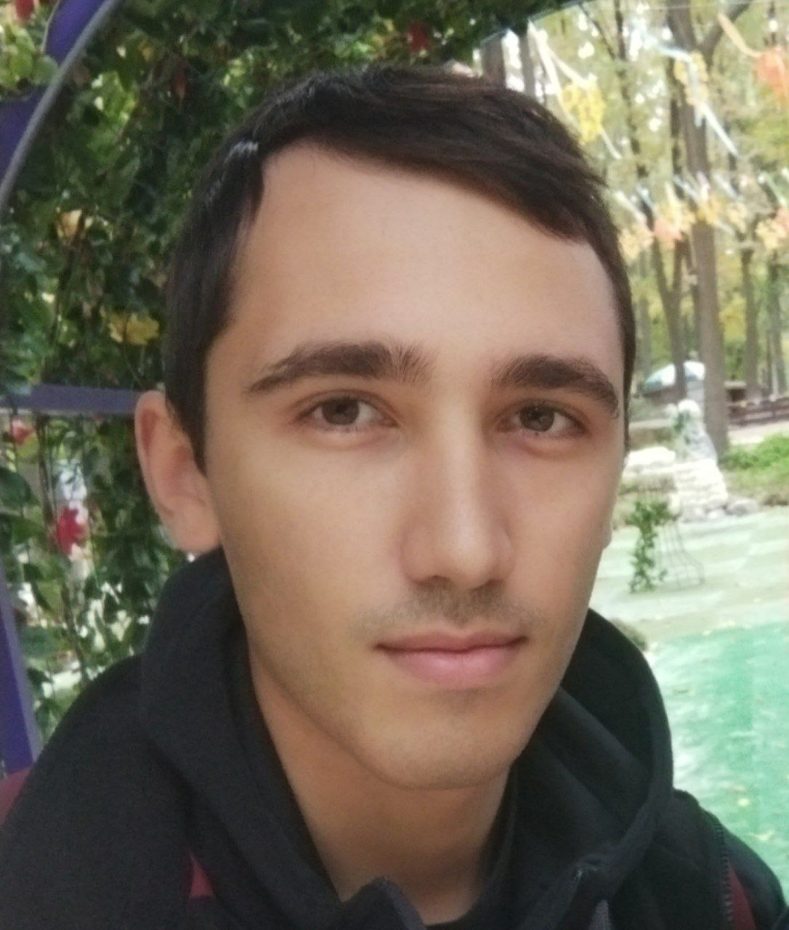

**Junior Front-end developer**

Date of birth: 19, April, 1997р  
Phone: +38(095)407-43-70  
Telegram: @itdmytro  
Gmail: [d.v.ilyushchenko@gmail.com](mailto:d.v.ilyushchenko@gmail.com)  
Github: itdmytro  
Lives: Kharkiv, Ukraine  
 (temp. at Poltava, Ukraine)

**Skills:**– HTML, CSS flex, SVG  
– JS  
– Responsive layout  
– Git

**Instruments:**– VS Code, Sublime  
– Web inspector  
– Figma, Zeplin  
– Photoshop  
– Github

**Additional skills:**  
– 1С, ArchiCad, 3DsMax, MS Office  
– Languages: English Pre-Intermediate, Ukranian (native)

**Education:**

***05.2022 – 09.2022: HTML&CSS course***  
[Drawitnow.online](http://drawitnow.online)  
 In this course, I made 5 projects and mastered HTML-markup, CSS-rules and tricks, code optimization and acquired team-work skills (git).

***06.2022 – present: JS, self-learn*** Learned JS theory and practical use in web development. The training was in the form of lectures and homework.

***04.2022 – 05.2022: “PRO Copywriting” course***  
 Learn to content-analyze and create marketing texts for landingpages, work accounts, etc.

***09.2013 – 07.2017: «Kharkiv College of Construction, Architecture and Design».  
«Equipment of buildings and structures and building design»***

**Experience**:

***2022: Course website development (Drawitnow.online)*** I worked on the team that created the landing page for the course. I laid out the blocks and created the basic styles, programmed the form validation (JS) and connected the PHP form processing plugin; worked with git; performed code reviews of other team members and code testing.

***07.2020 – present:*** ***Warehouse manager, «Chudo-Market»*** I worked as a warehouse manager in several stores of the Chudo-Market supermarket chain. I had up to 7 people under my command. Organized the work process, planned tasks and work schedules, adjusting them depending on the instructions of the management. I established contact with employees at all shopping complexes; good relations remained with the majority of colleagues.

***01.2020 – 06.2020:*** ***Video surveillance operator, Pharmacy "911"*** At my workplace, I carried out video surveillance of pharmacy outlets (up to 15 at the same time). Analyzed customer service for compliance with regulations and prepared reports in case of violations. Sharpened attention to detail, speed of reaction, attentiveness and perseverance (11-hour shifts).

***08.2017 – 12.2020: Freelacne (Copywriting, interior design)*** I independently searched for orders, selected and analyzed information, and planned the schedule. During the implementation of design projects, I conducted negotiations with customers and representatives of construction companies.

**Additional information:**

***Soft skills:***Teamwork, determination, diligence, responsibility, desire to acquire new knowledge.

***Hobbies:***Football, volleyball, fishing, driving, films

Driver's license category B

Marital status: married