SSD2828QN4
MIPI Master Bridge
RGB / SPI → MIPI DSI 橋接晶片
規格書文件版（Word）

原廠文件 | C48596_其他接口_SSD2828QN4R_规格书_WJ73954.PDF
文件版本 | Rev 1.3 · Mar 2013
原廠 | Solomon Systech Limited (Solomon Systech Semiconductor)
原始頁數 | 168 頁
轉換日期 | 2026-10-25
文件用途 | 供閱讀、搜尋、標註與技術筆記使用

使用說明（轉換說明）
▍ 這份文件是什麼
本文件由原廠 168 頁 PDF 規格書自動轉換、重排而成，目的是讓內容可以搜尋、複製、標註與編輯。文字、表格與圖片都取自原始 PDF，未改動技術內容。
▍ 內容完整性
第 1～18 章（含附錄 1 修訂記錄）全部保留，依原始章節順序排列。原始 PDF 的封面與目錄頁不重複收錄，改以下方的 Word 自動目錄取代。
▍ 表格
原本的表格已轉為 Word 表格，可直接編輯、複製到其他文件，或用 Excel 開啟後做計算。少數跨頁表格在轉換後會接續成同一個表格。
▍ 圖片
所有方塊圖、時序圖、波形圖皆以原圖裁切嵌入（200 dpi）。圖片中的線條、顏色與標註與原 PDF 相同。
▍ 已知差異
1) 部分原圖中的極小字（例如波形上的 T 標記）受限於原始解析度，清晰度略低於原 PDF；2) 表格框線與底色做了簡化統一；3) 上/下標（如 t_PCLK）在正文中保留為下標格式，但無法保證每一處都與原稿一致。遇到需要引用原文的場合，請以原 PDF 為準。
▍ 章節 ↔ 原始頁碼
本文件末尾附有「章節與原 PDF 頁碼對照表」，方便回頭查閱原 PDF。

目錄
（在 Word 中按 F9 或「更新功能變數」即可產生目錄；開啟文件時 Word 也會詢問是否更新。）

中文重點導讀
以下為依原始規格書內容整理的繁體中文摘要，方便快速掌握重點；技術細節與數值仍請以本文後續章節（原廠原文）為準。

一、晶片定位與用途
SSD2828QN4 是一顆 MIPI Master Bridge 橋接晶片：一邊接應用處理器（AP）的傳統並列 RGB 介面或序列 SPI 介面，另一邊以 MIPI DSI 驅動內建 MIPI slave 介面的 LCD driver IC。常見用途是把只有 RGB/SPI 輸出的 SoC，接到只吃 MIPI DSI 的面板上（第 1 章、第 4 章）。
支援兩種輸入介面，可由 PS[1:0] 腳位選擇：
• 並列 RGB（DPI-2.0），資料匯流排可為 16/18/24-bit
• 序列 SPI（DBI-2.0），支援 8-bit 4-wire、8-bit 3-wire、24-bit 3-wire 三種模式
輸出端為 MIPI DSI，最多 4 條 data lane + 1 條 clock lane，每 lane 最高 1Gbps（合計 4Gbps）。

二、主要規格（第 2 章）
項目 | 規格
序列連結總頻寬 | 最高 4Gbps（最多 4 data lanes，每 lane 1Gbps）
RGB 介面 | 並列 RGB / DPI-2.0，最高 24-bit
SPI 介面 | 序列 SPI / DBI-2.0，最高 16-bit
MIPI 標準 | DSI v1.01.00、DCS v1.02.00、D-PHY v1.00.00
最高解析度 | 1920 pixels/row @ 60Hz（Video mode）；2560 pixels/row @ 30Hz
像素格式 | 16 / 18 / 24 bpp（Raw 或 Pixel mode）
電源 | MVDD 1.2V ±10%（類比/數位核心與 PLL）；VDDIO 1.8～3.3V ±10%（IO）
其他功能 | 內建可變輸出 PLL、CABC、ULPS 超低功耗、雙向資料傳輸、TE 同步
封裝 | 68 QFN-EP（Tray 包裝）；型號 SSD2828QN4

三、腳位分組（第 6～7 章）
68 腳 QFN-EP。下表為功能分組摘要，完整腳號對照請見 Table 6-2，詳細功能說明見 Table 7-1～7-3。
群組 | 主要腳位 | 說明
電源 | MVDD、VDDIO、GND | MVDD 1.2V；VDDIO 1.8～3.3V；68 腳中 GND 佔多腳
MIPI 輸出 | CLKP/CLKN、DATAP0～3/DATAN0～3 | DSI_0 差動時脈與資料通道
RGB 輸入 | DATA0～DATA23、PCLK、DEN、HSYNC、VSYNC | 並列 RGB（DPI-2.0）
SPI 輸入 | SCK、SDI、SDO、SDC、CSX0 | 3-wire / 4-wire 序列介面
介面選擇 | PS0、PS1 | 選擇 RGB 或 SPI 介面組合
時脈 | TX_CLK_XIN、TX_CLK_XIO、SYS_CLK_OUT | 外部參考時脈輸入 / 系統時脈輸出
控制與重置 | RESET、SHUT | 重置與關閉
其他 | NC ×3 | 未接腳

四、暫存器速查（第 8 章）
SSD2828 全部功能都由暫存器設定。透過 SPI 介面以「指令 + 資料」方式存取，位址即 Table 8-1 的 Offset 欄。各暫存器的位元定義請見 8.1.1～8.1.67 各節（每節：先給 bit map，再給 description 表）。
共 66 個暫存器（Offset 0xB0～0xDD）。以下為完整位址、助憶符號、名稱與重置值速查；個別位元欄位請點回對應的 8.1.x 節。
Offset | Mnemonic | Reset | Offset | Mnemonic | Reset
0xB0 | DIR | 0x2828 | 0xD2 | LRTR2 | 0x0010
0xB1 | VICR1 | 0x020A | 0xD3 | TSR | 0x0000
0xB2 | VICR2 | 0x0214 | 0xD4 | LRR | 0x00FA
0xB3 | VICR3 | 0x0428 | 0xD5 | PLLR | 0x1450
0xB4 | VICR4 | 0x0780 | 0xD6 | TR | 0x0005
0xB5 | VICR5 | 0x0438 | 0xD7 | TECR | 0x0001
0xB6 | VICR6 | 0x0024 | 0xD8 | ACR1 | 0x2020
0xB7 | CFGR | 0x0301 | 0xD9 | ACR2 | 0x64A0
0xB8 | VCR | 0x0045 | 0xDA | ACR3 | 0x99A4
0xB9 | PCR | 0x0000 | 0xDB | ACR4 | 0x8098
0xBA | PLCR | 0x8120 | 0xDC | IOCR | 0x0000
0xBB | CCR | 0x0003 | 0xDD | VICR7 | 0x0000
0xBC | PSCR1 | 0x0000 | 0xDE | LCFR | 0x0000
0xBD | PSCR2 | 0x0000 | 0xDF | DAR7 | 0x0010
0xBE | PSCR3 | 0x0100 | 0xE0 | PUCR1 | 0x5556
0xBF | PDR | 0x0000 | 0xE1 | PUCR2 | 0x6656
0xC0 | OCR | 0x0000 | 0xE2 | PUCR3 | 0x0159
0xC1 | MRSR | 0x0001 | 0xE9 | CBCR1 | 0x0000
0xC2 | RDCR | 0x0000 | 0xEA | CBCR2 | 0x6900
0xC3 | ARSR | 0x0000 | 0xEB | CBSR | 0x0000
0xC4 | LCR | 0x0000 | 0xEC | ECR | 0x7800
0xC5 | ICR | 0x0080 | 0xED | VSDR | 0x0002
0xC6 | ISR | 0xCF06 | 0xEE | TMR | 0x0000
0xC7 | ESR | 0x0000 | 0xEF | GPIO1 | 0x0000
0xC9 | DAR1 | 0x1402 | 0xF0 | GPIO2 | 0x0000
0xCA | DAR2 | 0x2803 | 0xF1 | DLYA01 | 0x2020
0xCB | DAR3 | 0x0416 | 0xF2 | DLYA23 | 0x2020
0xCC | DAR4 | 0x0A0A | 0xF3 | DLYB01 | 0x2020
0xCD | DAR5 | 0x1000 | 0xF4 | DLYB23 | 0x2020
0xCE | DAR6 | 0x0405 | 0xF5 | DLYC01 | 0x2020
0xCF | HTTR1 | 0x0000 | 0xF6 | DLYC23 | 0x2020
0xD0 | HTTR2 | 0x0010 | 0xF7 | ACR5 | 0x0000
0xD1 | LRTR1 | 0x0000 | 0xFF | RR | 0x0000

五、上電初始化順序（第 15 章）
原廠的 power up sequence 圖（第 15 章）重點如下，各步驟之間的間隔時間見圖上標註：
順序 | 動作 | 備註
1 | VDDIO（VDDIOC / MAVDDV）上電 | 電源時序的第一個
2 | MVDD（VCC12A / MDVDD / MAVDD）上電 | 在原圖中緊接 VDDIO/MAVDDV 之後
3 | 放開 RESB（重置） | 重置釋放後才能存取暫存器
4 | 提供 TX_CLK | 外部參考時脈
5 | 透過輸入介面（SPI）下指令：PEN=1 開 PLL | 例：0xB9 = 0x0001（PLL ON）
6 | 離開 ULP 模式 | 例：0xB7 = 0x0300
7 | SLP=0、VEN&HS=1，進入 Video mode | 例：0xB7 = 0x0309（Video mode ON）
8 | 送 RGB 訊號 | 最後才讓 RGB 訊號有效
對應的關機（power off）順序見第 16 章；休眠進出（sleep in/out）的時序範例見第 17 章。

六、章節導覽：想找什麼看哪裡
需求 | 章節 | 原 PDF 頁
這是什麼晶片、有哪些功能 | 1. General Description、2. Features | 9–10
接腳定義與腳位功能 | 6. Pin Assignment、7. Pin Description | 18–22
暫存器位址與每個 bit 的意義 | 8. Command Table（8.1.x 各節） | 23–101
RGB 時序參數（HSA/HBP/HFP 等） | 8.1.2～8.1.8、9.3 Operating Modes | 26–33、102 起
PLL 倍率怎麼設、MIPI 速率怎麼算 | 8.1.10～8.1.12、9.4（Table 9-10～9-12） | 36–38、123–124
MIPI DSI 封包結構與資料順序 | 9.2（Packet、Data Type、Endian） | 115–121
SPI 介面怎麼下指令（3-wire/4-wire） | 10. SPI Interface | 139–148
電氣規格（電壓、電流、驅動能力） | 11～13. Ratings / DC Characteristics | 149–153
時序規格（SPI、RGB、Reset、TX_CLK） | 14. AC Characteristics | 154–158
上電 / 關機 / 休眠順序 | 15～17 | 159–161
封裝尺寸、絲印、Tray 資訊 | 18. Package / 附錄 | 165–168

Appendix 1 IC Revision history of SSD2828 Specification
Version | Change Items | Effective Date
1.0 | Initial release of Advance Information | 16-Oct-12
1.1 | - Modify the description of END and CO (Section 8.1.38)  - Modify the timing for data latch in RGB timing (Section 14.4) | 13-Dec-12
1.2 | - Specify the prefix T in RGB timing (Section14.4) | 09-Jan-13
1.3 | - Modify RGB color arrangement (Table 6-3)  - Update power up and power down sequence (Section 15 & Section 16)  - Include current consumption of using VDDIO=3.3V (Section 13) | 27-Mar-13

1 GENERAL DESCRIPTION
The SSD2828 IC is an MIPI master bridge chip that connects an application processor with traditional parallel LCD interface and an LCD driver with MIPI slave interface. The 2828 supports up to 1Gbps per lane speed with maximum 4 lanes using both parallel RGB interface and serial SPI interface.

2 FEATURES
• Support up to total of 4Gbps over the serial link
• Support up to 4 data lanes
• Number of signals is significantly reduced when compare to traditional RGB transfer
• Support up to 1920 pixels per display row in Video mode, up to 60hz refresh rate
• Support up to 2560 pixels per display row in Video mode, up to 30hz refresh rate
• Reduce power consumption and decrease EMI by using low amplitude signal over differential pair for serial data.
• Support parallel RGB interface (DPI 2.0) up to 24-bits
• Support serial SPI interface (DBI 2.0) up to 16-bits
• Support both command mode and video mode in MIPI DSI standard
• Support 16, 18 and 24-bit per pixel in Raw or Pixel mode for command mode transfer
• Support independent bi-directional data transfer (forward link in High Speed and Low Power mode and reverse link in Low Power mode) for each DSI
• Support Ultra low power mode in idle state for each DSI
• Support CABC function for Video mode
• On-chip PLL with variable output frequency
• MIPI analog and digital power supply: (MVDD) 1.2V +/-10%
• IO Power supply: (VDDIO) 1.8 ~ 3.3V +/-10%
• Support of MIPI standard DSI(v1.01.00), DCS(v1.02.00), D-PHY (v1.00.00)

2.1 References
• MIPI Alliance Standard for Display Serial Interface, version 1.01
• MIPI Alliance Standard for Display Command Set, version 1.02
• MIPI Alliance Standard for D-PHY, version 1.00
• MIPI Alliance Standard for Display Bus Interface, version 2.0
• MIPI Alliance Standard for Display Pixel Interface, version 2.0

2.2 Definitions
• HS High Speed
• SPI Type C interface option 1 of MIPI Alliance Standard for Display Bus Interface v2.0 (DBI-2)
• LP Low Power
• ULPS Ultra Low Power State
• RGB MIPI Alliance Standard for Display Pixel Interface v2.0 (DPI-2)
• VC Virtual Channel

3 ORDERING INFORMATION
Table 3-1：Ordering Information
 | rdering Part Number |  |  | Package Form
SSD2828QN4 |  |  | 68 QFN-EP (in Tray form)

4 BLOCK DIAGRAM
Figure 4-1：Overview of display system using SSD2828
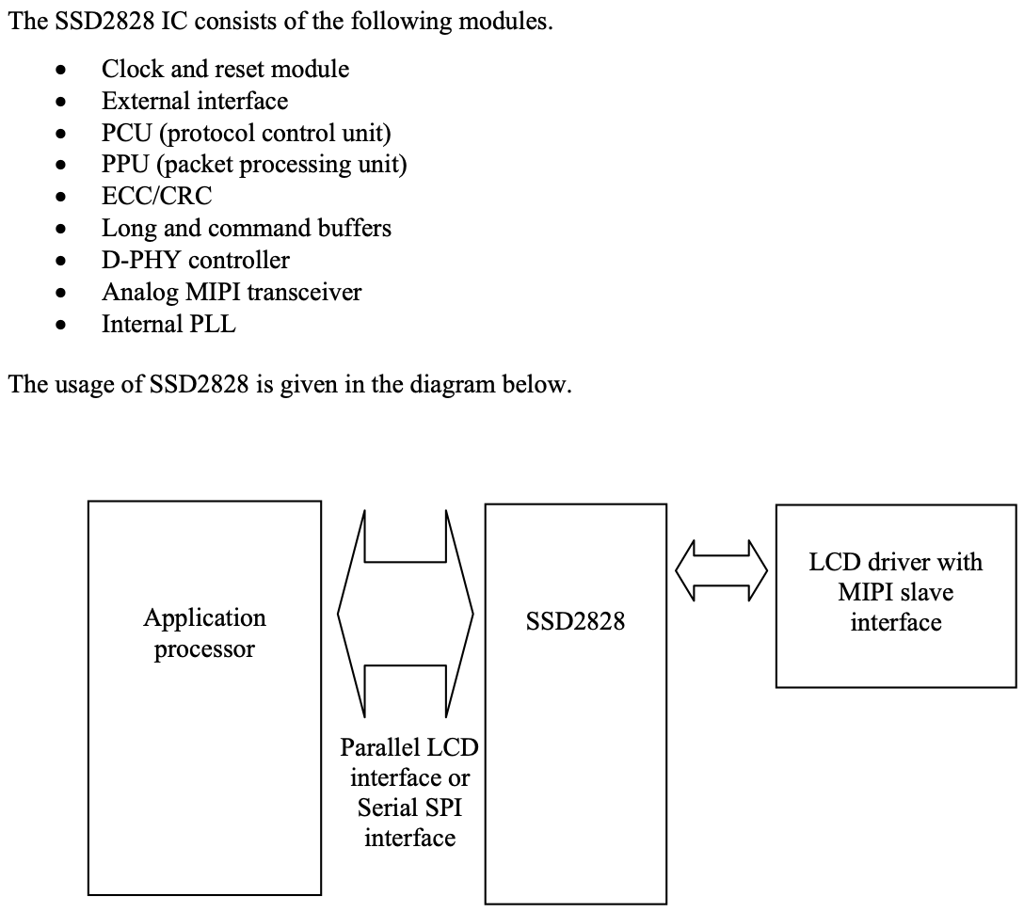
Below is the interface diagram for the SSD2828 driving MIPI slave panel. Three types of interface are supported which are RGB and SPI interfaces. The interfaces can be selected through ps[1:0] pins.
Figure 4-2：SSD2828 Interface Diagram
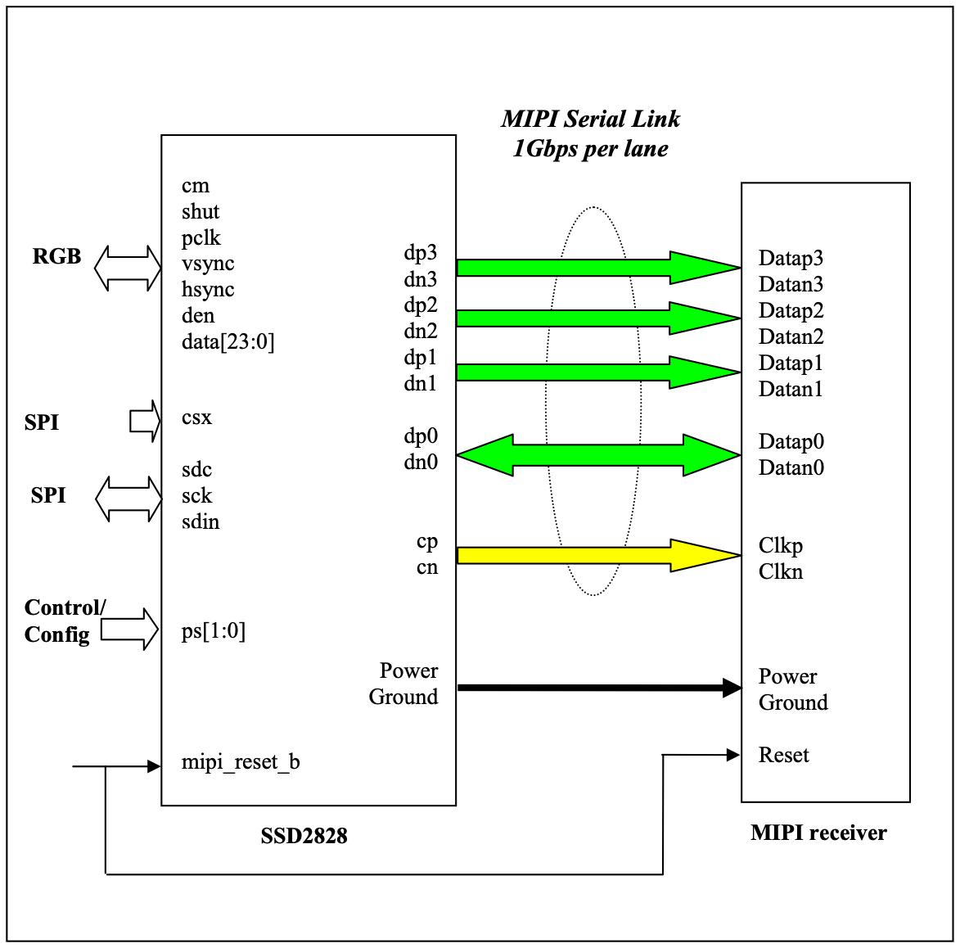
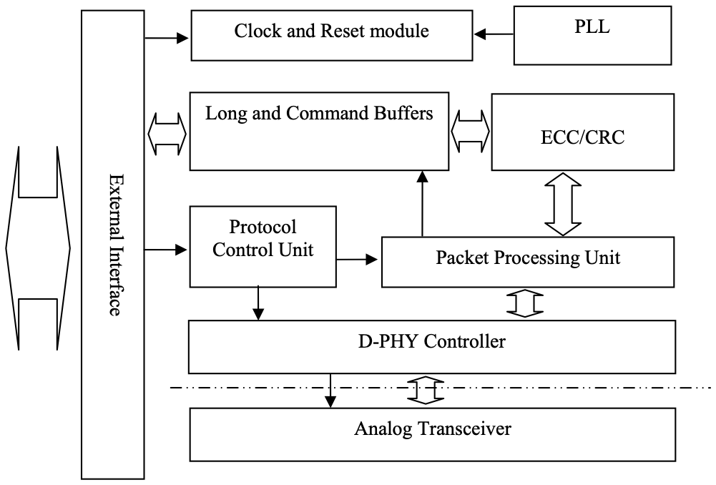
Figure 4-3：Block Diagram

5 FUNCTIONAL DESCRIPTION

5.1 Functional Blocks

5.2 Clock and Reset Module
The clock and reset module controls the generation of the operation clock for the whole system. There are two reference clock sources for the PLL. One is from the tx_clk and the other is from the pclk. The application processor can choose the reference clock for the PLL by program the CSS. The PLL output clock is used to generate the clock and data on the serial link during HS mode. The PLL frequency is the same as the data rate on 1 data lane. Hence, the PLL needs to be programmed according to the HS speed. Please refer to 9.3.5 for how to program the PLL.
NOTE: The default value of the CSS is 0 which selects the tx_clk. Hence, after power up, tx_clk must be present so that the registers can be programmed. If the application processor wants to switch the clock source, tx_clk must be provided first so that the CSS field can be programmed. After the CSS is programmed, the tx_clk can be turned off.
After powering up, the PLL is in sleep mode. The host needs to program the PLL setting before enable the PLL. If the host needs to switch the clock source of the PLL, it needs to put the PLL into sleep mode first. Afterwards, the host needs to program the PLL with new setting and enable the PLL. In both cases, the PLL needs a certain amount of time to lock the output clock frequency after being enabled. Hence, when the PLL is in sleep mode or when the PLL is enabled but not locked, the whole system is operating using the reference clock. After the PLL gets locked, the system is operating using the PLL output clock. Please see the diagram below for detailed clocking scheme. Since the reference clock is much slower than the PLL output clock, the host needs to operate at low speed too, before the PLL gets locked. Please refer to 14 for the requirement of low speed and normal speed.
Figure 5-1：The Clocking Scheme of SSD2828
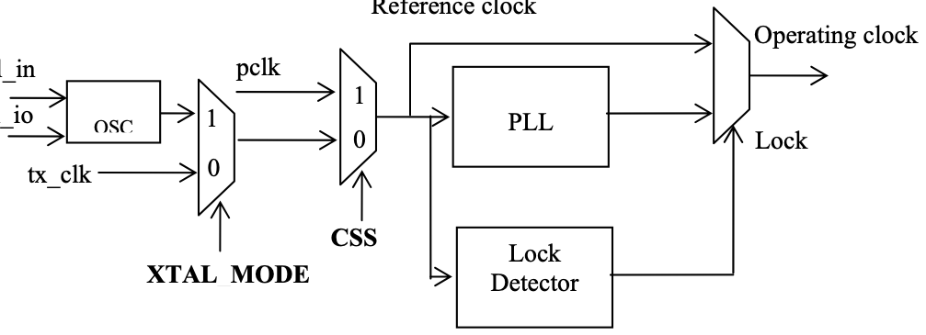
An output lock signal is provided for indication. This signal is connected to one of the interrupt source. The host can use the interrupt signal int to decide whether to operate at low speed or normal speed. The host can also poll the status bit PLS for the lock status.
Various clocks are mentioned in this document. Below is the explanation for each of them.
• Bit clock
It is the output clock from PLL. It is the clock source of all the clocks in the SSD2828.
• Nibble clock
It is a clock whose frequency is 1/4 of the bit clock.
• Byte clock
It is a clock whose frequency is 1/8 of the bit clock.
• Low power clock
It is a clock generated from byte clock. The divider value is given by field LPD. Please refer to 8.1.12. The low power clock period corresponds to 2 x T_{LPX}, as defined in MIPI D-PHY specification.

5.3 External Interface
The external interface is in charge of the communication with the application processor. It supports 2 types of interface, which are RGB and SPI.
• Parallel RGB interface for dumb display controller. The data bus width can be 16-bit, 18-bit and 24-bit.
• Serial SPI interface for smart display controller. The SPI interface supports 3 modes, which are 8-Bit 3 wire, 8- Bit 4 wire and 24-bit 3 wire. The 8-Bit 3 wire mode is the type C option 1 interface as specified in MIPI DBI 2.0. The 8-Bit 4 wire mode is the type C option 3 interface as specified in MIPI DBI 2.0.
The SPI interface is a completely separate interface from the other. Please see the pin table description for detailed scheme.
The SSD2828 supports one interface configuration.
• A combination of RGB and SPI interface
This configuration is mainly used to drive a dumb display panel through the MIPI link. The RGB interface inputs the display data to the dumb display. The SPI interface inputs the data which is to configure the dumb display. Alternatively, the SPI interface can also input the data which is to drive a smart display panel, if the MIPI slave can control a dumb display panel and a smart one at the same time.

5.4 Protocol Control Unit (PCU)
The PCU is in charge of the handling of outgoing and incoming data stream. It has a state machine to decide what packet to be sent when an event comes in and how to react to the received packet.

5.5 Packet Processing Unit (PPU)
The PPU is in charge of packet assembly and disassembly. During transmission, it will form the packet according to the instruction from the PCU. During reception, it will extract necessary information from the packet and pass to the PCU.

5.6 Error Correction Code/ Cyclic Redundancy Check (ECC/CRC)
During transmission, the ECC/CRC module will generate the ECC or CRC for the outgoing bit stream.
During reception, the ECC/CRC module will check the correctness of the ECC and CRC field of the incoming stream.
If there is 1 bit of error in the data and ECC field, this error will be corrected by the ECC module. If there are more than 1 bit of error in the data and ECC field, the ECC module will detect the error and report it. If there is at least 1 bit of error in the data and CRC field, the CRC module will detect the error and report it.

5.7 Long and Command Buffers
In the forward direction, the SSD2828 supports DCS short write, DCS long write, Generic short write, Generic long write packets and all video packets. The internal buffers are used as temporary storage for incoming data, so that the application processor does not need to wait for the packet to be transmitted before writing the next one. All the command packets will be stored in the command buffers, except DCS command 2C/3C. All the long packets in video mode and the long packets with DCS command 2C/3C in command mode will be stored in the long buffer. After a complete packet is written into the buffer, the SSD2828 will send out the packet.
The command buffer can contain one or multiple packets, up to the size of 1024 bytes. As long as 1 complete packet is received, the state machine will instructs the D-PHY Controller to send out the packet.
Each long buffer can contain, maximum, 2 packets.
For each buffer, there are 2 status bits associated. One is buffer empty and the other is buffer available. Buffer empty means there is no packet in the buffer. Buffer available means that there is space to hold at least one packet. The buffer status can be reflected to the application processor through interrupt signal.

5.8 Interrupt signal
An interrupt signal is provided to trigger the application processor for certain event in the SSD2828. The events include internal long or command buffer empty, internal long or command buffer available, data ready for read back, acknowledgement response from MIPI slave, BTA response from the MIPI slave, time out, and packet operation ready. Please see the interrupt register description and 9.3.1.6 for more details.

5.9 D-PHY Controller
The D-PHY controller is in charge of the communication with the analog transceiver. During transmission, it receives data from PPU and informs the analog transmitter how to transmit. During reception, it receives data from analog receiver and passes the data to the PPU for further processing. At the same time, it is also performing the handshaking process, such as, bus turn around and switching between different modes.

5.10 Analog Transceiver
It consists of 4 data lane controllers and 1 clock lane controller. 1 of the data lane controllers is capable of providing reverse transmission.

5.11 Internal PLL
The internal PLL will generate the required high speed clock for the whole system operation. The input reference clock can come from either the tx_clk (_XIN, _XIO) or the pclk.

6 SSD2828QN4 Pin Assignment
Table 6-1：SSD2828QN4 Pinout Diagram – 68 QFN-EP (Top view)
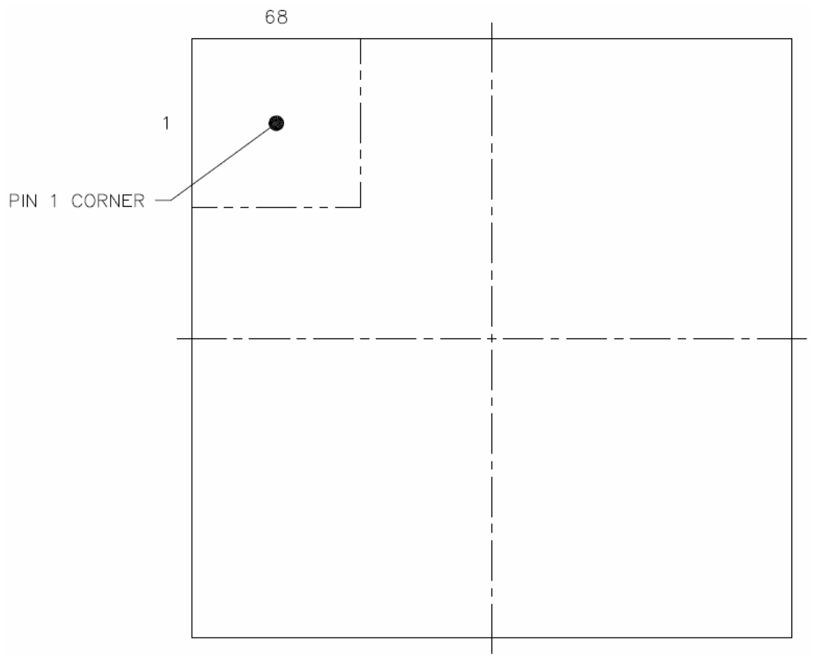
Table 6-2：SSD2828QN4 Pin Assignment – 68 QFN-EP (Top view)
QFN pin # | Net name | QFN pin # | Net name
1 | DATAP0 | 35 | DATA0
2 | DATAN0 | 36 | DATA1
3 | GND | 37 | DATA2
4 | DATAP1 | 38 | DATA3
5 | DATAN1 | 39 | DATA4
6 | GND | 40 | DATA5
7 | CLKP | 41 | DATA6
8 | CLKN | 42 | DATA7
9 | GND | 43 | DATA8
10 | DATAP2 | 44 | DATA9
11 | DATAN2 | 45 | DATA10
12 | GND | 46 | DATA11
13 | DATAP3 | 47 | DATA12
14 | DATAN3 | 48 | DATA13
15 | MVDD | 49 | DATA14
16 | VDDIO | 50 | DATA15
17 | PS0 | 51 | DATA16
18 | PS1 | 52 | DATA17
19 | NC | 53 | DATA18
20 | NC | 54 | DATA19
21 | NC | 55 | DATA20
22 | RESET | 56 | DATA21
23 | SDO | 57 | DATA22
24 | SDI | 58 | DATA23
25 | SCK | 59 | CSX0
26 | SDC | 60 | MVDD
27 | SHUT | 61 | SYS_CLK_OUT
28 | DEN | 62 | TX_CLK_XIO
29 | HSYNC | 63 | TX_CLK_XIN
30 | PCLK | 64 | VDDIO
31 | MVDD | 65 | GND
32 | GND | 66 | MVDD
33 | VDDIO | 67 | GND
34 | VSYNC | 68 | VDDIO

Table 6-3：SSD2828QN4 RGB data arrangement
 | D23 | D22 D | 21 | D20 | D19 | D18 | D17 | D16 | D15 | D14 | D13 | D12 | D11 | D10 | D9 | D8 | D7 | D6 | D5 | D4 | D3 | D2 | D1 | D0
24bpp | R7 | R6 R | 5 | R4 | R3 | R2 | R1 | R0 | G7 | G6 | G5 | G4 | G3 | G2 | G1 | G0 | B7 | B6 | B5 | B4 | B3 | B2 | B1 | B0
18bpp | X | X | X | X | X | X | R5 | R4 | R3 | R2 | R1 | R0 | G5 | G4 | G3 | G2 | G1 | G0 | B5 | B4 | B3 | B2 | B1 | B0
16bpp | X | X | X | X | X | X | X | X | R4 | R3 | R2 | R1 | R0 | G5 | G4 | G3 | G2 | G1 | G0 | B4 | B3 | B2 | B1 | B0

7 Pin Description
SSD2828 Pin Function Description
Key: I = Input O =Output I/O = Bi-directional (input/output) P = Power pin GND = System VSS
Table 7-1：Power Supply Pins
Name | Type | Connect to | Function | Description | When not in use
GND | P | GND | Ground of Power Supply | Ground for IC | -
MVDD | P | Power | Power for  Analog/Digital  Circuits and PLL Circuit | Power supply for the internal analog/digital circuit and PLL circuit. (1.2V +/-10%) | -
VDDIO | P | Power | Power for IO and Digital Interface Circuits | Power supply for IO and digital interface circuit. (1.8~3.3V +/-10%) | -

Table 7-1：MIPI Pins
Name | Type | Connect to | Function | Description | When not in use
CLKP0 | O | MIPI Rx | MIPI  Signals | Positive differential clock signal for DSI_0 | Open
CLKN0 | O | MIPI Rx | MIPI  Signals | Negative differential clock signal for DSI_0 | Open
DATAP0 | I/O | MIPI Rx | MIPI  Signals | Positive differential data signal 0 for DSI_0 | Open
DATAN0 | I/O | MIPI Rx | MIPI  Signals | Negative differential data signal 0 for DSI_0 | Open
DATAP1 | O | MIPI Rx | MIPI  Signals | Positive differential data signal 1 for DSI_0 | Open
DATAN1 | O | MIPI Rx | MIPI  Signals | Negative differential data signal 1 for DSI_0 | Open
DATAP2 | O | MIPI Rx | MIPI  Signals | Positive differential data signal 2 for DSI_0 | Open
DATAN2 | O | MIPI Rx | MIPI  Signals | Negative differential data signal 2 for DSI_0 | Open
DATAP3 | O | MIPI Rx | MIPI  Signals | Positive differential data signal 3 for DSI_0 | Open
DATAN3 | O | MIPI Rx | MIPI  Signals | Negative differential data signal 3 for DSI_0 | Open

Table 7-2：Interface Logic Pins
Name | Type | Connect to | Function | Description | When not in use
DATA[23:0] | I/O | AP | RGB  Interface | RGB data for RGB interface | Open
VSYNC | I | AP | RGB  Interface | VSYNC for RGB interface | VDDIO or GND
PCLK | I | AP | RGB  Interface | PCLK for RGB interface | VDDIO or GND
DEN | I | AP | RGB  Interface | DEN for RGB interface | VDDIO or GND
HSYNC | I | AP | RGB  Interface | HSYNC for RGB interface | VDDIO or GND
SDC | I | AP | SPI  Interface | Data or command for SPI interface (for 8 bit 4 wire) | VDDIO or GND
CSX0 | I | AP | SPI  Interface | Chip select of DSI_0 for SPI interface | VDDIO
SCK | I | AP | SPI  Interface | Serial clock for SPI interface (for 8 bit 3 wire, 8 bit 4 wire, 24 bit 3 wire) | VDDIO or GND
SDI | I | AP | SPI  Interface | Serial data input for SPI interface (for 8 bit 3 wire, 8 bit 4 wire, 24 bit 3 wire) | VDDIO or GND
SDO | O | - | SPI  Interface | Serial data output for SPI interface (for 8 bit 3 wire, 8 bit 4 wire, 24 bit 3 wire) | Open

Table 7-3：Miscellaneous Pins
Name | Type | Connect to | Function | Description | When not in use
SHUT | I | VDDIO or GND | Control  Signal | Shutdown signal of RGB interface (to put the driver into  sleep mode).  - 1: The panel is shut down (Sending 22h packet when SHUT changes from “0” (cid:198) “1” in video mode)  - 0: The panel is operating (Sending 32h packet at the  beginning of video mode automatically) | VDDIO
PS[1:0] | I | VDDIO or GND | Control  Signal | Interface selection signal  PS[1:0] is for SPI interface  - 00: 3 wire 24 bit SPI interface  - 01: 3 wire 8 bit SPI interface  - 10: 4 wire 8 bit SPI interface  - 11: SSL internal test mode | GND
TX_CLK_XIN | I | External  CLK | Control  Signal | Input system clock. 8 ~ 30MHz  ----------------------------------------------------------------------- Input crystal range for the crystal oscillator input. 8Mhz to 30Mhz | -
TX_CLK_XIO | I/O | - | Control  Signal | Input system clock. Open.  ----------------------------------------------------------------------- Input crystal range for the crystal oscillator input. 8Mhz to 30Mhz | Open
SYS_CLK_OUT | O | - | Control  Signal | Output system clock for MIPI slave | Open
RESET | I | VDDIO or GND | Control  Signal | Active low reset signal to the chip | VDDIO

8 COMMAND TABLE
Table 8-1：SSD2828 Register Summary
Offset | Name | Mnemonic |  | Reset
 |  |  |  | Value
0xB0 | Device Identification Register | DIR | 0x2828
0xB1 | RGB Interface Control Register 1 | VICR1 | 0x020A
0xB2 | RGB Interface Control Register 2 | VICR2 | 0x0214
0xB3 | RGB Interface Control Register 3 | VICR3 | 0x0428
0xB4 | RGB Interface Control Register 4 | VICR4 | 0x0780
0xB5 | RGB Interface Control Register 5 | VICR5 | 0x0438
0xB6 | RGB Interface Control Register 6 | VICR6 | 0x0024
0xB7 | Configuration Register | CFGR | 0x0301
0xB8 | VC Control Register | VCR | 0x0045
0xB9 | PLL Control Register | PCR | 0x0000
0xBA | PLL Configuration Register | PLCR | 0x8120
0xBB | Clock Control Register | CCR | 0x0003
0xBC | Packet Size Control Register 1 | PSCR1 | 0x0000
0xBD | Packet Size Control Register 2 | PSCR2 | 0x0000
0xBE | Packet Size Control Register 3 | PSCR3 | 0x0100
0xBF | Packet Drop Register | PDR | 0x0000
0xC0 | Operation Control Register | OCR | 0x0000
0xC1 | Maximum Return Size Register | MRSR | 0x0001
0xC2 | Return Data Count Register | RDCR | 0x0000
0xC3 | ACK Response Register | ARSR | 0x0000
0xC4 | Line Control Register | LCR | 0x0000
0xC5 | Interrupt Control Register | ICR | 0x0080
0xC6 | Interrupt Status Register | ISR | 0xCF06
0xC7 | Error Status Register | ESR | 0x0000
0xC9 | Delay Adjustment Register 1 | DAR1 | 0x1402
0xCA | Delay Adjustment Register 2 | DAR2 | 0x2803
0xCB | Delay Adjustment Register 3 | DAR3 | 0x0416
0xCC | Delay Adjustment Register 4 | DAR4 | 0x0A0A
0xCD | Delay Adjustment Register 5 | DAR5 | 0x1000
0xCE | Delay Adjustment Register 6 | DAR6 | 0x0405
0xCF | HS TX Timer Register 1 | HTTR1 | 0x0000
0xD0 | HS TX Timer Register 2 | HTTR2 | 0x0010
0xD1 | LP RX Timer Register 1 | LRTR1 | 0x0000
0xD2 | LP RX Timer Register 2 | LRTR2 | 0x0010
0xD3 | TE Status Register | TSR | 0x0000
0xD4 | SPI Read Register | LRR | 0x00FA
0xD5 | PLL Lock Register | PLLR | 0x1450
0xD6 | Test Register | TR | 0x0005
0xD7 | TE Count Register | TECR | 0x0001
0xD8 | Analog Control Register 1 | ACR1 | 0x2020
0xD9 | Analog Control Register 2 | ACR2 | 0x64A0
0xDA | Analog Control Register 3 | ACR3 | 0x99A4
0xDB | Analog Control Register 4 | ACR4 | 0x8098
0xDC | Interrupt Output Control Register | IOCR | 0x0000
0xDD | RGB Interface Control Register 7 | VICR7 | 0x0000
0xDE | Lane Configuration Register | LCFR | 0x0000
0xDF | Delay Adjustment Register 7 | DAR7 | 0x0010
0xE0 | Pull Control Register 1 | PUCR1 | 0x5556
0xE1 | Pull Control Register 2 | PUCR2 | 0x6656
0xE2 | Pull Control Register 3 | PUCR3 | 0x0159

Offset | Name | Mnemonic |  | Reset
 |  |  |  | Value
0xE9 | CABC Brightness Control Register 1 | CBCR1 | 0x0000
0xEA | CABC Brightness Control Register 2 | CBCR2 | 0x6900
0xEB | CABC Brightness Status Register | CBSR | 0x0000
0xEC | Encoder Control Register | ECR | 0x7800
0xED | Video Sync Delay Register | VSDR | 0x0002
0xEE | Trimming Register | TMR | 0x0000
0xEF | GPIO Register 1 | GPIO1 | 0x0000
0xF0 | GPIO Register 2 | GPIO2 | 0x0000
0xF1 | DLYA01 Register | DLYA01 | 0x2020
0xF2 | DLYA23 Register | DLYA23 | 0x2020
0xF3 | DLYB01 Register | DLYB01 | 0x2020
0xF4 | DLYB23 Register | DLYB23 | 0x2020
0xF5 | DLYC01 Register | DLYC01 | 0x2020
0xF6 | DLYC23 Register | DLYC23 | 0x2020
0xF7 | Analog Control Register 5 | ACR5 | 0x0000
0xFF | Read Register | RR | 0x0000

8.1 Register Description

8.1.1 Device Identification Register
Offset Address
DIR Device Identification Register 0xB0
BIT | 15 | 14 | 13 | 12 | 11 | 10 | 9 | 8
NAME | DIR[15:8]
TYPE | RO
RESET | 0x28
BIT | 7 | 6 | 5 | 4 | 3 | 2 | 1 | 0
NAME | DIR[7:0]
TYPE | RO
RESET | 0x28

Table 8-2：Device Identification Register Description
Name | Description | Setting
DIR  Bit 15-0 | Device Identification Number | 0x2828

8.1.2 RGB Interface Control Register 1
Offset Address
VICR1 RGB Interface Control Register 1 0xB1
BIT | 15 | 14 | 13 | 12 | 11 | 10 | 9 | 8
NAME | VSA
TYPE | RW
RESET | 0x02
BIT | 7 | 6 | 5 | 4 | 3 | 2 | 1 | 0
NAME | HSA
TYPE | RW
RESET | 0x0A

Table 8-3：RGB Interface Control Register 1 Description
Name | Description | Setting
VSA  Bit 15-8 | Vertical Sync Active Period – These bits  specify the Vsync active period. The Vsync  active period is from the Vsync falling edge to rising edge, in terms of Hsync pulses. It is only used in non-burst mode with Sync pulses.  Please refer to 9.3 for more details. | The minimum value is 1.
HSA  Bit 7-0 | Horizontal Sync Active Period – These bits  specify the Hsync active period. The Hsync  active period is from the Hsync falling edge to rising edge, in terms of pclk. It is only used in non-burst mode with Sync pulses.  Please refer to 9.3 for more details. | The minimum value is 1.

8.1.3 RGB Interface Control Register 2
Offset Address
VICR2 RGB Interface Control Register 2 0xB2
BIT | 15 | 14 | 13 | 12 | 11 | 10 | 9 | 8
NAME | VBP
TYPE | RW
RESET | 0x02
BIT | 7 | 6 | 5 | 4 | 3 | 2 | 1 | 0
NAME | HBP
TYPE | RW
RESET | 0x14

Table 8-4：RGB Interface Control Register 2 Description
Name | Description | Setting
VBP  Bit 15-8 | Vertical Back Porch Period – These bits  specify the vertical back porch period in terms of Hsync pulses. The vertical back porch period depends on the video mode setting.  If the mode is non-burst mode with Sync pulses, it is from the Vsync rising edge to the Hsync of the first line of active display.  If the mode is non-burst mode with Sync events, it is from the Vsync falling edge to the Hsync of the first line of active display.  If the mode is burst mode, it is the same as the non-burst mode with Sync events.  Please refer to 9.3 for more details.
HBP  Bit 7-0 | Horizontal Back Porch Period – These bits  specify the horizontal back porch period in  terms of pclk. The horizontal back porch period depends on the non-burst mode setting.  If the mode is non-burst mode with Sync pulses, it is from the Hsync rising edge to the start of  the valid display pixel.  If the mode is non-burst mode with Sync events, it is from the Hsync falling edge to the start of the valid display pixel.  If the mode is burst mode, it is the same as the non-burst mode with Sync events.  Please refer to 9.3for more details.

8.1.4 RGB Interface Control Register 3
Offset Address
VICR3 RGB Interface Control Register3 0xB3
BIT | 15 | 14 | 13 | 12 | 11 | 10 | 9 | 8
NAME | VFP
TYPE | RW
RESET | 0x04
BIT | 7 | 6 | 5 | 4 | 3 | 2 | 1 | 0
NAME | HFP
TYPE | RW
RESET | 0x28

Table 8-5：RGB Interface Control Register 3 Description
Name | Description | Setting
VFP  Bit 15-8 | Vertical Front Porch Period – These bits  specify the vertical front porch period in terms of Hsync pulses. The vertical front porch period is from the first Hsync after the last line of  active display to the next Vsync falling edge.  Please refer to 9.3 for more details.
HFP  Bit 7-0 | Horizontal Front Porch Period – These bits specify the horizontal front porch period in  terms of pclk. The horizontal front porch period is from the end of the valid display pixel to the next Hsync falling edge.  Please refer to 9.3 for more details.

8.1.5 RGB Interface Control Register 4
Offset Address
VICR4 RGB Interface Control Register 4 0xB4
BIT | 15 | 14 | 13 | 12 | 11 | 10 | 9 | 8
NAME | HACT[15:8]
TYPE | RW
RESET | 0x07
BIT | 7 | 6 | 5 | 4 | 3 | 2 | 1 | 0
NAME | HACT[7:0]
TYPE | RW
RESET | 0x80

Table 8-6：RGB Interface Control Register 4 Description
Name | Description | Setting
HACT  Bit 15-0 | Horizontal Active Period – These bits specify the horizontal active period in terms of pclk.  During the horizontal active period, the den  signal should always be high.  Please refer to 9.3 for more details. | The maximum value is 0x0A00.

8.1.6 RGB Interface Control Register 5
Offset Address
VICR5 RGB Interface Control Register 5 0xB5
BIT | 15 | 14 | 13 | 12 | 11 | 10 | 9 | 8
NAME | VACT[15:8]
TYPE | RW
RESET | 0x04
BIT | 7 | 6 | 5 | 4 | 3 | 2 | 1 | 0
NAME | VACT[7:0]
TYPE | RW
RESET | 0x38

Table 8-7：RGB Interface Control Register 5 Description
Name | Description | Setting
VACT  Bit 15-0 | Vertical Active Period – These bits specify the vertical active period in terms of Hsync pulses. Please refer to 9.3 for more details. | The minimum value is 1.

8.1.7 RGB Interface Control Register 6
Offset Address
VICR6 RGB Interface Control Register6 0xB6
BIT | 15 | 14 | 13 | 12 | 11 | 10 | 9 | 8
NAME | VS_P | HS_P | PCLK_P |  |  |  |  | CBM
TYPE | RW | RW | RW | RO | RO | RO | RO | RW
RESET | 0x0 | 0x0 | 0x0 | 0x0 | 0x0 | 0x0 | 0x0 | 0x0
BIT | 7 | 6 | 5 | 4 | 3 | 2 | 1 | 0
NAME | NVB | NVD | BLLP | VCS | VM |  | VPF
TYPE | RW | RW | RW | RW | RW |  | RW
RESET | 0x0 | 0x0 | 0x1 | 0x0 | 0x1 |  | 0x0

Table 8-8：RGB Interface Control Register 6 Description
Name | Description | Setting
VS_P  Bit 15 | VS_P – This bit control the polarity of the Vsync pulse  input. | 0 – Vsync Pulse is active low  1 – Vsync Pulse is active high
HS_P  Bit 14 | HS_P – This bit control the polarity of the Hsync pulse  output. | 0 – Hsync Pulse is active low  1 – Hsync Pulse is active high
PCLK_P  Bit 13 | PCLK_P – This bit control the polarity of the CM output. | 0 – Data is launch at falling edge, SSD2828 latch data at rising edge  1 – Data is launch at rising edge, SSD2828 latch data at falling edge
Reserved
Bit 12-9
CBM  Bit 8 | Compress Burst Mode Control – If the mode is burst and this bit is 1, MIPITX will send  video packet in compressed burst mode (i.e. no blanking packet after horizontal sync packet) | 0 – Video with blanking packet.  1 - Video with no blanking packet.
NVB  Bit 7 | Non Video Data Burst Mode Control – This bit specifies how non video data will be  interleaved with video data transmission in burst mode. | 0 – Non video data will be  transmitted during any BLLP period.  1 - Non video data will only be  transmitted during vertical  blanking period.
NVD  Bit 6 | Non Video Data Transmission Control –This bit specifies how non video data will be  interleaved with video data transmission. Please refer to 9.2.1 for more details.  The SSD2828 will send non video data (written from the SPI interface) during the vertical  blanking period (non burst mode) or any BLLP period in burst mode (depends on NVB setting). The data can be sent either in high speed mode or low power mode. This bit selects which  mode to use. If LP mode is selected, the data | 0 – Non video data will be  transmitted using HS mode.  1 – Non video data will be  transmitted using LP mode.

Name | Description | Setting
lane will enter LP mode for BLLP period, even if there is no non-video data to send.
Please note that sending data in LP mode is
much slower than HS mode. It is the
responsibility of the host processor to make sure that the duration is long enough to finish the
data transfer and the timing of Hsync and Vsync is not affected.
BLLP  Bit 5 | BLLP Control – This bit specifies the  SSD2828 operation during BLLP period. This bit takes effect only for non burst mode and  NVD being 0.  When the video mode is burst mode, the  SSD2828 will not send any blanking packet  during BLLP. It will enter LP mode.  When NVD is 1 in non burst mode, the  SSD2828 will stay in LP mode after sending the non video data (if there is any), until the BLLP period ends.  When NVD is 0 in non burst mode, the  SSD2828 will use this bit to decide whether to send blanking packet or enter LP mode after  sending non video data (if there is any), until the BLLP period ends.  Please note that entering and exiting from LP  mode needs more time, as the speed of LP mode is slow. It is the responsibility of the host  processor to make sure that the period is long  enough to finish the data transfer and the timing of Hsync and Vsync is not affected. | 0 – Blanking packet will be sent during BLLP period.  1 – LP mode will be used during BLLP period.
VCS  Bit 4 | Video Clock Suspend – This bit specifies the clock lane behavior. This bit is only applicable for burst mode. When the video mode is non  burst mode, the clock lane will remain in HS  mode all the time. | 0 – The clock lane remains in HS mode, when there is no data to transmit.  1 – The clock lane enters LP mode when there is no data to  transmit.
VM  Bit 3-2 | Video Mode – These bits specify the video  mode the SSD2828 will use, when RGB  interface is selected. Please refer to MIPI DSI for the definition of different modes. | 00 – Non burst mode with sync  pulses  01 – Non burst mode with sync  events  10 – Burst mode  11 – Reserved
VPF  Bit 1-0 | Video Pixel Format – These bits specify the  pixel format for video mode. | 00 – 16bpp  01 – 18bpp, packed  10 – 18bpp, loosely packed  11 – 24bpp

24bpp | D23 | D22 | D21 | D20 | D19 | D18 | D17 | D16 | D15 | D14 | D13 | D12 | D11 | D10 | D9 | D8 | D7 | D6 | D5 | D4 | D3 | D2 | D1 | D0
18bpp | X | X | X | X | X | X | D17 | D16 | D15 | D14 | D13 | D12 | D11 | D10 | D9 | D8 | D7 | D6 | D5 | D4 | D3 | D2 | D1 | D0
16bpp | X | X | X | X | X | X | X | X | D15 | D14 | D13 | D12 | D11 | D10 | D9 | D8 | D7 | D6 | D5 | D4 | D3 | D2 | D1 | D0

8.1.8 Configuration Register
Offset Address
CFGR Configuration Register 0xB7
BIT | 15 | 14 | 13 | 12 | 11 | 10 | 9 | 8
NAME |  |  |  |  | TXD | LPE | EOT | ECD
TYPE | RO | RO | RO | RO | RW | RW | RW | RW
RESET | 0x0 | 0x0 | 0x0 | 0x0 | 0x0 | 0x0 | 0x1 | 0x1
BIT | 7 | 6 | 5 | 4 | 3 | 2 | 1 | 0
NAME | REN | DCS | CSS | HCLK | VEN | SLP | CKE | HS
TYPE | RW | RW | RW | RW | RW | RW | RW | RW
RESET | 0x0 | 0x0 | 0x0 | 0x0 | 0x0 | 0x0 | 0x0 | 0x1

Table 8-9：Configuration Register Description
Name | Description | Setting
Reserved
Bit 15-12
TXD  Bit 11 | Transmit Disable – This bit specifies whether the SSD2828 will disable the sending of MIPI Packets stored in the buffers. Software can  enable TXD, fill out the buffers and then disable it to send all packets out in 1 burst. | 0 – Transmit on  1 – Transmit halt
LPE  Bit 10 | Long Packet Enable – This bit specifies  whether the SSD2828 will send out a Generic Long Write Packet or Generic Short Write  Packet when the payload is no more than 2  bytes.  It also specifies whether the SSD2828 will send out a DCS Long Write Packet or DCS Short  Write Packet when the payload is no more than 1 byte. | 0 – Short Packet  1 – Long Packet
EOT  Bit 9 | EOT Packet Enable – This bit specifies  whether the SSD2828 will send out the EOT  packet at the end of HS transmission or not. | 0 – Do not send  1 – Send
ECD  Bit 8 | ECC CRC Check Disable – This bit specifies whether SSD2828 will perform ECC and CRC checking for the packets received from the MIPI slave. | 0 – Enable  1 – Disable
REN  Bit 7 | Read Enable –This bit specifies whether the  next operation is a write or read operation. | 0 – Write operation  1 – Read operation
DCS  Bit 6 | DCS Enable – This bit specifies whether the  packet to be sent is DCS packet or generic  packet. This bit applies for both write and read operation. | 0 – Generic packet (The packet can be any one of Generic Long  Write, Generic Short Write,  Generic Read packet,  depending on the  configuration.)  1 – DCS packet (The packet can be any one of DCS Long Write, DCS Short Write, DCS Read packet, depending on the  configuration.)

Name | Description | Setting
CSS  Bit 5 | Clock Source Select – This bit selects the clock source for the PLL.  Please refer to 5.2 for the system behavior when the clock source is switched.  The CSS setting should be programmed only  when PEN is 0. It has no effect when PEN is 1. | 0 – The clock source is tx_clk  1 – The clock source is pclk
HCLK  Bit 4 | HS Clock Disable – This bit controls the clock lane behavior during the reverse direction  communication. This bit takes effect only when CKE is 0 and VEN is 0. | 0 – HS clock is enabled  1 – HS clock is disabled
VEN  Bit 3 | Video Mode Enable – This bit controls the  video mode operation. Only after this bit is set to 1, video mode is enabled. This bit takes  effect only when the interface setting is RGB + SPI. Please refer to 0 for the video mode  operation. | 0 – Video mode is disabled  1 – Video mode is enabled
SLP  Bit 2 | Sleep Mode Enable – This bit controls the  sleep mode operation.  Please refer to 9.3.2 for the sleep mode  operation.  When this bit is set to 1, the HS bit will be  cleared to 0 automatically. | 0 – Sleep mode is disabled  1 – Sleep mode is enabled. Only the register interface is active.
CKE  Bit 1 | Clock Lane Enable – This bit controls the  clock lane mode when data lane enters LP  mode. | 0 – Clock lane will enter LP mode, if it is not in reverse direction communication.  Clock lane will follow the  setting of HCLK, if it is in  reverse direction  communication.  1 – Clock lane will enter HS mode for all the cases.
HS  Bit 0 | HS Mode – This bit controls whether the  SSD2828 is using HS or LP mode to send data. This bit can be affected by the SLP bit value. | 0 – LP mode  1 – HS mode

8.1.9 VC Control Register
Offset Address
VCR VC Control Register 0xB8
BIT | 15 | 14 | 13 | 12 | 11 | 10 | 9 | 8
NAME
TYPE | RO | RO | RO | RO | RO | RO | RO | RO
RESET | 0x0 | 0x0 | 0x0 | 0x0 | 0x0 | 0x0 | 0x0 | 0x0
BIT | 7 | 6 | 5 | 4 | 3 | 2 | 1 | 0
NAME | VCM |  | VCE |  | VC2 |  | VC1
TYPE | RW |  | RW |  | RW |  | RW
RESET | 0x1 |  | 0x0 |  | 0x1 |  | 0x1

Table 8-10：VC Control Register Description
Name | Description | Setting
Reserved
Bit 15-8
VCM  Bit 7-6 | Virtual Channel ID for Maximum Return  Size Packet – These bits specify the VC ID for the Maximum Return Size Packet sent by  SSD2828.  This register field is included as the VC ID for this packet might be different from the VC ID for the packets carrying the actual data.
VCE  Bit 5-4 | Virtual Channel ID for EOT Packet – These bits specify the VC ID for the EOT Packet sent by SSD2828.  This register field is included as the VC ID for this packet might be different from the VC ID for the packets carrying the actual data.
VC2  Bit 3-2 | Virtual Channel ID for SPI Interface – These bits specify the VC ID for the packets written in through the SPI interface, when the interface  setting is RGB + SPI  This register field is included as the RGB + SPI interface can address two different LCD panels at the same time. The VC ID for the two panels is different.
VC1  Bit 1-0 | Virtual Channel ID for RGB Interface –  These bits specify the VC ID for the packets  written in through the RGB interface, when the interface is RGB + SPI

8.1.10 PLL Control Register
Offset Address
PCR PLL Control Register 0xB9
BIT | 15 | 14 | 13 | 12 | 11 | 10 | 9 | 8
NAME | SYSD |  | SYS_DIS
TYPE | RW |  | RW | RO | RO | RO | RO | RO
RESET | 0x0 |  | 0x0 | 0x0 | 0x0 | 0x0 | 0x0 | 0x0
BIT | 7 | 6 | 5 | 4 | 3 | 2 | 1 | 0
NAME |  |  |  |  |  |  |  | PEN
TYPE | RO | RO | RO | RO | RO | RO | RO | RW
RESET | 0x0 | 0x0 | 0x0 | 0x0 | 0x0 | 0x0 | 0x0 | 0x0

Table 8-11：PLL Control Register Description
Name | Description | Setting
SYSD  Bit 15-14 | SYS_clk Divider – These bits give the divider value for generating the sys_clk output from the tx_clk or crystal input. | 00 – Divide by 1  01 – Divide by 2  10 – Divide by 4  11 – Divide by 8
SYS_DIS  Bit 13 | SYS_clk DISable – This bit will shut off the  Sys_clk signal output when enabled. | 0 – Enable Sys_clk output  1 – Disable Sys_clk output
Reserved
Bit 12-1
PEN  Bit 0 | PLL Enable – This bit controls the PLL  operation. | 0 – PLL power down  1 – PLL enable

Remark: Frequency of PLL can only be changed during PEN = 0

8.1.11 PLL Configuration Register
Offset Address
PLCR PLL Configuration Register 0xBA
BIT | 15 | 14 | 13 | 12 | 11 | 10 | 9 | 8
NAME | FR |  |  | MS
TYPE | RW |  | RO | RW
RESET | 0x2 |  | 0x0 | 0x01
BIT | 7 | 6 | 5 | 4 | 3 | 2 | 1 | 0
NAME | NS
TYPE | RW
RESET | 0x20

Table 8-12：PLL Configuration Register Description
Name | Description | Setting
FR  Bit 15-14 | Frequency Range – These bits select the range of the output clock.  The FR setting should be programmed only  when PEN is 0. It has no effect when PEN is 1. | 00 – 62.5 < f OUT < 125  01 – 126 < f OUT < 250  10 – 251 < f OUT < 500  11 – 501 < f OUT < 1000
Reserved
Bit 13
MS  Bit 12-8 | PLL Divider – These bits specify the PLL pre- divider value, MS.  The frequency of the phase detector, f REF is  determined by  f PRE = f IN MS  The input frequency, f IN and phase detector  frequency, f REF should be between 5Mhz to  100Mhz.  The MS setting should be programmed only  when PEN is 0. It has no effect when PEN is 1. | - 0x00 : MS=1  - 0x01 : MS=1  - 0x02 : MS=2  …  - 0x1F : MS=31
NS  Bit 7-0 | PLL Multiplier – These bits specify the PLL output frequency multiplier value, NS.  The output frequency, f OUT is determined by f OUT = f PRE ∗ NF  The NS setting should be programmed only  when PEN is 0. It has no effect when PEN is 1. | - 0x00 : NS=1  - 0x01 : NS=1  - 0x02 : NS=2  …  - 0xFF : NS=255

e.g. TX_CLK = 10MHz, 0xBAh = 0x8028h
PLL = 40 x 10 / 1 = 400Mbps

8.1.12 Clock Control Register
Offset Address
CCR Clock Control Register 0xBB
BIT | 15 | 14 | 13 | 12 | 11 | 10 | 9 | 8
NAME
TYPE | RO | RO | RO | RO | RO | RO | RO | RO
RESET | 0x0 | 0x0 | 0x0 | 0x0 | 0x0 | 0x0 | 0x0 | 0x0
BIT | 7 | 6 | 5 | 4 | 3 | 2 | 1 | 0
NAME |  |  | LPD
TYPE | RO | RO | RW
RESET | 0x0 | 0x0 | 0x03

Table 8-13：Clock Control Register Description
Name | Description | Setting
Reserved
Bit 15-6
LPD  Bit 5-0 | LP Clock Divider – These bits give the divider value for generating the LP mode clock from the byte clock. | 0x0 – Divide by 1  0x1 – Divide by 2  …  0x3F – Divide by 64

Remark: e.g. LPD = 0x4
PLL = 400Mbps
LP clock = 400Mbps / LPD / 8 = 400 / 5 / 8 = 10MHz

8.1.13 Packet Size Control Register 1
Offset Address
PSCR1 Packet Size Control Register1 0xBC
BIT | 15 | 14 | 13 | 12 | 11 | 10 | 9 | 8
NAME | TDC[15:8]
TYPE | RW
RESET | 0x00
BIT | 7 | 6 | 5 | 4 | 3 | 2 | 1 | 0
NAME | TDC[7:0]
TYPE | RW
RESET | 0x00

Table 8-14：Packet Size Control Register 1 Description
Name | Description | Setting
TDC  Bit 15-0 | Transmit Data Count – These bits set the total number of data bytes to be transmitted by the  SSD2828 in the next operation. The SSD2828 will use the value in this field to decide what  type of packet to send out.  The settings of TDC and PST(0xBE) will  configure the transfer mode into partition and  non-partition mode when the command is 0x2C or 0x3C.  Partition mode(TDC > PST)  For DCS Long Write packet with DCS  command being 0x2C or 0x3C, there is no limit in the maximum number of bytes to be  transmitted in 1 write. The PST value can be set to maximum of 4096 bytes. The SSD2828 will auto insert 0x3C command at these boundaries. The maximum MCU speed at the input is 1/12 of the link frequency.  Non-Partition mode(TDC <= PST)  For DCS Long Write packet with DCS  command being 0x2C or 0x3C, the maximum number of bytes to be transmitted in 1 write is 4096 bytes(TDC). In this mode, the PST value is the same or greater than the TDC value.  The maximum MCU speed at the input is 1/8 of the link frequency.  Please refer to 9.3.1.1 for more details. | Partition mode  When TDC > PST.  Non-partition mode  When TDC <= PST.  Maximum TDC = 4096(0x1000)

8.1.14 Packet Size Control Register 2
Offset Address
PSCR2 Packet Size Control Register 2 0xBD
BIT | 15 | 14 | 13 | 12 | 11 | 10 | 9 | 8
NAME | TDC[31:24]
TYPE | RW
RESET | 0x0
BIT | 7 | 6 | 5 | 4 | 3 | 2 | 1 | 0
NAME | TDC[23:16]
TYPE | RW
RESET | 0x0

Table 8-15：Packet Size Control Register 2 Description
Name | Description | Setting
TDC[31:16] Bit 31-0 | Transmit Data Count – Please see the  description of Packet Size Control Register 1.

8.1.15 Packet Size Control Register 3
Offset Address
PSCR2 Packet Size Control Register 3 0xBE
BIT | 15 | 14 | 13 | 12 | 11 | 10 | 9 | 8
NAME |  |  |  | PST[12:8]
TYPE | RO | RO | RO | RW
RESET | 0x0 | 0x0 | 0x0 | 0x1
BIT | 7 | 6 | 5 | 4 | 3 | 2 | 1 | 0
NAME | PST[7:0]
TYPE | RW
RESET | 0x00

Table 8-16：Packet Size Control Register 3 Description
Name | Description | Setting
Reserved
Bit 15-13
PST  Bit 12-0 | Packet Size Threshold – These bits give the  threshold value for partitioning the incoming  long packet data into smaller packets. The  partitioning only applies to the DCS Long Write packet with DCS command being 0x2C or 0x3C in Command mode(if_sel=1). The payload will be partitioned into multiple packets.  The PST represents the threshold in term of  bytes.  The maximum MCU speed at the input is 1/10 of the link frequency.  Please refer to 9.3.1.1 for more details. | The maximum value allowed is  4096 bytes.  Program PST<TDC will allows auto insertion of 0x3C at the PST boundary(Partition mode).  If the user tries to program a larger value than the maximum allowed value into this field, SSD2828 will cap the value to the maximum  value.  When the interface setting is 16- bit, the value in this field must be multiple of 2 bytes, or even  number. If an odd number is  written in, it will be automatically truncated to an even number. For example, 0x5 will be truncated to 0x4.  When the interface setting is 24- bit, the value in this field must be in multiple of 3 bytes

8.1.16 Generic Packet Drop Register
Offset Address
GPDR Generic Packet Drop Register 0xBF
BIT | 15 | 14 | 13 | 12 | 11 | 10 | 9 | 8
NAME | GPD[15:8]
TYPE | WO
RESET | 0x0
BIT | 7 | 6 | 5 | 4 | 3 | 2 | 1 | 0
NAME | GPD[7:0]
TYPE | WO
RESET | 0x0

Table 8-17：Generic Packet Drop Register Description
Name | Description | Setting
GPD  Bit 15-0 | Generic Packet Drop – This register is not a  true register. It is the entry point for the internal buffer. The payload of the generic packets  (Generic Short Write, Generic Long Write, and Generic Read) or the command and payload if DCS packet should be written into this register. The SSD2828 will send them out using the  corresponding generic or DCS packet. DCS  field of CFGR register will be used to determine the data drop into this register is for generic or DCS packet generation.  The application processor can treat this register as an FIFO and continuously write data into it. When the interface is 16-bit, the width of this  field is 16-bit. When the interface is 8-bit, the width of this field is 8-bit. Since the register is only the entry point of the internal buffer, the  application processor is not able to read the data written into the buffer.

8.1.17 Operation Control Register
Offset Address
OCR Operation Control Register 0xC0
BIT | 15 | 14 | 13 | 12 | 11 | 10 | 9 | 8
NAME |  |  |  |  |  |  |  | RST
TYPE | RO | RO | RO | RO | RO | RO | RO | RWAC
RESET | 0x0 | 0x0 | 0x0 | 0x0 | 0x0 | 0x0 | 0x0 | 0x0
BIT | 7 | 6 | 5 | 4 | 3 | 2 | 1 | 0
NAME |  |  |  |  |  |  |  | COP
TYPE | RO | RO | RO | RO | RO | RO | RO | RWAC
RESET | 0x0 | 0x0 | 0x0 | 0x0 | 0x0 | 0x0 | 0x0 | 0x0

Table 8-18：Operation Control Register Description
Name | Description | Setting
Reserved
Bit 15-9
RST  Bit 8 | Software Reset - Writing a ‘1’ to this bit will reset the entire module except SSD2828 local register setting. This bit will be cleared after the reset is completed.  Wrting a ‘1’ to this bit will cause the MIPI link enters TX stop state immediately and any  outgoing MIPI packet will be terminated  immediately. | 0 – NOP  1 – Software Reset
Reserved
Bit 7-1
COP  Bit 0 | Cancel Operation – This bit is to cancel the  current operation.  When this bit is set to 1, the SSD2828 will still finish transmitting the current packet.  (Otherwise, the serial link operation will lose  sync.) Afterwards, the SSD2828 will stop any further transmission. It will clear its internal  buffer such that all the data being written in and not sent out yet will be cleared. It will also  bring the state machine to its initial state.  Once this process is finished, the COP bit will be automatically set to 0. At the same time, the PO bit of the status register will be set to 1 too. At this stage, there is no data in the internal  buffer. The application processor can start a  new operation. This operation is not valid in  video mode(VEN=1). | 0 – NOP  1 – Cancel the current operation

8.1.18 Maximum Return Size Register
Offset Address
MRSR Maximum Return Size Register 0xC1
BIT | 15 | 14 | 13 | 12 | 11 | 10 | 9 | 8
NAME | MRS
TYPE | RW
RESET | 0x00
BIT | 7 | 6 | 5 | 4 | 3 | 2 | 1 | 0
NAME | MRS
TYPE | RW
RESET | 0x01

Table 8-19：Maximum Return Size Register Description
Name | Description | Setting
MRS  Bit 15-0 | Maximum Return Size – These bits set the  maximum return size of the read response  packet returned by the MIPI slave.  The SSD2828 will automatically send out the  Set Maximum Return Size packet using the  value in this field, before every read operation. It informs the MIPI slave about the limit of the SSD2828. The application processor does not need to program the register before every read operation, if the maximum return size does not change. However, the Set Maximum Return  Size packet will always be sent.

8.1.19 Return Data Count Register
Offset Address
RDCR Return Data Count Register 0xC2
BIT | 15 | 14 | 13 | 12 | 11 | 10 | 9 | 8
NAME | RDC
TYPE | RO
RESET | 0x00
BIT | 7 | 6 | 5 | 4 | 3 | 2 | 1 | 0
NAME | RDC
TYPE | RO
RESET | 0x00

Table 8-20：Return Data Count Register Description
Name | Description | Setting
RDC  Bit 15-0 | Return Data Count – These bits reflect the  number of data bytes received from the MIPI  slave read response packet.  This register can only be updated by the  SSD2828 hardware.

8.1.20 ACK Response Status Register
Offset Address
ARSR ACK Response Status Register 0xC3
BIT | 15 | 14 | 13 | 12 | 11 | 10 | 9 | 8
NAME | AR
TYPE | RO
RESET | 0x00
BIT | 7 | 6 | 5 | 4 | 3 | 2 | 1 | 0
NAME | AR
TYPE | RO
RESET | 0x00

Table 8-21：ACK Response Status Register Description
Name | Description | Setting
AR  Bit 15-0 | ACK Response – These bits contain the ACK response from the MIPI slave. The register will be updated when ACK with Error Report packet is received. Otherwise, the value will be set to 0. The bits in this register follow the definition in MIPI DSI.  This register can only be updated by the  SSD2828 hardware.

8.1.21 Line Control Register
Offset Address
LCR Line Control Register 0xC4
BIT | 15 | 14 | 13 | 12 | 11 | 10 | 9 | 8
NAME
TYPE | RO | RO | RO | RO | RO | RO | RO | RO
RESET | 0x0 | 0x0 | 0x0 | 0x0 | 0x0 | 0x0 | 0x0 | 0x0
BIT | 7 | 6 | 5 | 4 | 3 | 2 | 1 | 0
NAME |  |  | IBC | RT | RTB | FBC | FBT | FBW
TYPE | RO | RO | RW | RWAC | RWAC | RWAC | RW | RW
RESET | 0x0 | 0x0 | 0x0 | 0x0 | 0x0 | 0x0 | 0x0 | 0x0

Table 8-22：Line Control Register Description
Name | Description | Setting
Reserved
Bit 15-6
IBC  Bit 5 | Ignore Bus Contention – This bit is to detect bus contention reported by the Analog Phy.  If this bit is disabled, whenever bus contention is detected, the state machine will ignore it and continue sending new packet if available.  If this bit is enabled, the state machine will halt further transmission. | 0 – Detect Bus Contention from Analog Phy  1 – Ignore Bus Contention  detected by Analog Phy
RT  Bit 4 | Reset Trigger – This bit is to send a Reset  Trigger Message.  When this bit is set to 1, the SSD2828 will send a Reset Trigger Message. It is recommended to enter LP mode and send this trigger message.  If this bit is programmed during vertical active data is being sent on MIPI link, the reset trigger will be delayed to next vertical blanking period so that the reset trigger message will not disturb the video timing on the MIPI link.  Once the Reset Trigger Message is sent out, RT bit will be automatically set to 0. | 0 – NOP  1 – Send a Reset Trigger Message
RTB  Bit 3 | Register Triggered BTA – This bit  automatically perform Bus Turnaround(BTA) when link is not used. When bus is returned  back from the slave, the link will remains in  Low Power state until a new request come in  where HS bit determination the transfer mode. | 0 – NOP  1 – Automatically perform BTA when link is available. In video mode, it will be sent at the next vertical blanking period.
FBC  Bit 2 | Force Bus Contention – This bit controls  whether to force a bus contention on the data  lane. This bit will be changed to 0, after the bus contention is not detected. | 0 – NOP  1 – Drive the data lane to LP11 to force a bus contention.
FBT | Force BTA TE – This bit controls whether to | 0 – No BTA after previous BTA

Name | Description | Setting
Bit 1 | perform automatic BTA after previous BTA so as to get the TE response from MIPI slave. | 1 – Perform automatic BTA after previous BTA
FBW  Bit 0 | Force BTA After Write – This bit controls  whether to automatically generate a BTA after a write operation. It is only valid for write  operation.  After performing BTA, the bus authority has  been passed to the MIPI slave. The SSD2828 is not able to send any data to the MIPI slave  before the bus authority is passed back. It is the responsibility of the application processor to  check the status of the bus before sending any data. | 0 – Not BTA after the next write packet.  1 – Automatically perform BTA after the next write packet.

8.1.22 Interrupt Control Register
Offset Address
ICR Interrupt Control Register 0xC5
BIT | 15 | 14 | 13 | 12 | 11 | 10 | 9 | 8
NAME | CBEE | CBAE |  |  |  |  | MLEE | MLAE
TYPE | RW | RW | RO | RO | RO | RO | RW | RW
RESET | 0x0 | 0x0 | 0x0 | 0x0 | 0x0 | 0x0 | 0x0 | 0x0
BIT | 7 | 6 | 5 | 4 | 3 | 2 | 1 | 0
NAME | PLSE | LPTOE | HSTOE |  | ARRE | BTARE | POE | RDRE
TYPE | RW | RW | RW | RO | RW | RW | RW | RW
RESET | 0x1 | 0x0 | 0x0 | 0x0 | 0x0 | 0x0 | 0x0 | 0x0

Table 8-23：Interrupt Control Register Description
Name | Description | Setting
CBEE  Bit 15 | Command Buffer Empty Enable – This bit  enables the mapping of CBE interrupt to the int pin. | 0 – Not enabled  1 – Enabled
CBAE  Bit 14 | Command Buffer Available Enable – This bit enables the mapping of CBA interrupt to the int pin. | 0 – Not enabled  1 – Enabled
Reserved
Bit 13-10
MLEE  Bit 9 | MCU Long Buffer Empty Enable – This bit enables the mapping of MLE interrupt to the int pin. | 0 – Not enabled  1 – Enabled
MLAE  Bit 8 | MCU Long Buffer Available Enable – This bit enables the mapping of MLA interrupt to the int pin. | 0 – Not enabled  1 – Enabled
PLSE  Bit 7 | PLL Lock Status Enable – This bit enables the mapping of the PLS interrupt to the int pin. | 0 – Not enabled  1 – Enabled
LPTOE  Bit 6 | LP RX Time Out Enable – This bit enables the mapping of the LPTO interrupt to the int pin. | 0 – Not enabled  1 – Enabled
HSTOE  Bit 5 | HS TX Time Out Enable – This bit enables the mapping of the HSTO interrupt to the int pin. | 0 – Not enabled  1 – Enabled
Reserved
Bit 4
ARRE  Bit 3 | ACK Response Ready Enable – This bit  enables the mapping of ARR interrupt to the int pin. | 0 – Not enabled  1 – Enabled
BTARE  Bit 2 | BTA Response Enable – This bit enables the mapping of the BTAR interrupt to the int pin. | 0 – Not enabled  1 – Enabled
POE  Bit 1 | Packet Operation Enable – This bit enables  the mapping of the PO interrupt to the int pin. | 0 – Not enabled  1 – Enabled
RDRE  Bit 0 | Read Data Ready Enable – This bit enables  the mapping of the RDR interrupt to the int pin. | 0 – Not enabled  1 – Enabled

8.1.23 Interrupt Status Register
Offset Address
ISR Interrupt Status Register 0xC6
BIT | 15 | 14 | 13 | 12 | 11 | 10 | 9 | 8
NAME | CBE | CBA |  |  | CST | DST | MLE | MLA
TYPE | RO | RO | RO | RO | RO | RO | RO | RO
RESET | 0x1 | 0x1 | 0x0 | 0x0 | 0x1 | 0x1 | 0x1 | 0x1
BIT | 7 | 6 | 5 | 4 | 3 | 2 | 1 | 0
NAME | PLS | LPTO | HSTO | ATR | ARR | BTAR | PO | RDR
TYPE | RO | RW1C | RW1C | RW1C | RW1C | RW1C | RO | RO
RESET | 0x0 | 0x0 | 0x0 | 0x0 | 0x0 | 0x1 | 0x1 | 0x0

Table 8-24：Interrupt Status Register Description
Name | Description | Setting
CBE  Bit 15 | Command Buffer Empty – This bit reflects the status of the internal command buffer of the SPI interface. If the command buffer is empty, this bit will be set to 1. The application processor can write up to the maximum size of the  command buffer. | 0 – The command buffer is not  empty.  1 – The command buffer is empty.
CBA  Bit 14 | Command Buffer Available – This bit reflects the status of the internal command buffer of the SPI interface. If the command buffer is not full, this bit will be set to 1. The application  processor can write at least 1 packet to the  command buffer. | 0 – The command buffer is full. 1 – The command buffer is not  full.
Reserved
Bit 13-12
CST  Bit 11 | Clock Lane Status – This bit reflects the status at the MIPI Clock lane. | 0 – Clock lane is not in LP-11.  1 – Clock lane is in LP-11.
DST  Bit 10 | Data Lane Status – This bit reflects the status at the MIPI Data lane. | 0 – Data lane is not in LP-11.  1 – Data lane is in LP-11.
MLE  Bit 9 | Reserved | Reserved
MLA  Bit 8 | Reserved | Reserved
PLS  Bit 7 | PLL Lock Status – This bit reflects the status of the PLL. Before the PLL is locked, the  whole system is running at the reference clock input of the PLL, as the PLL has no output  before getting lock. Hence, the application  processor must access the registers using slow speed. | 0 – PLL has not been locked  1 – PLL has been locked
LPTO  Bit 6 | LP RX Time Out – This bit reflects the status of the LP RX timer. | 0 – The LP RX timer has expired. 1 – The LP RX timer has not  expired.
HSTO  Bit 5 | HS TX Time Out – This bit reflects the status of the HS TX timer. | 0 – The HS TX timer has expired. 1 – The HS TX timer has not  expired.

Name | Description | Setting
ATR  Bit 4 | ACK Trigger Response – This bit reflects  whether the ACK trigger message has been  received or not. | 0 – ACK trigger message has not been received.  1 – ACK trigger message has been received.
ARR  Bit 3 | ACK Response Ready – This bit reflects  whether the ACK response has been received or not. The ACK response can be an ACK trigger message or ACK with Error Report packet. | 0 – Response has not been  received.  1 – Response has been received.
BTAR  Bit 2 | BTA Response – This bit reflects the data lane status after SSD2828 has made a BTA. | 0 – The MIPI slave has not passed the lane authority back.  1 – The MIPI slave has passed the lane authority back.
PO  Bit 1 | Packet Operation – This bit reflects whether the SSD2828 is ready to take in more data from the application processor. | 0 – Not ready  1 – Ready
RDR  Bit 0 | Read Data Ready – This bit reflects whether the data from the MIPI slave is ready for read by the application processor. This bit is valid only during the read operation. This bit will be  automatically cleared when all the received data are read out. | 0 – Not ready  1 – Ready

8.1.24 Error Status Register
Offset Address
ESR Error Status Register 0xC7
BIT | 15 | 14 | 13 | 12 | 11 | 10 | 9 | 8
NAME |  |  |  |  |  | CRCE | ECCE2 | ECCE1
TYPE | RO | RO | RO | RO | RO | RW1C | RW1C | RW1C
RESET | 0x0 | 0x0 | 0x0 | 0x0 | 0x0 | 0x0 | 0x0 | 0x0
BIT | 7 | 6 | 5 | 4 | 3 | 2 | 1 | 0
NAME | SO |  |  | MLO |  | CONT |  | VMM
TYPE | RW1C | RO | RO | RW1C | RO | RO | RO | RW1C
RESET | 0x0 | 0x0 | 0x0 | 0x0 | 0x0 | 0x0 | 0x0 | 0x0

Table 8-25：Error Status Register Description
Name | Description | Setting
Reserved
Bit 15-11
CRCE  Bit 10 | CRC Error – This bit reflects the status of CRC checking for the packets received from the MIPI slave. The status is valid only when the ECD bit is set to 0. Once a CRC error occurs, this bit will be set to 1. It will remain as 1 until the  application processor writes 1 to clear it. | 0 – No CRC error since this bit is cleared  1 – At least 1 CRC error since this bit is cleared
ECCE2  Bit 9 | ECC Multi Bit Error – This bit reflects the  status of ECC checking for the packets received from the MIPI slave. The status is valid only  when the ECD bit is set to 0. Once an ECC  multi-bit error occurs, this bit will be set to 1. It will remain as 1 until the application processor writes 1 to clear it. | 0 – No ECC multi-bit error since this bit is cleared  1 – At least 1 ECC multi-bit error since this bit is cleared
ECCE1  Bit 8 | ECC Single Bit Error – This bit reflects the  status of ECC checking for the packets received from the MIPI slave. The status is valid only  when the ECD bit is set to 0. Once an ECC  single-bit error occurs, this bit will be set to 1. It will remain as 1 until the application  processor writes 1 to clear it. | 0 – No ECC single-bit error since this bit is cleared  1 – At least 1 ECC single-bit error since this bit is cleared
CBO  Bit 7 | Command Buffer Overflow – This bit reflects the status of internal command buffer of the SPI interface. If the command buffer has  overflowed, this bit will be set to 1. It will  remain as 1 until the application processor  writes 1 to clear it. | 0 – Overflow has not occurred  1 – Overflow has occurred
Reserved
Bit 6-5
MLO  Bit 4 | Reserved | Reserved
Reserved
Bit 3
CONT | Contention – This bit reflects the status of the | 0 – No contention

Name | Description | Setting
Bit 2 | data lane contention detector. | 1 – Contention has occurred
Reserved
Bit 1
VMM  Bit 0 | VC Mis Match – This bit reflects whether there is a mismatch between the VC ID transmitted by the SSD2828 and the VC ID received from the MIPI slave | 0 – No mismatch  1 – Mismatch has occurred

8.1.25 Delay Adjustment Register 1
Offset Address
DAR1 Delay Adjustment Register 1 0xC9
BIT | 15 | 14 | 13 | 12 | 11 | 10 | 9 | 8
NAME | HZD
TYPE | RW
RESET | 0x14
BIT | 7 | 6 | 5 | 4 | 3 | 2 | 1 | 0
NAME | HPD
TYPE | RW
RESET | 0x02

Table 8-26：Delay Adjustment Register 1 Description
Name | Description | Setting
HZD  Bit 15-8 | HS Zero Delay – These bits specifies the  number of nibble clock for HS zero delay period T_{HS-ZERO}.
HPD  Bit 7-0 | HS Prepare Delay – These bits specifies the  number of nibble clock for HS prepare delay  period T_{HS-PREPARE}.

HZD It defined how many nibble clock is the T_{HS-ZERO} period (Figure 9-1). For example, if the PLL is running 600Mbps, the nibble clock frequency will be 150Mhz, or 6.67ns. The default of 20 means there are 133ns for T_{HS-ZERO} period. The T_{HS-ZERO} period will be 20 * nibble_clk = 20 * 6.67ns = 133.4ns.
HPD It defined how many nibble clock is the T_{HS-PREPARE} period (Figure 9-1). There is an inherence delay of around 4 nibble_clk from the edge of the LP-00. Hence the actual T_{HS-PREPARE} period will be 4 nibble_clk + HPD * nibble_clk periods. For example, if the PLL is running 600bps, the nibble clock frequency will be 150Mhz, or 6.67ns. The T_{HS-PREPARE} period will be 4 * nibble_clk + 2 * nibble_clk = 4 * 6.67ns + 2 * 6.67ns = 40.02ns.
Figure 8-1：Timing for delay calculation
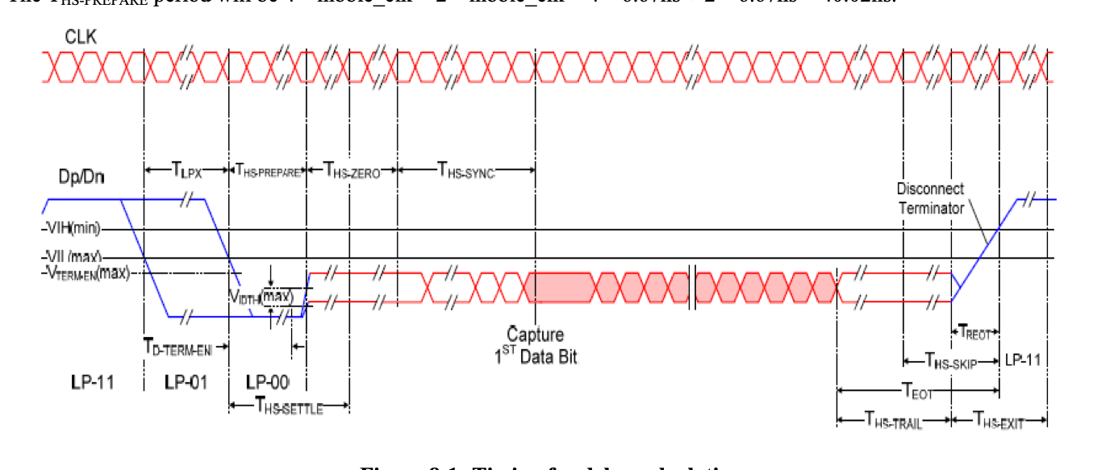

8.1.26 Delay Adjustment Register 2
Offset Address
DAR2 Delay Adjustment Register 2 0xCA
BIT | 15 | 14 | 13 | 12 | 11 | 10 | 9 | 8
NAME | CZD
TYPE | RW
RESET | 0x28
BIT | 7 | 6 | 5 | 4 | 3 | 2 | 1 | 0
NAME | CPD
TYPE | RW
RESET | 0x03

Table 8-27：Delay Adjustment Register 2 Description
Name | Description | Setting
CZD  Bit 15-8 | CLK Zero Delay – These bits specifies the  number of nibble clock for CLK zero delay  period T_{CLK-ZERO}.
CPD  Bit 7-0 | CLK Prepare Delay – These bits specifies the number of nibble clock for CLK prepare delay period T_{CLK-PREPARE}.

CZD It defined how many nibble clock is the T_{CLK-ZERO} period (Figure 9-2). For example, if the PLL is running 600bps, the nibble clock frequency will be 150Mhz, or 6.67ns. The T_{CLK-ZERO} period will be 40 * nibble_clk = 40 * 6.67ns ~= 266.8ns.
CPD It defined how many nibble clock is the T_{CLK-PREPARE} period (Figure 9-2). There is an inherence delay of around 3 nibble_clk from the edge of the LP-00. Hence the actual T_{CLK-PREPARE} period will be 3 nibble_clk + CPD * nibble_clk periods. For example, if the PLL is running 600bps, the nibble clock frequency will be 150Mhz, or 6.67ns. The T_{CLK-PREPARE} period will be 3 * nibble_clk + 3 * nibble_clk = 3 * 6.67ns + 3 * 6.67ns ~= 40.02ns.
Figure 8-2：Timing for delay calculation
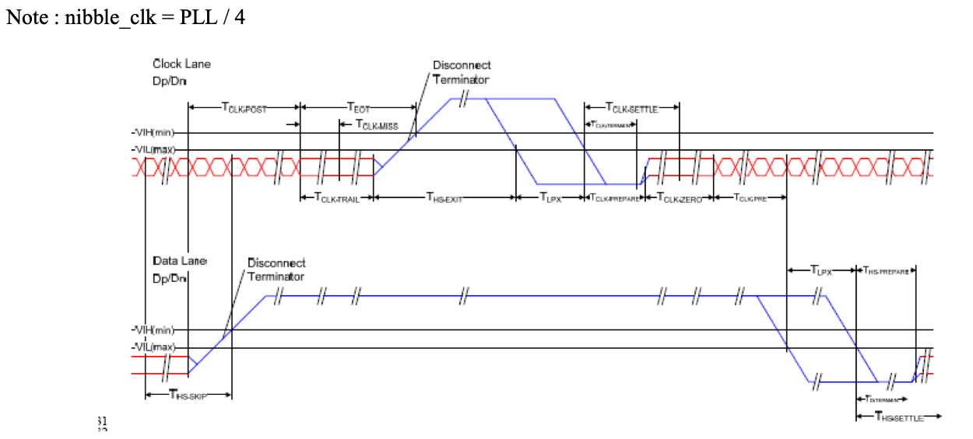

8.1.27 Delay Adjustment Register 3
Offset Address
DAR3 Delay Adjustment Register 3 0xCB
BIT | 15 | 14 | 13 | 12 | 11 | 10 | 9 | 8
NAME | CPED
TYPE | RW
RESET | 0x04
BIT | 7 | 6 | 5 | 4 | 3 | 2 | 1 | 0
NAME | CPTD
TYPE | RW
RESET | 0x16

Table 8-28：Delay Adjustment Register 3 Description
Name | Description | Setting
CPED  Bit 15-8 | CLK Pre Delay – These bits specifies the  number of nibble clock for CLK pre delay  period T_{CLK-PER}.
CPTD  Bit 7-0 | CLK Post Delay – These bits specifies the  number of nibble clock for CLK post delay  period T_{CLK-POST}.

CPED It defined how many nibble clock is the T_{CLK-PRE} period (Figure 9-2). There is an inherence delay of 0~1 lp_clk for the T_{CLK-PRE} period. For example, if the PLL is running 600bps, the nibble clock frequency will be 150Mhz, or 6.67ns. If the lpdiv is 7, then lp_clk is 9.375Mhz, or 106.67ns. The T_{CLK-PRE} period (min) will be 4 * nibble_clk + 0 * lp_clk = 4 * 6.67ns ~= 26.68ns The T_{CLK-PRE} period (max) will be 4 * nibble_clk + 1 * lp_clk = 4 * 6.67ns + 1 * 106.67ns ~= 133.35ns
CPTD It defined how many nibble clock is the T_{CLK-POST} period (Figure 9-2). For example, if the PLL is running 600bps, the nibble clock frequency will be 150Mhz, or 6.67ns. The T_{CLK-POST} period will be 22 * nibble_clk = 22 * 6.67ns ~= 146.74ns.
Note : lp_clk = PLL / (8 * (lpd+1))

8.1.28 Delay Adjustment Register 4
Offset Address
DAR4 Delay Adjustment Register 4 0xCC
BIT | 15 | 14 | 13 | 12 | 11 | 10 | 9 | 8
NAME | CTD
TYPE | RW
RESET | 0x0A
BIT | 7 | 6 | 5 | 4 | 3 | 2 | 1 | 0
NAME | HTD
TYPE | RW
RESET | 0x0A

Table 8-29：Delay Adjustment Register 4 0/1 Description
Name | Description | Setting
CTD  Bit 15-8 | CLK Trail Delay – These bits specifies the  number of nibble clock for CLK trail delay  period T_{CLK-TRAIL}.
HTD  Bit 7-0 | HS Trail Delay – These bits specifies the  number of nibble clock for HS trail delay period T_{HS-TRAIL}.  Please note that the minimum value for the T_{HS-} _{L} is 3.

CTD It defined how many nibble clock is the T_{CLK-TRAIL} period (Figure 9-2). For example, if the PLL is running 600bps, the nibble clock frequency will be 150Mhz, or 6.67ns. The T_{CLK-TRAIL} period will be 10 * nibble_clk = 10 * 6.67ns ~= 66.7ns
HTD It defined how many nibble clock is the T_{HS-TRAIL} period (Figure 9-2). For example, if the PLL is running 600bps, the nibble clock frequency will be 150Mhz, or 6.67ns.
The T_{HS-TRAIL} period will be 10 * nibble_clk = 10 * 6.67ns ~= 66.7ns.

8.1.29 Delay Adjustment Register 5
Offset Address
DAR5 Delay Adjustment Register 5 0xCD
BIT | 15 | 14 | 13 | 12 | 11 | 10 | 9 | 8
NAME | WUD[15:8]
TYPE | RW
RESET | 0x10
BIT | 7 | 6 | 5 | 4 | 3 | 2 | 1 | 0
NAME | WUD[7:0]
TYPE | RW
RESET | 0x00

Table 8-30：Delay Adjustment Register 5 Description
Name | Description | Setting
WUD  Bit 15-0 | Wake Up Delay – These bits specifies the  number of clock cycles for wake up delay period T_{WAKEUP}. The delay is used to wake up the  MIPI slave from ULPS state. The clock is the low power clock.

WUD It defined how many low power clock (lp_clk) is the T_{WAKEUP} period (Figure 9-3), from LP-10 to LP-11. For example, if the PLL is running 600bps, the nibble clock frequency will be 150Mhz, or 6.67ns. If the lpdiv = 7, lp_clk will be 9.375Mhz, or 106.6ns. The T_{WAKEUP} period will be 4096 * lp_clk = 4096 * 106.6ns ~= 436633 ns
Figure 8-3：T WAKEUP period delay calculation
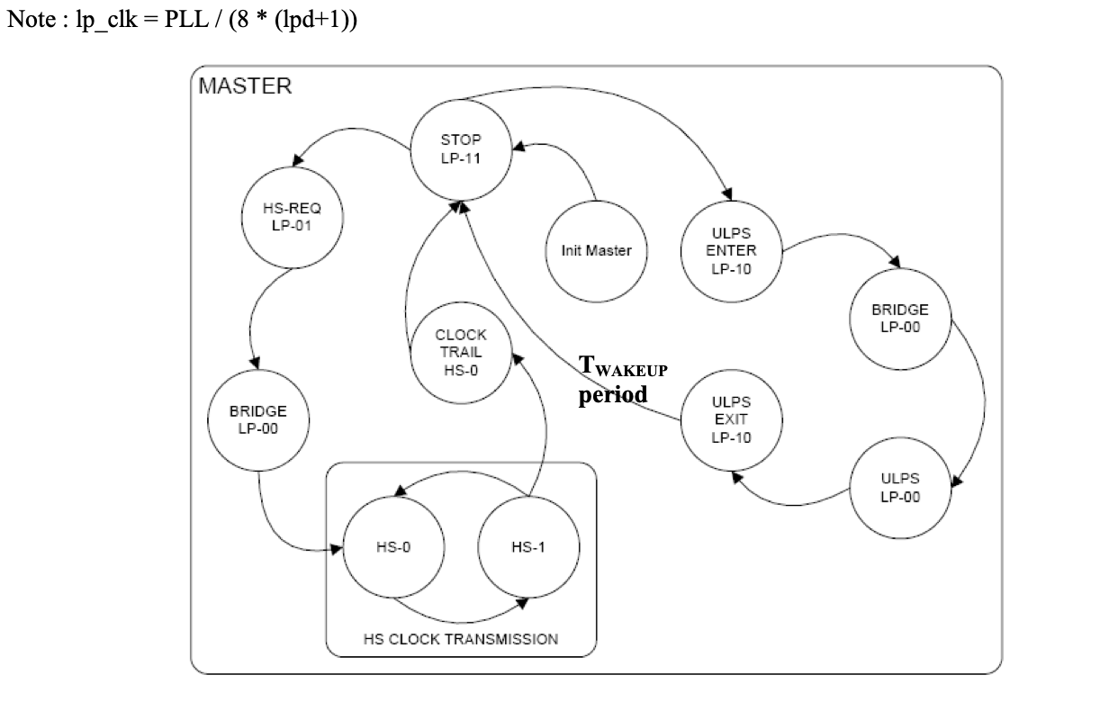

8.1.30 Delay Adjustment Register 6
Offset Address
DAR6 Delay Adjustment Register 6 0xCE
BIT | 15 | 14 | 13 | 12 | 11 | 10 | 9 | 8
NAME |  |  |  |  | TGO
TYPE | RO | RO | RO | RO | RW
RESET | 0x0 | 0x0 | 0x0 | 0x0 | 0x4
BIT | 7 | 6 | 5 | 4 | 3 | 2 | 1 | 0
NAME |  |  |  |  | TGET
TYPE | RO | RO | RO | RO | RW
RESET | 0x0 | 0x0 | 0x0 | 0x0 | 0x5

Table 8-31：Delay Adjustment Register 6 Description
Name | Description | Setting
Reserved
Bit 15-12
TGO  Bit 11-8 | TA Go Delay – These bits specifies the number of T_{LPX} for TA go delay period  T_{TA-GO}.
Reserved
Bit 7-4
TGET  Bit 3-0 | TA Get Delay – These bits specifies the number of T_{LPX} for TA get delay period  T_{TA-GET}.

TGO It defined how many T_{LPX} is the T_{TA-GO} period (Figure 9-4). T_{LPX} is half period of lp_clk. For example, if the PLL is running 600bps, the nibble clock frequency will be 150Mhz, or 6.67ns. If the lpdiv = 7, lp_clk will be 9.375Mhz, or 106.6ns. The T_{TA-GO} will be 4 * lp_clk/2 = 4 * 106.6/2 ~= 213.33ns
TGET It defined how many T_{LPX} is the T_{TA-GET} period (Figure 9-4). T_{LPX} is half period of lp_clk. For example, if the PLL is running 600bps, the nibble clock frequency will be 150Mhz, or 6.67ns. If the lpdiv = 7, lp_clk will be 9.375Mhz, or 106.6ns. The T_{TA-GET} will be 5 * lp_clk/2 = 5 * 106.6/2 ~= 266.5ns
Figure 8-4：Timing for delay calculation
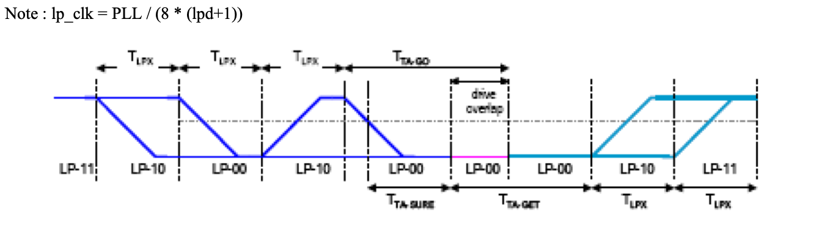

8.1.31 HS TX Timer Register 1
Offset Address
HTTR1 HS TX Timer Register 1 0xCF
BIT | 15 | 14 | 13 | 12 | 11 | 10 | 9 | 8
NAME | HTT[15:8]
TYPE | RW
RESET | 0x00
BIT | 7 | 6 | 5 | 4 | 3 | 2 | 1 | 0
NAME | HTT[7:0]
TYPE | RW
RESET | 0x00

Table 8-32：HS TX Timer Register 1 Description
Name | Description | Setting
HTT  Bit 31-0 | HS TX Timer – These bits specify the HS TX timer timeout value. PLL reference clock is  used to increment an internal timer.  The timer starts when the SSD2828 enters HS transmit mode. When the SSD2828 exits from HS transmit mode, the timer will be reset. If the timer expires before the end of HS transmission, the SSD2828 will signal an error and switch to LP mode to continue the transmission. At the same time, the HS bit will be cleared to 0.  Software intervention is required so that the  SSD2828 can go back to proper HS  transmission mode.

8.1.32 HS TX Timer Register 2
Offset Address
HTTR2 HS TX Timer Register 2 0xD0
BIT | 15 | 14 | 13 | 12 | 11 | 10 | 9 | 8
NAME | HTT[31:24]
TYPE | RW
RESET | 0x00
BIT | 7 | 6 | 5 | 4 | 3 | 2 | 1 | 0
NAME | HTT [23:16]
TYPE | RW
RESET | 0x10

Table 8-33：HS RX Timer Register 2 Description
Name | Description | Setting
HTT  Bit 31-0 | Please see the description of HS TX Timer  Register 1

8.1.33 LP RX Timer Register 1
Offset Address
LRTR1 LP RX Timer Register 1 0xD1
BIT | 15 | 14 | 13 | 12 | 11 | 10 | 9 | 8
NAME | LRT[15:8]
TYPE | RW
RESET | 0x00
BIT | 7 | 6 | 5 | 4 | 3 | 2 | 1 | 0
NAME | LRT[7:0]
TYPE | RW
RESET | 0x00

Table 8-34：LP TX Timer Register 1 Description
Name | Description | Setting
LRT  Bit 31-0 | LP RX Timer – These bits specify the LP RX timer timeout value. PLL reference clock is  used to increment an internal timer.  The timer starts when the SSD2828 enters LP receive mode. When the SSD2828 exits from LP receive mode, the timer will be reset. If the timer expires before exiting from LP receive  mode, the SSD2828 will signal an error and  switch to LP transmit mode. The DPHY will  drive the data lane to LP11 state.  Software intervention is required so that any  possible error could be cleared.

8.1.34 LP RX Timer Register 2
Offset Address
LRTR2 LP RX Timer Register 2 0xD2
BIT | 15 | 14 | 13 | 12 | 11 | 10 | 9 | 8
NAME | LRT[31:24]
TYPE | RW
RESET | 0x00
BIT | 7 | 6 | 5 | 4 | 3 | 2 | 1 | 0
NAME | LRT[23:16]
TYPE | RW
RESET | 0x10

Table 8-35：LP TX Timer Register 2 Description
Name | Description | Setting
LRT  Bit 31-0 | Please see the description of LP RX Timer  Register 1

8.1.35 TE Status Register
Offset Address
TSR TE Status Register 0xD3
BIT | 15 | 14 | 13 | 12 | 11 | 10 | 9 | 8
NAME
TYPE | RO | RO | RO | RO | RO | RO | RO | RO
RESET | 0x0 | 0x0 | 0x0 | 0x0 | 0x0 | 0x0 | 0x0 | 0x0
BIT | 7 | 6 | 5 | 4 | 3 | 2 | 1 | 0
NAME |  |  |  |  |  |  |  | TER
TYPE | RO | RO | RO | RO | RO | RO | RO | RW1C
RESET | 0x0 | 0x0 | 0x0 | 0x0 | 0x0 | 0x0 | 0x0 | 0x0

Table 8-36：TE Status Register Description
Name | Description | Setting
Reserved
Bit 15-1
TER  Bit 0 | TE Response – This bit reflects whether a TE response has been received or not. Once a TE response is received, this bit will be set to 1. At the same time, the output te signal will go high. The host processor can write 1 to clear this bit. Once the bit is cleared, the te signal will go low. | 0 –TE response has not been  received.  1 – TE response has been  received.

8.1.36 SPI Read Register
Offset Address
LRR SPI Read Register 0xD4
BIT | 15 | 14 | 13 | 12 | 11 | 10 | 9 | 8
NAME
TYPE | RO | RO | RO | RO | RO | RO | RO | RO
RESET | 0x0 | 0x0 | 0x0 | 0x0 | 0x0 | 0x0 | 0x0 | 0x0
BIT | 7 | 6 | 5 | 4 | 3 | 2 | 1 | 0
NAME | RRA
TYPE | RW
RESET | 0xFA

Table 8-37：SPI Read Register Description
Name | Description | Setting
Reserved
Bit 15-8
RRA  Bit 7-0 | Register Read Address – These bits specify the address of the register to be read through the SPI interface, when the interface is SPI 8-bit (either 3 wire or 4 wire).

8.1.37 PLL Lock Register
Offset Address
PLLR PLL Lock Register 0xD5
BIT | 15 | 14 | 13 | 12 | 11 | 10 | 9 | 8
NAME | LOCK
TYPE | RW
RESET | 0x14
BIT | 7 | 6 | 5 | 4 | 3 | 2 | 1 | 0
NAME | LOCK
TYPE | RW
RESET | 0x50

Table 8-38：PLL Lock Register Description
Name | Description | Setting
LOCK  Bit 15-0 | LOCK – These bits specify the PLL lock range in term of PLL reference frequency, f FIN . The maximum PLL lock period is 500us and the  default setting assumed the reference clock,  f FIN is 10Mhz from tx_clk.  The LOCK setting should be programmed only when PEN is 0. It has no effect when PEN is 1. | 0x1450 * f FIN = 520us

8.1.38 Test Register
Offset Address
TR Test Register 0xD6
BIT | 15 | 14 | 13 | 12 | 11 | 10 | 9 | 8
NAME | TM/FL0 |  | EIC |  |  |  |  | FLM
TYPE | RW |  | RW |  |  |  |  | RW
RESET | 0x0 |  | 0x00 |  |  |  |  | 0x0
BIT | 7 | 6 | 5 | 4 | 3 | 2 | 1 | 0
NAME | PNB |  |  |  |  |  | END | CO
TYPE | RW |  |  |  |  |  | RW | RW
RESET | 0x01 |  |  |  |  |  | 0x0 | 0x1

Table 8-39：Test Register Description
Name | Description | Setting
TM/FL0  Bit 15-14 | Test Mode – These bits selects whether to inject CRC/ECC error for the outgoing streams. They are used for debugging purpose only. They  should be set to 00 in normal mode!  Force Lane 0 – These bits are valid when FLM is 1. During this mode, user can write Low  Power value to the MIPI lane 0 data using these bits. SSD2828 will not respond to the normal  request through RGB or SPI interface.  FL0[1] controls MIPI_DP0 and FL0[0] controls MIPI_DN0. | 00 – Normal mode  01 – Inject CRC error  10 – Inject 1 bit ECC error  11 – Inject 2 bit ECC error
EIC  Bit 13-9 | Error Injection Control – These bits controls the position of the error being injected for  testing. It is only applicable when TM is 01.
FLM  Bit 8 | Force Lane Mode – This bit enable user to  write to FL0 bits to directly control the analog lane DP0 and DP1.  The lane should be in Low Power mode(HS=0) when write using FL0. | 0 – Normal Mode  1 – Force Lane Mode
PNB  Bit 7-2 | Packet Number in Blanking Period – These bits controls the number of packet to send  during video mode blanking period.
END  Bit 1 | Endianess – Internal test only. Default as 0
CO  Bit 0 | Color Order – This bit specifies the order of  the color component in the pixel.  During command mode transmission, this bit  takes effect only when the IFS bit is 1 and the transmitted packet is DCS write memory packet, 0x2C or 0x3C.  During video mode transmission, this bit must be set to 1 so as to follow the MIPI DSI  specification. | 1 – RGB. R is in the higher  portion of the pixel.  0 – BGR. B is in the higher  portion of the pixel.

Remark: 24 bits color format
CO | D23 | D22 | D21 | D20 | D19 | D18 | D17 | D16 | D15 | D14 | D13 | D12 | D11 | D10 | D9 | D8 | D7 | D6 | D5 | D4 | D3 | D2 | D1 | D0
1 | R7 | R6 | R5 | R4 | R3 | R2 | R1 | R0 | G7 | G6 | G5 | G4 | G3 | G2 | G1 | G0 | B7 | B6 | B5 | B4 | B3 | B2 | B1 | B0
0 | B7 | B6 | B5 | B4 | B3 | B2 | B1 | B0 | G7 | G6 | G5 | G4 | G3 | G2 | G1 | G0 | R7 | R6 | R5 | R4 | R3 | R2 | R1 | R0

8.1.39 TE Count Register
Offset Address
TECR TE Count Register 0xD7
BIT | 15 | 14 | 13 | 12 | 11 | 10 | 9 | 8
NAME | TEC[15:8]
TYPE | RW
RESET | 0x00
BIT | 7 | 6 | 5 | 4 | 3 | 2 | 1 | 0
NAME | TEC[7:0]
TYPE | RW
RESET | 0x01

Table 8-40：TE Count Register Description
Name | Description | Setting
TEC  Bit 15-0 | TE Count – These bits determines the pulse  width of the output te signal. A counter will be started after the TE signal goes to 1. When the counter reaches the value in TEC field, the te signal will be set to 0. The counter uses the  PLL reference clock to do counting. | The minimum value is 1.

8.1.40 Analog Control Register
Offset Address
ACR1 Analog Control 1 Register 0xD8
BIT | 15 | 14 | 13 | 12 | 11 | 10 | 9 | 8
NAME | D3_DELAY_SEL[3:2] |  | D1_DELAY_SEL
TYPE | RW |  | RW
RESET | 0x0 |  | 0x20
BIT | 7 | 6 | 5 | 4 | 3 | 2 | 1 | 0
NAME | D3_DELAY_SEL[1:0] |  | D0_DELAY_SEL
TYPE | RW |  | RW
RESET | 0x0 |  | 0x20

Table 8-41：Analog Control 1 Register Description
Name | Description | Setting
D3_DELAY_ SEL[3:2]  Bit 15-14 | Data lane 3 DELAY SELect[3:2] – These bits control the delay for serializer output to the HS transmitter.
D1_DELAY_ SEL  Bit 13-8 | Data lane 1 DELAY SELect – These bits  control the delay for serializer output to the HS transmitter.
D3_DELAY_ SEL[1:0]  Bit 7-6 | Data lane 3 DELAY SELect[1:0] – These bits control the delay for serializer output to the HS transmitter.
D0_DELAY_ SEL  Bit 5-0 | Data lane 0 DELAY SELect – These bits  control the delay for serializer output to the HS transmitter.

8.1.41 Analog Control Register 2
Offset Address
ACR2 Analog Control Register 2 0xD9
BIT | 15 | 14 | 13 | 12 | 11 | 10 | 9 | 8
NAME | HSTX_Z |  | LPTXDS |  |  | HSTX_DS
TYPE | RW |  | RW |  |  | RW
RESET | 0x1 |  | 0x4 |  |  | 0x4
BIT | 7 | 6 | 5 | 4 | 3 | 2 | 1 | 0
NAME | D3_DELAY_SEL[5:4] |  | D2_DELAY_SEL
TYPE | RW |  | RW
RESET | 0x2 |  | 0x20

Table 8-42：Analog Control Register 2 Description
Name | Description | Setting
HSTX_Z  Bit 15-14 | High Speed Transmit Trimming control –  These bits control the trimming for output  impedance control.
LPTXDS  Bit 13-11 | Low Power TX Drive strength Selection –  These bits control the drive strength for the TX in low power mode.
HSTX_DS Bit 10-8 | High Speed TX current Driver Selection –  These bits control the driving current for the TX in high speed mode.
D3_DELAY_ SEL[5:4]  Bit 7-6 | Data lane 3 DELAY SELect[5:4] –These bits control the delay for serializer output to the HS transmitter.
D2_DELAY_ SEL  Bit 5-0 | Data lane 2 DELAY SELect – These bits  control the delay for serializer output to the HS transmitter.

8.1.42 Analog Control Register 3
Offset Address
ACR3 Analog Control Register 3 0xDA
BIT | 15 | 14 | 13 | 12 | 11 | 10 | 9 | 8
NAME | TLFT1 | TLFT0 | PREEM_SEL |  |  | PREEM_MOD |  | PREEM_ E
TYPE | RW | RW | RW |  |  | RW |  | RW
RESET | 0x1 | 0x0 | 0x3 |  |  | 0x0 |  | 0x1
BIT | 7 | 6 | 5 | 4 | 3 | 2 | 1 | 0
NAME | THFT1 | THFT0 | TC |  |  | ISEL
TYPE | RW | RW | RW |  |  | RW
RESET | 0x1 | 0x0 | 0x04 |  |  | 0x04

Table 8-43：Analog Control Register 3 Description
Name | Description | Setting
TLFT1
Bit 15
TLFT0
Bit 14
PREEM_SE L  Bit 13-11 | PREEM_SEL – Used for tap selection for preemphasis.
PREEM_M OD  Bit 10-9 | PREEM_MOD – Preemphasis mode selection.
PREEM_E Bit 8 | PRE-EMphasis Enable – Used for HSTX.
THFT1  Bit 7 | ThresHold 1 – This bit controls the low power receiver  schmitt trigger high to low threshold selection1.
THFT0  Bit 6 | ThresHold 0 – This bit controls the low power receiver  schmitt trigger high to low threshold selection 0.
TC  Bit 5-3 | Temperature Coefficient Select – These bits  control the temperature coefficient of the bandbap regulator.
ISEL  Bit 2-0 | Current Output Trim – These bits control current output trim of the bandgap regulator.

8.1.43 Analog Control Register 4
Offset Address
ACR4 Analog Control Register 4 0xDB
BIT | 15 | 14 | 13 | 12 | 11 | 10 | 9 | 8
NAME | CLK_DELAY_SEL |  |  |  |  |  | CKF
TYPE | RW |  |  |  |  |  | RW | RO
RESET | 0x20 |  |  |  |  |  | 0x0 | 0x0
BIT | 7 | 6 | 5 | 4 | 3 | 2 | 1 | 0
NAME | TCI |  |  | ENLV | CD_EN | GFFT1 | GFFT0 | GF_E
TYPE | RW |  |  | RW | RW | RW | RW | RW
RESET | 0x4 |  |  | 0x1 | 0x1 | 0x0 | 0x0 | 0x0

Table 8-44：Analog Control Register 4 Description
Name | Description | Setting
CLK_DELA Y_SEL  Bit 15-10 | CLocK lane DELAY SELect – These bits  control the delay for serializer output to the HS transmitter.
CKF  Bit 9 | ClocK Flip – This bit controls whether to flip the  TX_LP_CP and TX_LP_CN to the analog block. It should be set to 0 for normal operation.
Reserved
Bit 8
TCI  Bit 7-5 | Current Temperature Coefficient Select
ENLV  Bit 4 | BandGap Reference Enable
CD_EN  Bit 3 | Contention Detection Enable
GFFT1  Bit 2 | Glitch Filter Selection 1
GFFT0  Bit 1 | Glitch Filter Selection 0
GF_E  Bit 0 | Glitch filter Enable

8.1.44 Interrupt Output Control Register
Offset Address
IOCR Interrupt Output Control Register 0xDC
BIT | 15 | 14 | 13 | 12 | 11 | 10 | 9 | 8
NAME
TYPE | RO | RO | RO | RO | RO | RO | RO | RO
RESET | 0x0 | 0x0 | 0x0 | 0x0 | 0x0 | 0x0 | 0x0 | 0x0
BIT | 7 | 6 | 5 | 4 | 3 | 2 | 1 | 0
NAME |  |  |  |  |  | IOT |  | IAS
TYPE | RO | RO | RO | RO | RO | RW |  | RW
RESET | 0x0 | 0x0 | 0x0 | 0x0 | 0x0 | 0x0 |  | 0x0

Table 8-45：Interrupt Output Control Register Description
Name | Description | Setting
Reserved
Bit 15-3
IOT  Bit 2-1 | Interrupt Output Type – These bits specify the type of output for the int.  Write to this bit is only valid when all the enable bits in the Interrupt Control Registers(0xC5) are 0. | 00 – CMOS output  01 – Open Drain active low  output(Wired-AND). The IAS  should be 0 when selected.  1x – Open Drain active high  output(Wired-OR). The IAS  should be 1 when selected.  11 – NA
IAS  Bit 0 | Interrupt Active State – This bit selects the  polarity of the int pin at the chip IO.  Write to this bit is only valid when all the enable bits in the Interrupt Control Registers(0xC5) are 0. | 0 – int pin is active low, when  there is no interrupt events,  it is normally high.  1 – int pin is active high, when  there is no interrupt events,  it is normally low.

8.1.45 RGB Interface Control Register 7
Offset Address
VICR7 RGB Interface Control Register7 0xDD
BIT | 15 | 14 | 13 | 12 | 11 | 10 | 9 | 8
NAME
TYPE | RO | RO | RO | RO | RO | RO | RO | RO
RESET | 0x0 | 0x0 | 0x0 | 0x0 | 0x0 | 0x0 | 0x0 | 0x0
BIT | 7 | 6 | 5 | 4 | 3 | 2 | 1 | 0
NAME | VBN |  |  |  | VFN
TYPE | RW |  |  |  | RW
RESET | 0x00 |  |  |  | 0x00

Table 8-46：RGB Interface Control Register 7 Description
Name | Description | Setting
Reserved
Bit 15-8
VBN  Bit 7-4 | Vertical Front Porch Non Video Data  Window  These fields specify the number of vertical back porch counting backward from the first vertical active line in which non-video data is not  allowed to be sent via MIPI link.  This field is only valid when VEN is 1 and the interface setting is RGB + SPI. This field should not larger than VBP. If it is larger, the internal logic will cap this field to VBP.
VFN  Bit 3-0 | Vertical Back Porch Non Video Data  Window  These fields specify the number of vertical front porch from the last vertical active line in which non-video data is not allowed to be sent via  MIPI link.  This field is only valid when VEN is 1 and the interface setting is RGB + SPI. This field should not larger than VFP. If it is larger, the internal logic will cap this field to VFP.

Note: Setting VBN ≥ VBP and VFN ≥ VFP at the same time will cause non-video data not being sent out through MIPI link when the video mode is non-burst mode or burst mode with NVB = 1.

8.1.46 Lane Configuration Register
Offset Address
LCFR Lane Configuration Register 0xDE
BIT | 15 | 14 | 13 | 12 | 11 | 10 | 9 | 8
NAME
TYPE | RO | RO | RO | RO | RO | RO | RO | RO
RESET | 0x0 | 0x0 | 0x0 | 0x0 | 0x0 | 0x0 | 0x0 | 0x0
BIT | 7 | 6 | 5 | 4 | 3 | 2 | 1 | 0
NAME |  |  |  |  |  |  | LS
TYPE | RO | RO | RO | RO | RO | RO | RW
RESET | 0x0 | 0x0 | 0x0 | 0x0 | 0x0 | 0x0 | 0x00

Table 8-47：Lane Configuration Register Description
Name | Description | Setting
Reserved
Bit 15-2
LS0  Bit 1-0 | Lane Select – These bits define the number of lane to be used for SSD2828. | 00 – 1 lane mode  01 – 2 lane mode  10 – 3 lane mode  11 – 4 lane mode

8.1.47 Delay Adjustment Register 7
Offset Address
DAR7 Delay Adjustment Register 7 0xDF
BIT | 15 | 14 | 13 | 12 | 11 | 10 | 9 | 8
NAME
TYPE | RO | RO | RO | RO | RO | RO | RO | RO
RESET | 0x0 | 0x0 | 0x0 | 0x0 | 0x0 | 0x0 | 0x0 | 0x0
BIT | 7 | 6 | 5 | 4 | 3 | 2 | 1 | 0
NAME |  |  | HED
TYPE | RO | RO | RW
RESET | 0x0 | 0x0 | 0x10

Table 8-48：Delay Adjustment Register 7 Description
Name | Description | Setting
Reserved
Bit 15-6
HED  Bit 5-0 | HS Exit Delay – These bits specifies the  number of nibble clock for HS exit delay period for data and clock lane.

8.1.48 Pull Control Register 1
Offset Address
PUCR1 Pull Control Register 1 0xE0
BIT | 15 | 14 | 13 | 12 | 11 | 10 | 9 | 8
NAME | XTAL_PULL |  | PS4_PULL |  | PS3_PULL |  | PS2_PULL
TYPE | RW |  | RW |  | RW |  | RW
RESET | 0x1 |  | 0x1 |  | 0x1 |  | 0x1
BIT | 7 | 6 | 5 | 4 | 3 | 2 | 1 | 0
NAME | PS1_PULL |  | PS0_PULL |  | IS_PULL |  | MR_PULL
TYPE | RW |  | RW |  | RW |  | RW
RESET | 0x1 |  | 0x1 |  | 0x1 |  | 0x2

Table 8-49：Pull Control Register 1 Description
Name | Description | Setting
CSX_PULL Bit 15-14 | Chip Select Pull – These bits select the pull  state of the pin csx. | 00 – No pull  10 – 75k pull-up  01 – 75k pull-down  11 – 75k Keeper
XTAL_PUL L  Bit 15-14 | Xtal Mode Pull – These bits select the pull  state of the pin xtal_mode. | 00 – No pull  10 – 75k pull-up  01 – 75k pull-down  11 – 75k Keeper
PS4_PULL Bit 13-12 | Pin Select 3 Pull – These bits select the pull  state of the pin ps[4]. | 00 – No pull  10 – 75k pull-up  01 – 75k pull-down  11 – 75k Keeper
PS3_PULL Bit 11-10 | Pin Select 3 Pull – These bits select the pull  state of the pin ps[3]. | 00 – No pull  10 – 75k pull-up  01 – 75k pull-down  11 – 75k Keeper
PS2_PULL Bit 9-8 | Pin Select 2 Pull – These bits select the pull  state of the pin ps[2]. | 00 – No pull  10 – 75k pull-up  01 – 75k pull-down  11 – 75k Keeper
PS1_PULL Bit 7-6 | Pin Select 1 Pull – These bits select the pull  state of the pin ps[1]. | 00 – No pull  10 – 75k pull-up  01 – 75k pull-down  11 – 75k Keeper
PS0_PULL Bit 5-4 | Pin Select 0 Pull – These bits select the pull  state of the pin ps[0]. | 00 – No pull  10 – 75k pull-up  01 – 75k pull-down  11 – 75k Keeper
IS_PULL  Bit 3-2 | If_Sel Pull – These bits select the pull state of the pin if_sel. | 00 – No pull  10 – 75k pull-up  01 – 75k pull-down  11 – 75k Keeper
MR_PULL Bit 1-0 | MIPI Reset Pull – These bits select the pull  state of the pin mipi_reset_b. | 00 – No pull  10 – 75k pull-up  01 – 75k pull-down

Name | Description | Setting
 |  | 11 – 75k Keeper

8.1.49 Pull Control Register 2
Offset Address
PUCR2 Pull Control Register 2 0xE1
BIT | 15 | 14 | 13 | 12 | 11 | 10 | 9 | 8
NAME | DEN_PULL |  | HS_PULL |  | PC_PULL |  | VS_PULL
TYPE | RW |  | RW |  | RW |  | RW
RESET | 0x1 |  | 0x2 |  | 0x1 |  | 0x2
BIT | 7 | 6 | 5 | 4 | 3 | 2 | 1 | 0
NAME | DH_PULL |  | DM_PULL |  | DL_PULL |  | CSX_PULL
TYPE | RW |  | RW |  | RW |  | RW
RESET | 0x1 |  | 0x1 |  | 0x1 |  | 0x2

Table 8-50：Pull Control Register 2 Description
Name | Description | Setting
DEN_PULL Bit 15-14 | Den Pull – These bits select the pull state of the pin den. | 00 – No pull  10 – 75k pull-up  01 – 75k pull-down  11 – 75k Keeper
HS_PULL Bit 13-12 | Hsync Pull – These bits select the pull state of the pin hsync. | 00 – No pull  10 – 75k pull-up  01 – 75k pull-down  11 – 75k Keeper
PC_PULL Bit 11-10 | Pixel_clk Pull – These bits select the pull state of the pin pclk. | 00 – No pull  10 – 75k pull-up  01 – 75k pull-down  11 – 75k Keeper
VS_PULL Bit 9-8 | Vsync Pull – These bits select the pull state of the pin vsync. | 00 – No pull  10 – 75k pull-up  01 – 75k pull-down  11 – 75k Keeper
DH_PULL Bit 7-6 | Data high byte Pull – These bits select the pull state of the pins data[23:16]. | 00 – No pull  10 – 75k pull-up  01 – 75k pull-down  11 – 75k Keeper
DM_PULL Bit 5-4 | Data medium byte Pull – These bits select the pull state of the pins data[15:8]. | 00 – No pull  10 – 75k pull-up  01 – 75k pull-down  11 – 75k Keeper
DL_PULL Bit 3-2 | Data low byte Pull – These bits select the pull state of the pins data[7:0]. | 00 – No pull  10 – 75k pull-up  01 – 75k pull-down  11 – 75k Keeper
CSX_PULL Bit 1-0 | Chip Select Pull – These bits select the pull  state of the pin csx. | 00 – No pull  10 – 75k pull-up  01 – 75k pull-down  11 – 75k Keeper

8.1.50 Pull Control Register 3
Offset Address
PUCR3 Pull Control Register 3 0xE2
BIT | 15 | 14 | 13 | 12 | 11 | 10 | 9 | 8
NAME |  |  |  |  |  |  | SDI_PULL
TYPE | RO | RO | RO | RO | RO | RO | RW
RESET | 0x0 | 0x0 | 0x0 | 0x0 | 0x0 | 0x0 | 0x1
BIT | 7 | 6 | 5 | 4 | 3 | 2 | 1 | 0
NAME | SCK_PULL |  | SDC_PULL |  | SHUT_PULL |  | CM_PULL
TYPE | RW |  | RW |  | RW |  | RW
RESET | 0x1 |  | 0x1 |  | 0x2 |  | 0x1

Table 8-51：Pull Control Register 3 Description
Name | Description | Setting
Reserved
Bit 15-10
SDI_PULL Bit 9-8 | SDI Pull – These bits select the pull state of the pin sdi. | 00 – No pull  10 – 75k pull-up  01 – 75k pull-down  11 – 75k Keeper
SCK_PULL Bit 7-6 | SCK Pull – These bits select the pull state of  the pin sck. | 00 – No pull  10 – 75k pull-up  01 – 75k pull-down  11 – 75k Keeper
SDC_PULL Bit 5-4 | SDC Pull – These bits select the pull state of the pin sdc. | 00 – No pull  10 – 75k pull-up  01 – 75k pull-down  11 – 75k Keeper
SHUT_PUL L  Bit 3-2 | Shut Pull – These bits select the pull state of the pin shut. | 00 – No pull  10 – 75k pull-up  01 – 75k pull-down  11 – 75k Keeper
CM_PULL Bit 1-0 | CM Pull – These bits select the pull state of the pin cm. | 00 – No pull  10 – 75k pull-up  01 – 75k pull-down  11 – 75k Keeper

8.1.51 CABC Brightness Control Register 1
Offset Address
CBCR1 CABC Brightness Control Register 1 0xE9
BIT | 15 | 14 | 13 | 12 | 11 | 10 | 9 | 8
NAME | WDBV
TYPE | RW
RESET | 0x00
BIT | 7 | 6 | 5 | 4 | 3 | 2 | 1 | 0
NAME |  | GAM18 | BL | DD | BCTR | BP_MODE |  | CABC_ EN
TYPE | RO | RW | RW | RW | RW | RW |  | RW
RESET | 0x0 | 0x0 | 0x0 | 0x0 | 0x0 | 0x0 |  | 0x0

Table 8-52：CABC Brightness Control Register 1 Description
Name | Description | Setting
WDBV  Bit 15-8 | Write Display Brightness Value – These bits control the brightness setting.
Reserved
Bit 7
GAM18  Bit 6 | Gamma 18 – This bit controls gamma 18  select.
BL  Bit 5 | BackLight Control – This bit controls the  backlight on/off at BC line. | 0 – Off  (Completely turn off backlight  circuit)  1 – On
DD  Bit 4 | Display Dimming – This bit controls the  display dimming feature. | 0 – Display Dimming Off  1 – Display Dimming On
BCTR  Bit 3 | Brightness Control – This bit controls the  On/Off state of the Brightness Control block. | 0 – Off  1 – On
BP_MODE Bit 2-1 | BP MODE – These bits control the Brightness Preservation of the CABC. | 00 – Disable DABC  01 – Conservation Mode  (Or User Interface Mode)  10 – Normal Mode  (Or Still Picture Mode)  11 – Aggressive Mode  (Or Moving Image Mode)
CABC_EN Bit 0 | CABC ENable – This bit enable the CABC  feature.  This bit is valid only when if_sel is 0. | 0 – CABC is disable  1 – CABC is enable

8.1.52 CABC Brightness Control Register 2
Offset Address
CBCR2 CABC Brightbess Control Register 2 0xEA
BIT | 15 | 14 | 13 | 12 | 11 | 10 | 9 | 8
NAME | PWM_PS |  |  |  | BCB_PS
TYPE | RW |  |  |  | RW
RESE T | 0x6 |  |  |  | 0x9
BIT | 7 | 6 | 5 | 4 | 3 | 2 | 1 | 0
NAME | CABC_MB
TYPE | RW
RESE T | 0x00

Table 8-53：CABC Brightness Control Register 2 Description
Name | Description | Setting
PWM_PS  Bit 15-12 | PWM PreScale – These bits control the PWM signal frequency. | This will depend on pixel clock  speed (pclk). For example,  10MHz = “0111” or “1000”  20MHz = “0110” or “0101”
BCD_PS  Bit 11-8 | BCB PreScale – These bits control the number of iternation per second carried out by the BCB unit. | This will depend on pixel clock  speed (pclk). For example,  5MHz = “0101”  10MHz = “0110”  25MHz = “1001”  50MHz = “1011”  75MHz = “1100”
CABC_MB Bit 7-0 | CABC Minimum Brightness – These bits  control the CABC Minimum Brightness level.

8.1.53 CABC Brightness Status Register
Offset Address
CBSR CABC Brightness Status Register 0xEB
BIT | 15 | 14 | 13 | 12 | 11 | 10 | 9 | 8
NAME | VGA_SEL |  |  |  |  |  |  | BCL
TYPE | RW |  |  |  | RO | RO | RO | RO
RESE T | 0x0 |  |  |  | 0x0 | 0x0 | 0x0 | 0x0
BIT | 7 | 6 | 5 | 4 | 3 | 2 | 1 | 0
NAME | RDBV
TYPE | RO
RESE T | 0x00

Table 8-54：CABC Brightness Status Register Description
Name | Description | Setting
VGA_SEL Bit 15-12 | VGA SELect – These bits select the type of  resolution of the RGB frame. Panel resolutions need not be matched exactly. For example,  "0111" will work for any panel with 384000  pixels (+/- 15%). In other words, the range is  326400 to 441600 pixels. Hence, 800x480,  480x800, 512x750 and 750x512 will be  supported by VGA_SEL= "0111". | 0001 - 400x240 (WQVGA)  0010 - 400x300 (SQVGA)  0011 - 480x320 (FVGA)  0100 - 540x360 (FVGA+)  0101 - 600x400 (FVGA++)  0110 - 640x480 (VGA)  0111 - 800x480 (WVGA)  1000 - 800x600 (SVGA)  1001 - 1024x600 (WSVGA)  1010 - 1024x768 (XGA)  1011 - 1280x768 (WXGA)  1100 - 1280x960 (SXGA)  1101 - Reserved  1110 - Reserved  1111 - Reserved
Reserved
Bit 11-9
BCL  Bit 8 | Brightness Control Line – This bit is the pulse width modulation signal output to control  external backlight power source.  This output is used for Architecture I.
RDBV  Bit 7-0 | Read Display Brightness Value – These bits show the brightness value of the CABC. This  output is used for Architecture II.

8.1.54 Encoder Control Register
Offset Address
ECR Encoder Control Register 0xEC
BIT | 15 | 14 | 13 | 12 | 11 | 10 | 9 | 8
NAME | ENC_LW
TYPE | RW
RESE T | 0x78
BIT | 7 | 6 | 5 | 4 | 3 | 2 | 1 | 0
NAME | ENC_LW |  |  |  |  |  | ENC_MO DE | ENC_EN
TYPE | RW |  |  |  | RO | RO | RW | RW
RESE T | 0x0 |  |  |  | 0x0 | 0x0 | 0x0 | 0x0

Table 8-55：Encoder Control Register Description
Name | Description | Setting
ENC_LW  Bit 15-4 | ENCoder LineWidth – These bits define the input line width of the Encoder input.
Reserved
Bit 3-2
ENC_MODE Bit 1 | ENCoder Mode – This bit select the Smartlink Encoder mode.  This bit is valid only when if_sel is 0. | 0 – Type 1  1 – Type 2
ENC_EN  Bit 0 | ENCoder ENable – This bit enable the  Smartlink Encoder feature.  This bit is valid only when if_sel is 0. | 0 – Encoder is disable  1 – Encoder is enable

8.1.55 Video Sync Delay Register
Offset Address
VSDR Video Sync Delay Register 0xED
BIT | 15 | 14 | 13 | 12 | 11 | 10 | 9 | 8
NAME | VSD
TYPE | RW
RESE T | 0x00
BIT | 7 | 6 | 5 | 4 | 3 | 2 | 1 | 0
NAME | HSD
TYPE | RW
RESE T | 0x02

Table 8-56：Video Sync Delay Register Description
Name | Description | Setting
VSD  Bit 15:8 | VSync Delay – These bits control the internal pipeline delay of the Vsync input.
HSD  Bit 7:0 | HSync Delay – These bits control the internal pipeline delay of the Hsync input.

8.1.56 Trimming Register
Offset Address
TMR Trimming Register 0xEE
BIT | 15 | 14 | 13 | 12 | 11 | 10 | 9 | 8
NAME | TRIM_ DONE | TRIM_ PASS | XORC_ DONE | XORC_ SEL | XORC_ EN | VBIST_ SRT | VBIST_ EN | TRIM_EN
TYPE | RO | RO | RO | RW | RWAC | RW | RW | RWAC
RESE T | 0x0 | 0x0 | 0x0 | 0x0 | 0x0 | 0x0 | 0x0 | 0x0
BIT | 7 | 6 | 5 | 4 | 3 | 2 | 1 | 0
NAME | TRIM_CMD[7:4] |  |  |  | TRIM_CMD[3:0]/XORC_FILTER[3:0]
TYPE | RW |  |  |  | RW
RESE T | 0x0 |  |  |  | 0x0

Table 8-57：Trimming Register Description
Name | Description | Setting
TRIM_DON E  Bit 15 | TRIMming DONE – This bit indicates if the trimming process is done.
TRIM_PASS Bit 14 | TRIMming PASS – This bit indicates if the  trimming process is successful. It is valid when bit 15 is set to 1.
XORC_DON E  Bit 13 | XOR Calibration DONE – This bit indicates if the trimming process is done. This bit will be  cleared when read.
XORC_SEL Bit 12 | XOR Calibration SELect – This bit select the internal byte data for calibration to be 8’hAA or 8’h55. | 0 = 8’h55  1 = 8’hAA
XORC_EN Bit 11 | XOR Calibration ENable – This bit starts the internal XOR calibration process and when the calibration is done, this bit will be auto clear and the status bits at bit 13 indicates that the  calibration process is done.
VBIST_SRT Bit 10 | Video BIST StaRT – This bit starts the video bist process. Once clear, the video bist engine will stop at the frame boundary.  The software should wait for at least 1 frame  time before disabling the VBIST_EN bit.
VBIST_EN Bit 9 | Video BIST ENable – This bit enables the  video bist function. The SSD2828 will  automatically send the color, red, green, blue, black and white repeatedly base on current  setting.  This bit should be 0 in normal mode.
TRIM_EN Bit 8 | TRIMming ENable – This bit enables the auto trimming process and when the trimming is  done, this bit will be auto clear and the status  bits at bit 14 and bit 15 indicates if the trimming process is successful.

Name | Description | Setting
 | This bit should be 0 in normal mode.
TRIM_CMD Bit 7:4 | TRIMming CoMmanD – These bits define the upper 4 bits of the command header byte to be used in auto-trimming mode, when  TRIM_EN=1, where SSD2828 send out a read request to the MIPI receiver.
TRIM_CMD /XORC_FIL TER  Bit 3:0 | TRIMming CoMmanD – These bits define the lower 4 bits of the command header byte to be used in auto-trimming mode, when  TRIM_EN=1, where SSD2828 send out a read request to the MIPI receiver.  When XORC_EN=1, these bits define the filter to qualify the XOR calibration pulse width.

8.1.57 GPIO1 Register
Offset Address
GPIO1 GPIO1 Register 0xEF
BIT | 15 | 14 | 13 | 12 | 11 | 10 | 9 | 8
NAME | GPIO1_ STAT | GPIO1_CTR
TYPE | RO | RW
RESE T | 0x0 | 0x00
BIT | 7 | 6 | 5 | 4 | 3 | 2 | 1 | 0
NAME | GPIO0_ STAT | GPIO0_CTR
TYPE | RO | RW
RESE T | 0x0 | 0x00

Table 8-58：GPIO1 Register Description
Name | Description | Setting
GPIO1_CTR Bit 15 | GPIO 1 Status – This bit provide the status of the te pin when it is configured as input.
GPIO1_CTR Bit 14:8 | GPIO 1 Control – These bits control the  output behavior of the te pin. | Please see the description at  bit 6-0.
GPIO0_CTR Bit 7 | GPIO 0 Status – This bit provide the status of the dbcl pin when it is configured as input.
GPIO0_CTR Bit 6:0 | GPIO 0 Control – These bits control the  output behavior of the dbcl pin. | Bit 0 – Module or Register  This bit controls the pin to be  module controlled or register  controlled.  0 – Module controlled  1 – Register controlled  Bit 1 – Direction  This bit controls the direction of the pin when bit 0 is 1. When bit 0 is 0, it has no effect.  0 – Pin is input  1 – Pin is output  Bit 2 : Output State  This bit controls the output state of the pin when bit 0 is 1. When bit 0 is 0, it has no effect.  0 – Output state is 0  1 – Output state is 1  Bit 4-3 : Pull State  These bits control the pull state of the pin when it is in input state.  00 – No pull  10 – 75k pull-up  01 – 75k pull-down  11 – 75k Keeper

Name | Description | Setting
Bit 5 : Interrupt Enable
This bit enables the GPIO0
input(bit 1 = 0) interrupt to the int pin. When bit 0 is 0, it has no
effect.
Bit 6 : Interrupt Polarity
This bit selects the polarity of the GPIO0 input(bit 1 = 0) when bit 5 is enabled. When bit 0 is 0, it has no effect.
0 – Active low
1 – Active high

8.1.58 GPIO2 Register
Offset Address
GPIO2 GPIO2 Register 0xF0
BIT | 15 | 14 | 13 | 12 | 11 | 10 | 9 | 8
NAME
TYPE | RO | RO | RO | RO | RO | RO | RO | RO
RESE T | 0x0 | 0x0 | 0x0 | 0x0 | 0x0 | 0x0 | 0x0 | 0x0
BIT | 7 | 6 | 5 | 4 | 3 | 2 | 1 | 0
NAME | GPIO2_ STAT | GPIO2_CTR
TYPE | RO | RW
RESE T | 0x0 | 0x00

Table 8-59：GPIO1 Register Description
Name | Description | Setting
Reserved
Bit 15-8
GPIO2_CTR Bit 7 | GPIO 2 Status – This bit provide the status of the sys_clk_out pin when it is configured as  input.
GPIO2_CTR Bit 6:0 | GPIO 2 Control – These bits control the  output behavior of the sys_clk_out pin. | Bit 0 – Module or Register  This bit controls the pin to be  module controlled or register  controlled.  0 – Module controlled  1 – Register controlled  Bit 1 – Direction  This bit controls the direction of the pin when bit 0 is 1. When bit 0 is 0, it has no effect.  0 – Pin is input  1 – Pin is output  Bit 2 : Output State  This bit controls the output state of the pin when bit 0 is 1. When bit 0 is 0, it has no effect.  0 – Output state is 0  1 – Output state is 1  Bit 4-3 : Pull State  These bits control the pull state of the pin when it is in input state.  00 – No pull  10 – 75k pull-up  01 – 75k pull-down  11 – 75k Keeper  Bit 5 : Interrupt Enable

Name | Description | Setting
This bit enables the GPIO0
input(bit 1 = 0) interrupt to the int pin. When bit 0 is 0, it has no
effect.
Bit 6 : Interrupt Polarity
This bit selects the polarity of the GPIO0 input(bit 1 = 0) when bit 5 is enabled. When bit 0 is 0, it has no effect.
0 – Active low
1 – Active high

8.1.59 DLYA01 Register
Offset Address
DLYA01 DLYA01 Register 0xF1
BIT | 15 | 14 | 13 | 12 | 11 | 10 | 9 | 8
NAME |  |  | DELAY_A_1
TYPE | RO | RO | RO
RESE T | 0x0 | 0x0 | 0x20
BIT | 7 | 6 | 5 | 4 | 3 | 2 | 1 | 0
NAME |  |  | DELAY_A_0
TYPE | RO | RO | RO
RESE T | 0x0 | 0x0 | 0x20

Table 8-60：DLYA01 Register Description
Name | Description | Setting
Reserved
Bit 15-14
DELAY_A_1 Bit 13-8 | DELAY A for lane 1 – These bits provide the status of the XOR calibration results when  XORC_SEL is set to 0.
Reserved
Bit 7-6
DELAY_A_0 Bit 5-0 | DELAY A for lane 0 – These bits provide the status of the XOR calibration results when  XORC_SEL is set to 0.

8.1.60 DLYA23 Register
Offset Address
DLYA23 DLYA23 Register 0xF2
BIT | 15 | 14 | 13 | 12 | 11 | 10 | 9 | 8
NAME |  |  | DELAY_A_3
TYPE | RO | RO | RO
RESE T | 0x0 | 0x0 | 0x20
BIT | 7 | 6 | 5 | 4 | 3 | 2 | 1 | 0
NAME |  |  | DELAY_A_2
TYPE | RO | RO | RO
RESE T | 0x0 | 0x0 | 0x20

Table 8-61：DLYA23 Register Description
Name | Description | Setting
Reserved
Bit 15-14
DELAY_A_3 Bit 13-8 | DELAY A for lane 3 – These bits provide the status of the XOR calibration results when  XORC_SEL is set to 0.
Reserved
Bit 7-6
DELAY_A_2 Bit 5-0 | DELAY A for lane 2 – These bits provide the status of the XOR calibration results when  XORC_SEL is set to 0.

8.1.61 DLYB01 Register
Offset Address
DLYB01 DLYB01 Register 0xF3
BIT | 15 | 14 | 13 | 12 | 11 | 10 | 9 | 8
NAME |  |  | DELAY_B_1
TYPE | RO | RO | RO
RESE T | 0x0 | 0x0 | 0x20
BIT | 7 | 6 | 5 | 4 | 3 | 2 | 1 | 0
NAME |  |  | DELAY_B_0
TYPE | RO | RO | RO
RESE T | 0x0 | 0x0 | 0x20

Table 8-62：DLYB01 Register Description
Name | Description | Setting
Reserved
Bit 15-14
DELAY_B_1 Bit 13-8 | DELAY B for lane 1 – These bits provide the status of the XOR calibration results when  XORC_SEL is set to 1.
Reserved
Bit 7-6
DELAY_B_0 Bit 5-0 | DELAY B for lane 0 – These bits provide the status of the XOR calibration results when  XORC_SEL is set to 1.

8.1.62 DLYB23 Register
Offset Address
DLYB23 DLYB23 Register 0xF4
BIT | 15 | 14 | 13 | 12 | 11 | 10 | 9 | 8
NAME |  |  | DELAY_B_3
TYPE | RO | RO | RO
RESE T | 0x0 | 0x0 | 0x20
BIT | 7 | 6 | 5 | 4 | 3 | 2 | 1 | 0
NAME |  |  | DELAY_B_2
TYPE | RO | RO | RO
RESE T | 0x0 | 0x0 | 0x20

Table 8-63：DLYB23 Register Description
Name | Description | Setting
Reserved
Bit 15-14
DELAY_B_3 Bit 13-8 | DELAY B for lane 3 – These bits provide the status of the XOR calibration results when  XORC_SEL is set to 1.
Reserved
Bit 7-6
DELAY_B_2 Bit 5-0 | DELAY B for lane 2 – These bits provide the status of the XOR calibration results when  XORC_SEL is set to 1.

8.1.63 DLYC01 Register
Offset Address
DLYC01 DLYC01 Register 0xF5
BIT | 15 | 14 | 13 | 12 | 11 | 10 | 9 | 8
NAME |  |  | DELAY_C_1
TYPE | RO | RO | RO
RESE T | 0x0 | 0x0 | 0x20
BIT | 7 | 6 | 5 | 4 | 3 | 2 | 1 | 0
NAME |  |  | DELAY_C_0
TYPE | RO | RO | RO
RESE T | 0x0 | 0x0 | 0x20

Table 8-64：DLYC01 Register Description
Name | Description | Setting
Reserved
Bit 15-14
DELAY_C_1 Bit 13-8 | DELAY C for lane 1 – These bits provide the status of the average XOR calibration results  from DELAY_A_1 and DELAY_B_1.
Reserved
Bit 7-6
DELAY_C_0 Bit 5-0 | DELAY C for lane 0 – These bits provide the status of the average XOR calibration results  from DELAY_A_0 and DELAY_B_0.

8.1.64 DLYC23 Register
Offset Address
DLYC23 DLYC23 Register 0xF6
BIT | 15 | 14 | 13 | 12 | 11 | 10 | 9 | 8
NAME |  |  | DELAY_C_3
TYPE | RO | RO | RO
RESE T | 0x0 | 0x0 | 0x20
BIT | 7 | 6 | 5 | 4 | 3 | 2 | 1 | 0
NAME |  |  | DELAY_C_2
TYPE | RO | RO | RO
RESE T | 0x0 | 0x0 | 0x20

Table 8-65：DLYC23 Register Description
Name | Description | Setting
Reserved
Bit 15-14
DELAY_C_3 Bit 13-8 | DELAY C for lane 3 – These bits provide the status of the average XOR calibration results  from DELAY_A_3 and DELAY_B_3.
Reserved
Bit 7-6
DELAY_C_2 Bit 5-0 | DELAY C for lane 2 – These bits provide the status of the average XOR calibration results  from DELAY_A_2 and DELAY_B_2.

8.1.65 Analog Control Register 5
Offset Address
ACR5 ACR5 Register 0xF7
BIT | 15 | 14 | 13 | 12 | 11 | 10 | 9 | 8
NAME
TYPE | RO | RO | RO | RO | RO | RO | RO | RO
RESE T | 0x0 | 0x0 | 0x0 | 0x0 | 0x0 | 0x0 | 0x0 | 0x0
BIT | 7 | 6 | 5 | 4 | 3 | 2 | 1 | 0
NAME | DEC_XO R_E | DEC_FB_ E | D3_FB_E | D2_FB_E | D1_FB_E | D0_FB_E | XOR_TU NE_EN | REG_ CTR
TYPE | RW | RW | RW | RW | RW | RW | RW | RW
RESE T | 0x0 | 0x0 | 0x0 | 0x0 | 0x0 | 0x0 | 0x0 | 0x0

Table 8-66：ACR5 Register Description
Name | Description | Setting
Reserved
Bit 15-8
DEC_XOR_ E  Bit 7 | DECoder XOR Enable – This bit enables the XOR function in the analog when Bit[0] is set. This bit is used for internal testing and should be programmed to 0 for normal use.
DEC_FB_E Bit 6 | DECoder FeedBack Enable – This bit enables the Decoder function in the analog when Bit[0] is set.  This bit is used for internal testing and should be programmed to 0 for normal use.
D3_FB_E  Bit 5 | D3 FeedBack Enable – This bit enables the  XOR Feedback Tuning for lane 3 when Bit[0] is set.  This bit is used for internal testing and should be programmed to 0 for normal use.
D2_FB_E  Bit 4 | D2 FeedBack Enable – This bit enables the  XOR Feedback Tuning for lane 2 when Bit[0] is set.  This bit is used for internal testing and should be programmed to 0 for normal use.
D1_FB_E  Bit 3 | D1 FeedBack Enable – This bit enables the  XOR Feedback Tuning for lane 1 when Bit[0] is set.  This bit is used for internal testing and should be programmed to 0 for normal use.
D0_FB_E  Bit 2 | D0 FeedBack Enable – This bit enables the  XOR Feedback Tuning for lane 0 when Bit[0] is set.

Name | Description | Setting
 | This bit is used for internal testing and should be programmed to 0 for normal use.
XOR_TUNE _EN  Bit 1 | XOR TUNE ENable – This bit enables the  XOR Feedback Tuning when Bit[0] is set.  This bit is used for internal testing and should be programmed to 0 for normal use.
REG_CTR Bit 0 | Analog REGister ConTRol – This bit enable the control of the XOR feedback tuning through register Bit[7:1] or through Analog Test mode 4. This bit is used for internal testing and should be programmed to 0 for normal use. | 0 – Controlled by Analog Test  mode 4.  1 – Controlled from Bit[7:1].

8.1.66 Read Register
Offset Address
RR Read Register 0xFF
BIT | 15 | 14 | 13 | 12 | 11 | 10 | 9 | 8
NAME | RD[15:8]
TYPE | RO
RESET | 0x00
BIT | 7 | 6 | 5 | 4 | 3 | 2 | 1 | 0
NAME | RD[7:0]
TYPE | RO
RESET | 0x00

Table 8-67：Read Register Description
Name | Description | Setting
RD  Bit 15-0 | Read Data – This register is not a true register. It is the entry point for the internal buffer. It is used to read the data returned by the MIPI slave. The application processor can treat this register as an FIFO and continuously read data from it. When the interface is 16-bit, the width of this  field is 16-bit. When the interface is 8-bit, the width of this field is 8-bit.  The read of this register is only valid when the RDY bit is 1. In other words, only when the  data returned by the MIPI slave is received, the application processor can read this register to  get return data.

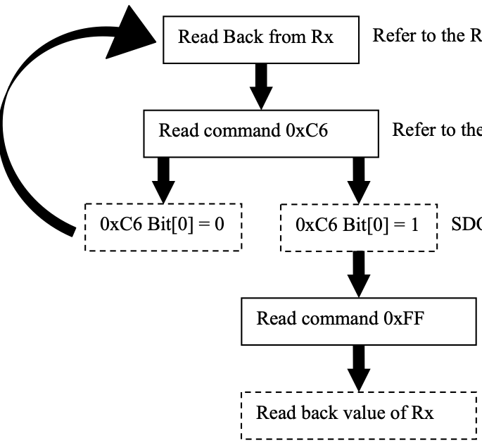

9 Configuration
The SSD2828 can be configured to support various operations. The signals involved are ps[1:0] pins, LS register bits. These signals define the interface type supported at the front-end as well as lane distribution at the MIPI link. The features that define the operation of SSD2828 are as below.
• Number of lane for each MIPI link
• RGB and SPI interfaces select at the front-end
• Dump and smart configurations

9.1 Lane Management
The number of lanes used in SSD2828 is determined by the LS(0xDE[1:0]) bits. The SSD2828 DPHY lanes consist of 1 clock lane(CL) and 4 data lanes(DL0, DL1, DL2, DL3).
The table below list down all the combination of lane usage and the active state of each of the DPHY lanes.
LS | SSD2828 | CL | DL0 | DL1 | DL2 | DL3 | Max. Speed
00 | 1 lane | ON | ON | OFF | OFF | OFF | Up to 1.0Gbps
01 | 2 lanes | ON | ON | ON | OFF | OFF | Up to 2.0Gbps
10 | 3 lanes | ON | ON | ON | ON | OFF | Up to 3.0Gbps
11 | 4 lanes | ON | ON | ON | ON | ON | Up to 4.0Gbps

Table 9-1：SSD2828 Lane Management

9.2 Use cases
The SSD2828 can support one interface configuration. Combination of RGB and SPI interfaces. The details of supported configuration are listed below.

9.2.1 RGB + SPI Interface
The application processor can use this configuration to drive a dumb display panel or a smart display panel or both panels. The user needs to set ps[1:0] to select the desired SPI interface. When the SPI interface is not used, the csx pin needs to be kept high.
Since the RGB and SPI interface are completely separated, the two interfaces can operate independently. The RGB interface is used to provide display data for the video mode. The SPI interface is used to program the local registers of SSD2828. If a dumb display panel is driven and the registers of the display need to be programmed, the SPI interface can also be used for register programming. If a smart display panel is driven, the SPI interface can also be used to configure the smart display and send display data, in command mode. Below are some illustrations for the use case.
Figure 9-1：SSD2828 with RGB and SPI Interface
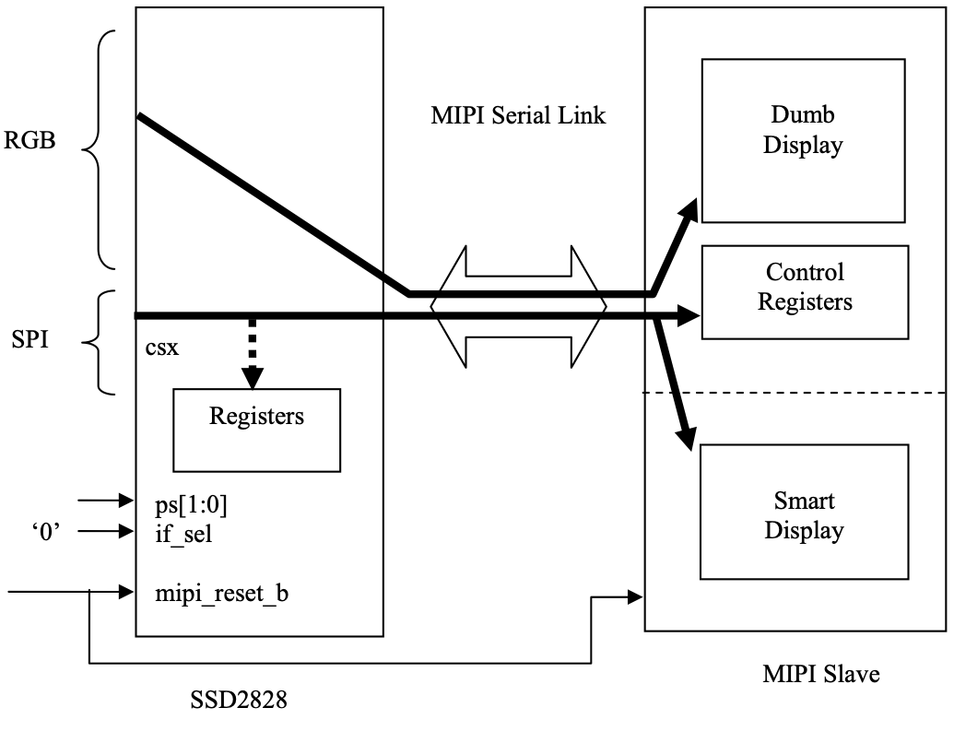
The data for different destinations are separated by the VC field of the packets. The user can program the register VCR to set the VC field. When this configuration is used, the primary usage of the serial link is for sending display video data to the dumb panel. If there is a need to send non-video data through SPI interface concurrently, the SSD2828 can put them into generic write or DCS write packet and interleave them with the video packets.
If the non-burst video mode is selected, the non-video data packet will only be sent during vertical blanking period. If burst video mode is selected, the non-video data packet can be sent during both horizontal and vertical blanking period (e.g. BLLP period).
During both horizontal and vertical blanking period, the serial link can either remain in HS mode (sending blanking packet) or enter LP mode. The non-video data can also be sent in HS or LP mode. Options have been provided for whether to use HS or LP mode for the blanking period and whether to send the non-video data in HS or LP mode. The NVD and BLLP bits in register VICR6 are provided for this purpose. Please refer to the table below for details.
Table 9-2：Operation during Video Mode BLLP Period
NVD | BLLP | Non-burst mode | Burst mode
0 | 0 | If there is no non-video data to send, the serial link will send blanking  packet in HS mode during BLLP  period.  If there is non-video data to send,  the non-video data will be sent in HS mode. Afterwards, the serial link will send blanking packet in HS mode for the remaining period of BLLP period. | If there is no non-video data to send, the serial link will enter LP mode  during BLLP period.  If there is non-video data to send,  non-video data will be sent in HS  mode. Afterwards, the serial link will enter LP mode for the remaining  period of BLLP period.
0 | 1 | If there is no non-video data to send, the serial link will enter LP mode  during BLLP period.  If there is non-video data to send,  non-video data will be sent in HS  mode. Afterwards, the serial link will enter LP mode for the remaining  period of BLLP period. | Same as non-burst mode.
1 | x | The serial link will enter LP mode for BLLP mode. If there is non-video  data to send, the data will be sent in LP mode at the beginning of BLLP period. | Same as non-burst mode.

9.2.2 MIPI DC Characteristics
Different State Code of the DSI represents different DC voltage levels in the Data and Clock Lanes as stated in below table.
Table 9-3：DSI State Code and DC Characteristics
Code Line Voltage Levels
Dp-Line Dn-Line
-0 HS Low | HS High
-1 HS High | HS Low
00 LP Low | LP Low
01 LP Low | LP High
10 LP High | LP Low
11 LP High | LP High

As shown in Figure 9-2, the logic level is different in different state.
Figure 9-2：MIPI Line Levels
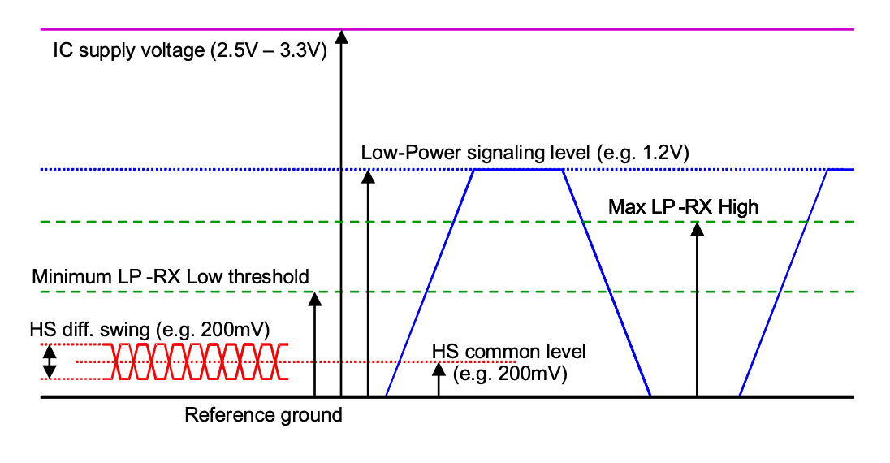

9.2.3 High Speed Clock Transmission
In High-Speed mode the Clock Lane provides a low-swing, differential DDR (half-rate) clock signal from Master to Slave for High-Speed Data Transmission. The Clock Start and Stop procedures are shown in the following figure.
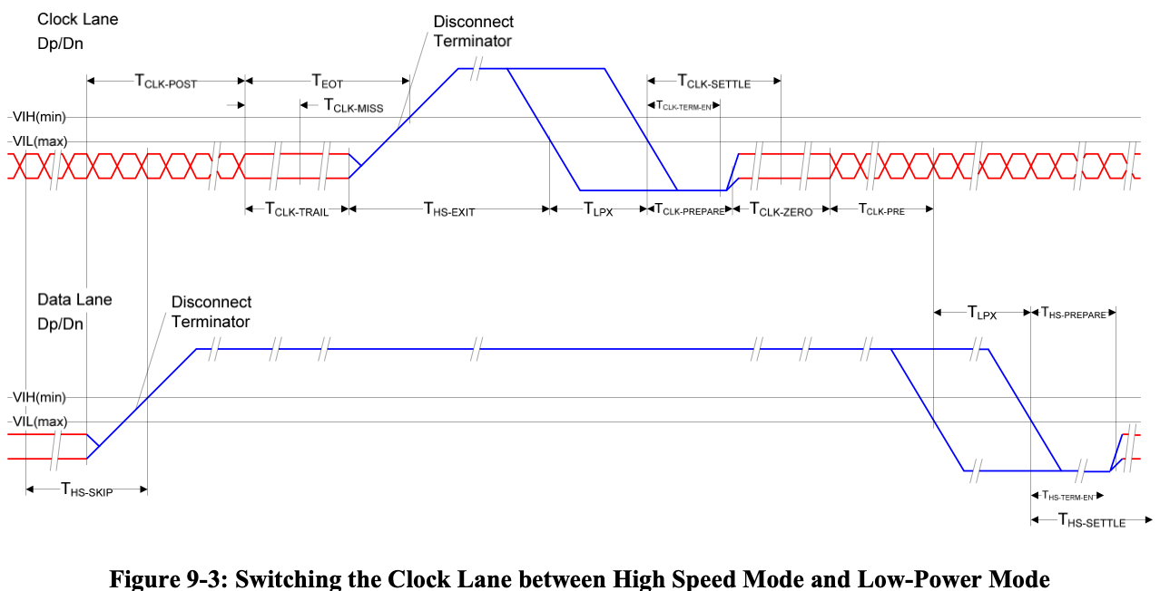

9.2.4 Data Lane State Flow
There are three modes that the Data Lane can be driven into:
1. High Speed Data Transmission
2. Bi-Directional Data Lane Turnaround
3. Escape Mode
Table 9-4：Data Lane Mode Entering/Exiting Sequences
Mode | Entering Mode Sequences | Exiting Mode Sequences
High Speed Data Transmission | LP-11 =>LP-10 =>LP-00 =>LP-01 =>LP- 00 | LP-00 =>LP-10 =>LP- 11
Bi-Directional Data Lane Turnaround | LP-11 =>LP-01 =>LP-00 =>HS-0 | (HS-0 or HS-1) =>LP-11
Escape | LP-11 =>LP-10 =>LP-00 =>LP-10 =>LP- 00 | High-Z

9.2.5 High Speed Data Transmission
High-Speed Data Transmission occurs in bursts. Transmission starts from, and ends with, a Stop state. During
the intermediate time between bursts a Data Lane shall remain in the Stop state, unless a Turnaround or
Escape request is presented on the Lane. During a HS Data Burst the Clock Lane shall be in High-Speed
mode, providing a DDR Clock to the Slave side.
After a Transmit request, a Data Lane leaves the Stop state and prepares for High-Speed mode by means of a Start-of-Transmission (SoT) procedure. Table 9-5 describes the sequence of events on TX and RX side.
Table 9-5：Start-of-Transmission Sequence
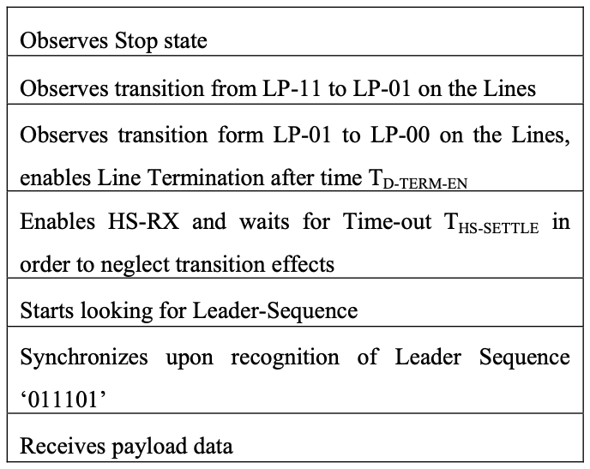
At the end of a Data Burst, a Data Lane leaves High-Speed Transmission mode and enters the Stop state by
means of an End-of-Transmission (EoT) procedure. Table 9-6 shows a possible sequence of events during the
EoT procedure. Note, EoT processing may be handled by the protocol or by the D-PHY.
Table 9-6：End-of-Transmission Sequence
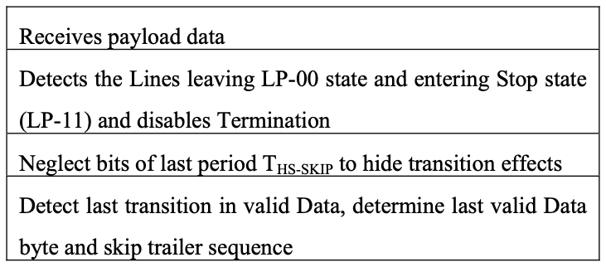
The following shows the sequence of the high speed data transmission including SoT data.
Figure 9-4：High-Speed Data transmission in Bursts
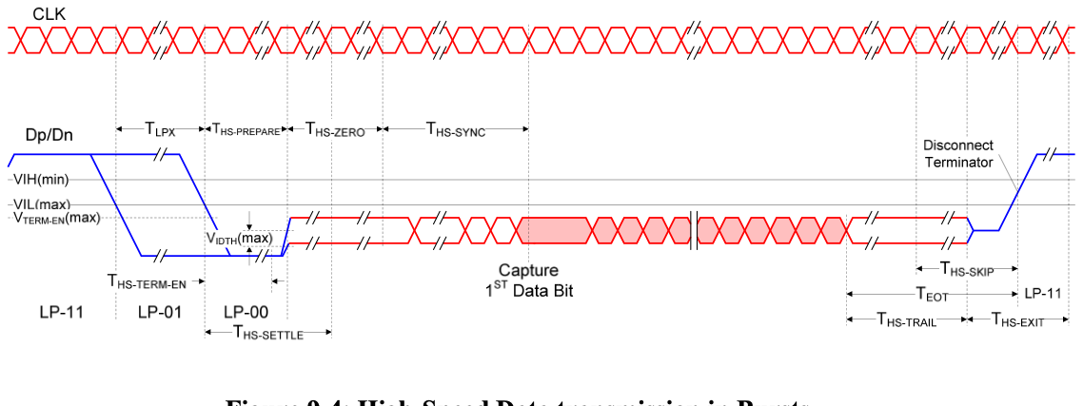

9.2.6 Bi-Directional Data Lane Turnaround
The transmission direction of a bi-directional Data Lane can be swapped by means of a Link Turnaround procedure. This procedure enables information transfer in the opposite direction of the current direction. The procedure is the same for either a change from Forward-to-Reverse direction or Reverse-to-Forward direction.
Figure 9-5：Turnaround Procedure
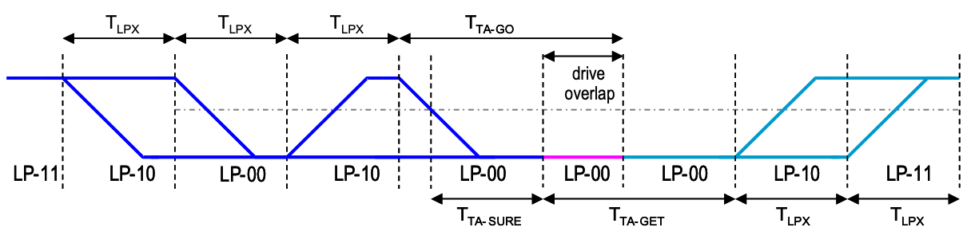

9.2.7 Escape Mode
Escape mode is a special mode of operation for Data Lanes using Low-Power states. With this mode some
additional functionality becomes available. Escape mode operation shall be supported in the Forward
direction and is optional in the Reverse direction. If supported, Escape mode does not have to include all
available features.
A Data Lane enters Escape mode via an Escape mode Entry procedure (LP-11, LP-10, LP-00, LP-01, LP-00).
As soon as the final Bridge state (LP-00) is observed on the Lines the Lane shall enter Escape mode in Space
state (LP-00). If an LP-11 is detected at any time before the final Bridge state (LP-00), the Escape mode Entry
procedure shall be aborted and the receive side shall wait for, or return to, the Stop state.
For Data Lanes, once Escape mode is entered, the transmitter shall send an 8-bit entry command to indicate
the requested action. Table 9-7 lists all currently available Escape mode commands and actions. All
unassigned commands are reserved for future expansion.
The Stop state is be used to exit Escape mode and cannot occur during Escape mode operation because of the
Spaced-One-Hot encoding. Stop state immediately returns the Lane to Control mode. If the entry command
doesn’t match a supported command, that particular Escape mode action shall be ignored and the receive side
waits until the transmit side returns to the Stop state.
Table 9-7：MIPI Escape Mode Entry Code
Escape Mode Action | Command Type | Entry Command Pattern (first bit transmitted to last bit transmitted)
Low-Power Data  Transmission | mode | 11100001
Ultra-Low Power State | mode | 00011110
Undefined-1 | mode | 10011111
Undefined-2 | mode | 11011110
Reset-Trigger  [Remote Application] | Trigger | 01100010
Tearing Effect | Trigger | 01011101
Acknowledge | Trigger | 00100001
Unknown-5 | Trigger | 10100000

9.2.8 Low Power Data Transmission
The Low Power Data Transmission can be started as the following sequences: (cid:122) Start: LP-11 (cid:122) Escape Mode Entry: LP-11, LP-10, LP-00, LP-01,LP-00 (cid:122) Low Power Data Transmission command: 11100001 (cid:132) One or more bytes (8 bit) (cid:132) Pause mode when data lane are stopped (cid:122) Exit Escape Mode: LP-00, LP-10, LP-11 (cid:122) Stop State : LP-11
Figure 9-6：Low Power Data Transmission
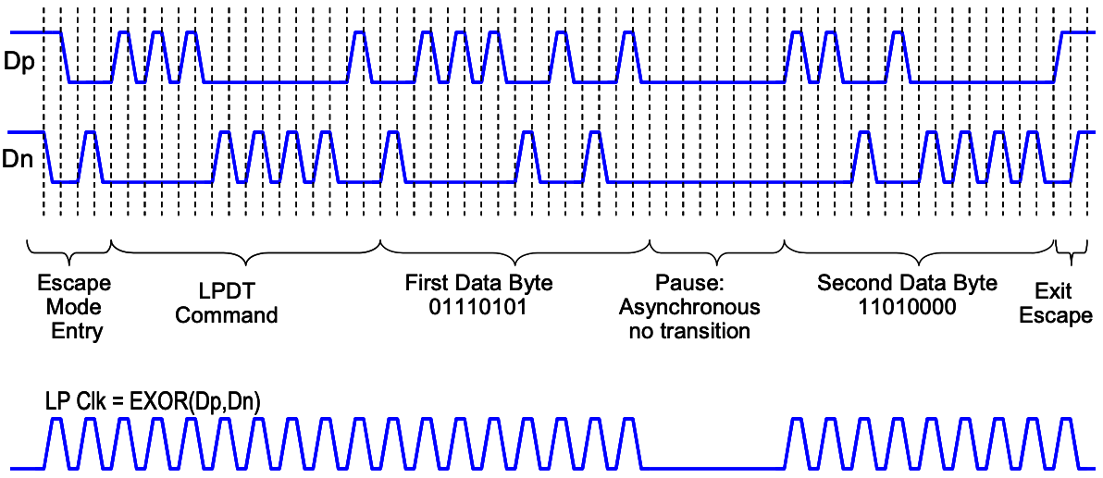

9.2.9 Reset Trigger
The AP can inform to the display module that it should be reseted in Reset trigger when data lanes are entering in Escape Mode. The Remote Application Reset (RAR) is using a following sequence: (cid:122) Start: LP-11 (cid:122) Escape Mode Entry: LP-11, LP-10, LP-00, LP-01, LP-00 (cid:122) Remote Application Reset (RAR) command in Escape Mode: 0110 0010 (First to Last bit) (cid:122) Mark-1: LP-00, LP-10, LP-11 (cid:122) Stop State: LP-11
LP-11>10>00>01>00>01>00>10>00>...
 |  |  | 0
 |  |  | 0 | 1 | 1
Escap | e Mode | Entry | 0

 | 0 | 0 | 0
 | 0 | 0 |  |  | 1
E | ntry Co | mmand

Figure 9-7：Trigger – Reset Command in Escape Mode
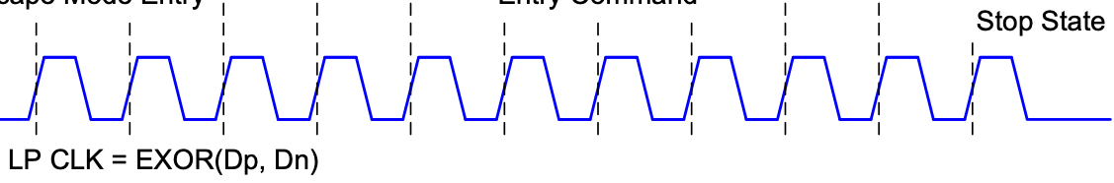

9.2.10 Tearing Effect
The display module can inform to the AP when a tearing effect event (New V-synch) has been happen on the display module by Tearing Effect (TEE).
The Tearing Effect (TEE) is using a following sequence: (cid:122) Start: LP-11 (cid:122) Escape Mode Entry (EME): LP-11, LP-10, LP-00, LP-01, LP-00 (cid:122) Tearing Effect: 0101 1101 (First to Last bit) (cid:122) Mark-1: LP-00, LP-10, LP-11 (cid:122) Stop State: LP-11
Figure 9-8：Tearing Effect Command in Escape Mode
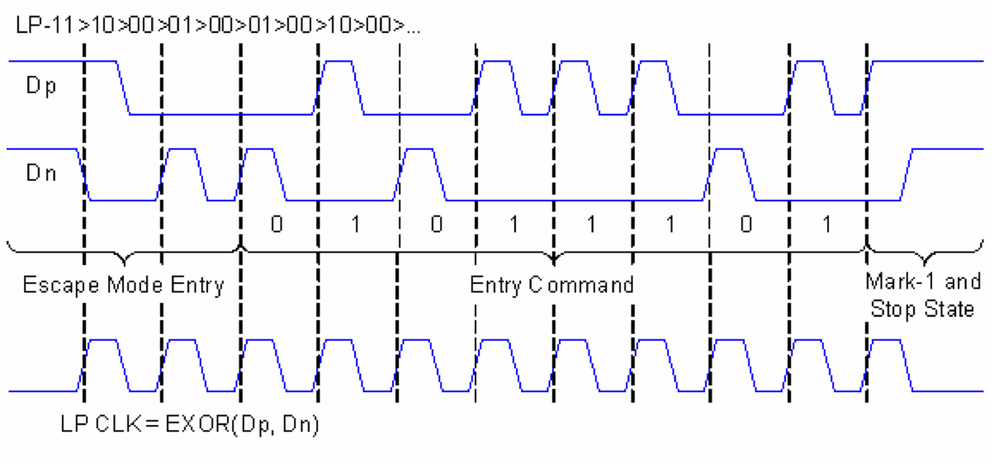

9.2.11 Acknowledge
The display module can inform to the AP when an error has not recognized on it by Acknowledge (ACK). The Acknowledge (ACK) is using a following sequence: (cid:122) Start: LP-11 (cid:122) Escape Mode Entry: LP-11, LP-10, LP-00, LP-01, LP-00 (cid:122) Acknowledge (ACK) command: 0010 0001 (First to Last bit) (cid:122) Mark-1: LP-00 =>LP-10 =>LP-11 (cid:122) Stop State: LP-11
Figure 9-9：Acknowledge Command in Escape Mode
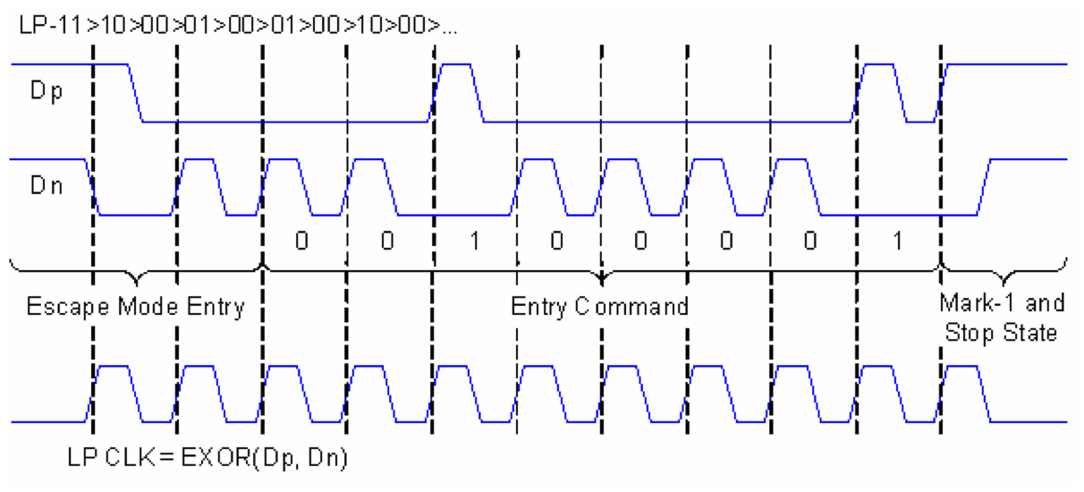

9.2.12 Packet Transmission
SSL MIPI CORE supports two data transmission defined in MIPI DSI specification.
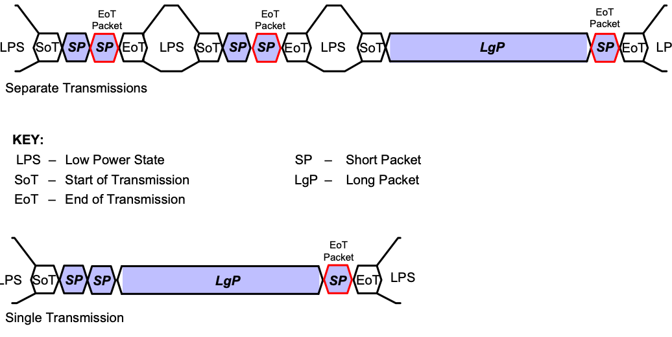
Figure 9-10：Two Data Transmission Mode (Separate, single)

9.2.13 HS Transmission Example
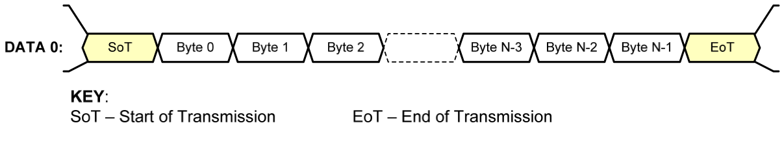
Figure 9-11：One Lane Data Transmission Example
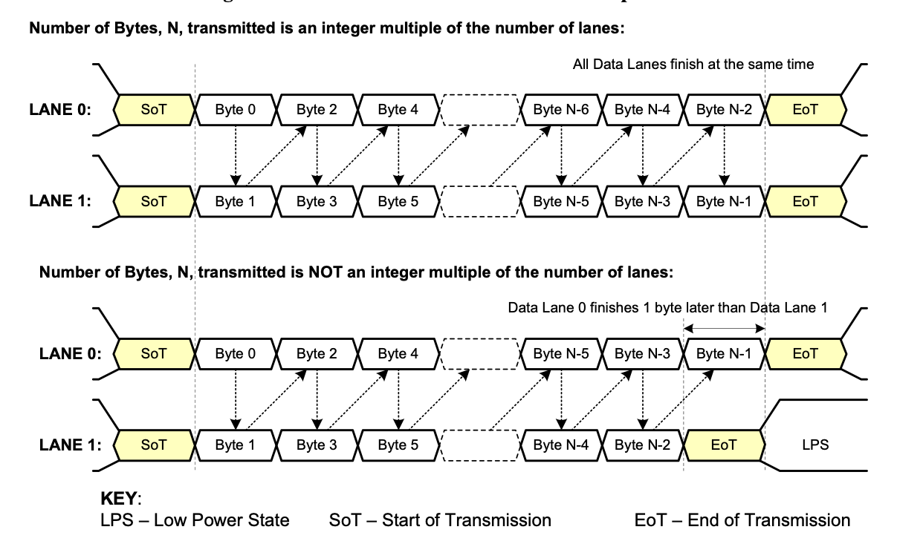
Figure 9-12：Two Lane HS Transmission Example

9.2.14 General Packet Structure
Two packet structures are defined for low-level protocol communication: Long packets and Short packets. For both packet structures, the Data Identifier is always the first byte of the packet. All packet data traverses the interface as bytes. Sequentially, a transmitter shall send data LSB first, MSB last. For packets with multi-byte fields, the least significant byte shall be transmitted first unless otherwise specified.
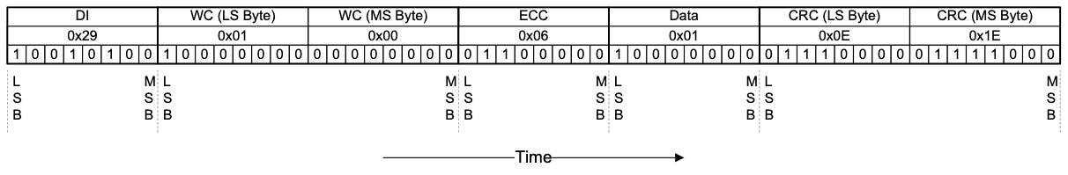
Figure 9-13：Endian Example (Long Packet)

9.2.15 Long Packet Format
Figure 9-14 shows the structure of the Long packet. A Long packet shall consist of three elements: a 32-bit Packet Header (PH), an application-specific Data Payload with a variable number of bytes, and a 16-bit Packet Footer (PF). The Packet Header is further composed of three elements: an 8-bit Data Identifier, a 16- bit Word Count, and 8-bit ECC. The Packet Footer has one element, a 16-bit checksum. Long packets can be from 6 to 65,541 bytes in length.
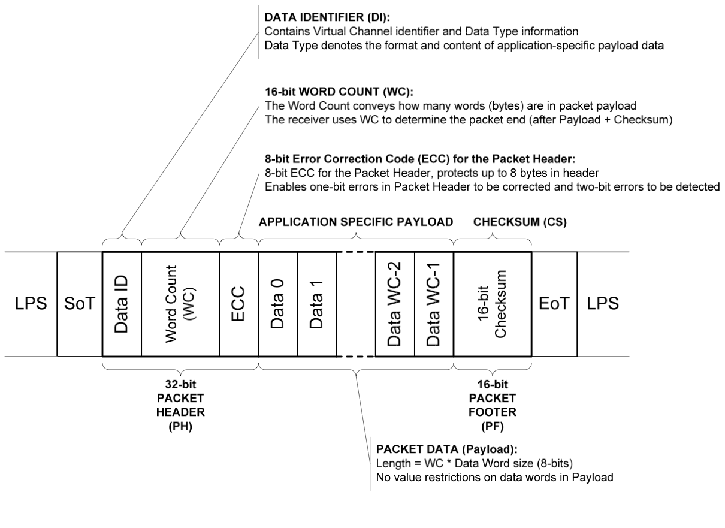
Figure 9-14：Long Packet Structure

9.2.16 Short Packet Structure
Figure 9-15 shows the structure of the Short packet. A Short packet shall contain an 8-bit Data ID followed by two command or data bytes and an 8-bit ECC; a Packet Footer shall not be present. Short packets shall be four bytes in length. The Error Correction Code (ECC) byte allows single-bit errors to be corrected and 2-bit errors to be detected in the Short packet.
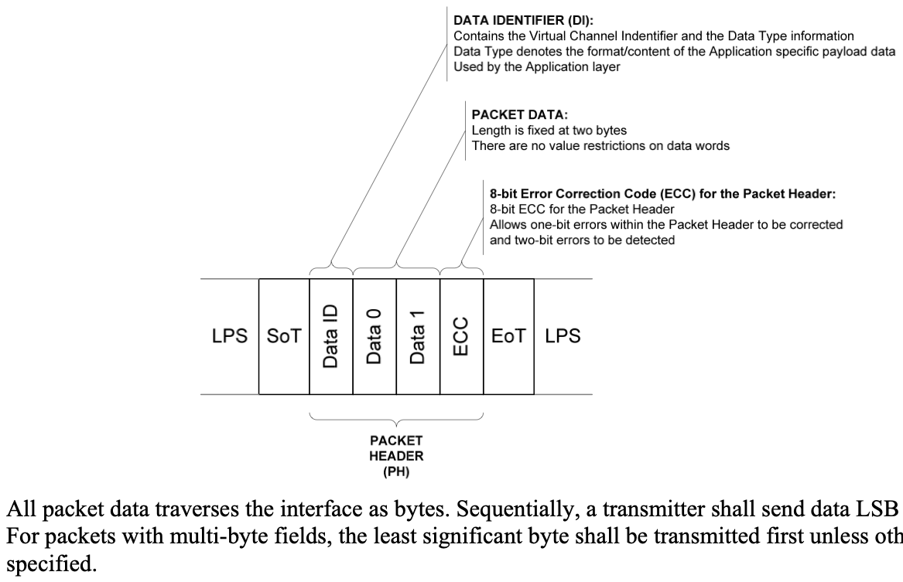
Figure 9-15：Short Packet Structure
Figure 9-13 shows a complete Long packet data transmission. Note, the figure shows the byte values in standard positional notation, i.e. MSB on the left and LSB on the right, while the bits are shown in chronological order with the LSB on the left, the MSB on the right and time increasing left to right.

9.2.17 Data Identifier (DI)
The Data Identifier defines the Virtual Channel for the data and the Data Type for the application specific payload data.
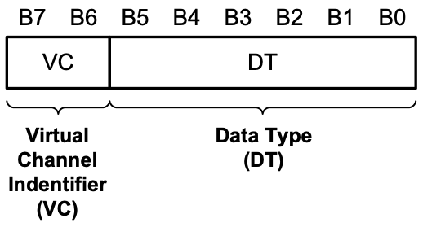
Figure 9-16：Data Indentifier Structure

9.2.18 Victual Channel Identifier (VC)
The VC is the address of the channel between the AP and the display modules. During the data transactions, both AP and display module will use the same VC for communication. In SSD2085, the VC for the command mode is 0x02H and the VC for the video mode is 0x01H.

9.2.19 Data Type (DT)
There are two groups of Data Type: (cid:122) Processor to Display Module, (cid:122) Display Module to Processor
Table 9-8：Data Types for Processor-sourced Packets
Data Type, hex | Data Type, binary | Description | Packet Size
01h | 00 0001 | Sync Event, V Sync Start | Short
11h | 01 0001 | Sync Event, V Sync End | Short
21h | 10 0001 | Sync Event, H Sync Start | Short
31h | 11 0001 | Sync Event, H Sync End | Short
08h | 00 1000 | End of Transmission (EoT) packet | Short
02h | 00 0010 | Color Mode (CM) Off Command | Short
12h | 01 0010 | Color Mode (CM) On Command | Short
22h | 10 0010 | Shut Down Peripheral Command | Short
32h | 11 0010 | Turn On Peripheral Command | Short
03h | 00 0011 | Generic Short WRITE, no parameters | Short
13h | 01 0011 | Generic Short WRITE, 1 parameter | Short
23h | 10 0011 | Generic Short WRITE, 2 parameters | Short
04h | 00 0100 | Generic READ, no parameters | Short
14h | 01 0100 | Generic READ, 1 parameter | Short
24h | 10 0100 | Generic READ, 2 parameters | Short
05h | 00 0101 | DCS WRITE, no parameters | Short
15h | 01 0101 | DCS WRITE, 1 parameter | Short
06h | 00 0110 | DCS READ, no parameters | Short
37h | 11 0111 | Set Maximum Return Packet Size | Short
09h | 00 1001 | Null Packet, no data | Long

Data Type, hex | Data Type, binary | Description | Packet Size
19h | 01 1001 | Blanking Packet, no data | Long
29h | 10 1001 | Generic Long Write | Long
39h | 11 1001 | DCS Long Write/write_LUT Command Packet | Long
0Eh | 00 1110 | Packed Pixel Stream, 16-bit RGB, 5-6-5 Format | Long
1Eh | 01 1110 | Packed Pixel Stream, 18-bit RGB, 6-6-6 Format | Long
2Eh | 10 1110 | Loosely Packed Pixel Stream, 18-bit RGB, 6-6-6 Format | Long
3Eh | 11 1110 | Packed Pixel Stream, 24-bit RGB, 8-8-8 Format | Long
x0h and xFh,  unspecified | xx 0000  xx 1111 | DO NOT USE  All unspecified codes are reserved

Table 9-9：Data Types for Peripheral-sourced Packets
Data Type, hex | Data Type, binary | Description | Packet Size
00h – 01h | 00 000x | Reserved | Short
02h | 00 0010 | Acknowledge and Error Report | Short
03h – 07h | 00 0011 –  00 0111 | Reserved
08h | 00 1000 | End of Transmission (EoT) packet | Short
09h – 10h | 00 1001 –  01 0000 | Reserved
11h | 01 0001 | Generic Short READ Response, 1 byte returned | Short
12h | 01 0010 | Generic Short READ Response, 2 bytes returned | Short
13h – 19h | 01 0011 –  01 1001 | Reserved
1Ah | 01 1010 | Generic Long READ Response | Long
1Bh | 01 1011 | Reserved
1Ch | 01 1100 | DCS Long READ Response | Long
1Dh – 20h | 01 1101 –  10 0000 | Reserved
21h | 10 0001 | DCS Short READ Response, 1 byte returned | Short
22h | 10 0010 | DCS Short READ Response, 2 bytes returned | Short
23h – 3Fh | 10 0011 –  11 1111 | Reserved

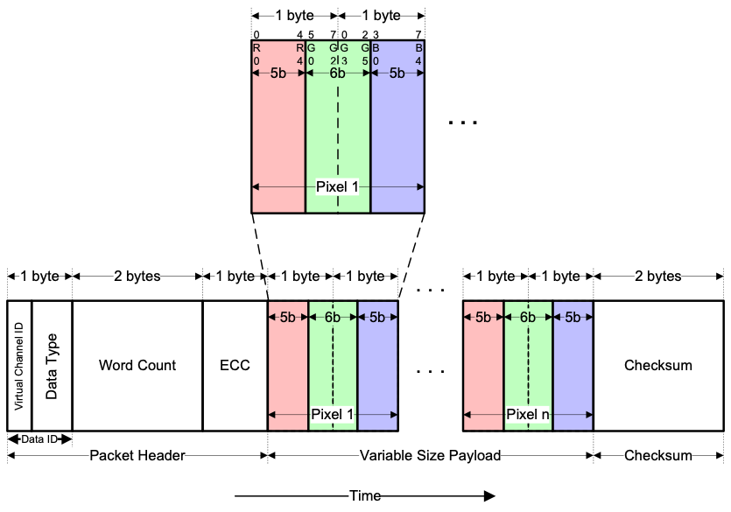
Figure 9-17：16-bit per pixel RGB Color Format, Long packet for MIPI Interface
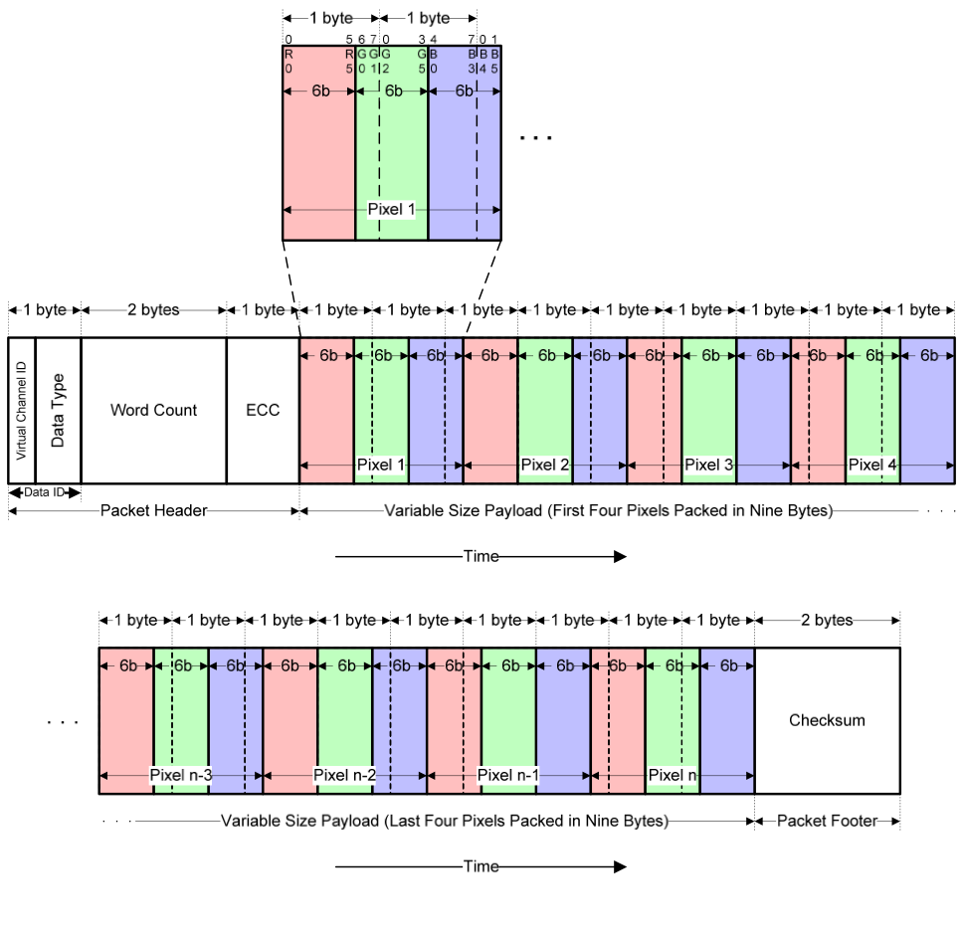
Figure 9-18：18-bit per Pixel– RGB Color Format, Long packet for MIPI Interface
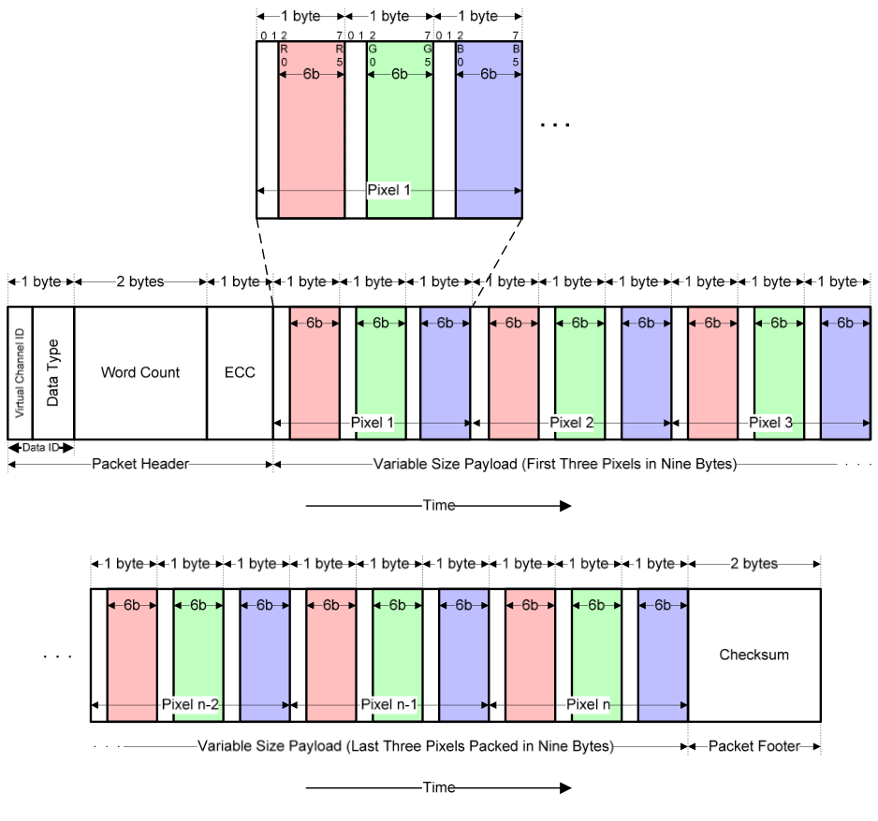
Figure 9-19：18-bit per Pixel in Three Bytes – RGB Color Format, Long packet for MIPI Interface
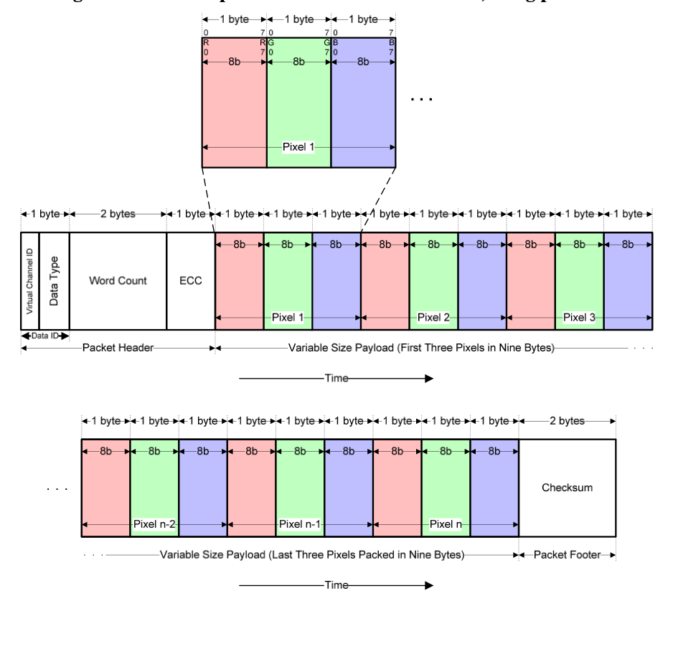
Figure 9-20：24-bit per Pixel – RGB Color Format, Long packet for MIPI Interface

9.3 Operating Modes
The video data come from the RGB interface and the configuration is done through the SPI interface. To support different bpp settings, the following data pins are used. For all cases, R should be at the upper bits and B should be at the lower bits.
• data[15:0] for 16 bpp.
• data[17:0] for 18 bpp, packed.
• data[17:0] for 18 bpp, loosely packed.
• data[23:0] for 24 bpp.
The user, first, needs to program the registers VICR1 to VICR6 with correct values. The user also needs to program the END and CO bits to 0 and 1 respectively. After programming those register fields, the user can turn on the RGB interface and enable the VEN bit to start transmission. All three video mode sequence defined in the MIPI DSI specification are supported.
In Non-Burst Mode, the CSS (register 0xB7 bit 5) can be set to 0 or 1. When it is set to 1 to select the pclk as PLL reference clock, the PLL multiplication factor should be equal to the bpp value. When it is set to 0 to select the tx_clk as PLL reference clock, the PLL multiplication factor should be set such that the serial link data rte is faster than the incoming data rate. Please refer to the table below for the PLL settings. Registers VICR1 to VICR6 (0xB1 to 0xB6) needs to be programmed. (VICR1 is not used for non-burst mode with Sync Events). (VICR1 is not used for non-burst mode with Sync Events.) Below is the diagram to illustrate the definition of all the fields.
Figure 9-21：Illustration of RGB Interface Parameters for Non-burst Mode with Sync Pulses
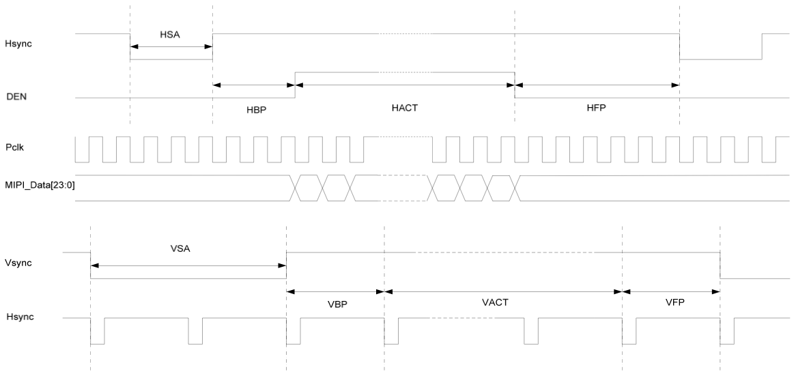
Table 9-10：PLL Setting for Non-burst Mode (PLL reference using pclk)
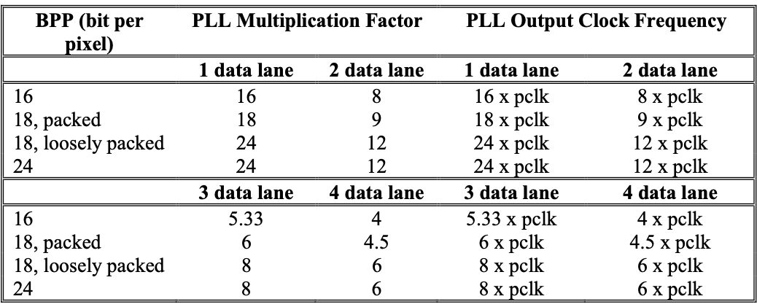
Table 9-11：PLL Setting for Non-burst Mode (PLL reference using tx_clk)
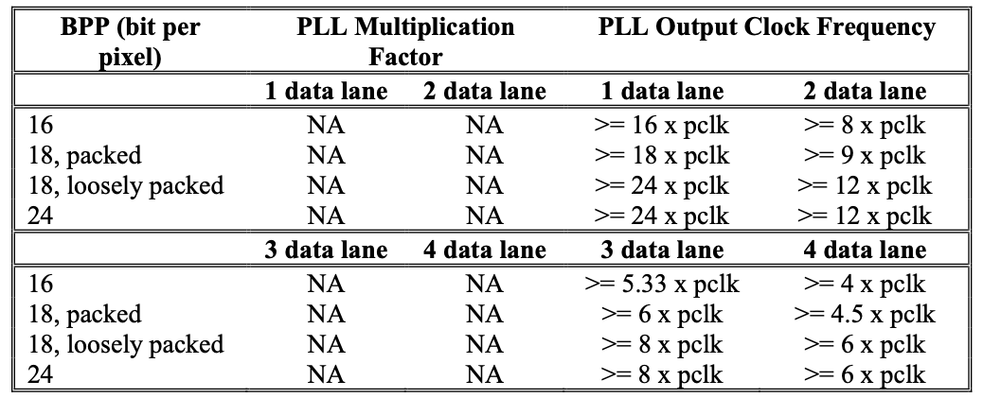
In Burst Mode, the CSS (register 0xB7 bit 5) needs to be set to 0 to select the tx_clk as PLL reference clock. The PLL multiplication factor should be set such that the serial link data rate is faster than the incoming data rate. Please refer to the table below for the PLL settings. Registers VICR2 to VICR6 (0xB1 to 0xB6) needs to be programmed. VICR1 is not used for this mode. The definition of all the fields is the same as non-burst mode with Sync Events.
Figure 9-22：Illustration of RGB Interface Parameters for Non-burst Mode with Sync Events and Burst Mode
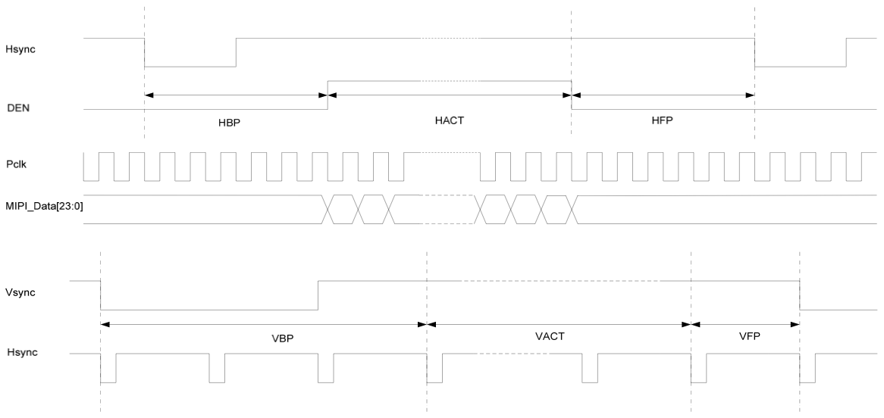
Table 9-12：PLL Setting for Burst Mode
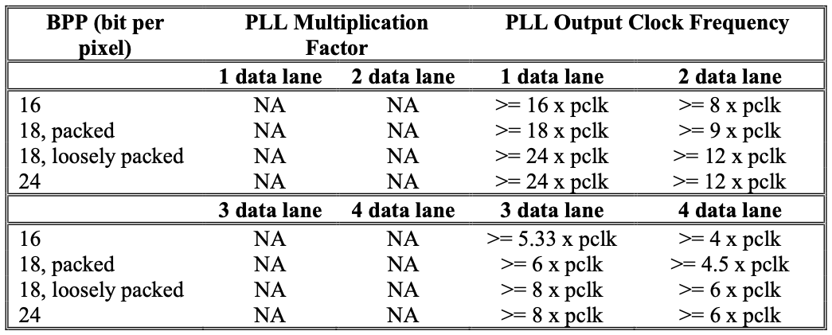
*: This value should be set such that the serial link data rate is faster than incoming data rate
The SSD2828 will also monitor the status of CM and SHUT signal. When there is a change of these signals, it will send out appropriate packets. On the rising edge of CM, the CM on packet will be sent. On the falling edge of CM, the CM off packet will be sent. On the rising edge of SHUT, the Shut Down Peripheral packet will be sent. On the falling edge of SHUT, the Turn On Peripheral packet will be sent. With these packets, the MIPI slave will be able to reconstruct the RGB interface signals.
Figure 9-23：Non-Burst mode MIPI structure
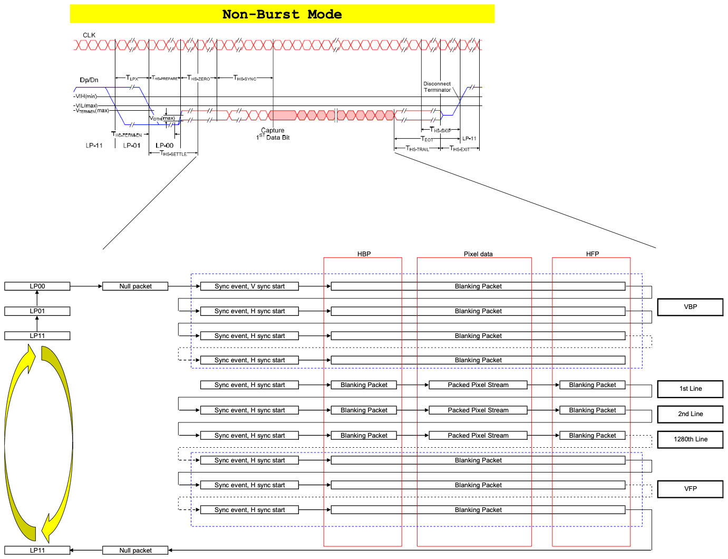
Figure 9-24：Burst mode MIPI structure
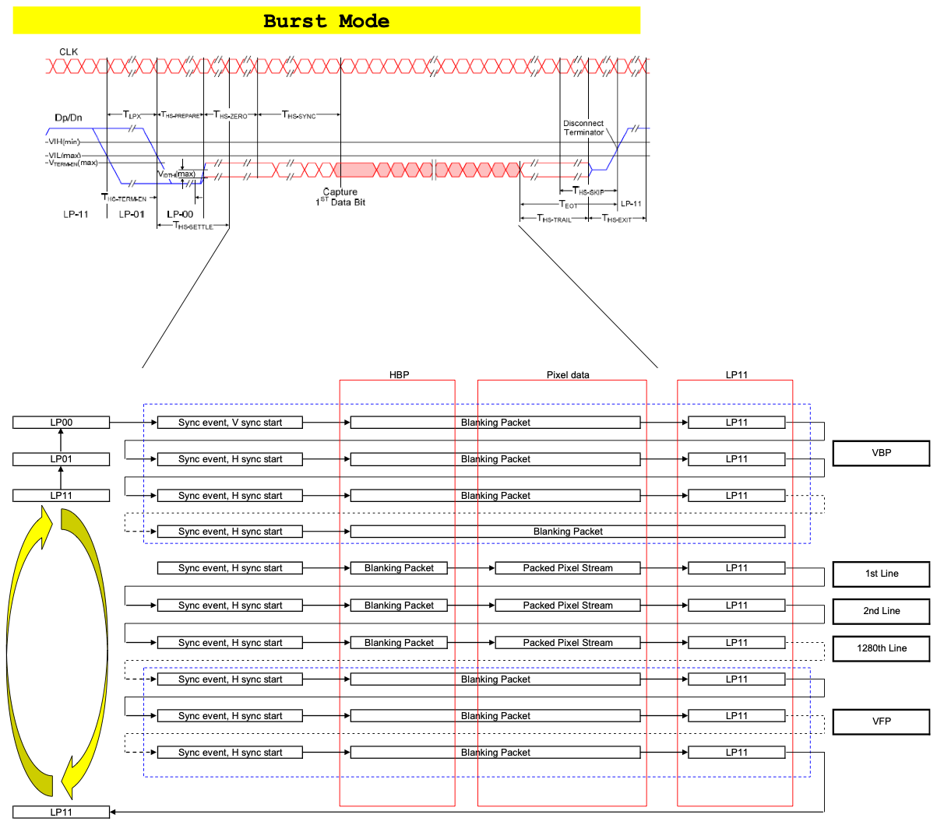
9.3.1.1 Write Operation
To perform write operation, the user needs to set the REN bit to 0. The SSD2828 can issue four kinds of packets for write operation, which are Generic Short Write Packet, Generic Long Write Packet, DCS Short Write Packet and DCS Long Write Packet. The bit DCS controls whether Generic Write Packet or DCS Write Packet will be sent out. The VC1 or VC2 field determines the VC ID of the outgoing packets. (Please see the 8.1.9 for the difference between VC1 and VC2.)
The SSD2828 needs to know the payload size of the outgoing packets. Hence, the user needs to program the corresponding control registers. PSCR1 and PSCR2 form the TDC field that indicates the total number of payload bytes.
To send a DCS Write Packet, the user needs to write the DCS command/header and the payload to the register PDR and DCS bit set to 1. If the TDC field is no more than 2, the SSD2828 will send out DCS Short Write Packet with the correct type. Otherwise, DCS Long Write Packet will be sent out.
To send a Generic Write Packet, the user needs to write the payload to the register PDR and DCS bit set to 0. If the TDC field is no more than 2, the SSD2828 will send out Generic Short Write Packet with the correct type. Otherwise, Generic Long Write Packet will be sent out.
For DCS Write Packet, the partition is only enabled if the DCS command is 0x2C or 0x3C. Otherwise, SSD2828 will not perform automatic partition. (This is because the DCS command 0x2C and 0x3C are to write display data into the LCD panel display memory.) The payload will be partitioned into a few packets where the payload of each packet is PST bytes. The first byte is the DCS command and the following PST bytes are the payload. Only the last packet might contain less payload, as the total payload might not be integer multiple of PST. If the incoming DCS command is 0x2C, the DCS command for the first packet is 0x2C and the DCS command for all other packets is 0x3C. If the incoming DCS command is 0x3C, the DCS command of all the packets is 0x3C.
For example, in the raw data mode(IFC=0), if the TDC field is 200 and PST field is 80, 3 packets will be sent. The first two have 80 bytes of payload. The last packet has 40 bytes of payload.
After performing a write operation, the user can optionally make a BTA to let the MIPI slave report its status. This is done by setting FBW bit to 1. The SSD2828 will automatically make a BTA after each write operation. Please refer to 0 for how to handle the acknowledgement received.
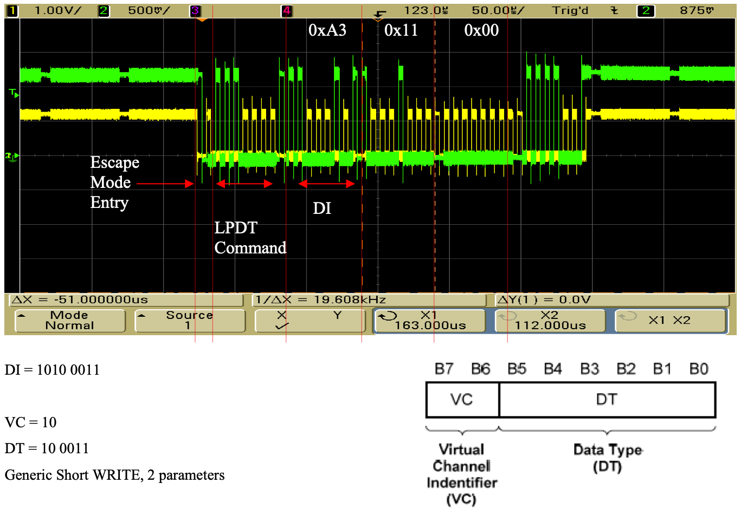
9.3.1.2 Read Operation
To perform read operation, the user needs to set the REN bit to 1. The SSD2828 can issue two kinds of packets for read operation, which are Generic Read Packet, and DCS Read Packet. The bit DCS controls whether Generic Read Packet or DCS Read Packet will be sent out. The VC1 or VC2 field determines the VC ID of the outgoing packets. (Please see the 8.1.9 for the difference between VC1 and VC2.)
Before the read packet is sent out, the SSD2828 will always send out the Set Maximum Return Size Packet. This is to limit the Read Response Packet sent by the MIPI slave such that there is no over flow. Two factors determine the maximum size. One is the limit of the SSD2828 and the other is the limit of the application processor. The user should choose the smaller one among these two limits to use as the maximum return size.
The parameter in the Set Maximum Return Size Packet is taken from register MRSR. The user could program the MRSR before every read so that the correct value is sent through Set Maximum Return Size Packet. If the value in the MRSR is already the desired value, the user can choose not to program it. The SSD2828 will always automatically send out Set Maximum Return Size Packet using the value in MRSR.
To send a DCS Read Packet, the user just needs to write the DCS command (as there is no parameter for DCS read) to PDR register and DCS bit set to 1.
To send a Generic Read Packet, the user needs to write the payload to the register PDR and DCS bit set to 0.
Similar to the write operation, the TDC field is used to determine the payload size of the outgoing packet. For DCS Read Packet, the payload is just the DCS command. There is no parameter associated. For Generic Read Packet, the SSD2828 will send out the correct packet type according to the TDC value.
After sending out the read packet, the SSD2828 will automatically perform a BTA to wait for the Read Response Packet from the MIPI slave. The return data will be stored in register RR. No matter what read packet is sent out, there is only one packet returning data. Therefore, no matter whether the read is DCS read or Generic read, no matter what command is used in DCS read, the return data is always stored in register RR. The user can read the data out when the RDR bit is set to 1. After seeing RDR bit been set to 1, the user should first read register RDCR which contains the number of bytes returned by the MIPI slave. By using this information, the user will know how many data should be read out from register RR. After all the return data are read out, the RDR bit will be set to 0 by the SSD2828.
After the RDR bit been set to 1, the user can choose not to read the data out from register RR. The user can continue performing another operation. Once the user does so, the RDR bit will be set to 0 by the SSD2828.
There might be Acknowledge and Error Report Packet sent by the MIPI slave at the same time. The operation of acknowledgement handling is described in 0.
Under certain circumstance, the MIPI slave might only send back Acknowledge and Error Report Packet without any data. Thus, the RDR bit will not be set. Therefore, it is recommended that the user check the bit BTAR first. The BTAR is to indicate whether the MIPI slave has passed the bus authority back to the SSD2828 or not. Only when the BTAR is 1, there might be return data. If there is no return data, the user should follow 0 to handle the acknowledgement.
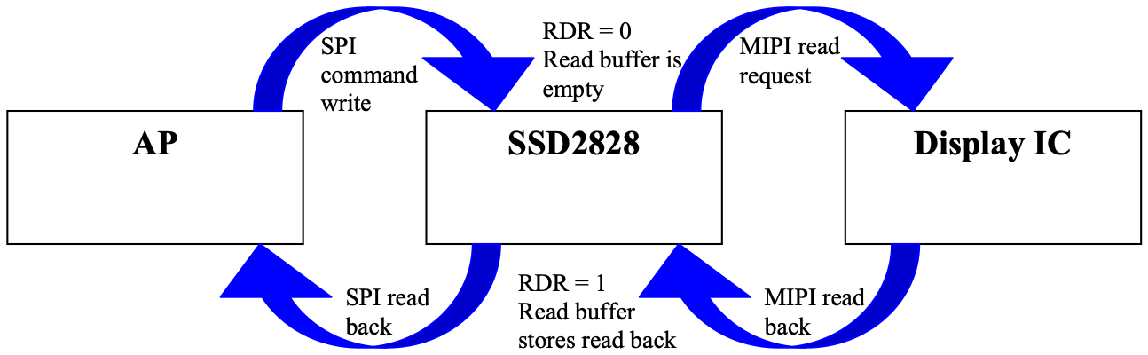
data
MIPI read back
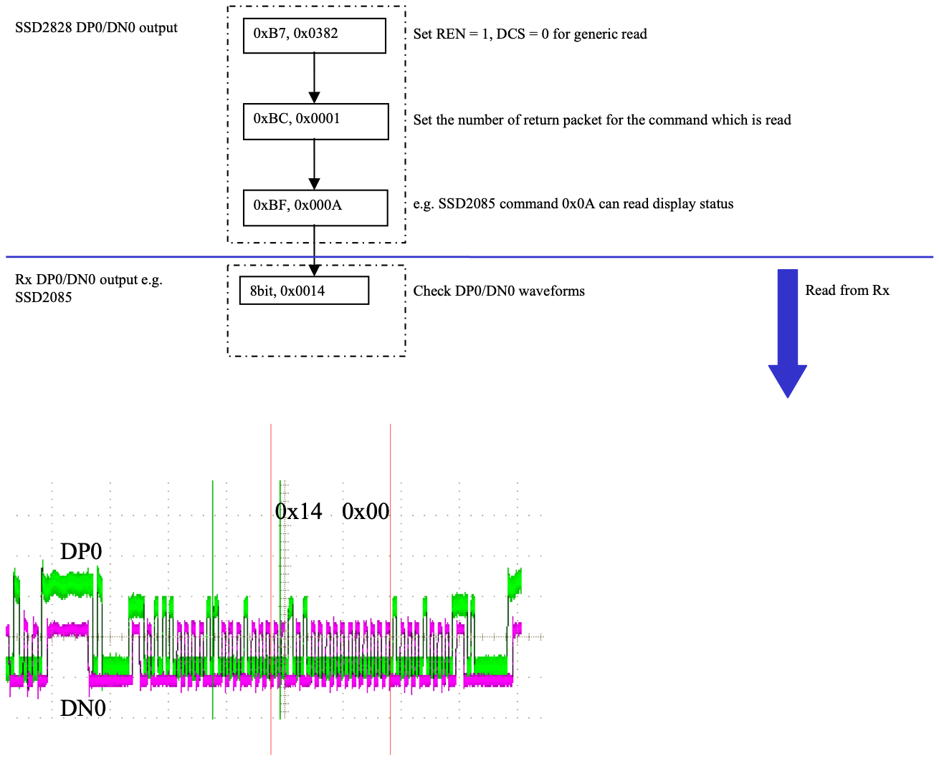
9.3.1.3 Acknowledgement Operation
The SSD2828 can perform a BTA to give the bus authority to the MIPI slave and let it report its status. The BTA can be enabled by setting FBW bit to 1 and performing a write operation, or just performing a read operation. After the MIPI slave passes the bus authority back, the SDD2828 will set bit BTAR to 1.
If there is no error on the slave side, the MIPI slave will return ACK trigger message, if the packet before BTA is a write packet. The MIPI slave will return Read Response Packet, if the packet before BTA is a read packet. In this case, after receiving the response from the MIPI slave, SSD2828 will set bit ARR and ATR bits to 1. ARR indicates that response has been received from MIPI slave. ATR indicates that the MIPI slave has reported no error with ACK trigger message. Consequently, the register ARSR will be cleared to 0.
If there is error on the slave side, the MIPI slave will return Acknowledge and Error Report packet, if the packet before BTA is a write packet. The MIPI slave will return Read Response Packet (depending on the error type) and Acknowledge and Error Report Packet, if the packet before BTA is a read packet. In this case, after receiving the response from the MIPI slave, SSD2828 will set bit ARR bit to 1 and ATR bits to 0. ARR indicates that response has been received from MIPI slave. ATR indicates that the MIPI slave has sent Acknowledge and Error Report Packet instead of ACK trigger message. Therefore, the MIPI slave has reported error. The error reported by the MIPI slave will be stored in register ARSR. The user can read this register to see what error the MIPI slave has encountered.
For the detailed description of each error bit, please refer to MIPI DSI specification. Below are the flow charts of handling the MIPI slave acknowledgement. They are just for reference.
Figure 9-25：Acknowledgement Handling after Non-Read Command
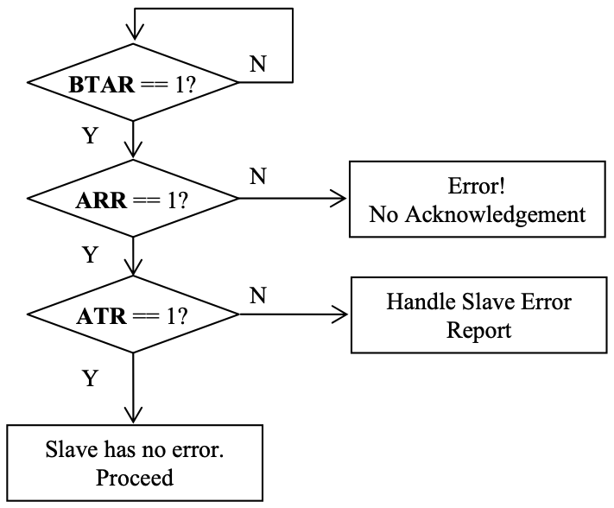
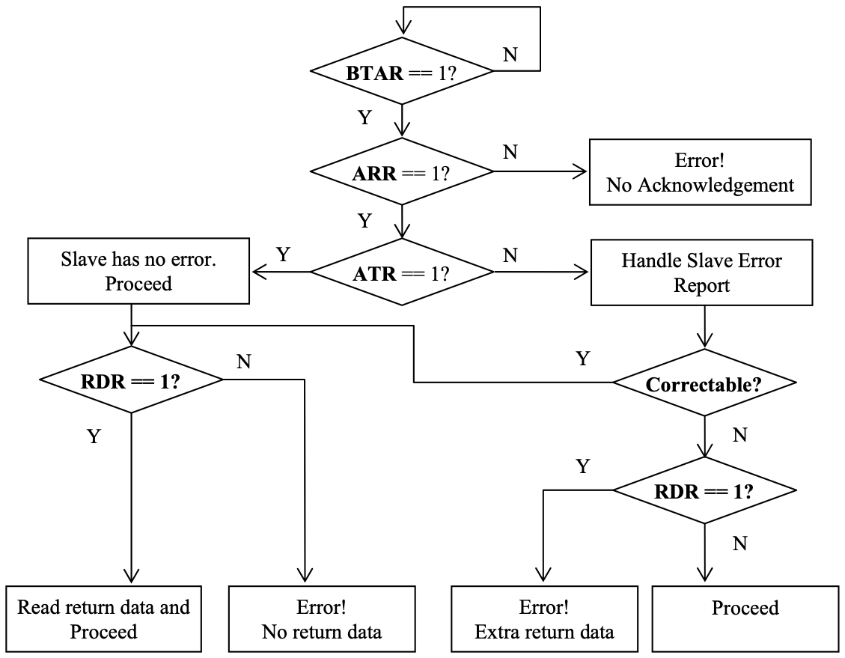
Figure 9-26：Acknowledgement Handling after Read Command
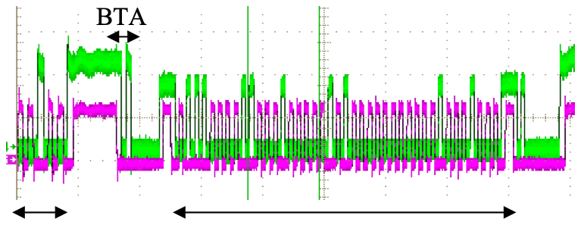
Tx Rx Read return data
Remark: LP clock of Rx must be within 10% of Tx LP clock
Bit | Description
0 | SoT Error
1 | SoT Sync Error
2 | EoT Sync Error
3 | Escape Mode Entry Command Error
4 | Low-Power Transmit Sync Error
5 | Peripheral Timeout Error
6 | False Control Error
7 | Contention Detected
8 | ECC Error, single-bit (detected and corrected)
9 | ECC Error, multi-bit (detected, not corrected)
10 | Checksum Error (Long packet only)
11 | DSI Data Type Not Recognized
12 | DSI VC ID Invalid
13 | Invalid Transmission Length
14 | Reserved
15 | DSI Protocol Violation

Table 9-13：MIPI error report
9.3.1.4 Tearing Effect (TE) Operation
The TE operation is to perform a BTA following the previous BTA without transmitting anything in between. The bus is handed to the MIPI slave for providing TE information. After getting the TE event from display driver, the MIPI slave will pass the bus authority back to the SSD2828 by using BTA trigger message.
The TE operation can be enabled by setting bit FBT and FBW to 1 before writing the last command to the MIPI slave. Afterwards, the application processor can instruct the SSD2828 to send out the last command in a write packet. Since FBW is 1, the SSD2828 will automatically perform a BTA after the write operation. The MIPI slave will response and pass the bus authority back. Since FBT is 1, the SSD2828 will perform another BTA without sending any data. This makes the MIPI slave enter TE mode.
The MIPI slave will send a TE trigger message back when it gets the TE event. After getting the trigger message, the SSD2828 will set the TE pin to 1 to indicate that TE event has been received. DATA[16] is used as the TE pin. At the same time, bit TER will be set to 1. The application processor can write 1 to this bit to clear it. As the TE trigger message only determines when the TE pin will be set to 1, a counter is used to determine when to set the TE pin to 0. The TE pin will be set to 0, once the counter reaches the value in TEC. The counter uses the reference clock to do counting.
If the MIPI slave does not send back the TE trigger message but just perform a BTA to pass the bus back, the SSD2828 will automatically perform another BTA to pass the bus to the MIPI slave again. It will continue do so until the MIPI slave respond with the TE trigger message, or the FBT bit is set to 0, or the LP RX timer expires.
If the MIPI slave does not send back the TE trigger message and still holds the bus, the user can set the bit FBC to 1 to force a bus contention. After bus contention is resolved, the slave will pass the bus back to SSD2828.
9.3.1.5 Contention Detection and Timer Operation
Two timers have been defined in SSD2828 to resolve the potential contention issue on the bus. The two timers are the HS TX timer and LP RX timer. Please see the register description for the detailed usage.
Whenever the SSD2828 sees a contention being detected, it will reset the state machine and enter the default mode, which is LP TX idle mode. The data line will be kept at LP11.
9.3.1.6 Interrupt Operation
An interrupt signal int_0/int_1 has been provided to interrupt the application processor so that it does not need to poll the status all the time. This will save the processing time of the application processor. int_0/int_1 is an active low signal, in other words, when the event has happened, it will go low.
There are many sources that can be mapped to the interrupt signal. The user can select different source to perform different task. If more than 1 source is selected, the int_0/int_1 signal will go low when the event for 1 of the sources has happened. In this case, the user needs to read the register ISR to determine what event has happened. The different sources can be enabled/disabled through register ICR. Below is the list of available interrupt sources and their usage.
RDR
To indicate that return data from MIPI slave is available for read.
BTAR
To indicate whether the SSD2828 has the bus authority or not. It can be used after SSD2828 makes a BTA. If the MIPI slave has returned the bus authority back to SSD2828, the interrupt will be set to indicate so. Please note that, on power up, the bus authority is already on the SSD2828. Hence, the SSD2828 will show that it has the bus authority.
ARR
To indicate whether the SSD2828 has received the acknowledge response from the MIPI slave. The acknowledge response can either report error or not error. This is to be determined by the ATR bit.
The above three interrupts are provided to the user to handle reading data from the MIPI slave or getting acknowledgement response from the MIPI slave.
PLS
To indicate whether the PLL has been locked or not. If the PLL is not locked, the programming speed at the external interface must be slow. After changing the PLL setting or changing the reference clock source, the user also needs to use this interrupt to determine the PLL status.
On power up, only PLS interrupt is enabled. This is to let the user determine the programming speed before configuring the SSD2828.
LPTO
To indicate that there is LP RX time out.
HSTO
To indicate that there is HS TX time out.
The above two interrupts are provided to the user for error handling.
PO
To indicate whether the SSD2828 is ready to accept any data from the user. The SSD2828 has several internal buffers to hold the data written by the user. When the user writes after than the serial link speed, those buffers will be full. If the user still writes data to SSD2828, those data will be lost. The length of the payload of the next packet that the user is going to write is determined by TDC, PST, and DCS fields. The SSD2828 will use these fields to decide whether the user can write the next packet or not. Hence, after programming the above mentioned fields, the user needs to check the interrupt status before writing.
SE, SA, SLE, SLA, MLE, MLA
All these interrupts are provided to indicate the status of the internal data buffers. They are used if the user is familiar with the buffer management of the SSD2828. Otherwise, it is recommended to use the PO interrupt.
One important thing to note is the interrupt latency. The output interrupt signal does not change immediately after an operation. This is due to the internal processing of the SSD2828. For example, after changing the interrupt source from one to another, the output int_0/int_1 level will remain at the old level for a short period after the programming is done. Another example is that after programming the TDC field, the interrupt will take a short period to reflect the correct PO status on int_0/int_1. There is always a delay between the actual event and the interrupt.
In order to guarantee that the user can get the correct interrupt, it is recommended that the user performs a read of any SSD2828 local register before taking in the interrupt signal or polling the interrupt status bits. The read operation will cover the interrupt latency period. Alternatively, the user can wait for certain amount of time to make sure the interrupt reflects the true status. Below is a diagram for illustration.
Figure 9-27：Illustration of Interrupt Latency
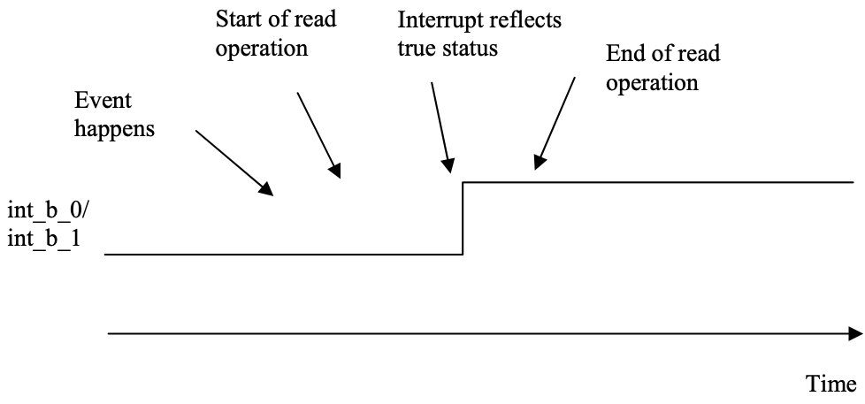
9.3.1.7 Internal Buffer Status
There are totally 1 data buffer inside the SSD2828QN4, which is SPI command interface buffer (CB).
For CB buffers, all packets will be stored into them. They can store multiple packets and each packet size can be set to 1023 bytes. Below is a list of possible packets
• Generic Short Write Packet
• Generic Read Packet
• DCS Short Write Packet
• DCS Read Packet
• Generic Long Write Packet
• DCS Long Write Packet
In case of automatic partitioning, the packet length is determined by the PST field. It is not recommended to make the PST field so small.
The user can write the data through SPI interface. All packets will be written into the CB buffers. Hence, the user needs to check the corresponding interrupts. The usage of the interrupts is listed below.
CBE
To indicate that the Command buffer is empty.
CBA
To indicate that the Command buffer can hold at least 1 more packet. The user can write 1 such packet into CB buffer.
The interrupts mentioned here can be used as flow control between the application processor and the SSD2828. However, it requires the user to know the buffer operation well. The PO interrupt is a combination of the eight. It makes decision according to the parameters provided by the user for the next packet to be written. Hence, the user does not need to know which buffer is going to be used and how the buffer status is.

9.3.2 State machine operation
The state machine controls the sending and receiving of the data packet over the serial link. It is triggered by an event from the application processor or the received data. Once a complete packet is written into the SSD2828 buffer, it will send it out through the serial link. The user can write 1 to bit COP at any time to cancel all the current operations. Please see 8.1.17 for the description.
When the SSD2828 is in high speed mode, the serial link is mainly used to send display data. If there is no data to send, it will send null packet to maintain the serial link timing. If the application processor does not have display data to send in a long period, it can turn the serial link into low power mode by setting the register bit HS to 0.
When the SSD2828 is in low power mode, the serial link is mainly used to send command and configuration data. If there is no data to sent, the SSD2828 will be idle in LP TX stop mode.
The user can also enter sleep mode by writing 1 to SLP bit. Once the SLP bit is set to 1, the SSD2828 will automatically enter LP mode. If the HS bit is 1, the SSD2828 will clear the HS bit to 0 and switch from HS to LP mode. Afterwards, the SSD2828 will issue ULPS trigger message to the MIPI slave to enter Ultra Low Power State. During this state, the clock to SSD2828 can be switched off such that the SSD2828 only consumes leakage current. This will save the overall system power consumption. When exiting from the ULPS, the user can write 0 to SLP bit. However, the user should be aware that the time to exit from ULPS is relatively long (pleaser refer to MIPI DPHY specification). Hence, the user cannot perform any data transmission before the system exits from ULPS.
During reception, the state machine will disassemble the incoming data packet and put the received register content into the internal buffer for reading out. Once all the data are put into the buffers, it will set the register bit RDY to 1 to indicate that the SSD2828 is ready for read. The total number of received bytes will also be stored in RDCR.
After the reception is completed, the SSD2828 will perform a bus turn around to enter the transmission mode. It will always come back to the LP TX stop mode before it enters any other mode.

9.3.3 D-PHY operation
D-PHY controls the operation of the analog transceiver. It controls whether the serial link is in high speed or low power mode and whether it’s in transmit or receive mode.
In transmit mode, the D-PHY will perform the handshaking procedure when switching between LP mode and HS mode according to the control from PCU. During HS mode, D-PHY will provide parallel data and clock to the analog transmitter for transmitting in differential signals serially. During LP mode, D-PHY will directly drive the Datap and Datan line output. It will provide serial data to the analog transmitter.
In receive mode, D-PHY will detect the handshaking sequence in LP mode and inform the PCU. Once entering escape mode, it will collect the serial data from analog receiver and put them in byte form for the PCU to process.
Various timing parameter has been defined in MIPI DPHY specification. The timing parameters are a mixture of absolute time and cycle counts. Hence, for different operation speed, there is different timing requirement. Registers DAR1 to DAR6 are provided for this purpose. The user can adjust the value in these registers to have different DPHY timing parameters. This gives maximum flexibility for different operation speed.

9.3.4 Analog Transceiver

9.3.5 PLL
The PLL output frequency is calculated by the equations below,
f IN f PRE = MS f OUT = f PRE * NS
where the f IN is the input reference clock frequency and f OUT is the output clock frequency of the PLL.
The clock frequencies need to satisfy the constraint below.
5MHz > f IN ≥ 100MHz 5MHz > f REF ≥ 100MHz 62.5MHz > f OUT ≥ 1000MHz
The value of FR, MS, and NS are controlled in the register PLCR.
All the values of FR, MS and NS can only be modified when the PLL is turned off. Hence, the sequence for modification is to turn off PLL, modify register value, and turn on PLL.

9.3.6 Clock Source Example
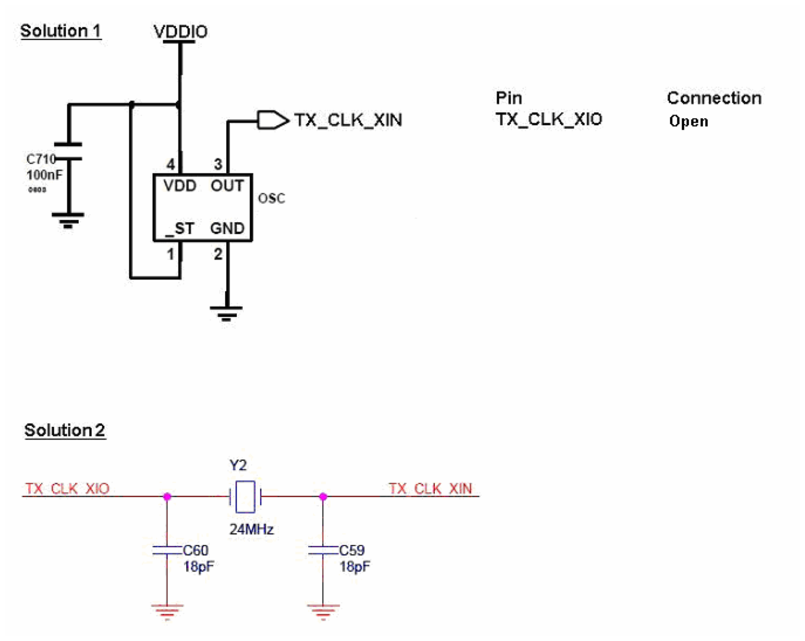

10 External Interface
The SSD2828 supports three types of SPI interface,
• 8-Bit 3 wire (type C option 1, DBI 2.0)
• 8-Bit 4 wire (type C option 3, DBI 2.0)
• 24-bit 3 wire
and RGB interfaces.
The selection is controlled by ps[1:0] pins.
RGB interface supports 4 bpp settings. Below are the data pins used for each interface. For all cases, R should be at the upper bits and B should be at the lower bits.
• data[15:0] for 16 bpp.
• data[17:0] for 18 bpp, packed.
• data[17:0] for 18 bpp, loosely packed.
• data[24:0] for 24 bpp.
SPI interface supports 8-Bit data bus. The least significant byte should be written first.
Below is the operation and timing diagram for each of the interfaces.

10.1 SPI Interface 8 bit 4 Wire
This interface consists of sdcx, sck, sdin, sdout and csx. It only supports 8-Bit data. Each cycle contains 8- Bit data. The first cycle should be a command write cycle to specify the register address for access. The subsequent cycles are read or write cycles for read or write operations.
The csx should be driven from 1 to 0 to start an operation and from 0 to 1 to end an operation. During 1 operation, the application processor can write or read multiple bytes.
sdcx indicates whether the operation is for data or command. When sdcx i_{t}s_{h} 1, the operation is for data. When sdcx is 0, the operation is for command. sdcx is sampled at every 8 rising edge of sck during 1 operation.
During write operation, sdin will be sampled by SSD2828 at the rising edge of sck. The first rising edge of sck after the falling edge of csx samples the bit 7 of the 8-Bit _{t}d_{h} ata. The second rising edge of sck samples the bit 6 of the 8-Bit data, and so on. The value of sdcx is sampled at the 8 rising edge of sck, together with bit 0 of the 8-Bit data. Please see the diagram below for illustration. Optionally, the csx can be driven to 1 in between cycles.
Figure 10-1：Illustration of Write Operation for 8 bit 4 Wire Interface
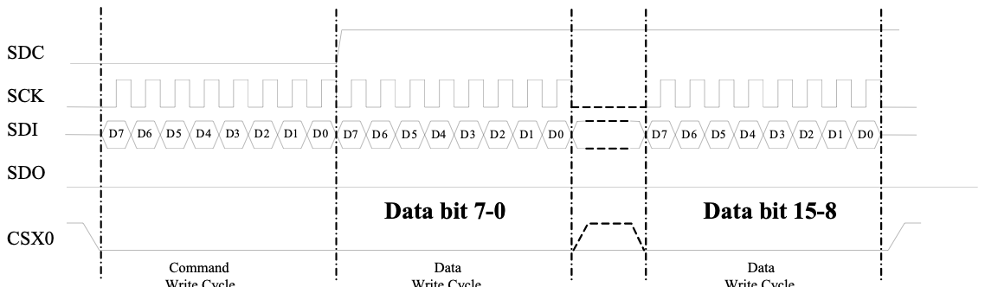
Remark: Send LSB 8bit of data before MSB 8bit
During read operation, since there is no rwx signal to indicate whether the operation is read or write. After csx is driven low, the first cycle is always a command write cycle, which specifies the register to access. The second cycle is still a command write cycle. If the command in this cycle matches the command in register LRR, the SPI interface will enter read mode. The subsequent cycles will be read cycles. If the command does not match, the SPI interface will remain in write mode.
After entering the read mode, the return data is provided on sdout, on the falling edge of sck. The application processor should use the rising edge of sck to sample the data. sdcx should be driven to 1 during the read cycles. Please see the diagram below for illustration. Optionally, the csx can be driven to 1 in between cycles.
Figure 10-2：Illustration of Read Operation for 8 bit 4 Wire Interface
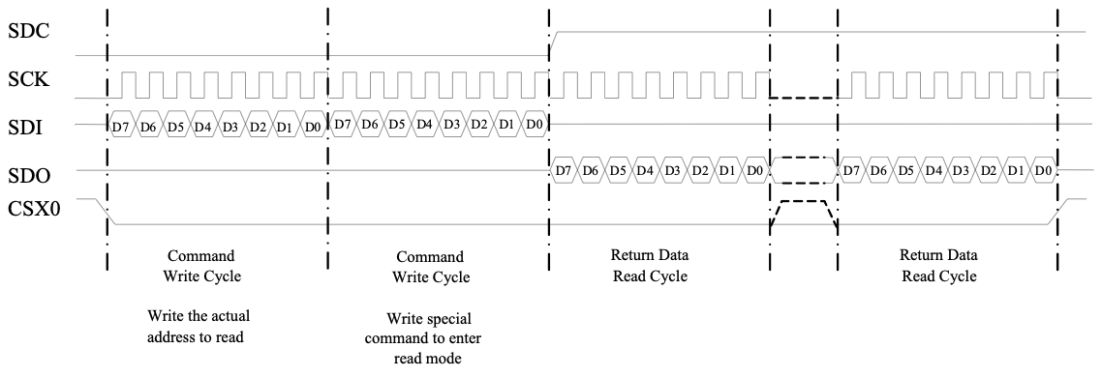

10.2 SPI Interface 8 bit 3 Wire
This interface consists of sck, sdin, sdout and csx. It only supports 8-Bit data. Each cycle contains 8-Bit data. The first cycle should be a write cycle to specify the register address for access. The subsequent cycles are read or write cycles for read or write operations.
The csx should be driven from 1 to 0 to start an operation and from 0 to 1 to end an operation. During 1 operation, the application processor can write or read multiple bytes.
Instead of sdcx, an sdcx bit is used to indicate whether the operation is for data or command. Each byte is associated with an sdcx bit. When sdcx is 1, the operation is for display data. When sdcx is 0, the operation is for command. The sdcx bit is sent priori to each byte. In other words, the sdcx bit is the first bit of every 9 bits during 1 operation.
During write operation, sdin will be sampled by SSD2828 at the rising edge of sck. The first rising edge of sck after the falling edge of csx samples the sdcx bit. The second rising edge samples bit 7 of the 8-Bit data. The third rising edge of sck samples the bit 6 of the 8-Bit data, and so on. Please see the diagram below for illustration. Optionally, the csx can be driven to 1 in between cycles.
Figure 10-3：Illustration of Write Operation for 8 bit 3 Wire Interface
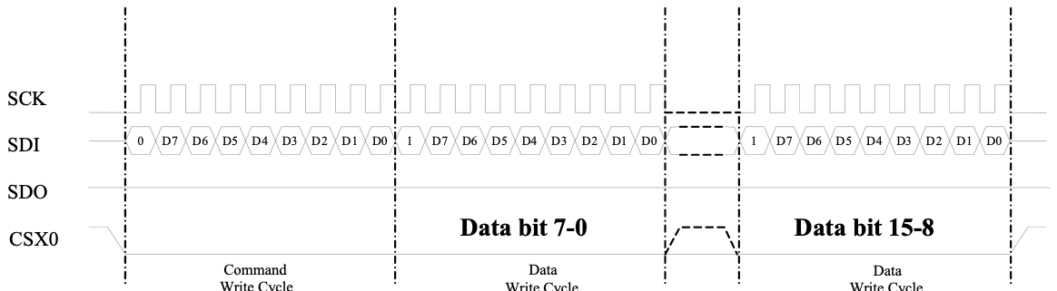
Remark: Send LSB 8bit of data before MSB 8bit
During read operation, since there is no rwx signal to indicate whether the operation is read or write. After csx is driven low, the first cycle is always a command write cycle, which specifies the register to access. The second cycle is still a command write cycle. If the command in this cycle matches the command in register LRR, the SPI interface will enter read mode. The subsequent cycles will be read cycles. If the command does not match, the SPI interface will remain in write mode.
After entering the read mode, the return data is provided on sdout, on the falling edge of sck. The application processor should use the rising edge of sck to sample the data. Please note that there is no sdcx bit to read out from SSD2828. Hence, each read cycle consists of 8-Bits instead of 9 bits. This is the difference between read and write cycles. Please see the diagram below for illustration. Optionally, the csx can be driven to 1 in between cycles.
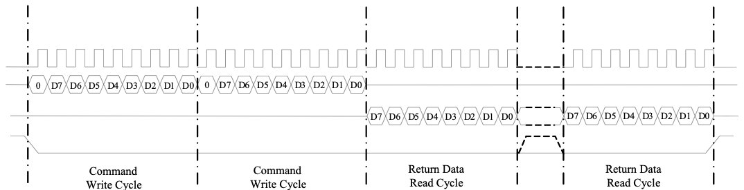
SCK
CSX0
_{reaudal} _{commreaanddmtoodeenter}
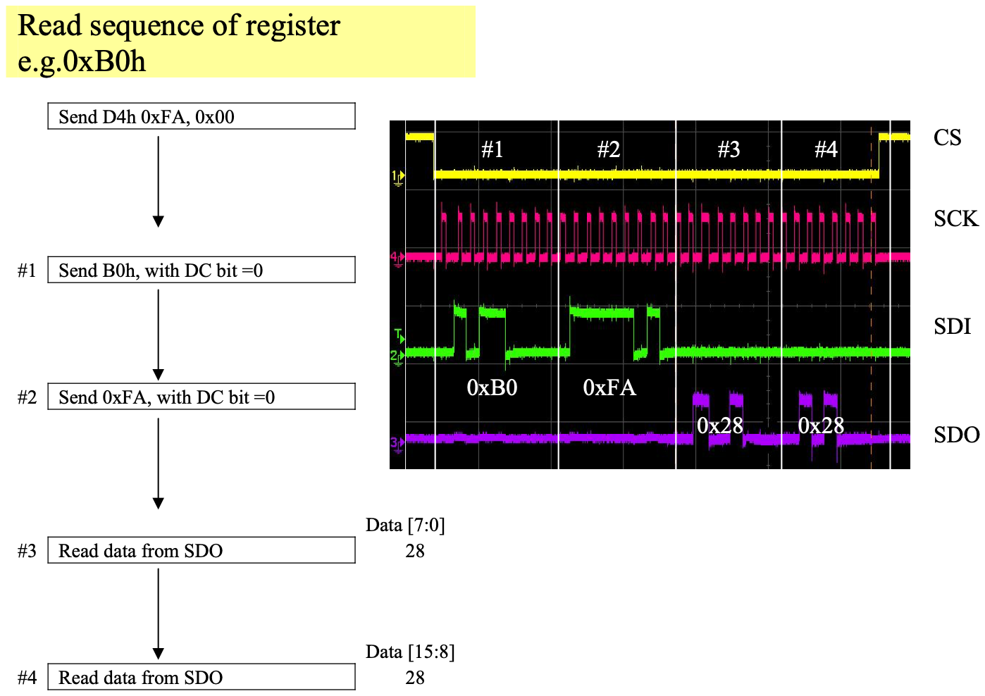
Figure 10-4：Illustration of Read Operation for 8 bit 3 Wire Interface
10.2.1 3 or 4 wires 8bit SPI read back sequence for 0xFF register which is stored MIPI read back data
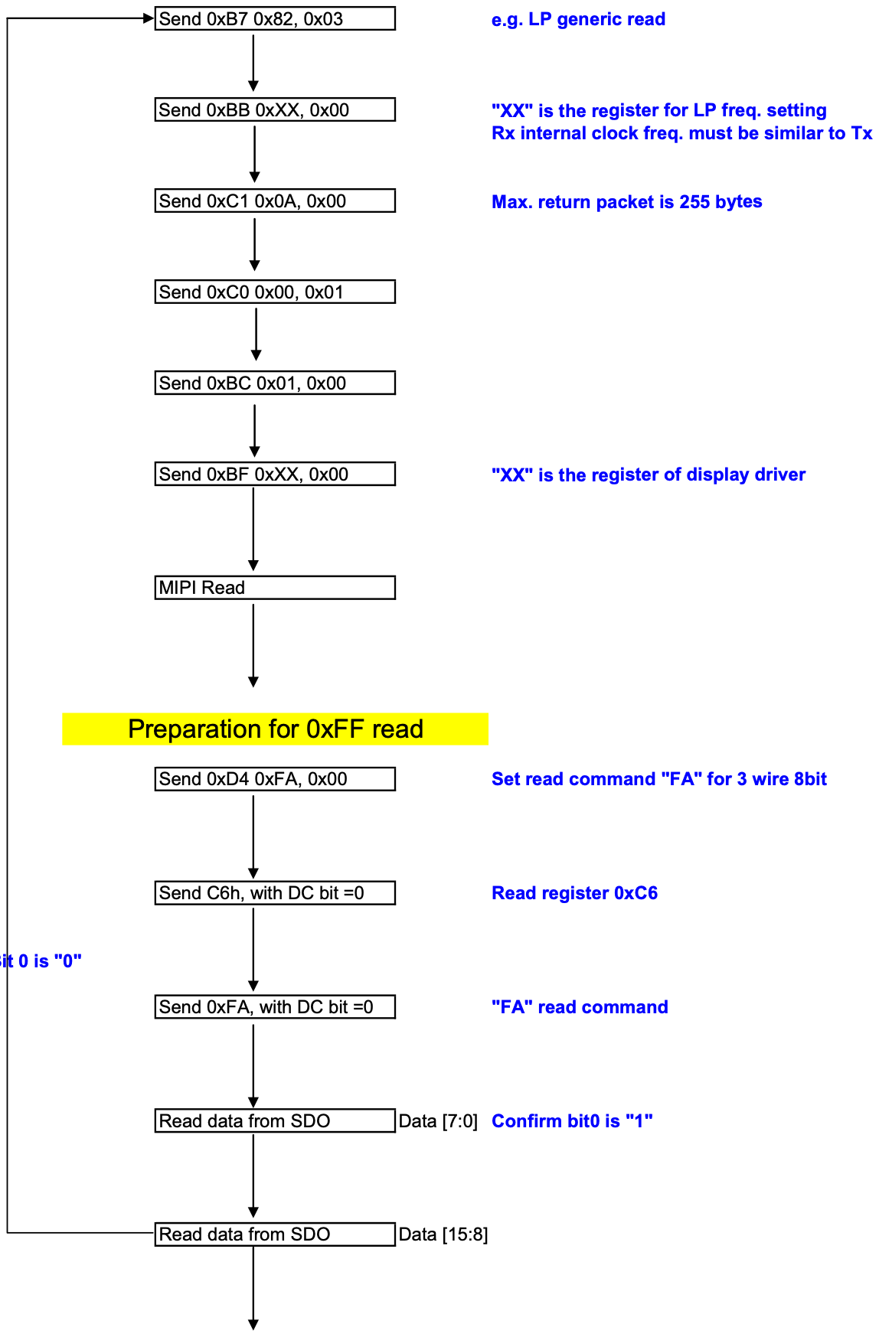
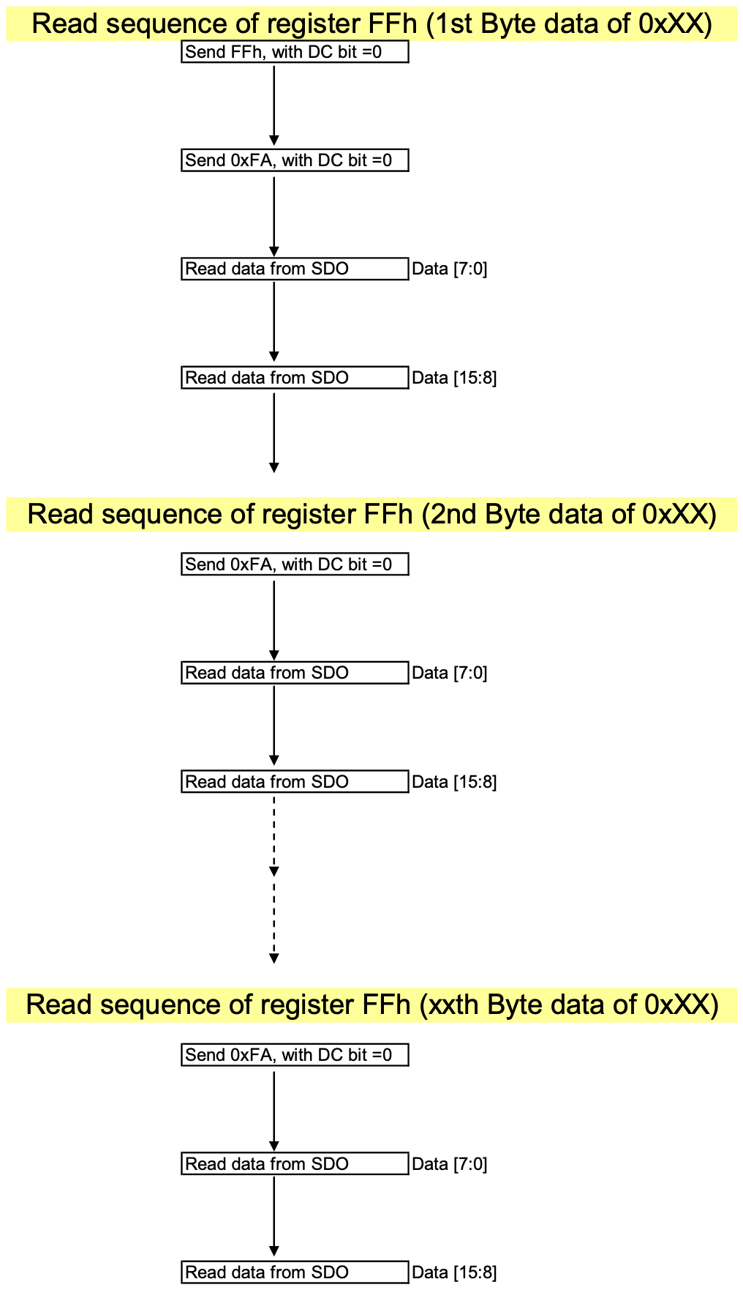

10.3 SPI Interface 24 bit 3 Wire
This interface consists of sck, sdin, sdout and csx. It only supports 16-bit data. Each cycle contains 16-bit data. The first cycle should be a write cycle to specify the register address for access. The subsequent cycles are read or write cycles for read or write operations.
The csx should be driven from 1 to 0 to start cycle and from 0 to 1 to end a cycle. During 1 operation, the application processor can have multiple write or read cycles. However, the csx must go from 0 to 1 at the end of each cycle.
Each cycle contains 24-bit data. Among the 24-bit data, the first 8-Bit are for control purpose and the next 16-bit are the actual data. The first 6 bits are the ID bit for SSD2828, which must be 011100. If this field does not match, the cycle will not be taken in. The 7th bit is the sdcx bit which is the same as the 8-Bit 3 wire interface. The 8th bit is the RW bit which indicates whether the current cycle is a read or write cycle. When RW is 1, the cycle is a read cycle. When RW is 0, the cycle is a write cycle.
During write operation, sdin will be sampled by SSD2828 at the rising edge of sck. Please see the diagram below for illustration. It is an example for writing data 0x1264 to register address 0x28.
Figure 10-5：Illustration of Write Operation for 24 bit 3 wire Interface
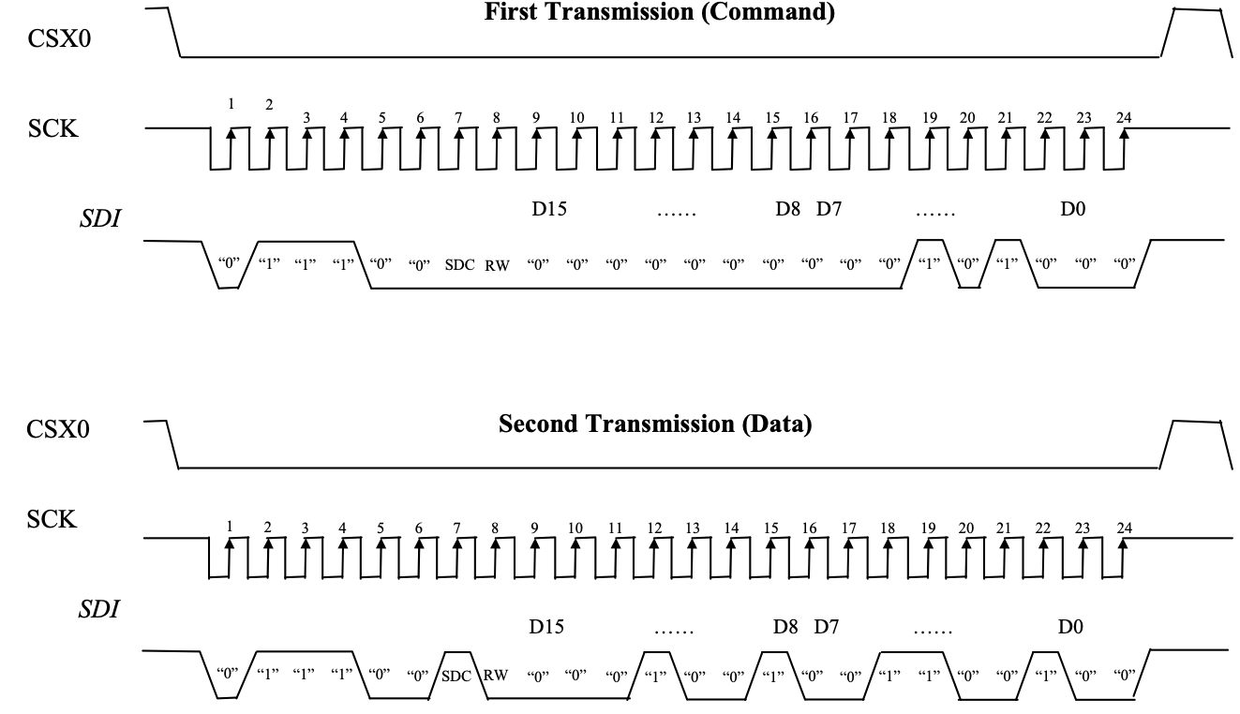
Remark: Send MSB 8bit of data before LSB 8bit
During read operation, the first 8-Bit are still written by the application processor to specify whether the following 16-bit are for command or data. Afterwards, the SSD2828 will provide the return data on sdout, on the falling edge of sck. The application processor should use the rising edge of sck to sample. Please see the diagram below for illustration.
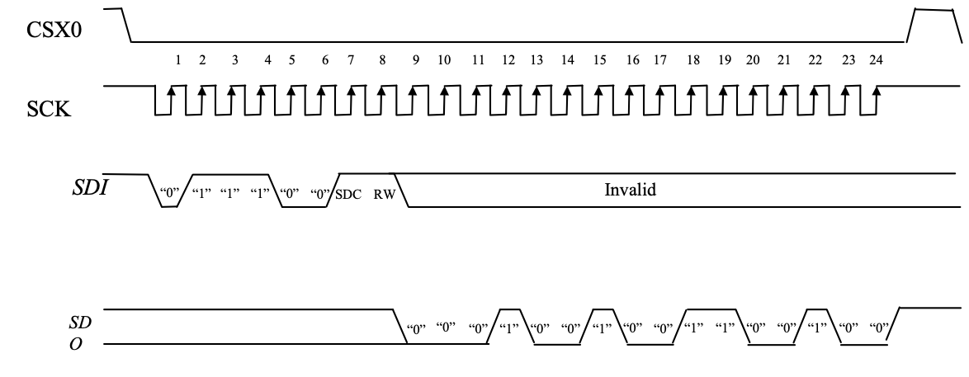
Figure 10-6：Illustration of Read Operation for 24 bit 3 Wire Interface
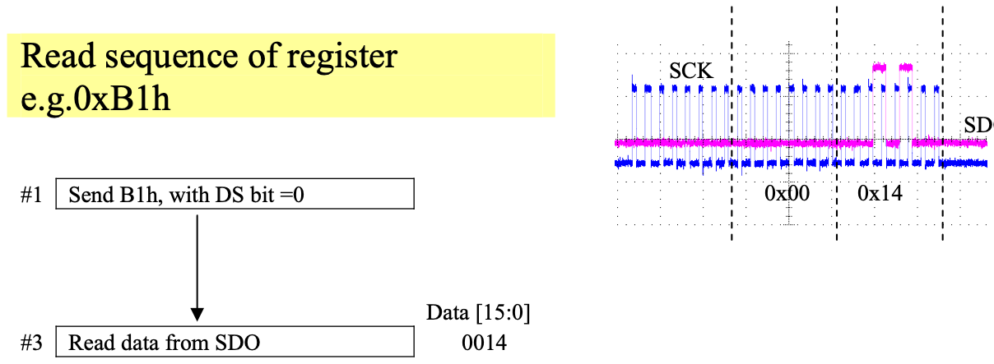
10.3.1 3 wires 24bit SPI read back sequence for 0xFF register which is stored MIPI read back data
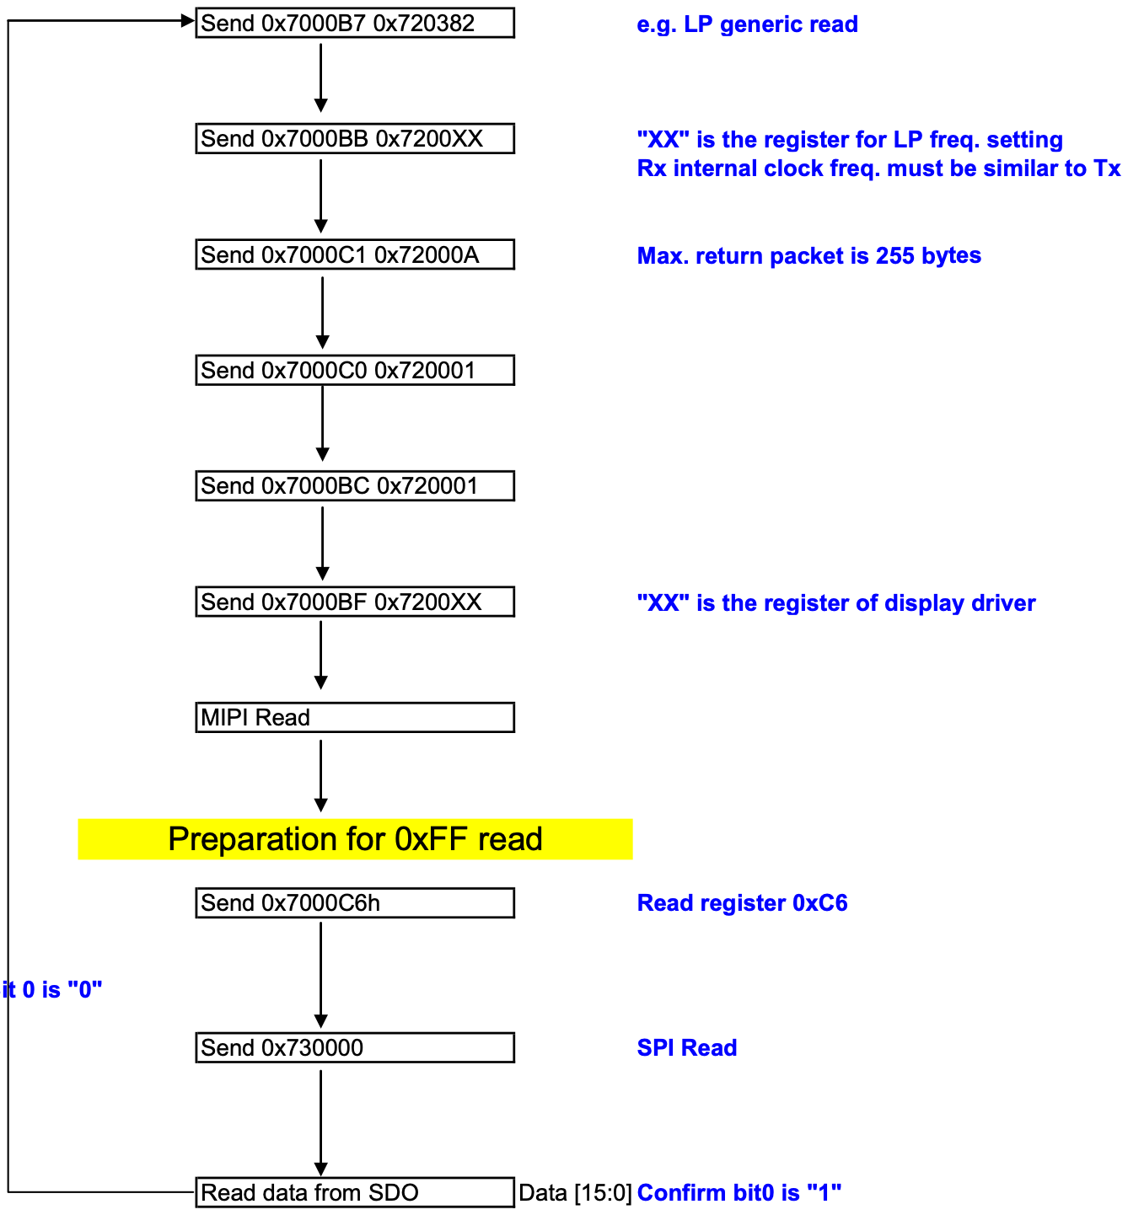
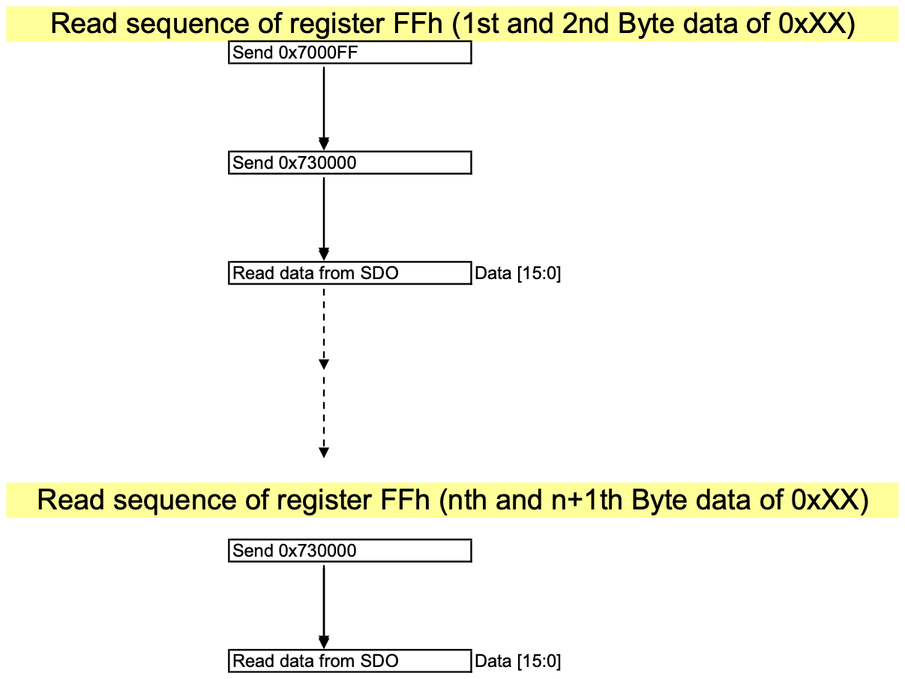

11 MAXIMUM RATINGS
Table 11-1：Maximum Ratings (Voltage Referenced to V SS )
 | ymbol |  |  | arameter |  |  | alue |  |  | Unit
MVDD |  |  | Core Power Supply |  |  | -0.3 to 1.44 |  |  | V
VDDIO |  |  | I/O Power Supply |  |  | -0.3 to 4.0 |  |  | V
T_{SOL} |  |  | Solder Temperature / Time |  |  | 225 for 40 sec max at solder ball |  |  | _{o}C
T_{STG} |  |  | Storage Temperature |  |  | -40 to 100 |  |  | _{o}C

Maximum ratings are those values beyond which damages to the device may occur. Functional operation should be restricted to the limits specified in the electrical characteristics tables and Pin Description section
This device contains circuitry to protect the inputs against damage due to high static voltages or electric fields; however, it is advised that normal precautions be taken to avoid application of any voltage higher than maximum rated voltages to this high impedance circuit. Unused outputs must be left open. This device may be light sensitive. Caution should be taken to avoid exposure of this device to any light source during normal operation. This device is not radiation protected.

12 RECOMMENDED OPERATING CONDITIONS
Table 12-1：Recommended Operating Conditions
 | Symbol |  | Parameter |  |  | Min |  |  | Typ |  |  | Max |  |  | nit
MVDD |  |  | Digital Core Power Supply |  | 1.08 |  |  | 1.2 |  |  | 1.32 |  |  | V
VDDIO |  |  | I/O AND Digital Power Supply |  | 2.97 |  |  | 3.3 |  |  | 3.63 |  |  | V
 |  |  |  |  | 1.62 |  |  | 1.8 |  |  | 1.98 |  |  | V
T_{A} |  |  | Operating Temperature |  | -30 |  |  | 25 |  |  | 85 |  |  | _{o}C

13 DC Characteristics
Conditions: Voltage referenced to GND MVDD = 1.2V VDDIO = 1.8V Frame frequency = 60Hz Number of lane = 4 Display pattern = 1080x1920, 8 colors vertical bar T_{A} = 25°C
Table 13-1：DC Characteristics
 | Symbol |  |  | arameter |  |  | est Condition |  |  | Min |  |  | Typ |  |  | Max |  |  | Unit
I_{MVDD_HS} |  |  | High Speed Mode Current |  |  | 1Gbps |  |  | - |  |  | 46.8 |  |  | 76.2 |  |  | mA
I_{VDDIO_HS} (1.8V) |  |  |  |  |  |  |  |  | - |  |  | 0.36 |  |  | 0.75 |  |  | mA
I_{VDDIO_HS} (3.3V) |  |  |  |  |  |  |  |  | - |  |  | 0.79 |  |  | 1.64 |  |  | mA
I_{MVDD_LP} |  |  | Low Power Mode Current |  |  | 10Mbps |  |  | - |  |  | 16.00 |  |  | 39.90 |  |  | mA
I_{VDDIO_LP} (1.8V) |  |  |  |  |  |  |  |  | - |  |  | 0.17 |  |  | 0.43 |  |  | mA
I_{VDDIO_LP} (3.3V) |  |  |  |  |  |  |  |  | - |  |  | 0.37 |  |  | 0.94 |  |  | mA
I_{MVDD_ULPS} |  |  | Ultra Low Power State Current |  |  | PLL off, no change in all input signals |  |  | - |  |  | 292.4 |  |  | 435 |  |  | μA
I_{VDDIO_ULPS} (1.8V) |  |  |  |  |  |  |  |  | - |  |  | 75.6 |  |  | 150 |  |  | μA
I_{VDDIO_ULPS} (3.3V) |  |  |  |  |  |  |  |  | - |  |  | 165.2 |  |  | 327.8 |  |  | μA
VOH (CMOS) |  |  | Output High  Voltage (CMOS) |  |  | IOH = -2 ~ -16 mA |  |  | V_{DDIO} x 0.8 |  |  | - |  |  | - |  |  | V
VOL (CMOS) |  |  | Output Low Voltage (CMOS) |  |  | IOL= 2 ~ 16 mA |  |  | - |  |  | - |  |  | V_{DDIO} x 0.15 |  |  | V
VIH (CMOS) |  |  | Input High Voltage (CMOS) |  |  |  |  |  | V_{DDIO} x 0.7 |  |  | - |  |  | - |  |  | V
VIL (CMOS) |  |  | Input Low Voltage (CMOS) |  |  |  |  |  | - |  |  | - |  |  | V_{DDIO} x 0.2 |  |  | V
IOZ |  |  | Tri-state Output  Leakage Current |  |  |  |  |  | - |  |  | +/-1 |  |  | - |  |  | μA
IIN |  |  | Input Leakage  Current |  |  | VIN = V_{DDIO} or GND |  |  | - |  |  | +/-1 |  |  | - |  |  | μA
CIN |  |  | Input Capacitance |  |  |  |  |  | - |  |  | 2.2 |  |  | - |  |  | pF

Table 13-2：HS Transmitter DC Characteristics
 | Symbol |  |  | Parameter |  |  | Min |  |  | Typ |  |  | Max |  |  | Unit
V_{CMTX} |  |  | HS Transmit Static Common-mode Voltage |  |  | 150 |  |  | - |  |  | 250 |  |  | mV
|V_{OD}| |  |  | HS Transmit Differential Voltage |  |  | 140 |  |  | - |  |  | 270 |  |  | mV
|ΔV_{OD}| |  |  | HS Differential Mismatch |  |  | - |  |  | - |  |  | 10 |  |  | mV
V_{OHHS} |  |  | HS Output High Voltage |  |  | - |  |  | - |  |  | 360 |  |  | mV

Table 13-3：LP Transmitter DC Characteristics
 | Symbol |  |  | Parameter |  |  | Min |  |  | Typ |  |  | Max |  |  | Unit
V_{OH} |  |  | LP Thevenin Output High Level |  |  | 1.1 |  |  | 1.2 |  |  | 1.3 |  |  | V
V_{OL} |  |  | LP Thevenin Output Low Level |  |  | -50 |  |  | - |  |  | 50 |  |  | mV
Z_{OLP} |  |  | LP Transmitter Output Impedance |  |  | 110 |  |  | - |  |  | - |  |  | Ohm

Table 13-4：LP Receiver DC Characteristics
 | Symbol |  |  | Parameter |  |  | Min |  |  | Typ |  |  | Max |  |  | Unit
V_{IH} |  |  | LP Logic 1 Input Voltage |  |  | 880 |  |  | - |  |  | - |  |  | mV
V_{IL} |  |  | LP Logic 0 Input Voltage |  |  | - |  |  | - |  |  | 550 |  |  | mV

14 AC Characteristics
NOTE:
1. After PLL gets locked, T is the period of the PLL output clock unless specified. Before PLL gets locked, T is the period of PLL input reference clock. The reference clock can be either the tx_clk or the pclk, depending on the CSS bit.
1 / T = PLL / 2,
e.g. When PLL is Off <0xB9 0x0000>,
TX_CLK = 10MHz,
PLL = TX_CLK x 2 = 20Mbps
1 / T = 10MHz
2. W is the width of the display, e.g. the number of pixels for the horizontal line.
3. The AC characteristics specifie the maximum speed of the incoming signals at the input interface. However, the data throughput on the serial link is another factor affecting the speed. If the user takes in the INT signal, there will be automatic flow control. If the user does not take the INT signal, the user needs to ensure that the output throughput is larger than the incoming data rate.
14.1 8 Bit 4 Wire SPI Interface Timing
Table 14-1：8 Bit 4 Wire SPI Interface Timing Characteristics
Symbol | Parameter | Min | Typ | Max | Unit
t_{cycle} | Clock Cycle Time | 8T |  | - | ns
f_{CLK} | Serial Clock Cycle Time | - |  | 1/8T | MHz
t_{AS} | Register select Setup Time | 4 |  | - | ns
t_{AH} | Register select Hold Time | 0 |  | - | ns
t_{CSS} | Chip Select Setup Time | 4 |  | - | ns
t_{CSH} | Chip Select Hold Time | 0 |  | - | ns
t_{DSW} | Write Data Setup Time | 4 |  | - | ns
t_{DHW} | Write Data Hold Time | 0 |  | - | ns
t_{ACC} | Read Data Access Time | - |  | 4.4+6T | ns
t_{DHR} | Read Data Hold Time | 1.2+4T |  | 4.4+6T | ns
t_{CLKL} | Clock Low Time | 4T |  | - | ns
t_{CLKH} | Clock High Time | 4T |  | - | ns
t_{CSWD} | Chip Select Write Delay Time | 8T |  | - | ns
t_{CSRD} | Chip Select Read Delay Time | 16T |  | - | ns
t_{R} | Rise time | - |  | 2 | ns
t_{F} | Fall time | - |  | 2 | ns

Figure 14-1：8 Bit 4 Wire SPI Interface Timing Diagram
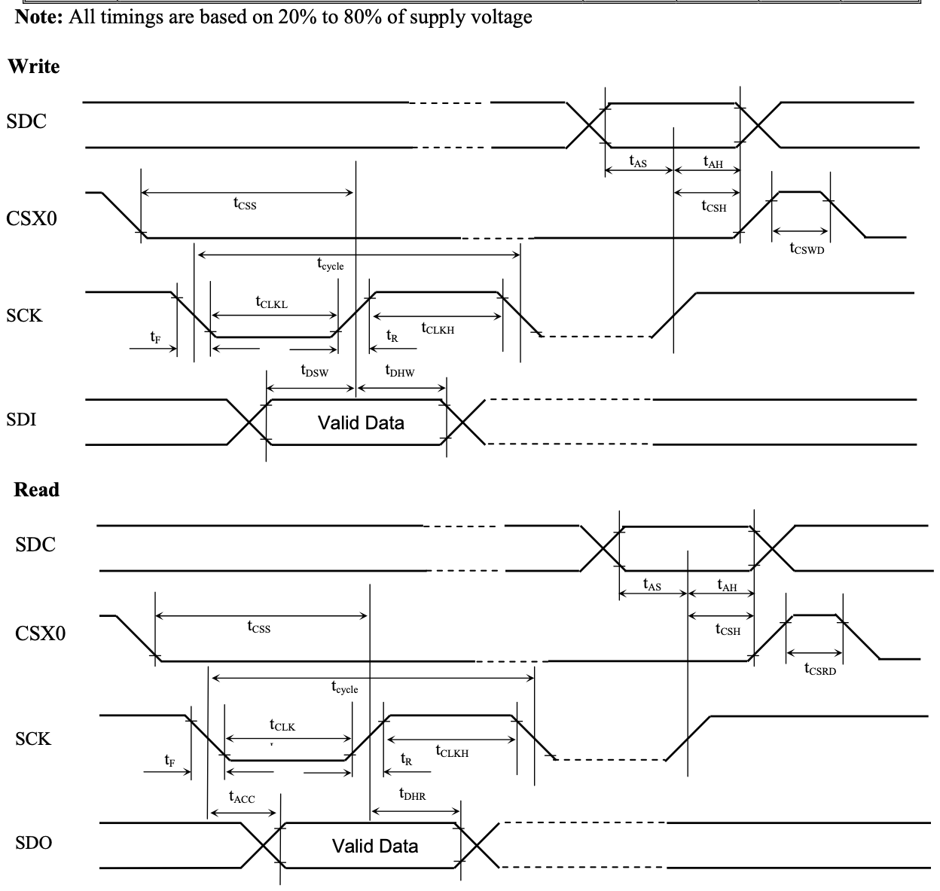
14.2 8 Bit 3 Wire SPI Interface Timing
Table 14-2：8 Bit 3 Wire SPI Interface Timing Characteristics
Symbol | Parameter | Min | Typ | Max | Unit
t_{cycle} | Clock Cycle Time | 8T |  | - | ns
f_{CLK} | Serial Clock Cycle Time | - |  | 1/8T | MHz
t_{CSS} | Chip Select Setup Time | 4 |  | - | ns
t_{CSH} | Chip Select Hold Time | 0 |  | - | ns
t_{DSW} | Write Data Setup Time | 4 |  | - | ns
t_{OHW} | Write Data Hold Time | 0 |  | - | ns
t_{ACC} | Read Data Access Time | - |  | 4.4+6T | ns
t_{DHR} | Read Data Hold Time | 1.2+4T |  | 4.4+6T | ns
t_{CLKL} | Clock Low Time | 4T |  | - | ns
t_{CLKH} | Clock High Time | 4T |  | - | ns
t_{CSWD} | Chip Select Write Delay Time | 8T |  | - | ns
t_{CSRD} | Chip Select Read Delay Time | 16T |  | - | ns
t_{R} | Rise time | - |  | 2 | ns
t_{F} | Fall time | - |  | 2 | ns

Figure 14-2：8 Bit 3 Wire SPI Interface Timing Diagram
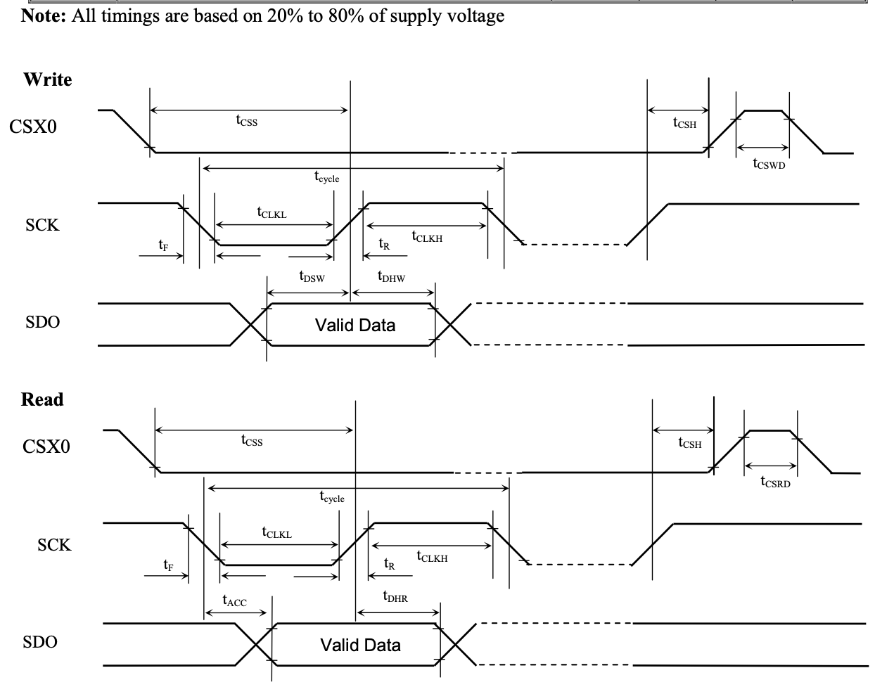
14.3 24 Bit 3 Wire SPI Interface Timing
Table 14-3：24 Bit 3 Wire SPI Interface Timing Characteristics
Symbol | Parameters | Min | Typ | Max | Units
t_{cycle} | Clock Cycle Time | 8T |  | - | ns
f_{CLK} | Serial Clock Cycle Time | - |  | 1/8T | MHz
t_{CSS} | Chip Select Setup Time | 4 |  | - | ns
t_{CSH} | Chip Select Hold Time | 0 |  | - | ns
t_{DSW} | Write Data Setup Time | 4 |  | - | ns
t_{OHW} | Write Data Hold Time | 0 |  | - | ns
t_{ACC} | Read Data Access Time | - |  | 4.4+6T | ns
t_{DHR} | Read Data Hold Time | 1.2+4T |  | 4.4+6T | ns
t_{CLKL} | Clock Low Time | 4T |  | - | ns
t_{CLKH} | Clock High Time | 4T |  | - | ns
t_{CSWD} | Chip Select Write Delay Time | 8T |  | - | ns
t_{CSRD} | Chip Select Read Delay Time | 16T |  | - | ns
t_{R} | Rise time | - |  | 2 | ns
t_{F} | Fall time | - |  | 2 | ns

Figure 14-3：24 Bit 3 Wire SPI Interface Timing Diagram
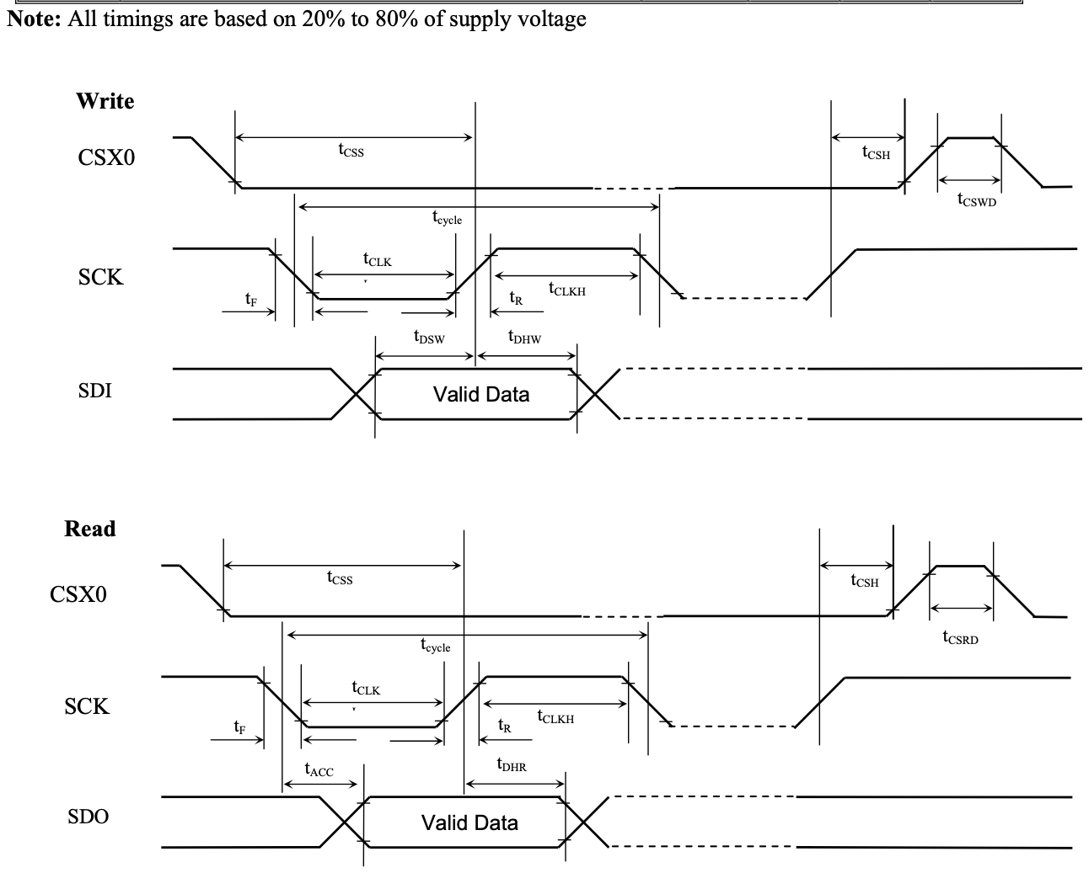

14.4 RGB Interface Timing
Table 14-4：RGB Interface Timing Characteristics
Symbol | Parameters | Min | Typ | Max | Units
t_{pclk} | pclk Period | 16/18/24T | 16/18/24T |  | ns
t_{vsys} | Vertical Sync Setup Time | 5 |  |  | ns
t_{vsyh} | Vertical Sync Hold Time | 5 |  |  | ns
t_{hsys} | Horizontal Sync Setup Time | 5 |  |  | ns
t_{hsyh} | Horizontal Sync Hold Time | 5 |  |  | ns
t_{hv} | Phase difference of Sync Signal Falling Edge | 0 |  | W | t_{pclk}
t_{CKL} | pclk Low Period | 8/9/12T | 8/9/12T |  | ns
t_{CKH} | pclk High Period | 8/9/12T | 8/9/12T |  | ns
t_{ds} | Data Setup Time | 3.3 |  |  | ns
t_{dh} | Data hold Time | 3.3 |  |  | ns

Note:
1. T represents the total bit rate Tmax = 1 / (PLL x number of lane) Tmax = 1 / 4G = 250ps
2. All timings are based on 20% to 80% of supply voltage
3. W is the number of pixel in a horizontal line
4. The pclk period depends on the bit per pixel (bpp) setting and whether the video mode is burst or non-burst mode. In burst mode, the values in the Min column should be followed. In non-burst mode, the values in the Typ column should be followed.
Figure 14-4：RGB Interface Timing Diagram
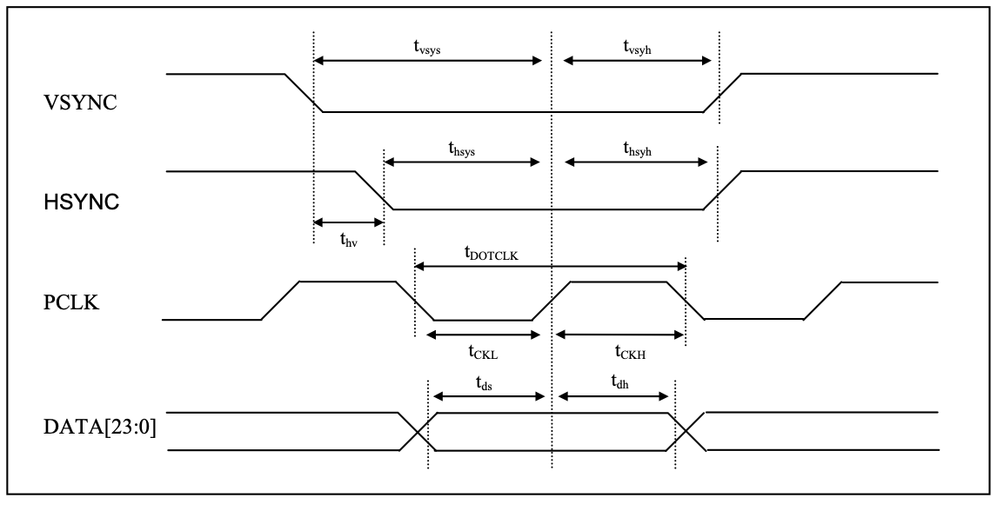

14.5 RESET Timing
Table 14-5：RESET Timing
 | Symbol | Parameters | Min | Typ |  |  | Max |  |  | Units
T_{RESET} |  | RESET “Low” Pulse Width | 10 | - |  | - |  |  | ms

14.6 TX_CLK Timing
Table 14-6：TX_CLK Timing Characteristics
 | Symbol | Parameters | Min | Typ |  |  | Max |  |  | Units
f_{TXCLK} |  | TX_CLK Frequency | 8 | - |  | 30 |  |  | MHz
t_{R} |  | Rise Time | - |  |  | 10 |  |  | ns
t_{F} |  | Fall Time | - |  |  | 10 |  |  | ns

Figure 14-5：TX_CLK Timing Diagram
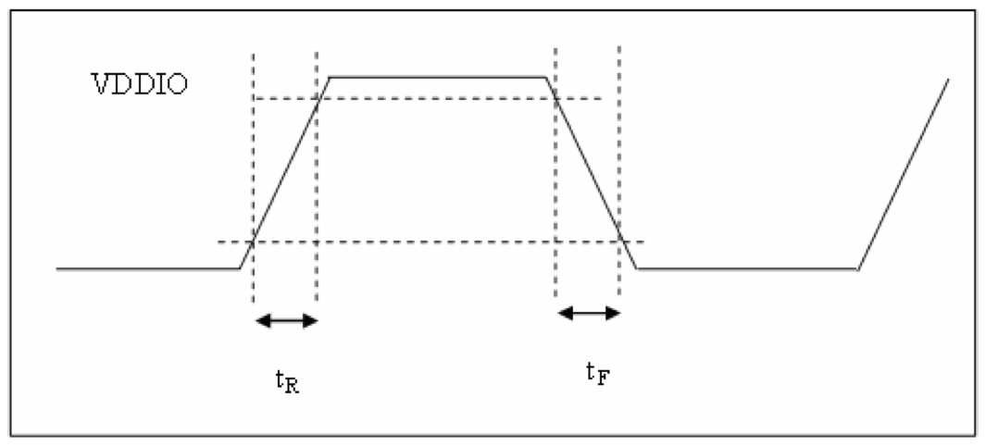

15 Power up sequence
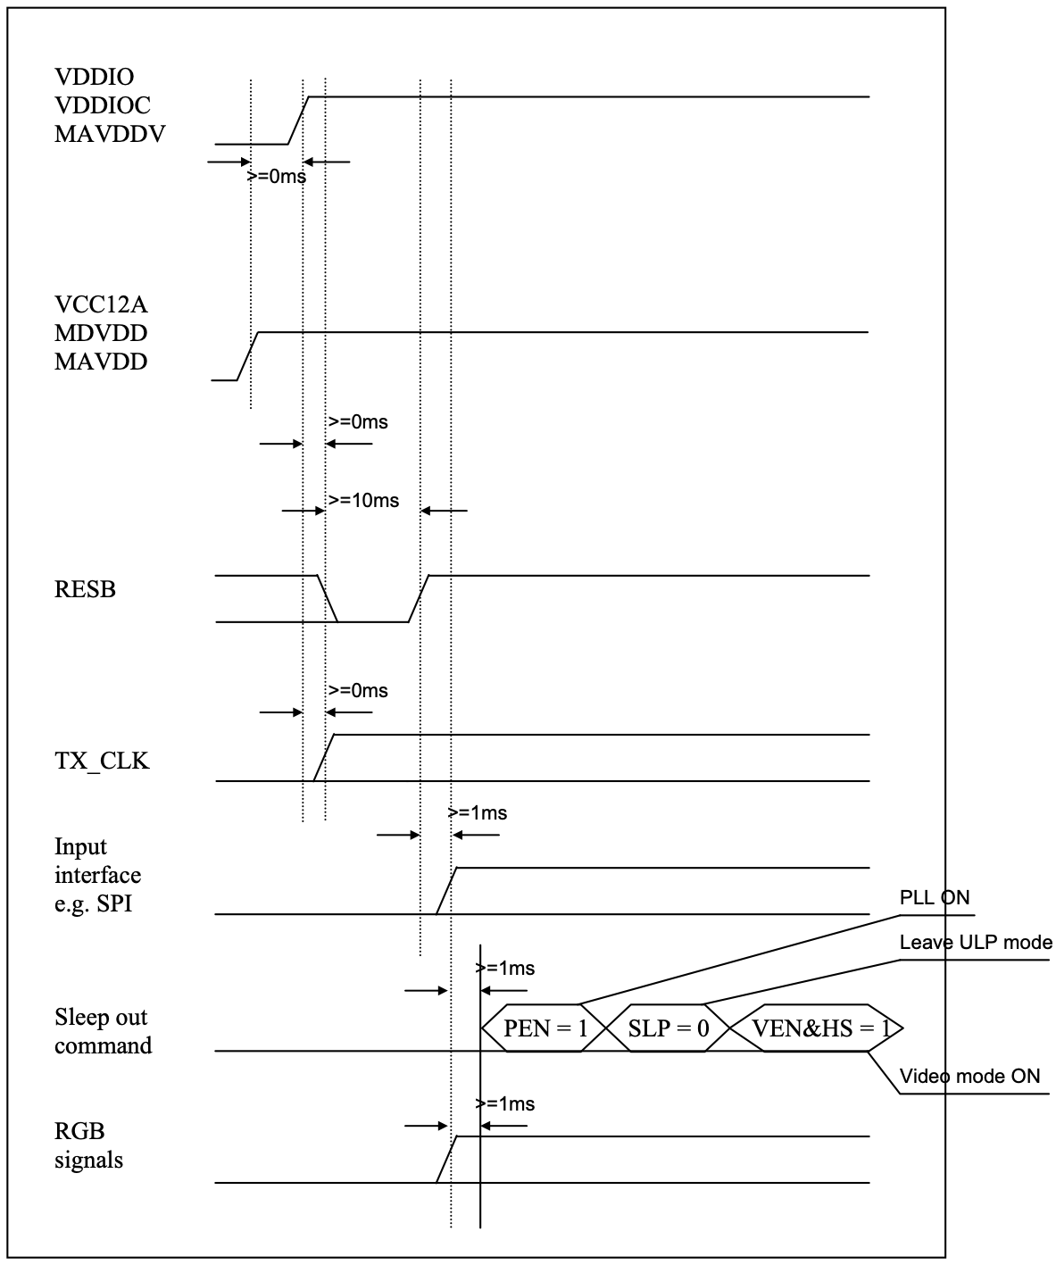

16 Power off sequence
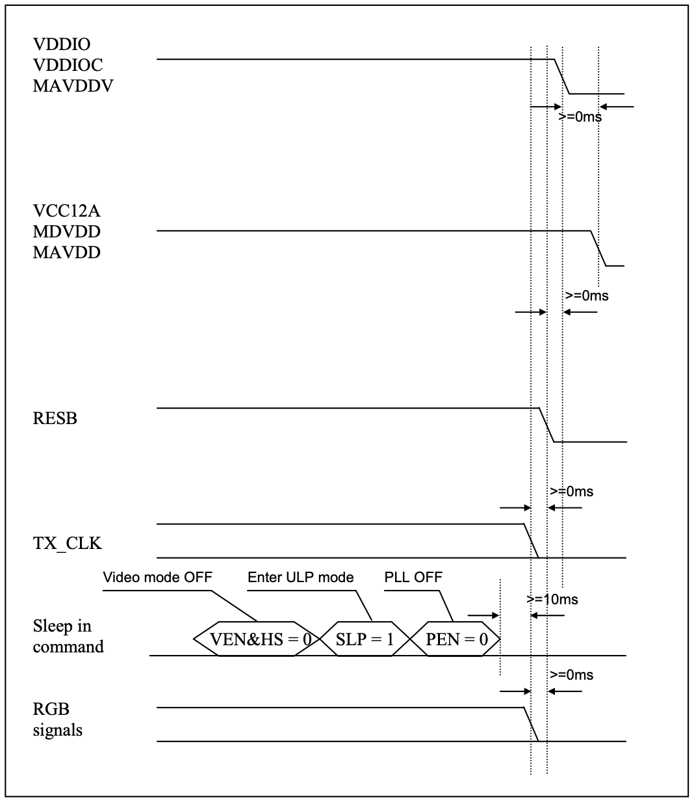

17 Example for system sleep in and out
Note: Following example is only for reference, application must be related to the particular information of AP and driver IC, e.g.Wait time and TX_CLK (_XIN, _XIO) csontrol of AP
 |  |  |  |  |  |  |  | AP switches ON TX_CLK | Driver IC Sleep In
 |  |  |  |  |  |  |  | AP switches ON RGB signals | Driver IC Sleep In
 |  |  |  |  |  |  |  | Wait 10ms | Driver IC Sleep In
 |  |  |  |  |  |  |  | SSD2828 PLL ON  e.g. 0xB9 0x0001 | Driver IC Sleep In
 |  |  |  |  |  |  |  | SSD2828 Leaves ULP Mode e.g. 0xB7 0x0300 | Driver IC Sleep In
 |  |  |  | AP switches OFF RGB signals
Driver IC Sleep In |  |  |  |  |  |  |  | Driver Sleep In Command  e.g. 0x11
SSD2828 Video Mode ON
e.g. 0xB7 0x0309
 |  |  |  | AP switches OFF TX_CLK
 |  |  | SSD2828 Sleep In

18 Serial Link Data Order
There are many possible ways of doing parallel to serial conversion. SSD2828 provides flexibility by programming two register bits END and CO. During video mode, they must be programmed to 0 and 1 respectively.
Below is the order to receive the display data over the serial link, when the END bit is 1 and CO bit is 0.
For 16 bit per pixel data, below is the byte order. Each byte of data is sent in the order of LSB first and MSB last.
MSB Byte 1 LSB |  |  |  |  |  |  |  | MSB Byte2 LSB |  |  |  |  |  |  |  | MSB Byte3 LSB |  |  |  |  |  |  |  | MSB Byte4 LSB
R4 | R3 | R2 | R1 | R0 | G5 | G4 | G3 | G2 | G1 | G0 | B4 | B3 | B2 | B1 | B0 | R4 | R3 | R2 | R1 | R0 | G5 | G4 | G3 | G2 | G1 | G0 | B4 | B3 | B2 | B1 | B0

Time
For 18 bit per pixel data, below is the byte order. Each byte of data is sent in the order of LSB first and MSB last.
MSB Byte 1 LSB |  |  |  |  |  |  |  | MSB Byte2 LSB |  |  |  |  |  |  |  | MSB Byte3 LSB |  |  |  |  |  |  |  | MSB Byte4 LSB
R5 | R4 | R3 | R2 | R1 | R0 | G5 | G4 | G3 | G2 | G1 | G0 | B5 | B4 | B3 | B2 | B1 | B0 | R5 | R4 | R3 | R2 | R1 | R0 | G5 | G4 | G3 | G2 | G1 | G0 | B5 | B4

Time
For 24 bit per pixel data, below is the byte order. Each byte of data is sent in the order of LSB first and MSB last.
MSB Byte 1 LSB |  |  |  |  |  |  |  | MSB Byte2 LSB |  |  |  |  |  |  |  | MSB Byte3 LSB |  |  |  |  |  |  |  | MSB Byte4 LSB
R7 | R6 | R5 | R4 | R3 | R2 | R1 | R0 | G7 | G6 | G5 | G4 | G3 | G2 | G1 | G0 | B7 | B6 | B5 | B4 | B3 | B2 | B1 | B0 | R7 | R6 | R5 | R4 | R3 | R2 | R1 | R0

Time
Below is the order to send the display data over the serial link, when the END bit is 0 and CO bit is 0.
For 16 bit per pixel data, below is the byte order. Each byte of data is sent in the order of LSB first and MSB last.
MSB Byte 1 LSB |  |  |  |  |  |  |  | MSB Byte2 LSB |  |  |  |  |  |  |  | MSB Byte3 LSB |  |  |  |  |  |  |  | MSB Byte4 LSB
G2 | G1 | G0 | B4 | B3 | B2 | B1 | B0 | R4 | R3 | R2 | R1 | R0 | G5 | G4 | G3 | G2 | G1 | G0 | B4 | B3 | B2 | B1 | B0 | R4 | R3 | R2 | R1 | R0 | G5 | G4 | G3

Time
For 18 bit per pixel data, below is the byte order. Each byte of data is sent in the order of LSB first and MSB last.
MSB Byte 1 LSB |  |  |  |  |  |  |  | MSB Byte2 LSB |  |  |  |  |  |  |  | MSB Byte3 LSB |  |  |  |  |  |  |  | MSB Byte4 LSB
G1 | G0 | B5 | B4 | B3 | B2 | B1 | B0 | R3 | R2 | R1 | R0 | G5 | G4 | G3 | G2 | B5 | B4 | B3 | B2 | B1 | B0 | R5 | R4 | R1 | R0 | G5 | G4 | G3 | G2 | G1 | G0

Time
For 24 bit per pixel data, below is the byte order. Each byte of data is sent in the order of LSB first and MSB last.
MSB Byte 1 LSB |  |  |  |  |  |  |  | MSB Byte2 LSB |  |  |  |  |  |  |  | MSB Byte3 LSB |  |  |  |  |  |  |  | MSB Byte4 LSB
B7 | B6 | B5 | B4 | B3 | B2 | B1 | B0 | G7 | G6 | G5 | G4 | G3 | G2 | G1 | G0 | R7 | R6 | R5 | R4 | R3 | R2 | R1 | R0 | R7 | R6 | R5 | R4 | R3 | R2 | R1 | R0

Time
Below is the order to send the display data over the serial link, when the END bit is 1 and CO bit is 1.
For 16 bit per pixel data, below is the byte order. Each byte of data is sent in the order of LSB first and MSB last.
MSB Byte 1 LSB |  |  |  |  |  |  |  | MSB Byte2 LSB |  |  |  |  |  |  |  | MSB Byte3 LSB |  |  |  |  |  |  |  | MSB Byte4 LSB
B4 | B3 | B2 | B1 | B0 | G5 | G4 | G3 | G2 | G1 | G0 | R4 | R3 | R2 | R1 | R0 | B4 | B3 | B2 | B1 | B0 | G5 | G4 | G3 | G2 | G1 | G0 | R4 | R3 | R2 | R1 | R0

Time
For 18 bit per pixel data, below is the byte order. Each byte of data is sent in the order of LSB first and MSB last.
MSB Byte 1 LSB |  |  |  |  |  |  |  | MSB Byte2 LSB |  |  |  |  |  |  |  | MSB Byte3 LSB |  |  |  |  |  |  |  | MSB Byte4 LSB
B5 | B4 | B3 | B2 | B1 | B0 | G5 | G4 | G3 | G2 | G1 | G0 | R5 | R4 | R3 | R2 | R1 | R0 | B5 | B4 | B3 | B2 | B1 | B0 | G5 | G4 | G3 | G2 | G1 | G0 | R5 | R4

Time
For 24 bit per pixel data, below is the byte order. Each byte of data is sent in the order of LSB first and MSB last.
MSB Byte 1 LSB |  |  |  |  |  |  |  | MSB Byte2 LSB |  |  |  |  |  |  |  | MSB Byte3 LSB |  |  |  |  |  |  |  | MSB Byte4 LSB
B7 | B6 | B5 | B4 | B3 | B2 | B1 | B0 | G7 | G6 | G5 | G4 | G3 | G2 | G1 | G0 | R7 | R6 | R5 | R4 | R3 | R2 | R1 | R0 | R7 | R6 | R5 | R4 | R3 | R2 | R1 | R0

Time
Below is the order to send the display data over the serial link, when the END bit is 0 and CO bit is 1.
For 16 bit per pixel data, below is the byte order. Each byte of data is sent in the order of LSB first and MSB last.
MSB Byte 1 LSB |  |  |  |  |  |  |  | MSB Byte2 LSB |  |  |  |  |  |  |  | MSB Byte3 LSB |  |  |  |  |  |  |  | MSB Byte4 LSB
G2 | G1 | G0 | R4 | R3 | R2 | R1 | R0 | B4 | B3 | B2 | B1 | B0 | G5 | G4 | G3 | G2 | G1 | G0 | R4 | R3 | R2 | R1 | R0 | B4 | B3 | B2 | B1 | B0 | G5 | G4 | G3

Time
For 18 bit per pixel data, below is the byte order. Each byte of data is sent in the order of LSB first and MSB last.
MSB Byte 1 LSB | MSB Byte2 LSB | MSB Byte3 LSB | MSB Byte4 LSB

G1 | G0 | R5 | R4 | R3 | R2 | R1 | R0 | B3 | B2 | B1 | B0 | G5 | G4 | G3 | G2 | R5 | R4 | R3 | R2 | R1 | R0 | B5 | B4 | B1 | B0 | G5 | G4 | G3 | G2 | G1 | G0

Time
For 24 bit per pixel data, below is the byte order. Each byte of data is sent in the order of LSB first and MSB last.
MSB Byte 1 LSB |  |  |  |  |  |  |  | MSB Byte2 LSB |  |  |  |  |  |  |  | MSB Byte3 LSB |  |  |  |  |  |  |  | MSB Byte4 LSB
R7 | R6 | R5 | R4 | R3 | R2 | R1 | R0 | G7 | G6 | G5 | G4 | G3 | G2 | G1 | G0 | B7 | B6 | B5 | B4 | B3 | B2 | B1 | B0 | R7 | R6 | R5 | R4 | R3 | R2 | R1 | R0

Time

19 PACKAGE INFORMATION

19.1 Dimension for SSD2828QN4
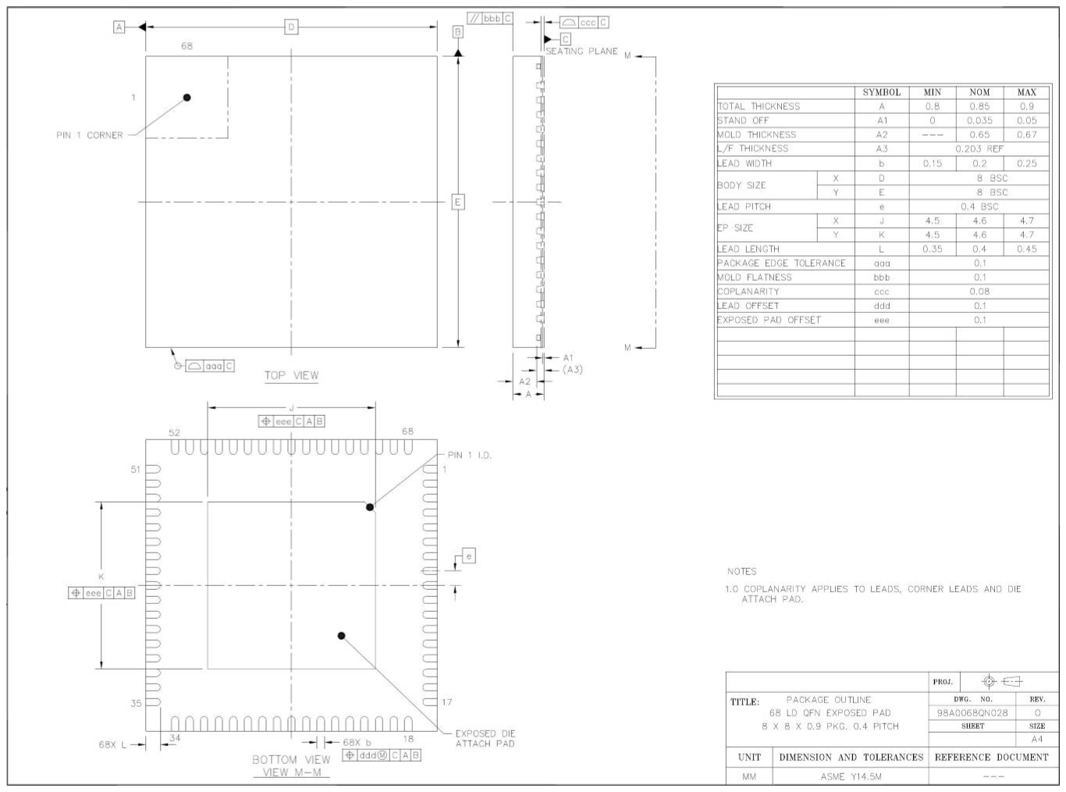
Figure 19-1：Package Information
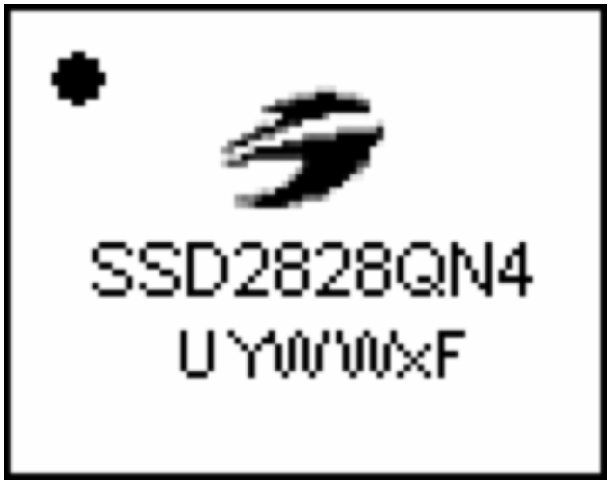
Figure 19-2：Marking Information
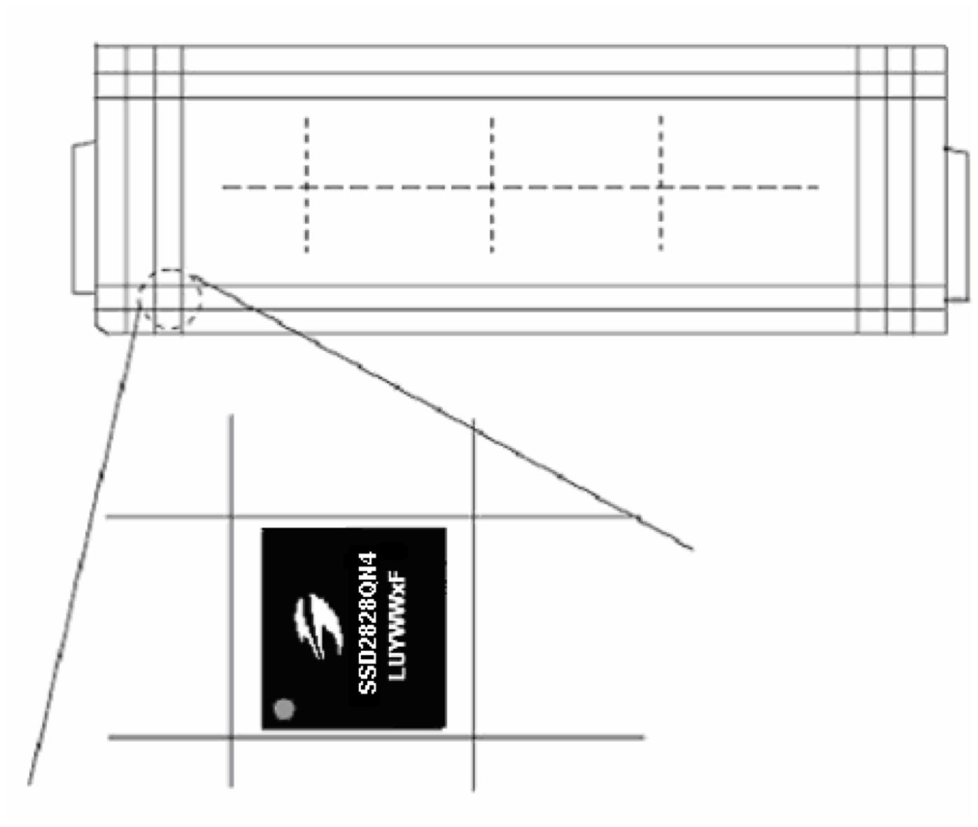
Figure 19-3：Tray Information
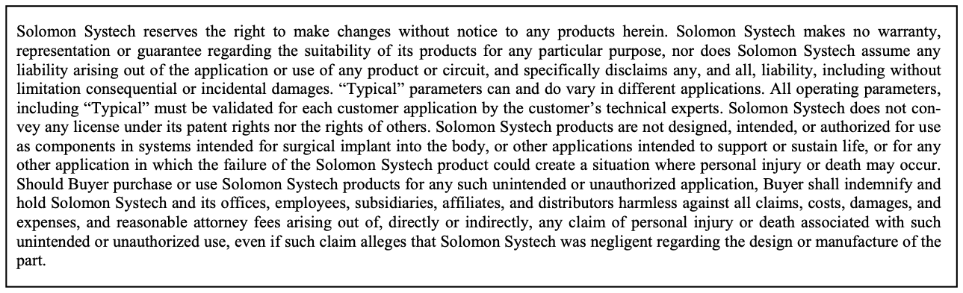
The product(s) listed in this datasheet comply with Directive 2002/95/EC of the European Parliament and of the council of 27 January 2004 on the restriction of the use of certain hazardous substances in electrical and electronic equipment and People’s Republic of China Electronic Industry Standard SJ/T 11363-2006 “Requirements for concentration limits for certain hazardous substances in electronic information products (电子信息产品 中有毒有害物质的限量要求)”. Hazardous Substances test report is available upon request.
http://www.solomon-systech.com

附錄：章節與原 PDF 頁碼對照
本文件經過重排，頁碼與原 PDF 不同。若需要回頭對照原始 PDF（或引用頁碼給同事），可用下表查詢各章節在原始 PDF 中的起始頁。
節 | 標題 | 原頁 | 節 | 標題 | 原頁
1 | GENERAL DESCRIPTION | 9 | 9.1 | LANE MANAGEMENT | 102
2 | FEATURES | 10 | 9.2 | USE CASES | 103
2.1 | REFERENCES | 10 | 9.3 | OPERATING MODES | 122
2.2 | DEFINITIONS | 10 | 10 | EXTERNAL INTERFACE | 139
3 | ORDERING INFORMATION | 11 | 10.1 | SPI INTERFACE 8 BIT 4 WIRE | 139
4 | BLOCK DIAGRAM | 11 | 10.2 | SPI INTERFACE 8 BIT 3 WIRE | 141
5 | FUNCTIONAL DESCRIPTION | 14 | 10.3 | SPI INTERFACE 24 BIT 3 WIRE | 145
5.1 | FUNCTIONAL BLOCKS | 14 | 11 | MAXIMUM RATINGS | 149
5.2 | CLOCK AND RESET MODULE | 14 | 12 | RECOMMENDED OPERATING CONDITIONS | 150
5.3 | EXTERNAL INTERFACE | 15 | 13 | DC CHARACTERISTICS | 151
5.4 | PROTOCOL CONTROL UNIT (PCU) | 15 | 14 | AC CHARACTERISTICS | 153
5.5 | PACKET PROCESSING UNIT (PPU) | 15 | 14.1 | 8 BIT 4 WIRE SPI INTERFACE TIMING | 154
5.6 | ERROR CORRECTION CODE/ CYCLIC REDUNDANCY CHECK (ECC/CRC) | 16 | 14.2 | 8 BIT 3 WIRE SPI INTERFACE TIMING | 155
5.7 | LONG AND COMMAND BUFFERS | 16 | 14.3 | 24 BIT 3 WIRE SPI INTERFACE TIMING | 156
5.8 | INTERRUPT SIGNAL | 16 | 14.4 | RGB INTERFACE TIMING | 157
5.9 | D-PHY CONTROLLER | 16 | 14.5 | RESET TIMING | 158
5.10 | ANALOG TRANSCEIVER | 16 | 14.6 | TX_CLK TIMING | 158
5.11 | INTERNAL PLL | 17 | 15 | POWER UP SEQUENCE | 159
6 | SSD2828QN4 PIN ASSIGNMENT | 18 | 16 | POWER OFF SEQUENCE | 160
7 | PIN DESCRIPTION | 20 | 17 | EXAMPLE FOR SYSTEM SLEEP IN AND OUT | 161
8 | COMMAND TABLE | 23 | 18 | SERIAL LINK DATA ORDER | 162
8.1 | REGISTER DESCRIPTION | 25 | 19 | PACKAGE INFORMATION | 165
9 | CONFIGURATION | 102 | 19.1 | DIMENSION FOR SSD2828QN4 | 165

