ABSTRACT
SKYLENS: An Intelligent System for Flight Delay Prediction Using Machine Learning Techniques
Air travel plays a vital role in today’s fast-paced world, but flight delays remain a significant and frequent problem faced by passengers and airlines globally. Delays can lead to missed connections, financial losses, operational inefficiencies, and passenger dissatisfaction. With the increasing volume of air traffic, predicting flight delays in advance has become an important challenge in the aviation industry.
This project, titled “SKYLENS: An Intelligent System for Flight Delay Prediction Using Machine Learning Techniques,” aims to develop a predictive system that analyses historical flight data to estimate the likelihood of delays. The dataset used includes key operational features such as distance, scheduled elapsed time, month of travel, and departure delay. A target variable, Delay-Flag, is created to classify flights as delayed or on-time based on arrival delay thresholds.
The data is pre-processed and divided into training and testing sets to ensure effective model evaluation. Multiple machine learning algorithms, including Logistic Regression, Decision Tree, and Random Forest, are implemented and compared. The models are evaluated using accuracy metrics and confusion matrix analysis to determine their effectiveness. Among these, the Random Forest model demonstrates superior performance in predicting flight delays.
In addition to predictive modelling, data visualization is performed using Power BI to identify patterns, trends, and key factors influencing delays. Feature importance analysis further helps in understanding the contribution of each variable in the prediction process.
The proposed system provides a practical and data-driven approach to flight delay prediction, which can support better planning and decision-making for both passengers and airline operators. Future enhancements may include incorporating real-time data and deploying the system as an interactive web-based application.

1.INTRODUCTION
Air transportation has become one of the most important modes of travel in today’s fast-moving world. Millions of passengers rely on flights daily for business, tourism, and personal travel. However, flight delays remain a common and challenging issue in the aviation industry. These delays can occur due to various factors such as weather conditions, air traffic congestion, technical issues, and operational inefficiencies.
Flight delays not only cause inconvenience to passengers but also lead to serious consequences such as missed connecting flights, increased travel costs, and reduced customer satisfaction. For airlines, delays result in financial losses, inefficient resource utilization, and disruption of schedules. With the rapid growth in air traffic, managing and predicting these delays has become increasingly important.
In recent years, data-driven approaches and machine learning techniques have gained significant attention in solving real-world problems. Machine learning allows systems to learn patterns from historical data and make accurate predictions without being explicitly programmed. In the context of aviation, these techniques can be used to analyze past flight data and identify factors that contribute to delays.
This project focuses on developing an intelligent system that uses machine learning to predict flight delays based on key operational features. By analyzing factors such as flight distance, scheduled time, departure delay, and time of travel, the system aims to provide insights into whether a flight is likely to be delayed or on time.
The main objective of this project is to build a reliable and efficient prediction model that can assist in better decision-making for both passengers and airline operators. Additionally, the project also includes data visualization to understand trends and patterns related to flight delays, making the analysis more meaningful and interpretable.
With the help of this system, it is possible to move towards smarter and more efficient air travel planning, reducing uncertainty and improving overall travel experience.

  - ABOUT THE PROJECT
The project titled “SKYLENS: An Intelligent System for Flight Delay Prediction Using Machine Learning Techniques” aims to develop a data-driven system that predicts flight delays using machine learning algorithms. In today’s fast-paced world, flight delays are a common issue that affects both passengers and airline operations. This project focuses on analyzing historical flight data to identify patterns and factors that contribute to delays, and uses this information to build an intelligent prediction model.
The system is designed to take into account several important operational features such as flight distance, scheduled elapsed time, month of travel, and departure delay. These features are carefully selected based on their relevance to flight performance and delay patterns. By processing this data and applying machine learning techniques, the system predicts whether a flight is likely to be delayed or arrive on time.
The project is carried out through a series of well-defined steps, which include:
- Data collection and loading from the dataset
- Data preprocessing to handle missing values and ensure consistency
- Creation of a target variable (Delay_Flag) to classify delays
- Selection of important features that influence flight delays
- Splitting the dataset into training and testing sets
- Training multiple machine learning models
- Comparing model performance based on accuracy
- Evaluating results using confusion matrix
- Analyzing feature importance to understand key influencing factors
To ensure a comprehensive analysis, multiple machine learning algorithms are implemented and compared, including:
- Logistic Regression for baseline prediction
- Decision Tree for rule-based classification
- Random Forest for improved accuracy and robustness
Among these, the Random Forest model demonstrates better performance in handling complex patterns within the dataset and provides higher prediction accuracy.
In addition to prediction, the project also emphasizes data visualization to better understand trends and insights related to flight delays. Power BI is used as a visualization tool to present the data in an interactive and meaningful way. This includes identifying delay patterns across different time periods, analyzing the impact of various factors, and highlighting key observations that support the predictive model.
The system developed in this project offers several advantages, such as:
- Providing early insights into potential flight delays
- Assisting passengers in better travel planning
- Helping airlines improve operational efficiency
- Supporting data-driven decision-making
However, the project also has certain limitations. The prediction model is based only on the features available in the dataset and does not include external factors such as weather conditions, air traffic congestion, or pilot-related information. As a result, the predictions are dependent on historical data patterns and may not always reflect real-time situations.
Despite these limitations, the system provides a strong foundation for flight delay prediction and demonstrates the effectiveness of machine learning in solving real-world problems. The project can be further enhanced by incorporating real-time data, additional features, and deploying the system as a web-based application for user interaction and accessibility.

2.SYSTEM ANALYSIS
System analysis is an important step in developing any project, as it helps in understanding the current system and identifying its limitations. In the context of flight delay prediction, traditional methods often rely on basic analysis and do not provide accurate or timely results.
With the increasing amount of flight data, there is a need for a more efficient and automated approach. This project focuses on analysing the available data and identifying key factors that affect flight delays. Based on this analysis, a machine learning-based system is proposed to improve prediction accuracy.
The system analysis phase helps in defining the requirements and provides a clear direction for designing and implementing the proposed solution.
2.1 EXISTING SYSTEM
In the current scenario, flight delay prediction is mainly based on basic analysis and past experience. Most systems rely on manual methods or simple statistical approaches, which are not always accurate or efficient. These methods often fail to handle large volumes of data and complex patterns that influence flight delays.
Passengers usually depend on airline updates or airport announcements, which are often provided after delays have already occurred. Similarly, airlines use internal systems that may not fully utilize advanced data analysis techniques for predicting delays in advance.
The existing system has several limitations, such as:
- Lack of accurate prediction methods
- Dependency on manual or rule-based approaches
- Inability to handle large and complex datasets
- No real-time or early prediction for passengers
- Limited use of modern technologies like machine learning
Due to these limitations, there is a need for a more advanced and data-driven system that can provide reliable and timely predictions of flight delays.

2.2 PROPOSED SYSTEM
To overcome the limitations of the existing system, a machine learning-based approach is proposed in this project. The system, named SKYLENS, is designed to analyze historical flight data and predict whether a flight is likely to be delayed or on time. By using data-driven techniques, the system provides more accurate and reliable predictions compared to traditional methods.
The proposed system uses important features such as distance, scheduled elapsed time, month, and departure delay to train machine learning models. Multiple algorithms, including Logistic Regression, Decision Tree, and Random Forest, are implemented and compared to identify the most effective model for prediction.
The system works by processing input data, applying the trained model, and generating predictions based on learned patterns. It also includes data visualization using Power BI to provide better insights into delay trends and influencing factors.
The proposed system offers several advantages:
- Improved accuracy using machine learning techniques
- Ability to handle large datasets efficiently
- Faster and automated prediction process
- Better understanding of delay patterns through visualization
- Support for informed decision-making for passengers and airlines
Overall, the proposed system provides a more efficient and intelligent solution for flight delay prediction, addressing the shortcomings of the existing system.
2.3 REQUIREMENT ANALYSIS
Requirement analysis is an important step in system development, as it helps in identifying the needs and functionalities required for the system. It defines what the system should do and how it should perform to achieve the desired results.
The requirements of this system can be broadly classified into functional and non-functional requirements.
Functional Requirements
Functional requirements describe the main operations of the system. The system should be able to:
- Load and process the flight dataset
- Perform data cleaning and preprocessing
- Create a target variable for delay prediction
- Select important features for model training
- Train machine learning models such as Logistic Regression, Decision Tree, and Random Forest
- Evaluate model performance using accuracy and confusion matrix
- Predict whether a flight will be delayed or on time
- Generate outputs based on predictions
- Provide data visualization using Power BI
Non-Functional Requirements
Non-functional requirements define the quality and performance aspects of the system. These include:
- The system should provide results efficiently
- The prediction accuracy should be reasonably high
- The system should be easy to use and understand
- The system should handle large datasets effectively
- The system should be reliable and produce consistent results
- The system should be easy to maintain and update

2.4 HARDWARE REQUIREMENTS
The hardware requirements for this project are minimal and can be fulfilled using a standard computer system. Since the project mainly involves data processing, machine learning model training, and visualization, no specialized hardware is required.
2.5 SOFTWARE REQUIREMENTS
The project is developed using commonly available software tools and platforms that support data analysis, machine learning, and visualization. These tools are easy to use and provide the necessary environment for implementing the system effectively.
The software requirements for this project are as follows:
- Operating System: Windows, Linux, or macOS
- Programming Language: Python
- Development Environment: Jupyter Notebook or Visual Studio Code
- Visualization Tool: Power BI
- Required Python Libraries: Pandas, NumPy, Scikit-learn, Matplotlib
These software components enable efficient data processing, model training, evaluation, and visualization, making the system reliable and easy to implement.
2.6 TECHNOLOGIES USED AND LIBRARIES
This project uses a combination of technologies and libraries to perform data processing, machine learning, and visualization tasks efficiently. These tools help in building an effective and reliable flight delay prediction system.
The main technologies and libraries used in this project are:
- Python:
The primary programming language used for implementing the project due to its simplicity and strong support for data science.
- Pandas:
Used for data manipulation and analysis, including handling datasets and performing preprocessing tasks.
- NumPy:
Used for numerical computations and efficient handling of arrays.
- Scikit-learn:
Used for implementing machine learning algorithms such as Logistic Regression, Decision Tree, and Random Forest.
- Matplotlib:
Used for creating basic graphs and visualizations.
- PowerBI:
Used for creating interactive dashboards and visual analysis of flight delay data.
These technologies and libraries together provide a complete environment for building, analyzing, and visualizing the flight delay prediction system.
2.7 USE CASES
The system developed in this project can be used in various real-world scenarios where flight delay prediction is useful. It helps different types of users make better decisions based on predicted outcomes and data insights.
Some of the important use cases of the system are:
- For Passengers:
Passengers can use the system to understand the likelihood of flight delays and plan their travel accordingly, reducing inconvenience and uncertainty.
- For Airline Operators:
Airlines can analyze delay patterns and improve scheduling, resource allocation, and overall operational efficiency.
- For Airport Authorities:
The system can assist in better management of flight schedules and help reduce congestion at airports.
- For Data Analysts:
Analysts can use the system to study trends, identify key factors affecting delays, and gain meaningful insights from the data.
Overall, the system provides valuable support in improving planning, efficiency, and decision-making in the aviation domain.
3.SYSTEM DESIGN
System design defines the structure and working of the system. It shows how data flows through different stages and how the system processes input to generate output. In this project, the system is designed to take flight data, process it, apply machine learning models, and generate delay predictions along with visual insights.
3.1 UI DIAGRAM
The UI diagram represents how the user interacts with the system. It shows the flow from user input to the final output generated by the system. Although the system is primarily data-driven, the interface is designed to be simple and user-friendly so that results can be easily understood.
The main components of the UI include:
- Input section for selecting flight-related details (if implemented)
- Processing unit where the system applies the trained model
- Output section displaying prediction results (Delayed / On-Time)
- Visualization support through charts or dashboards
The UI ensures that users can interpret the results without requiring technical knowledge.
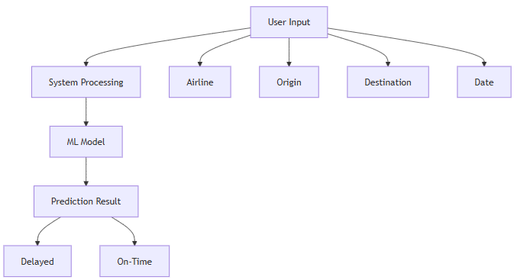
3.2 ARCHITECTURE DESIGN
The architectural design diagram shows the overall workflow and structure of the system. It explains how data flows through different stages and how each component contributes to the final prediction.
The architecture consists of the following stages:
- Data collection from the flight dataset
- Data preprocessing to clean and prepare the data
- Feature selection to identify important variables
- Model training using machine learning algorithms
- Prediction generation based on trained models
- Visualization of results using Power BI
This design ensures smooth data flow and efficient processing from input to output.

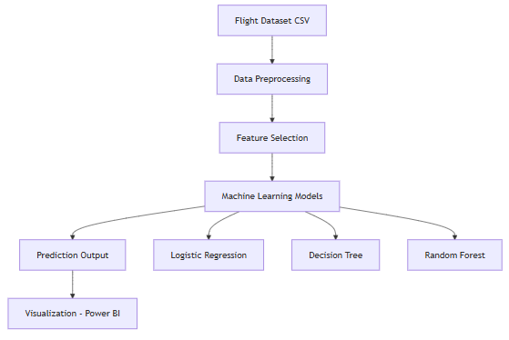
3.3 CLASS DIAGRAM
The class diagram represents the structure of the system in terms of different classes and their relationships. It helps in understanding how different modules are organized and how they interact with each other.
The system includes the following key components:
- Dataset class for loading and managing data
- Preprocessing class for cleaning and transforming data
- Model class for training and prediction
- Evaluation class for analyzing model performance
- Visualization class for generating charts and dashboards
Each class performs a specific function, and together they form the complete system.
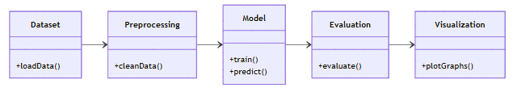
3.4 SEQUENCE DIAGRAM
The sequence diagram illustrates the interaction between different components of the system in a step-by-step manner. It shows how data flows and how operations are executed in sequence.
The main sequence of operations includes:
- User or system initiates the process
- Dataset is loaded into the system
- Data preprocessing is performed
- Features are selected for model training
- Machine learning model is applied
- Prediction is generated
- Result is displayed to the user
This diagram helps in understanding the order and interaction of system components.
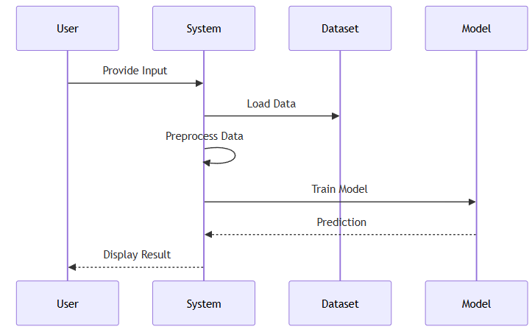
3.5 ACTIVITY DIAGRAM
The activity diagram represents the workflow of the system from start to end. It shows how different activities are connected and how decisions are made during execution.
The workflow includes the following steps:
- Start of the process
- Loading the dataset
- Performing data preprocessing
- Selecting relevant features
- Training the machine learning model
- Evaluating model performance
- Generating prediction
- Decision step (Delayed or On-Time)
- Displaying the result
- End of the process
This diagram provides a clear visualization of the system’s working process and decision-making flow.

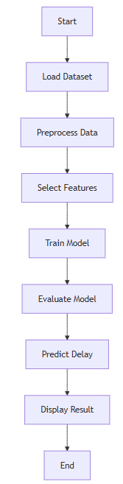

4.IMPLEMENTATION
The implementation phase focuses on the practical development of the system using machine learning techniques. In this project, the system is implemented using Python and various libraries to process data, train models, and generate predictions for flight delays.
The implementation is carried out in multiple steps, starting from data loading to model evaluation and prediction generation. The entire process ensures that the system works efficiently and produces accurate results.
4.1 PROJECT IMPLEMENTATION
The project is implemented in the following stages:
- Data Loading:
The flight dataset is loaded using the Pandas library for further processing.
- Data Preprocessing:
The dataset is cleaned and prepared by handling missing values and selecting relevant columns.
- Target Variable Creation:
A new variable (Delay_Flag) is created based on arrival delay to classify flights as delayed or on-time.
- Feature Selection:
Important features such as distance, scheduled elapsed time, month, and departure delay are selected.
- Data Splitting:
The dataset is divided into training and testing sets to evaluate model performance.
- Model Training:
Multiple machine learning models such as Logistic Regression, Decision Tree, and Random Forest are trained.
- Model Evaluation:
The models are evaluated using accuracy score and confusion matrix.
- Prediction:
The trained model is used to predict whether a flight will be delayed or not.
4.2 DATASET
The dataset used in this project contains historical flight information, which is essential for training the machine learning model. It includes various attributes related to flight operations.
Some important features of the dataset include:
- Distance of the flight
- Scheduled elapsed time
- Month of travel
- Departure delay
- Arrival delay
The dataset is pre-processed to remove inconsistencies and ensure accurate model training. A target variable is created to classify delays based on arrival delay thresholds.

5. RESULT AND ANALYSIS
This presents the results obtained from the machine learning models and the analysis performed using data visualization. The aim is to evaluate the performance of the models and extract meaningful insights from the flight dataset. Various dashboards and visualizations are used to understand delay patterns and influencing factors.
5.1 MODEL PERFORMANCE ANALYSIS
The system was trained using multiple machine learning algorithms, including Logistic Regression, Decision Tree, and Random Forest. The performance of these models was evaluated using accuracy.
- Logistic Regression showed good baseline performance
- Decision Tree captured non-linear patterns but may overfit
- Random Forest achieved the highest accuracy (~93%)
Based on the comparison, Random Forest was selected as the final model due to its better accuracy and ability to handle complex data patterns.
5.2 CONFUSION MATRIX ANALYSIS
The confusion matrix is used to evaluate the classification performance of the model.
- True Positives: Correctly predicted delayed flights
- True Negatives: Correctly predicted on-time flights
- False Positives: Flights predicted delayed but actually on time
- False Negatives: Flights predicted on-time but actually delayed
The model shows strong performance with a high number of correct predictions, indicating its reliability in real-world scenarios.
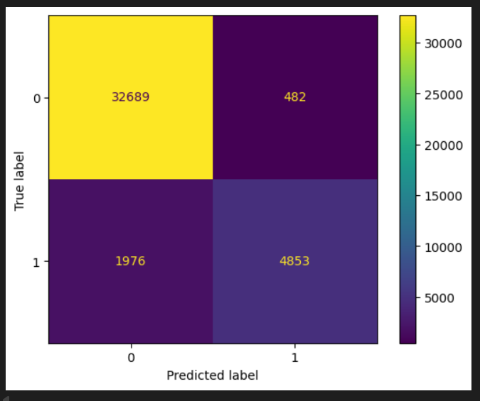
5.3 DASHBOARD ANALYSIS
5.3.1 Flight Delay Overview Dashboard
This dashboard provides a high-level overview of flight performance.
Key metrics:
- Total Flights: ~5.6 Million
- Average Arrival Delay: ~3.47 minutes
- On-Time Percentage: ~65%
Key insights:
- Majority of flights are on time, but delays still occur significantly
- Certain origins show higher average delays
- Delay reasons vary across airlines
- Monthly trends show fluctuations, with peaks in mid-year
This dashboard helps in understanding overall delay patterns and system behavior.

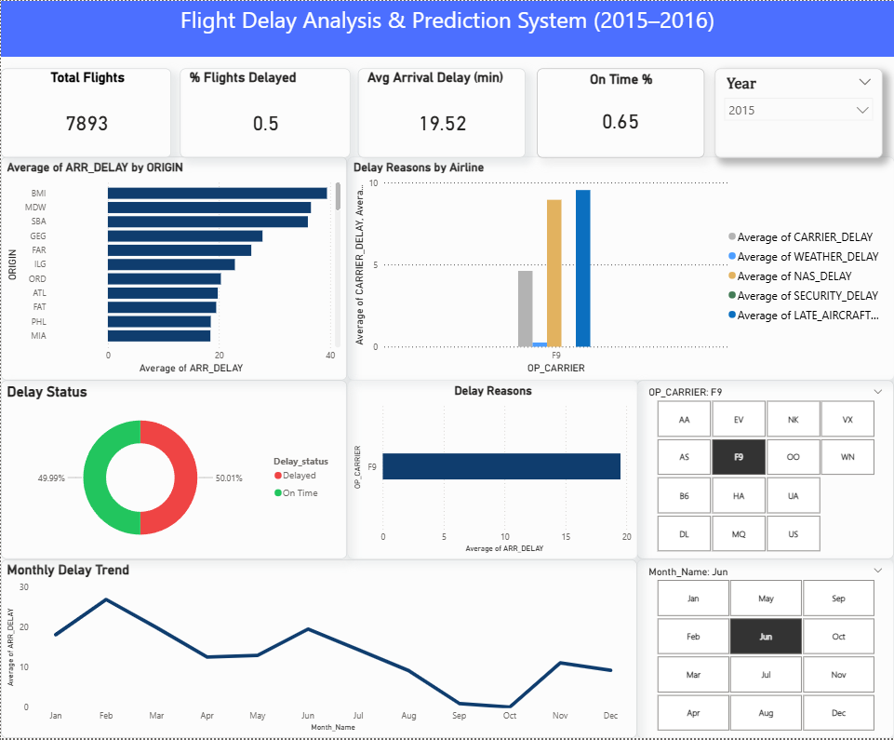
5.3.2 Flight-Level Performance Analysis Dashboard
This dashboard provides detailed analysis at airline and route level.
Key features:
- Filters for airline, origin, and destination
- Monthly delay trends visualization
- Airline comparison on similar routes
- Delay reason breakdown
Key insights:
- Some airlines perform better on the same routes
- Delay trends vary across months
- Certain routes consistently show higher delays
- Late aircraft delay and carrier delay are major contributors
This dashboard is useful for analyzing performance at a granular level.
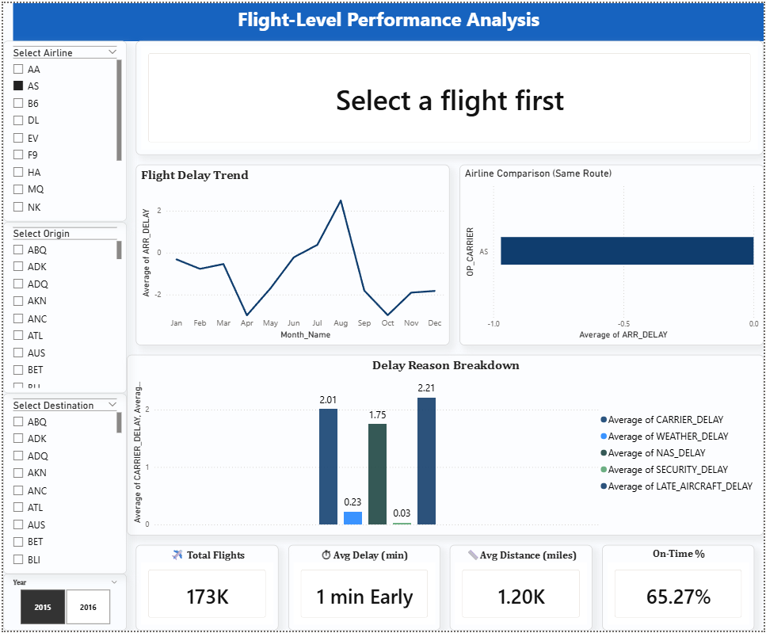
5.3.3 Flight Delay Prediction Dashboard
This dashboard demonstrates the output of the machine learning model.
Key outputs:
- Model Accuracy: 93%
- Prediction Result: On-Time Expected
- Risk Level: Low Risk
Key insights:
- Predicted values closely match actual values
- Majority of flights fall under on-time category
- Prediction distribution shows high reliability
This dashboard highlights how machine learning can be used for real-time decision-making.
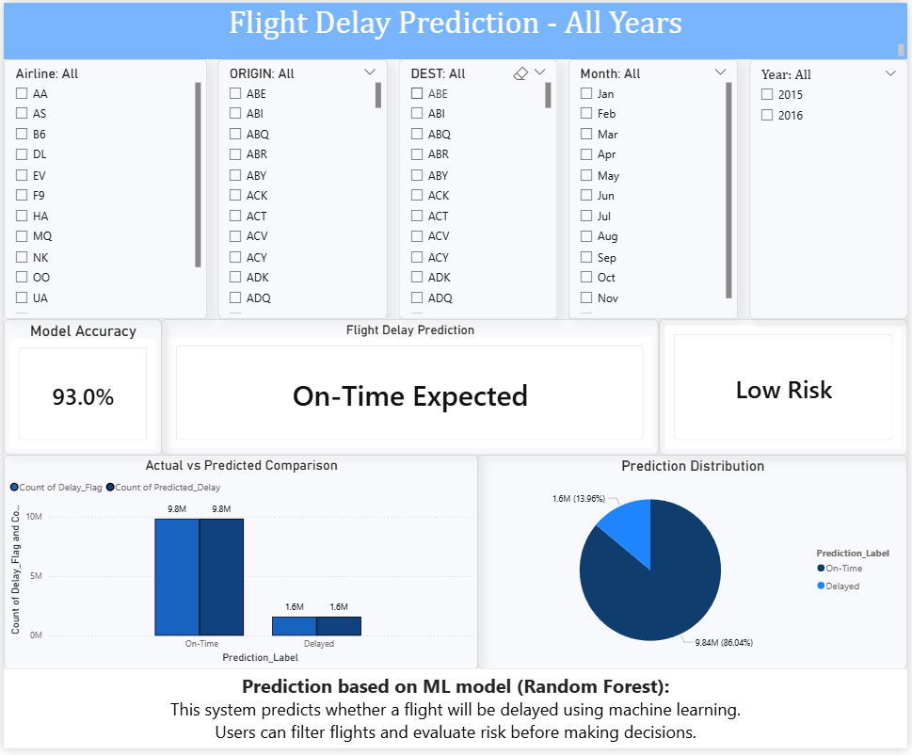
5.3.4 Insights and Recommendations Dashboard
This dashboard focuses on identifying key influencing factors.
Key features:
- Key influencers for delay prediction
- Geographic distribution of delays
- On-time performance percentage
Key insights:
- Departure delay is the most influential factor
- Certain locations experience higher delays
- Seasonal trends affect delay patterns
- Airline performance varies significantly
This dashboard helps in understanding root causes and improving decision-making.
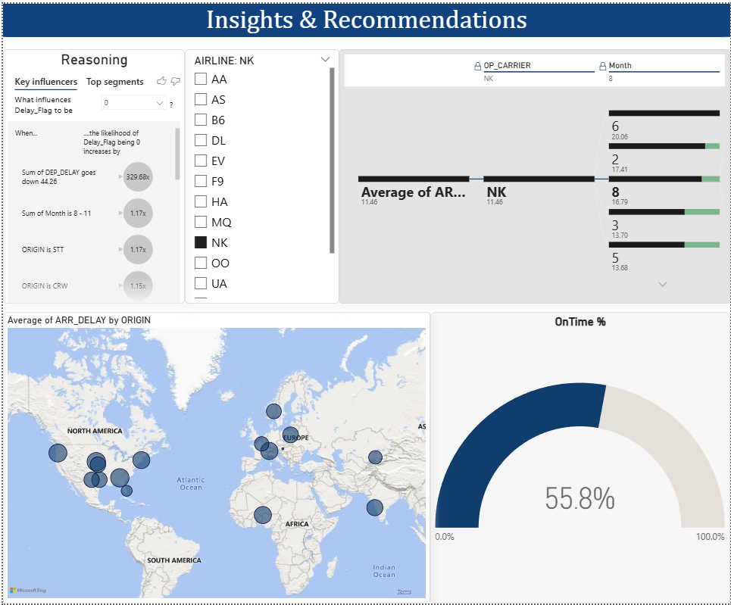
5.4 FEATURE IMPORTANCE ANALYSIS
Feature importance analysis identifies the most impactful variables in prediction.
Key findings:
- Departure delay has the highest influence
- Scheduled elapsed time has moderate impact
- Distance has lower influence
This confirms that operational factors play a major role in flight delays.
5.5 KEY OBSERVATIONS
From the overall analysis, the following observations are made:
- Flight delays are strongly influenced by departure delays
- Some months show higher delay frequency
- Airline performance varies across routes
- Machine learning models effectively predict delays
- Data visualization helps in understanding complex patterns

6. CONCLUSION
This project, “SKYLENS: An Intelligent System for Flight Delay Prediction Using Machine Learning Techniques,” successfully demonstrates the use of machine learning and data visualization to analyze and predict flight delays.
The system was developed using historical flight data and key operational features such as distance, scheduled elapsed time, month, and departure delay. Multiple machine learning models were implemented and compared, among which the Random Forest model achieved the highest accuracy of approximately 93%.
The project also includes Power BI dashboards that provide meaningful insights into flight delay patterns, airline performance, and influencing factors. These visualizations help in understanding complex data in a simple and effective manner.
Key conclusions from the project include:
- Machine learning can effectively predict flight delays with high accuracy
- Departure delay is the most significant factor influencing delays
- Airline performance and seasonal trends play an important role
- Data visualization enhances understanding and decision-making
Overall, the system provides a reliable and practical approach for flight delay prediction and analysis. It can assist passengers, airlines, and airport authorities in better planning and reducing uncertainty related to delays.

7. FUTURE SCOPE
Although the project provides a strong foundation for flight delay prediction, there are several areas where it can be further improved and expanded.
The future enhancements of the system may include:
- Integration with real-time flight data for more accurate predictions
- Inclusion of additional factors such as weather conditions, air traffic, and aircraft details
- Development of a web-based or mobile application for user interaction
- Implementation of advanced machine learning or deep learning models
- Improvement in model accuracy using larger and more diverse datasets
These enhancements can make the system more robust, scalable, and useful in real-world scenarios. With further development, the system can be transformed into a fully functional decision-support tool for the aviation industry.

8. APPENDIX A-CODES
8.1 DATA LOADING AND COMBINATION
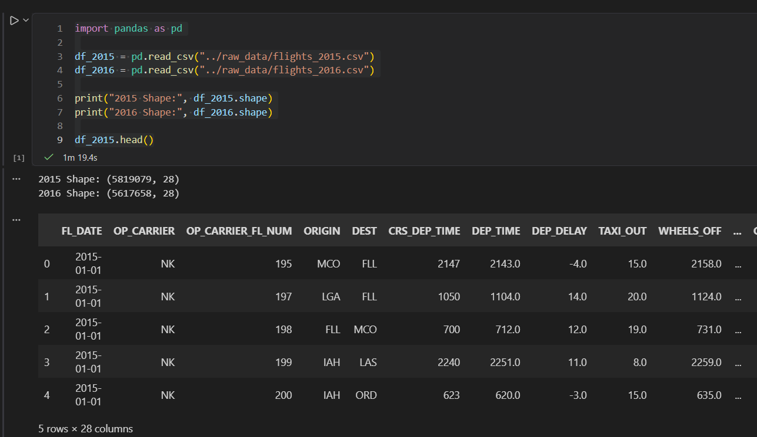
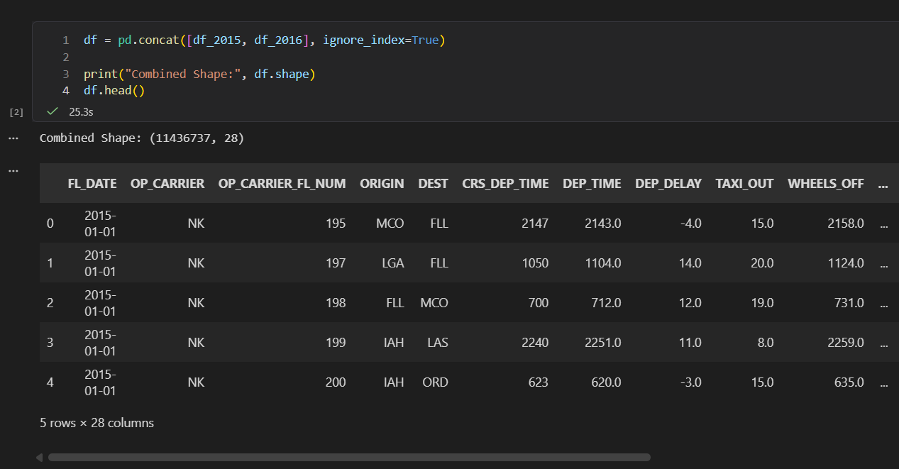

8.2 REMOVAL OF UNNECESSARY COLUMNS
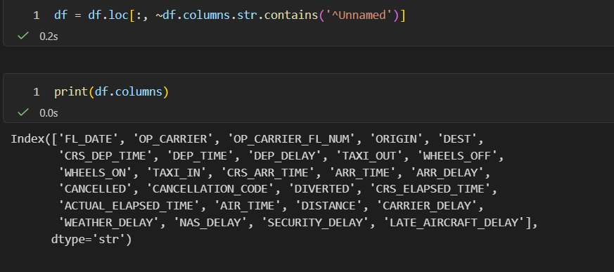
8.3 HANDLING MISSING VALUES
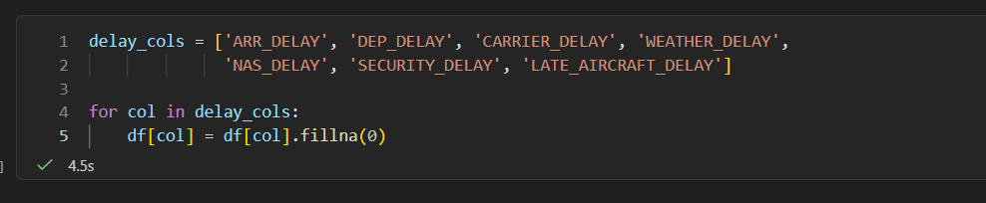
8.4 DATE PROCESSING AND FEATURE CREATION
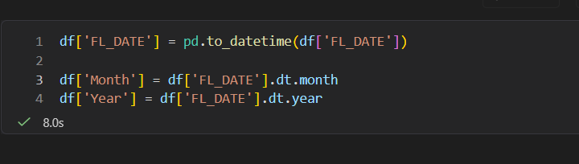
8.5 TARGET VARIABLE CREATION
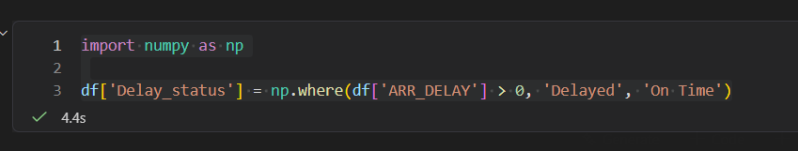

8.6 SAVING CLEANED DATASET
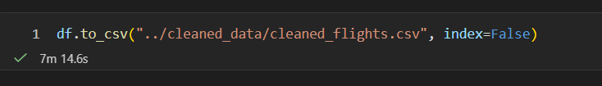
8.7 MODEL PREPARATION AND FEATURE SELECTION
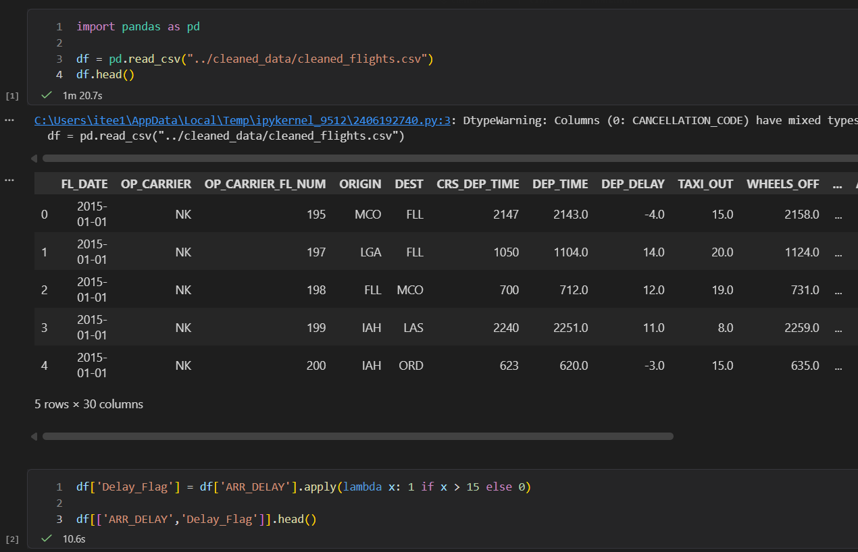
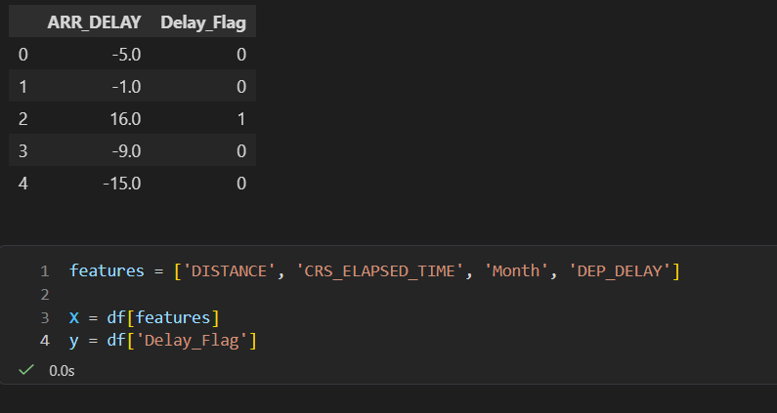
8.8 DATA SAMPLING AND SPLITTING
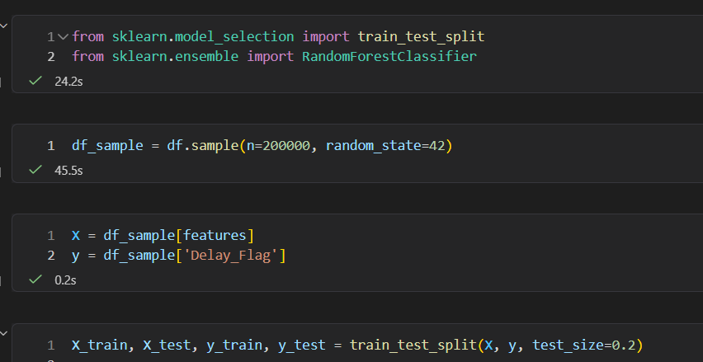
8.9 MODEL TRAINING, PREDICTION AND EVALUATION
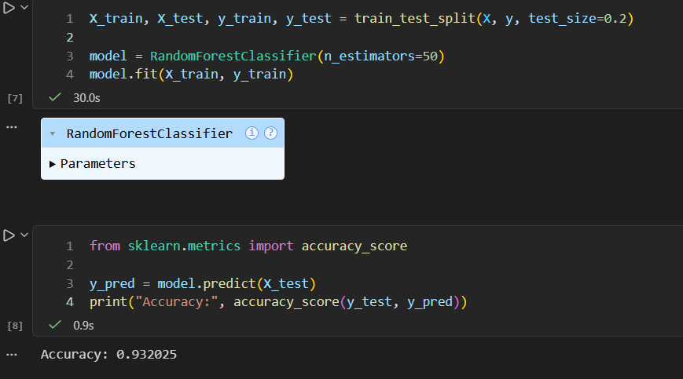

8.11 MULTIPLE MODEL COMPARISON
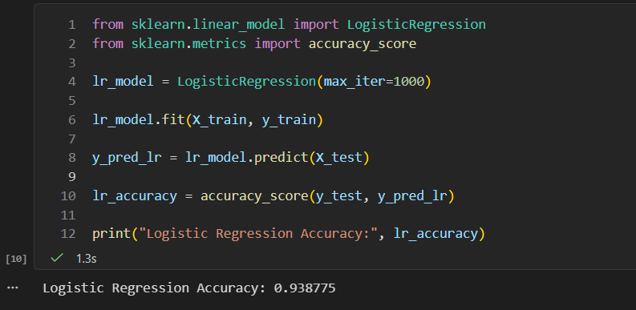
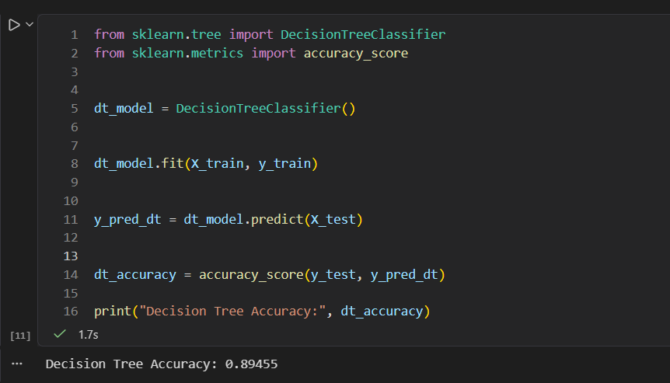
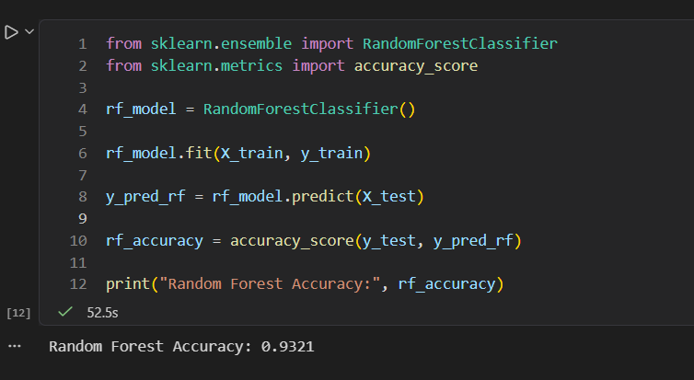
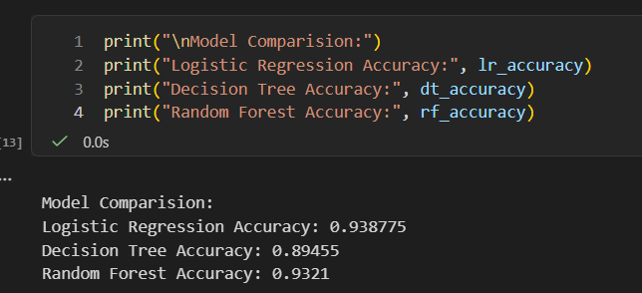
8.12 CONFUSION MATRIX VISUALIZATION
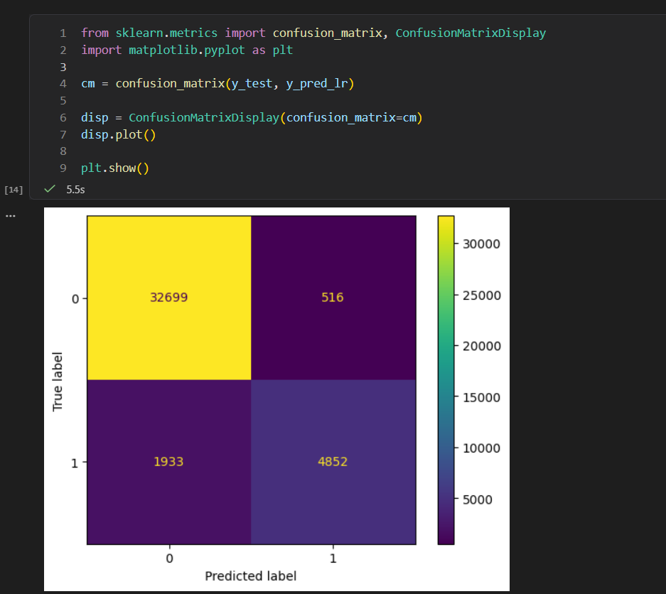

8.13 FEATURE IMPORTANCE ANALYSIS AND MODEL SAVING
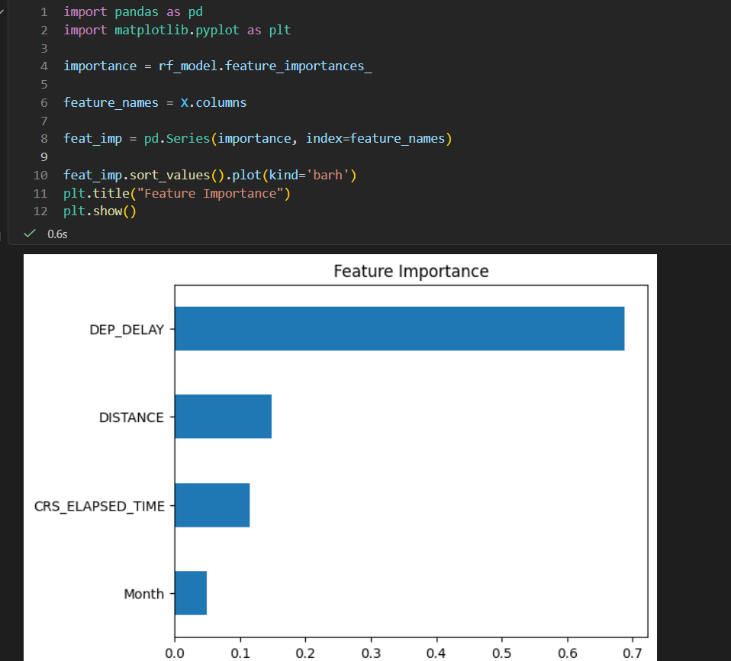
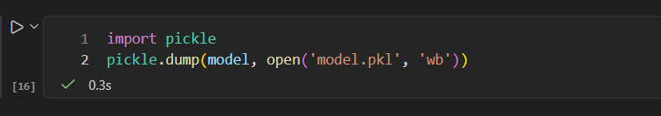

9. APPENDIX B-SCREENSHOTS
9.1 FLIGHT DELAY OVERVIEW DASHBOARD



9.2 FLIGHT-LEVEL PERFORMANCE ANALYSIS DASHBOARD



9.3 FLIGHT DELAY PREDICTION DASHBOARD



9.4 INSIGHTS AND RECOMMENDATIONS DASHBOARD


10. BIBLIOGRAPHY
- Python Software Foundation, Python Documentation. Available at: https://www.python.org
- Scikit-learn Developers, Scikit-learn Documentation. Available at: https://scikit-learn.org
- Pandas Documentation. Available at: https://pandas.pydata.org
- Matplotlib Documentation. Available at: https://matplotlib.org
- Microsoft Power BI Documentation. Available at: https://learn.microsoft.com/en-us/power-bi/
- Kaggle, Flight Delay Dataset. Available at: https://www.kaggle.com
- GeeksforGeeks – https://www.geeksforgeeks.org
- TutorialsPoint – https://www.tutorialspoint.com
- W3Schools – https://www.w3schools.com
- Stack Overflow – https://stackoverflow.com
- Coursera – Machine Learning Courses
- Udemy – Python and Data Science Courses
- CodeHelp by Babbar – Web Development and ML basics
- Krish Naik – Machine Learning Tutorials
- freeCodeCamp.org – Data Science and Python Tutorials

TABLE OF CONTENTS
TITLE PAGE NUMBER
ABSTRACT 1
- INTRODUCTION 2
1.1 ABOUT THE PROJECT
- SYSTEM ANALYSIS 5
2.1 EXISTING SYSTEM
2.2 PROPOSED SYSTEM
2.3 REQUIREMENT ANALYSIS
2.4 HARDWARE REQUIREMENTS
2.5 SOFTWARE REQUIREMENTS
2.6 TECHNOLOGIES AND LIBRARIES
2.7 USE CASES
- SYSTEM DESIGN 10
3.1 UI DIAGRAM
3.2 ARCHITECTURE DESIGN
3.3 CLASS DIAGRAM
3.4 SEQUENCE DIAGRAM
3.5 ACTIVITY DIAGRAM
- IMPLEMENTATION 15
4.1 PROJECT IMPLEMENTATION
4.2 DATASET
- RESULT AND ANALYSIS 17
5.1 MODEL PERFORMANCE ANALYSIS
5.2 CONFUSION MATRIX ANALYSIS
5.3 DASHBOARD ANALYSIS
5.3.1 FLIGHT DELAY OVERVIEW DASHBOARD
5.3.2 FLIGHT-LEVEL PERFORMANCE ANALYSIS DASHBOARD
5.3.3 FLIGHT DELAY PREDICTION DASHBOARD
5.3.4 INSIGHTS AND RECOMMENDATIONS DASHBOARD
5.4 FEATURE IMPORTANCE ANALYSIS
5.5 KEY OBSERVATIONS
- CONCLUSION 23
- FUTURE SCOPE 24
- APPENDIX A – CODES 25
- APPENDIX B – SCREENSHOTS 32
- BIBLIOGRAPHY 36

LIST OF FIGURES
TITLE PAGE NUMBER
- UI DIAGRAM 10
- ARCHITECTURE DESIGN 11
- CLASS DIAGRAM 12
- SEQUENCE DIAGRAM 13
- ACTIVITY DIAGRAM 14
- CONFUSION MATRIX 18
- FLIGHT DELAY OVERVIEW DASHBOARD 19
- FLIGHT-LEVEL PERFORMANCE DASHBOARD 20
- FLIGHT DELAY PREDICTION DASHBOARD 21
- INSIGHTS AND RECOMMENDATIONS DASHBOARD 22

