Hardware for beacon access tracking system:

1. Here is the listing of the sensors and equipment used to build the embedded prototyping platform for the beacon access tracking system:
2. Sensors / Dongles
   1. BLE Beacon (Estimote)
   2. BLE Radio Dongle (IOGear)
   3. Wi-Fi USB adapter (Edimax)
3. Embedded Microcontroller and Shields
4. Raspberry Pi 2
5. Grove Pi+ Shield
6. Other Electronics Equipment
   1. Electromagnetic Lock (EbelCo)
   2. GrovePi Relay
   3. GrovePi LED light

2. The steps to connect the components together for the beacon access tracking system are described below:

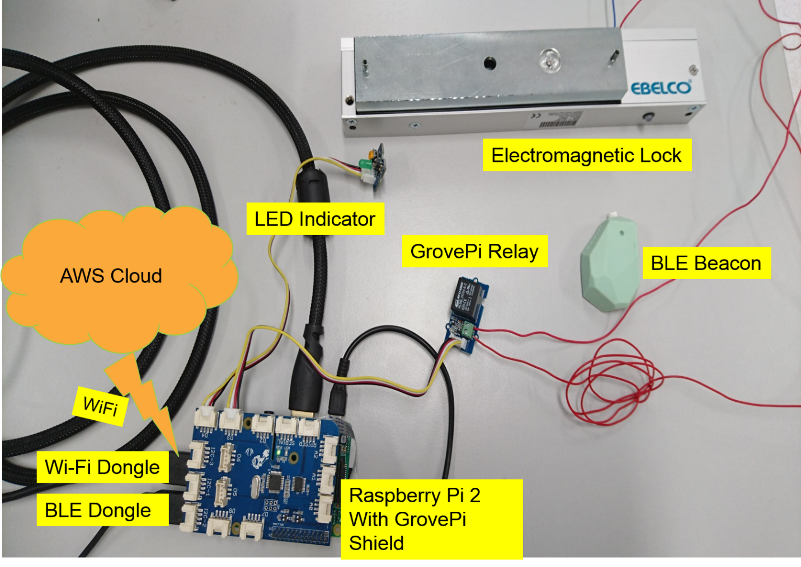

**Figure 1 Set Up of Hardware for beacon access tracking system**

3. Connect the different sensors and equipment as shown in Figure 1 above.

4. Connect the GrovePi sensors to the respective ports on the GrovePi+ shield below:

a. GrovePi Relay: Port D3.

b. GrovePi LED: Port D4.

5. Connect the N.C. output of the GrovePi Relay to the 12V input of the electromagnetic lock.

6. Connect the Ground output of the GrovePi Relay to the Ground input of the electromagnetic lock.

7. Use secure shell to login your RaspBerry Pi 2 and enter the following commands.

8. Set up pybluez for scanning beacons by running the following commands in RaspBerry Pi:

**cd /home/pi**

**sudo apt install bluetooth bluez blueman**

**sudo cp -r /usr/include old_include**

**wget https://github.com/lupyuen/AWSIOT/raw/master/include.zip**

**unzip include.zip**

**sudo cp -r include/* /usr/include/**

**sudo apt install python3-dev**

**sudo apt install libbluetooth-dev**

**sudo pip3 install pybluez**

**sudo apt install libboost-dev**

**sudo apt install libboost-python-dev**

**sudo apt install libboost-thread-dev**

**sudo pip3 install gattlib**

**wget https://github.com/karulis/pybluez/zipball/master**

**mv master master.zip**

**unzip master.zip**

**cd karulis-pybluez-*/examples/ble**

**sudo python3 beacon_scan.py**

The detailed pybluez installation steps can be found here: <https://github.com/lupyuen/AWSIOT/blob/master/README.md>

9. Run the following Python 3 program to scan beacons and send beacons detected to AWS IoT.

Sudo python3 beacon_scan.py

The beacon_scan.py code in pybluez will return the list of beacon UUID, major, minor and signal strength:

```Beacon: address:C1:8B:BF:C6:4E:56 uuid:b9407f30-f5f8-466e-aff9-25556b57fe6d major:22094 minor:50879 txpower:182 rssi:-75  
Beacon: address:D4:AC:86:66:3A:0D uuid:b9407f30-f5f8-466e-aff9-25556b57fe6d major:3386 minor:26246 txpower:182 rssi:-79  
Beacon: address:D8:22:CB:53:63:B0 uuid:b9407f30-f5f8-466e-aff9-25556b57fe6d major:45155 minor:21451   
txpower:182 rssi:-83  
Beacon: address:F7:43:86:4E:B9:CD uuid:b9407f30-f5f8-466e-aff9-25556b57fe6d major:52665 minor:20102 txpower:182 rssi:-68  
Beacon: address:D8:B1:B7:D4:38:AE uuid:b9407f30-f5f8-466e-aff9-25556b57fe6d major:44600 minor:54455 txpower:182 rssi:-79 ```

The source code can also be found at

<https://github.com/lupyuen/RaspberryPiImage/blob/master/home/pi/TPIoT/send_beacon_data.py>

The installation Log can also be found at: <https://github.com/lupyuen/AWSIOT/blob/master/install_pybluez.log>