Simulation of Tokamak Edge Plasma with Account for Self-Consistent Electric Fields

V. Rozhansky*, S. Voskoboynikov*, E. Kovaltsova*, D. Coster**,

R. Schneider**

* St.Petersburg State Technical University, 195251, St.Petersburg, Russia
** Max-Planck Institut fur Plasmaphysik, Euroatom Association, Garching, Germany

Abstract
The most complete system of transport equations with all the important perpendicular currents was derived for simulation of tokamak edge plasma. Transport equations were implemented in the B2.5 code and solved for the parameters of ASDEX-Upgrade tokamak. Relative role of different mechanisms of transverse conductivity in the formation of potential profile is studied. It is demonstrated that reasonable potential distribution in tokamak edge plasma can be obtained without ad hoc assumption of the existence of the anomalous perpendicular conductivity. The role of 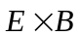 drifts in redistribution of the edge plasma and closing of the currents in plasma are analysed.

- Introduction

Fluid transport equations of Braginskii [1] are widely used for simulation of the edge tokamak plasma in the transport codes such as B2 [2-3], UEDGE [4-5], EDGE2D [6]. In the recent years it has been recognised that impact of electric fields and corresponding 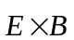 drifts are rather important for redistribution of plasma and impurities between the divertor legs [7-9]. Radial electric field in the vicinity of a separatrix is responsible for the transition into improved confinement regime (L-H transition). Therefore, effects associated with electric field should be included into the transport codes. However, the 2D problem of calculation of self-consistent electric field is quite complicated, since it is necessary to perform calculations both on open and closed field lines, while electric field is determined by various mechanisms of perpendicular conductivity. Rather subtle effects such as diamagnetic currents, different components of viscosity tensor, inertia and collisions with neutrals determine effective transverse conductivity, and, therefore, current distribution and self-consistent electric fields in the edge plasma. Up to now only some of these effects were taken into account in the transport codes. Moreover, even the initial set of transport equations was not quite clear.
In the present paper we derive the full set of transport equations based on Braginskii fluid equations. To avoid numerical problems during running the code in several places divergence free terms in particle and current balance equations are cancelled analytically. Similar cancellation is made in the parallel momentum balance and energy balance equations, where inertia terms are combined with gyroviscosity terms, and is taken into account the fact that the diamagnetic heat fluxes are almost divergence free. This approach is similar to that of [10,4,5], however, several important terms, which were absent in the previous versions, are kept in the equations. Note that our approach differs from that based on the moments of kinetic equation in the guiding centre approximation [11], still having much in common in final results. The derived equation system is pure classical. The anomalous effects are introduced by replacing the classical perpendicular particle and heat fluxes by anomalous fluxes. The perpendicular viscosity coefficient is also replaced by anomalous value.
We present here results of simulation of the edge plasma of ASDEX-Upgrade tokamak by means of B2.5 code based on reduced form of transport equations. Plasma parameters of ASDEX-Upgrade in the vicinity of a separatrix and in SOL correspond to Pfirsch-Schlueter regime thus justifying the applicability of fluid equation for simulation. The equations and results of the simulation correspond to the single fluid case (deuterium).
It is demonstrated that on the closed flux surfaces and in the vicinity of the separatrix in the scrape-off layer (SOL) potential profile is determined by the perpendicular conductivity. Since, due to the pressure asymmetry, the diamagnetic current integrated over the closed flux surface is not automatically zero, additional radial current arises to make the averaged net current zero. The main perpendicular current, which balances the diamagnetic current, is the transverse current driven by parallel viscosity. Perpendicular currents caused by ion neutral friction, inertia and perpendicular anomalous viscosity are less important. In contrast, the potential in the main part of SOL is determined mainly by the parallel force balance for electrons and is a weak function of the transverse conductivity. On the closed flux surfaces far from separatrix, where the pressure is almost constant, parallel currents practically coincide with the Pfirsch-Schlueter currents. In the SOL far from separatrix parallel currents are the combination of Pfirsch-Schlueter part and thermal current flowing from one plate to another. Asymmetry of poloidal and parallel particle and heat fluxes caused by 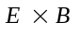 drifts is discussed.

2. Basic equations

Equations are derived in a toroidal geometry with the x and y coordinates correspond to directions along and across flux surfaces accordingly, z is the toroidal direction, Fig.1. The metric coefficients are
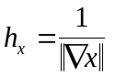, 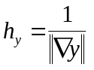, 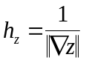, 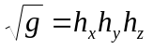.
One can also replace 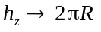, where R is the major radius. Physical components of a vector are used. The ions of single species are considered with Z=1 so that 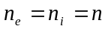. Subscript “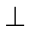” denotes the direction perpendicular both to magnetic field 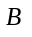 and to the y-axis, 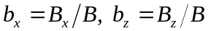.

- Perpendicular and poloidal velocities

Ion velocities 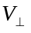 and 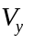 are determined from two perpendicular to a magnetic field components of the momentum balance equation for ions. Using the Braginskii expressions for friction force, one obtains
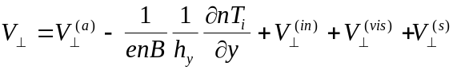,
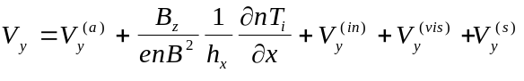, (1)
where
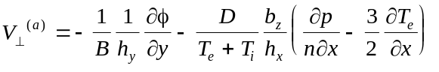
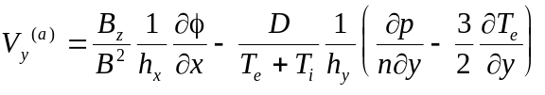 (2a)
The classical diffusion coefficient D is
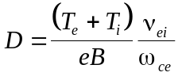,
where 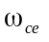 is the electron cyclotron frequency, 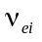 is the electron-ion collision frequency. Velocities 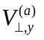 are the sum of the drifts and classical diffusive and thermodiffusive velocities. This part corresponds to the ambipolar flux; it is the same both for ions and electrons. The second term in the r.h.s. of Eq. (1) corresponds to diamagnetic flux of ions, while the other terms 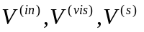 are caused by inertial, viscous and ion-neutral friction forces respectively. These non-ambipolar terms are expressed through the corresponding currents, which are defined below:
.
In the presence of anomalous transport Eq. (2a) is to be replaced by [2]

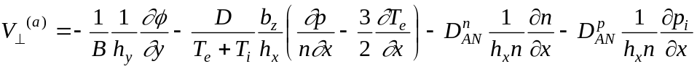, (2b)
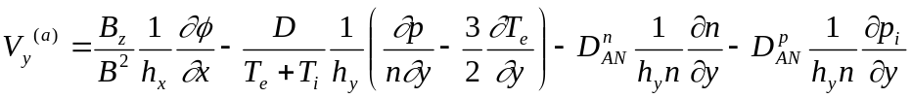.

The poloidal velocity is a sum

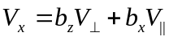 (3)

- Particle balance

In the particle balance equation we take into account the fact that the diamagnetic velocity is almost divergence free. Therefore, instead of diamagnetic velocity it is possible to introduce the effective velocity 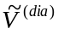, which gives the same contribution to the divergence of the particle flux. We have thus
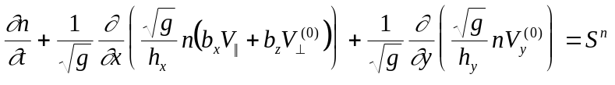, (4)
where
(5)
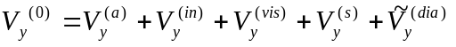,
and
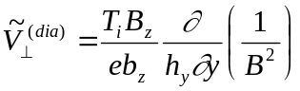, (6)
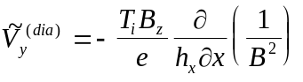.

Note that the velocity 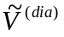 is an effective velocity and is to be inserted only into Eq. (4), in contrast to the full velocity Eq. (1). Physically, velocity Eq. (6) represents vertical guiding centre drift of ions caused by 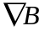.

- Parallel momentum balance for ions

Combining the inertia and gyroviscosity terms in the Braginskii equations, we find
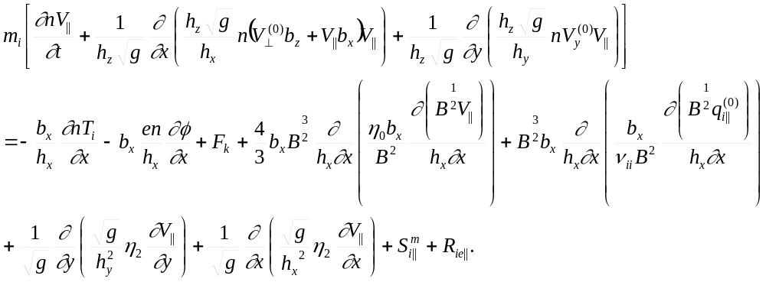 (7)

The diamagnetic terms in the l.h.s. are almost cancelled [10,4,5] so that velocities normal to the flux surface in the second and third terms, as in particle balance equation, are determined by Eq. (5). In [10] the divergence part of diamagnetic velocity Eq. (6) has been neglected in Eq. (5). We keep it, because the corresponding flux is still relatively large and can be comparable with the diffusive flux even for anomalous diffusion coefficients. The authors of [4-5] also kept this flux. However, in contrast to [4-5] there is additional term 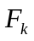 of the same kind in the r.h.s. of Eq. (7):

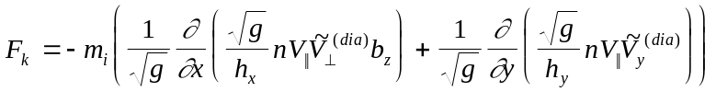. (8)

The parallel force 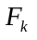 is the Coriolis force, connected with the diamagnetic drift velocity and toroidal (parallel) rotation. This force can be obtained in different way by averaging the drift kinetic equation [11]. This force is of the same order as inertia terms in the l.h.s. of Eq. (7).
Parallel viscosity is represented by the forth and fifths terms in the r.h.s. The first of them is the Braginskii viscosity term with parallel viscosity coefficient

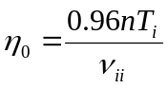.
The fifth term in the r.h.s. of Eq.(7) corresponds to the parallel viscosity driven by parallel ion heat flux 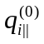, where
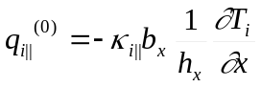.

This viscosity is absent in the Braginskii equations, however in a tokamak, where parallel particle flux multiplied by temperature is of the order of ion heat flux, these two viscosities are of the same order. On the closed flux surfaces far from separatrix the averaged over the flux surface parallel viscosity coincides with the well-known neoclassical expression for the Pfirsch-Schlueter regime [12]. Thus parallel viscosity in Eq. (7) provides smooth transition to neoclassical theory.
The classical perpendicular viscosity coefficient is

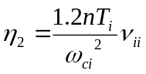.

It can be replaced by anomalous value, for example 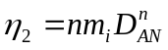, as in [4-5], so that perpendicular viscosity can also be anomalous. Perpendicular viscosity and inertia terms with the anomalous particle flow are responsible for the transport of the parallel momentum in radial and poloidal directions. The radial transport could be rather important in spite if the fact that 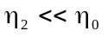, since the scale in y direction is rather small.
The term 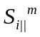 represents the momentum loss due to ion-neutral friction and momentum input from neutral beam injection; 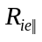 is the ion-electron friction:

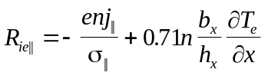

with 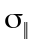 being Spitzer conductivity.

- Parallel momentum balance for electrons

It has the standard form

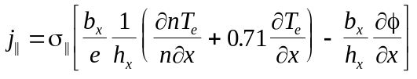. (9)

- Current continuity equation

Equation for charge conservation is

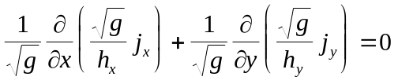. (10)

Poloidal component is expressed through perpendicular and parallel components according to

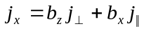. (11)

Expressions for 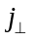 and 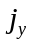 components are obtained from the radial and poloidal projections of the total momentum balance equations (the sum of electron and ion momentum balance equations). The resulting current is a sum of contributions from pressure gradient (diamagnetic current) 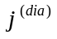, inertia and gyroviscosity 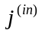, viscosity 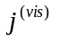and ion-neutral friction 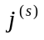:

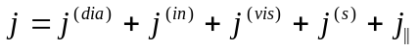. (12)

Similar to the particle continuity equation we introduce the effective current, which gives the same contribution to 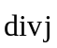, as the ordinary current. We denote this effective current by . Instead of Eqs. (10)-(12) we have

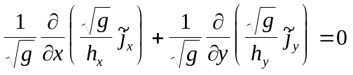, (13)

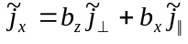, (14)

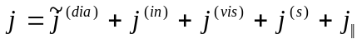. (15)

Effective diamagnetic current can be chosen in a form

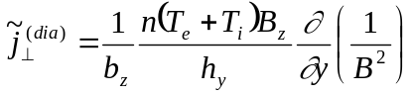,
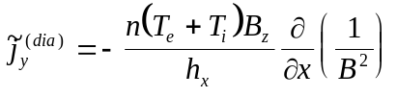. (16)

Current driven by parallel viscosity should be taken into account in Eq. (15). This current is a small correction to the diamagnetic current Eq. (16). However, on the closed flux surfaces, where pressure is almost constant, the diamagnetic current averaged over the flux surfaces tends to zero. The resulting remaining part can become comparable to the parallel viscosity driven current, which is necessary to satisfy the condition that the averaged net radial current should be zero.
Note that in spite of the fact that the parallel viscosity contributes to 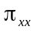 and 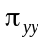 components of viscosity tensor, the terms, which contain viscosity coefficient 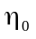, produce almost divergence free currents. Similar to the case of diamagnetic currents it can be reduced to the form:
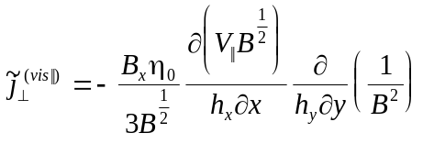,
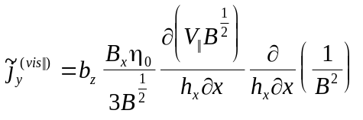. (17)

The current produced by components of viscosity tensor which are connected with heat fluxes can be written in the same form:

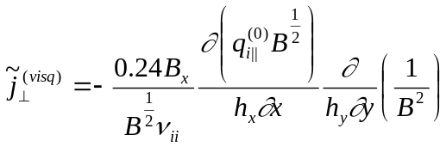,
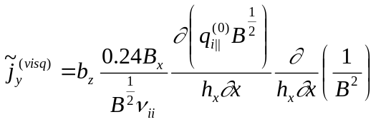. (18)

The second part of the current contains contributions both from inertia and gyroviscosity forces. In contrast to the parallel momentum balance, the cancellation is not complete (as has been noticed in [10]). Expressions for this part of the current are

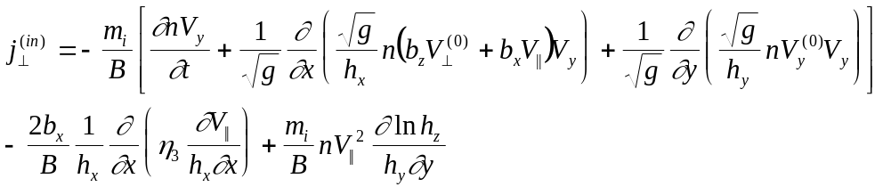,
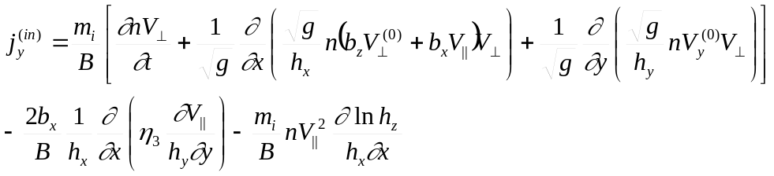, (19)
where 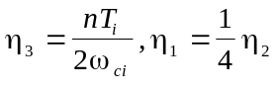.
The last terms in Eq. (19) proportional to correspond to the vertical guiding centre drift of ions caused by centrifugal force. This current can be simply added to the diamagnetic current Eq. (16). Other terms seem to be less important.
The contribution from perpendicular viscosity is

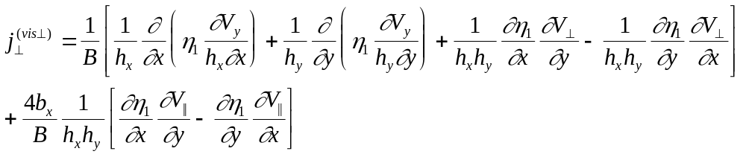
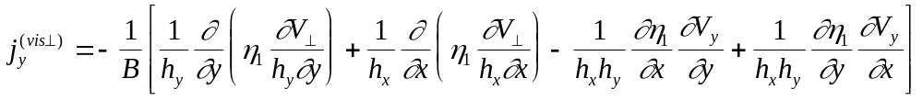. (20)

Here the largest is the first term in the r.h.s. of the expression for radial current, since the radial derivatives are the largest. This current corresponds to pure cylindrical approximation. It is responsible, for example, for closing of the currents near the flush-mounted probes [13]. It was taken into account in [5,6]. However, in the problem of global current structure in the edge plasma the currents driven by parallel viscosity seems to be more important.
The total current caused by viscosity is

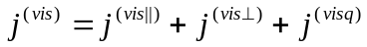.

The contribution from ion neutral friction results in the currents is

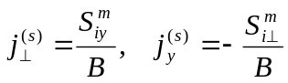, (21)

where 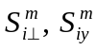 are the momentum sinks due to ion-neutral friction. They have the form

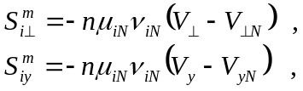 (22)

where 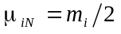 is the effective mass, 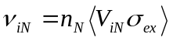 is ion-neutral collision frequency, 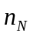 is the neutral density and 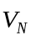 is the neutral mean velocity. In the expressions for the ion velocity, which are to be substituted into Eq. (22), we leave the electric and diamagnetic drifts only, neglecting the smaller terms:

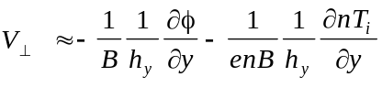
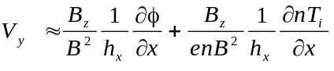. (23)

Combining Eqs. (21)-(23) we obtain

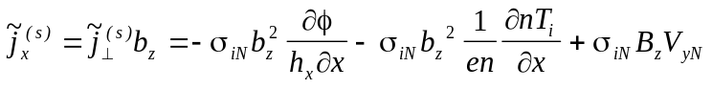,
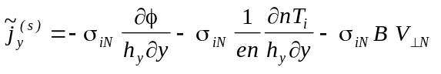, (24)
where 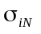 is the ion-neutral perpendicular conductivity

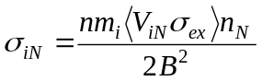. (25)

The rate of charge-exchange reaction 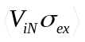 can be expressed through the mobility 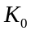 measured in the absence of a magnetic field for the room temperature and atmospheric pressure for deuterium [14]:

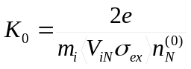, 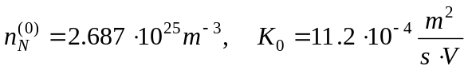.

Assuming that charge-exchange cross-section 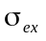 is approximately constant, we have

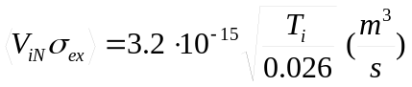, (26)

where is measured in eV. Similar expression, which gives approximately the same result, is [15]:
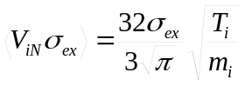. (27)

- Energy balance equations

In the energy balance equations we combine the convective heat flux with the diamagnetic heat flux as it is done in [4,5,10]. Equations can be rewritten in the following form. Energy balance equation for electrons is
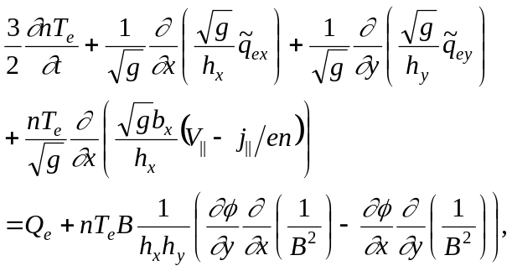 (28)
where
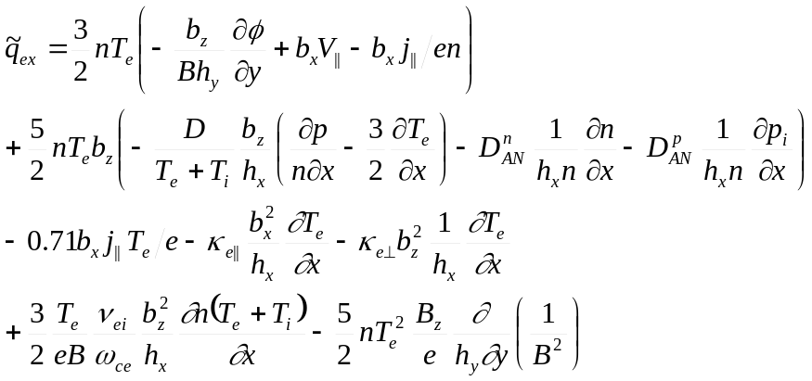,
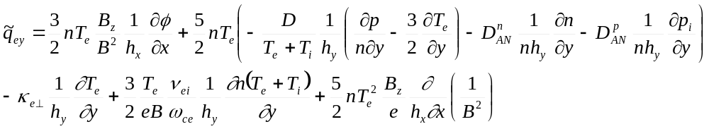,
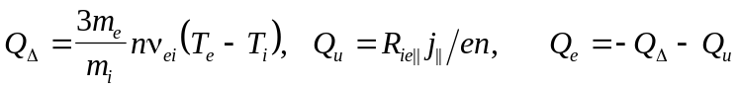.
Here 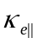 is the Braginskii heat conductivity. The perpendicular heat conductivity 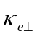can be taken either classical or anomalous. In the last term of the r.h.s. of Eq. (28) we took into account the fact that drift velocity is almost divergence free.
The ion energy balance equation is

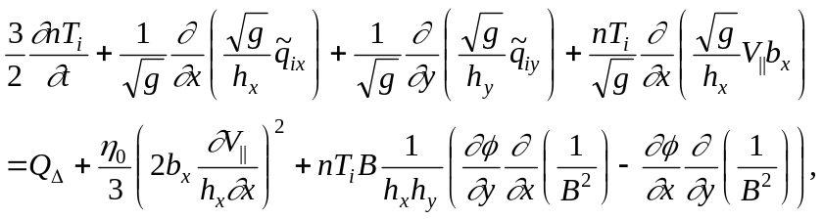 (29)
where
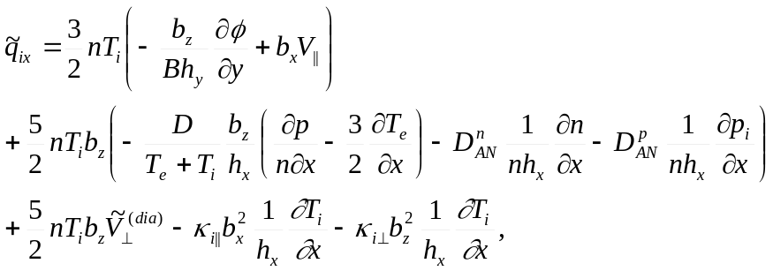
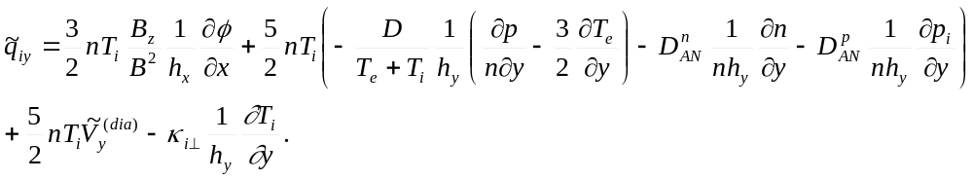.

As for electrons, parallel heat conductivity is classical, while perpendicular heat conductivity coefficient can be taken either classical or anomalous.
There is the discussion in the literature how to take into account anomalous terms in the energy balance equations. One point of view (see for example [16]) is to cancel the contribution from anomalous particle fluxes in the terms 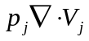 (or 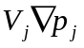 when equations are written in different form) in Eqs. (28), (29). In contrast, according to derivation [10], where kinetic equation with fluctuating term has been integrated, the anomalous fluxes should be kept in all terms in energy balance equations. This variant was used in the UEDGE code [4-5]. We leave in Eqs. (28)-(29) only the contribution from anomalous radial particle flux to the convective heat flux in the expressions for 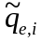. In the term the anomalous particle flux is absent. We neglect also the possible anomalous heat exchange terms between ions and electrons. Our decision is based on the fact that in the classical case the classical diffusion contribution to the sum of 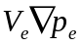 and 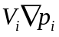 (in the sum of energy balance equations) is cancelled by the work of perpendicular friction on the diamagnetic current in Q_{e} term. However, this problem deserves further study for the case of anomalous transport.

- Boundary conditions

The charged particle density on the inner flux surface (in the core) is assumed to be constant . On the walls (with exception of the divertor plates) the y component of the particle flux is put to zero. For the parallel velocity simplified boundary condition with account for poloidal 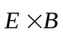 drifts is imposed at the plates

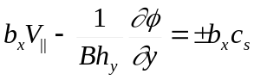, (30)

where c_{s} is the sound speed. If poloidal drift is directed towards the plate and in the vicinity of the plate exceeds poloidal sound speed, the boundary condition Eq. (30) is replaced by the condition V||=0. In other words, parallel velocity cannot be directed away from the plate. On the inner flux surface the condition 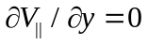 was imposed in the absence of neutral beam injection, or 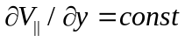 for the case of neutral beam injection. On the other boundaries the flux of parallel momentum is zero.
Boundary conditions for current continuity equation at the plates correspond to sheath current-voltage characteristics. Current to the plates (absolute value) is

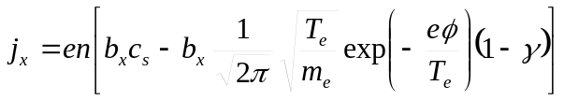, (31)

where γ is the secondary emission coefficient. At the inner flux surface two variants of boundary conditions were used: 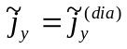, where the divergent part of diamagnetic current is given by Eq. (16), and 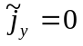. Both conditions give the same result and both guarantee that net current integrated over the inner flux surface should be zero. At the walls the same conditions on the normal current components were imposed: or .
For the energy balance equations, the energy flux through the inner flux surface was specified for each of the electron and ion channels. The electron and ion heat fluxes to the divertor plates are

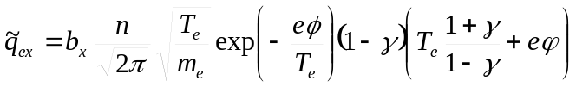,
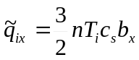. (32)

3. Results of the simulations

Simulations were performed for ASDEX-Upgrade both for Ohmic discharge and discharges with additional heating. Anomalous values of diffusion coefficient, perpendicular electron and ion heat conductivity and perpendicular viscosity coefficients were taken. To provide a convergence of a numerical scheme an anomalous current was added in the form

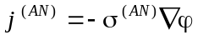, . (33)

Such low values of σ^{(AN)} on the one hand provide the convergence of the numerical scheme, and on the other hand do not influence the final result. It should be noted that anomalous conductivity in the form of Eq. (33) does not exist in the presence of turbulence, in contrast to diffusion or heat conductivity, due to ambipolar nature of Coulomb collisions (see for example [11]). The indirect influence of anomalous transport is connected with anomalous transport of momentum due to inertia and viscosity terms.
To test sensitivity of the potential profile to different type of transverse currents, in some runs all currents, except diamagnetic and anomalous currents, were switched off. In other words, anomalous conductivity in this case represents the effective transverse conductivity in the edge plasma. By changing the coefficient 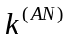 in the range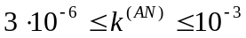 we could change anomalous conductivity. The and diamagnetic drifts were also switched off in these test runs. Potential profile in this case is shown in Fig.2. It is clearly seen that electric field on the closed flux surfaces and in SOL in the vicinity of the separatrix is very sensitive to the value of effective transverse conductivity. Electric field in the core is negative and is, roughly speaking, inversely proportional to 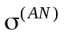. This can be understood since averaged over flux surface diamagnetic current is balanced by radial anomalous current. Surface averaged diamagnetic current in the absence of drifts is a given value, it is determined by quite subtle details of pressure distribution over the flux surface, Fig.3. Therefore, to balance it for smaller anomalous conductivity the larger radial electric field is necessary.
In contrast, in the SOL not very close to separatrix the potential distribution is quite insensitive to the value of the transverse conductivity. Here mainly the parallel momentum balance for electrons determines potential.
Switching on and diamagnetic drifts results in the redistribution of the density, temperature and pressure over the flux surfaces (Fig.3). Thus drifts have strong influence on diamagnetic current averaged over the closed flux surfaces, and, finally, on the radial potential profile. For simulation of normal discharges the anomalous conductivity was reduced to quite low value: 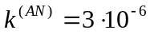, and all important perpendicular currents and all drifts were switched on. Anomalous conductivity in this case was more than two order of magnitude smaller than anomalous conductivity calculated using Einstein relation, 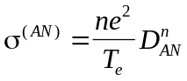, as proposed by some authors. To check the relative influence of various types of perpendicular currents these currents were switched on and off.
Results of the simulation for the Ohmic discharge for the normal direction of the magnetic field (B drift of ions is directed towards the X-point) are shown in Figs.4-6. All drifts are switched on. In Fig.4 density, temperatures and potential are displayed. Poloidal currents and drifts are shown in Figs.5-6 correspondingly. Potential reaches its maximum somewhere near the separatrix, it is negative in the core and is positive in SOL. Radial electric field is negative in the core and is positive in SOL. One can see that drifts are directed from the inner to the outer target in the SOL and from the outer to the inner target in the private region. In the core plasma rotates in the direction opposite to that in the SOL, thus creating a strong shear near separatrix. Such direction is consistent with results of other simulations and experiments [5,6,10].
The divergent part of the diamagnetic current corresponds to the particle guiding centre vertical current. Its radial component is the largest in the system. On the closed flux surfaces far from the separatrix this current is closed by the parallel Pfirch-Schlueter current

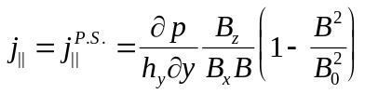. (34)

This expression is in good agreement with simulation results, Fig.7. On the closed field lines parallel current is a combination of a Pfirch-Schlueter current and thermal current which flows from outer to inner plate due to the temperature differences in the divertor legs: plasma in the vicinity of the outer plate is much hotter than plasma near the inner plate.
Since the anomalous conductivity is reduced now to quite low value, diamagnetic current averaged over the closed flux surfaces is balanced by other currents. The largest of them is the radial current caused by parallel viscosity, Eqs. (17-18). Resulting potential radial profile in the equatorial midplane is shown in Fig. 8. Switching on current driven by ion-neutral collisions, inertial current (centrifugal effect) and current driven by anomalous perpendicular viscosity did not change significantly the potential profile. Radial potential profile strongly depends on the plasma temperature and density in the vicinity of the separatrix and in the core. For larger power input into the electron and ion components the radial electric field in the core is larger, Fig.9. Far from separatrix radial electric field is close to neoclassical electric field, Fig.10, and, therefore, is proportional to the local ion temperature. The neoclassical electric field has been calculated according to

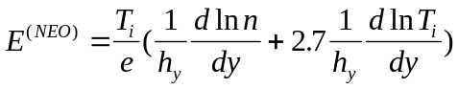. (35)

To test the role of electrostatic drifts several runs were made without drifts and without either poloidal or radial components of drifts. In the Ohmic regime the influence of the drifts is relatively modest. Switching on the poloidal drifts results in density decrease near the inner divertor and its increase at the outer divertor leg of the order of 10% in accordance with the direction of the poloidal drifts. The temperature increase in the inner divertor leg was of the order of 10%. The asymmetry of parallel particle flow in the upper part of SOL was observed, Fig. 11. Parallel flow here is directed towards the inner leg even if the poloidal drifts are switched off. Switching on the poloidal drifts leads to further increase of the parallel velocity, because the poloidal projection of the parallel velocity compensates poloidal drifts, so that poloidal rotation roughly remains the same (as was predicted in [8]). The exception is the region very close to separatrix where contribution from to the poloidal rotation is the largest. Switching on radial drifts results in smaller variation of plasma parameters (less than 10%): density increases near the inner plate and decreases near the outer plate, while the temperatures change in the opposite direction.

3. Summary

The fluid model for 2D plasma transport in the tokamak edge plasma has been presented. The divergence free terms were rigorously cancelled in the fluid equations to make the equation system more effective for numerical simulations. All important contributions to perpendicular currents are taken into account. It is demonstrated that reasonable potential distribution in tokamak edge plasma can be obtained without ad hoc assumption of the existence of the anomalous perpendicular conductivity. Radial potential profile on the closed flux surfaces and in SOL in the vicinity of a separatrix is determined mainly by the balance of diamagnetic currents and currents driven by parallel viscosity. In the major part of SOL potential profile is rather insensitive to the mechanism of transverse conductivity, and is determined by the parallel force balance for electrons. Radial electric field in the vicinity of a separatrix is determined by rather subtle details of the pressure, parallel velocity and parallel heat flux distribution over the flux surfaces.

Acknowledgements

The work was performed in the framework of German-Russian Scientific Technical Cooperation in the Field of Peaceful Use Of Atomic Energy, Project RUS-561-98. The work of group from St.-Petersburg was also supported by grant of Ministry of Education of Russia (Program on Nuclear Physics and Beams on Ionized Emission) and grant SpbSU 97-0-5.3-17.

References

1. Braginskii S.I. in Rev. Plasma Phys. Ed. by M.A. Leontovich, Consultants Bureau N.Y. v. 1. 1965, p.205.
2. Braams B. J., Contrib. Plasma Phys. 36 2/3 (1996) 276.
- Baelmans M., Reiter D., Weynants R.R., Contrib. Plasma Phys. 36 2/3 (1996) 117.
- Rognlien T.D., Ryutov D.D., Contrib. Plasma Phys. 38 1/2 (1998) 152; Rognlien T.D., Ryutov D.D., N. Mattor, Chech. Journ. Phys. 48 Suppl. S2 (1998) 201.
- Rognlien T.D., Ryutov D.D., Mattor N., Porter G.D., Phys. Plasmas 6 (1999) 1851.
- Radford G. J. et al., Contrib. Plasma Phys. 38 2/3 187 (1996).
- Rozhansky V., Tendler M. in Rev. Plasma Phys. Ed. by B.B. Kadomtsev, Consultants Bureau N.Y. v. 19 1996 p.147; Tendler M., Rozhansky V., Comments Plasma Phys. Contr. Fusion 13 (1990) 191.
- Hutchinson I. H. et al. Plasma Phys. Contr. Fusion 37 (1995) 389.
- Boedo et al, Proc. 26th EPS Conf. Contr. Fus. & Plasma Phys. (1999) P3.063.
- Hinton F.L., Kim Y.-B. Nucl. Fusion 34 (1994) 899.
- Mihailovski A.B., Tsypin V.S., Beitr. Plasmaphys. 24 (1984) 335.
- Hirshman S.P., Sigmar D.J., Nucl. Fusion 21 (1981) 239.
- Rozhansky V.A., Ushakov A.A., Voskoboynikov S.V., Nucl. Fusion 39 (1999) 613.
- McDaniel E.W., Mason E.A. The mobility and diffusion of ions in gases N.Y., Wiley (1973).
- Rozhansky V., Tsendin L., Collisional transport in partially ionised plasma, Moscow, Energoatomizdat, (1988) (in Russian).
- Zagorski R., Gerhauser H., Claaβen H.A. Contrib. Plasma Phys. 38 1/2 (1998) 61.

Figure captions
Fig.1. Coordinate system and simulation mesh; x is the poloidal coordinate, y is the radial coordinate ortogonal to the flux surfaces, coordinate "perp" corresponds to the direction perpendicular both to magnetic field and to the y-axis. The directions of magnetic field and plasma current correspond to normal operation conditions of ASDEX-Upgrade (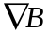 drift of ions directed towards the X-point).
Fig.2. Potential profile at the outer midplane. Anomalous perpendicular current balances diamagnetic drift current. All other transverse currents are switched off. and diamagnetic drifts are also switched off.
Fig.3. Pressure profiles on the closed flux surface. 1. All drifts are switched off. 2. drifts are switched on. 3. Both and diamagnetic drifts are switched on.
Fig.4. Main plasma parameters for the Ohmic discharge, normal direction of the magnetic field: a) electron density; b) electron temperature; c) ion temperature; d) potential.
Fig.5. Poloidal currents for the Ohmic discharge, normal direction of the magnetic field. Arrows represent full current in the xy plane and colours correspond to the values of the poloidal currents.
Fig.6. Poloidal 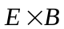 drift velocity for the Ohmic discharge, normal direction of the magnetic field. Arrows represent full drifts in the xy plane and colours correspond to the values of the poloidal drifts.
Fig.7. Parallel current on the closed flux surface as a function of the poloidal coordinate. Ohmic discharge, normal direction of the magnetic field.
Fig.8. Radial potential profiles at the outer midplane. 1. drifts and diamagnetic particle fluxes are switched off. 2. drifts are switched on. 3. All drifts and fluxes are switched on. Ohmic discharge, normal direction of the magnetic field.
Fig.9. Radial potential profile at the outer midplane for discharge with additional heating, normal direction of the magnetic field.
Fig.10. Comparison of radial electric field at the outer midplane with neoclassical electric field. Ohmic discharge, normal direction of the magnetic field.
Fig.11. Radial profile of the parallel velocity in the upper part of the SOL, Ohmic discharge, normal direction of the magnetic field. 1. In the presence of poloidal drift. 2. In the absence of drift.

