**Matlab script to prepare the post-contingency input data for Task 1**

*Merge of the post-contingency load flow results of the SN, FO and MCLA states with the same timestamp into a single file*

**INESC TEC**

José Meirinhos, Helena Vasconcelos

**17 July 2018**

1. Objective 2

2. Input Data 2

2.1 Post-contingency load flow results 2

2.2 CE file (list of substations with the corresponding transmission area) 3

3. Steps to execute the MATLAB script 3

4. Outputs 4

5. ANNEX 6

5.1 Pseudocode for the developed algorithm 6

5.2 Script to obtain the csv files for pre-specified online workflows (export_data.sh) 7

# Objective

This MATLAB script aims to prepare the input data for task 1 (evaluation of the capability of the uncertainty model used by the MCLA in assessing the security of contingencies for the overload problem).

For a set of pre-selected transmission lines (defined by a pre-specified transmission area and nominal voltage), this scrip imports the values of post-contingency active power flow (“P”, in MW), post-contingency electric current (“I”, in A) and the adopted maximum permanent current limits (“Imax*”*, in A), from the following files:

- A csv file containing the post-contingency load flow results for each SN (snapshot) [created by the online workflow, by the itools command export-online-workflow-postcontingency-states];

- A csv file containing the post-contingency load flow results for each FO (forecast state), the corresponding MCLA states and the adopted “Imax*”* values for each branch [created by the online workflow, by the itools command export-online-workflow-postcontingency-states].

The script merges, into a single output csv file, the post-contingency load flow results for the SN, FO + MCLA states with the same timestamp, including the adopted “Imax” limits. An output csv file is created for each timestamp (defined by the timestamp of the considered FO states).

Warning: This script requires MATLAB R2016b.

# Input Data

## Post-contingency load flow results

Each input csv file (containing the post-contingency load flow results for a SN or a FO with the corresponding MCLA states) must be named “9.workflow_postcontingency_states.csv” and obtained in the following way:

* ”SN” files: Run the online workflow for each SN without uncertainty (i.e. without MCLA states) and then get the csv file provided by the itools command export-online-workflow-postcontingency-states;
* “FO” files: Run the online workflow for each FO with MCLA states and then get the csv file provided by the itools command export-online-workflow-postcontingency-states.

The “SN” files must be stored into a single SN folder. The “FO” files must also be stored into a single FO folder. Inside each SN and FO folder, a different folder must exist for each timestamp to store the corresponding “9.workflow_postcontingency_states.csv” file. These folders must be named “workflow_” + “ID of the online workflow defined by the platform”. An example is “workflow_20130227_1930_20160116091728215”.

A bash language script (named “export_data.sh”) was created to automatize the creation of these “9.workflow_postcontingency_states.csv” files for a set of pre-specified online workflows (see annex for more details).

## CE file (list of substations with the corresponding transmission area)

In the CE folder, a “lienPostesCE.csv” file must exist (which was provided by RTE) to define the “transmission area”, named CE (“Centre d’Exploitation”), for each substation of the French transmission system. The first lines of this file are presented below:

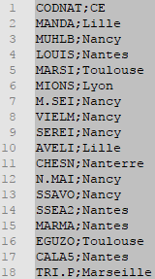

For each substation (identified by its code name) in the first column, the second column defines its corresponding “transmission area” (i.e. CE). This information is used to filter all substations associated to a user defined “transmission area”.

# Steps to execute the MATLAB script

To execute the Matlab script, the following steps must be performed:

1. Open the MATLAB file “MAIN_Import_PostCont.m”
2. Inside the code, the following configuration must be specified (see example in figure below):

* Path for the FO folder (in “path_FO =”);
* Path for the SN folder (in “path_SN =”);
* Path for the CE folder with the “lienPostesCE.csv” CE file (in “CE_path=”).
* Path for the output data (in “out_path =”), where the output files are going to be stored.
* The “transmission area” (in “CE =“) to only include the transmission line records with the specified “transmission area”. If not specified, this filter is not performed and therefore all the line records are considered.
* The nominal voltage (in “Voltage = “) to only include the transmission line records with the specified nominal voltages. If not specified, no voltage filter is performed.

1. 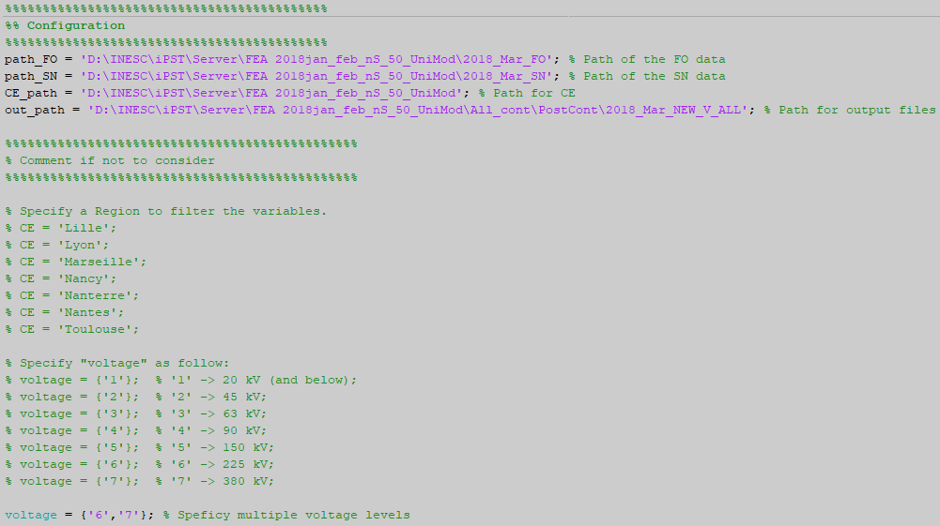Run the script.

Warning: This script is based on the FO base cases (defined by its timestamps). If the SN base case does not exist, the corresponding timestamp is not imported. For some timestamps, the power flow may not converge for one or more states, therefore, the post contingency results for these states will be missing in the “9.workflow_postcontingency_states.csv” file. If it occurs in the SN state, there will be no data to create the csv file.

# Outputs

For each matched FO/SN, the script creates a folder for each contingency in the user defined output_path and saves a csv file with the name “WF_YearMonthDay_Hour_PostCont.csv” inside the correspondent folder/contingency.

* 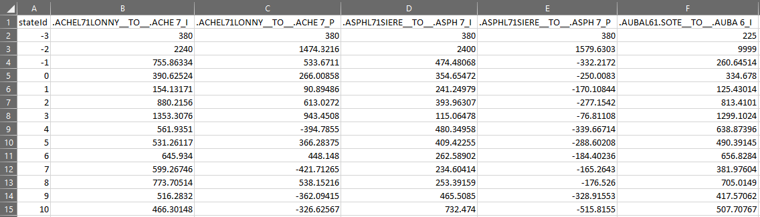In each csv file, the output results are organized as follows:

1. The first column identifies the state ID where:

* **State -3** identifies the nominal voltage of the line (Un, in kV).
* **State -2** identifies the data line with the permanent maximum limit values of each recorded post-contingency operating condition (“Imax”, in A, for electric currents and “Smax”, in MVA, for active power flows).
* **State -1** identifies the data line with the SN post-contingency load-flow results.
* **State 0** identifies the data line with the FO post-contingency load-flow results.
* **The remaining states** (state 1, state 2, …) identify the ensemble members post-contingency load-flow results [the ensemble members are the MCLA states created for the FO base case].

1. The remaining columns identify the recorded post-contingency operating conditions, which can be the active power flow (P in MW) or the electric current (I in A) for each pre-selected transmission line.

Note 1: The codification used for these operating conditions is the one obtained from the input files.

Note 2: The maximum permanent limit for active power flows (“Smax”, in MVA) is calculated from the maximum permanent limit for the electric current (“Imax”, in A) and by assuming the line nominal voltage (“Un”, in kV). Namely, by assuming that Smax = sqrt(3)*Un*Imax/1000.

# ANNEX

## Pseudocode for the developed algorithm

|  |  |
| --- | --- |
| **Main Algorithm** | |
| **Step 1:** | *Specify the input data* |
| **Step 2:** | *Get the “substation code names” for the specified “transmission area”.* |
| **Step 3:** | ***For*** *each timestamp:* |
| **Step 4:** | *From the SN input file, get the “variable header” of the active power flow and electric current in the transmission lines defined by the specified “transmission area” and voltage level;* |
| **Step 5:** | *From the SN input file, get the nominal voltage and limits of each “variable header” (State -3 and -2);* |
| **Step 6:** | *From the SN input file, get the record of each “variable header” from the SN base case (State -1);* |
| **Step 7:** | *From the FO input file, get the record of each “variable header” from the FO base case (State 0) and from the remaining states corresponding to the ensemble forecast (from State 1 to State m-1, being m the number of ensemble forecasts provided from the MCLA including the FO base case).* |
| **Step 8:** | ***End*** |
| **Step 9:** | *Save the results in .csv files (one file for each timestamp).* |

In the follow pseudocode, **step 4** of the main algorithm is detailed, namely how to get, from the SN input file, the “variable header” of the active power flow and electric current in the transmission lines defined by the specified “transmission area” and voltage level.

|  |  |
| --- | --- |
| **Step 4 - Variables filter** | |
| **1:** | *Filter all the “variable headers” * that are active power flow and electric current in branches*  *(variables with “__TO__”* ***AND*** *(“_I”* ***OR*** *“_P”) at the end of the variable code name).* |
| **2:** | *From the last set of “variable headers”, retain the ones associated to transmission lines (transformers operating conditions are excluded) of the user defined voltage level*  *(retain variables with "L" in the 6th character* ***AND*** *where the 7th defines the specified voltage level – see voltage level codification in **).* |
| **3:** | ***For*** *each “substation code name” obtained from step 2 of the main algorithm:* |
| **4:** | *Retain the “variable headers” associated to the specified “substation code name”* |
| **5:** | ***End*** |

*\* Example of a “variable header”:*

* “variable header”: “B.CARL71BIANC__TO__B.CARP7_P”
* “line ID”: “B.CARL71BIANC”
* “substation code name”: “B.CAR”

*\*\* Voltage Level Codification:*

“1” –> 20 kV (and below);

“2” –> 45 kV;

“3” –> 63 kV;

“4” –> 90 kV;

“5” –> 150 kV;

“6” –> 225 kV;

“7” –> 380 kV.

In the follow pseudocode, **step 5** of the main algorithm is detailed, namely how to get the nominal voltage and the maximum permanent limit of electric current and active power flow for the specified transmission lines.

|  |  |
| --- | --- |
| **Step 5 - Get the voltage level and limits of each “variable header” (State -3 and -2)** | |
| **1:** | ***For*** *each “variable header” obtained from step 4 of the main algorithm:* |
| **2:** | *Get the nominal voltage from the code of 7th character of each “variable header” (State -3);* |
| **3:** | *Filter all the “variable headers” with “_IMAX” at the end of the variable code name.* |
| **4:** | *Get the max value of each “_IMAX” variable for all states.* |
| **12:** | ***IF*** *the “_IMAX” variable = “NaN”* |
| **13:** | *Remove “variable header” from the current timestamp* |
| **14:** | ***End*** |
| **15:** | ***End*** |

## Script to obtain the csv files for pre-specified online workflows (export_data.sh)

To automatize the creation of the “9.workflow_postcontingency_states.csv” files for a set of pre-specified online workflows already in the server, a bash language script, named “export_data.sh”, must be copy to the server and the command line must be called in the server.

Before calling this script, the ID of the pretended online workflows must be included inside the batch file, for example, like in the following line code:

for i in 20170401_0030_20171127164817978 20170416_0030_20171127170150804 20170416_0130_20171127280150521

In this case, the script will create a folder for each workflow “20170401_0030_20171127164817978”, “20170416_0030_20171127170150804” and “20170416_0130_20171127280150521”, and inside the folder will store the csv files outputted by the specified itools commands.